**ASSIGNMENT-1**

1. Initialialized DBT

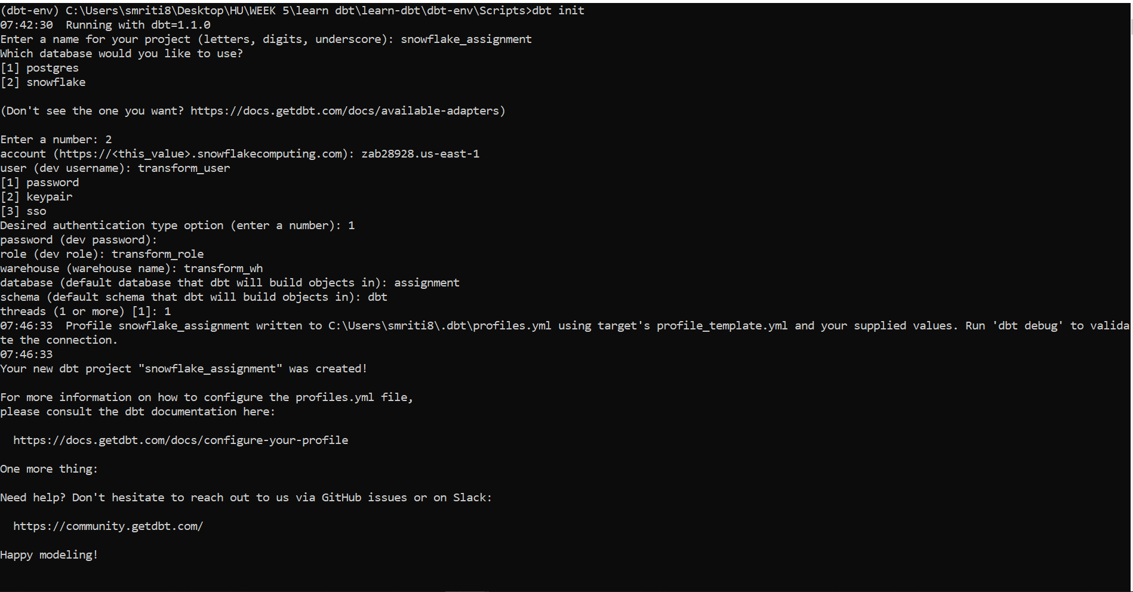

1. To load all data into database I initially tried to upload data from snowflake, but it won’t load any data above 16mb in size.

Another way to upload is to split xml file into multiple smaller xml files then load it. But for me it wasn’t working as I was getting error while running java file(maybe environment variable setup issue).

Last approach which worked for me was using snowSql (Post command wasn’t working on snowflake, so I used snowSql).

1. First created table for respective database on snowflake by providing all details on snowSql we can connect to it and add table values from cmd.

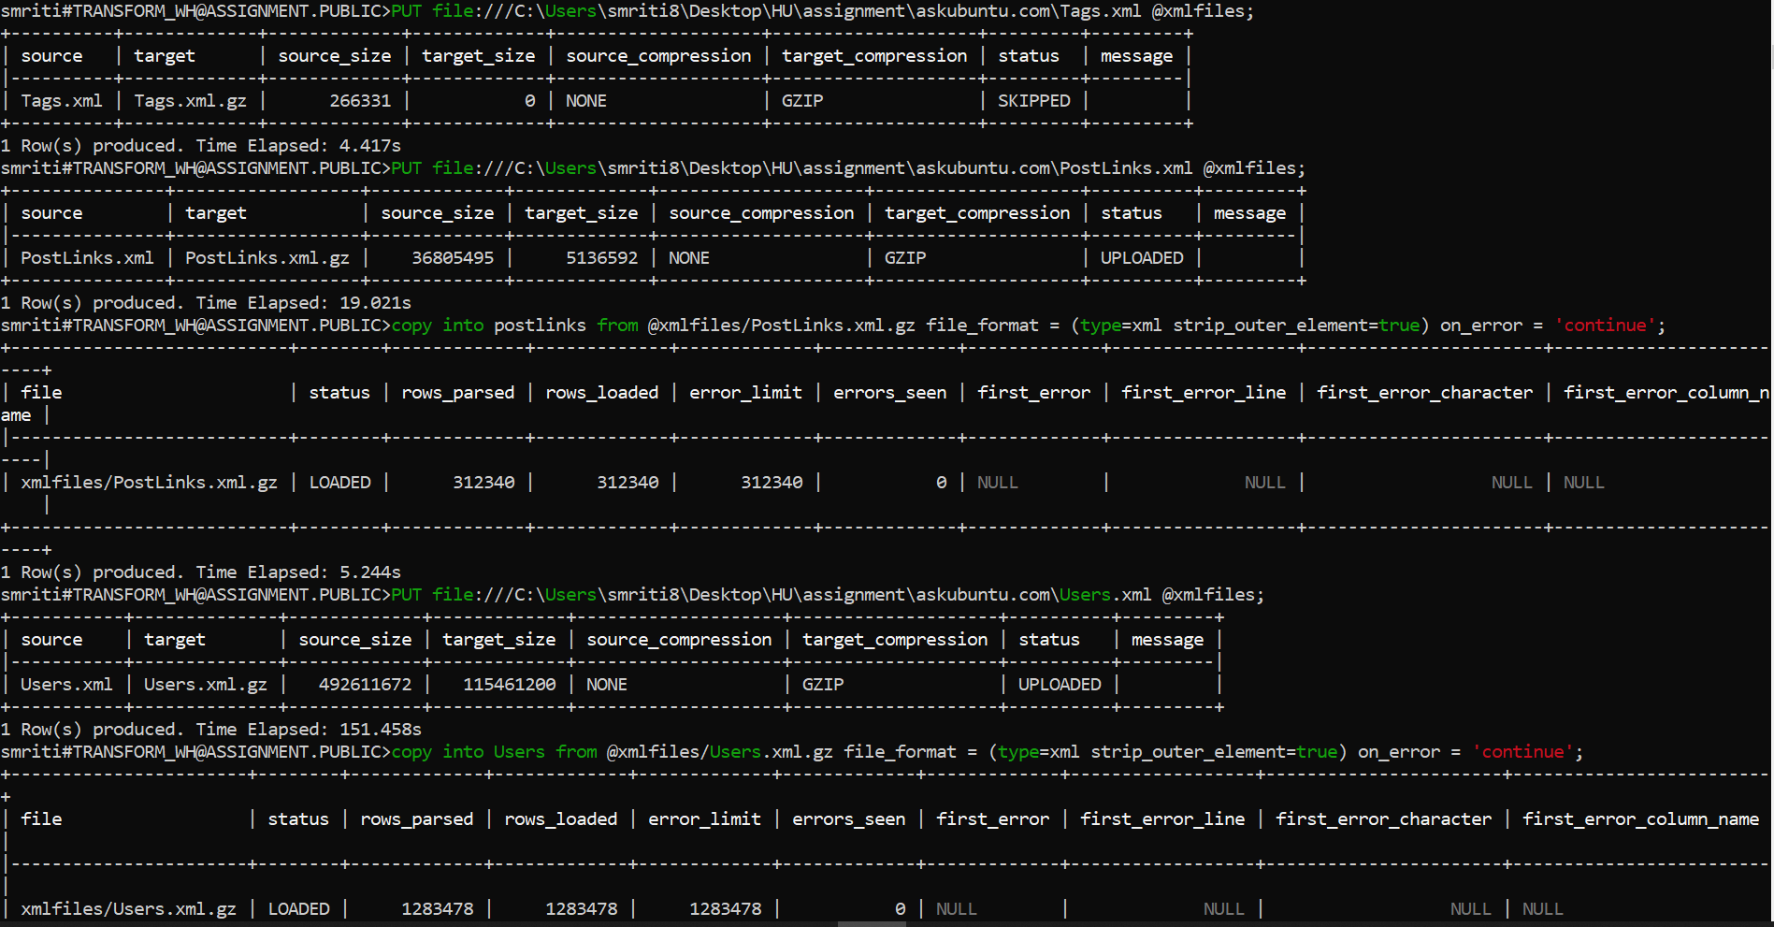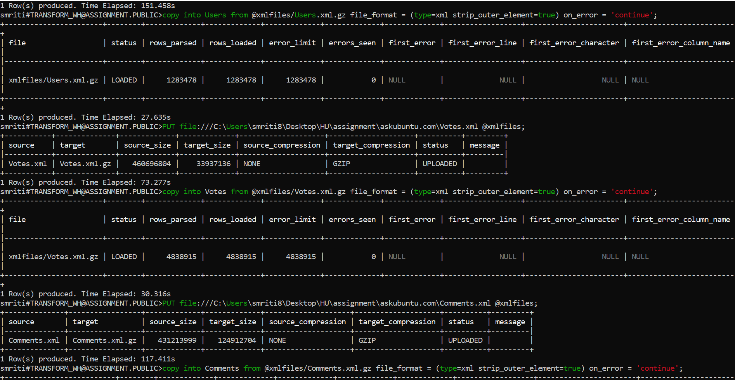

All Data Values are loaded:

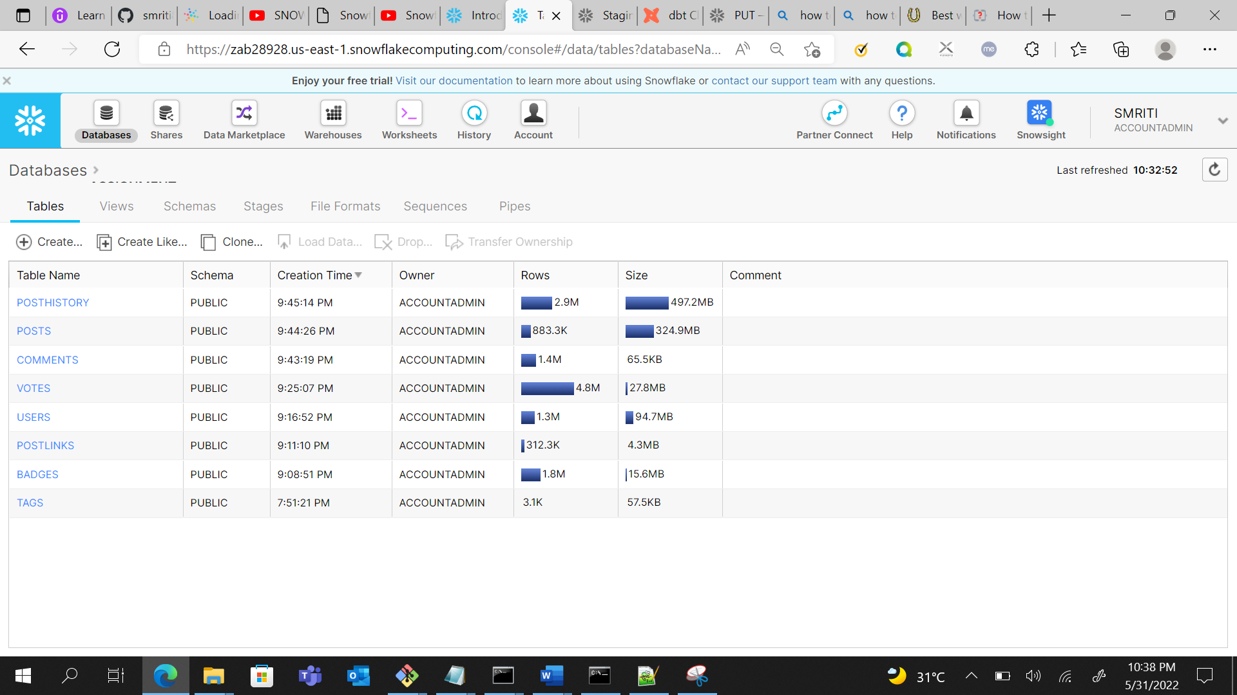

Query to select the XML data in table format:

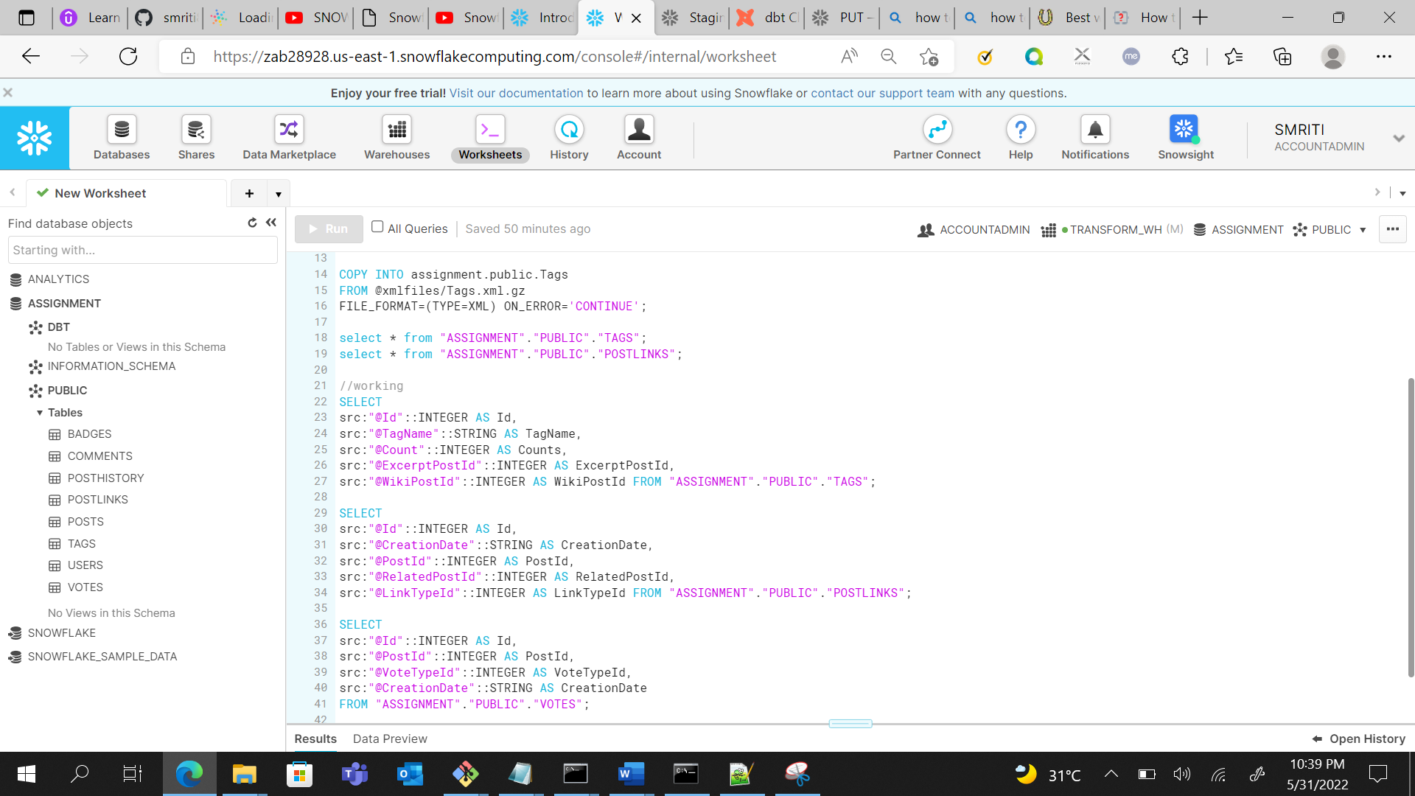

Here, the Screen shot of table tag:

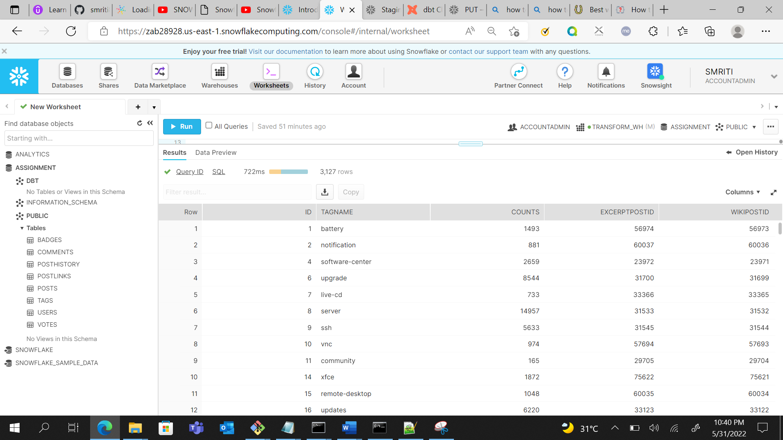

#REPUTATION

