

**Tribhuvan University**

**Faculty of Humanities and Social Science**

**Orchid International College**

**RECIPE RECOMMENDATION MOBILE APPLICATION**

**A PROJECT REPORT**

**Submitted to**

**Department of Computer Application**

**Orchid International College**

***In partial fulfillment of the requirements for the Bachelors in Computer Application***

Submitted by

Smriti Khadka (93902090)

July 2024

Under the Supervision of

**Dhiraj Kumar Jha**



**Tribhuvan University**

**Faculty of Humanities and Social Science**

**Orchid International College**

# SUPERVISOR’S RECOMMENDATION

I hereby recommend that this project prepared under my supervision by Jyoti Koirala entitled **“Recipe Recommendation Mobile Application”** in partial fulfillment of the requirements for the degree of Bachelor of Computer Application is recommended for the final evaluation.

**SIGNATURE**

Mr. Dhiraj Kumar Jha

**SUPERVISOR**

Head of Department

Faculty of Humanities and Social Science

Bijayachowk, Gaushala, Kathmandu



**Tribhuvan University**

**Faculty of Humanities and Social Science**

**Orchid International College**

# LETTER OF APPROVAL

This is to certify that this project prepared by Jyoti Koirala entitled “**Recipe Recommendation Mobile Application”** in partial fulfillment of the requirements for the degree of Bachelor in Computer Application has been evaluated. In our opinion it is satisfactory in the scope and quality as a project for the required degree.

|  |  |
| --- | --- |
| **Signature of Supervisor**  _____________________  Mr. Dhiraj Kumar Jha  Head of Department  Department of IT  Orchid International College | **Signature of HOD/ Coordinator**  ___________________  Mr. Dhiraj Kumar Jha  Head of Department  Department of IT |
| **Signature of Internal Examiner**  Dhiraj Kumar Jha  Head of Department | **Signature of External Examiner**  ______________________ |

# ABSTRACT

**Chef's Delights** is an innovative culinary application designed to provide users with personalized recipe recommendations based on their preferences and dietary needs. Developed using Java in Android Studio for the front end and PHP with MySQL for the backend, Chef's Delights utilizes advanced algorithms and user data to deliver a highly customized and engaging cooking experience. As the demand for convenient and user-friendly cooking aids grows, this app meets the need for accessible and enjoyable recipe discovery through mobile devices.

**Personalized Recipe Recommendations** allow users to discover new dishes tailored to their tastes, cooking skills, and available ingredients. **Video Tutorials** provide access to a curated library of cooking videos that guide users step by step through the preparation of various dishes, ensuring a seamless and educational experience in the kitchen.

The integration of PHP and MySQL in the backend ensures efficient data management and smooth user interactions, while the Java and Android Studio-based front end delivers an intuitive and responsive user interface. This project demonstrates how Chef's Delights successfully combines modern technology with culinary expertise to create an enjoyable and effective cooking environment, helping users enhance their culinary skills and discover new favorite dishes.

**Keywords:** Chef's Delights, Recipe Recommendation App, Personalized Recipes, Culinary Quiz, Video Tutorials, Java, Android Studio, PHP, MySQL

# ACKNOWLEDGEMENT

We have invested a significant amount of effort into the **Chef's Delights** project. However, completing this project would not have been possible without the unwavering support and guidance of numerous individuals. We would like to extend our sincere thanks to all of them.We are profoundly grateful to our supervisor, **Mr. Dhiraj Kumar Jha**, for his expert guidance and supervision. His valuable insights, along with his continuous encouragement and constructive feedback, have been pivotal in the successful completion of this project.We would also like to express our deepest appreciation to our fellow team members who have contributed their expertise and effort towards the development of **Chef's Delights**. Their cooperation and dedication have been essential in bringing this project to fruition.

Finally, we wish to acknowledge and thank everyone who has provided assistance, advice, and support throughout this journey. Your contributions have been indispensable

**Smriti Khadka (93902067)**

# TABLE OF CONTENTS

SUPERVISOR’S RECOMMENDATION i

LETTER OF APPROVAL ii

ABSTRACT iii

ACKNOWLEDGEMENT iv

TABLE OF CONTENTS v

LIST OF FIGURES vii

Chapter 1: Introduction 1

1.1 Introduction 1

1.2 Problem Statement 1

1.3 Objectives 1

1.4 Scope and Limitation 2

1.4.1 Scope 2

1.4.2 Limitation 2

1.5 Report Organization 2

Chapter 2: Background Study and Literature 3

2.1 Background Study 3

2.2 Literature Review 3

Chapter 3: System Analysis and Design 4

3.1 System Analysis 4

3.1.1 Requirement Analysis 4

3.1.2 Feasibility Analysis 5

3.1.3 Data Modelling (ER-Diagram) 6

7

3.2 System Design 7

3.2.1 Architectural Design 7

3.2.2 Database Schema Design 9

3.2.3 Physical DFD 11

Chapter 4: Conclusion and Future Recommendations 12

# LIST OF FIGURES

Figure 3.1‑1 Use Case Diagram of Recipe Recommendation Application 4

Figure 3.1‑2 Gantt Chart of Recipe Recommendation Application 6

Figure 3.2‑1 MVC Architecture 8

Figure 3.2‑2 Database Schema Design of Recipe Recommendation Application 9

Figure 3.2‑4 Category Page UI 10

Figure 3.2‑5 Starting Page UI 10

# Introduction

## Introduction

In today's busy world, finding time to prepare delicious and healthy meals can be a challenge. The Recipe recommendation application, Chef's Delight, is designed to make cooking easy, fun, and accessible for everyone. With an intuitive frontend developed in Android Studio using Java, the application ensures a seamless and enjoyable user experience. Local data storage is efficiently managed with SQLite, providing quick and reliable access to your favorite recipes. The backend, built with PHP and MySQL, guarantees secure and scalable data handling. Key features such as personalized recipe recommendations, meal planning empower users to take control of their culinary adventures and achieve their cooking goals with ease.

## Problem Statement

Cooking can be a challenging task for many individuals, especially when faced with the daunting task of deciding what to cook or finding recipes that match their dietary preferences. Traditional methods of recipe discovery, such as cookbooks or word of mouth, can be limiting and often fail to cater to specific needs like dietary restrictions or ingredient availability. There is a growing demand for a more personalized approach to cooking that simplifies the process and makes it enjoyable. Some challenges faced by individuals when trying to prepare meals are:

* Limited time and resources can make it difficult for people to plan and prepare healthy, balanced meals regularly.
* Lack of culinary skills or experience can make it intimidating for individuals to try new recipes or cooking techniques.
* Dietary restrictions or specific health conditions may require special ingredients or modifications to traditional recipes, which can be difficult to manage without proper guidance.

## Objectives

The main purpose of **"Chef's Delights"** is to achieve the following objectives:

* To provide personalized recipe recommendations tailored to individual preferences and dietary needs.
* To offer an engaging and enjoyable cooking experience through interactive culinary tasks.
* To save time and reduce the stress of meal planning by simplifying the process of discovering new recipes.

## Scope and Limitation

Scope and limitation of Chef’s Delight are listed below.

### Scope

**Chef's Delights** offers a vibrant and interactive culinary experience, designed to transform how users discover, learn, and share recipes. This app eliminates the need for static cookbooks and traditional recipe resources by providing a dynamic platform that combines recipe discovery, video tutorials, and community engagement. Users can explore a diverse range of recipes at their own pace, receive visual guidance for complex cooking techniques. The app’s intuitive interface and interactive features make it easy for users to enhance their culinary skills and find inspiration, while fostering a collaborative environment for sharing and feedback. By simplifying recipe exploration and offering an engaging learning experience, Chef's Delights aims to enrich the cooking journey and elevate the culinary experience for all users.

### Limitation

The limitations of the existing system are listed as follows:

1. Although the app offers a diverse range of recipes and video tutorials, it may lack the hands-on experience and direct guidance that in-person cooking classes provide.
2. The app might not fully accommodate all skill levels or dietary preferences, potentially limiting its usefulness for users with specific needs or advanced cooking skills.
3. Performance issues such as app crashes, slow loading times, or compatibility problems with certain devices could disrupt the user experience and hinder access to recipes and tutorials.
4. Over-reliance on digital platforms for culinary inspiration might reduce opportunities for hands-on cooking practice and real-world culinary exploration, impacting users' overall cooking skills development.

## Report Organization

This report document contains five chapters including this chapter. Chapter two defines and describes Background Study and Overview of related existing systems and their pros and cons. Chapter three presents the System Analysis and Design including Requirement Analysis and Feasibility Analysis. Chapter four presents the Implementation, Testing and debugging are explained. In chapter five, Conclusion, Limitations and Future enhancement are briefly explained. Overall, this report contains architecture of the system and tools and technologies that are used to build the system.

# Background Study and Literature

## Background Study

In traditional culinary resources, such as cookbooks and static recipe websites, users often face limitations in engagement and personalization. Cookbooks provide structured recipes but lack interactive features and adaptability to individual preferences. Static websites may offer a broad range of recipes but typically do not offer personalized recommendations or real-time updates. These traditional methods can also make it difficult for users to find recipes suited to their specific tastes or dietary needs, leading to a less dynamic cooking experience. **Chef's Delights** addresses these issues by providing a user-friendly, interactive digital platform that offers personalized recipe recommendations, video tutorials, and community engagement, meeting the need for a more tailored and engaging culinary experience in today’s fast-paced lifestyle.

## Literature Review

# System Analysis and Design

## System Analysis

The system analysis of the system is done by conducting requirement analysis, feasibility study, data modelling and process modelling.

### Requirement Analysis

Understanding and analyzing requirements is vital for ensuring the success of a system or software project. These requirements can be broadly categorized into two types:

1. Functional requirements (what the system should do)
2. Non-functional requirements (how the system should perform).
3. **Functional Requirements**

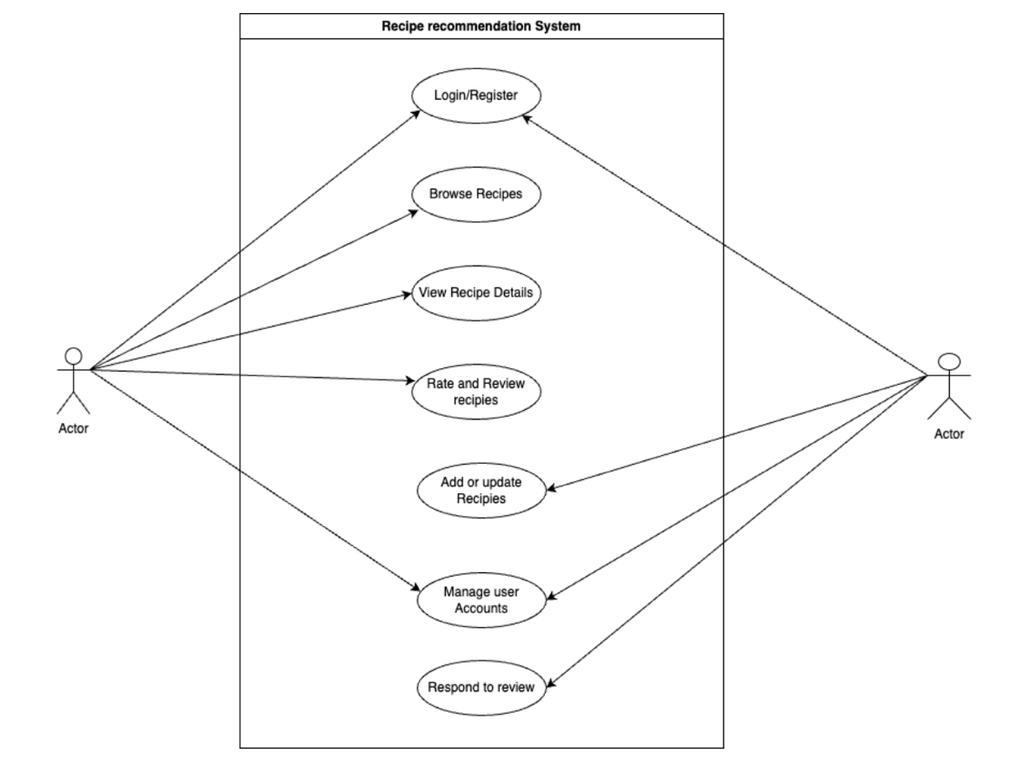Functional Requirements are the services the system should provide, how the system should react to particular inputs and how the system should behave in various situations. Some of the functional requirements are as follows.

Figure 3.1‑1 Use Case Diagram of Recipe Recommendation Application

This use case diagram illustrates the functionality of a Recipe Recommendation System. The primary actor, labeled as "Actor," can interact with the system in several ways. The actor can register or log in to access the application, browse recipes, view recipe details, rate and review recipes, add or update recipes, manage user accounts, and respond to reviews.The diagram effectively outlines the core features of the application, demonstrating how a user would interact with the system to create an account, explore and view recipe content, provide feedback, contribute by adding or updating recipes, manage their account, and engage with other users through reviews. This structure provides a clear overview of the application's main functionalities and the user's potential interactions with the recipe recommendation system

#### **Non-Functional Requirements**

Non-functional requirement of the system are as follows: -

* Security: The system should ensure the safety and confidentiality of customer data and payment information.
* User-Friendly Interface: The system should have an intuitive and easy-to-use interface to improve the user experience.

### Feasibility Analysis

**i. Technical Feasibility:** The system has the technical capacity to store and manage data such as user details, recipe information, reviews, and ratings. The project is designed to be scalable, allowing for future expansions if needed. It involves the use of reliable hardware, software, and technologies. The application requires a device (such as a smartphone, tablet, or computer) and internet connectivity. The system's user interface is intuitive and user-friendly. It should be supported by hardware with adequate CPU, processing power, and memory to ensure smooth operation and responsiveness.

**ii. Operational Feasibility:** The proposed system is operationally feasible, offering a reliable experience for all types of users, including those with minimal technical knowledge. The system is designed to cater to individual users and can be easily adapted to small or large-scale organizations. Its simplicity and straightforward navigation ensure that users can easily browse, manage, and interact with recipes without requiring extensive training or technical support.

**iii. Economic Feasibility:** The application will be free to use, with potential monetization options such as premium features or services like personalized meal plans or exclusive content. The app is not resource-intensive, making it accessible on devices with basic specifications. Operating the application will require minimal human resources and hardware, making it cost-effective. The development of this application will involve a moderate financial investment, making it economically viable for implementation and maintenance.

**iv. Schedule Feasibility:** Schedule feasibility assesses the realism and achievability of the project timeline. The feasibility of the Recipe Recommendation Application is high, as it can be completed within a set deadline. The project plan is designed to ensure that all milestones, from development to testing and deployment, are met within the allocated time frame, ensuring timely delivery without compromising quality.

The schedule and duration of the project is shown in the Gantt chart below: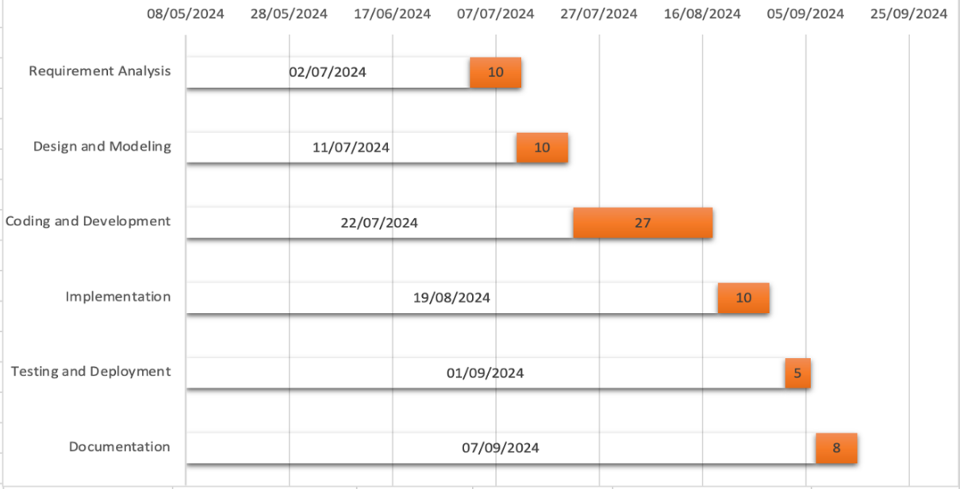

Figure 3.1‑2 Gantt Chart of Recipe Recommendation Application

The Gantt chart outlines a project timeline with six phases: Requirement Analysis (02/07/2024, 10 days), Design and Modeling (11/07/2024, 10 days), Coding and Development (22/07/2024, 27 days), Implementation (19/08/2024, 10 days), Testing and Deployment (01/09/2024, 5 days), and Documentation (07/09/2024, 8 days). Each phase includes its respective start date and duration, providing a clear schedule for the project's progression from initial analysis through to final documentation.

### Data Modelling (ER-Diagram)

# 

Figure 3.1‑3 ER Diagram of Recipe Recommendation Application

This ER diagram represents a recipe recommendation application with four main entities: Recipe, Ingredients, Category, and User. The Recipe entity contains attributes like Recip**e i**d, Description, Quantity, Recipe Type, and Recipe name, storing comprehensive information about each dish. Ingredients are linked to recipes through a "has" relationship, with their own attributes including Ingredientid, type, name, and amount. Categories classify recipes into types such as Breakfast, Lunch, Dinner, Drinks, and Vegan Options, allowing for easy organization and searching. Users interact with the system by searching for recipes and entering ingredients, as shown by the "Searches" and "Enter" relationships. The User entity stores basic account information like Userid, Password, and Signinaccount. This structure enables a dynamic system where users can search for recipes based on ingredients, categories, or other criteria, and potentially receive personalized recommendations. The interconnected nature of the entities allows for complex queries and interactions, making it possible to filter recipes by dietary preferences, meal types, or available ingredients, thus providing a versatile and user-friendly recipe recommendation experience.

## System Design

### Architectural Design

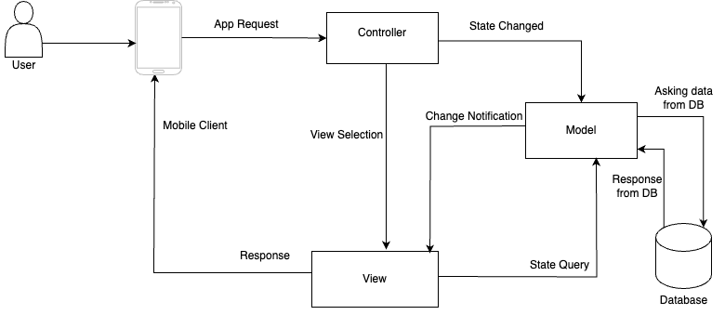

Figure 3.2‑1 MVC Architecture

This diagram illustrates the Model-View-Controller (MVC) architecture in a mobile application context. The process begins with the User interacting with the Mobile Client, which sends an App Request to the Controller. The Controller manages the application logic and communicates with both the Model and View components. When the state changes, the Controller informs the Model, which then interacts with the Database to retrieve or update data. The Model notifies the View of any changes, and the View queries the Model for updated state information. The Controller also selects the appropriate View to display, which then provides the Response back to the Mobile Client for the User to see. This architecture separates concerns, with the Model handling data and business logic, the View managing the user interface, and the Controller coordinating between them, allowing for a more organized and maintainable application structure.

### Database Schema Design

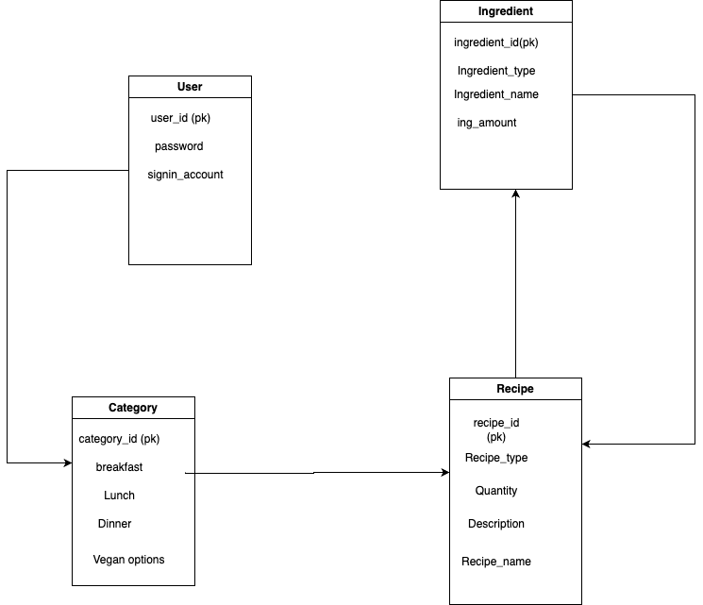

Figure 3.2‑2 Database Schema Design of Recipe Recommendation Application

The entity-relationship diagram for the recipe management system includes four main entities: User, Category, Recipe, and Ingredient. The User entity stores information about system users, including a unique user ID (primary key), password, and sign-in details. The Category entity organizes recipes into different meal types or dietary options, with attributes such as category ID (primary key) and options for breakfast, lunch, dinner, and vegan meals. The Recipe entity is central to the system, containing details like recipe ID (primary key), type, quantity, description, and name. It is linked to both the Category and Ingredient entities, indicating that recipes are categorized by meal type and consist of various ingredients. The Ingredient entity holds information about recipe components, including an ingredient ID (primary key), type, name, and amount. The relationships between these entities enable users to access recipes by category, view detailed descriptions, and find the necessary ingredients, providing a well-organized and efficient recipe management system. Interface Design (UI Interface / Interface Structure Diagrams)

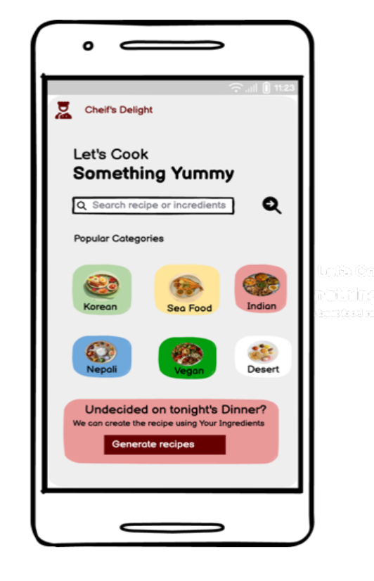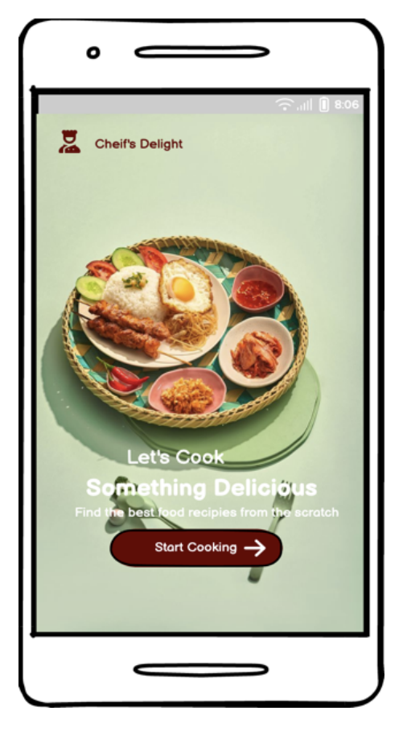

Figure 3.2‑4 Category Page UI

Figure 3.2‑5 Starting Page UI

### Physical DFD

# Conclusion and Future Recommendations

For a recipe recommendation project, the expected outcomes could be:

* **Secure Account Registration and Login**: Users can create accounts and log in securely.
* **Personalized Recipe Recommendations**: Users receive recipe suggestions based on their preferences and dietary needs.
* **Easy Navigation**: Users can effortlessly browse, search, and filter recipes.
* **Interactive and Engaging Experience**: The application offers an engaging interface with features like cooking tips, videos, and step-by-step instructions.