|  |
| --- |
| **DAYANANDA SAGAR UNIVERSITY**  Devarakaggalahalli, Harohalli  Kanakapura Road, Ramanagara - 562112, Karnataka, India   |

**Bachelor of Technology**

**in**

**COMPUTER SCIENCE AND ENGINEERING**

**Full Stack Development**

**Mini Project Report**

**(REMOTE WORK AND DIGITAL COLLABORATION)**

By

**SHREYA N- ENG22CS0165**

**SMRITI ELIGAR- ENG22CS0172**

**SPANDANA B.V- ENG22CS0181**

**Under the supervision of**

**Prof Yashpal Gupta S**

**Prof Vishwas D B**

**Asisstant professor Dept of CSE**

**DEPARTMENT OF COMPUTER SCIENCE & ENGINEERING,**

**SCHOOL OF ENGINEERING**

**DAYANANDA SAGAR UNIVERSITY,**

**(2023-2024)**

**DAYANANDA SAGAR UNIVERSITY**

Department of Computer Science & Engineering

Devarakaggalahalli, Harohalli

Kanakapura Road, Ramanagara - 562112, Karnataka, India

CERTIFICATE

This is to certify that the Full Stack Development Mini Project work titled **“remote work and collaboration”** is carried out by **Shreya N (ENG22CS0172), Smriti E (ENG22CS0172),** **Spandana B.V (ENG22CS0181),** bonafide students of Third semester of Bachelor of Technology in Computer Science and Engineering at the School of Engineering, Dayananda Sagar University, Bangalore in partial fulfillment for the award of degree in Bachelor of Technology in Computer Science and Engineering, during the year **2023-2024**.

|  |  |
| --- | --- |
| **Prof. Yashpal Gupta**  **S Prof. Vishwas D B** | **Dr. Girisha G S** |
| Assistant Professor  Dept. of CS&E,  School of Engineering  Dayananda Sagar University  Date: | Chairman CSE  School of Engineering  Dayananda Sagar University  Date: |

**Name of the Examiner** **Signature of Examiner**

<

DECLARATION

We, **Shreya N (ENG22CS0165), Smriti E (ENG22CS0172),** **Spandana B.V (ENG22CS0181),** are students of Third semester B. Tech in **Computer Science and Engineering**, at School of Engineering, **Dayananda Sagar University**, hereby declare that the Mini Project titled **“Remote work and digital collaboration”** has been carried out by us and submitted in partial fulfilment for the award of degree in **Bachelor of Technology in Computer Science and Engineering** during the academic year **2023‑2024.**

|  |  |
| --- | --- |
| Student | Signature |
| Name1:Shreya N  USN :ENG22CS0165 |  |
| Name2: Smriti Eligar  USN : ENG22CS0172 |  |
| Name3:Spandana B.V  USN :ENG22CS0181 |  |
|  |  |
| Place : Bangalore  Date : |  |

**ACKNOWLEDGEMENT**

*It is a great pleasure for us to acknowledge the assistance and support of many individuals who have been responsible for the successful completion of Full Stack Development mini project work.*

*First, we take this opportunity to express our sincere gratitude to School of Engineering & Technology, Dayananda Sagar University for providing us with a great opportunity to pursue our Bachelor’s degree in this institution.*

*We would like to thank* ***Dr. Udaya Kumar Reddy K R, Dean, School of Engineering & Technology, Dayananda Sagar University*** *for his constant encouragement and expert advice.*

*It is a matter of immense pleasure to express our sincere thanks to* ***Dr. Girisha G S,******Department Chairman****,* ***Computer Science and Engineering****,* ***Dayananda Sagar University,*** *for providing right academic guidance that made our task possible.*

*We would like to thank our guide*  ***Prof. Yashpal Gupta S, Prof. Vishwas D B* ,*Assistant Professor****,* ***Dept. of Computer Science and Engineering****,* ***Dayananda Sagar University****, for sparing his/her valuable time to extend help in every step of our project work, which paved the way for smooth progress and fruitful culmination of the project.*

*We are also grateful to our family and friends who provided us with every requirement throughout the course.*

*We would like to thank one and all who directly or indirectly helped us in the mini Project work.*

**TABLE OF CONTENTS**

LIST OF FIGURES

ABSTRACT

Page

CHAPTER 1 INTRODUCTION………................................................................. 7

CHAPTER 2 OVERVIEW OF PROJECT……..................................................... 3

2.1. Purpose and Goals.......................................................................... 4

2.2. Technologies Used........................................................................... 5

CHAPTER 3 FUNCTIONAL REQUIREMENTS..................................................... 6

CHAPTER 4 CODE SNIPPETS………...................................................................... 7

CHAPTER 5 RESULT………………………........................................................... 10

CONCLUSION……………………………………………………………………... 15

**LIST OF FIGURES**

|  |  |  |
| --- | --- | --- |
| Fig. No. | Description of the figure | Page No. |
| 1.1 | *The login page of employee and employer* | 8 |
| 1.2 | *The sign up page of employee and employer* | 9 |
| 1.3 | *Dashboard* | 9 |
| 1.4 | *Employment Details* | 10 |
| 1.5 | *Financial records* | 10 |
| 1.6 | *Record of Bonus* | 11 |
| 1.7 | *Assigned tasks for employees* | 11 |
| 1.8 | *Settings page* | 12 |
| 1.9 | *Log out page* | 13 |

Abstract

Design and develop a secure, user-friendly mobile application catering to both employees and employers, facilitating seamless access to pertinent information and administrative functionalities while upholding stringent data privacy and security measures.

Employee Features: Provide employees with secure access to personal details, schedules, pay stubs, benefits, and other work-related information.

Employer Features: Enable employers to manage employee profiles, payroll, company policies, and other administrative tasks securely and efficiently.

Monitoring & Logging: Implement logging mechanisms to track user activities for accountability purposes while respecting user privacy and confidentiality.

Compliance & Regulations: Ensure adherence to relevant data protection laws (e.g., GDPR, CCPA) and industry standards to maintain compliance and protect user data.

CHAPTER 1 INTRODUCTION

The course of full stack development aims to teach us the basics of building a whole website from scratch and making the website interactive with the user whilst being capable of storing data and retrieving it from the server on demand. Full stack development refers to the practice of developing both the front-end and back-end parts of a web application or a software.

* 1. **Front End:**

Front end of an application is what the user interacts with directly. It involves everything the user sees, touches, clicks or interacts with the page or application in any way. This includes the design layout, user interface (UI) and user experience (UX). This make the page more creative, visually appealing and interactive thereby creating a unique experience for the user. Developers ensure that websites adapt to various screen sizes and devices using media queries and flexible layouts. This is crucial for a seamless user experience across desktops, tablets and mobile devices.

* + 1. **Languages involved in front end**
       1. *HTML (HyperText Markup Language):*

HTML is the foundational markup language used to structure content on the web. It provides a set of elements or tags that define the structure of a web page. These elements range from headings (<h1> to <h6>), paragraphs (<p>), and lists (<ul>, <ol>, <li>) to more complex structures like forms (<form>) and tables (<table>). HTML creates the backbone of a web page, forming the structure that is then styled and enhanced with CSS.

* + - 1. *CSS (Cascading Style Sheets):*

CSS is a styling language that complements HTML by providing a way to control the presentation and layout of web pages. CSS allows developers to define styles for HTML elements, specifying aspects such as colors, fonts, spacing, and positioning. With CSS, you can create visually appealing and responsive designs, ensuring a consistent look and feel across different devices. It operates on a "cascade" principle, meaning styles can be inherited or overridden based on specificity and source order.

* + - 1. *JavaScript:*

JavaScript is a dynamic scripting language that adds interactivity and behavior to web pages. It enables developers to create responsive and interactive user interfaces. JavaScript can manipulate the HTML and CSS of a page in real-time, respond to user actions, and interact with external data or APIs. With the advent of modern frameworks like React, Angular, and Vue, JavaScript has become a key player in building complex, single-page applications (SPAs) that offer seamless user experiences.

* 1. **figures :**

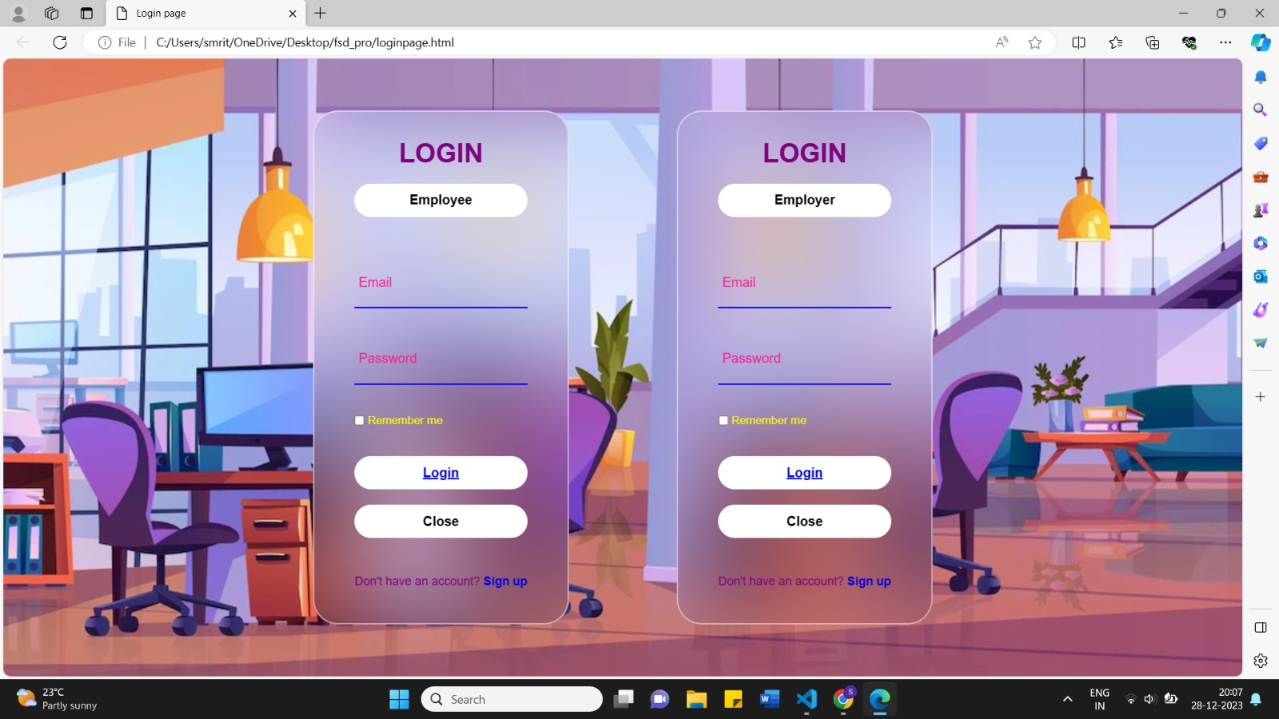

**Figure 1.1 The login page of employee and employer**

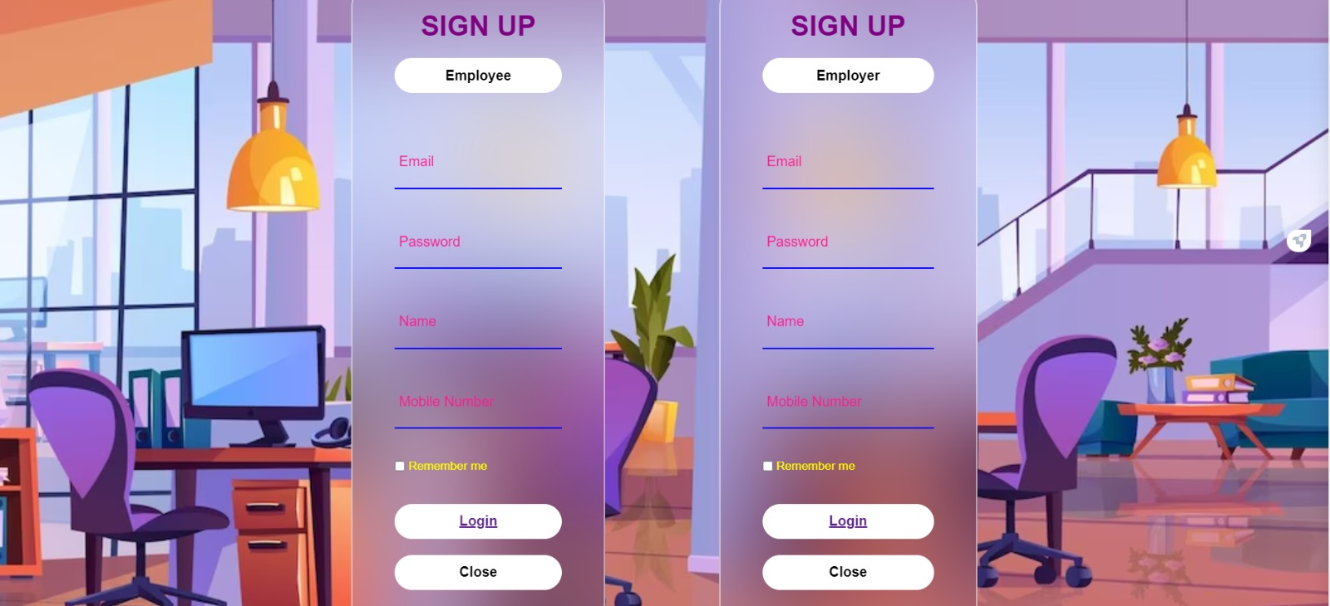

**Figure 1.2 The sign up page of employee and employer**

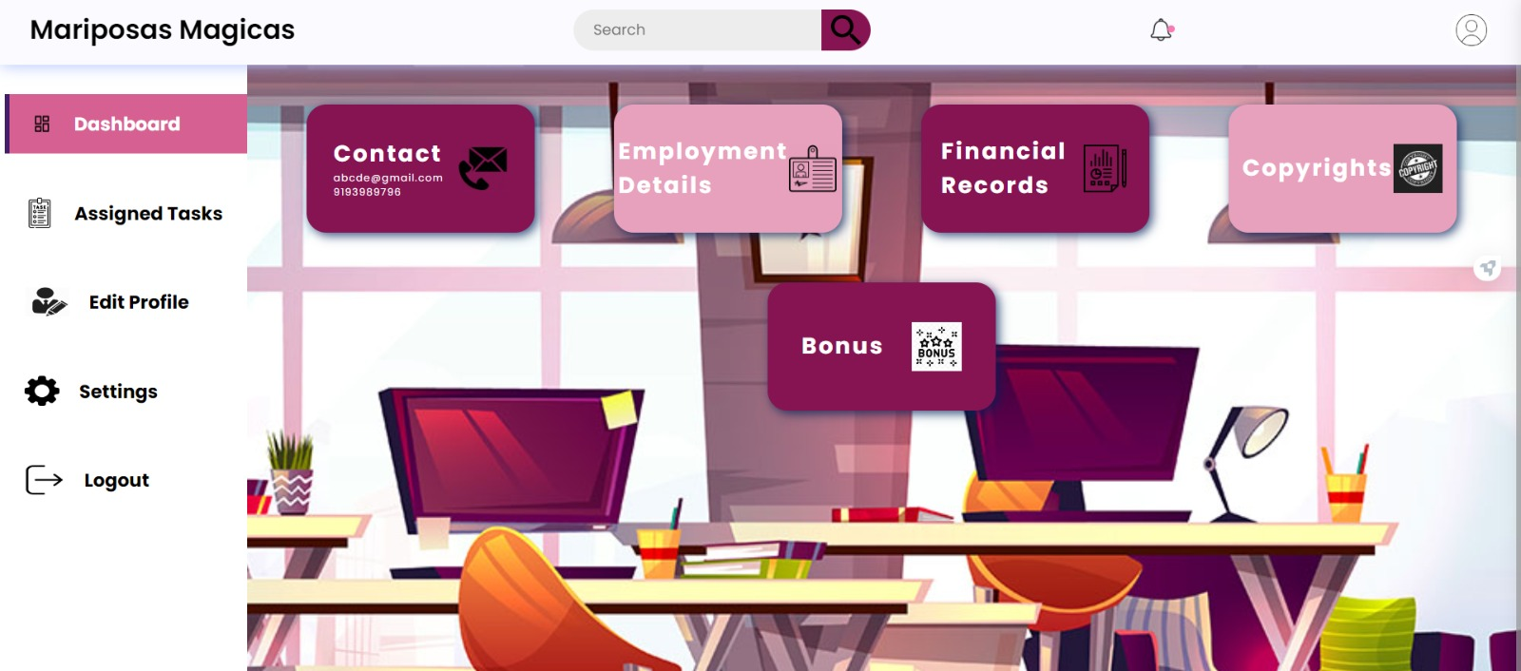

**Figure 1.3 dashboard**

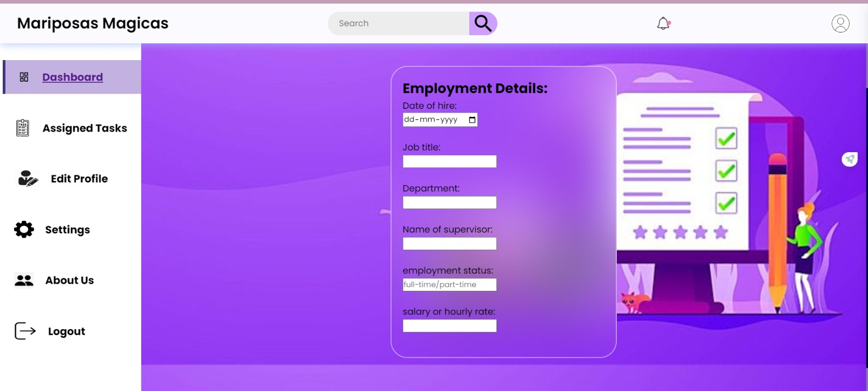

**Figure 1.4 Employment Details**

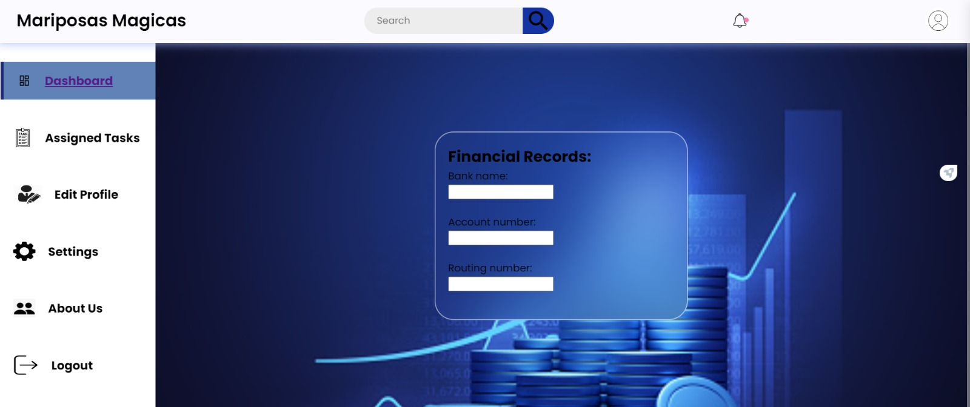

**Figure 1.5 Financial Records**

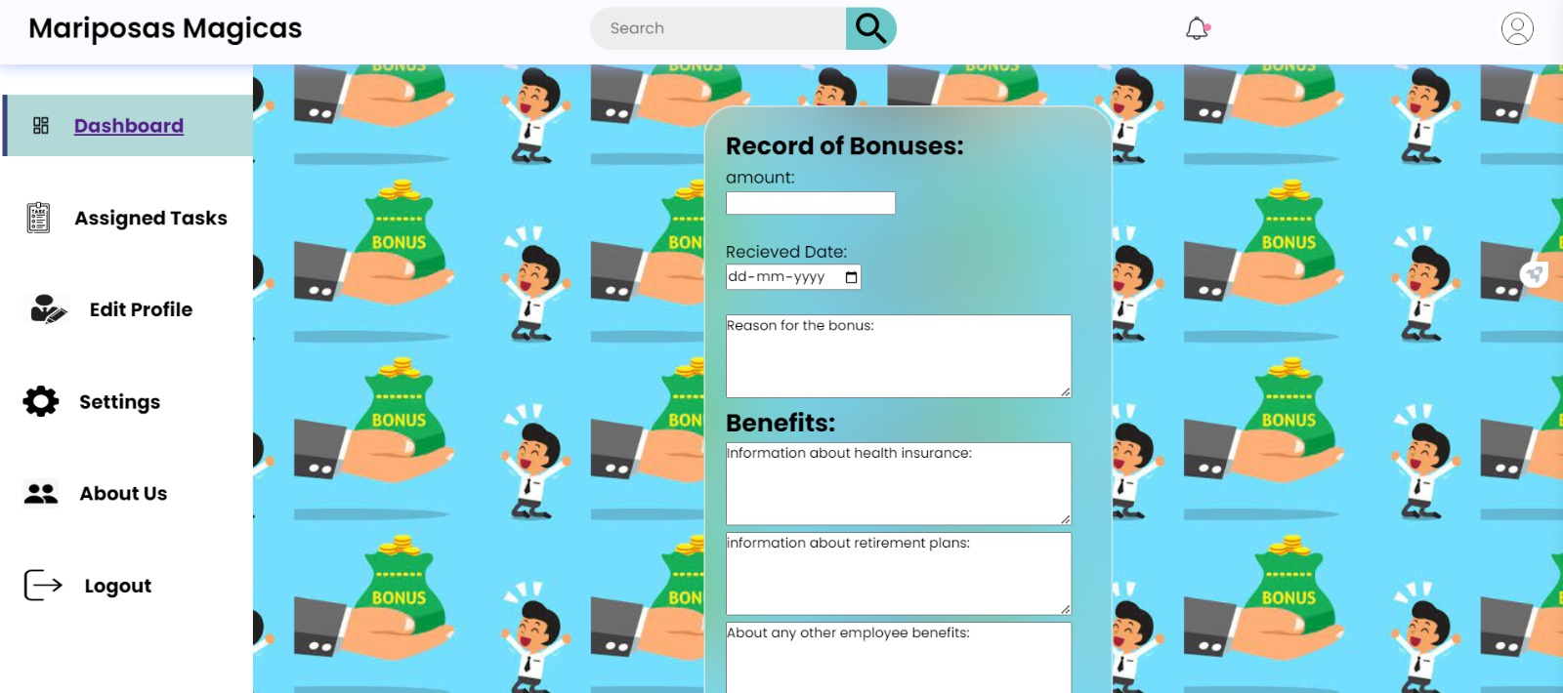

**Figure 1.6 Record of Bonus**

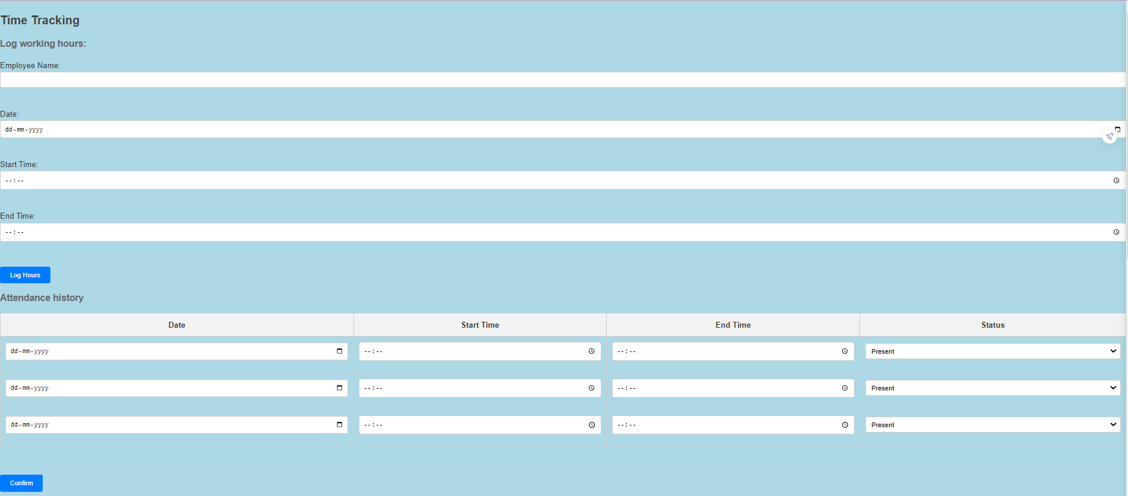

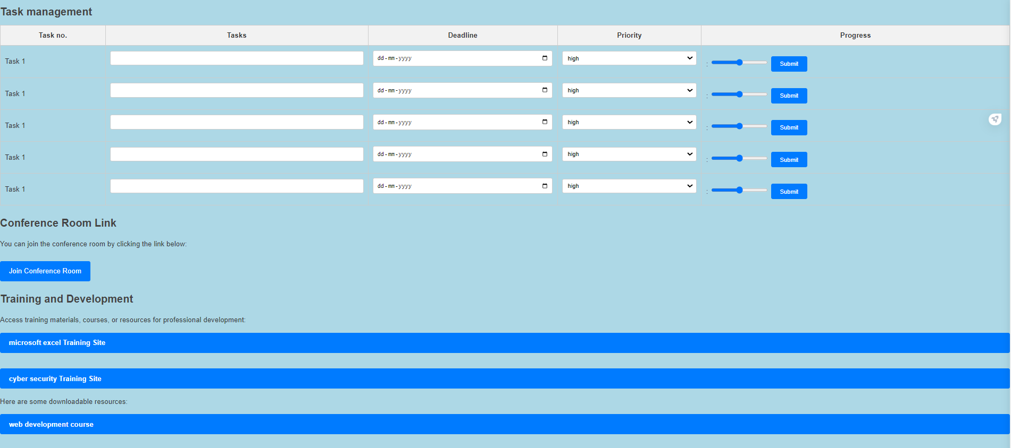

**Figure 1.7 Assigned tasks for employees**

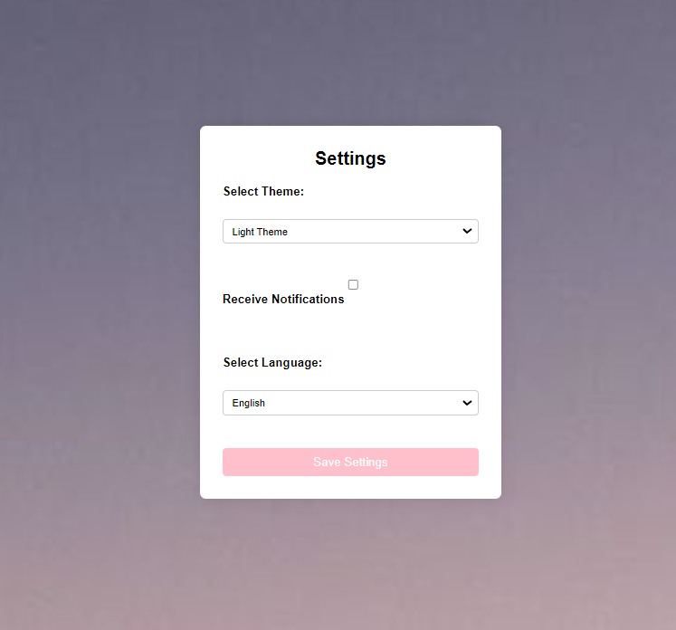

**Figure 1.8 Settings page**

**

**Figure 1.9 logout page**

After logging in as an employer the dashboard,assigned task page ,settings page and logout page is the same as employees.

**CHAPTER 2 OVERVIEW OF PROJECT**

**2.1. Purpose and Goals:**

The purpose of the Full Stack Development Mini Project titled "REMOTE WORK AND COLLABORATION" is to design and implement a web-based application that addresses the challenges and opportunities associated with remote work and collaboration. The project aims to create a platform that facilitates efficient communication, seamless collaboration, and effective task management for individuals and teams working remotely.

*Goals:*

1. User-Friendly Interface

2. Authentication and Authorization

3. Communication Features

4. Collaborative Tools

5. Task Management

6. Remote Accessibility

7. Data Security and Privacy

8. Scalability

9. Feedback Mechanism

10. Documentation

**2.2. Technologies Used:**

**2.2.1 HTML:**

Structure: Defines the structure of a webpage, including headings, paragraphs, images, and links.

Semantics: Uses meaningful tags to convey the purpose of different parts of the content.

**2.2.2 CSS:**

Styling: Controls the visual presentation of HTML elements, ensuring a consistent and aesthetically pleasing design.

Layout: Manages the layout of web pages, including responsiveness for various screen sizes.

**2.2.3 JavaScript:**

Interactivity: Enables dynamic content updates and interactive user interfaces.

Event Handling: Responds to user actions such as clicks, form submissions, and keyboard inputs.

*Collaboration:*

HTML, CSS, and JavaScript work together seamlessly to create modern, feature-rich websites. HTML provides the structure, CSS enhances the presentation, and JavaScript adds interactivity. This trio forms the foundation for web development, facilitating the creation of engaging and user-friendly online experiences. As web technologies continue to evolve, staying proficient in HTML, CSS, and JavaScript remains crucial for web developers.

**CHAPTER 3 FUNCTIONAL REQUIREMENTS**

Functional requirements outline the specific features and capabilities that the "REMOTE WORK AND COLLABORATION" Full Stack Development Mini Project should have to meet its goals. Below are the functional requirements for the project:

1. User Registration and Authentication:

• Users should be able to register for an account.

• Provide secure authentication mechanisms (e.g., email verification, password encryption) to ensure user identity.

2. User Profile Management:

• Allow users to create and update their profiles with relevant information.

• Include profile pictures and a brief bio to facilitate team member recognition.

3. Dashboard:

• Display a personalized dashboard for each user upon login.

• Provide an overview of tasks, notifications, and recent activities.

4. Task Management:

• Allow users to create, assign, and prioritize tasks.

• Include due dates, task descriptions, and status tracking.

5. Project Management:

• Enable users to create and manage projects.

• Provide tools for project planning, tracking, and collaboration.

6. Feedback Mechanism:

• Provide a way for users to submit feedback and suggestions.

• Include a mechanism for administrators to collect and analyze user feedback.

7. Role-Based Access Control:

• Define user roles (e.g., admin, manager, team member) with specific permissions.

• Admins should have the ability to manage user roles and permissions.

8. Documentation:

• Create user manuals and developer documentation for onboarding and maintenance.

By incorporating these functional requirements, the "REMOTE WORK AND COLLABORATION" project aims to deliver a comprehensive and user-friendly solution for remote work and collaboration.

**CHAPTER 4 CODE SNIPPETS:**

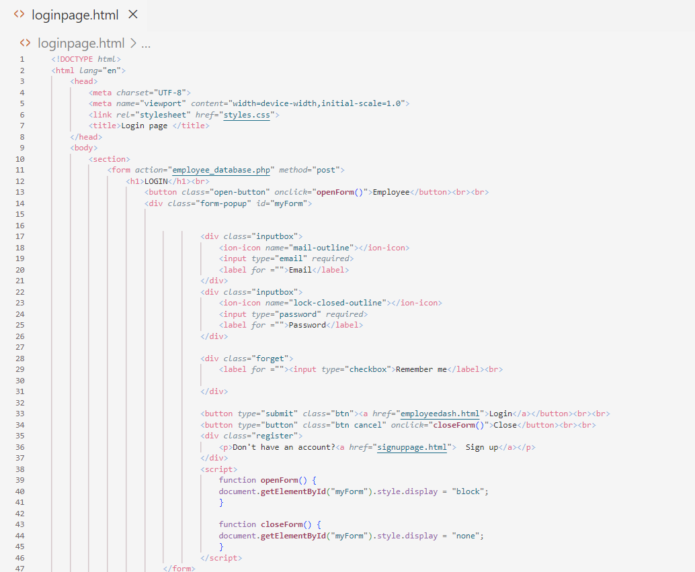

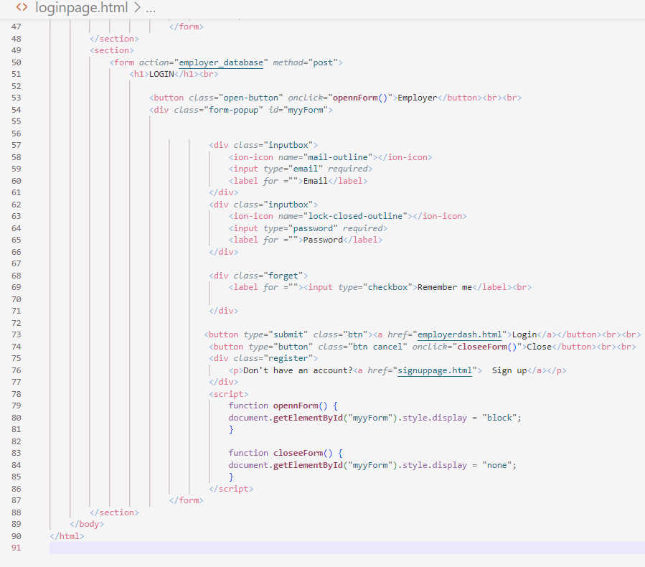

*A code snippet for login page*

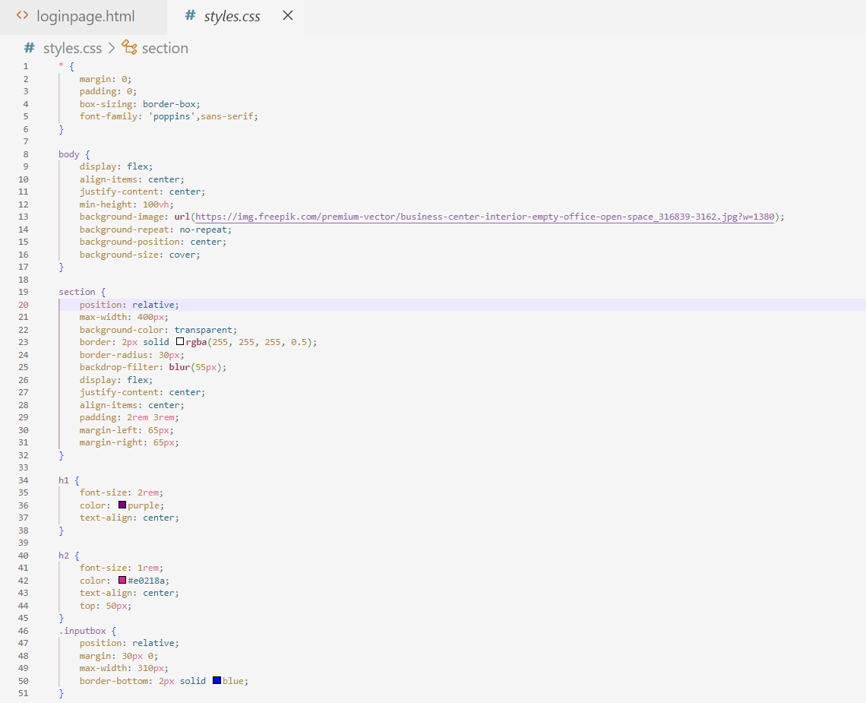

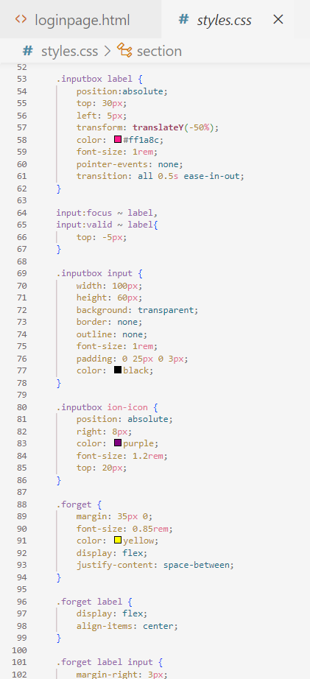

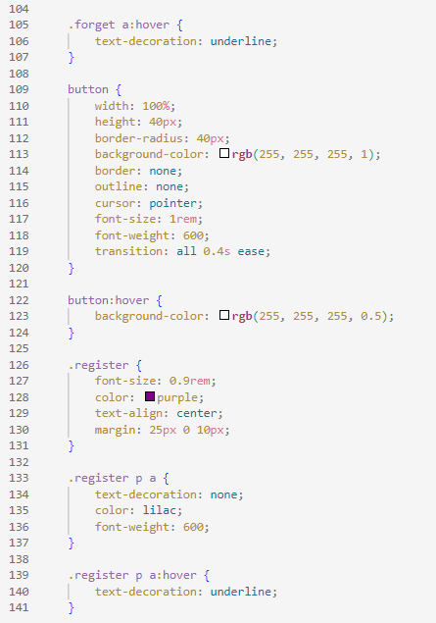

*Code snippets of css for login page*

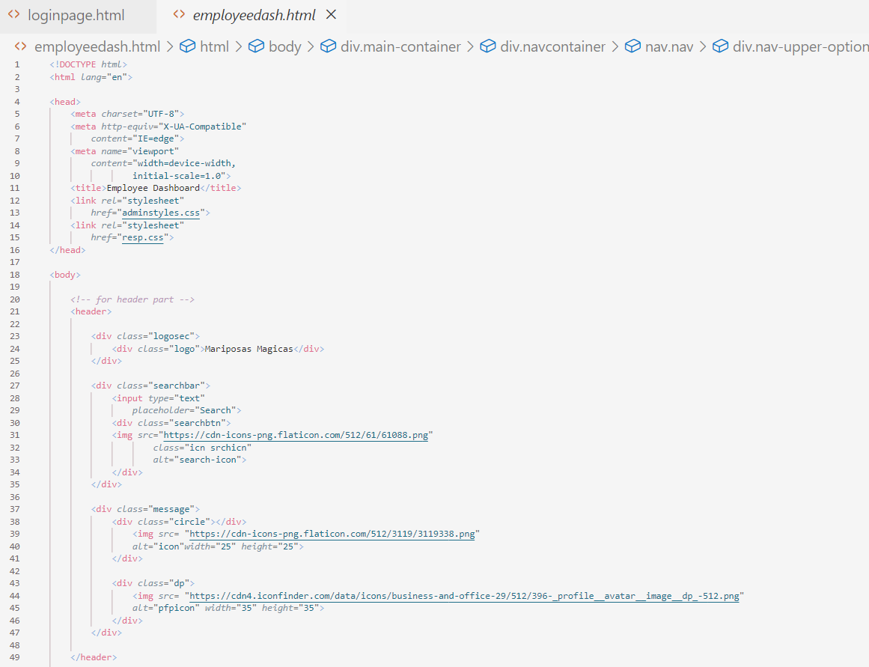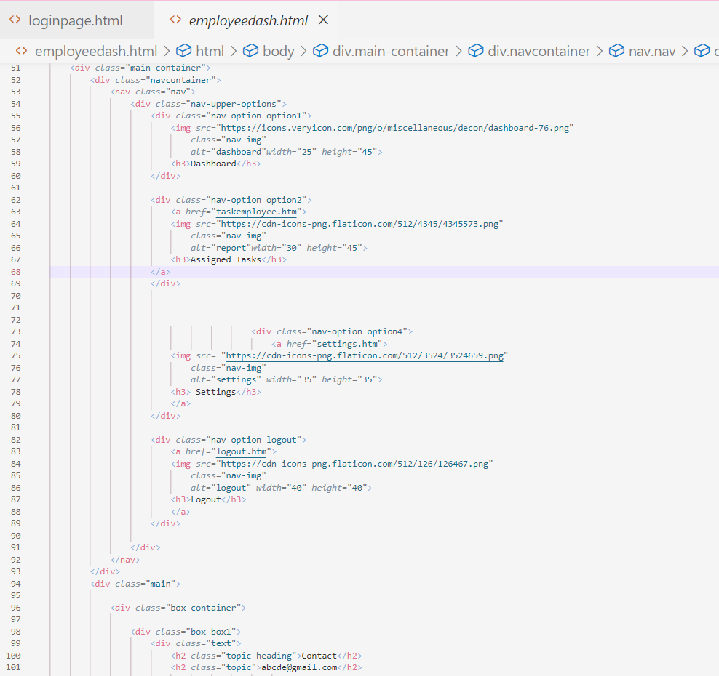

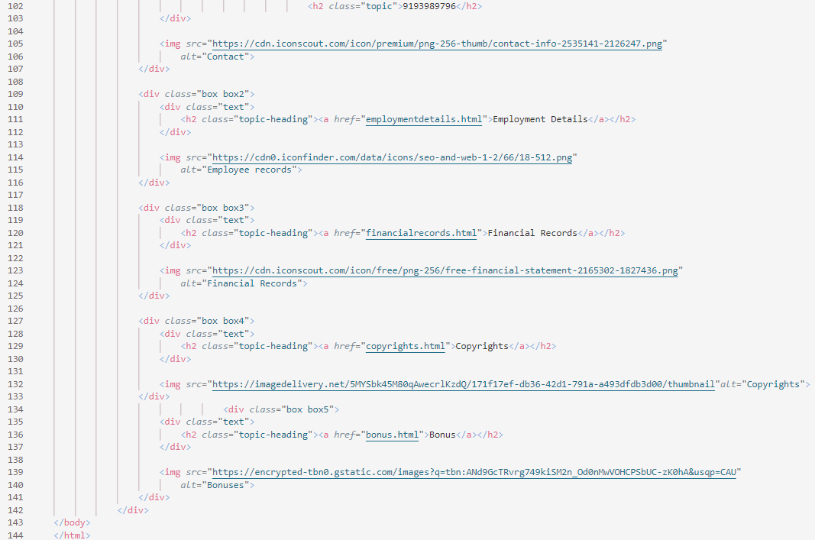

*Code snippet for employee dashboard*

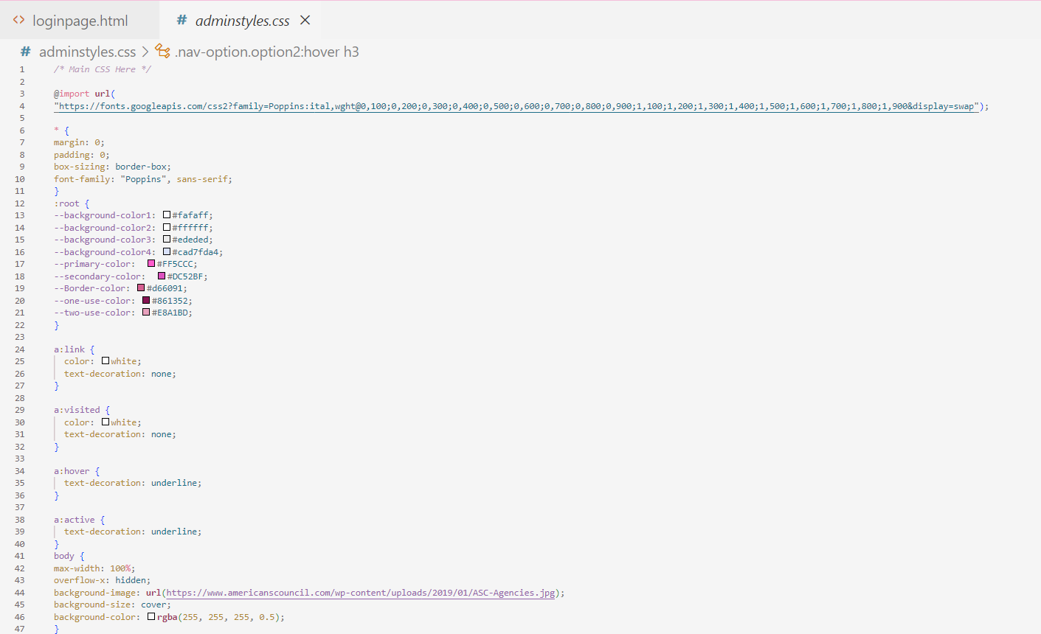

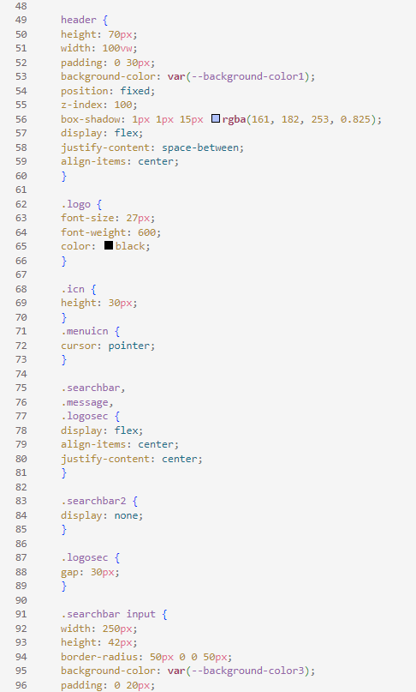

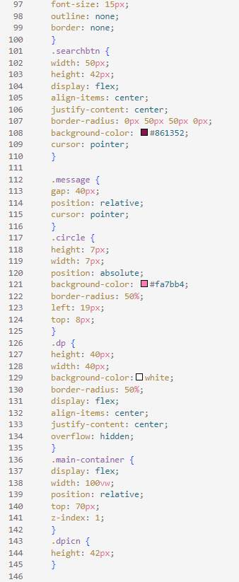

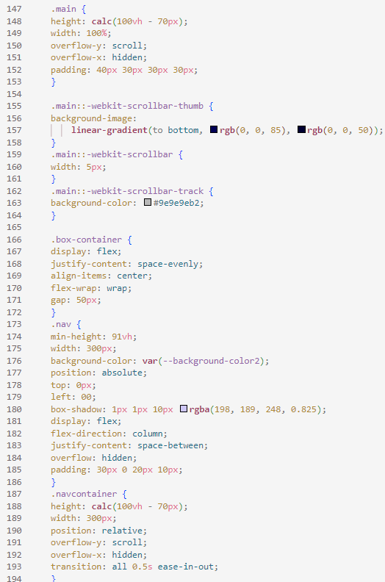

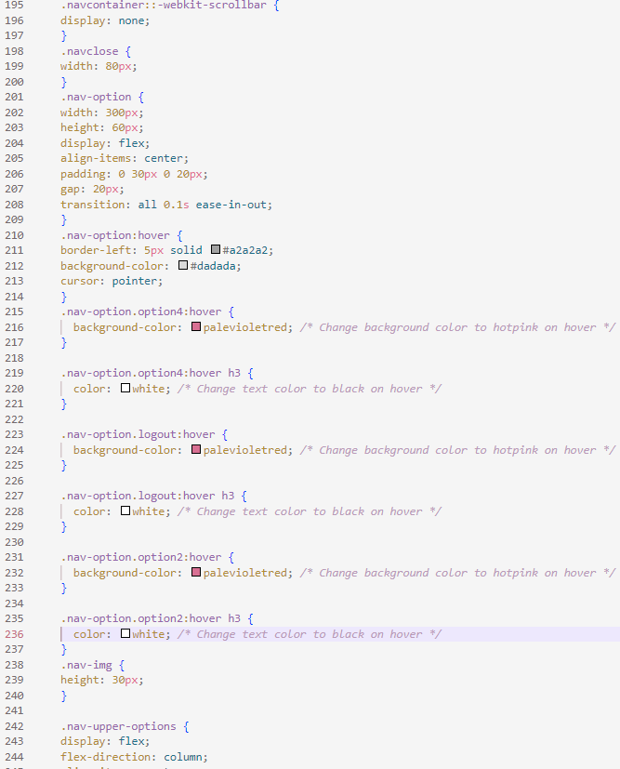

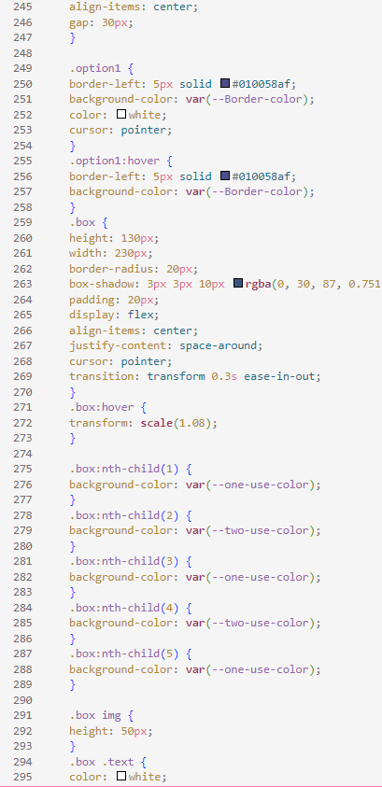

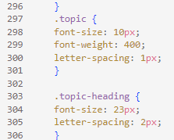

*Code snippet of css for employee dashboard*

**CHAPTER 5 RESULT**

The "REMOTE WORK AND COLLABORATION" Full Stack Development Mini Project focuses on creating a user-friendly web application to address the challenges of remote work, leveraging frontend web development technologies. The platform will include secure user authentication and profile management, a personalized dashboard displaying tasks. Frontend web development tools and frameworks will be utilized to ensure an intuitive and engaging user interface. Additionally, the system will incorporate robust security measures, role-based access control, notifications, feedback mechanisms, and data backup for a comprehensive remote work solution. Usability testing will guide continuous improvements, and thorough documentation will facilitate user onboarding and maintenance. The project is designed to enhance collaboration and productivity for remote teams through the application of frontend web development principles

**CONCLUSION**

An Employee and Employer Dashboard serves as a comprehensive and interactive platform that enhances communication, efficiency, and transparency in the workplace. From the employee's perspective, it provides a centralized hub for accessing essential information, such as work schedules, performance metrics, and benefits.

This not only streamlines daily tasks but also empowers employees by offering insights into their own professional development.

For employers, the dashboard offers a real-time overview of workforce dynamics, allowing for informed decision-making. It facilitates better management of resources, workforce planning, and performance evaluation.

The integration of analytics and reporting tools enables employers to identify trends, address issues promptly, and optimize overall organizational performance.

In conclusion, an Employee and Employer Dashboard is a pivotal tool in modern workplaces, promoting efficiency, transparency, and collaboration. Its multifaceted features contribute to enhanced productivity, employee satisfaction, and organizational success. As technology continues to advance, these dashboards will likely evolve, playing an increasingly integral role in shaping the future of work.