## Running the project:

1. Run the User Driver class
2. Start Fidler
3. Using the composer tab post request /create with json in body to create
4. Use get /users to get all the list of uses
5. Use put /update with updated json to update the collection in the document

## Class Diagram for Module

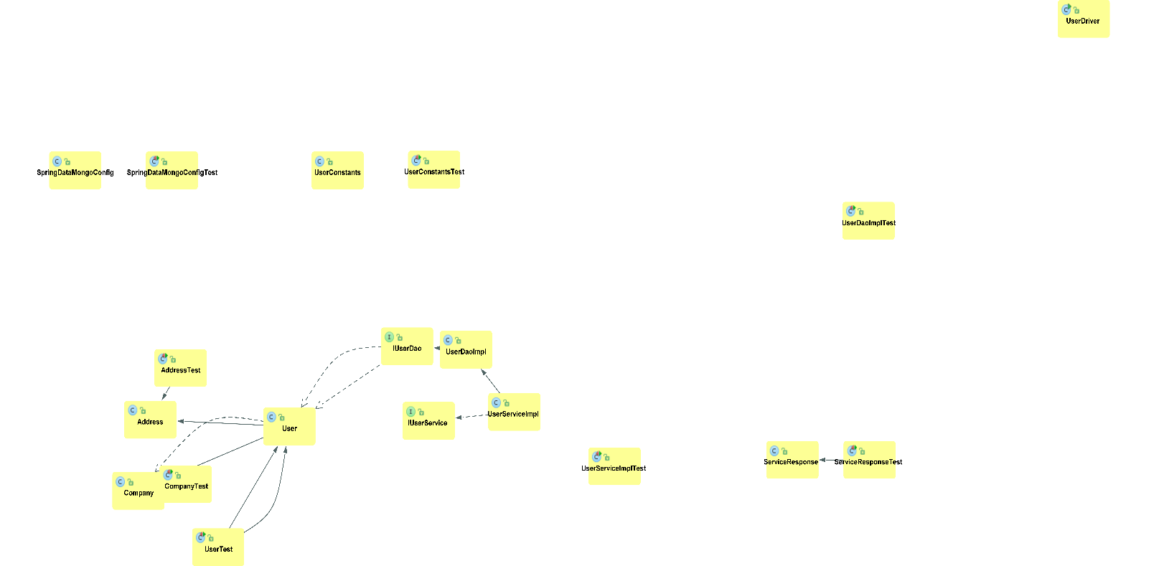

## Results for /users list all

HTTP/1.1 200 OK

Content-Type: text/html; charset=UTF-8

Content-Length: 1356

Server: Jetty(9.0.2.v20130417)

"{\r\n \"id\" : \"1630215c-2608-44b9-aad4-9d56d8aafd4c\",\r\n \"firstName\" : \"Dorris\",\r\n \"lastName\" : \"Keeling\",\r\n \"dateCreated\" : \"2016-03-15T07:02:40.896Z\",\r\n \"profilePic\" : \"http://lorempixel.com/640/480/people\",\r\n \"address\" : {\r\n \"street\" : \"193 Talon Valley\",\r\n \"zip\" : 47069,\r\n \"city\" : \"South Tate furt\",\r\n \"state\" : \"IA\",\r\n \"country\" : \"US\"\r\n }\r\n}\n{\r\n \"id\" : \"1630215c-2608-44b9-aad4-9d56d8a6778c\",\r\n \"firstName\" : \"Smriti\",\r\n \"lastName\" : \"Raj\",\r\n \"dateCreated\" : \"2016-03-15T07:02:40.896Z\",\r\n \"profilePic\" : \"http://lorempixel.com/640/480/people\",\r\n \"address\" : {\r\n \"street\" : \"193 Talon Valley\",\r\n \"zip\" : 47069,\r\n \"city\" : \"South Tate furt\",\r\n \"state\" : \"IA\",\r\n \"country\" : \"US\"\r\n }\r\n}\n{\r\n \"id\" : \"1234abcd\",\r\n \"firstName\" : \"Preet\",\r\n \"lastName\" : \"raj\",\r\n \"email\" : \"smriti.raj@gmail.com\",\r\n \"dateCreated\" : \"8/22/2020\",\r\n \"profilePic\" : \"www.facebook.com/123\",\r\n \"address\" : {\r\n \"street\" : \"Sing Street\",\r\n \"zip\" : 400,\r\n \"city\" : \"Chicago\",\r\n \"state\" : \"IL\",\r\n \"country\" : \"USA\"\r\n },\r\n \"company\" : {\r\n \"name\" : \"Egen\",\r\n \"website\" : \"egen.io\"\r\n }\r\n}"

## Results for updating a collection \update

HTTP/1.1 200 OK

Content-Type: text/html; charset=UTF-8

Content-Length: 66

Server: Jetty(9.0.2.v20130417)

{

"message" : "User Updated Successfully",

"status" : 200

}

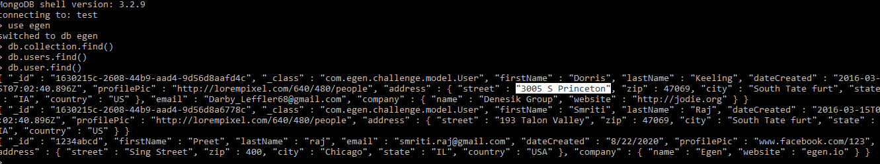

## Results for create \create a collection

HTTP/1.1 200 OK

Content-Type: text/html; charset=UTF-8

Content-Length: 66

Server: Jetty(9.0.2.v20130417)

{

"message" : "User Created Successfully",

"status" : 200

}