ENTERPRISE ERP & OPERATIONS SUITE · OFFICIAL DOCUMENTATION
PrathamOne EduOS
Complete User Manual & Operational Reference Guide
A comprehensive, step-by-step technical and operational manual covering every module, role capability, financial workflow, security gate, and reporting feature in PrathamOne EduOS.
Software Product | PrathamOne Coaching Institutes Enterprise Suite
Author & Chief Architect | Jawahar R Mallah
Organization | AITDL — AI Technology & Development Lab
Official Website | https://prathamone.com
Verified Release Version | v1.0.0 (Build: 2026.11.06-STABLE-v1.0.0)
Manual Revision Date | November 06, 2026

Document Control & Technical Support
This official manual provides authoritative operational guidance for administrators, principals, accountants, teachers, and administrative staff using the PrathamOne EduOS platform. All instructions reflect verified system behavior under production release v1.0.0.
[OFFICIAL SUPPORT CONTACTS] Primary Technical Helpline: +91 9323 023 007 / +91 9324 117 007
Official Helpdesk Email: support@prathamone.com (Alternate: prathamone@outlook.com)
Platform Website: https://prathamone.com
Author: Jawahar R Mallah · AITDL (AI Technology & Development Lab)

1. Welcome & Product Architecture Overview
PrathamOne EduOS is an enterprise-grade ERP platform engineered specifically for modern coaching institutes, exam preparation academies, and multi-branch tutorial networks. Designed by Jawahar R Mallah and AITDL, the suite unifies academic scheduling, student admissions, attendance, fees, ledger governance, examinations, and statutory compliance into a secure, cohesive web interface.

1.1 Architecture & Production Components
PrathamOne EduOS is deployed as a high-concurrency containerized platform comprising:
• Single Page Application (SPA): React 18, Vite 5.4, TypeScript, TailwindCSS.
• Asynchronous Backend API: Python 3.11, FastAPI, SQLAlchemy 2.0 Async (204 endpoints).
• Relational Data Store: PostgreSQL 16 Enterprise with Alembic migrations.
• Production Server: Docker Compose on Alpine Linux with Nginx 1.25 reverse proxy.
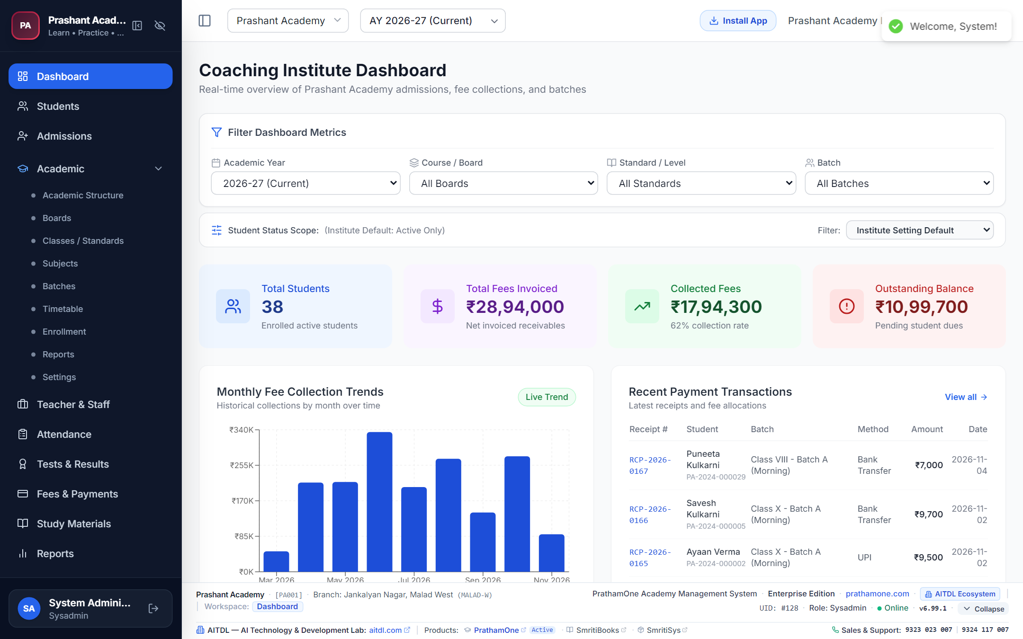
Figure 1.1: PrathamOne EduOS Master Dashboard Overview.

2. User Roles & RBAC Permission Matrix
Access control in PrathamOne EduOS is governed by a strict 8-tier Role-Based Access Control (RBAC) hierarchy. The table below details verified permissions across the application modules:
Role | Dashboard | Academic Master | Student Lifecycle | Fees & Payments | SysAdmin Center
SysAdmin | Full Analytics | Full CRUD | Full Lifecycle & Allowlists | Full + Posted Edit Gate | Exclusive Full Access
Superadmin | Full Analytics | Full CRUD | Full Lifecycle | Full Management | View Telemetry
Admin | Full Branch | Full CRUD | Admit, Edit, Exit, Reactivate | Full Management | Restricted
Principal | Full Academic | Full CRUD | Admit, Edit, Exit, Reactivate | Approve & View | Restricted
Accountant | Financial View | View Only | View & Fee Commitment | Collect, Draft, Post, Refund | Denied
Teacher | Class Roster | View Only | View Allocated Batches | Denied | Denied
Staff | Front Desk | View Only | Inquiry & Intake Forms | Draft Payments Only | Denied
Student | Self Portal | Denied | View Self Profile | View Self Dues & Pay Online | Denied
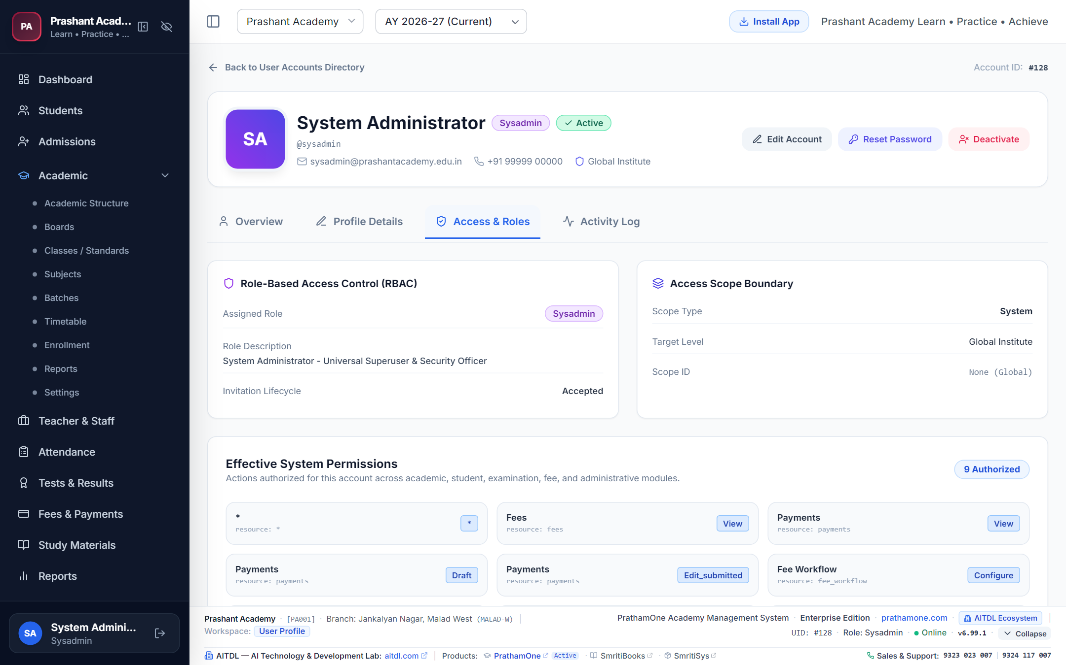
Figure 2.1: Granular Role & Permission Matrix visualizer.

3. Getting Started & Sign-In
Open your browser and navigate to http://localhost:80/login. Enter your assigned username or email and password, then click Sign In. Upon authentication, a secure JWT session token is created, and you are directed to the dashboard.
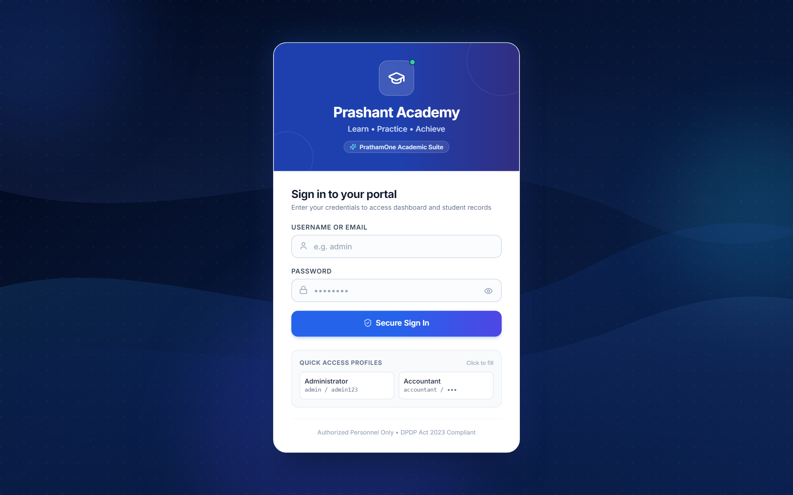
Figure 3.1: PrathamOne EduOS Secure Sign-In Portal.

4. Complete Module-by-Module User Guide

4.1 Academic Structure & Batch Management
Route: /academic | Access: Admin, Principal, SysAdmin
The Academic workspace organizes your educational offerings across Boards, Standards, Divisions, and Batches.
• Boards: Create curriculums (CBSE, ICSE, State Board).
• Standards: Add grades/levels (8th to 12th Standard).
• Batches: Set up morning/evening divisions, capacity limits, and mentor assignments.
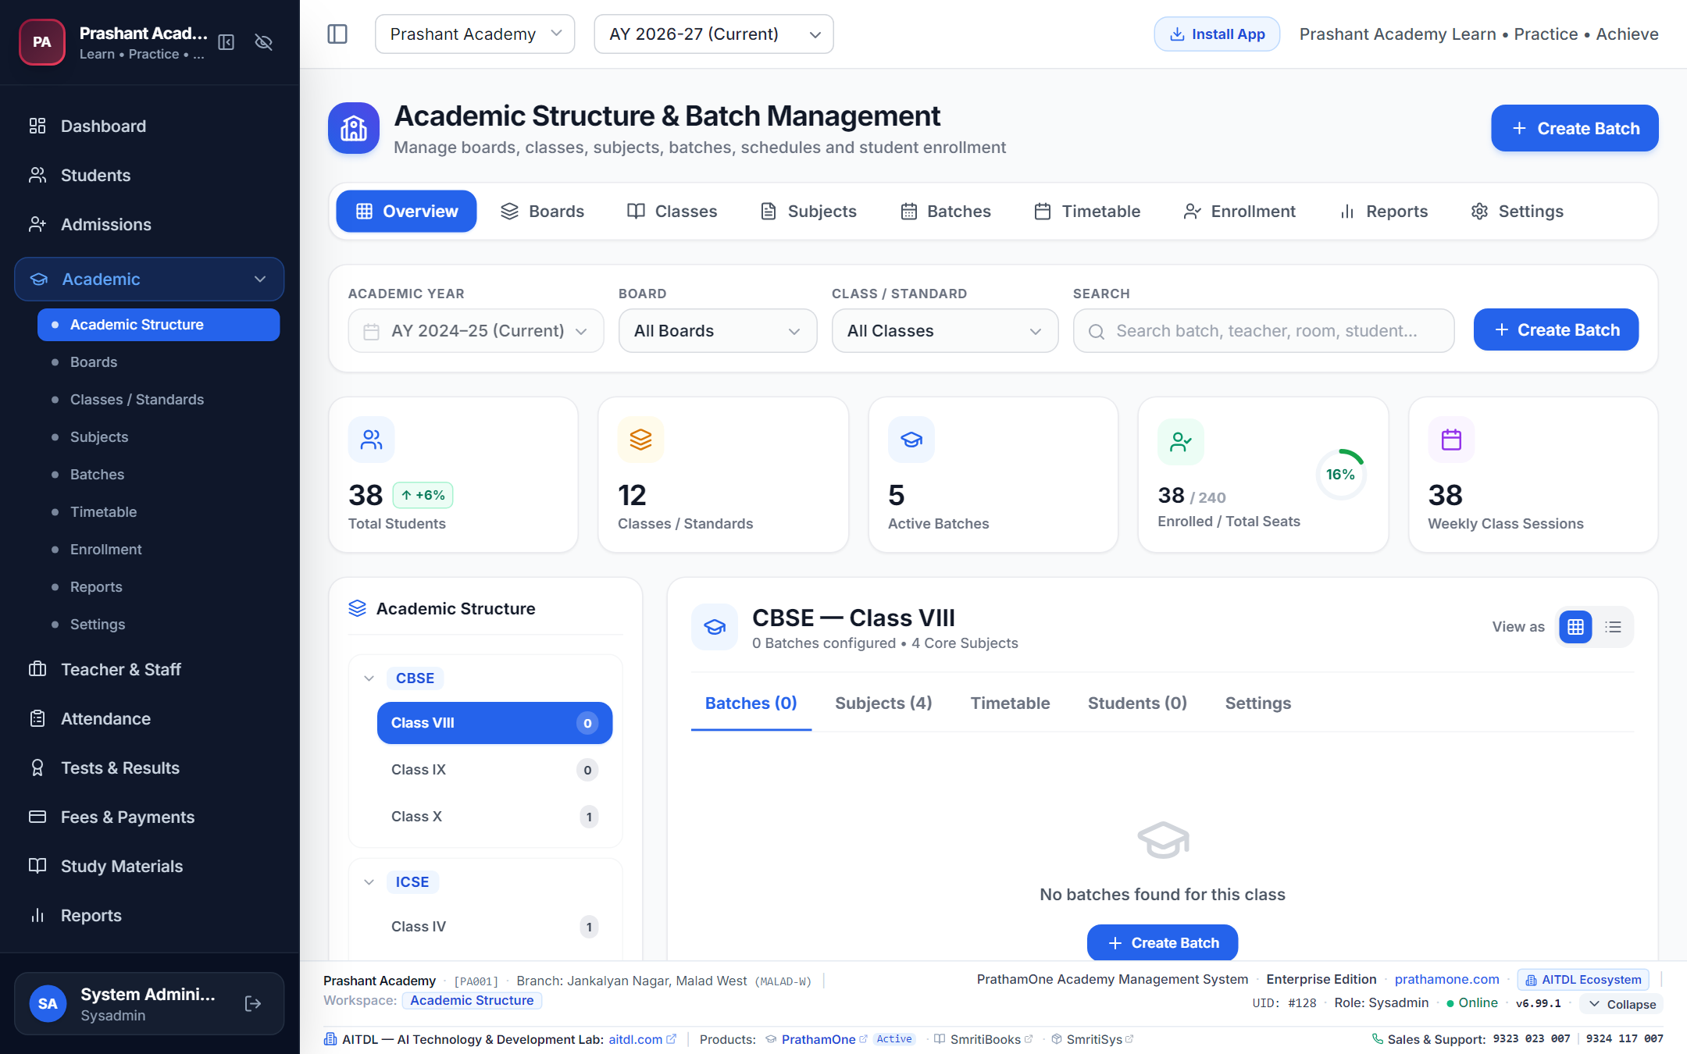
Figure 4.1: Academic Hierarchy Manager.

4.2 Student Admission & Lifecycle Management
Routes: /students, /students/add, /students/{id}
PrathamOne EduOS provides complete student lifecycle management from initial inquiry to exit and reactivation:
1. Admission Wizard: 4-step wizard capturing personal, contact, academic, and guardian records.
2. Student Detail Profile: Central workspace displaying academics, attendance, fees ledger, and KYC documents.
3. Profile Editing: Update contact numbers, address, or academic allocations.
4. Exit / Withdrawal: Formal withdrawal modal requiring an exit date, reason dropdown, and notes.
5. Reactivation: Seamless one-click reactivation restoring an exited student to an active batch.
6. KYC Documents: Upload, download, and verify Aadhaar cards, birth certificates, and transfer certificates.
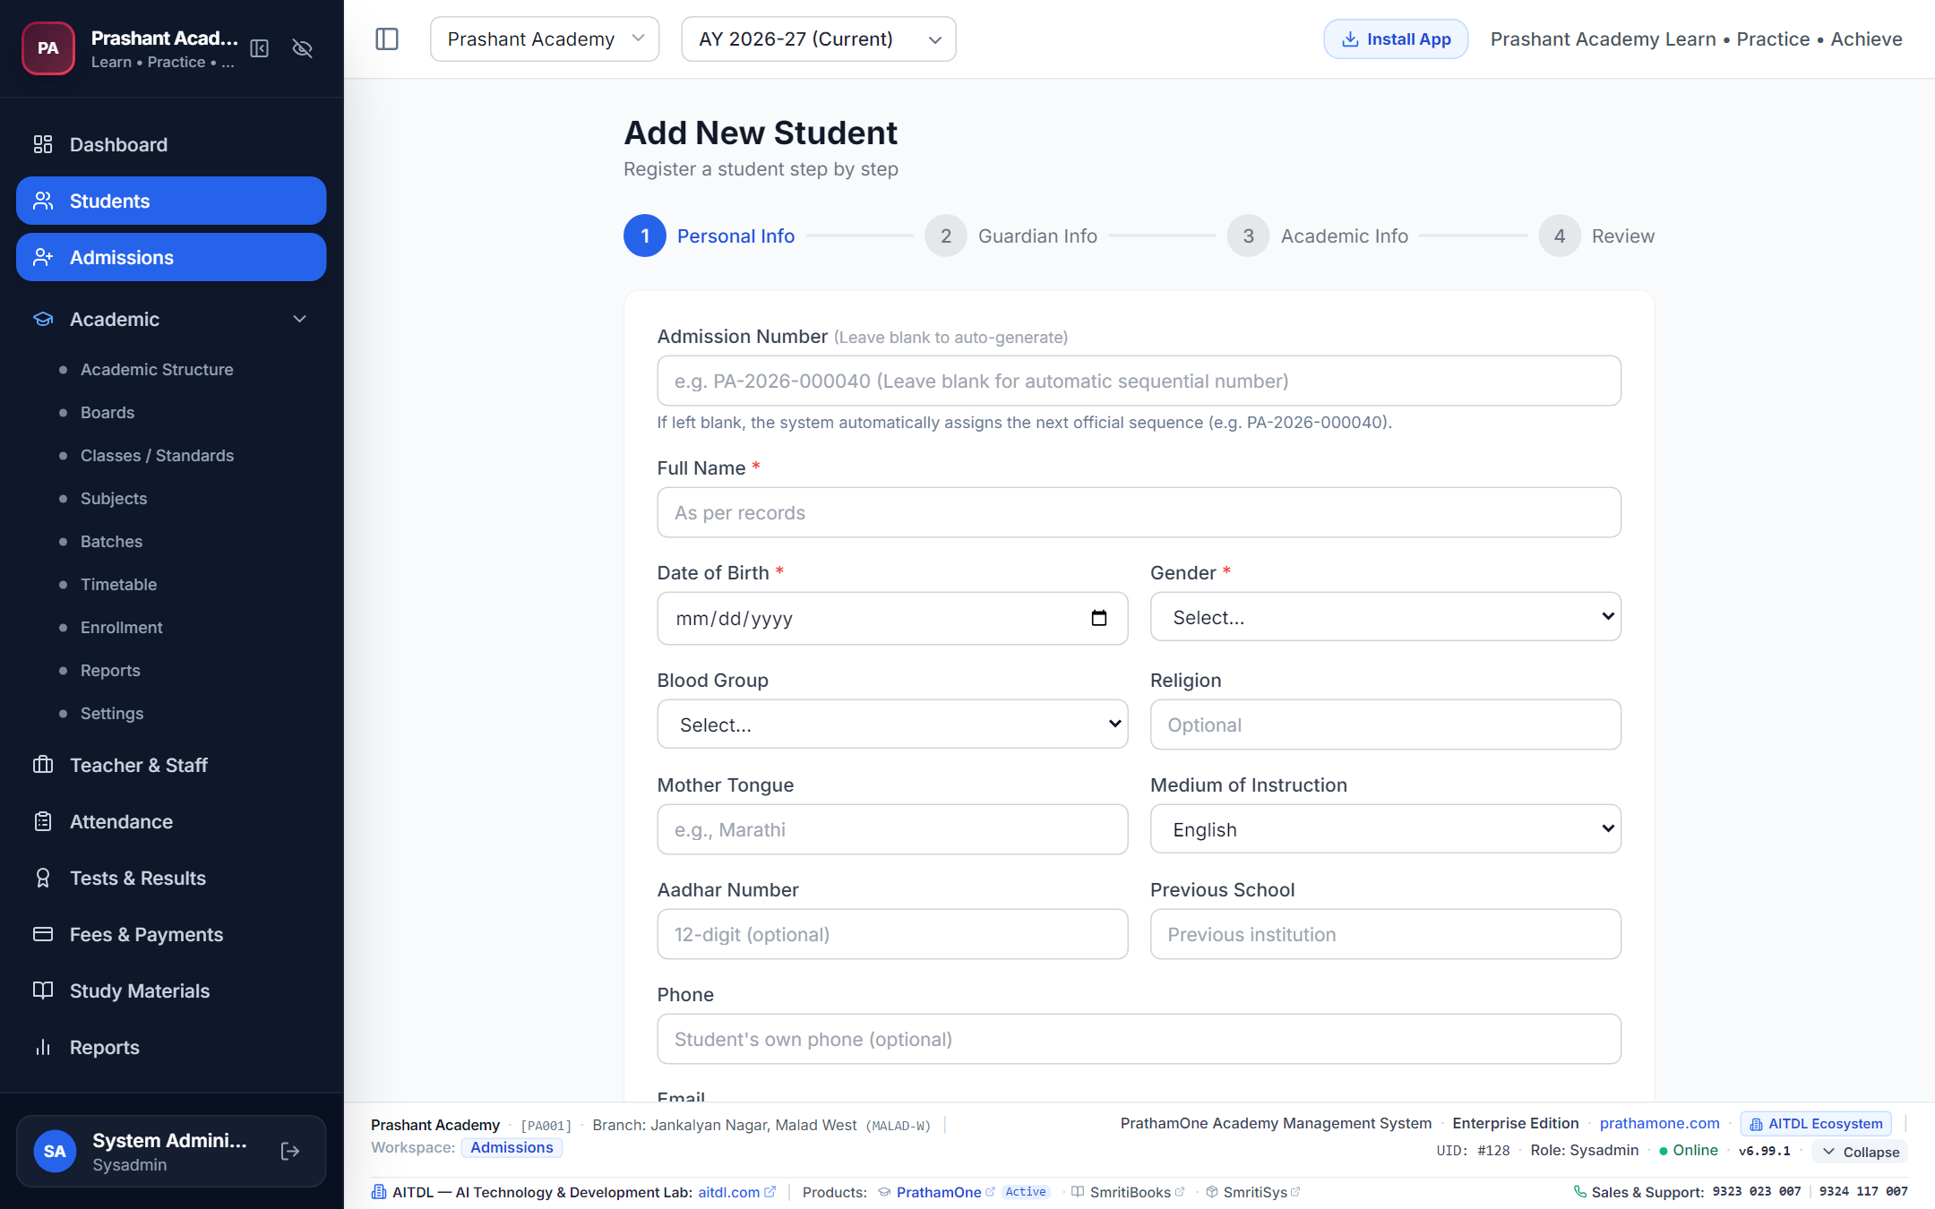
Figure 4.2: Multi-step Student Admission Wizard.
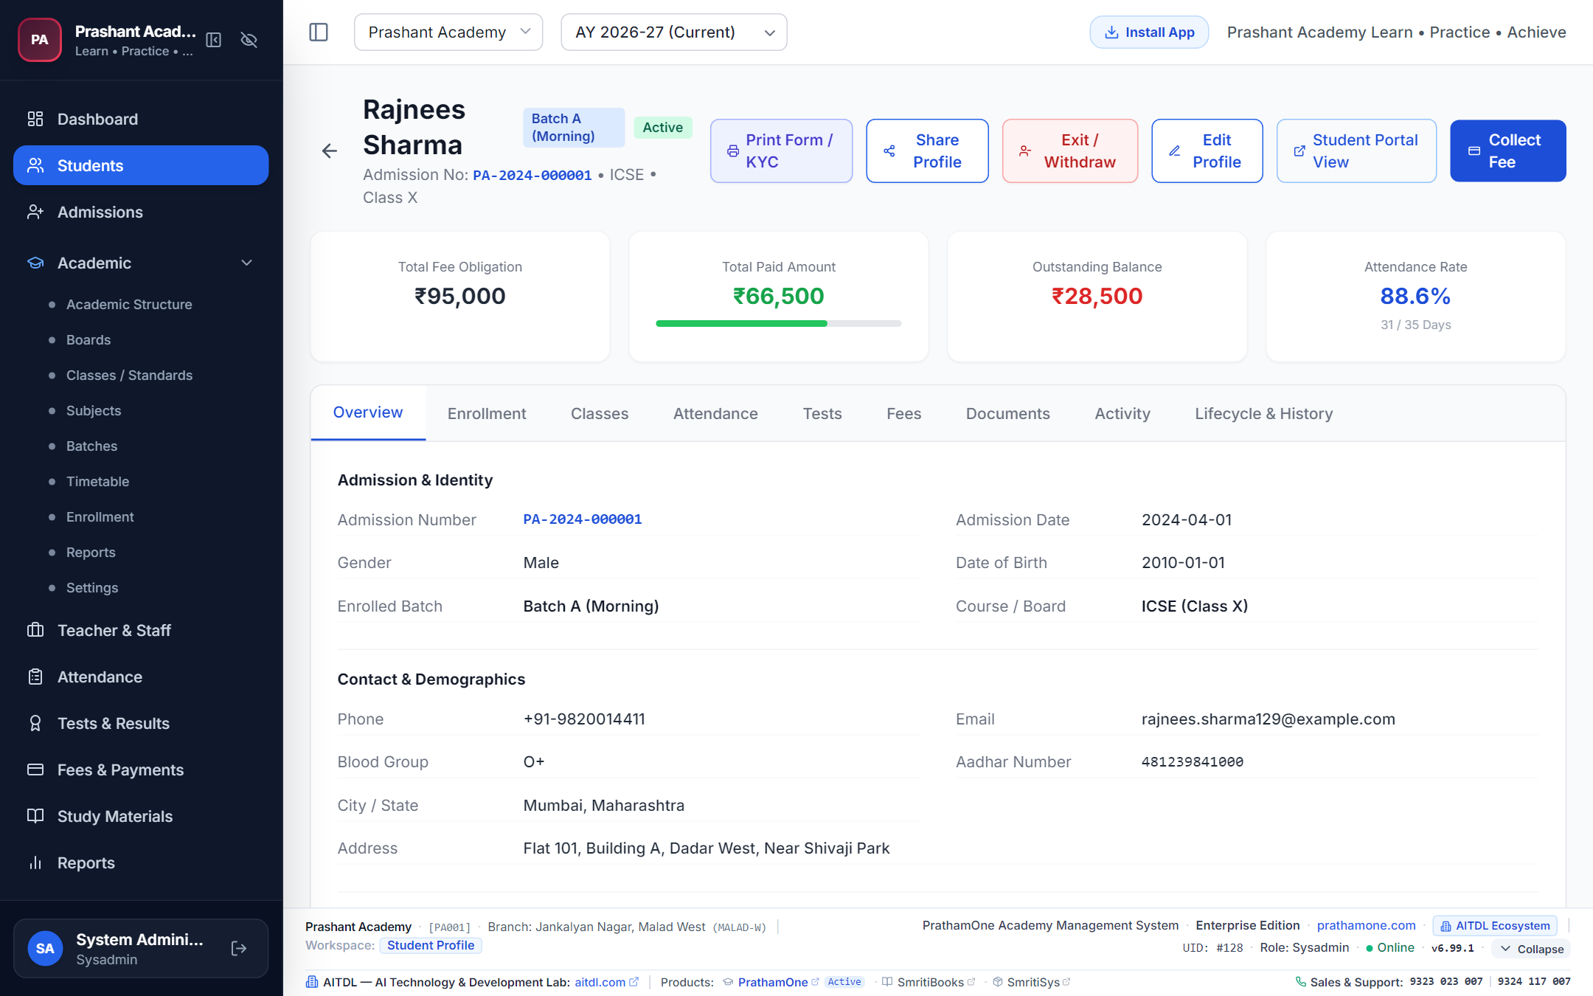
Figure 4.3: Comprehensive Student Detail Workspace.
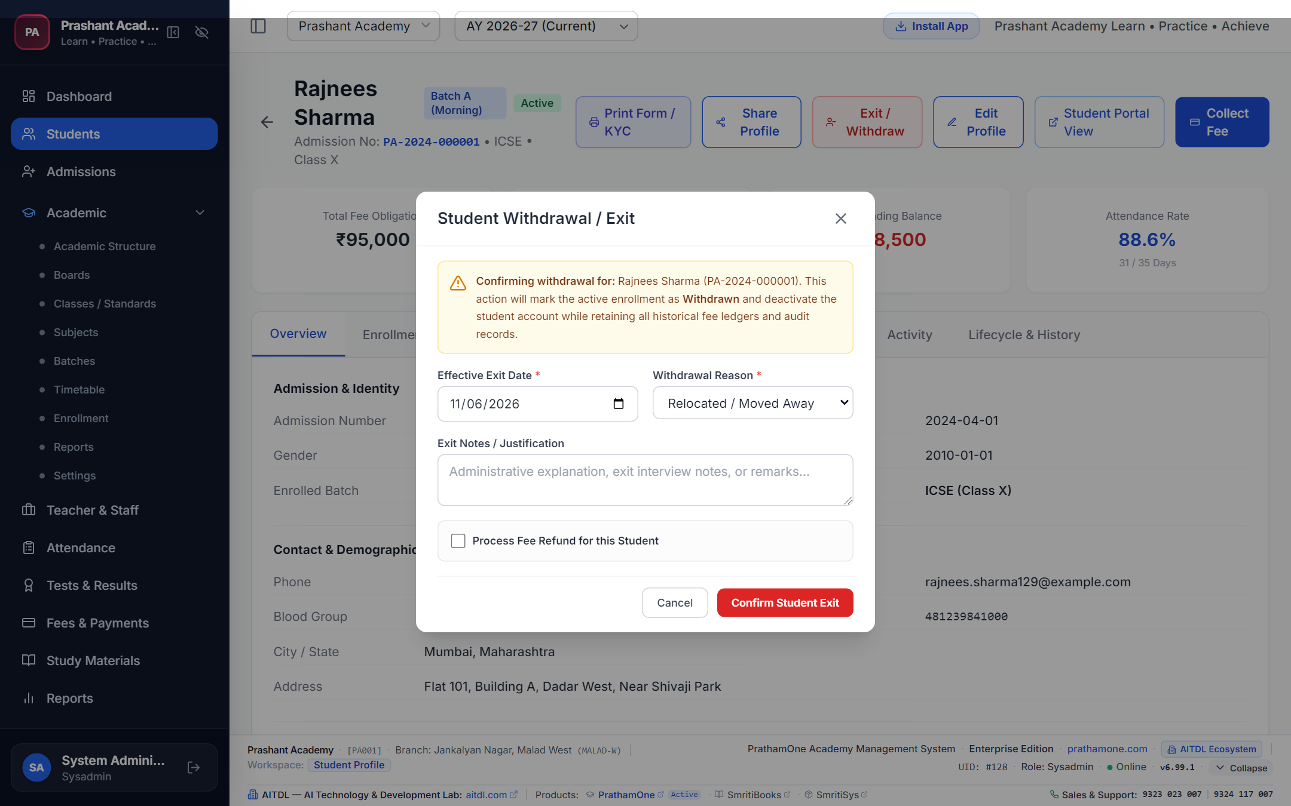
Figure 4.4: Student Exit and Withdrawal Modal.

4.3 Teacher & Faculty Workspace & Dedicated Profile
Routes: /teachers, /teachers/{id} | Access: Admin, Principal, Teachers, SysAdmin
The Teacher Workspace provides comprehensive faculty governance with real-time academic workload analytics:
• Live Workforce Status KPIs: Total Teachers (42), Active (36), Assigned (30), Unassigned (6), Without Timetable (3), and On Leave (4).
• Teacher Status Donut Chart: Visually flags unassigned faculty requiring immediate batch allocation.
• 6-Month Teaching Hours Trend: Reconciles verified classroom lecture hours for accurate automated payroll calculation.
• Dedicated 12-Tab Profile: Includes Overview, Personal (Dual Addresses), Employment, Qualifications, Subjects, Assignments, Timetable, Attendance, Leave, Payroll, Documents, and Activity.
• Batch Allocation: Assign faculty to boards, standards, divisions, and subjects with weekly workload meters.
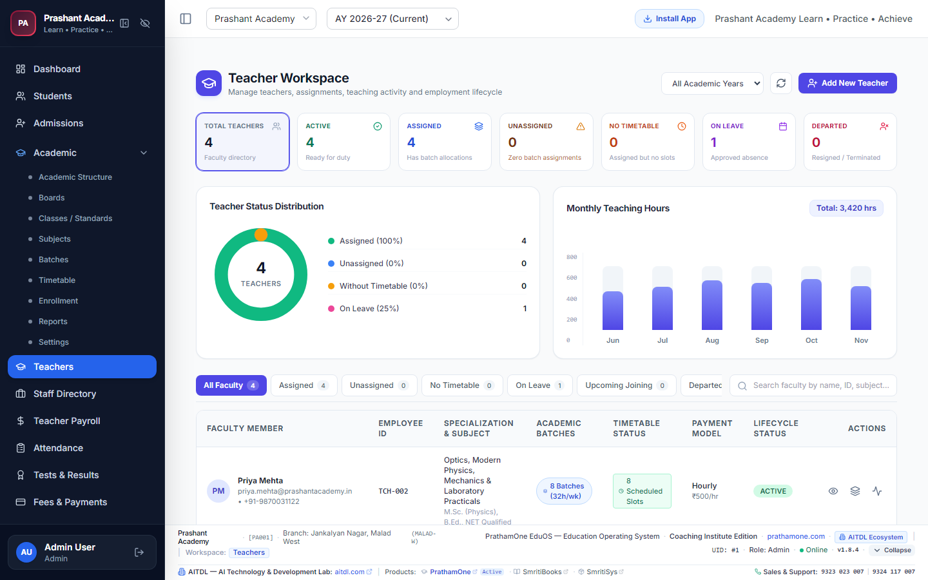
Figure 4.5A: Teacher Workspace Dashboard with real-time status donut and monthly teaching hours trend.
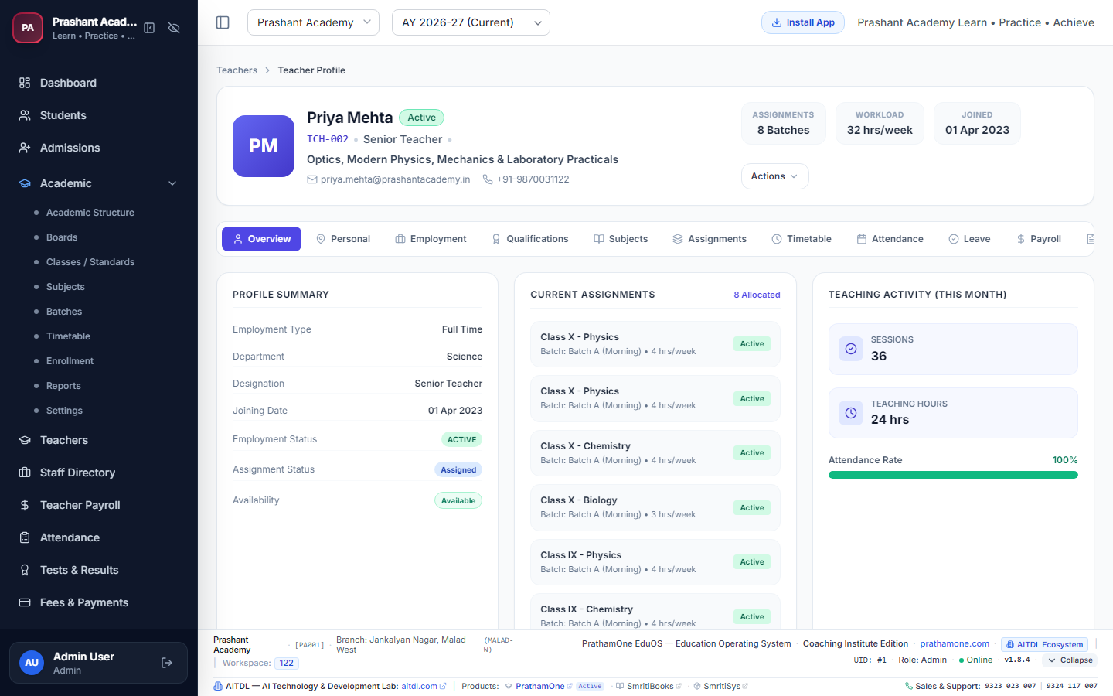
Figure 4.5B: Dedicated Teacher Profile with Workforce Hero Card and 12 specialized tabs.

4.4 Non-Teaching Staff Workspace & Dedicated Profile
Routes: /staff, /staff/{id} | Access: Admin, Principal, Staff, SysAdmin
Manage administrative, accounts, library, IT, and campus support personnel:
• Live Headcounts: Track personnel across departments with real-time headcount indicators.
• Dynamic Department Analytics: Live donut chart displaying staff distribution across Administration, Accounts, IT, Library, and Operations.
• Financial Liabilities: Real-time calculation of Salary Payable (Current Month) and outstanding Pending Payment vouchers.
• Dedicated 12-Tab Profile: Tailored to administrative staff with key responsibilities, attendance history, and official HR documents.
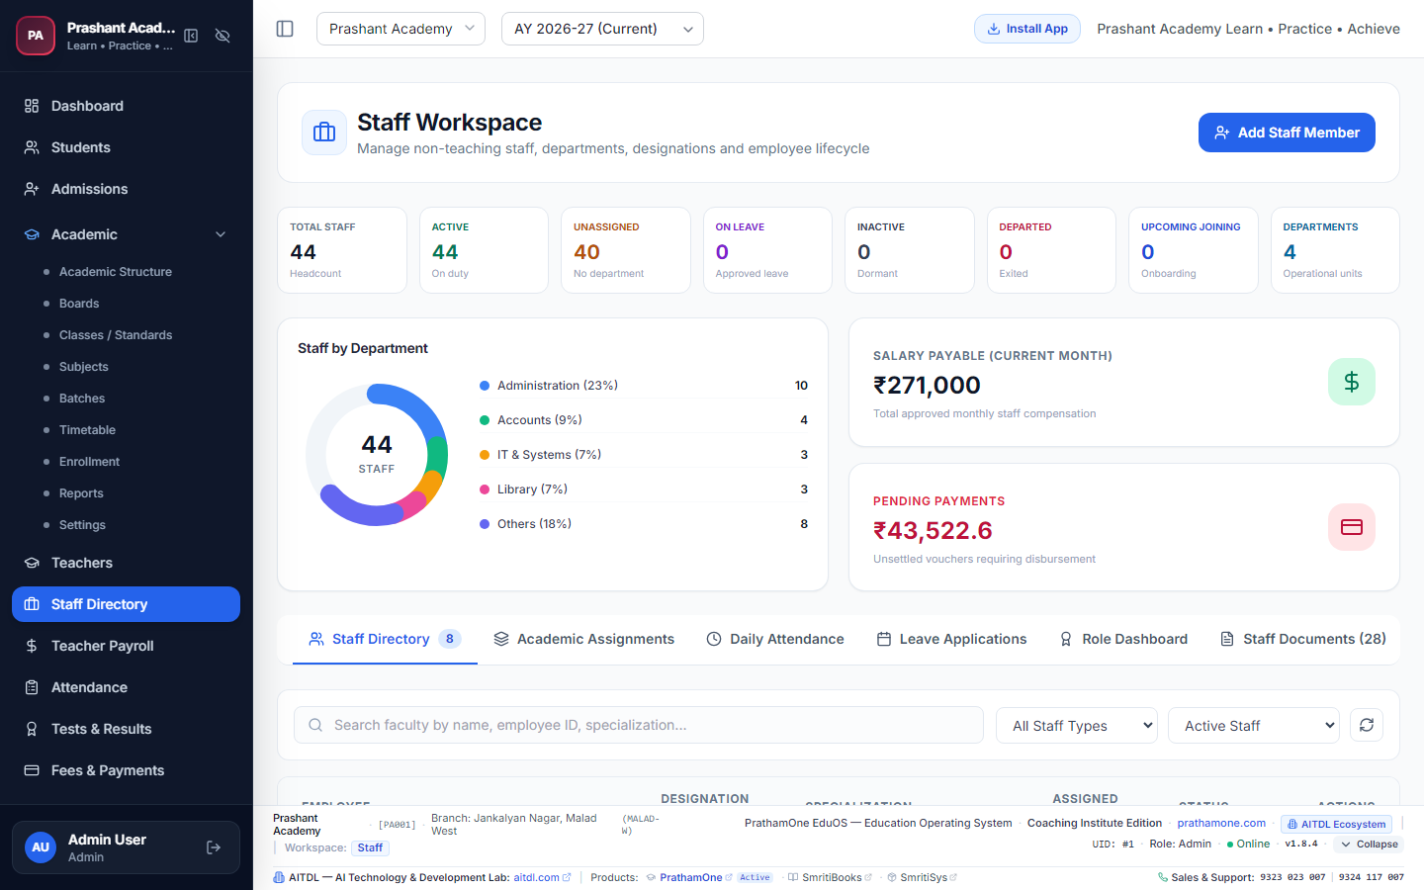
Figure 4.5C: Staff Workspace Dashboard with department breakdown and salary liability cards.
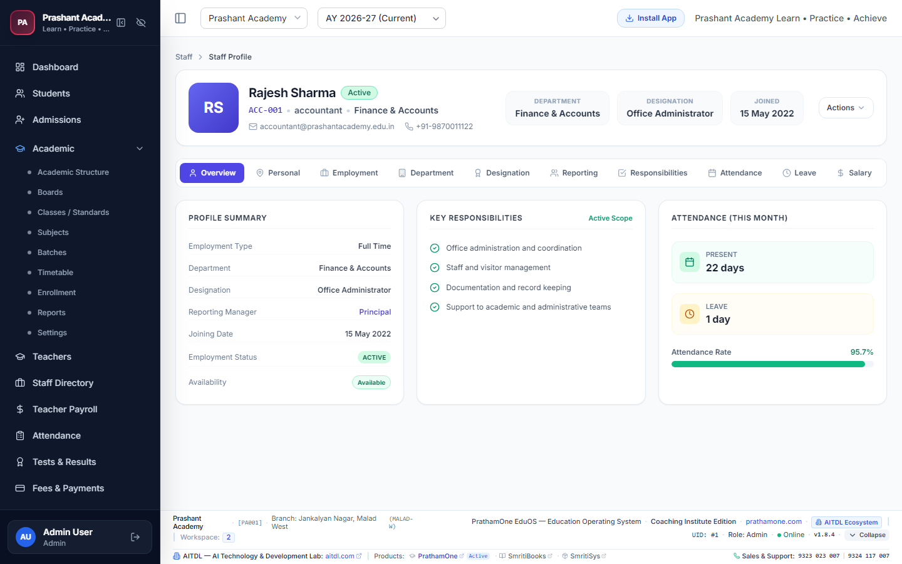
Figure 4.5D: Dedicated Staff Profile with responsibilities matrix and documents archive.

4.5 Employee Dossier & Universal Print Studio
Single-click generation of the official multi-section Employee Dossier. Includes institutional branding, dual residential and permanent addresses, multiple bank accounts with primary salary designation, key emergency contacts, batch workload allocations, and statutory verification signature blocks. The Universal Print Studio enables seamless printing on A4, A5, Letter, and custom formats with auto-scaling to prevent horizontal or vertical overflow.

4.6 Multi-Table Delete Protection & Workforce Safeguards
To prevent accidental data loss and audit corruption, PrathamOne EduOS enforces strict referential delete protection. Attempting to hard-delete any user with existing payroll records, teaching sessions, batch assignments, attendance punches, leave records, payment transactions, or student enrollments returns an explicit HTTP 400 error blocking the operation. Administrators use Soft Deactivation instead, which safely revokes login access while keeping financial and academic ledgers intact.

4.7 Daily Attendance & Defaulter Tracking
Route: /attendance | Access: Teachers, Staff, Admin, Principal
Select the Standard and Batch. The complete student roster loads defaulted to Present. Click individual pills to toggle Present, Absent, Late, or Excused, then click Save Attendance Roster. Attendance statistics update instantaneously across reports and parent feeds.
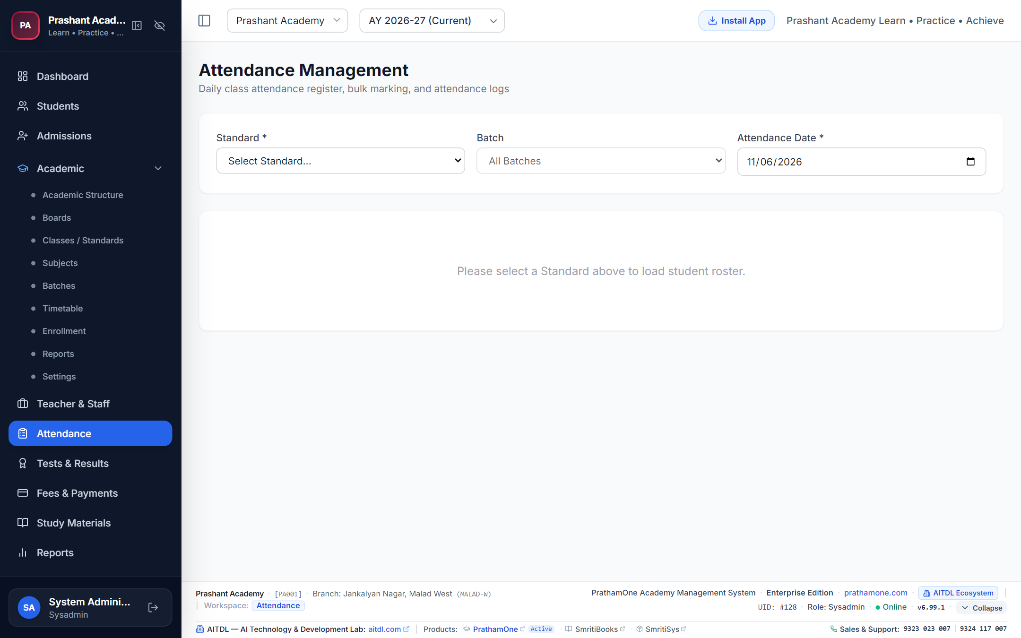
Figure 4.5: Daily Attendance Roster Workspace.

4.4 Fees, Payments & Posted Edit Security Gate
Routes: /fees, /payments | Access: Accountant, Admin, SysAdmin
• Fee Structures: Build customized packages with tuition, practical, study material, and exam heads.
• Payments Ledger: Record cash, cheque, UPI, and bank transfer payments.
• Receipt Printing: Issue official sequential receipts (REC-2026-XXXXXX) in thermal or A4 formats.
• Posted Payment Security Gate: Normal staff cannot alter posted payments. Only SysAdmin with explicit permission can unlock and modify posted transactions with mandatory reason logging and receipt supersession.
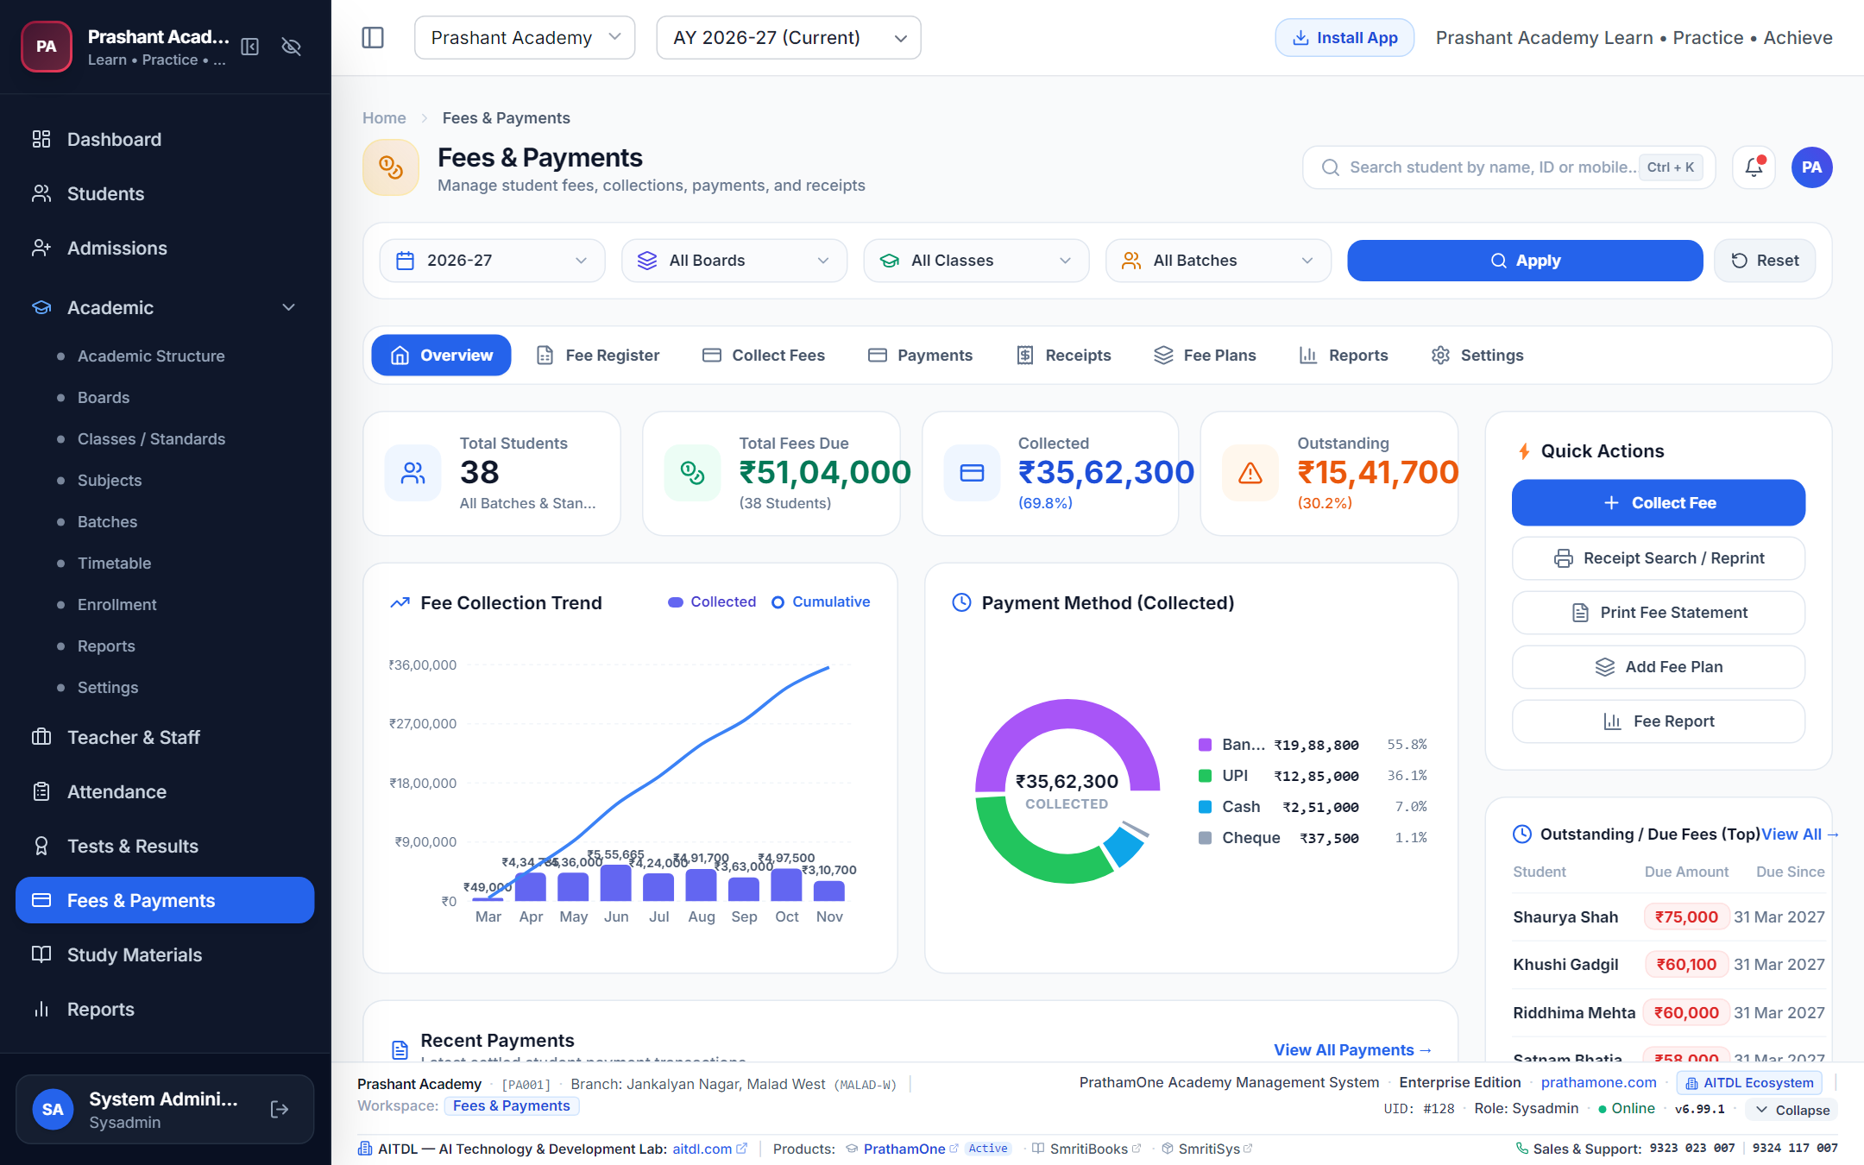
Figure 4.6: Fee Structure Builder.
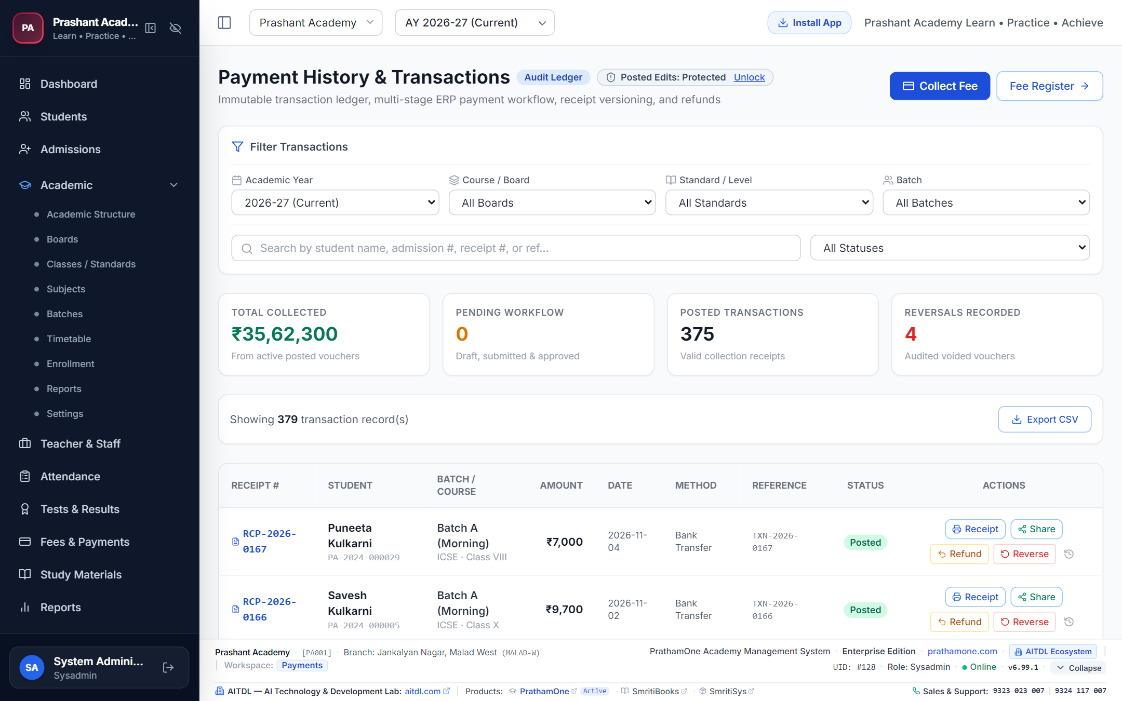
Figure 4.7: Payments Financial Ledger.
Figure 4.8: Posted Payment Security Gate Modal.

4.5 Examinations, Grading & Report Cards
Route: /examinations | Access: Teachers, Admin, Principal
Schedule periodic unit tests and term examinations. Input subject marks directly into the online grid. The system calculates grade percentages and renders official printable report cards.
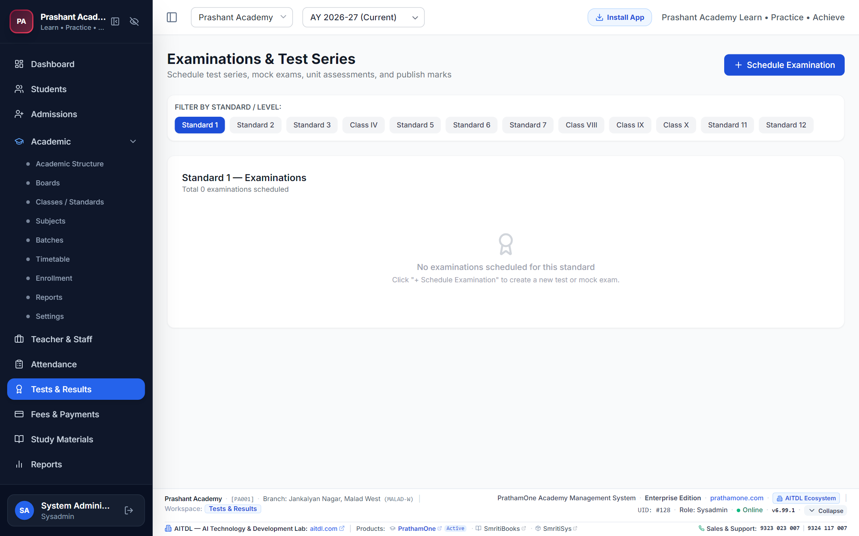
Figure 4.9: Examinations & Grading Workspace.

4.6 High-Performance Reports & Analytics Grid
Route: /reports | Access: Accountant, Admin, Principal, SysAdmin
Enterprise reporting grid equipped with real-time column grouping, dynamic pivoting, cascading filters, and one-click Excel/CSV export for fee realization, defaulters, batch headcounts, and academic rankings.
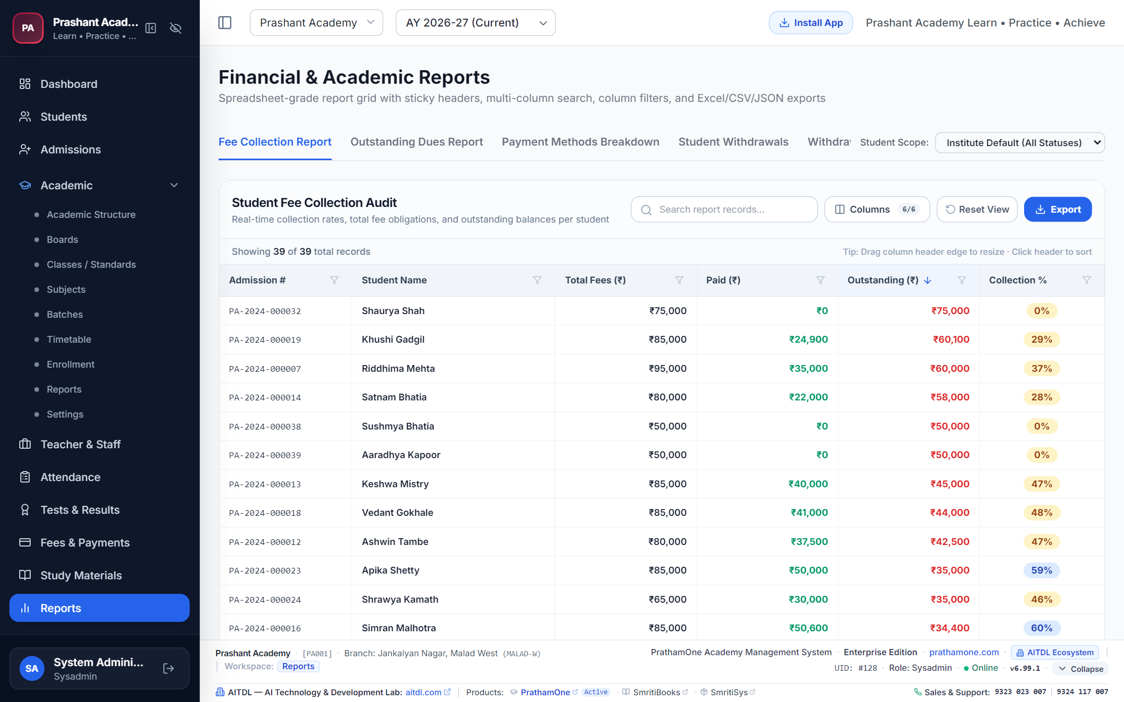
Figure 4.10: High-Performance Excel Report Grid.

4.7 Forms & Documents Printing Center (DPDP Compliant)
Route: /forms | Access: Admin, Staff, SysAdmin
Generate official Student ID Cards, Admission Forms, Fee Receipts, and Bonafide Certificates. Every generation event is recorded in the Digital Personal Data Protection (DPDP) compliance audit log.
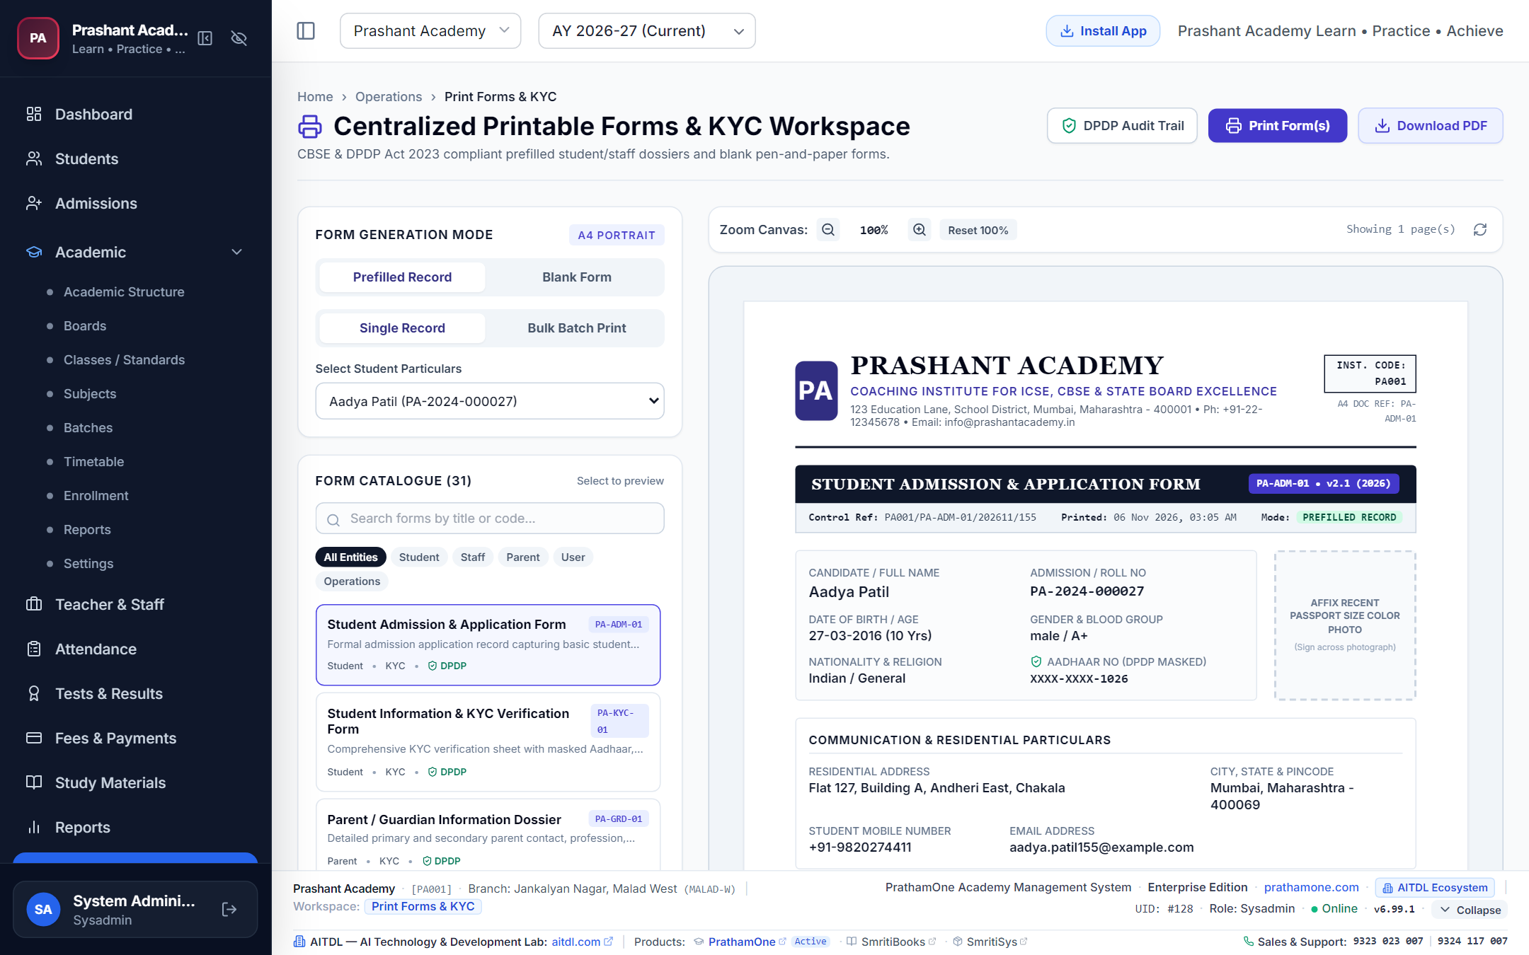
Figure 4.11: Forms & Documents Printing Center.

4.11 CodeX — Configurable Feature Activation & Numeric Coding Studio
Route: /codex | Access: Business Owner / Authorized SysAdmin
CodeX is an optional, high-security numeric obfuscation engine that masks sensitive business figures (salaries, fees, profit margins) using custom owner-defined alphanumeric symbol mappings.
• Mandatory System Default Policy: DISABLED (OFF) everywhere until explicitly activated by the Business Owner.
• Bijective Reversible Mapping: Digits 0-9 substitute into custom symbols (e.g. 0->Q, 1->A, 2->Z...); amounts like ₹12,500 encode to AZPQQ and decode back to 12500.
• Granular 16-Feature Toggles: Independently toggle CodeX on student fees, staff payroll, invoices, receipts, and reporting grids.
• Scoped Access Overrides: Define permissions by department, role, or user.
• PIN Protection & QR Tokens: Decoding operations require administrative PIN verification. Ephemeral QR tokens support mobile decoder scanning.
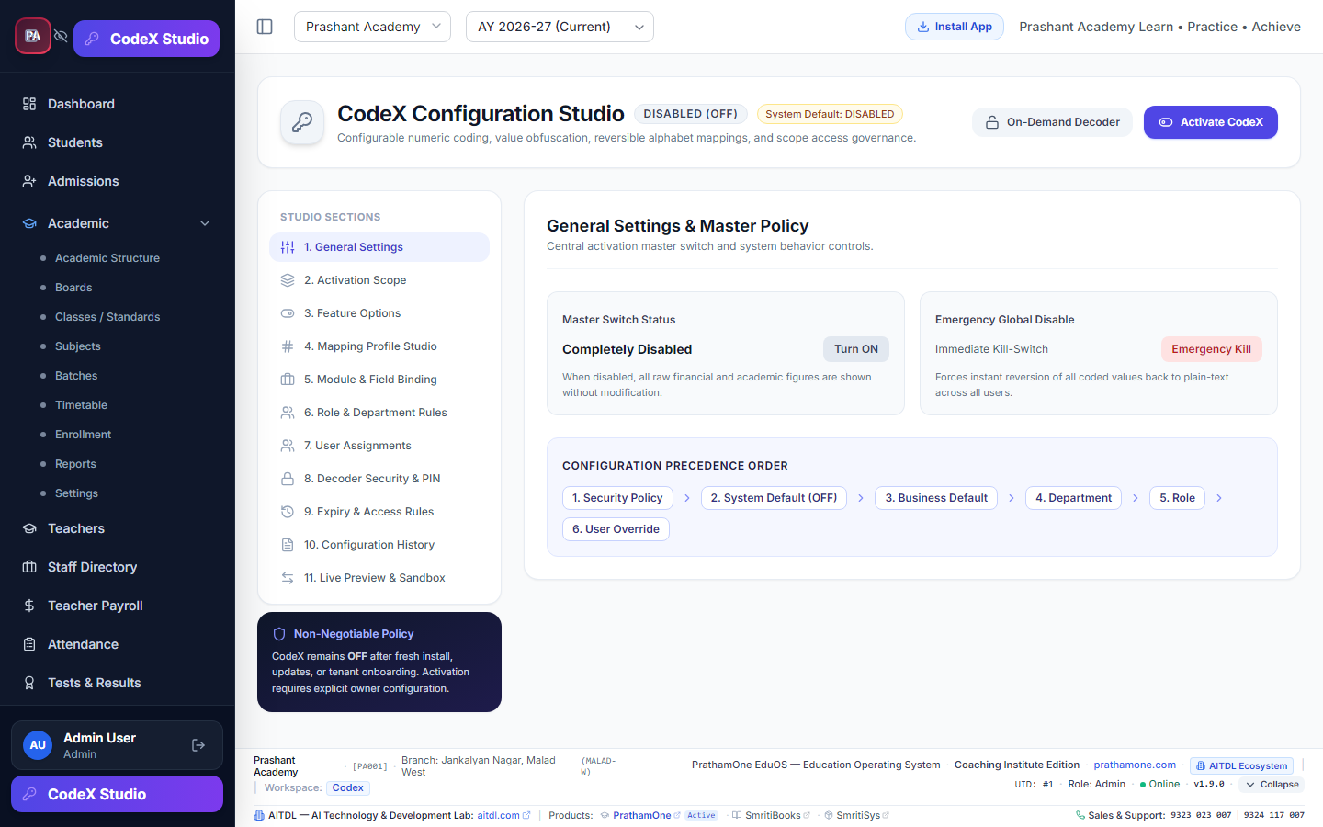
Figure 4.12: CodeX Configuration Studio with master toggle and 16 feature switches.
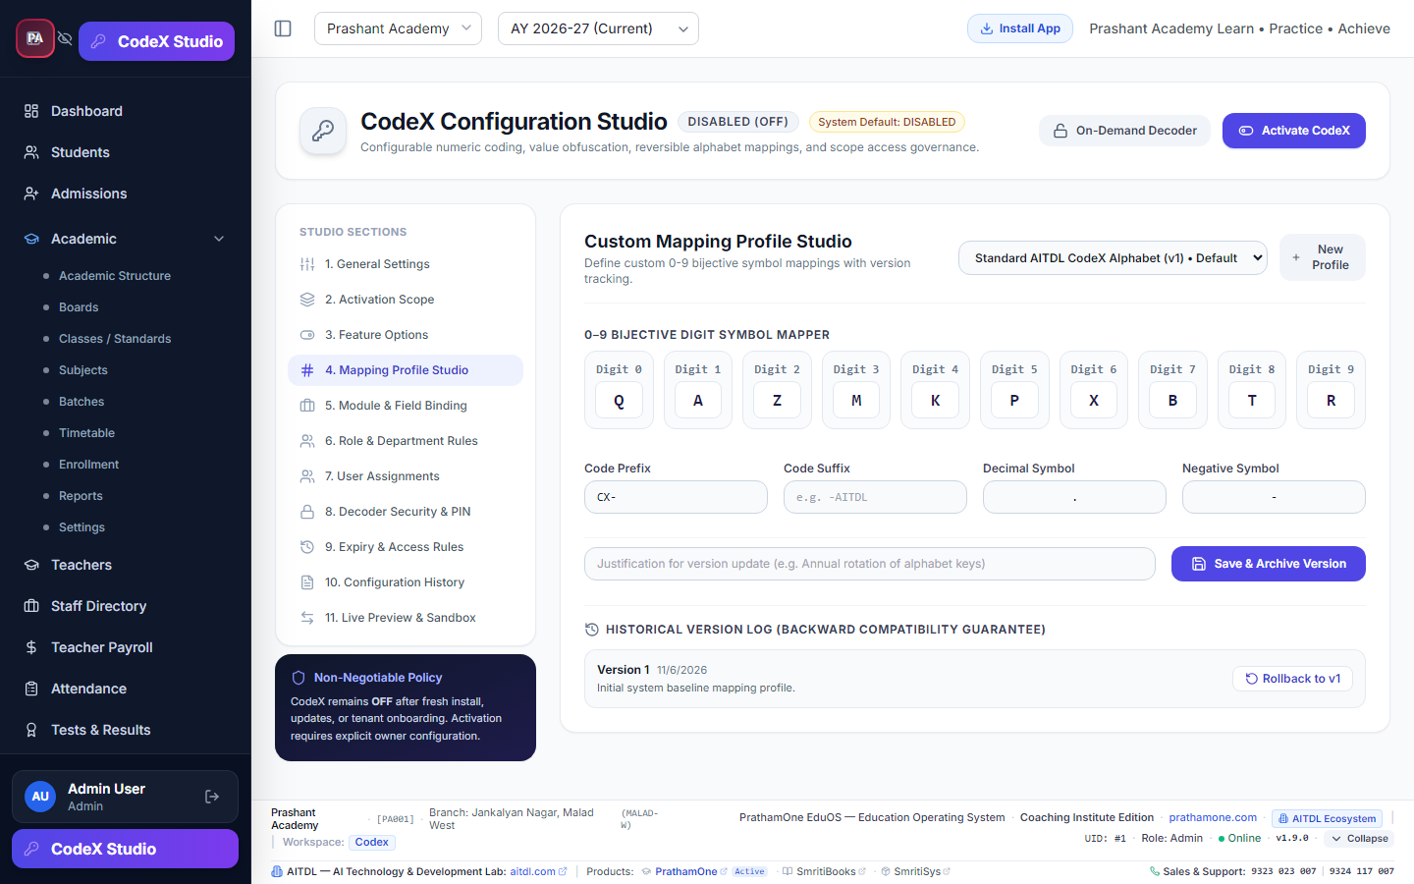
Figure 4.13: CodeX Mapping Studio with reversible symbol substitutions.
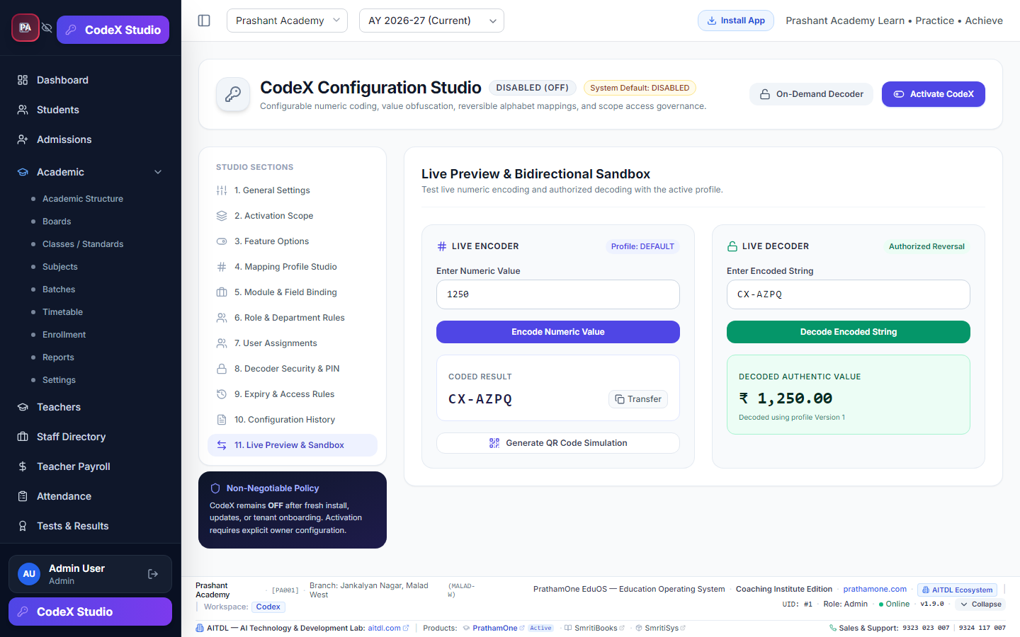
Figure 4.14: Verification Sandbox testing live bidirectional encoding and decoding.

4.12 Universal Print Fit & Page Layout Engine
Integrated across all document triggers (Dossiers, ID Cards, Receipts, Report Cards, Invoices). Supports standard office paper (A4, Letter) and compact receipt formats (A5, 80mm Thermal Rolls). Auto-calculates CSS scale factors to eliminate clipping and preserve corporate color branding.

4.13 Branding & System Settings
Route: /settings | Access: Admin, SysAdmin
Configure institute profile details, upload official logos, and customize brand primary/secondary colors with the interactive Live Branding Preview card before saving.
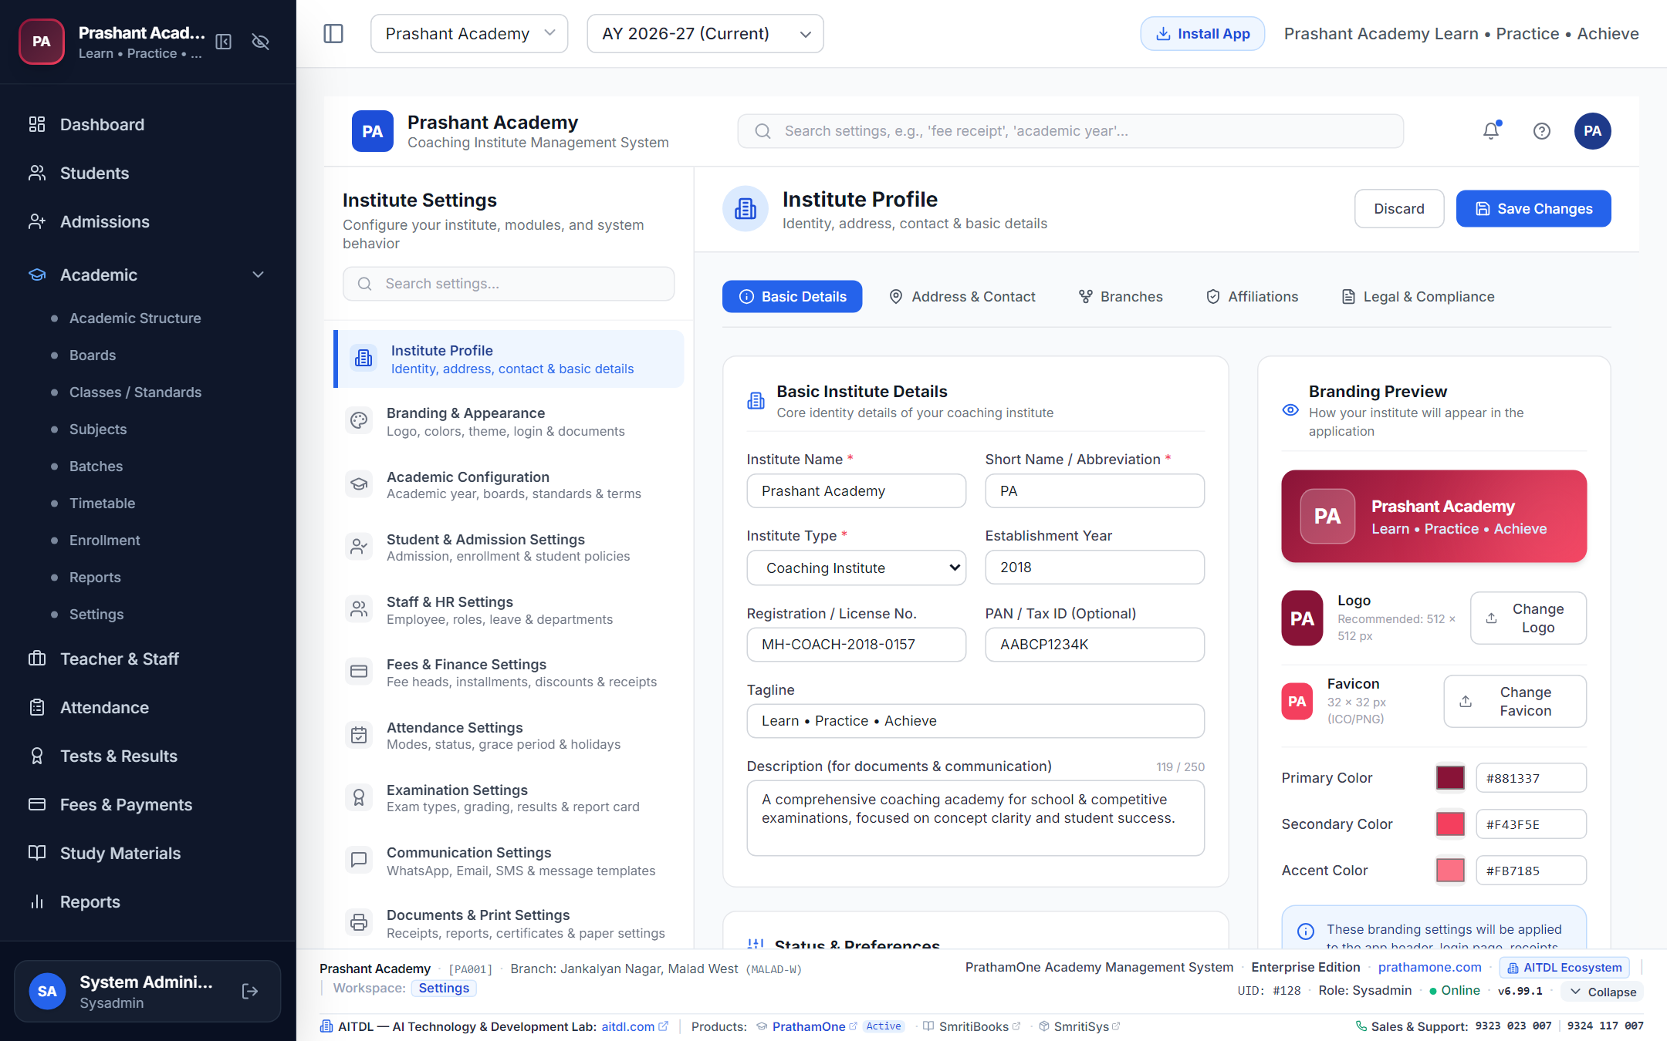
Figure 4.12: Settings & Live Branding Preview.

4.9 SysAdmin Center & Universal Records Editor
Route: /sysadmin | Access: SysAdmin Exclusive
Superuser dashboard featuring system diagnostics, database connection pools, immutable security audit logs, and the Universal Records Editor. Allows surgical master data corrections across 8 models while strictly enforcing field-level allowlists and preventing self-deactivation.
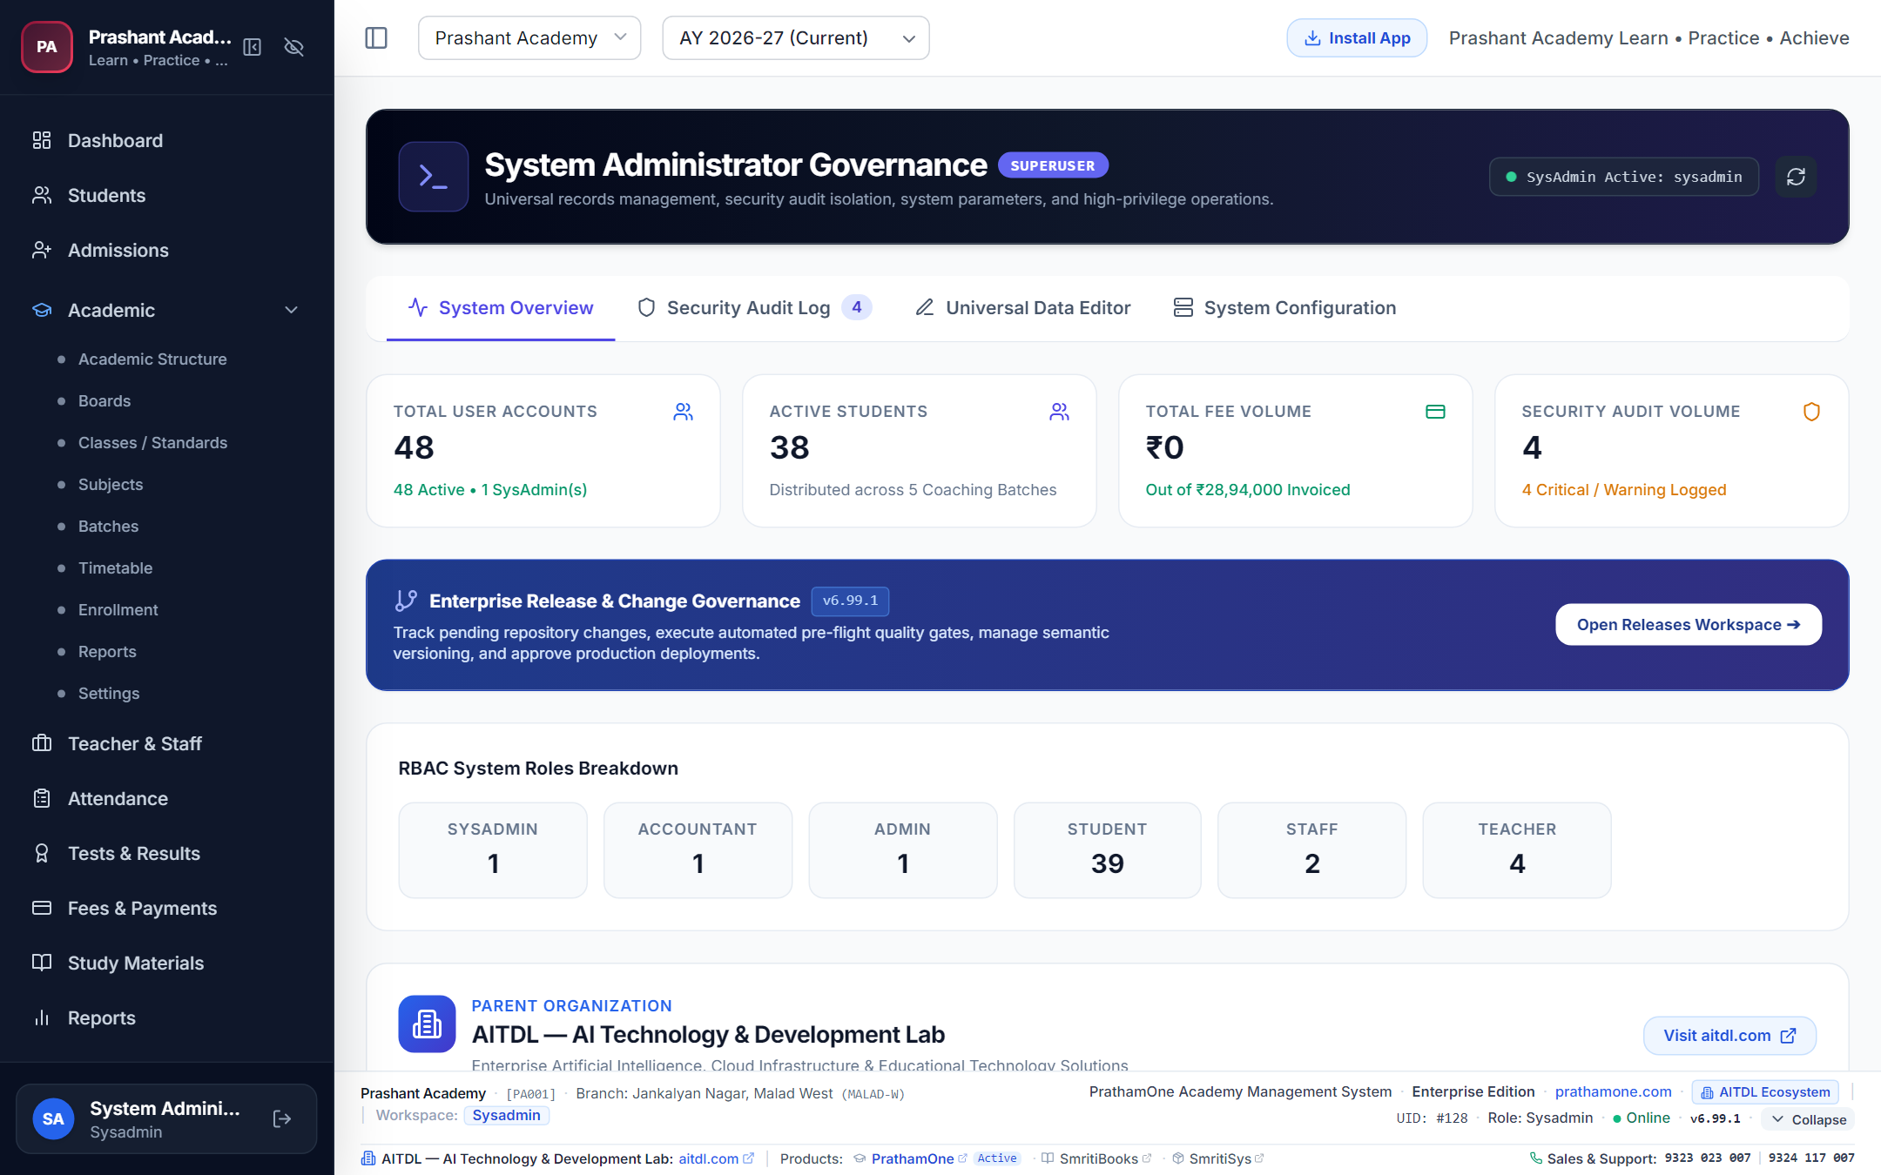
Figure 4.13: SysAdmin Operations Center.
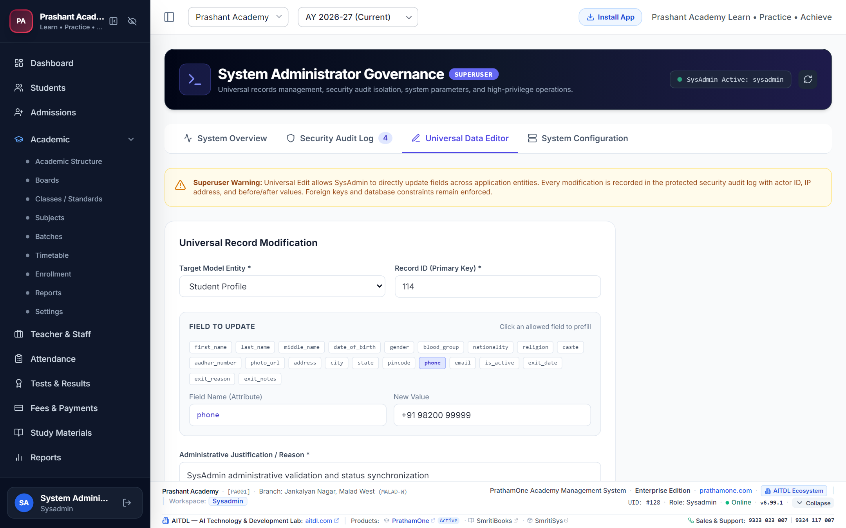
Figure 4.14: Universal Records Editor.

5. Troubleshooting, Error Codes & FAQ
PrathamOne EduOS includes a centralized error tracking taxonomy. When an error occurs, a reference code (e.g. ERR-20261106-XXXX) is displayed. Common resolutions:
• INTERNET_DISCONNECTED: The application enters PWA offline mode. Reconnect Wi-Fi to sync.
• SESSION_EXPIRED (401): JWT session expired. Re-authenticate on /login.
• PERMISSION_DENIED (403): User role lacks access. Request permission from SysAdmin.
• VALIDATION_FAILED (400): Ensure all required fields (e.g. edit reason) are provided.

5.1 Official Support Desk
For enterprise assistance, system training, or custom integrations:
• Phone / WhatsApp: +91 9323 023 007 / +91 9324 117 007
• Support Email: support@prathamone.com | Alternate: prathamone@outlook.com
• Website: https://prathamone.com
• Author & Architect: Jawahar R Mallah
• Organization: AITDL — AI Technology & Development Lab

