**Power BI Assignment 2**

1. Explain the advantages of Natural Queries in PowerBi with an example?
2. Explain Web Front End(WFE) cluster from Power BI Service Architecture?
3. Explain Back End cluster from Power BI Service Architecture?
4. What ASP.NET component does in Power BI Service Architecture?
5. Compare Microsoft Excel and PowerBi Desktop on the following features:

Data import

Data transformation

Modeling

Reporting

Server Deployment

Convert Models

Cost

1. List 20 data sources supported by Power Bi desktop.

**ANS:**1.

Natural Queries in Power BI refer to the ability to ask questions in a natural language format, rather than having to write complex queries or formulas. This feature makes data exploration and analysis more intuitive and accessible to users who may not be proficient in SQL or DAX. For example, instead of writing a query to find sales data for a specific product in a particular region, a user can simply ask, "Show me sales for Product A in Europe." The advantage is that it speeds up the analysis process and empowers users to interact with data in a more conversational manner, leading to faster insights and decision-making.

2.

The Web Front End (WFE) cluster in Power BI Service Architecture handles incoming user requests and serves the Power BI web interface to users. It acts as the entry point for users accessing Power BI reports, dashboards, and other content through their web browsers. The WFE cluster manages user authentication, authorization, session management, and handles tasks such as rendering visualizations and executing queries against underlying data sources. Essentially, it provides the user-facing interface for interacting with Power BI content hosted in the cloud.

3.

The Back End cluster in Power BI Service Architecture consists of multiple components responsible for processing, storing, and managing data and metadata associated with Power BI workspaces, datasets, reports, and other artifacts. This includes data ingestion, storage, processing, and management tasks performed by services such as Power BI Dataset Engine, Power BI Gateway, and Power BI Dataflows. The Back End cluster also includes components for managing security, data refresh schedules, and other administrative tasks related to Power BI content hosted in the cloud.

4.

The ASP.NET component in Power BI Service Architecture is responsible for hosting and serving the web application framework used to build the Power BI service interface. It handles user authentication, session management, and serves the user interface elements (HTML, CSS, JavaScript) required for interacting with Power BI content through web browsers. ASP.NET provides the underlying infrastructure for building dynamic, interactive web applications, and it is utilized by the Web Front End (WFE) cluster to deliver the Power BI web interface to users.

5.

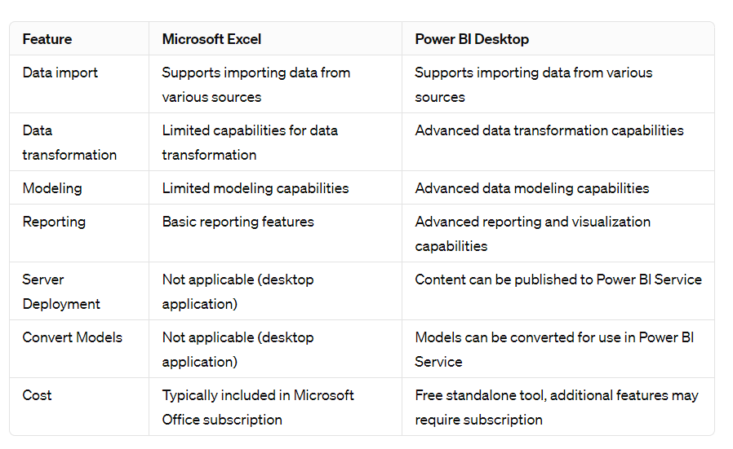

6.

1. Excel

2. CSV

3. SQL Server

4. MySQL

5. PostgreSQL

6. Oracle Database

7. Azure SQL Database

8. SharePoint Online

9. Dynamics 365

10. Google Analytics

11. Salesforce

12. Azure Blob Storage

13. JSON

14. XML

15. Hadoop File (HDFS)

16. Azure Data Lake Storage

17. OData Feed

18. Facebook

19. GitHub

20. Web (HTML)