AutoCar

Design Document

**Table of Contents**

**1** **INTRODUCTION 3**

**2** **DESIGN GOALS 4**

**3** **SYSTEM BEHAVIOR 4**

**4** **LOGICAL VIEW 5**

**4.1** **High-Level Design (Architecture) 5**

**4.2** **Mid-Level Design 6**

**4.3** **Detailed Class Design 8**

**5** **PROCESS VIEW 11**

**6** **DEVELOPMENT VIEW 12**

**7** **PHYSICAL VIEW 12**

**8** **USE CASE VIEW 12**

Change History

**Version:** 1.0

**Modifier:** Smruthi Gadenkanahalli, Pratham Mehta, Umang Garg

**Date:** 10/18/2017

**Description of Change:** Added Component Diagram for Active Redundancy Scenario

______________________________________________________

# **Introduction**

This document describes the architecture and design for the Autonomous Car application being developed for Software Architecture and Product Line course. The application is developed to demonstrate the availability quality attributes such as Heartbeat mechanism and Active Redundancy.

The purpose of this document is to describe the architecture and design of the Autonomous Car application in a way that addresses the interests and concerns of all major stakeholders.

Here the architecture of the Autonomous Car application is described from different perspectives:

1. Logical View – major components, their attributes and operations. This view also includes relationships between components and their interactions.
2. Physical View- major physical components of the autonomous car will be represented in this view

# **Design Goals**

There is no absolute measure for distinguishing between good and bad design. The value of a design depends on stakeholder priorities. For example, depending on the circumstances, an efficient design might be better than a maintainable one, or vise versa. Therefore, before presenting a design it is good practice to state the design priorities. The design that is offered will be judged according to how well it satisfies the stated priorities.

The design priorities for the autonomous car application are:

* The design should minimize complexity and development effort.
* The design should emphasize on the availability tactics.

# **System Behavior**

The Autonomous Driving Car shall allow the driver to choose between self drive and manual drive mode. The detailed set of requirements are listed in the Requirements document (see [Requirements Document](https://docs.google.com/spreadsheets/d/1pPy07Qwbf_2rPLQ0FU7cLxgf5YEgw0TjA7ABzdvamxc/edit#gid=1195136722)).

The critical components shall send heartbeats to the monitoring system at regular intervals. In case of failure in one of the nodes of the critical components, the system shall use data from the redundant node that is maintained in the same state. The downtime shall be less than 500 milliseconds.

# **Logical View**

The logical view describes the main functional components of the autonomous car. This includes modules, the static relationships between modules, and their dynamic patterns of interaction.

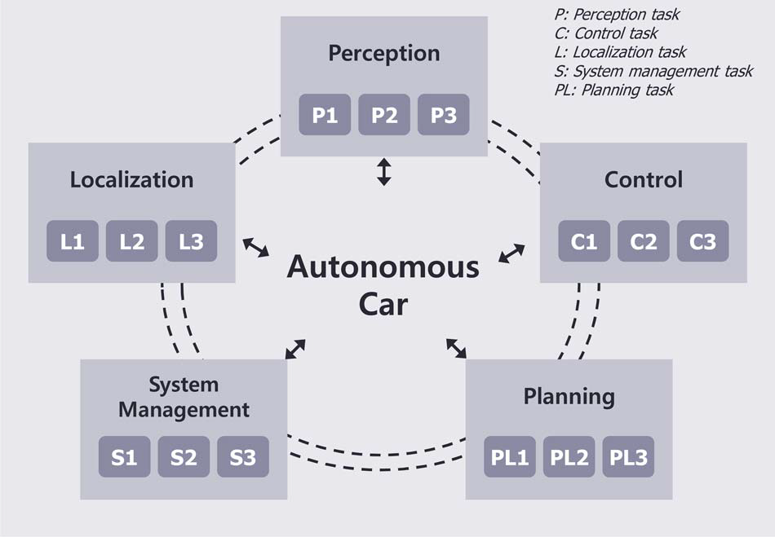

## ***High-Level Design (Architecture)***

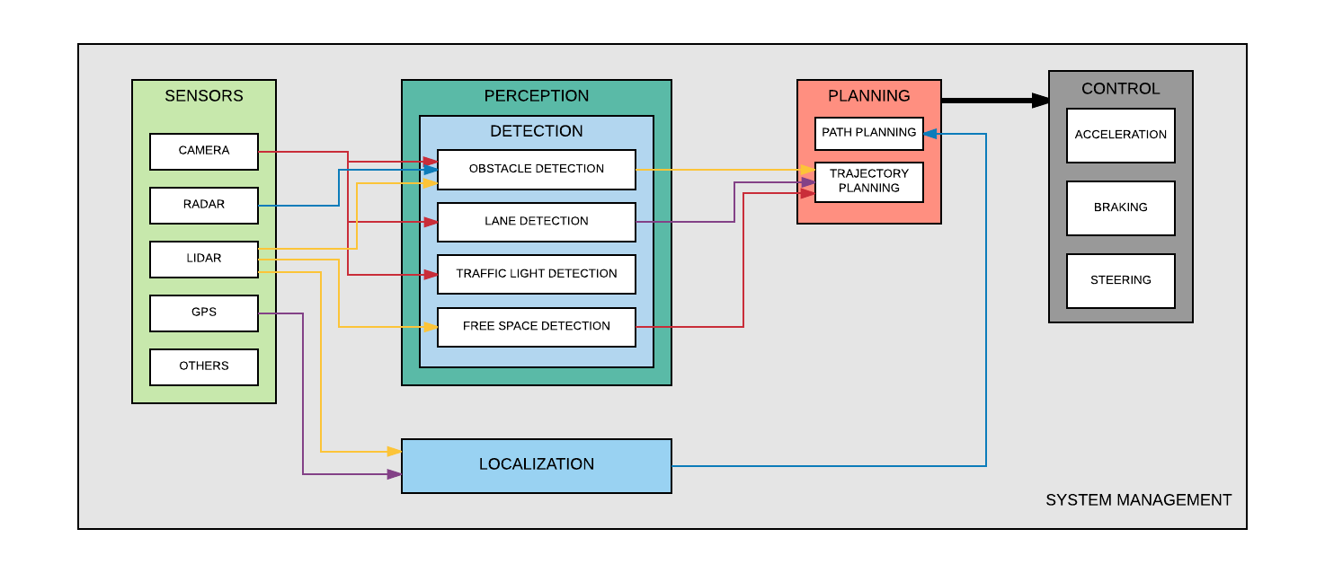

The five basic functions that drive an autonomous car are: perception, localization, planning, control, and system management.

**Perception**: This component uses a variety of techniques to detect the surrounding of the autonomous car, such as radar, laser light, GPS, and computer vision.

**Localization**: This component finds the position of the car in the external environment.

**Planning**: This system interprets the information from the perception component to identify appropriate navigation paths, as well as obstacles and relevant signage.

**Control**: This function follows the desired command from the planning function by steering, accelerating, and braking the autonomous car.

**System Management**: This component manages the overall functioning of the car and interactions with the driver.

## ***Mid-Level Design***

*This section shall be updated in later stages of the project*

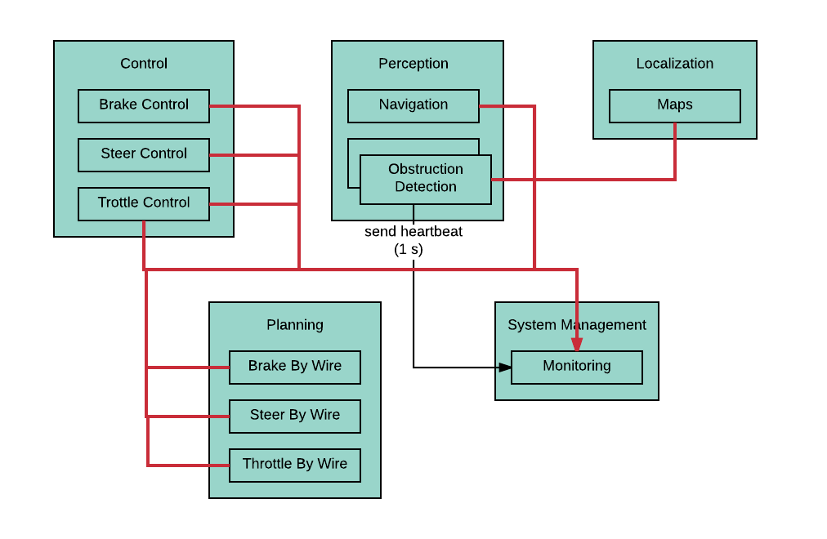

## ***Detailed Class Design***

*This section shall be updated in later stages of the project*

# **Process View**

*This section shall be updated in later stages of the project*

# **Physical View**

The major physical components of the autonomous car will be deployed as shown:

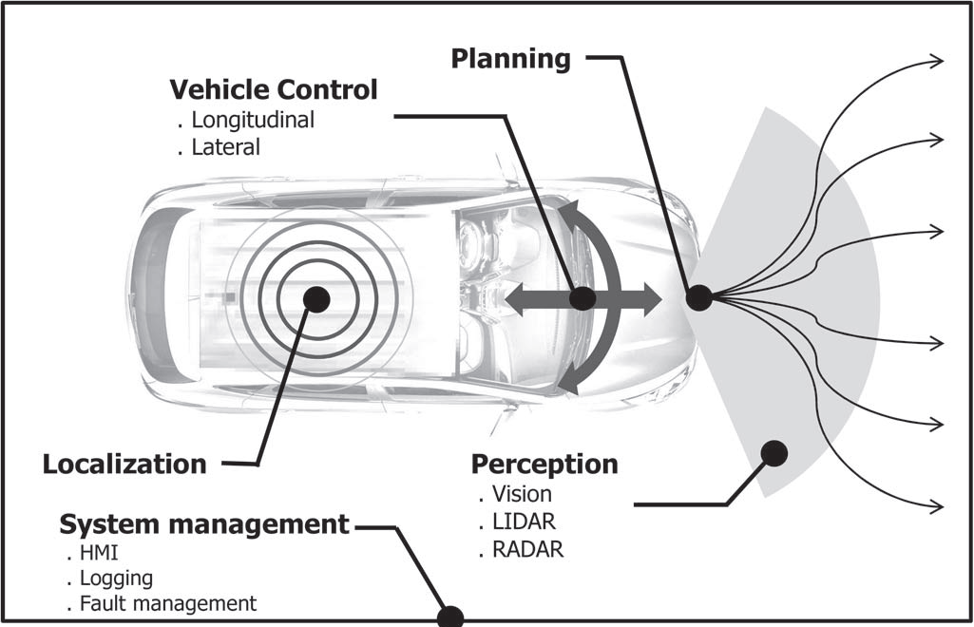

# **Use Case View**

*This section shall be updated in later stages of the project*