- Tic Tac Toe :
Output:
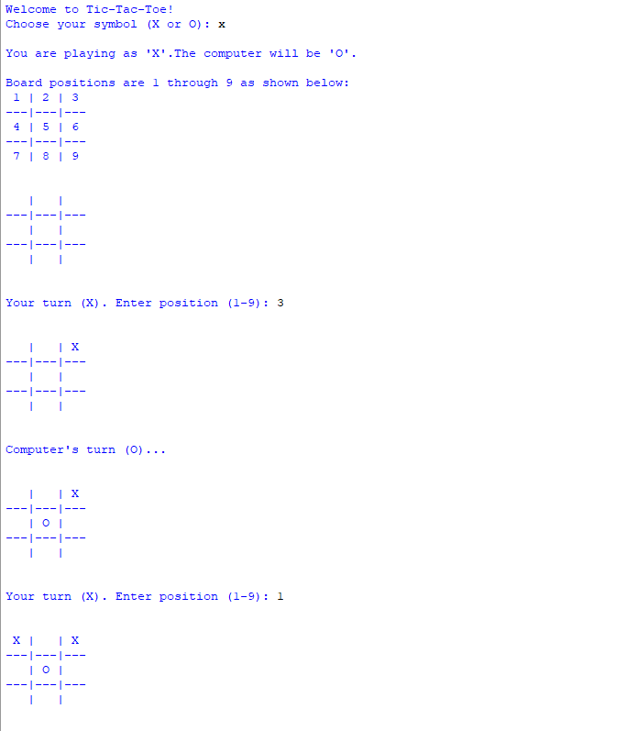
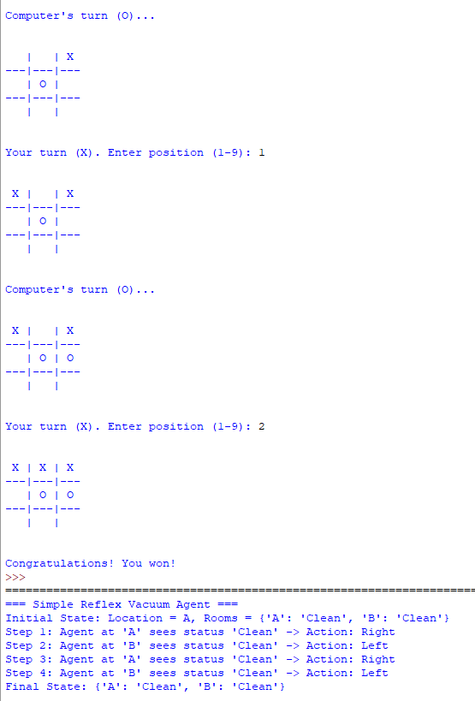

- Vacuum agent:
Output:

