LAB-3

- Round Robin Scheduling
Program:
#include <stdio.h>
#include <stdlib.h>
struct process {
int pid, at, bt, ct, tat, wt, rt;
};
struct Queue {
int items[100];
int front, rear;
};
void enqueue(struct Queue *q, int value) {
q->items[++q->rear] = value;
}
int dequeue(struct Queue *q) {
return q->items[++q->front];
}
int isEmpty(struct Queue *q) {
return q->front == q->rear;
}
void roundRobin(struct process p[], int n, int tq) {
struct Queue q;
q.front = q.rear = -1;
int time = 0, completed = 0;
int sum_tat = 0, sum_wt = 0;
int visited[n];
int gantt_pid[100], gantt_start[100], gantt_end[100], gantt_count = 0;
for (int i = 0; i < n; i++) visited[i] = 0;
for (int i = 0; i < n; i++) {
if (p[i].at == 0) {
enqueue(&q, i);
visited[i] = 1;
}
}
while (completed < n) {
if (!isEmpty(&q)) {
int idx = dequeue(&q);
gantt_pid[gantt_count] = p[idx].pid;
gantt_start[gantt_count] = time;
if (p[idx].rt > tq) {
time += tq;
p[idx].rt -= tq;
} else {
time += p[idx].rt;
p[idx].rt = 0;
p[idx].ct = time;
completed++;
}
gantt_end[gantt_count] = time;
gantt_count++;
for (int i = 0; i < n; i++) {
if (p[i].at <= time && !visited[i]) {
enqueue(&q, i);
visited[i] = 1;
}
}
if (p[idx].rt > 0) {
enqueue(&q, idx);
}
} else {
time++;
for (int i = 0; i < n; i++) {
if (p[i].at <= time && !visited[i]) {
enqueue(&q, i);
visited[i] = 1;
}
}
}
}
printf("\nProcess Table:\n");
printf("PID\tAT\tBT\tCT\tTAT\tWT\n");
for (int i = 0; i < n; i++) {
p[i].tat = p[i].ct - p[i].at;
p[i].wt = p[i].tat - p[i].bt;
sum_tat += p[i].tat;
sum_wt += p[i].wt;
printf("%d\t%d\t%d\t%d\t%d\t%d\n",
p[i].pid, p[i].at, p[i].bt, p[i].ct, p[i].tat, p[i].wt);
}
double avgtat = (double)sum_tat / n;
double avgwt = (double)sum_wt / n;
printf("Average TAT = %.2f\n", avgtat);
printf("Average WT = %.2f\n", avgwt);
printf("\nGantt Chart:\n");
for (int i = 0; i < gantt_count; i++) {
printf("| P%d (%d-%d) ", gantt_pid[i], gantt_start[i], gantt_end[i]);
}
printf("|\n");
}
int main() {
int n, tq;
printf("Enter the number of processes: ");
scanf("%d", &n);
printf("Enter the time quantum: ");
scanf("%d", &tq);
struct process p[n];
for (int i = 0; i < n; i++) {
p[i].pid = i + 1;
printf("Enter arrival time for process %d: ", i + 1);
scanf("%d", &p[i].at);
printf("Enter burst time for process %d: ", i + 1);
scanf("%d", &p[i].bt);
p[i].rt = p[i].bt;
}
roundRobin(p, n, tq);
return 0;
}

Output:
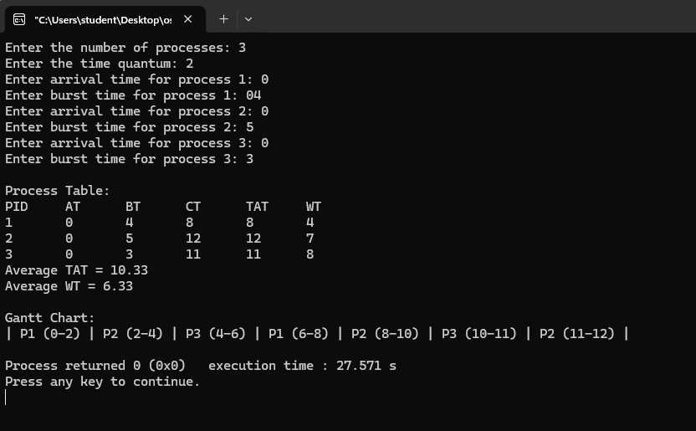
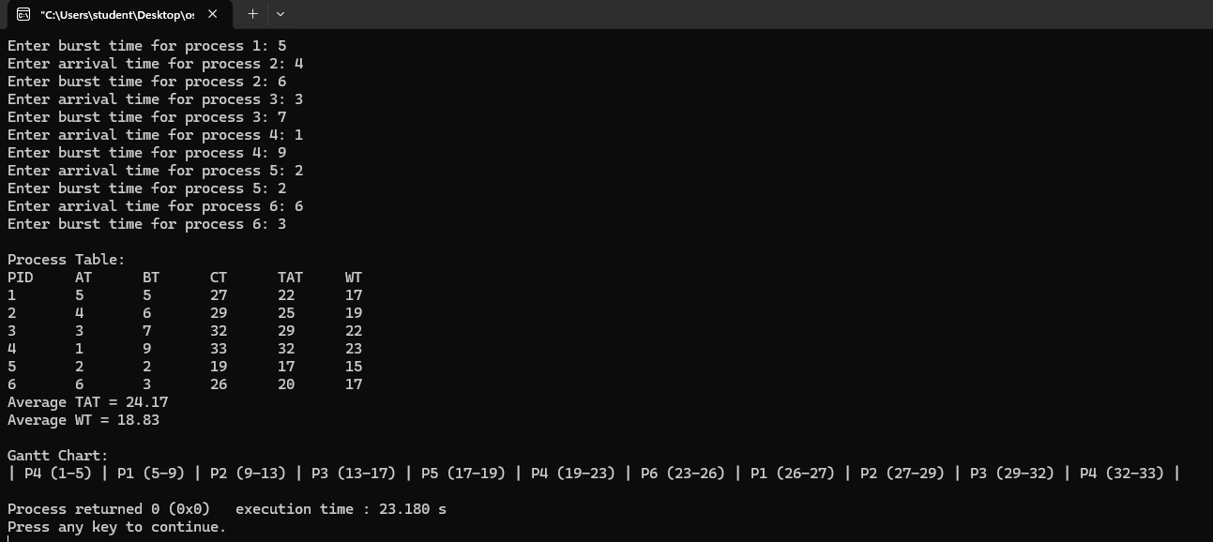

- Multilevel Scheduling
Program:
#include <stdio.h>
#define MAX 100
struct process {
int pid, at, bt, type, ct, tat, wt, start;
};
void sortByArrival(struct process q[], int n) {
for (int i = 0; i < n - 1; i++) {
for (int j = i + 1; j < n; j++) {
if (q[i].at > q[j].at) {
struct process temp = q[i];
q[i] = q[j];
q[j] = temp;
}
}
}
}
int executeQueue(struct process q[], int n, int time) {
for (int i = 0; i < n; i++) {
if (time < q[i].at) time = q[i].at;
q[i].start = time;
time += q[i].bt;
q[i].ct = time;
q[i].tat = q[i].ct - q[i].at;
q[i].wt = q[i].tat - q[i].bt;
}
return time;
}
void printGanttChart(struct process sysQ[], int sysCount, struct process userQ[], int userCount) {
printf("\nGantt Chart:\n");
for (int i = 0; i < sysCount; i++) {
printf("| P%d (%d-%d) ", sysQ[i].pid, sysQ[i].start, sysQ[i].ct);
}
for (int i = 0; i < userCount; i++) {
printf("| P%d (%d-%d) ", userQ[i].pid, userQ[i].start, userQ[i].ct);
}
printf("|\n");
}
int main() {
int n;
printf("Enter number of processes: ");
scanf("%d", &n);
struct process p[MAX], systemQ[MAX], userQ[MAX];
int sysCount = 0, userCount = 0;
printf("Enter PID AT BT TYPE (0=System,1=User):\n");
for (int i = 0; i < n; i++) {
scanf("%d %d %d %d", &p[i].pid, &p[i].at, &p[i].bt, &p[i].type);
if (p[i].type == 0) systemQ[sysCount++] = p[i];
else userQ[userCount++] = p[i];
}
sortByArrival(systemQ, sysCount);
sortByArrival(userQ, userCount);
int time = 0;
time = executeQueue(systemQ, sysCount, time);
time = executeQueue(userQ, userCount, time);
printf("\nProcess Table:\n");
printf("PID\tAT\tBT\tTYPE\tCT\tTAT\tWT\n");
for (int i = 0; i < sysCount; i++) {
printf("%d\t%d\t%d\tSys\t%d\t%d\t%d\n",
systemQ[i].pid, systemQ[i].at, systemQ[i].bt,
systemQ[i].ct, systemQ[i].tat, systemQ[i].wt);
}
for (int i = 0; i < userCount; i++) {
printf("%d\t%d\t%d\tUser\t%d\t%d\t%d\n",
userQ[i].pid, userQ[i].at, userQ[i].bt,
userQ[i].ct, userQ[i].tat, userQ[i].wt);
}
printGanttChart(systemQ, sysCount, userQ, userCount);
return 0;
}
Output:
