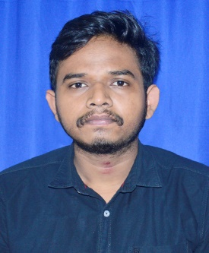SMRUTI SOURAV ACHARYA

 Regional college of

Management

[smrutisourav.acharya460@gmail.com ](mailto:smrutisourav.acharya460@gmail.com)

+91-7894858572 

Panimala square,nilai,cuttack

**https://**[**www.linkedin.com/in/smruti-sourav-acharya-**](http://www.linkedin.com/in/smruti-sourav-acharya-)

**289b57256**

Strong in design and integration with intuitive problem-solving skills. Passionate about implementing and launching new projects. Ability to translate business requirements into technical solutions. Looking to start the career as an entry-level software engineer with a reputed firm driven by technology.

# EDUCATION

### Master’s in Computer Application

Regional College of Management

### Bachelor of Science | (2019-2022)

U.N Auto College Of Science & Tech

### Intermediate in Science | (2017-2019)

U.N Auto College Of Science & Tech

### Matriculation | (2016-2017)

Madhabananda Jew high School

# LIVE PROJECT

**Live Project**

## Graduation

*Achievements / Tasks*

–

Statistical analysis on the impact of birth and death rate on Cuttack economy from 2017-2019

## Post Graduation

*Achievements / Tasks*

–

Responsive Personal Portfolio Website using HTML CSS & JavaScript.

Animated Login Form using HTML and CSS.

**CERTIFICATES**

* Post graduate diploma in computer application
* SQL programming
* Core java
* Database.

# TECHNICAL SKILLS

* + MY SQL/ Database
  + C Programming
  + Java programming
  + Front end development

# SOFT SKILLS

Interpersonal Skills

* + Verbal and Written Communication Skills.
  + Team-Worker

Adaptive Leadership

* + Accountable and Responsible.
  + Continuous Learning

# ACHIEVEMENTS

**E-START BOOTCAMP**

#### It is organized by Regional College Of Management in collaboration with

**STARTUPODISHA.**

Get certified of cyber security and privacy from NPTEL.

Conducted blood donation camp to preach importance of donating blood

# AVOCATION

* + Reading Books
  + Writing code
  + Playing Badminton & Cricket

# PERSONAL PROFILE

* + English
  + Hindi
  + Odia