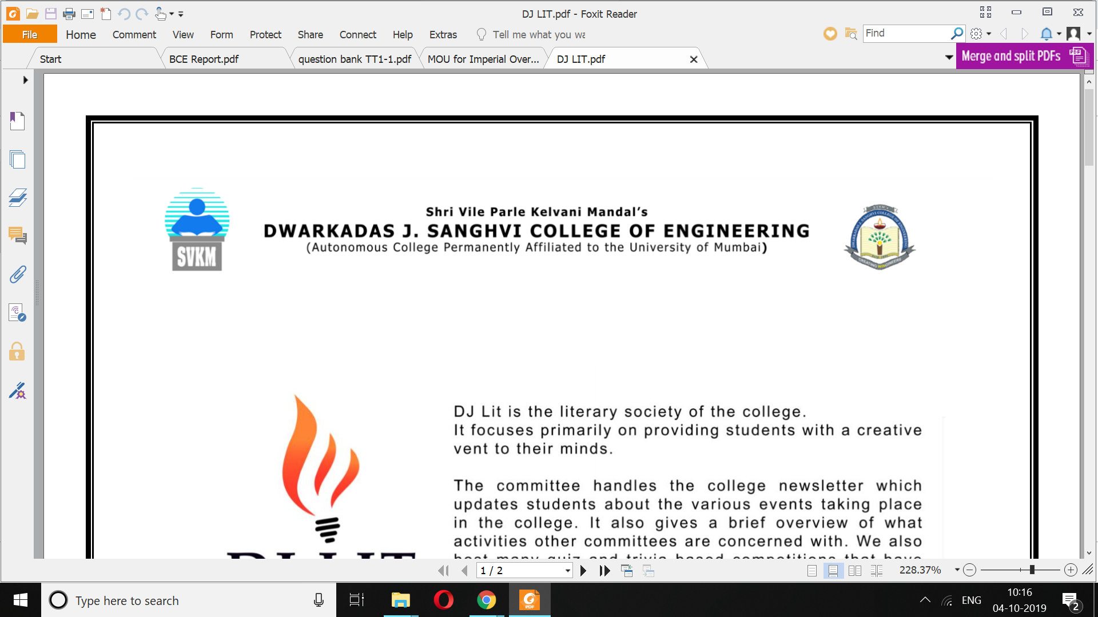

Unorthodox Careers

2019

A Report on

Unorthodox Careers

A report submitted in partial fulfilment of the Subject Business Communication and Ethics to the subject in-charge,

**Prof. Smita Rane**

by

|  |  |  |
| --- | --- | --- |
| SAP ID  60003170001  60003170002  60003170003  60003170004  60003170005  60003170006  60003170007  60003170008  60003170009  60003170010  Prepared for:  Date of Submission: | NAME  Aayush Shah  Aayushi Gandhi  Abheet Shaju  Adnan Hakim  Ali Abbas Rizvi  Ankit Basrur  Anmol Khemka  Ansh Shah  Arsh Shaikh  Arti Koul  Term Work | SIGNATURE |

**Preface**

It is a great opportunity for us to present the report as a part of the subject: Business Communication And Ethics on the topic ‘Unorthodox Careers’ which is prepared in order to examine the transition of career choices in our country.

This report has been segregated into major and popular career options in 2019: Film Making,Critic,Digital Marketing,Comedian,YouTuber,Social Media Influencer,Fitness Trainer and Event Management showing the change in preferences with changing times.

The report starts with the history of the industry, covering the early influence and growth in our country. It then explains the increasing demand of the career in India.

Finally, it tells about the scope and its increasing popularity.

Through this report we have enhanced our knowledge and skills. So let us take you through this transition of media service providers in the past years. We hope that you find this report satisfactory.

**Acknowledgements**

We would also like to acknowledge our sincere thanks and are indebted to our Subject in charge Prof.Smita Rane for her valuable guidance and assistance in preparing this report.

We would like to acknowledge our sincere thanks and are indebted to the Principal Dr. Hari Vasudevan for granting us the usage of the college library facilities for the purpose of reference for this report.

We are also thankful to our Head of Department Meera Narvekar for allowing us to use the computer laboratory and the internet facilities.

We are deeply indebted to our families for their moral support and encouragement because of which this project has been completed in the true sense. Their patience and support in the course of the report writing has helped us to rejuvenate ourselves and thus give our best for the report.

Table of Contents

***Preface***

***Acknowledgement***

1.0 **Introduction** **1**

Fears of taking Unorthodox Careers: 1

1.0.2 Approach 2

1.0.3 Perks 3

1.0.4 Careers which we have considered 3

2.1 **Filmmaking** **5**

2.1.1 Eligibility Criteria & Skills 5

2.1.2 Stages of production 5

2.1.3 Other Film Related Careers 7

2.1.4 Institutes offering various film making courses in India 7

2.2 **Critics and Reviews (Film, Food, Sports)** **8**

2.2.1 What is a critic? 8

2.2.2 Career Objectives 8

2.2.3 How to become a critic 9

2.2.4 Career Prospects and Salary 11

2.3 **Digital Marketing** **1**2

2.3.1 What is digital marketing? 12

2.3.2 Scope 12

2.3.3 What does a digital marketer do? 13

2.3.4 Opportunities 14

2.3.5 Skills Required 15

1. You should think creatively 15

2. You've to be strong in analytical reasoning 15

3.1 **Comedian** **17**

3.1.1 Skills needed to be a comedian 18

3.1.2 Famous Comedians, their journey and incomes of comedians 18

**3.2 YouTuber** **2**2

3.2.1 Indian YouTubers and their Earnings 24

3.2.2 Global YouTubers and their Earnings 25

**3.3 Social Media Influencer** **27**

3.3.1 What is an influencer? 27

3.3.2 Types of Influencers 27

3.3.3 How to become a Social Media Influencer 28

4.0 **Fitness Trainer** **3**1

4.0.1 How to Get Started in This Career 31

4.0.2 Qualifications and experience required 33

4.0.3 Quick Facts About Fitness Trainers 33

4.0.4 Successful examples in India 33

4.2 **Event Management** **3**5

4.2.1 Skills Required 35

4.2.2 Is it the right career for me? 36

4.2.3 What would it Cost Me?

5.0 **Survey Analysis** 37

6.0 **Conclusion** **39**

***Summary***

***Bibliography***

***Glossary***

# 

**SUMMARY:**

Gone are the days when choosing a traditional career was the only option one could have for a safe and promising future. Now dreaming somewhat off-beat can let you enjoy the difference of a road less travelled.

Generation today, have a pool of options to choose from depending upon their interests, skills and personal characteristics. The career you choose today not only let you have an experience filled with fun and thrill but also make a way for an advantageous prospect.

Unconventional careers are becoming more and more popular with majority of individuals opting for these challenging opportunities with a will to make an impact in this ever changing and growing world.

Gearing your mind for the [jobs](https://timesofindia.indiatimes.com/home/education/news/Off-beat-careers-treading-the-passion-path/articleshow/www.timesjobs.com/) of the future could work wonders in making sure you are a success when future becomes your present.

Considering various occupations, there will be a significant amount of growth between now and in coming 10 years.

Off-beat careers mostly rely on individual skills and talents as they don't follow the canonical learning techniques. Yet there are some institutes, colleges and universities providing a professional knowledge to expand the expertise horizon.

As a career seeker one needs to plan and prepare oneself for the bigger picture. Move one step at a time and gather all necessary information required to tread the passion path.

Whether you are already in any of such career tracks or want to be in one that you really love it's a good idea to develop your job seeking skills so that you can grow within your own profession.

Every career track offers a generous way to climb a success ladder, all you must do is to develop a love, passion and expertise for it.

With ever changing economy, it is nice to know that there will be plenty of jobs to take advantage of soon. Now it's up to you to take the steps necessary to increase your chances of bracing them.

**BIBLIOGRAPHY**:

* + [www.nyfa.edu](http://www.nyfa.edu)
  + [www.indiaeducation.net](http://www.indiaeducation.net)
  + en.wikipedia.org
* <https://www.netspaceindia.com/top-10-richest-indian-millionaires-selected-youtube-career/>
* ELON JOURNAL OF UNDERGRADUATE RESEARCH IN COMMUNICATIONS VOL. 7 NO. 1 – Margaret Holland
* "Youtube.com Traffic, Demographics and Competitors". – [www.alexa.com](http://www.alexa.com)
* <https://www.webwise.ie/parents/what-is-youtube/>
* Aparna Banerji (2009-07-24). "Lady laughter sends T-town rolling". Tribune India. Retrieved 2014-07-21.
* "Kapil Sharma plays the 'Traffic monitor' at India Gate". The Times of India. 26 September 2013.
* Hofstetter, Steve (2 July 2015). "What to Expect when You're Expecting...to be Paid at a Club". Comedy Hints: Helping Comedians Help Themselves. Retrieved 8 February 2019.
* Zinoman, Jason; Megan, Angelo (2012-11-02). "Clever, How They Earn That Laugh". The New York Times. Retrieved 2019-01-26.
* mattoo, Priyanka (22 September 2015). "What Comedy Pays". Vulture: Devouring Culture. NEW YORK MEDIA LLC. Retrieved 7 February 2019.
* Simons, Seth (24 January 2018). "How Much Does Netflix Pay for 15 Minutes of Stand-Up?". PASTE. Retrieved 3 February 2019.
* Abramovitch, Seth (15 June 2018). "'I Sold the Same Special Twice!' How Netflix Is Driving an L.A. Comedy Gold Rush". The Hollywood Reporter.
* Flanagan, Caitlin (September 2015). "That's Not Funny! Today's college students can't seem to take a joke". The Atlantic. Retrieved 26 January 2019.
* <http://www.businessworld.in/quickbytes/Five-Major-Protests-That-Confronted-Modi/20-05-2016-102/>
* https://www.theartcareerproject.com/become/comedian/
* <https://influencermarketinghub.com/what-is-an-influencer/>
* <https://blog.hootsuite.com/influencer-marketing/>
* <https://www.pixlee.com/definitions/definition-social-media-influencer>
* <https://www.thinkwithgoogle.com/intl/en-apac/trends-and-insights/indias-100b-opportunity-peek-digital-consumer-spending-2020/>
* <https://www.webmarketingacademy.in/scope-of-digital-marketing-in-india/>
* <https://blog.hubspot.com/marketing/what-is-digital-marketing>
* <https://www.webtrainings.in/what-is-scope-of-digital-marketing-in-india/>
* <https://neilpatel.com/what-is-digital-marketing/>
* https://www.simplilearn.com/tips-to-learn-digital-marketing-article

**GLOSSARY**

* CTR – Click-Through Rate. Click-through Rate identifies the percentage of people who click on link.
* CPA – Cost per Acquisition
* CPC – Cost per Click.
* CPM – Cost per Thousand

### Speech bubble-A [speech/word/dialogue balloon](https://en.wikipedia.org/wiki/Speech_balloon) or speech/word/dialogue bubble is a speech indicator, containing the characters' dialogue.

#### Dailies- a comic strip that is normally run six days a week in a newspaper

* B2B -This acronym stands for ‘Business to Business’ events, meaning corporate or trade-related events.
* B2C-The opposite of B2B, this acronym means ‘Business to Consumer/Customer’ events, often relating to more consumer and public-facing events.
* Breakdown / Load Out / Strike-These terms all mean to [take down equipment](https://convene.com/catalyst/av-terms-event-planners-should-know/) and clear away items that have been set up for an event, after the event is complete.
* Concurrent Sessions-During larger events, meeting planners often host shorter educational meetings known as ‘concurrent sessions’
* Conference Pack-If you want to provide your delegates with some information at your conference, offer them a conference pack, which could include a schedule or program of events
* Consumer Show-A consumer show is a B2C exhibition or showcase of products, exclusives and activations designed to attract the attention of new potential buyers.
* Day Delegate Rate -Day Delegate Rate, or DDR, is a charge by a venue per attendee, per day for an event, based on a full day’s meeting.
* Early Bird Registration-Early is the key word here for registration for an event, which often means tickets and services purchased before a specified date are available at a reduced fee.
* Emcee/MC-This is the host who presides over the event program. *Emcee* is shorthand for ‘Master of Ceremonies.’
* Get-in -This term refers to the specified time for crew and staff to arrive and access a venue for setup before the public or guests arrive.
* Honorarium -A fee paid to a guest speaker.
* Hybrid Event -A conference, tradeshow, seminar, workshop or other meeting that combines a live, in-person audience with a virtual, online audience.
* Installation & Dismantle (I&D)- Also called ‘Setup and Take Down’—the process of preparing equipment for an event and taking apart that equipment after the event.
* Itinerary- Another word for a schedule, agenda, or program. A detailed event itinerary can be created for attendees or team briefings to outline the flow of the event.
* Keynote-Whether it’s a presentation or speaker, a keynote refers to the opening address or important plenary session at a meeting that sets the tone or theme of the event.
* [accusatory](https://www.macmillandictionary.com/dictionary/british/accusatory#accusatory__1) -[intended](https://www.macmillandictionary.com/dictionary/british/intended_1) to show someone that you [think](https://www.macmillandictionary.com/dictionary/british/think_1) they have done something [wrong](https://www.macmillandictionary.com/dictionary/british/wrong_1).
* [accusing](https://www.macmillandictionary.com/dictionary/british/accusing#accusing__1) -i[ntended](https://www.macmillandictionary.com/dictionary/british/intended_1) to show someone that you [think](https://www.macmillandictionary.com/dictionary/british/think_1) they have done something [wrong](https://www.macmillandictionary.com/dictionary/british/wrong_1)
* [acerbic](https://www.macmillandictionary.com/dictionary/british/acerbic#acerbic__1) - [showing](https://www.macmillandictionary.com/dictionary/british/showing) [criticism](https://www.macmillandictionary.com/dictionary/british/criticism) in a way that is [clever](https://www.macmillandictionary.com/dictionary/british/clever) and [funny](https://www.macmillandictionary.com/dictionary/british/funny), but rather [cruel](https://www.macmillandictionary.com/dictionary/british/cruel)
* [astringent](https://www.macmillandictionary.com/dictionary/british/astringent_1#astringent_1__3) - an [astringent](https://www.macmillandictionary.com/dictionary/british/astringent_1) [remark](https://www.macmillandictionary.com/dictionary/british/remark_1) is one that [criticizes](https://www.macmillandictionary.com/dictionary/british/criticize) someone [severely](https://www.macmillandictionary.com/dictionary/british/severely)
* [barbed](https://www.macmillandictionary.com/dictionary/british/barbed#barbed__1) - [barbed](https://www.macmillandictionary.com/dictionary/british/barbed) [comments](https://www.macmillandictionary.com/dictionary/british/comment_1) [contain](https://www.macmillandictionary.com/dictionary/british/contain) [criticisms](https://www.macmillandictionary.com/dictionary/british/criticism) or [insults](https://www.macmillandictionary.com/dictionary/british/insult_1)
* [biting](https://www.macmillandictionary.com/dictionary/british/biting#biting__2) - a [biting](https://www.macmillandictionary.com/dictionary/british/biting) [remark](https://www.macmillandictionary.com/dictionary/british/remark_1), [criticism](https://www.macmillandictionary.com/dictionary/british/criticism) etc is [cruel](https://www.macmillandictionary.com/dictionary/british/cruel) and [unkind](https://www.macmillandictionary.com/dictionary/british/unkind)
* [crushing](https://www.macmillandictionary.com/dictionary/british/crushing#crushing__5) -[criticizing](https://www.macmillandictionary.com/dictionary/british/criticize) someone or something very [severely](https://www.macmillandictionary.com/dictionary/british/severely)
* [deprecating](https://www.macmillandictionary.com/dictionary/british/deprecating#deprecating__1) -[showing](https://www.macmillandictionary.com/dictionary/british/showing) that you do not [approve](https://www.macmillandictionary.com/dictionary/british/approve) of something or someone.