**Smruti Chhatwani (Tableau Assignment)**

**Live VS Extract**

Extract takes a snapshot of the data that is to be used by Tableau for carrying out the further processes. Live is connecting to the database via server and new queries or visualizations will be reflected as new or updated.

An advantage of using extract over live is that it can be used anywhere without any connection and we can build the visualization without any connection to the database.

**Creating connection**

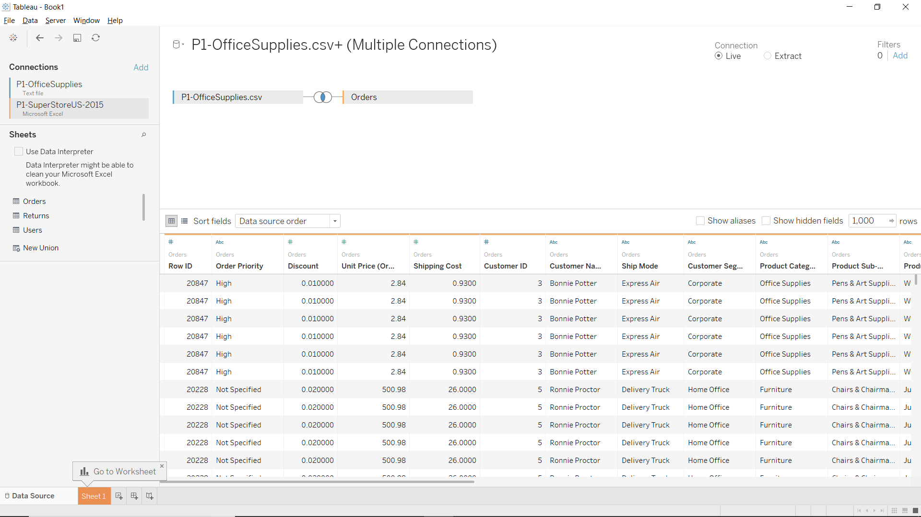

**Graph**

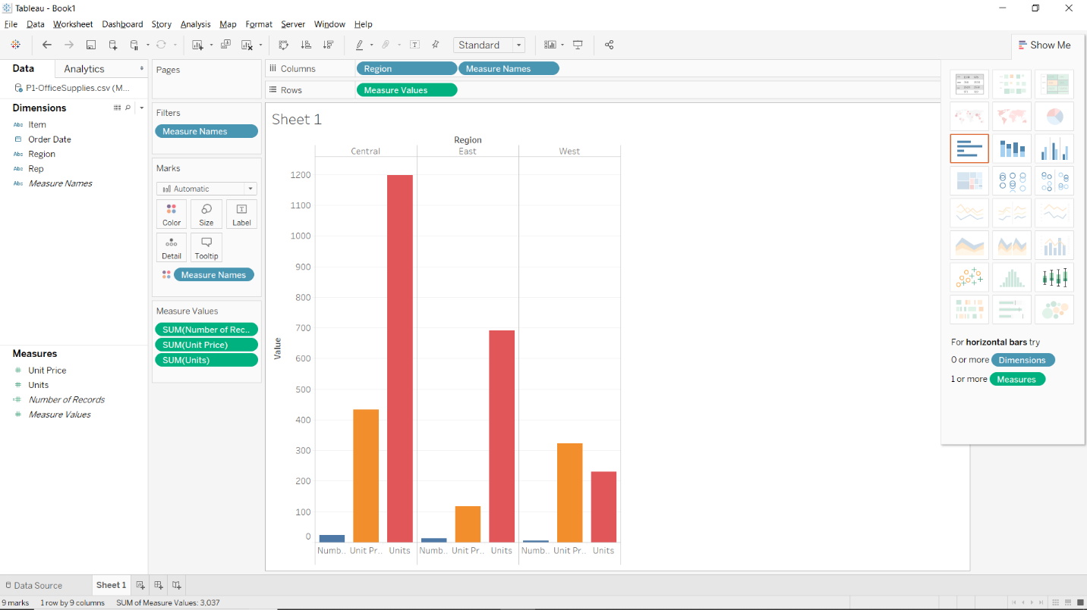

**Label**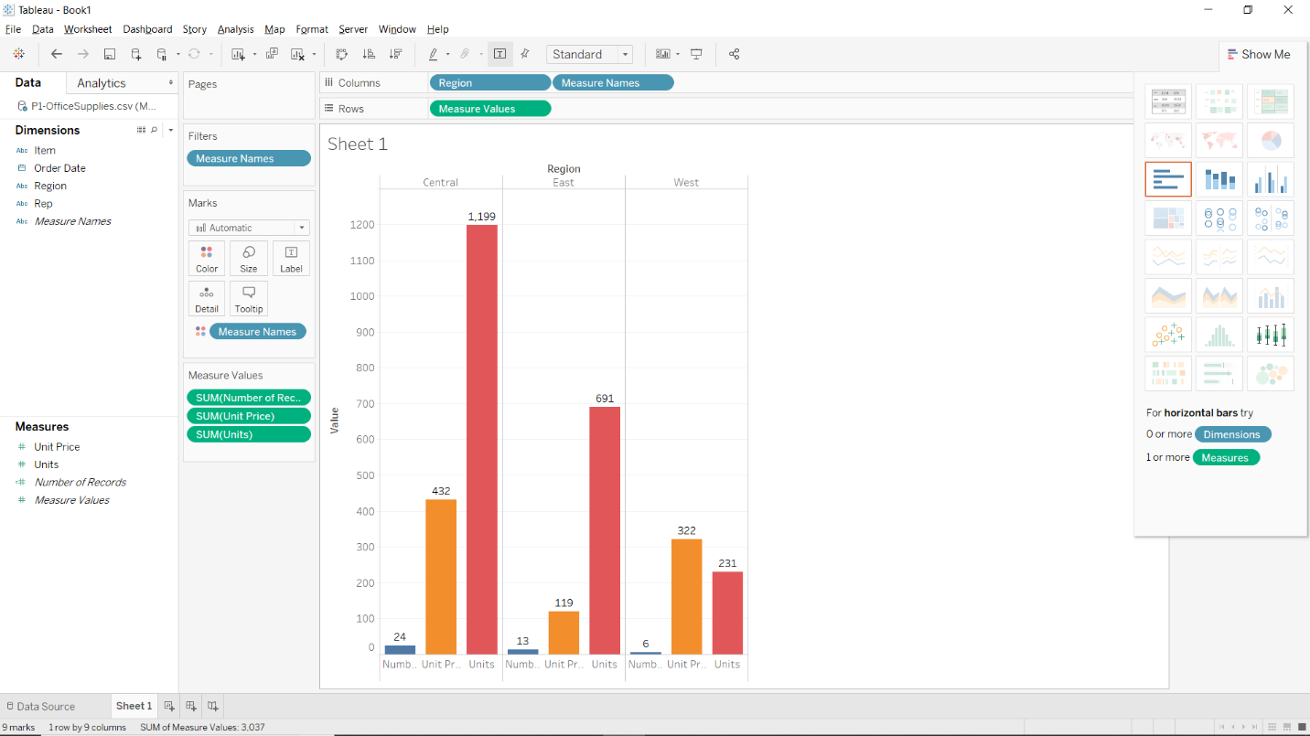

**Format**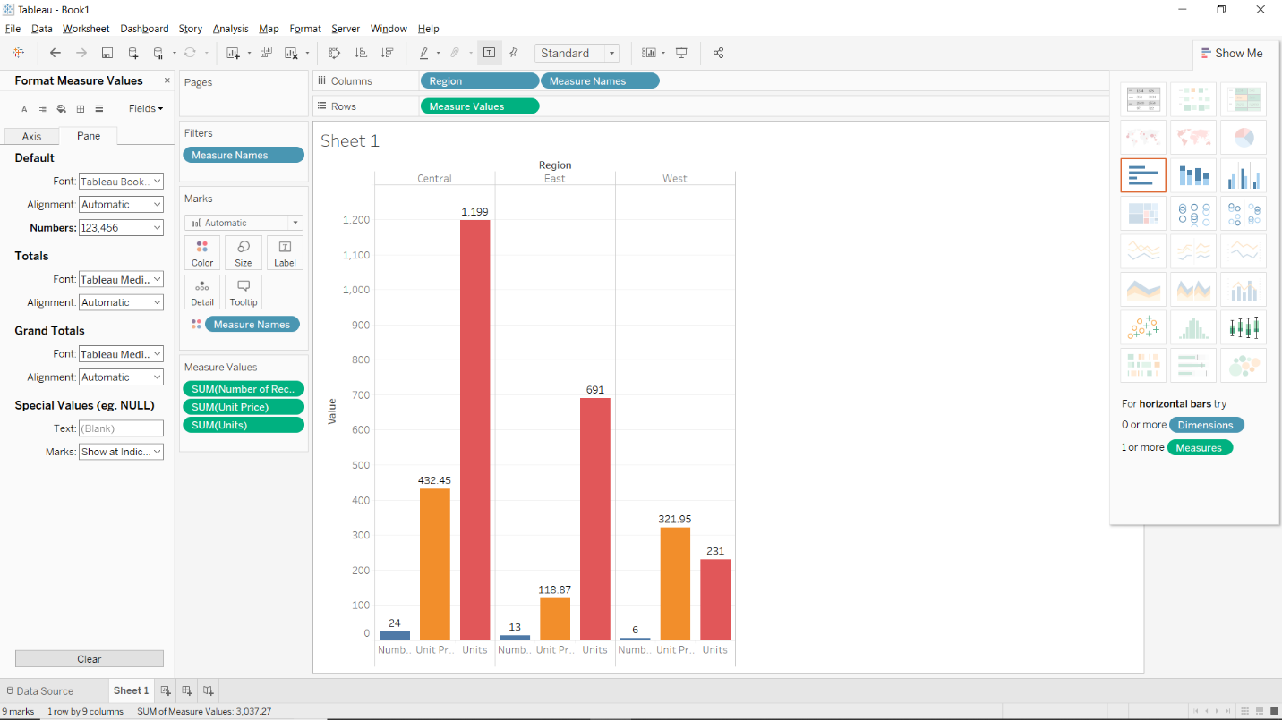

**Title**

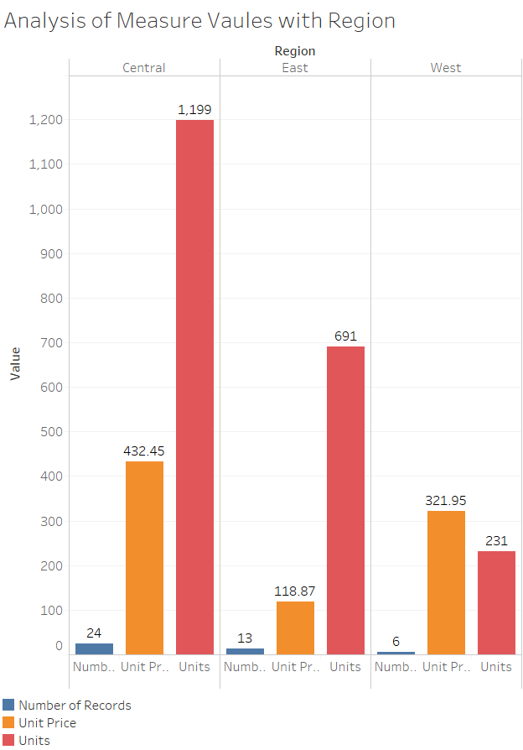

**Gender filter**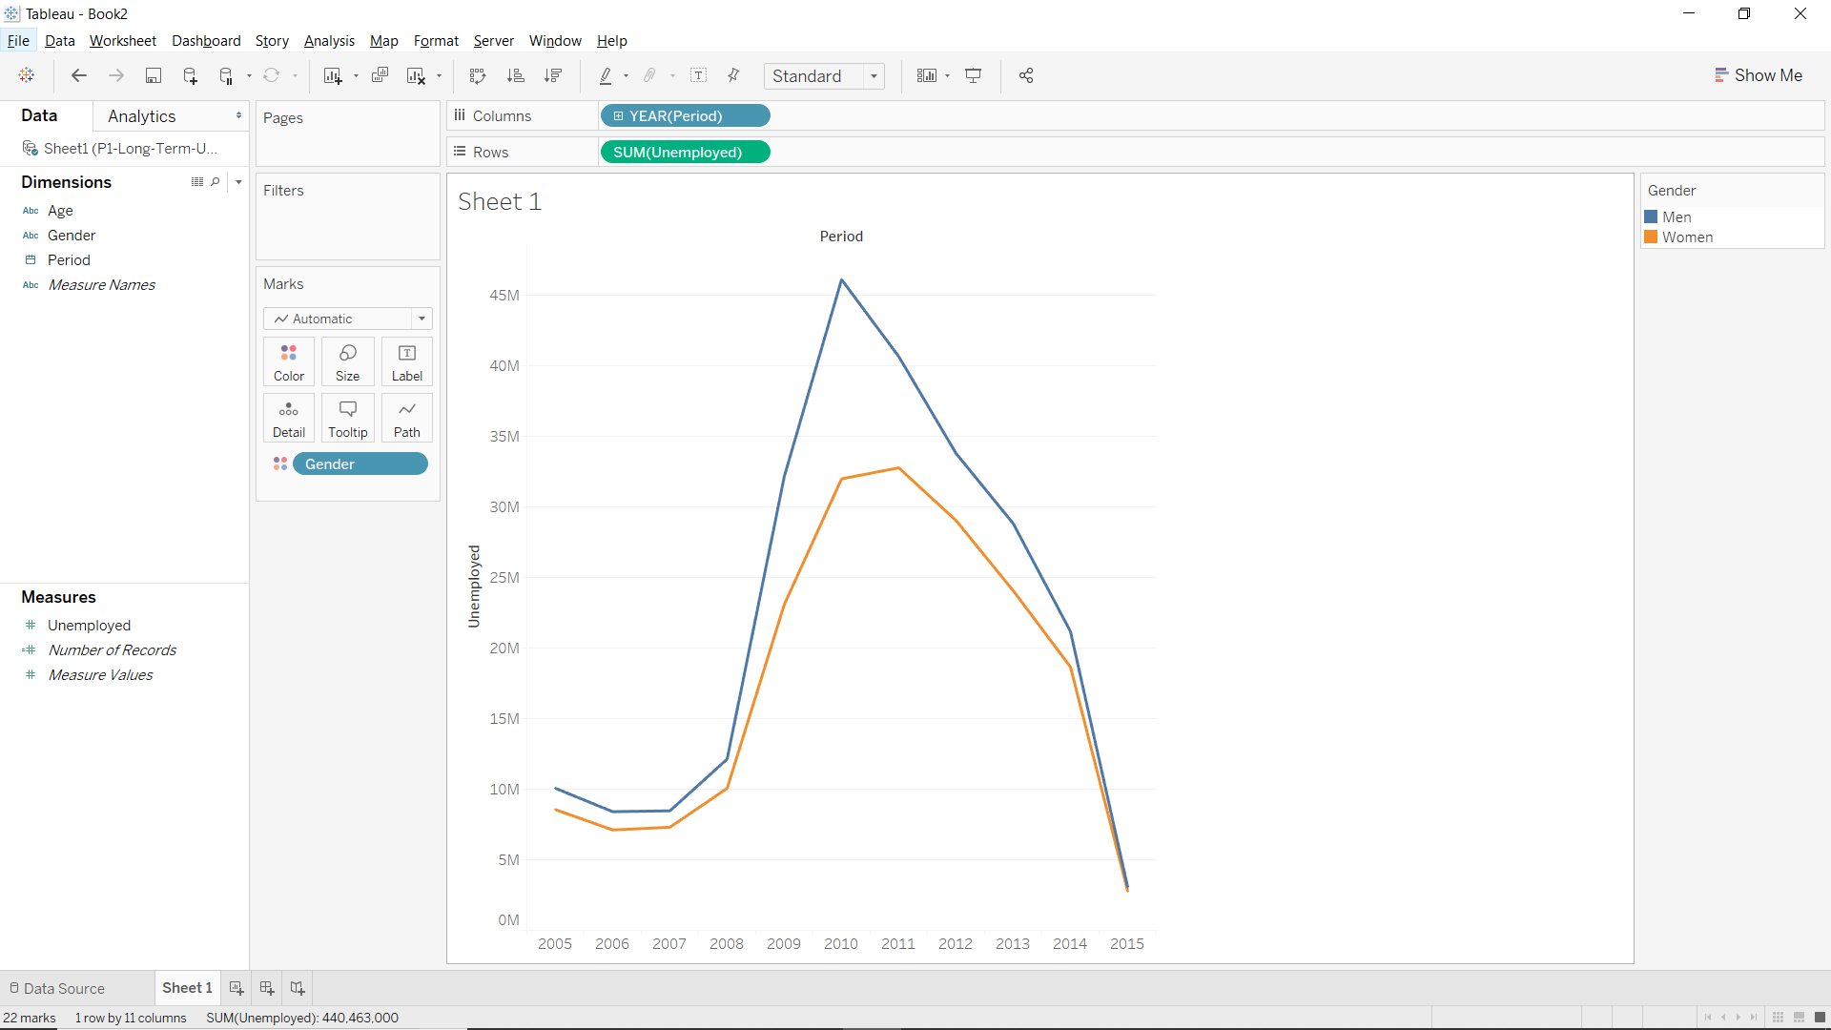

**Age Filter**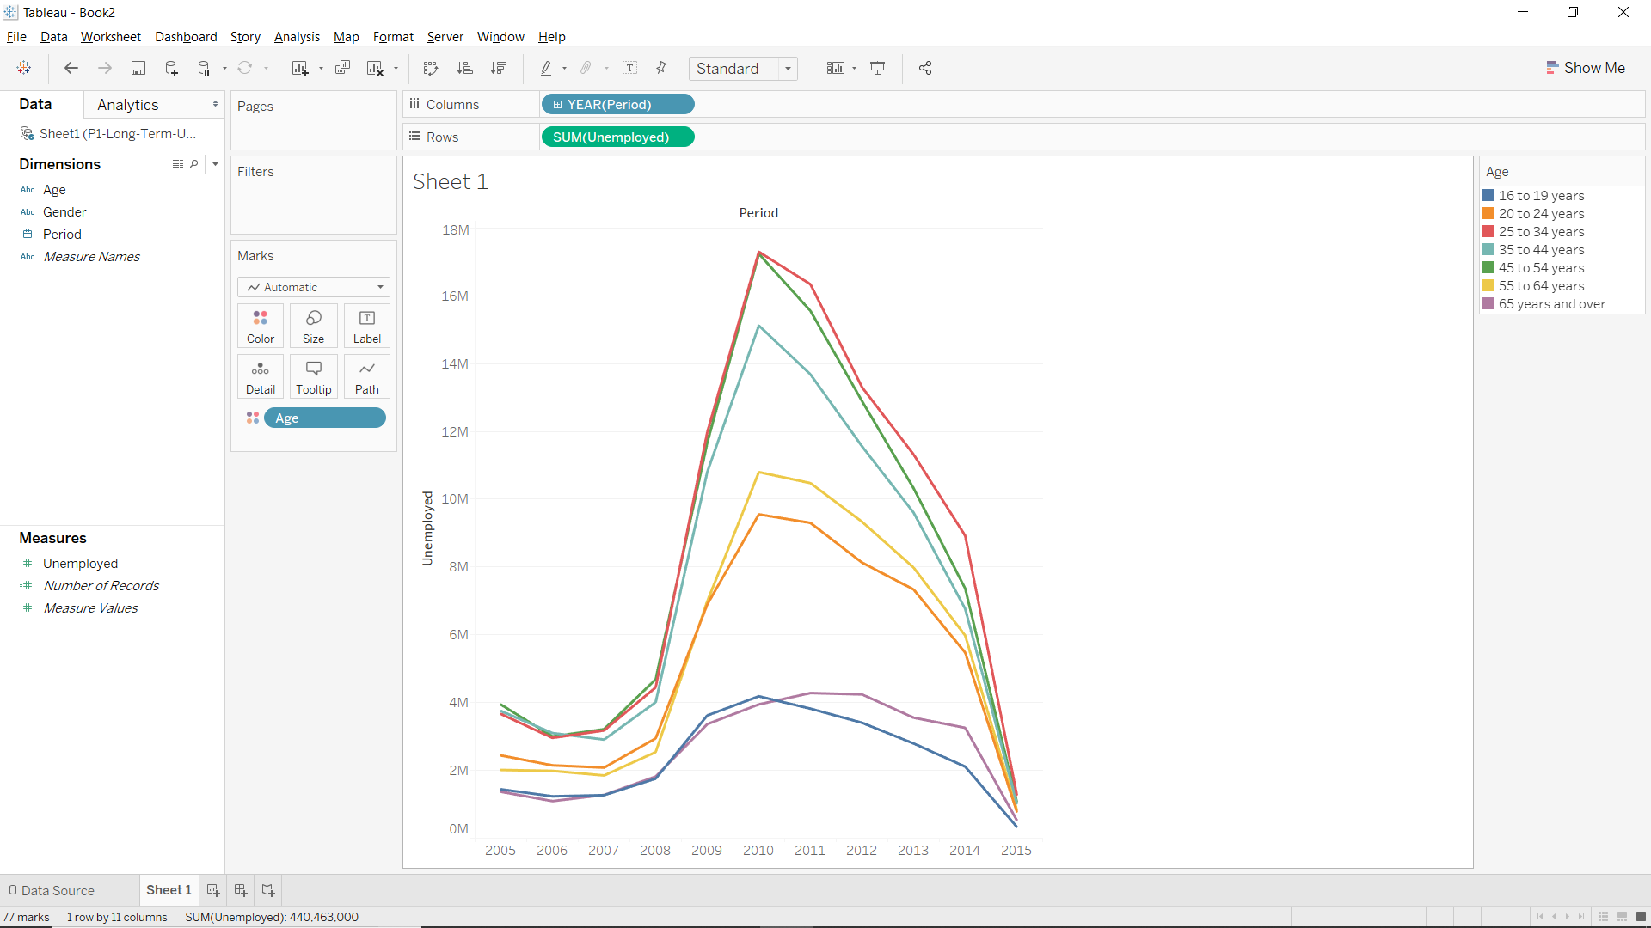

**Label with Age Filter**