15-09-2025

o String - complete
o StringBuilder, and StringBuffer,
o Navigating (Searching) HashSet ,TreeSets & TreeMaps, , HashMap, collection,
o exception
o Equals , hash code function , comparable, comparator interface.
o Concurrent Collections - complete
o Layered Architecture -complete
▪ Business Delegate Pattern - complete
▪ Data Access Object Pattern- complete
▪ Transfer Object Pattern- complete
▪ Iterator Pattern- complete

What is string? Why it is immutable?
A String in Java is a sequence of characters, represented as an object of the String class. in the java.lang package.
String are widely used in Java programming for storing and manipulating text.
Immutability means that once a String object is created, its value cannot be changed. When you modify a string, a new String object is created instead of modifying the existing one.
And old one is ready for garbage collection.
Strring s1 = “xyz”
If it is mutable we can change the object.
As string is immutable a new object will be created old 1 ready for garbage collection.
String s1=”abc”

Reasons for Immutability
- Security
Strings are often used for sensitive data such as passwords, file paths, and URLs. Making them immutable prevents unintended modifications.
- String Pooling
Java uses a string pool for memory optimization. When strings are immutable, the same string literal can be reused by multiple references, reducing memory usage.
String str1 = "Hello";
String str2 = "Hello"; // Both references point to the same object in the pool.
What is java String pool
The area where immutable object being created that is string constant pool.

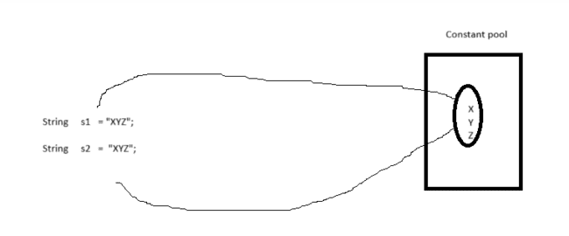

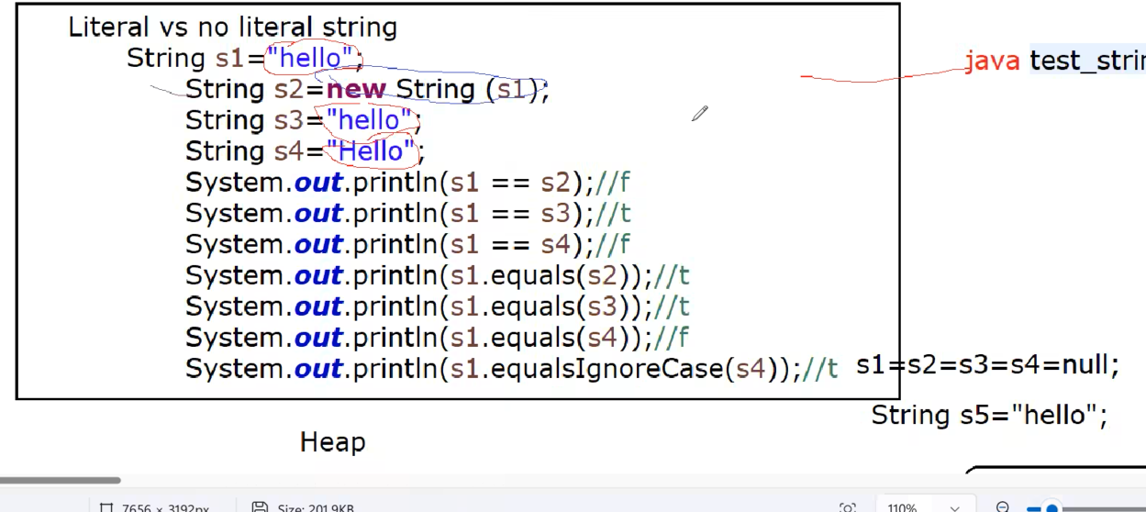

== & .equals()
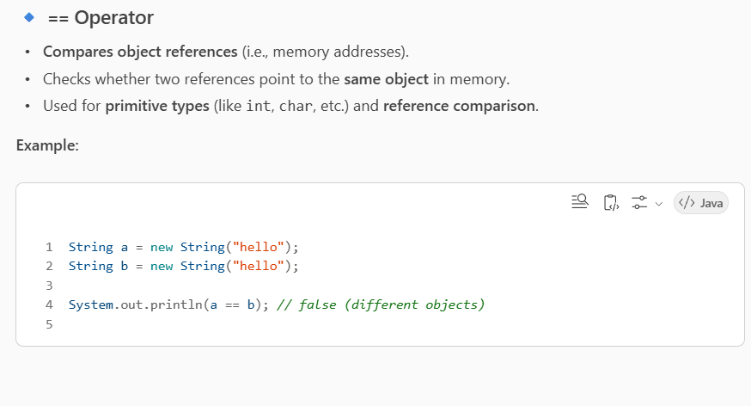

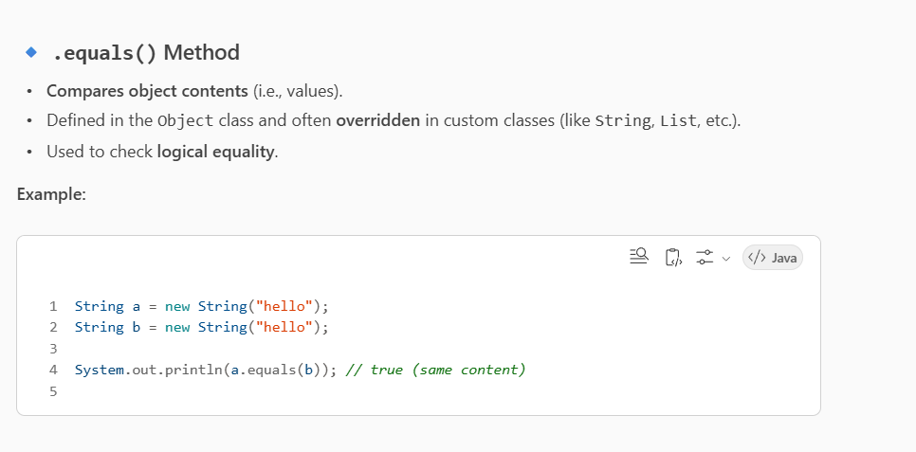

What is String intern( ) method used for?
Uses of intern()
When to Use intern()
when dealing with a large number of duplicate string values.
To ensure faster comparisons using == instead of .equals() for strings that are logically the same.

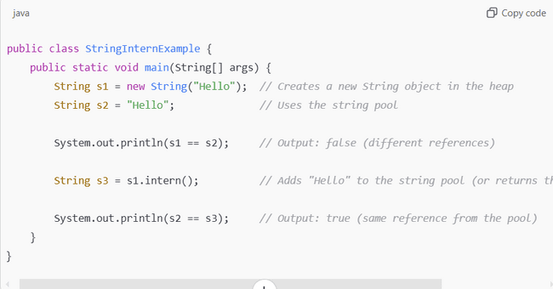
String Pool and intern()
String Pool: A special area in the heap where string literals are stored.
When a string literal is created (e.g., "Hello"), it is automatically interned.
Using new String("Hello") creates a new object outside the pool. Calling intern() on it ensures that a reference from the string pool is returned
What is exception and how to handle exception in java ? Exception hierarchy
Exception
When a bad user input given the program execution will stop abruptly then it is called exception
package p1;
public class A{
public static void main (String [] args){
int z =6;
int y=0;
int r = z/y; //Arithmetic exception
System.out.println (“Welcome”);
}
}

Handling the exception

try block will create exceptions object & that objects address will go to catch block.
catch block will suppress (forcefully stopped) that execution & hence further code will continue to run.

eg
package p1;
public class A{
public static void main (String [] args){
try{
int z =6;
int y=0;
int r = z/y;
}
catch (Exception e) {
System.out.println (e);// this is to know exact location of exception
}
System.out.println ("Welcome to Exception");
}
}
Try/catch block helping to further run the code.
Types of Exception
1.Run Time Exception (Unchecked Exception)-These exceptions occur when you run .class file or during runtime of the program.
2.Compile Time Exception (Checked Exception)-These exception occur when you compiling the your program or during compilation of the code.

Exception Class Hierarchy

Throwable: Throwable is the superclass of all errors and exceptions. It has two main subclasses: Error and Exception, which represent different types of issues that can occur during the execution of a program.

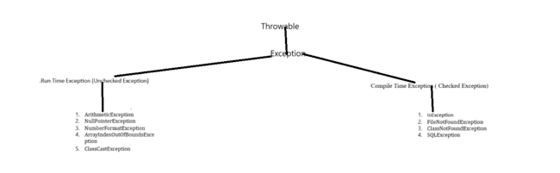

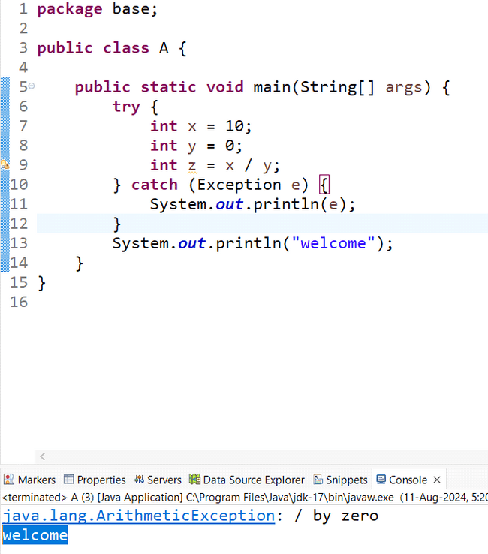

Difference between Exception and error
Exception : Error :
- It is occurred by programmer • It is occurred by lack of System resources
- It is recoverable • It is not recoverable
- runtime & compile time • runtime

RUNTIME EXCEPTION (TYPES)
- Arithmetic Exception:
- This is a runtime exception .
- Arithmetic exception can handle only exception that occur when invalid mathematical operation is preferred.
- Below one is the arithmetic exception.

Ex
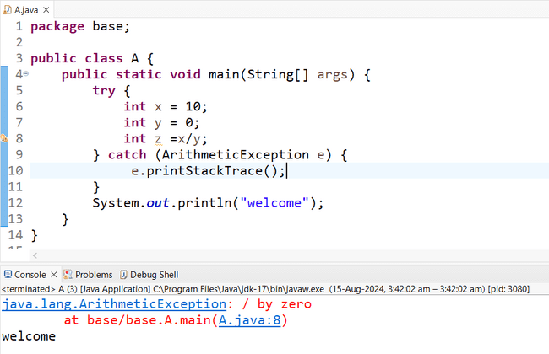

- NullPointer Exception:
This exception occurs with when null reference variable we try to access non static members.
Using Null pointer exception class we can handle the exception.

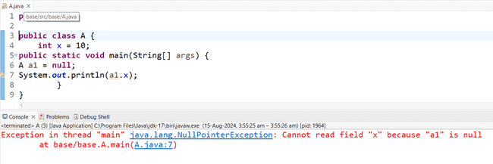
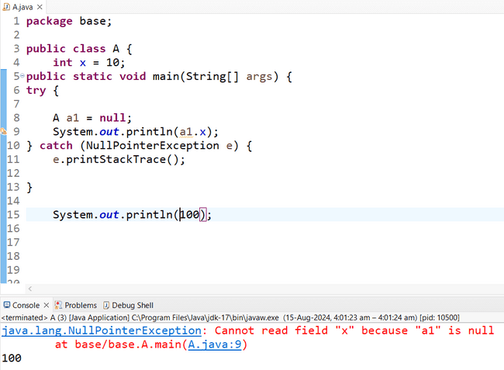
- NumberFormatException(to know it we understand first conversion of data type)

Example of number format exception
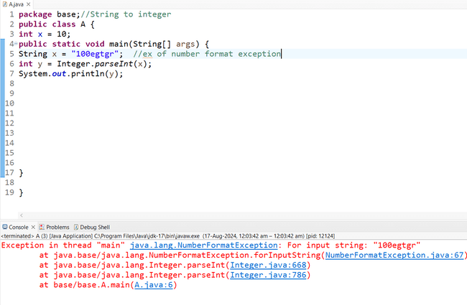
String to integer example:

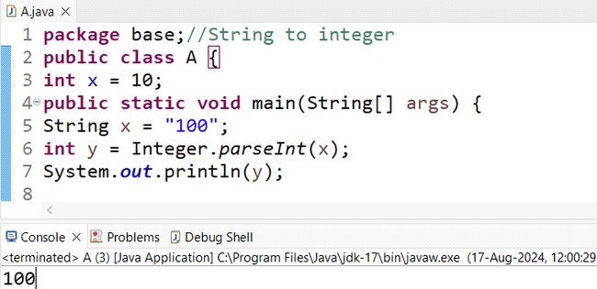

String to Float
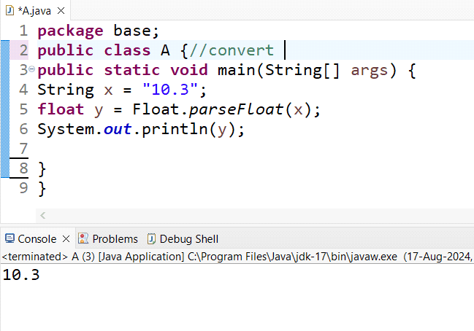
String to Double
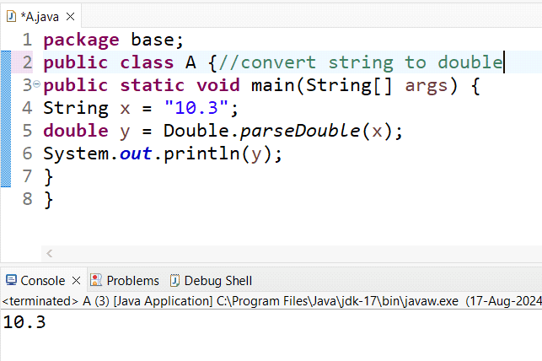
convert string to Boolean
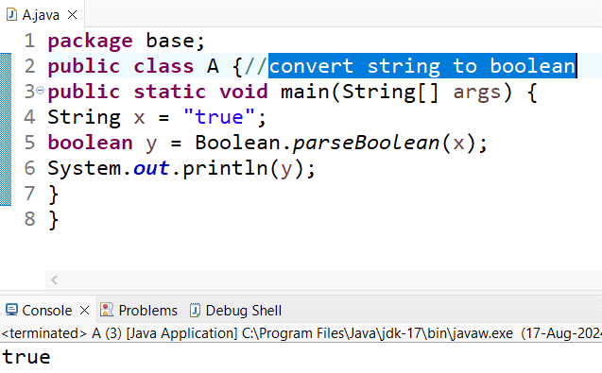

if you give anything than false o/p will come

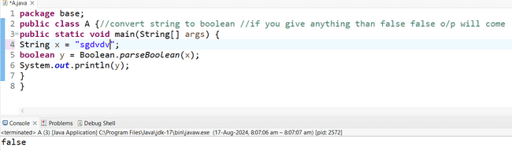

Finally:
- Extension: It is extension of try catch block.
- Restriction: Any code that we write inside finally block it will run 100%.
- Stopping: To stop Finally block forcefully. ➔System.exit(0);
package p; public class A{
public static void main try{
int x= 10/2;
}
catch(Exception e){ e.printStackTrace();
}
}

package p;
public class A{
public static void main (String [] args){ try{
int x= 10/2;
{ finally{ system.out.println(100);
}
system.out.println(100);
}
}
package p; public class A{
public static void main (String [] args){ try{
int x= 10/2;
{ finally{ system.out.println(100);
}
System.exit(0); system.out.println(100);
}
}

package p; public class A{ int x =66;
public static void main (String [] args){ try{
A a1= null; system.out.println(a1.x);
}
catch (ArithmeticException e){ system.out.println(100);
}
}
Difference between Exception and error

Exception : Error :
- It is occurred by programmer • It is occurred by lack of System resources
- It is recoverable • It is not recoverable
- runtime & compile time • runtime

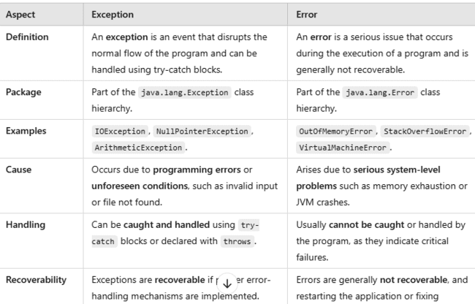

Can we write try finally without catch?
Yes we can write finally without catch.
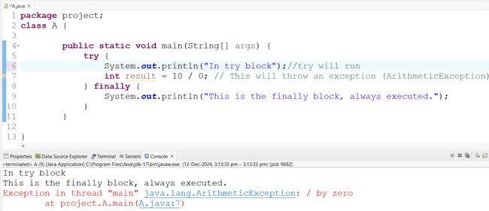

Why to use finally block in try catch? Example? Example
To handle the application and give the error message .
Difference between throw, throws and throwable.

THROWS , THROW & THROWABLE
- Throws Keyword :
- It is applied on a method.
- If any exception occurs in the method then the exception will be passed on to the calling statement of the method.

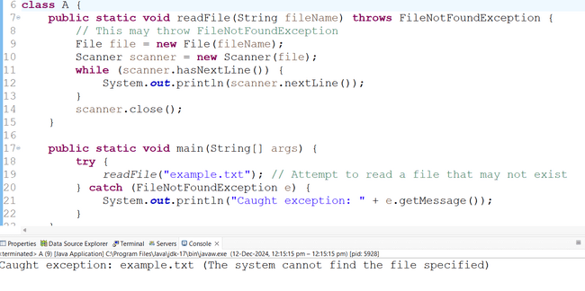

Throw keyword:

It helps us to create the customize exception as per the requirement of the developers.
Using throw keyword we can customized named exception inside try catch block.
Note: Throwable is a built in class and throw is a keyword.

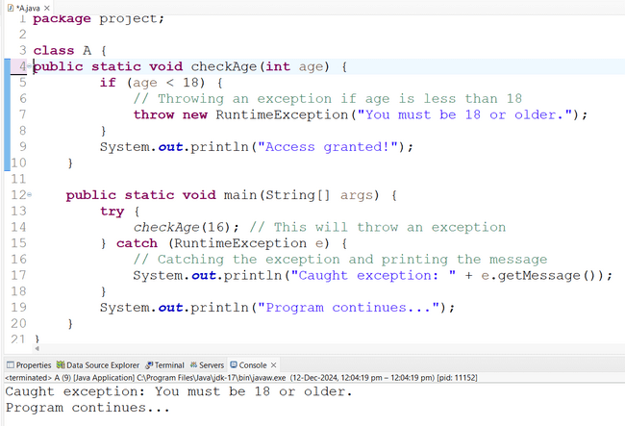

Throwable
In Java, Throwable is the superclass of all errors and exceptions.
It is the root class for all objects that can be thrown by the Java Virtual Machine (JVM). Any object that extends Throwable can be thrown using the throw keyword or caught using a try-catch block.
Throwable is a built in class

Error

- Definition: Errors are serious issues that usually cannot be recovered from. They are typically caused by the environment, such as the Java Virtual Machine (JVM), and often indicate problems that are beyond the control of the program itself.
- Examples:
- OutOfMemoryError
- StackOverflowError
- InternalError
- When to handle: You generally cannot handle or recover from errors. These are usually fatal and require fixing the environment or system resources.

How to create custom exception? Write code.
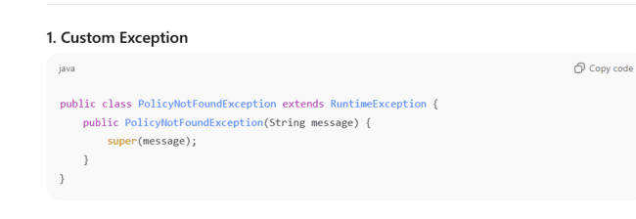
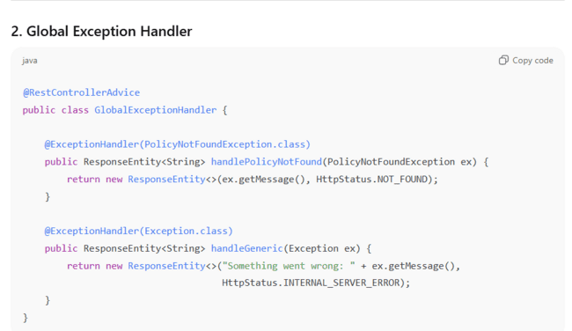
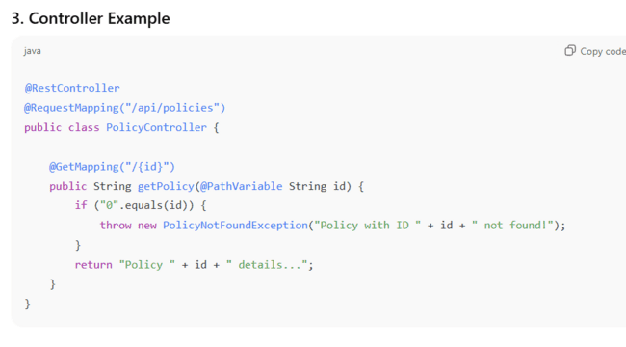

Suppose there is three class and each class is independent with each other if exception occur in last class then how to handle it in first class?
Ans)
In Java, if you have three independent classes and want to handle an exception that occurs in the last class in the first class, you need to propagate the exception from the last class back to the first class. This can be done using exception throwing and catching with throws and try-catch blocks.
Can you write multi catch block?
Example of multi catch block

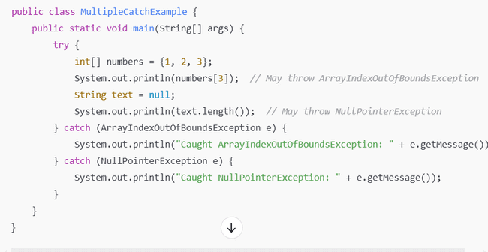

string &String buffer and String builder
Both String Buffer and StringBuilder are classes in Java that are used to manipulate strings. They differ mainly in terms of thread-safety and performance. Below is a detailed comparison.

feature | String | String buffer | String builder
Mutability  -----------------------  Thread safety  ---------------------  Performance  ----------------------Use cases | Immutable  ------------------------------  Thread safe  -----------------------------  Slow-  -----------------------------  Immutable string or frequent modification | Mutable  ----------------------------  Not thread safe  ----------------------------  Fast  ----------------------------  Single threaded applications | Mutable.  -------------------------------  Thread safe.  -------------------------------  Slower than string buffer due .to synchronisation  --------------------------------  Multithreaded applications.
1. StringBuffer
- Thread-Safe:
StringBuffer is synchronized, which makes it thread-safe.
- Performance:
Due to synchronization, it is slower compared to StringBuilder in single-threaded scenarios.
- Usage:
Use StringBuffer when working with multiple threads and you need to modify strings concurrently.

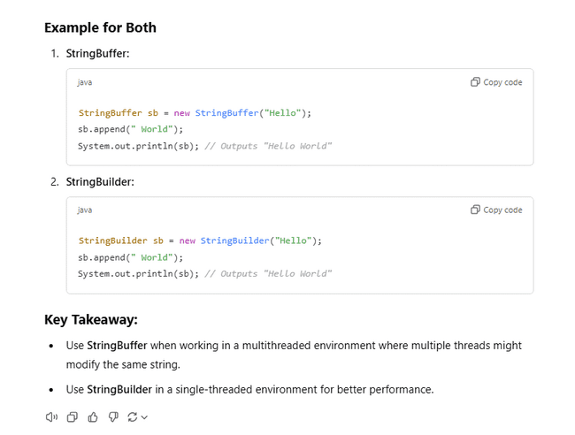

StringBuilder
• Not Thread-Safe:
StringBuilder is not synchronized, so it is not thread-safe..
• Performance:
It is faster than StringBuffer because it does not have the overhead of synchronization.
• Usage:
Use StringBuilder in single-threaded applications where performance is critical
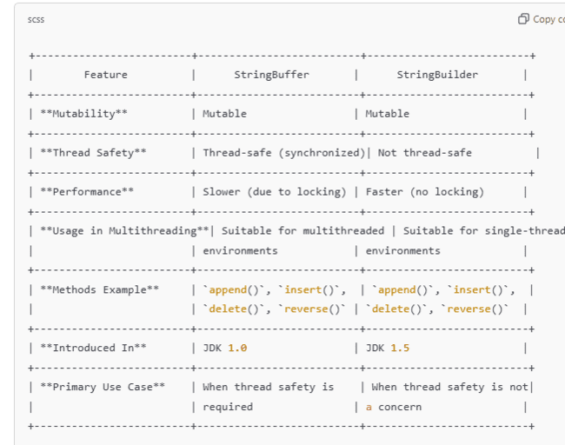

Difference between comparable and comparator
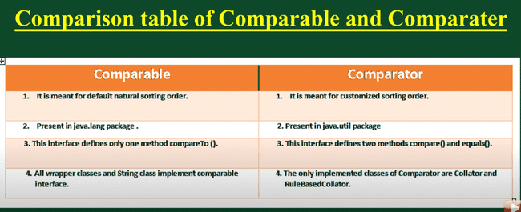s
Array
When we want to store group of values in a single variable.
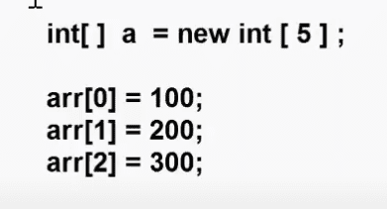
========Limitation=====================
Array Size is fixed.
Common method like insert, update , delete not supported.
Homogeneous value is allowed only. Like if we created int value we can create int value in it.
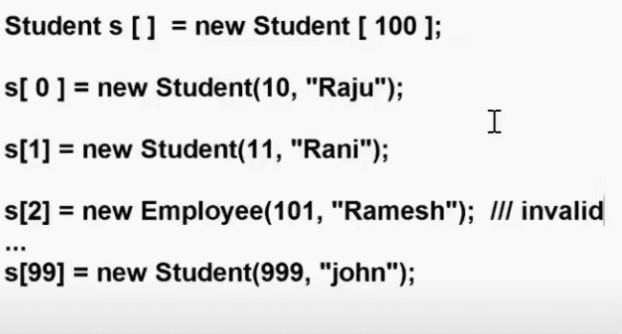
=============================================
Object Array concept
==============================================
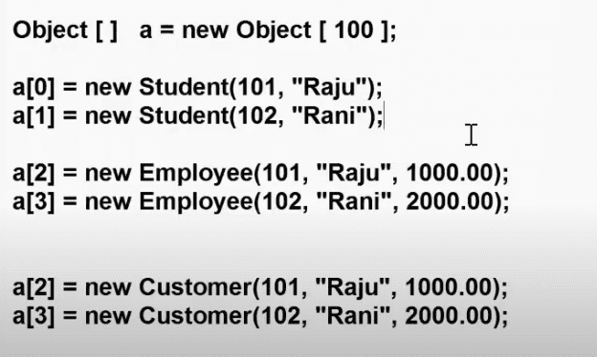

On this approach we can store any data type homogeneous got resolved.
But in above approach still size is fixed.
============================================
Collection
===========================================
->Collections are used to store group of objects.
->Collections are Growable in nature.
->Collection can store homogeneous and Heterogeneous data.
->Collection provide predefined methods like insert,update,delete,retrieve the data.
->Collection is a framework because it is providing predetermined interface, classes, methods on data.
===============================================
Collection Hierarchy
One family
Integrable
collection
List
Set
Queue

One family
Map

Red-interface
Green -class

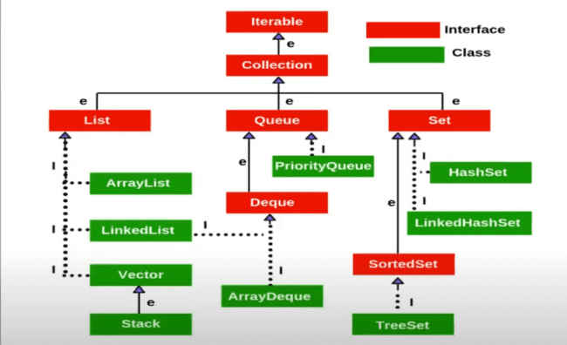

Map
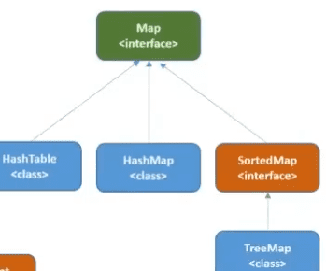

List- is used to store group of object.
i)Duplicates are allowed
ii)child interface of collection interface
iii) it have 4 implementation classes
1)Array List 2)Linked list 3)vector 4)Stack

1)Array List
Minimum size is 10.
It internally uses Array.
We are storing homogenious and heterogeneous data allowed.
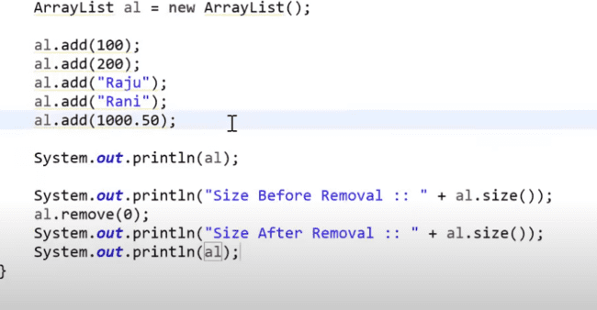

Set- is used to Store group of object.
i)Duplicates are not allowed
1.Hashset
2.Linked Hash set
3.Tree Set

Queue- is used to Store group of object.
i)FIFO order
1.Priority Queue

Map- is used to Store group of object key value pair.
i)Data will store in key – value pair.

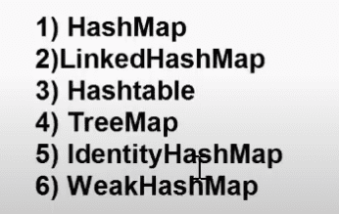

Coursers : used to iterate the data from collections.
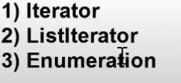

Class 69 (class2)
-> Collections framework related classes & interfaces are part of java.util package

=================
Collection interface
=================

-> It is super interface for List, Set and Queue
-> Collection interface providing several methods to store and retrieve objects
There are several methods available in collections

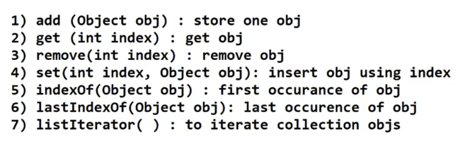

============
List Interface
============

-> Extending properties from Collection interface
-> Allow duplicate objects
-> It will maintain objects insertion order
-> It is having 4 implementation classes

1) ArrayList
2) LinkedList
3) Vector
4) Stack

List l = new List ( ); // invalid

List l = new ArrayList ( ) ; // valid

List l = new LinkedList ( ) ; // valid

========
ArrayList
========
-> Implementation class of List interface
-> Internal data structure of Array List is growable array.
-> Duplicate objects are allowed
-> Insertion order preserved
-> null values are accepted
-> Default Capacity is 10 it will create a new array after reaching max capacity it will copy the data into new array.

=====================
Array List Constructors
=====================

1) ArrayList al = new ArrayList ( ) ; (when size is not fixed)
2) ArrayList al = new ArrayList (int capacity); (when you know the size)
3) ArrayList al = new ArrayList (Collection c); if you want to convert 1 collection to another collection.

========================================================
Methods of Array List
========================================================
1) add (Object obj ) ---> add object at end of the collection
2) add(int index, Object) --> add object at given index
3) addAll (Collection c) ---> to add collection of objects at end of the collection
4) remove(Object obj) ---> To remove given object
5) remove(int index) ----> to remove object based on given index
6) get(int index) --> to get object based on index
7) contains(Object obj) ---> To check presense of the object
8) clear( ) ---> to remove all objects from collection
9) isEmpty ( ) ---> to check collection si empty or not
10) retainAll(Collection c) --> keep only common elements and remove remaining object
11) indexOf(Object obj) --> to get first occurence of given obj
12) lastIndexOf(Object obj) ---> to get last occurance of given object
13) set(int index, Object obj) ---> replace the object based on given index
14) iterator ( ) --> forward direction
15) listIterator ( ) --> forward & back

Class 70
public class Demo {
public static void main(String[] args) {
ArrayList<Integer> al = new ArrayList<>();
al.add(10);
al.add(20);
al.add(30);
al.add(40);

System.out.println("======For Loop Approach=======");

// Approach-1
for (int i = 0; i < al.size(); i++) {
System.out.println(al.get(i));
}
System.out.println("======For-Each loop Approach=======");
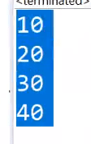

// Approach-2
for (Object obj : al) {
System.out.println(obj);
}
System.out.println("=====Iterator Approach=====");
// Approach-3
Iterator iterator = al.iterator();
while (iterator.hasNext()) {
System.out.println(iterator.next());
}

System.out.println("=====ListIterator Approach=====");

// Approach-4
ListIterator listIterator = al.listIterator();
while (listIterator.hasNext()) {
System.out.println(listIterator.next());
}

System.out.println("=====forEach ( ) Approach=====");

// Approach-5
al.forEach(i -> {
System.out.println(i);
});

}

How to make type safety

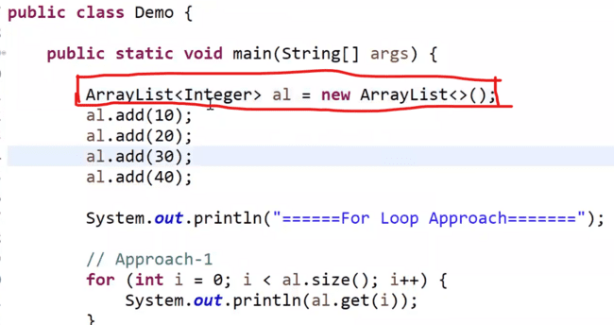

------------------------------
public class Student {

int id;
String name;

public Student(int id, String name) {
this.id = id;
this.name = name;
}

public String toString() {
return id + " - " + name;
}
}

public class Demo {

public static void main(String[] args) {

ArrayList<Student> al = new ArrayList<>();//generics type seafty

al.add(new Student(1, "Raju"));
al.add(new Student(2, "John"));
al.add(new Student(3, "Smith"));
al.add(new Student(4, "Rani"));

ListIterator<Student> li = al.listIterator();

while (li.hasNext()) {
System.out.println(li.next());
}

System.out.println("=====================");

while (li.hasPrevious()) {
System.out.println(li.previous());
}
}
}

uses

1) ArrayList class is not recommended for insertions because it has to perform lot of shiftings
2) ArrayList class is recommended for retrieval operations because it will retrieve based on index directley
5) homegeneuous & hetereogenious data supported

===========
LinkedList
============

-> Implementation of List interface
-> Internal data structure is double linked list
-> insertion order preserved
-> duplicate objects are allowed
-> null objects also allowed
-> homogenious & hetereogenious data we can store
uses

Used for insertion operation.

public class Demo {

public static void main(String[] args) {

LinkedList<Integer> ll = new LinkedList<>();

ll.add(10); // 1 node
ll.add(20); // 1 node
ll.add(30); // 1 node
ll.add(40); // 1 node

System.out.println(ll); // 10, 20, 30, 40
ll.add(1, 15);
System.out.println(ll); // 10, 15, 20, 30, 40

System.out.println(ll.getLast());

}
}

=======
Vector
======

-> Implementation class of List interface
-> Internal data structure is growable array
-> duplicates are allowed
-> insertion order preserved
-> This is synchronized
-> Vector is called as legacy class ( jdk v 1.0)
It is synchronize method

-> To traverse vector we can use Enumeration as a cursor
-> Enumeration is called as Legacy Cursor (jdk 1.0v)

public class Demo {
public static void main(String[] args) {
Vector<Integer> v = new Vector<>();

v.add(100);
v.add(200);
v.add(300);
v.add(null);

Enumeration<Integer> elements = v.elements();
while (elements.hasMoreElements()) {
System.out.println(elements.nextElement());
}
}
}

====
Stack
=====

-> Implementation class of List interface
-> Extending from Vector class
-> Data Structure of Stack is LIFO (last in first out)

push ( ) ---> to insert object
peek ( ) ---> to get last element
pop ( ) ---> to remove last element

1) ArrayList ---------> Growable Array
2) LinkedList ----------> Double Linked List
3) Vector -------------> Growable Array
4) Stack -----------> L I F O

1) Iterator ----> forward direction ( List & Set )
2) ListIterator ---> forward & backward direction ( List impl classes )
3) Enumeration ----> forward direction & supports for legacy collection classes

Part 2
======
Set
======

-> Set is a interface available in java.util package
-> Set interface extending from Collection interface
-> Set is used to store group of objects
-> Duplicate objects are not allowed
-> Supports Homogenious & hetero genious

===============================
Set interface Implementation classes
================================
1) HashSet
2) LinkedHashSet
3) TreeSet
=========
HashSet
=========

-> Implementation class of Set interface
-> Duplicate Objects are not allowed
-> Null is allowed
-> Insertion order will not be maintained
-> Initial Capacity is 16
-> Load Factor 0.75
-> Internal Datastructure is Hashtable

============
Constructors
===========

HashSet hs = new HashSet( );
HashSet hs = new HashSet(int capacity);
HashSet hs = new HashSet(int capacity, float loadFactor);

// Java Program on HashSet

public class Demo {

public static void main(String[] args) {

HashSet<String> hs = new HashSet<>(100, 10.05f);

hs.add("one");
hs.add("two");
hs.add("three");
hs.add("four");
hs.add("one");
hs.add(null);

System.out.println(hs);
hs.remove("three");
System.out.println(hs);

Iterator<String> iterator = hs.iterator();
while (iterator.hasNext()) {
System.out.println(iterator.next());
}
}
}

public class Demo {

public static void main(String[] args) {

HashSet<Student> hs = new HashSet<>();

hs.add(new Student(101, "Raju"));
hs.add(new Student(102, "Rani"));
hs.add(new Student(103, "John"));

Iterator<Student> iterator = hs.iterator();
while (iterator.hasNext()) {
System.out.println(iterator.next());
}
}
}

=================
LinkedHasSet
==================

-> Implementation class for Set interface
-> Duplicates are not allowed
-> Insertion order will be preserved
-> Internal Data Structure is Hash table + Double linked list
-> Initial capacity 16
-> Load Factory 0.75

public class Demo {

public static void main(String[] args) {

LinkedHashSet<Integer> lhs = new LinkedHashSet<>();
lhs.add(10);
lhs.add(20);
lhs.add(30);
lhs.add(null);
lhs.add(40);
lhs.add(20);

System.out.println(lhs);
}
}

Note: HashSet will not maintain insertion order where as LinkedHashSet will maintain insertion order.
HashSet will follow Hastable data structure where as LinkedHashSet will follow Hashtable + Double Linked List data structure.

========
TreeSet
========

-> Implementation class for Set interface
-> It will maintain Natural Sorting Order
-> Duplicates are not allowed
-> null values are not allowed
Note: When we add null value it will try to compare null value with previous object then we will get NullPointerException.
-> It supports only homogeniuous data

Note : TreeSet should perform sorting so always it will compare newly added object with old object. In order to compare the objects should be of same type other wise we will get ClassCastException.
-> Internal data structure is binary tree.

public class Demo {

public static void main(String[] args) {

TreeSet ts = new TreeSet();

ts.add("raja");
ts.add("raja");
ts.add("rani");
ts.add("ashok");

System.out.println(ts); // ashok, raja, rani

Iterator iterator = ts.iterator();
while(iterator.hasNext()) {
System.out.println(iterator.next());
}
}
}

List interface & implementation classes

- duplicates allowed
- insertion order maintained
- homogenious & heterogenious data allowed

Ex: ArrayList, LinkedList, Vector & Stack

Set interface & implementation classes

- Duplicates not allowed
- only LHS will maintain insertion order
- TreeSet supports only homogenious data (For sorting)

Ex: HashSet, LinkedHashSet & TreeSet

Cursors : To traverse collection objects

1) Iterator
2) ListIterator
3) Enumeration

Part 3
=====
Map
=====
-> Map is an interface available in java.util package
-> Map is used to store the data in key-value format
-> One Key-Value pair is called as one Entry
-> One Map object can have multiple entries
-> In Map, keys should be unique and values can be duplicate
-> If we try to store duplicate keys in map then it will replace old key data with new key data.

-------------------------------------------
Ex:-1 ( Map<Integer,String> )
-------------------------------------------
101 - John
102 - Smith
103 - David
104 - Robert
105 - Orlen
101 - Charles
-------------------------------------------
Ex:-2 (Map<String, Integer>
-------------------------------------------
India - 120
USA - 30
UK - 20

Map interface having several implementation classes

1) HashMap
2) LinkedHashMap
3) TreeMap
4) Hashtable
5) IdentityHashMap
6) WeakHashMap

=============
Map methods
=============

1) put (k,v) ---> To store one entry in map object
2) get(k) ---> to get value based on given key
3) remove(k) ---> to remove one entry based on given key
4) containsKey(k) ---> to check presense of given key
5) keySet ( ) ---> To get all keys of map
6) values ( ) ----> To get all values of the map
7) entryset ( ) --> to get all entries of map
8) clear ( ) --> to remove all the entries of map
9) isEmpty ( ) --> To check weather map obj is empty or not
10) size ( ) --> to get size of the map (how many entries avaiable)

public class Demo {

public static void main(String[] args) {

Map<Integer, String> map = new HashMap<>();

map.put(101, "John");
map.put(102, "Smith");
map.put(103, "Orlen");
map.put(102, "David");

System.out.println("Map size :: " + map.size()); // 3

System.out.println(map.get(101)); // john
System.out.println(map.get(300)); // null

Collection<String> values = map.values();
for(String v : values) {
System.out.println(v);
}

Set<Integer> keySet = map.keySet();
for (Integer key : keySet) {
System.out.println(key +"--"+map.get(key));
}

Set<Entry<Integer, String>> entrySet = map.entrySet();
/*Iterator<Entry<Integer, String>> iterator = entrySet.iterator();
while(iterator.hasNext()) {
Entry<Integer, String> entry = iterator.next();
System.out.println(entry.getKey()+"--"+entry.getValue());
}*/

for(Entry<Integer,String> entry : entrySet) {
System.out.println(entry.getKey()+"--"+entry.getValue());
}

System.out.println(map.containsKey(102));
System.out.println(map.containsKey(200));
System.out.println(map.isEmpty());

map.clear();

System.out.println(map.size());
}
}

public class StudentMapDemo {

public static void main(String[] args) {

Student s1 = new Student(101, "John");
Student s2 = new Student(102, "Smith");
Student s3 = new Student(103, "Orlen");

Map<Integer, Student> map = new HashMap<Integer, Student>();
map.put(1, s1);
map.put(2, s2);
map.put(3, s3);
/*
Set<Integer> keySet = map.keySet();
for(Integer key : keySet) {
System.out.println(map.get(key));
}*/

Set<Entry<Integer,Student>> entrySet = map.entrySet();
for(Entry<Integer,Student> entry : entrySet) {
System.out.println(entry.getKey());
System.out.println(entry.getValue());
}
}
}

==========
HashMap
=========

-> It is impl class for Map interface
-> Used to store data in key-value format
-> Default capacity is 16
-> Load factor 0.75
-> Underlying datastructure is hashtable
-> Insertion Order will not be maintained by HashMap

==================
LinkedHashMap
==================

-> Implementation class for Map interface
-> Maintains insertion order
-> Data structure is hashtable + double linkedlist

==========
TreeMap
==========

-> Implementation class for Map interface
-> It maintains natural sorted order for keys
-> Internal Data structure for Tree map is binary tree

=========
Hashtable
=========

-> It is implementation class for Map interface
-> Default capacity is 11
-> Load factor 0.75
-> key-value format to store the data
-> Hashtable is legacy class (jdk 1.0 v)
-> Hashtable is synchronized

-> If thread safety is not required then use HashMap instead of Hastable.
-> If thread safety is important then go for ConcurrentHashMap instead of Hashtable.

Collection vs collections

Collection | Collections
is a interface. | Is a class.
It is represent group of objects as a single entity.  Then we should go for collection. | Collections is a utility class present in java. util package.  it is defining several utility methods for collection object.  Sorting, searching etc.

Concurrent Collections
Concurrent collections in Java are part of the java.util.concurrent package and are designed to handle concurrent access and modification safely in multithreaded environments. They are essential when you're working with multiple threads that need to read/write shared data structures without causing data corruption or race conditions.
Here’s a quick overview of the most commonly used concurrent collections:

1. ConcurrentHashMap
- A thread-safe version of HashMap.
- Allows concurrent read and updates without locking the entire map.
- Uses segment-based locking (in older versions) or bucket-level locking (in Java 8+).
- Ideal for high-concurrency scenarios.
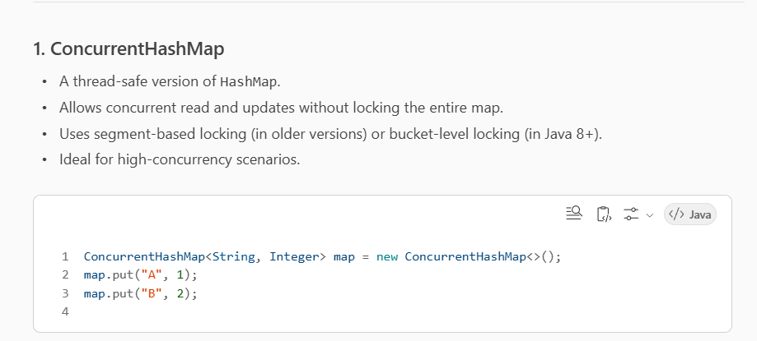
Example:-
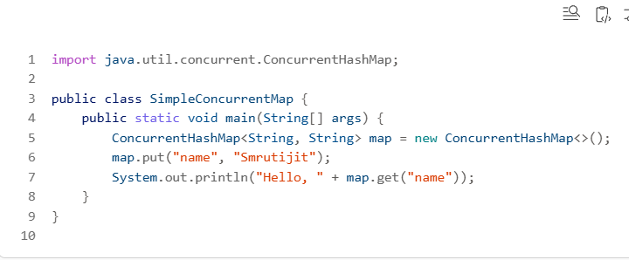

2. CopyOnWriteArrayList
- A thread-safe variant of ArrayList.
- On modification (add/remove), it creates a new copy of the underlying array.
- Best suited for scenarios with frequent reads and infrequent writes.

3. CopyOnWriteArraySet
- Backed by CopyOnWriteArrayList.
- Thread-safe set implementation.
- Good for read-heavy use cases.

4. ConcurrentLinkedQueue
- A non-blocking, thread-safe queue based on linked nodes.
- Suitable for high-throughput applications.

5. ConcurrentLinkedDeque
- A thread-safe double-ended queue.
- Allows insertion and removal from both ends.

6. BlockingQueue and its implementations
These are used when you want threads to wait for the queue to become non-empty or non-full.
- ArrayBlockingQueue – bounded, backed by array.
- LinkedBlockingQueue – optionally bounded, backed by linked nodes.
- PriorityBlockingQueue – unbounded, elements ordered by priority.
- DelayQueue – elements become available after a delay.
- SynchronousQueue – each insert waits for a corresponding remove.

Layered Architecture
This architectural style is widely used in enterprise applications.
🧱 What is Layered Architecture?
Layered Architecture is a design pattern that organizes software into distinct layers, each with a specific responsibility. This separation improves modularity, testability, and maintainability.

🔄 Typical Layers in Layered Architecture
1. Presentation Layer (UI Layer)
- Purpose: Interacts with the user.
- Responsibilities:
  - Display data to the user.
  - Capture user input.
  - Send requests to the business layer.
- Examples:
  - Web controllers (@Controller in Spring MVC).
  - HTML/JS front-end, REST APIs.

2. Business Logic Layer (Service Layer)
- Purpose: Contains the core logic of the application.
- Responsibilities:
  - Process user input.
  - Apply business rules.
  - Coordinate between presentation and data layers.
- Examples:
  - Service classes (@Service in Spring).
  - Business workflows, validations.

3. Data Access Layer (DAO/Repository Layer)
- Purpose: Handles data persistence.
- Responsibilities:
  - CRUD operations.
  - Querying databases.
  - Mapping data to domain models.
- Examples:
  - DAO classes, @Repository in Spring.
  - JPA/Hibernate, JDBC.

4. Database Layer
- Purpose: Stores application data.
- Responsibilities:
  - Physical storage of data.
  - Indexing, constraints, stored procedures.
- Examples:
  - MySQL, PostgreSQL, Oracle, DB2.

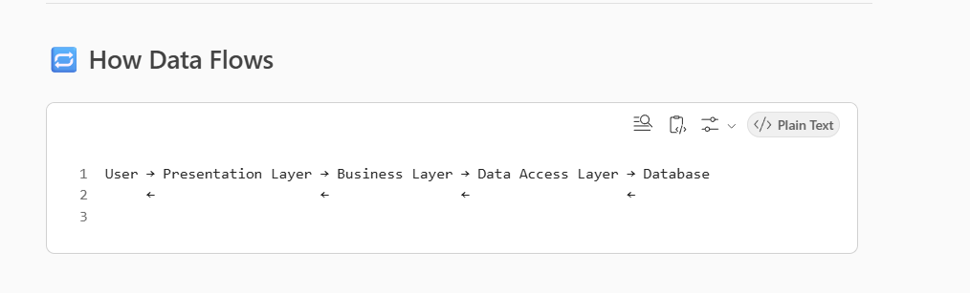

Each layer only communicates with the layer directly above or below it, ensuring clean separation.

✅ Benefits
- Separation of concerns: Each layer has a distinct role.
- Testability: Easier to write unit tests for isolated layers.
- Maintainability: Changes in one layer don’t affect others.
- Scalability: Layers can be scaled independently.

⚠️ Challenges
- Overhead: More layers can mean more complexity.
- Tight coupling (if not designed well): Layers may become dependent on each other’s implementation.
- Performance: More layers can introduce latency.

Business Delegate Pattern
The Business Delegate Pattern is a design pattern used in enterprise applications to decouple the presentation layer from the business logic layer, especially when interacting with remote services like REST APIs, or microservices.

🧩 Purpose
- Encapsulate the complexity of remote communication.
- Reduce coupling between layers.
- Provide a uniform interface to access business services.
- Improve maintainability and testability.

🏗️ Structure
Here’s how the pattern typically works:
1. Client (Presentation Layer)
- Calls the Business Delegate instead of directly accessing the business service.
2. Business Delegate
- Acts as a proxy or façade.
- Handles lookup, exception handling, and communication with the business service.
3. Business Service
- The actual service that performs business logic (could be local or remote).

🔁 Flow Diagram (Textual)

✅ Benefits
- Abstraction: Hides the complexity of service lookup and invocation.
- Loose Coupling: Presentation layer doesn’t need to know service details.
- Centralized Control: Easier to manage changes in service access logic.

// BusinessService Interface
public interface BusinessService {
void doProcessing();
}
// Concrete Business Service
public class EJBService implements BusinessService {
public void doProcessing() {
System.out.println("Processing task in EJB Service");
}
}
// Business Delegate
public class BusinessDelegate {
private BusinessService service;
public BusinessDelegate() {
// Lookup logic can be added here
service = new EJBService();
}
public void doTask() {
service.doProcessing();
}
}
// Client
public class Client {
private BusinessDelegate delegate;
public Client(BusinessDelegate delegate) {
this.delegate = delegate;
}
public void execute() {
delegate.doTask();
}
}

🧠 Use Cases
- Enterprise applications using EJB, Spring Services, or microservices.
- When you want to abstract service lookup and reduce boilerplate in the UI layer.

The Data Access Object (DAO) Pattern
The Data Access Object (DAO) Pattern is a structural pattern that provides an abstract interface to some type of database or other persistence mechanism. It separates the low-level data accessing operations from the high-level business services, promoting loose coupling and clean architecture.

🧩 Purpose
- Encapsulate all access to the data source.
- Hide the implementation details of the persistence layer.
- Provide a clean API for the business layer to interact with data.

🏗️ Structure
1. DAO Interface
Defines the standard operations to be performed on a model object.
2. DAO Implementation
Implements the DAO interface and contains the actual logic to interact with the database.
3. Model/Entity
Represents the data structure (e.g., a table in the database).
4. Client/Service Layer
Uses the DAO to perform operations without knowing the underlying data access logic.

🔁 Flow Diagram (Textual)
Service Layer → DAO Interface → DAO Implementation → Database
📦 Example in Java (Simplified)
Model Class
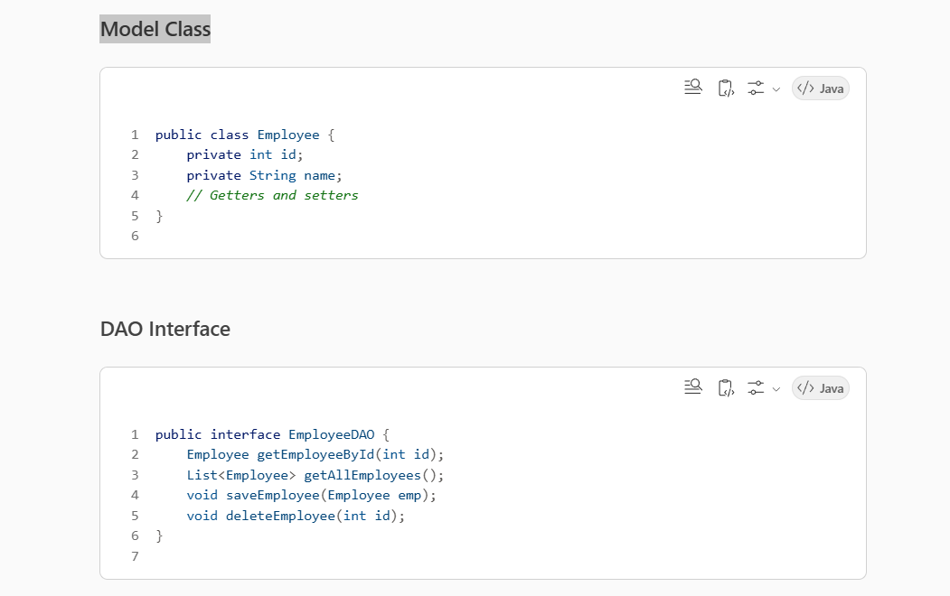

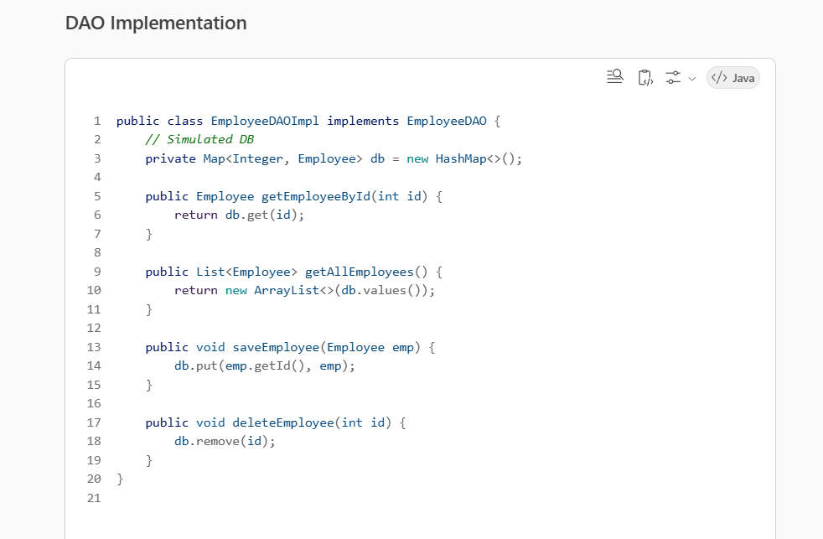

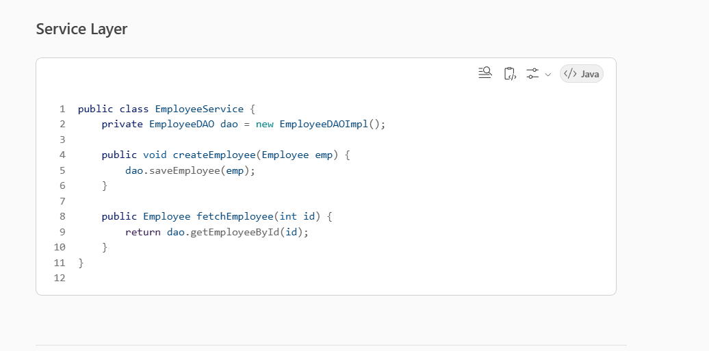

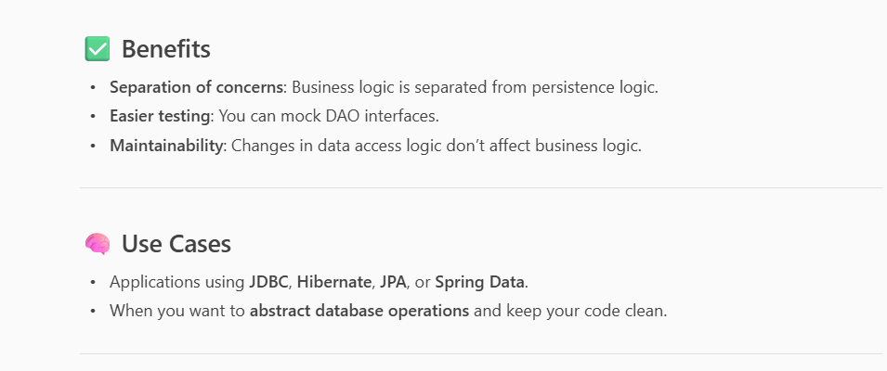
Transfer Object Pattern
The Transfer Object Pattern, also known as the Data Transfer Object (DTO) Pattern, is a design pattern used to transfer data between software application subsystems or layers. It’s especially common in distributed systems and layered architectures like those using Spring Framework, including Spring Batch

🔍 Purpose of the Transfer Object Pattern
- To encapsulate data in a simple object without behavior (no business logic).
- To reduce the number of method calls between layers or across network boundaries.
- To improve performance by bundling multiple pieces of data into one object.

🧱 Structure
A typical DTO:
- Contains private fields for data.
- Provides getters and setters.
- May include constructors for easy instantiation.
- Does not contain business logic.
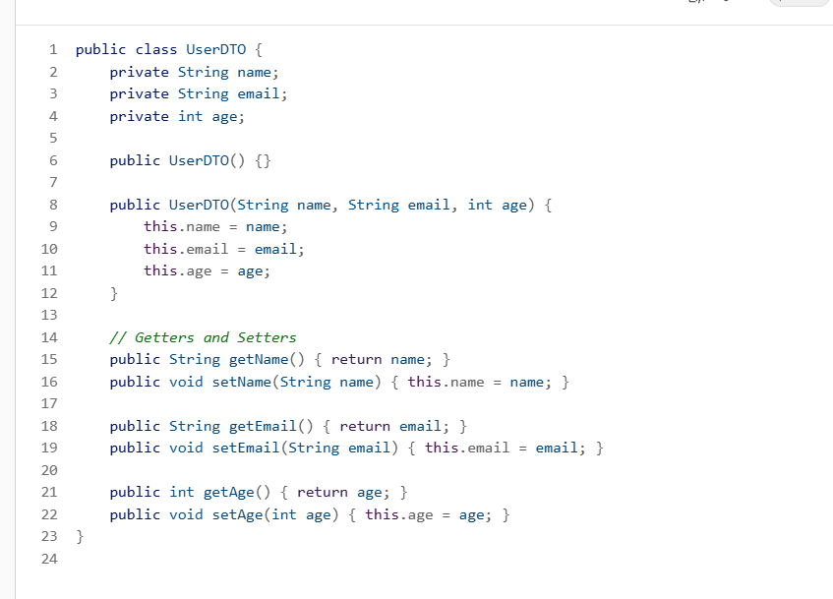

🧩 Where It’s Used
- Spring Boot / Spring Batch: DTOs are often used to transfer data between layers (Controller → Service → Repository).
- REST APIs: DTOs are used to define request and response payloads.
- Microservices: DTOs help in serializing/deserializing data across services.

⚖️ DTO vs Entity
Aspect | DTO | Entity
Purpose | Data transfer | Represents DB table
Contains Logic | No | May contain business logic
Used In | API, service layers | Persistence layer

Iterator Pattern
The Iterator Pattern is a behavioral design pattern that provides a way to access the elements of a collection (like a list or set) sequentially without exposing its underlying representation. It’s widely used in Java and other object-oriented languages to simplify traversal logic.
🔍 Purpose
- To traverse a collection without exposing its internal structure.
- To provide a uniform interface for iteration.
- To support multiple simultaneous traversals.

🧱 Key Components
- Iterator Interface
Defines methods like hasNext() and next().
- Concrete Iterator
Implements the iterator interface and keeps track of the current position.
- Aggregate Interface
Defines a method to create an iterator.
- Concrete Aggregate
Implements the aggregate interface and returns an instance of the concrete iterator.

✅ Example in Java
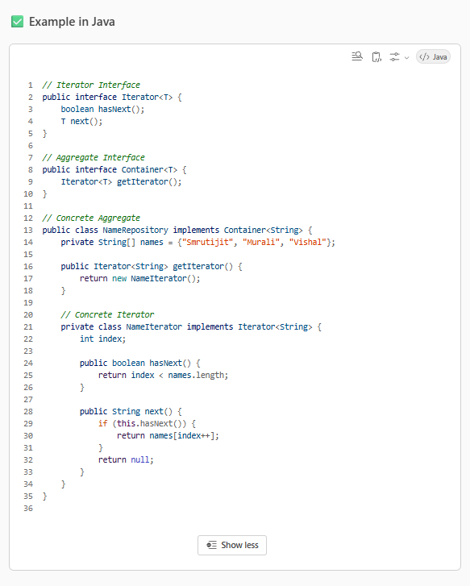

🧩 Usage in Java Collections
Java’s built-in collections like ArrayList, HashSet, etc., implement the Iterable interface, which provides an iterator via the iterator() method.
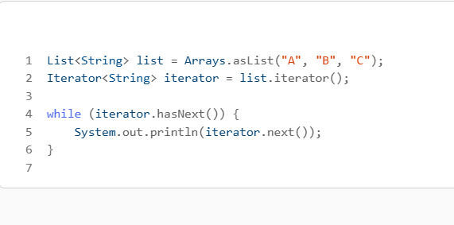

📦 Benefits
- Decouples traversal logic from the collection.
- Supports different traversal strategies.
- Makes code cleaner and more maintainable.

Video plural

https://app.pluralsight.com/ilx/video-courses/a2db5908-8aaf-4860-b7e7-a4c5f141e1dc/f835440c-98f0-4812-af0b-9113e5ec651f/d6247150-066d-4db0-bf4a-e10b87c9c22a

