19-09-2025

Advance Testing Concepts
o Parameterized Test Cases
o Insights from Testing
o Mocking Concepts
o Mockito Overview
o Mockito Demo
o Creating Mock Instances
o Stubbing Method Calls

Parameterized Test Cases
Parameterized test cases are a powerful feature in unit testing frameworks that allow you to run the same test logic with different sets of input data. This helps reduce code duplication and improves test coverage.
Here’s a quick overview depending on the language or framework you're using:

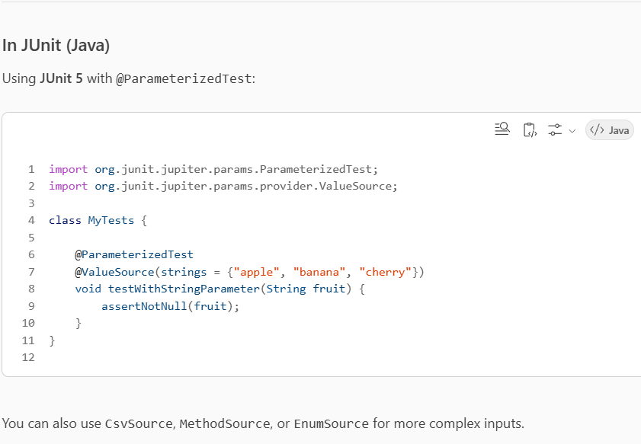

Mocking Concepts

✅ Core Mocking Concepts in Java (with Mockito)
1. Creating a Mock
You simulate a dependency using Mockito.mock():

MyService mockService = Mockito.mock(MyService.class);

2. Stubbing Behavior
Define how the mock should behave when a method is called:
when(mockService.getData()).thenReturn("Mocked Response");

3. Verifying Interactions
Check if a method was called with expected arguments:
verify(mockService).getData();

4. Argument Matchers
Use matchers to verify or stub methods with flexible arguments:
when(mockService.process(anyString())).thenReturn("Processed");
verify(mockService).process(eq("input"));
5. Spying
Use spy() to wrap a real object and override specific behavior:
List list = new ArrayList<>();
List spyList = spy(list);
doReturn("Mocked").when(spyList).get(0);

6. Mocking Exceptions
Simulate exceptions for negative test cases:
when(mockService.getData()).thenThrow(new RuntimeException("Error"));

