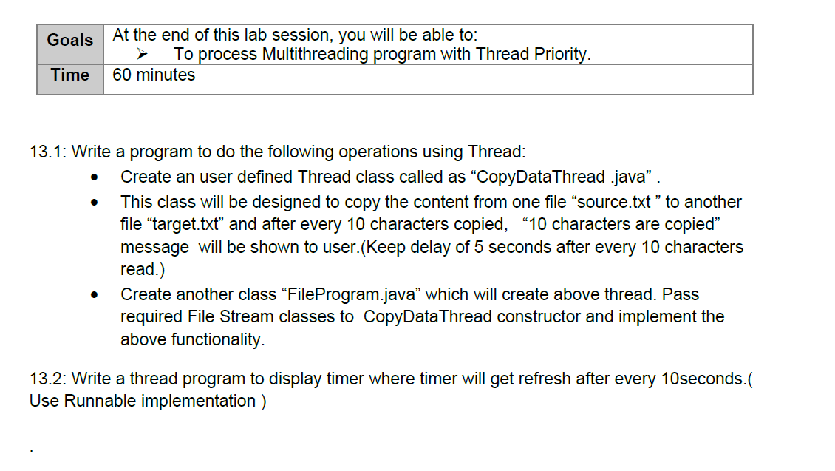
Solution :-
13.1
import java.io.FileReader;
import java.io.FileWriter;
import java.io.IOException;
public class FileProgram {
public static void main(String[] args) {
try {
FileReader fr = new FileReader("C:\\kafka\\source.txt");
FileWriter fw = new FileWriter("C:\\kafka\\target.txt");
CopyDataThread thread = new CopyDataThread(fr, fw);
thread.start();
} catch (IOException e) {
e.printStackTrace();
}
}
}
import java.io.FileReader;
import java.io.FileWriter;
public class CopyDataThread extends Thread {
FileReader fr;
FileWriter fw;
public CopyDataThread(FileReader fr, FileWriter fw) {
this.fr = fr;
this.fw = fw;
}
public void run() {
try {
int i;
int count = 0;
while ((i = fr.read()) != -1) {
fw.write(i);
count++;
if (count == 10) {
System.out.println("10 characters are copied");
Thread.sleep(5000); // 5 seconds delay
count = 0;
}
}
fr.close();
fw.close();
} catch (Exception e) {
e.printStackTrace();
}
}
}
o/p
13.2

public class TimerThread implements Runnable {
public void run() {
int seconds = 0;
try {
while (true) {
System.out.println("Timer: " + seconds + " seconds");
Thread.sleep(10000); // Wait for 10 seconds
seconds += 10;
}
} catch (InterruptedException e) {
System.out.println("Timer interrupted");
}
}
public static void main(String[] args) {
Thread timer = new Thread(new TimerThread());
timer.start();
}
}

Section 2
