22-09-2025 Creational Design Pattern
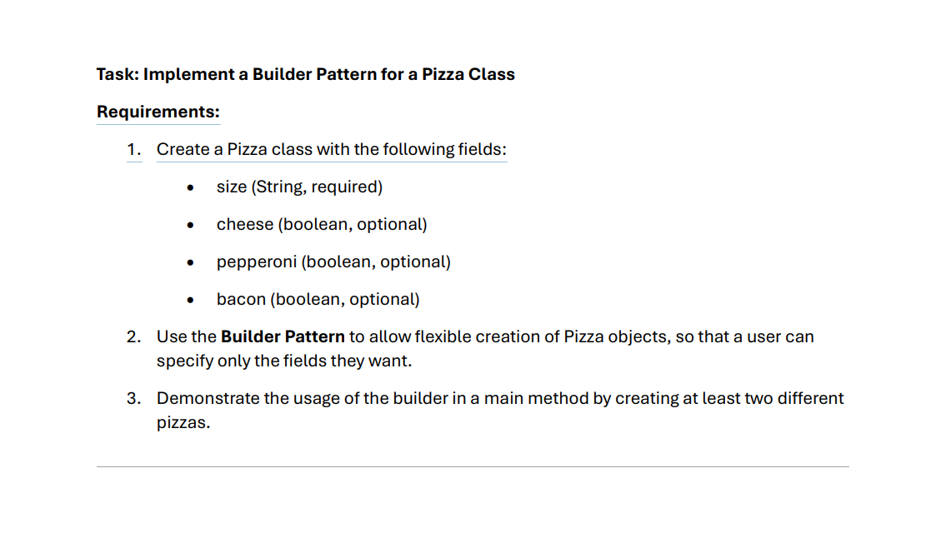

package com.employee.System.entity;

public class EmployeeEntity {

private Long id;

private String name;

private String emailId;

private String role;

public Long getId() {
return id;
}

public void setId(Long id) {
this.id = id;
}

public String getName() {
return name;
}

public void setName(String name) {
this.name = name;
}

public String getEmailId() {
return emailId;
}

public void setEmailId(String emailId) {
this.emailId = emailId;
}

public String getRole() {
return role;
}

public void setRole(String role) {
this.role = role;
}

private EmployeeEntity(Builder builder){
this.id = builder.id;
this.name = builder.name;
this.emailId = builder.emailId;
this.role = builder.role;
}

private EmployeeEntity(){

}

public static class Builder{
private Long id;

private String name;

private String emailId;

private String role;

public Builder id(Long id){
this.id = id;
return this;
}

public Builder name(String name){
this.name=name;
return this;
}

public Builder emailId(String emailId){
this.emailId = emailId;
return this;
}

public Builder role(String role){
this.role = role;
return this;
}

public EmployeeEntity build(){
return new EmployeeEntity(this);
}

}

}

Question bank?
Factory Pattern
Singleton Pattern
Prototype Pattern

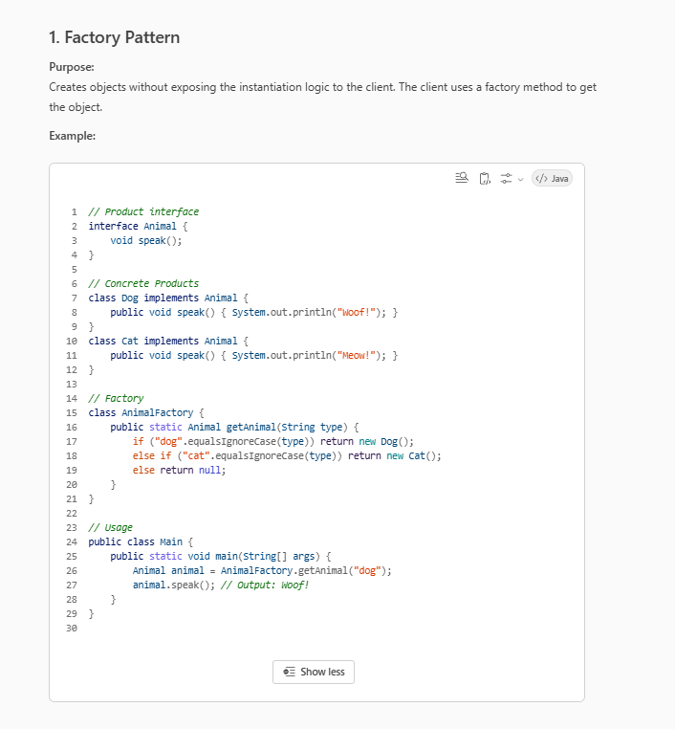
Where It’s Used in Real Projects
- JDBC: DriverManager.getConnection() → returns different database connections.
- Spring Framework: The BeanFactory and ApplicationContext create beans.
- Loggers: LoggerFactory.getLogger() in SLF4J.

Singleton design pattern explanation. How to restrict a class to create only single instance?
The Singleton Design Pattern is a design pattern that ensures a class has only one object and provides a global point of access to that object.
Example:-
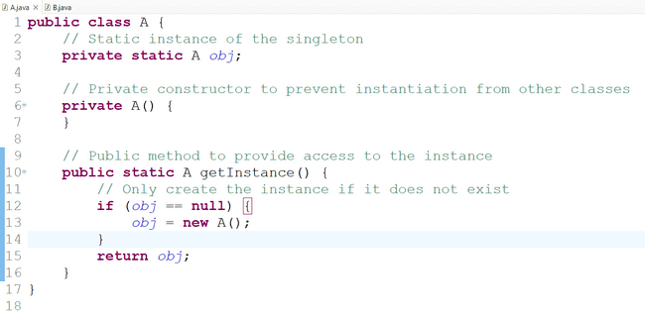
private static A obj;
· private: The instance variable is marked private so it can't be accessed directly from outside the class.
· static: This ensures that the variable instance belongs to the class itself.
· A instance: Holds the single instance of the class. This variable will be initialized only once .

private A() {
}
private A(): This is a private constructor.
- The private modifier means this constructor cannot be called from outside the class..
- By making the constructor private, we ensure that no one can instantiate A directly, enforcing the singleton pattern by restricting object creation to within the class itself.
public static A getInstance() {
· public: Allows external code to access this method and retrieve the instance of A.
· static: Ensures that the method can be called on the class itself (e.g., A.getInstance()) rather than on an instance of the class. This is critical for a singleton, as it provides a global access point to the single instance.
· A getInstance(): Returns the instance of A.

if (instance == null) {
instance = new A();
}
- if (instance == null): Checks if instance has already been created.
- If instance is null, it means no object of A has been created yet, so the code inside the if block will run to create the instance.
- instance = new A();: Creates a new instance of A and assigns it to the instance variable.
- This logic ensures that new A() is called only once. After the first call, instance will no longer be null, so this block will be skipped in subsequent calls to getInstance().

return instance;
}
}
- return instance;: This statement returns the single instance of the class A.
- Once created, every call to getInstance() will return the same object.

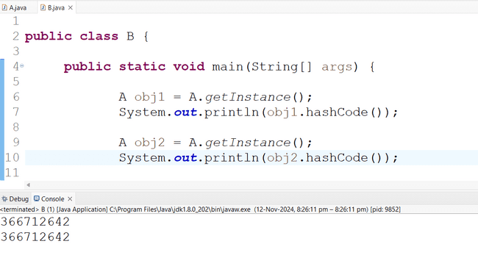

Lazy loading
Lazy loading is a design pattern that delays the initialization of an object until it’s actually needed. In the context of a singleton lazy loading means that the singleton instance isn’t created until the first time getInstance() is called.
In your code, lazy loading is implemented by checking if instance is null:
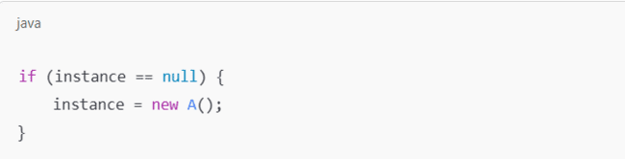

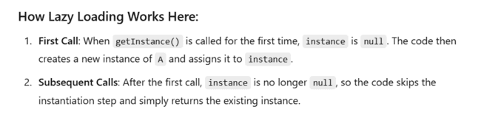

Eager loading
In eager loading, an instance of an object is created as soon as the program starts, rather than waiting until it’s needed.

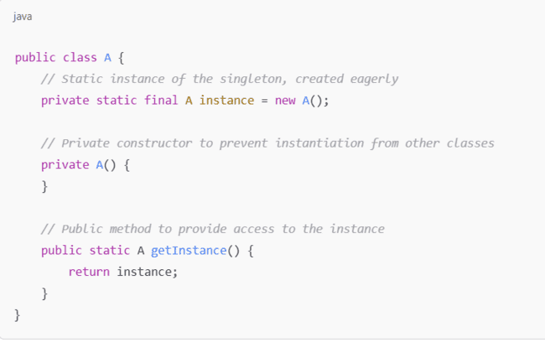

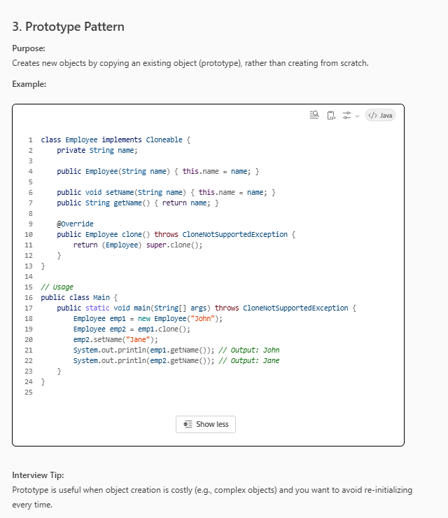

What is the difference between composition and inheritance in the context of design patterns?

