26-09-2025
Introduction / Developing Web applications with Spring MVC
- Model View Controller
- Front Controller Pattern
- DispatcherServlet Configuration
- Controllers, RequestMapping
- Working with Forms
- Getting at the Request, @RequestParam, @RequestHeader
- ModelAndView
- Thymleaf

🌐 Spring MVC Overview
Spring MVC is a part of the Spring Framework used to build robust, scalable, and maintainable web applications. It follows the Model-View-Controller design pattern, which separates the application into three interconnected components:

🧩 MVC Architecture Breakdown
1. Model
- Represents the data and business logic of the application.
- Typically consists of Java classes, JPA entities, and services.
- Interacts with the database using Spring Data JPA, Hibernate, or other ORM tools.
2. View
- Responsible for rendering the UI.
- Usually implemented using JSP, Thymeleaf, or HTML templates.
- Receives data from the controller and displays it to the user.
3. Controller
- Handles HTTP requests and maps them to appropriate methods.
- Uses annotations like @Controller, @RequestMapping, @GetMapping, @PostMapping.
- Interacts with the model and returns a view name.

🔁 Spring MVC Request Flow
- User sends a request (e.g., via browser).
- DispatcherServlet intercepts the request.
- It routes the request to the appropriate Controller.
- The Controller processes the request, interacts with the Model, and returns a View name.
- The View is rendered and sent back to the user.

🛠️ Key Spring MVC Annotations
- @Controller: Marks a class as a Spring MVC controller.
- @RequestMapping: Maps HTTP requests to handler methods.
- @GetMapping, @PostMapping: Specialized annotations for GET and POST requests.
- @ModelAttribute: Binds method parameters or return values to model attributes.
- @ResponseBody: Sends data directly in the response body (used in REST APIs).

🧭 What is the Front Controller Pattern?
The Front Controller Pattern centralizes request handling by routing all incoming HTTP requests through a single controller. This controller then delegates the request to appropriate handlers (controllers, services, etc.).
In Spring MVC, this role is played by the DispatcherServlet.

🔄 How It Works in Spring MVC
- Client sends a request to the server (e.g., /home).
- The DispatcherServlet (front controller) intercepts the request.
- It consults the HandlerMapping to find the right controller.
- The matched controller processes the request and returns a ModelAndView.
- The ViewResolver resolves the view name to an actual view (e.g., JSP, Thymeleaf).
- The view is rendered and returned to the client.

🧱 Benefits of Front Controller Pattern
- Centralized control: All requests go through one entry point.
- Consistent processing: Common tasks like logging, authentication, and error handling can be done in one place.
- Flexible routing: Easy to map URLs to controllers.
- Decoupling: Separates request handling from business logic and view rendering.

🧩 DispatcherServlet in Spring MVC
In web.xml (or via annotations in Spring Boot), the DispatcherServlet is configured like this:

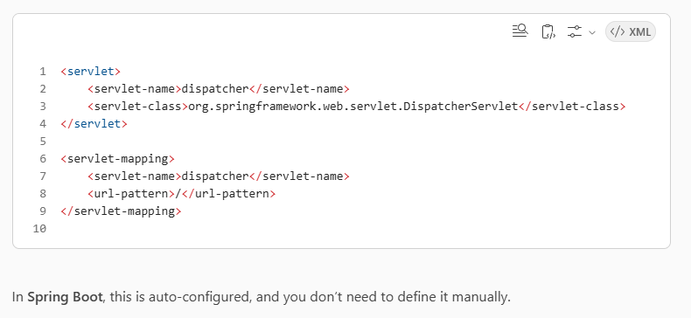

DispatcherServlet Configuration

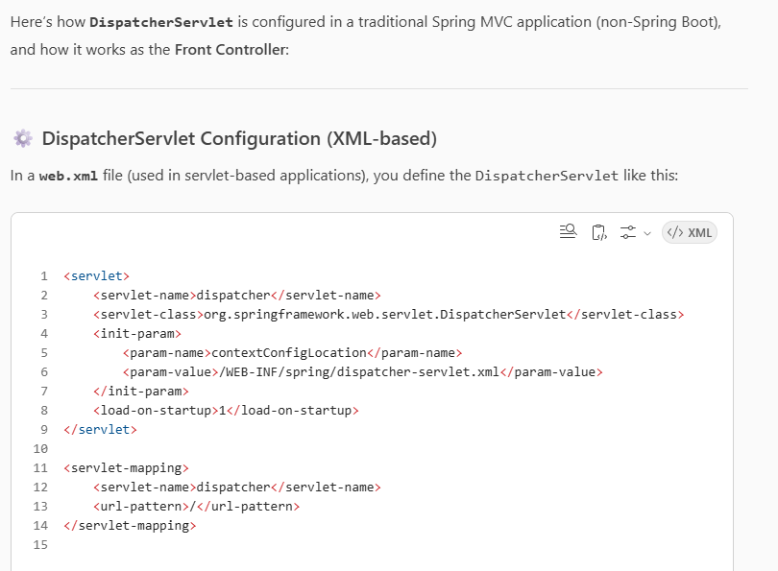

- servlet-name: Logical name of the servlet.
- servlet-class: Fully qualified class name of Spring’s DispatcherServlet.
- contextConfigLocation: Points to the Spring configuration file.
- url-pattern: Maps all requests to the DispatcherServlet (acts as Front Controller).

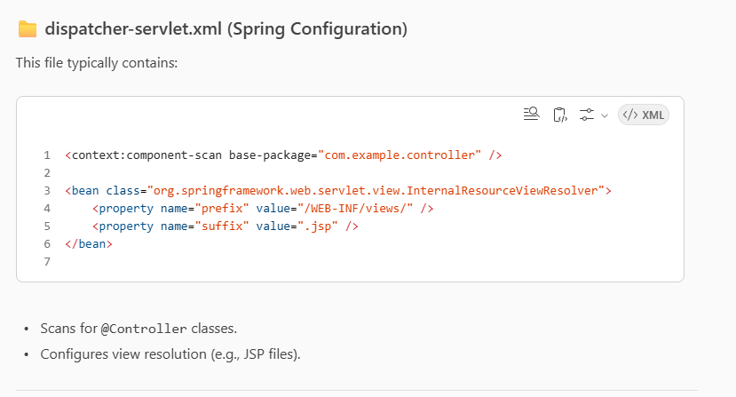

🚀 Spring Boot Configuration
In Spring Boot, the DispatcherServlet is auto-configured. You don’t need to define it manually. You just create controllers like:

@Controller
public class HomeController {
@GetMapping("/home")
public String home(Model model) {
model.addAttribute("message", "Welcome to Spring MVC!");
return "home"; // resolved to /templates/home.html or /WEB-INF/views/home.jsp
}
}

Controllers, RequestMapping
- Working with Forms
- Getting at the Request, @RequestParam, @RequestHeader
- ModelAndView
- Thymleaf

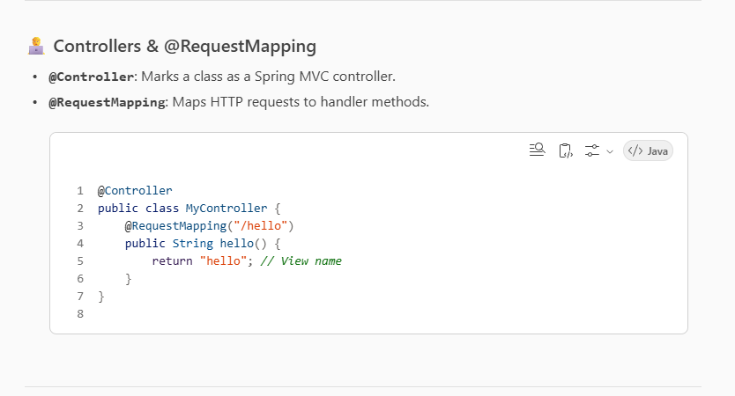

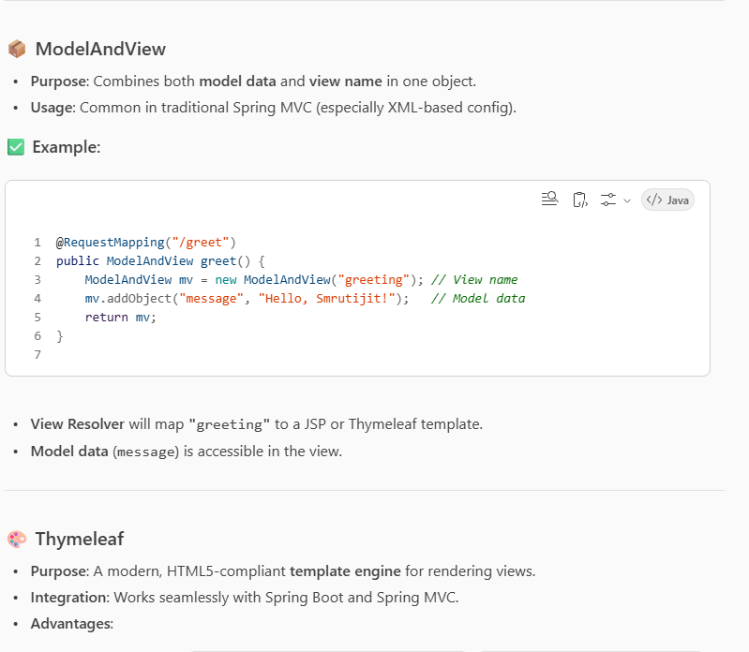
- Natural templating (valid HTML)
- Easy to bind model data
- Supports loops, conditions, fragments, etc.
