YOCTO BUILD SCRIPT DOCUMENTATION

Step 1: Create a folder yocto and copy the script file into that folder and run it.

$ sh build_script.sh
It will gives you the boards menu select any one board name by using the < space bar > .
and < enter >.

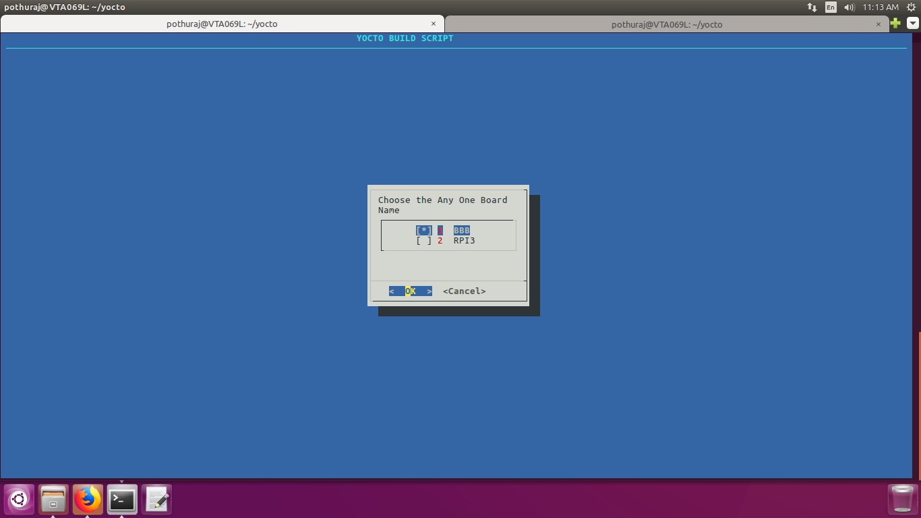
Step 2: Select the any one branch given in menu. I tested the three branches any one you can choose.
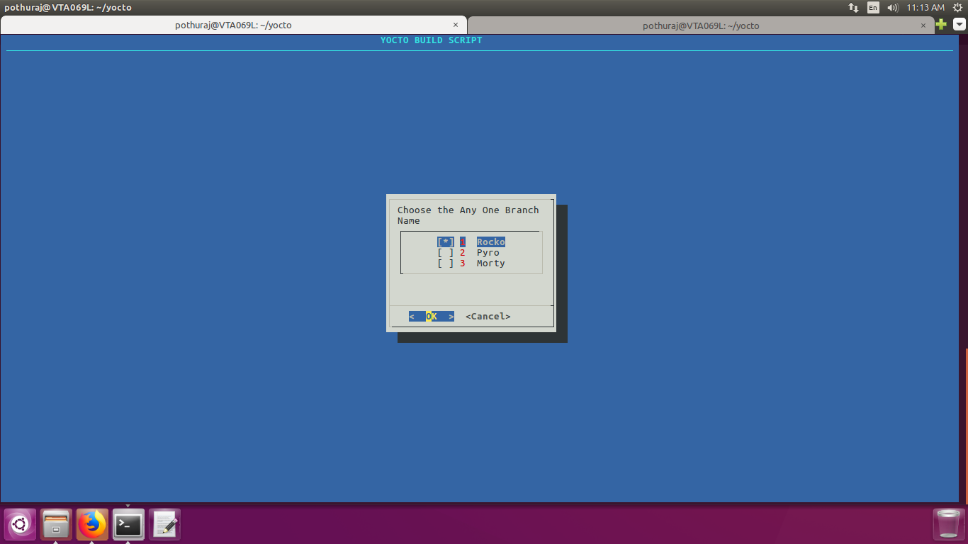

Step 3 : From the setup menu,
For creating the image select Build Image. It will gives the types of images 1.console image 2. qt5 image select any one of those.

Console image: It will gives you the user command propt to test environment.

Qt5 image : It will gives you the graphical interface and some default qt5 apps.

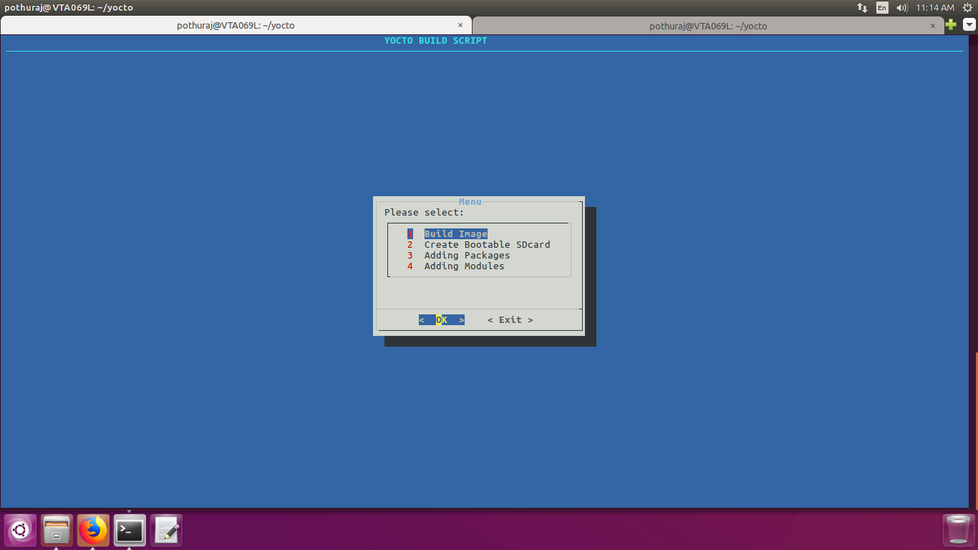
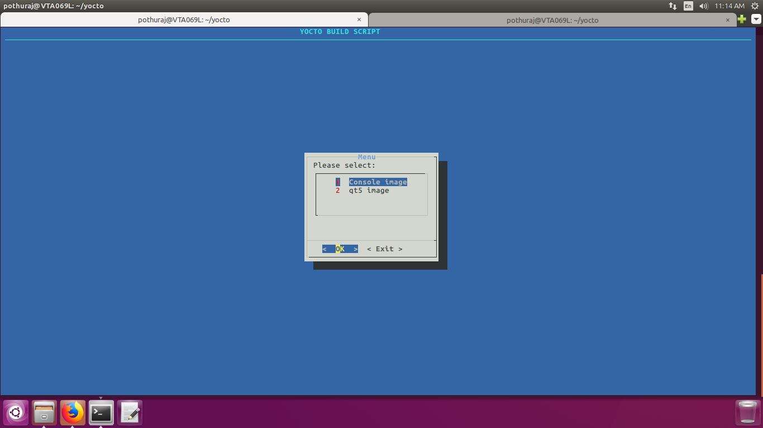
Creating bootable image.
Specify the sdcard name in the given box.You can find by run command lsblk .

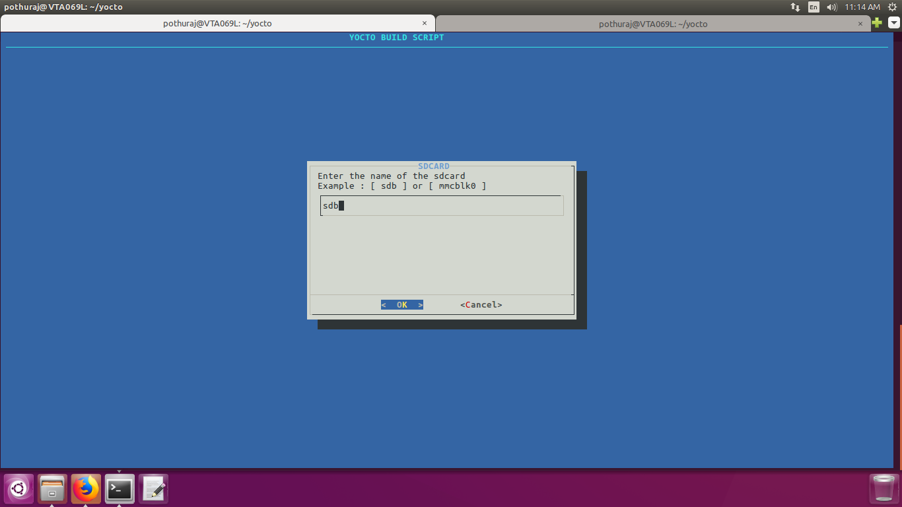
Adding Packages :

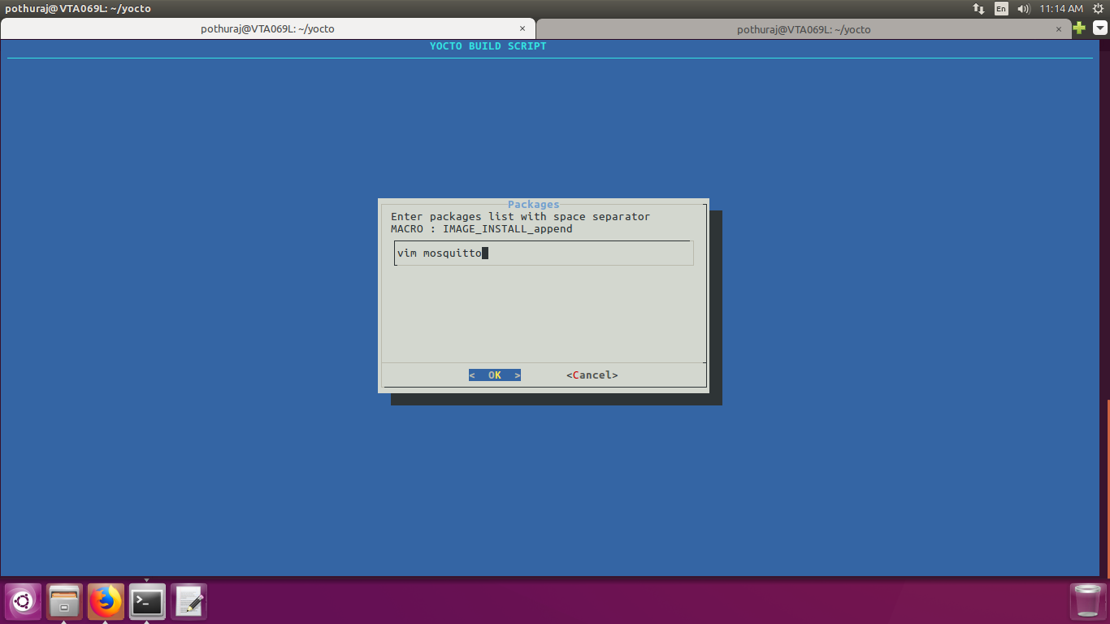
Adding Modules :

