NAME:-SMRUTI RANJAN BEHERA
COURSE;-MCA
REG NO;-2025CAO96
ASSIGNMENT NO 2

1)
a)insertion sort be most suitable

b)#include<stdio.h>
#include <ctype.h>

//most valid algoritm whould be insertion sort
void insertion(int arr[],int size){

for(int i=1;i<size;i++){
int temp=arr[i];
int j=i-1;
while(j>=0 && arr[j]>temp){
arr[j+1]=arr[j];
j--;
}
arr[j+1]=temp;
}
}
int main(){
printf("Enter the size of array\n");
int n;
scanf("%d",&n);
if(n<=0){
printf("INVALID size!\n");
return 0;
}

int arr[n];
printf("Input %d elements\n",n);
for(int i=0;i<n;i++)
{
if(scanf("%d", &arr[i]) != 1) {
printf("INVALID element!\n");
return 0;
}
}
insertion(arr,n);
printf("The sorted array is\n");
for(int i=0;i<n;i++){
printf("%d ",arr[i]);
}
return 0;
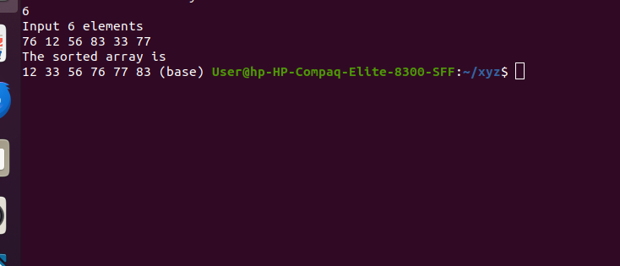
}

3)
best case=O(n)
worst case:-O(n2)
2)
1)merge sort is a valid algorithm for it
2) its implemention is;-
#include<stdio.h>
//most valid algoritm whould be insertion sort
void merge(int arr[], int low,int mid, int high){
int i=low;
int j=mid+1;
int temp[high-low+1];
int k=0;
while(i<=mid && j<=high){
if(arr[i]<arr[j])
temp[k++]=arr[i++];
if(arr[j]<arr[i])
temp[k++]=arr[j++];
else{
temp[k++]=temp[j++];
temp[k++]=temp[i++];
}
}
while(i<=mid)
temp[k++]=temp[i++];

while(j<=high)
temp[k++]=temp[j++];
for(int i=low;i<=high;i++){
arr[i]=temp[i-low];
}

}
void mergesort(int arr[],int low,int high) {
if(low<=high) {
int mid=(low+high)/2;
mergesort(arr,low,mid);
mergesort(arr,mid+1,high);
merge(arr,low,mid,high);
}

}

int main() {
printf("Enter the size of array\n");
int n;
scanf("%d",&n);
int arr[n];
printf("Input %d elements\n",n);
for(int i=0;i<n;i++)
{
if(scanf("%d", &arr[i]) != 1) {
printf("INVALID element!\n");
return 0;
}
}
mergesort(arr,0,n-1);
printf("The sorted array is\n");
for(int i=0; i<n; i++) {
printf("%d ",arr[i]);
}
return 0;
}
3) The appproach is scalable beacause we can bring only a segment of data in the main memeory and perform operations on it.

3)
#include <stdio.h>

void swap(int *a, int *b) {
int temp = *a;
*a = *b;
*b = temp;
}

int partition(int arr[], int low, int high) {
int pivot = arr[high];
int i = low - 1;

for (int j = low; j < high; j++) {
if (arr[j] <= pivot) {
i++;
swap(&arr[i], &arr[j]);
}
}
swap(&arr[i + 1], &arr[high]);
return i + 1;
}
void quickSort(int arr[], int low, int high) {
if (low < high) {
int pi = partition(arr, low, high);

quickSort(arr, low, pi - 1);
quickSort(arr, pi + 1, high);
}
}

int main() {
int arr[] = {45, 23, 89, 12, 67, 34, 90};
int n = sizeof(arr) / sizeof(arr[0]);

quickSort(arr, 0, n - 1);

printf("Sorted array:\n");
for (int i = 0; i < n; i++)
printf("%d ", arr[i]);

return 0;
}



