Class Assignment
Question 1:
A small delivery company keeps track of packages waiting to be shipped.
Each package record contains:
● Package ID
● Destination city
Packages are stored in the order they arrive.
The system must support the following operations:
1. Add a new package at the end of the collection
2. Remove a package using its Package ID
3. Display all remaining packages in the order they were received
Once a package is removed, the surrounding packages must reconnect correctly so that the
order remains intact.
Task
Write a C program that:
● Dynamically stores package records
● Allows deletion of any package using its ID
● Displays the updated collection after each operation
Note: Memory should be allocated and released dynamically.

/*
smruti ranjan behera
2025ca096
19.01.26

A small delivery company keeps track of packages waiting to be shipped.
Each package record contains:
● Package ID
● Destination city
Packages are stored in the order they arrive.
The system must support the following operations:
1. Add a new package at the end of the collection
2. Remove a package using its Package ID
3. Display all remaining packages in the order they were received
Once a package is removed, the surrounding packages must reconnect correctly so that the
order remains intact.
Task
Write a C program that:
● Dynamically stores package records
● Allows deletion of any package using its ID
● Displays the updated collection after each operation

*/

#include<stdio.h>
#include<stdlib.h>
#include <string.h>

struct node{
int p_id;
char city[50];
struct node *next ;
};

//func for adding new package in the linkedlist

struct node* newPackage(int id , char city[]){
struct node *new_pack ;
new_pack = (struct node* )malloc(sizeof(struct node));

new_pack -> p_id = id;
strcpy(new_pack->city, city);
new_pack -> next = NULL;

return new_pack;
}

// removing any package with package-id

void removepackage(struct node **head,int id){
struct node *temp,*prev;

if(*head == NULL){
printf("There is no package to remove\n");
return;
}

if((*head) -> p_id == id){
temp = *head;
*head = (*head)->next;
free(temp);
printf("Package %d is removed Successfully\n",id);
return;
}

prev = *head;
temp = (*head)->next;

while(temp != NULL && temp -> p_id != id){
prev = temp;
temp = temp->next;
}

if(temp != NULL){
prev -> next = temp->next;
free(temp) ;
printf("Package %d is removed Successfully\n",id);
}else {
printf("Package %d is not found\n" , id);
}
}

//for displaying the linkedlist

void display(struct node *head){
struct node *temp = head;

if(temp == NULL){
printf("NO package available.\n");
return ;
}

while(temp != NULL){
printf("Package ID : %d , Destination : %s\n",temp -> p_id,temp-> city);
temp = temp->next;
}
}

int main(){
struct node *head = NULL;
struct node *temp;
int choice , id;
char city[50];

while(1){
printf("1. ADD New Package \n");
printf("2. Remove any Package \n");
printf("3. Display all Package \n");
printf("4. exit\n");
printf("Enter Your Choice: \n");
scanf("%d" , &choice);

switch(choice){
case 1 :
printf("Enter package id: ");
scanf("%d" ,&id);

printf("Enter city:");
scanf("%s" ,city);

temp = newPackage(id,city);

if(head == NULL){
head = temp;
}
else {
struct node *p = head;
while(p->next != NULL){
p = p->next;
}
p->next = temp;
}
display(head);
break;
case 2:
printf("Enter Package ID to remove: ");
scanf("%d", &id);

removepackage(&head, id);
display(head);
break;
case 3:
display(head);
break;
case 4:
printf("Exit the program\n");
return 0;
default:
printf("Enter Valid choice\n");

}
}
}

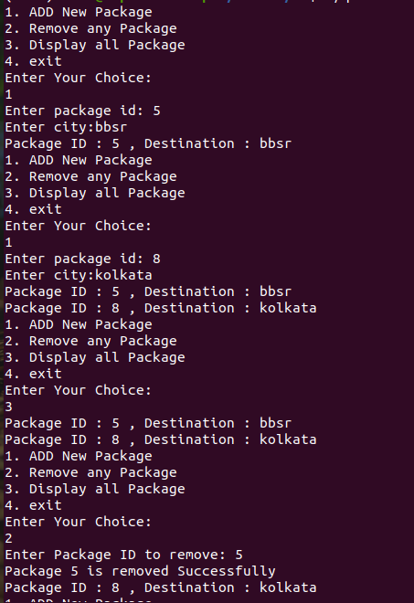

Question 2:
A music player maintains a playlist where each song has:
● Song ID
● Song title
The user can:
1. Move forward to the next song
2. Move backward to the previous song
3. Insert a new song at any position in the playlist
4. Remove a song using its Song ID
Navigation must work correctly in both directions after every insertion or deletion.
Task
Write a C program that:
● Stores songs dynamically
● Supports forward and backward navigation
● Allows insertion and deletion at any position
● Displays the playlist from beginning to end and end to beginning

#include <stdio.h>
#include <stdlib.h>
#include <string.h>

struct node {
int song_id;
char title[50];
struct node *prev;
struct node *next;
};

// create new song
struct node* newSong(int id, char title[]) {
struct node* new_song = (struct node*)malloc(sizeof(struct node));
new_song->song_id = id;
strcpy(new_song->title, title);
new_song->prev = NULL;
new_song->next = NULL;
return new_song;
}

// remove song by id
void removeSong(struct node **head, int id) {
struct node *temp = *head;

if (*head == NULL) {
printf("Playlist is empty\n");
return;
}

while (temp != NULL && temp->song_id != id) {
temp = temp->next;
}

if (temp == NULL) {
printf("Song %d not found\n", id);
return;
}

if (temp->prev != NULL)
temp->prev->next = temp->next;
else
*head = temp->next;

if (temp->next != NULL)
temp->next->prev = temp->prev;

free(temp);
printf("Song %d removed successfully\n", id);
}

// display forward
void displayForward(struct node *head) {
struct node *temp = head;

if (temp == NULL) {
printf("No songs in playlist\n");
return;
}

while (temp != NULL) {
printf("Song ID: %d , Title: %s\n", temp->song_id, temp->title);
temp = temp->next;
}
}

// display backward
void displayBackward(struct node *head) {
struct node *temp = head;

if (temp == NULL) {
printf("No songs in playlist\n");
return;
}

while (temp->next != NULL)
temp = temp->next;

while (temp != NULL) {
printf("Song ID: %d , Title: %s\n", temp->song_id, temp->title);
temp = temp->prev;
}
}

int main() {
struct node *head = NULL, *temp;
int choice, id;
char title[50];

while (1) {
printf("\n1. Add Song\n");
printf("2. Remove Song\n");
printf("3. Display Forward\n");
printf("4. Display Backward\n");
printf("5. Exit\n");
printf("Enter your choice: ");
scanf("%d", &choice);

switch (choice) {
case 1:
printf("Enter Song ID: ");
scanf("%d", &id);
printf("Enter Song Title: ");
scanf("%s", title);

temp = newSong(id, title);

if (head == NULL) {
head = temp;
} else {
struct node *p = head;
while (p->next != NULL)
p = p->next;
p->next = temp;
temp->prev = p;
}
displayForward(head);
break;

case 2:
printf("Enter Song ID to remove: ");
scanf("%d", &id);
removeSong(&head, id);
displayForward(head);
break;

case 3:
displayForward(head);
break;

case 4:
displayBackward(head);
break;

case 5:
return 0;

default:
printf("Enter valid choice\n");
}
}
}

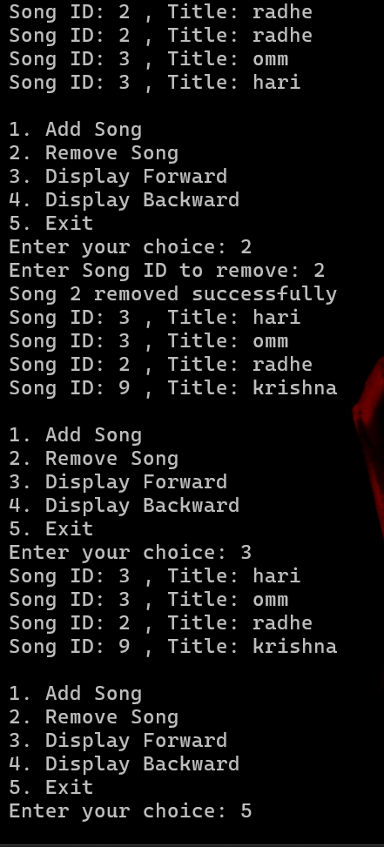
Question 3:
In a multiplayer game lobby, players are arranged in a circle for turn-based gameplay.
Each player has:
● Player ID
● Player name
Rules:

1. Turns move in a fixed direction and never reach a “last” player
2. A player may leave the game at any time
3. New players can join the circle at any position
The turn system must continue smoothly even after players join or leave.
Task
Write a C program that:
● Maintains players in a continuous circular order
● Supports adding and removing players
● Simulates turn rotation for a given number of turns
● Displays all players starting from any chosen player

#include <stdio.h>
#include <stdlib.h>
#include <string.h>

struct node {
int player_id;
char name[50];
struct node *next;
};

// create new player
struct node* newPlayer(int id, char name[]) {
struct node* new_player = (struct node*)malloc(sizeof(struct node));
new_player->player_id = id;
strcpy(new_player->name, name);
new_player->next = NULL;
return new_player;
}

// remove player
void removePlayer(struct node **tail, int id) {
struct node *curr, *prev;

if (*tail == NULL) {
printf("No players in lobby\n");
return;
}

curr = (*tail)->next;
prev = *tail;

do {
if (curr->player_id == id) {
if (curr == *tail && curr->next == *tail) {
free(curr);
*tail = NULL;
printf("Player removed\n");
return;
}

prev->next = curr->next;
if (curr == *tail)
*tail = prev;

free(curr);
printf("Player removed\n");
return;
}
prev = curr;
curr = curr->next;
} while (curr != (*tail)->next);

printf("Player not found\n");
}

// display players
void displayPlayers(struct node *tail) {
if (tail == NULL) {
printf("No players available\n");
return;
}

struct node *temp = tail->next;
do {
printf("Player ID: %d , Name: %s\n", temp->player_id, temp->name);
temp = temp->next;
} while (temp != tail->next);
}

// simulate turns
void simulateTurns(struct node *tail, int turns) {
if (tail == NULL) return;

struct node *temp = tail->next;
for (int i = 1; i <= turns; i++) {
printf("Turn %d: %s\n", i, temp->name);
temp = temp->next;
}
}

int main() {
struct node *tail = NULL, *temp;
int choice, id, turns;
char name[50];

while (1) {
printf("\n1. Add Player\n");
printf("2. Remove Player\n");
printf("3. Display Players\n");
printf("4. Simulate Turns\n");
printf("5. Exit\n");
printf("Enter your choice: ");
scanf("%d", &choice);

switch (choice) {
case 1:
printf("Enter Player ID: ");
scanf("%d", &id);
printf("Enter Player Name: ");
scanf("%s", name);

temp = newPlayer(id, name);

if (tail == NULL) {
tail = temp;
tail->next = tail;
} else {
temp->next = tail->next;
tail->next = temp;
tail = temp;
}
displayPlayers(tail);
break;

case 2:
printf("Enter Player ID to remove: ");
scanf("%d", &id);
removePlayer(&tail, id);
displayPlayers(tail);
break;

case 3:
displayPlayers(tail);
break;

case 4:
printf("Enter number of turns: ");
scanf("%d", &turns);
simulateTurns(tail, turns);
break;

case 5:
return 0;

default:
printf("Enter valid choice\n");
}
}
}

