ASSIGNMENT - 03

NAME = Smruti Ranjan Behera

Date = 29.01.26

Reg-no = 2025ca096

Question 1
WAP to create linked list with n nodes. C Program:
#include <stdio.h> #include <stdlib.h>

struct Node { int data;
struct Node* next;
};

int main() { int n = 3;
int values[] = {10, 20, 30};
struct Node *head = NULL, *tail = NULL;

for(int i = 0; i < n; i++) {
struct Node* newNode = (struct Node*)malloc(sizeof(struct Node)); newNode‐>data = values[i];
newNode‐>next = NULL;

if(head == NULL) {
head = tail = newNode;
} else {
tail‐>next = newNode; tail = newNode;
}
}

struct Node* temp = head; printf("Linked List: "); while(temp) {
printf("%d ‐> ", temp‐>data); temp = temp‐>next;
}
printf("NULL"); return 0;
}
Output:



Question 2
WAP to count number of nodes in the given linked list. C Program:
#include <stdio.h> #include <stdlib.h>

struct Node { int data;
struct Node* next;
};

int main() {
int count = 0;
int values[] = {5, 15, 25, 35}; int n = 4;

struct Node *head = NULL, *tail = NULL; for(int i = 0; i < n; i++) {
struct Node* node = (struct Node*)malloc(sizeof(struct Node)); node‐>data = values[i];
node‐>next = NULL; if(!head) head = tail = node;
else { tail‐>next = node; tail = node; }
}

struct Node* temp = head; while(temp) {
count++;
temp = temp‐>next;
}

printf("Number of nodes = %d", count);

return 0;
}
Output:
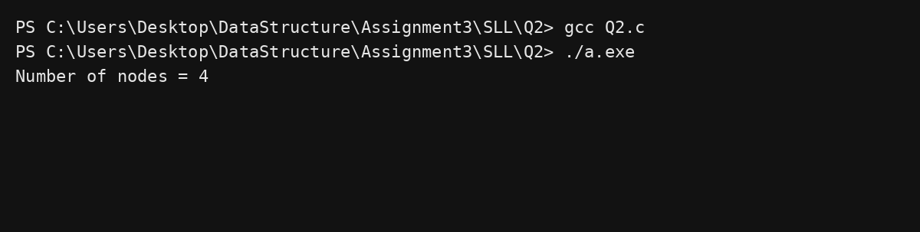

Question 3
WAP to insert the new node at the beginning of the linked list. C Program:
#include <stdio.h> #include <stdlib.h>

struct Node { int data;
struct Node* next;
};

int main() {
struct Node* head = NULL;

int values[] = {20, 30, 40}; for(int i = 0; i < 3; i++) {
struct Node* node = (struct Node*)malloc(sizeof(struct Node)); node‐>data = values[i];
node‐>next = head; head = node;
}

struct Node* newNode = (struct Node*)malloc(sizeof(struct Node)); newNode‐>data = 10;
newNode‐>next = head; head = newNode;

struct Node* temp = head;

printf("Linked List after insertion: "); while(temp) {
printf("%d ‐> ", temp‐>data); temp = temp‐>next;
}
printf("NULL"); return 0;
}
Output:


Question 4
WAP to insert the new node at the end of the linked list. C Program:
#include <stdio.h> #include <stdlib.h>
struct Node { int data; struct Node* next; }; int main() {
int arr[] = {10,20,30};
struct Node *head=NULL,*tail=NULL; for(int i=0;i<3;i++){
struct Node* n=malloc(sizeof(struct Node)); n‐>data=arr[i]; n‐>next=NULL;
if(!head) head=tail=n;
else { tail‐>next=n; tail=n; }
}
struct Node* newNode=malloc(sizeof(struct Node)); newNode‐>data=40; newNode‐>next=NULL; tail‐>next=newNode; tail=newNode;

printf("List after insertion: ");

for(struct Node* t=head;t;t=t‐>next) printf("%d ‐> ",t‐>data); printf("NULL");
return 0;
}
Output:
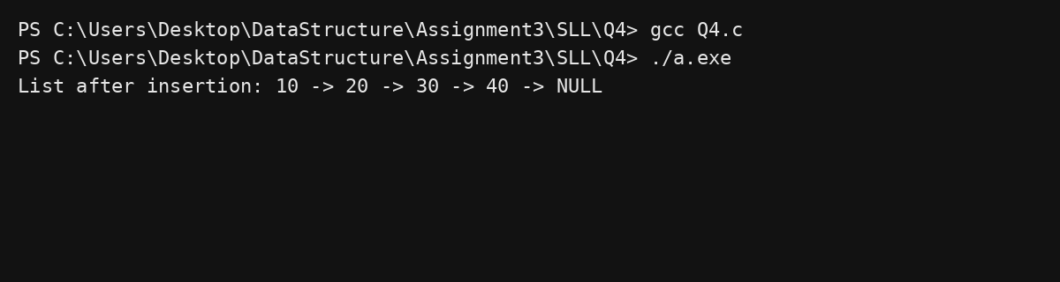

Question 5
WAP to insert the new node at the given position. C Program:
#include <stdio.h> #include <stdlib.h>
struct Node { int data; struct Node* next; }; int main() {
int arr[] = {10,20,40};
struct Node *head=NULL,*tail=NULL; for(int i=0;i<3;i++){
struct Node* n=malloc(sizeof(struct Node)); n‐>data=arr[i]; n‐>next=NULL;
if(!head) head=tail=n;
else { tail‐>next=n; tail=n; }
}
int pos=3;
struct Node* newNode=malloc(sizeof(struct Node)); newNode‐>data=30;

struct Node* temp=head;
for(int i=1;i<pos‐1;i++) temp=temp‐>next; newNode‐>next=temp‐>next; temp‐>next=newNode;

printf("List after insertion: ");
for(struct Node* t=head;t;t=t‐>next) printf("%d ‐> ",t‐>data);

printf("NULL"); return 0;
}
Output:
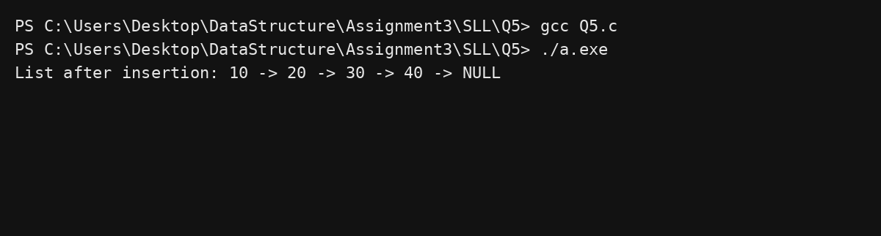

Question 6
WAP to delete last node of the given linked list. C Program:
#include <stdio.h> #include <stdlib.h>
struct Node { int data; struct Node* next; }; int main() {
int arr[]={10,20,30,40};
struct Node *head=NULL,*tail=NULL; for(int i=0;i<4;i++){
struct Node* n=malloc(sizeof(struct Node)); n‐>data=arr[i]; n‐>next=NULL;
if(!head) head=tail=n;
else { tail‐>next=n; tail=n; }
}
struct Node* temp=head; while(temp‐>next‐>next) temp=temp‐>next; free(temp‐>next);
temp‐>next=NULL;

printf("List after deleting last node: ");
for(struct Node* t=head;t;t=t‐>next) printf("%d ‐> ",t‐>data); printf("NULL");
return 0;
}
Output:

Question 7
WAP to delete first node of the given linked list. C Program:
#include <stdio.h> #include <stdlib.h>
struct Node { int data; struct Node* next; }; int main() {
int arr[]={10,20,30};
struct Node *head=NULL,*tail=NULL; for(int i=0;i<3;i++){
struct Node* n=malloc(sizeof(struct Node)); n‐>data=arr[i]; n‐>next=NULL;
if(!head) head=tail=n;
else { tail‐>next=n; tail=n; }
}
struct Node* temp=head; head=head‐>next; free(temp);

printf("List after deleting first node: ");
for(struct Node* t=head;t;t=t‐>next) printf("%d ‐> ",t‐>data); printf("NULL");
return 0;
}
Output:

Question 8
WAP to delete the node with even position of the given linked list. C Program:
#include <stdio.h> #include <stdlib.h>
struct Node { int data; struct Node* next; }; int main(){
int arr[]={10,20,30,40,50};
struct Node *head=NULL,*tail=NULL; for(int i=0;i<5;i++){
struct Node* n=malloc(sizeof(struct Node)); n‐>data=arr[i]; n‐>next=NULL;
if(!head) head=tail=n;
else { tail‐>next=n; tail=n; }
}
struct Node* curr=head; while(curr && curr‐>next){
struct Node* del=curr‐>next; curr‐>next=del‐>next; free(del);
curr=curr‐>next;
}
printf("List after deleting even positions: ");
for(struct Node* t=head;t;t=t‐>next) printf("%d ‐> ",t‐>data); printf("NULL");
return 0;
}
Output:

Question 9
WAP to find whether cycle exist or does not exist in given linked list. C Program:
#include <stdio.h> #include <stdlib.h>
struct Node{int data; struct Node* next;}; int main(){
struct Node *a=malloc(sizeof(struct Node)); struct Node *b=malloc(sizeof(struct Node)); struct Node *c=malloc(sizeof(struct Node)); a‐>data=1; b‐>data=2; c‐>data=3; a‐>next=b; b‐>next=c; c‐>next=b; // cycle

struct Node *slow=a,*fast=a; int cycle=0;
while(fast && fast‐>next){ slow=slow‐>next; fast=fast‐>next‐>next; if(slow==fast){ cycle=1; break; }
}
if(cycle) printf("Cycle exists"); else printf("No cycle");
return 0;
}
Output:

Question 10
WAP to find merge point in the given two linked list. C Program:
#include <stdio.h> #include <stdlib.h>
struct Node{int data; struct Node* next;}; int main(){
struct Node *common=malloc(sizeof(struct Node)); common‐>data=30; common‐>next=NULL;

struct Node *a1=malloc(sizeof(struct Node)); struct Node *a2=malloc(sizeof(struct Node)); a1‐>data=10; a2‐>data=20;
a1‐>next=a2; a2‐>next=common;

struct Node *b1=malloc(sizeof(struct Node)); b1‐>data=5; b1‐>next=common;

struct Node *p=a1,*q=b1; while(p!=q){
p = p ? p‐>next : b1;
q = q ? q‐>next : a1;
}
printf("Merge point data = %d", p‐>data); return 0;
}
Output:

Question 11
WAP to reverse the given linked list. C Program:
#include <stdio.h> #include <stdlib.h>
struct Node{int data; struct Node* next;}; int main(){
int arr[]={10,20,30}; struct Node *head=NULL; for(int i=0;i<3;i++){
struct Node* n=malloc(sizeof(struct Node)); n‐>data=arr[i]; n‐>next=head; head=n;
}
struct Node *prev=NULL,*curr=head,*next=NULL; while(curr){
next=curr‐>next; curr‐>next=prev; prev=curr; curr=next;
}
head=prev; printf("Reversed list: ");
for(struct Node* t=head;t;t=t‐>next) printf("%d ‐> ",t‐>data); printf("NULL");
return 0;
}

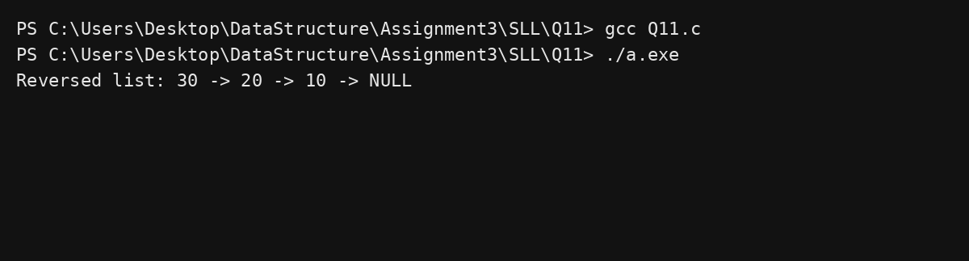
Output:

Question 12
Write a program in C to create and display a doubly linked list. C Program:
#include <stdio.h> #include <stdlib.h>
struct Node { int data; struct Node *prev, *next; }; int main(){
int arr[]={2,5,8};
struct Node *head=NULL,*tail=NULL; for(int i=0;i<3;i++){
struct Node* n=malloc(sizeof(struct Node)); n‐>data=arr[i]; n‐>prev=tail; n‐>next=NULL; if(!head) head=n;
else tail‐>next=n; tail=n;
}
printf("Data entered in the list are:\n"); int i=1;
for(struct Node* t=head;t;t=t‐>next) printf("node %d : %d\n",i++,t‐>data);
return 0;
}
Output:

Question 13
Write a program in C to create a doubly linked list and display in reverse order. C Program:
#include <stdio.h> #include <stdlib.h>
struct Node { int data; struct Node *prev,*next; }; int main(){
int arr[]={2,5,8};
struct Node *head=NULL,*tail=NULL; for(int i=0;i<3;i++){
struct Node* n=malloc(sizeof(struct Node)); n‐>data=arr[i]; n‐>prev=tail; n‐>next=NULL; if(!head) head=n;
else tail‐>next=n; tail=n;
}
printf("Data in reverse order are:\n"); int i=1;
for(struct Node* t=tail;t;t=t‐>prev) printf("Data in node %d : %d\n",i++,t‐>data);
return 0;
}
Output:

Question 14
Write a program in C to insert a new node at the beginning in a doubly linked list. C Program:
#include <stdio.h> #include <stdlib.h>
struct Node{int data; struct Node *prev,*next;}; int main(){
int arr[]={2,5,8};
struct Node *head=NULL,*tail=NULL; for(int i=0;i<3;i++){
struct Node* n=malloc(sizeof(struct Node)); n‐>data=arr[i]; n‐>prev=tail; n‐>next=NULL; if(!head) head=n;
else tail‐>next=n; tail=n;
}
struct Node* newNode=malloc(sizeof(struct Node)); newNode‐>data=1; newNode‐>prev=NULL; newNode‐>next=head; head‐>prev=newNode; head=newNode;

int i=1;
for(struct Node* t=head;t;t=t‐>next) printf("node %d : %d\n",i++,t‐>data);
return 0;
}
Output:

Question 15
Write a program in C to insert a new node at the end of a doubly linked list. C Program:
#include <stdio.h> #include <stdlib.h>
struct Node{int data; struct Node *prev,*next;}; int main(){
int arr[]={2,5,8};
struct Node *head=NULL,*tail=NULL; for(int i=0;i<3;i++){
struct Node* n=malloc(sizeof(struct Node)); n‐>data=arr[i]; n‐>prev=tail; n‐>next=NULL; if(!head) head=n;
else tail‐>next=n; tail=n;
}
struct Node* newNode=malloc(sizeof(struct Node)); newNode‐>data=9; newNode‐>next=NULL; newNode‐>prev=tail; tail‐>next=newNode; tail=newNode;

int i=1;
for(struct Node* t=head;t;t=t‐>next) printf("node %d : %d\n",i++,t‐>data);
return 0;
}
Output:

Question 16
Write a program in C to insert a new node at any position in a doubly linked list. C Program:
#include <stdio.h> #include <stdlib.h>
struct Node{int data; struct Node *prev,*next;}; int main(){
int arr[]={2,4,5};
struct Node *head=NULL,*tail=NULL; for(int i=0;i<3;i++){
struct Node* n=malloc(sizeof(struct Node)); n‐>data=arr[i]; n‐>prev=tail; n‐>next=NULL; if(!head) head=n;
else tail‐>next=n; tail=n;
}
int pos=2;
struct Node* temp=head;
for(int i=1;i<pos;i++) temp=temp‐>next;
struct Node* newNode=malloc(sizeof(struct Node)); newNode‐>data=3;
newNode‐>prev=temp‐>prev; newNode‐>next=temp; temp‐>prev‐>next=newNode; temp‐>prev=newNode;

int i=1;
for(struct Node* t=head;t;t=t‐>next) printf("node %d : %d\n",i++,t‐>data);
return 0;
}
Output:

Question 17
Write a program in C to insert a new node at the middle in a doubly linked list. C Program:
#include <stdio.h> #include <stdlib.h>
struct Node{int data; struct Node *prev,*next;}; int main(){
int arr[]={2,4,5};
struct Node *head=NULL,*tail=NULL; for(int i=0;i<3;i++){
struct Node* n=malloc(sizeof(struct Node)); n‐>data=arr[i]; n‐>prev=tail; n‐>next=NULL; if(!head) head=n;
else tail‐>next=n; tail=n;
}
struct Node* mid=head‐>next;
struct Node* newNode=malloc(sizeof(struct Node)); newNode‐>data=3;
newNode‐>prev=mid‐>prev; newNode‐>next=mid; mid‐>prev‐>next=newNode; mid‐>prev=newNode;

int i=1;
for(struct Node* t=head;t;t=t‐>next) printf("node %d : %d\n",i++,t‐>data);
return 0;
}
Output:

Question 18
Write a program in C to delete a node from the beginning of a doubly linked list. C Program:
#include <stdio.h> #include <stdlib.h>
struct Node{int data; struct Node *prev,*next;}; int main(){
int arr[]={1,2,3};
struct Node *head=NULL,*tail=NULL; for(int i=0;i<3;i++){
struct Node* n=malloc(sizeof(struct Node)); n‐>data=arr[i]; n‐>prev=tail; n‐>next=NULL; if(!head) head=n;
else tail‐>next=n; tail=n;
}
struct Node* del=head; head=head‐>next; head‐>prev=NULL; free(del);

int i=1;
for(struct Node* t=head;t;t=t‐>next) printf("node %d : %d\n",i++,t‐>data);
return 0;
}
Output:

Question 19
Write a program in C to delete a node from the last of a doubly linked list. C Program:
#include <stdio.h> #include <stdlib.h>
struct Node{int data; struct Node *prev,*next;}; int main(){
int arr[]={1,2,3};
struct Node *head=NULL,*tail=NULL; for(int i=0;i<3;i++){
struct Node* n=malloc(sizeof(struct Node)); n‐>data=arr[i]; n‐>prev=tail; n‐>next=NULL; if(!head) head=n;
else tail‐>next=n; tail=n;
}
struct Node* del=tail; tail=tail‐>prev; tail‐>next=NULL; free(del);

int i=1;
for(struct Node* t=head;t;t=t‐>next) printf("node %d : %d\n",i++,t‐>data);
return 0;
}
Output:

Question 20
Write a program in C to delete a node from any position of a doubly linked list. C Program:
#include <stdio.h> #include <stdlib.h>
struct Node{int data; struct Node *prev,*next;}; int main(){
int arr[]={1,2,3};
struct Node *head=NULL,*tail=NULL; for(int i=0;i<3;i++){
struct Node* n=malloc(sizeof(struct Node)); n‐>data=arr[i]; n‐>prev=tail; n‐>next=NULL; if(!head) head=n;
else tail‐>next=n; tail=n;
}
int pos=3;
struct Node* temp=head;
for(int i=1;i<pos;i++) temp=temp‐>next; temp‐>prev‐>next=temp‐>next; free(temp);

int i=1;
for(struct Node* t=head;t;t=t‐>next) printf("node %d : %d\n",i++,t‐>data);
return 0;
}
Output:

Question 21
Write a program in C to delete a node from the middle of a doubly linked list. C Program:
#include <stdio.h> #include <stdlib.h>
struct Node{int data; struct Node *prev,*next;}; int main(){
int arr[]={1,2,3};
struct Node *head=NULL,*tail=NULL; for(int i=0;i<3;i++){
struct Node* n=malloc(sizeof(struct Node)); n‐>data=arr[i]; n‐>prev=tail; n‐>next=NULL; if(!head) head=n;
else tail‐>next=n; tail=n;
}
struct Node* mid=head‐>next; mid‐>prev‐>next=mid‐>next; mid‐>next‐>prev=mid‐>prev; free(mid);

int i=1;
for(struct Node* t=head;t;t=t‐>next) printf("node %d : %d\n",i++,t‐>data);
return 0;
}
Output:

Question 22
Write a program in C to find the maximum value from a doubly linked list. C Program:
#include <stdio.h> #include <stdlib.h>
struct Node{int data; struct Node *prev,*next;}; int main(){
int arr[]={5,9,1};
struct Node *head=NULL,*tail=NULL; for(int i=0;i<3;i++){
struct Node* n=malloc(sizeof(struct Node)); n‐>data=arr[i]; n‐>prev=tail; n‐>next=NULL; if(!head) head=n;
else tail‐>next=n; tail=n;
}
int max=head‐>data;
for(struct Node* t=head;t;t=t‐>next) if(t‐>data>max) max=t‐>data;

printf("Maximum value = %d", max); return 0;
}
Output:

Question 23
Write a program in C to create and display a circular linked list. C Program:
#include <stdio.h> #include <stdlib.h>
struct Node{int data; struct Node* next;}; int main(){
int arr[]={2,5,8};
struct Node *head=NULL,*tail=NULL; for(int i=0;i<3;i++){
struct Node* n=malloc(sizeof(struct Node)); n‐>data=arr[i]; n‐>next=NULL;
if(!head) head=tail=n; else tail‐>next=n, tail=n;
}
tail‐>next=head; struct Node* t=head; int i=1;
do{
printf("Data %d = %d\n",i++,t‐>data); t=t‐>next;
}while(t!=head); return 0;
}
Output:

Question 24
Write a program in C to insert a node at the beginning of a circular linked list. C Program:
#include <stdio.h> #include <stdlib.h>
struct Node{int data; struct Node* next;}; int main(){
int arr[]={2,5,8};
struct Node *head=NULL,*tail=NULL; for(int i=0;i<3;i++){
struct Node* n=malloc(sizeof(struct Node)); n‐>data=arr[i]; n‐>next=NULL;
if(!head) head=tail=n; else tail‐>next=n, tail=n;
}
tail‐>next=head;
struct Node* newNode=malloc(sizeof(struct Node)); newNode‐>data=1;
newNode‐>next=head; tail‐>next=newNode; head=newNode;

struct Node* t=head; int i=1;
do{
printf("Data %d = %d\n",i++,t‐>data); t=t‐>next;
}while(t!=head); return 0;
}
Output:

Question 25
Write a program in C to insert a node at the end of a circular linked list. C Program:
#include <stdio.h> #include <stdlib.h>
struct Node{int data; struct Node* next;}; int main(){
int arr[]={2,5,8};
struct Node *head=NULL,*tail=NULL; for(int i=0;i<3;i++){
struct Node* n=malloc(sizeof(struct Node)); n‐>data=arr[i]; n‐>next=NULL;
if(!head) head=tail=n; else tail‐>next=n, tail=n;
}
tail‐>next=head;
struct Node* newNode=malloc(sizeof(struct Node)); newNode‐>data=9;
newNode‐>next=head; tail‐>next=newNode; tail=newNode;

struct Node* t=head; int i=1;
do{
printf("Data %d = %d\n",i++,t‐>data); t=t‐>next;
}while(t!=head); return 0;
}
Output:

Question 26
Write a program in C to insert a node at any position in a circular linked list. C Program:
#include <stdio.h> #include <stdlib.h>
struct Node{int data; struct Node* next;}; int main(){
int arr[]={2,5,8};
struct Node *head=NULL,*tail=NULL; for(int i=0;i<3;i++){
struct Node* n=malloc(sizeof(struct Node)); n‐>data=arr[i]; n‐>next=NULL;
if(!head) head=tail=n; else tail‐>next=n, tail=n;
}
tail‐>next=head; int pos=3;
struct Node* temp=head;
for(int i=1;i<pos‐1;i++) temp=temp‐>next;

struct Node* newNode=malloc(sizeof(struct Node)); newNode‐>data=7;
newNode‐>next=temp‐>next; temp‐>next=newNode;

struct Node* t=head; int i=1;
do{
printf("Data %d = %d\n",i++,t‐>data); t=t‐>next;
}while(t!=head);

return 0;
}
Output:
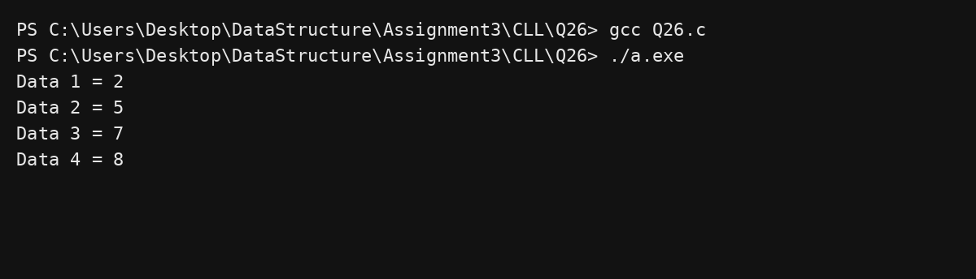

Question 27
Write a program in C to delete node from the beginning of a circular linked list. C Program:
#include <stdio.h> #include <stdlib.h>
struct Node{int data; struct Node* next;}; int main(){
int arr[]={2,5,8};
struct Node *head=NULL,*tail=NULL; for(int i=0;i<3;i++){
struct Node* n=malloc(sizeof(struct Node)); n‐>data=arr[i]; n‐>next=NULL;
if(!head) head=tail=n; else tail‐>next=n, tail=n;
}
tail‐>next=head;
struct Node* del=head; head=head‐>next; tail‐>next=head; free(del);

struct Node* t=head; int i=1;
do{
printf("Data %d = %d\n",i++,t‐>data); t=t‐>next;
}while(t!=head);

return 0;
}
Output:
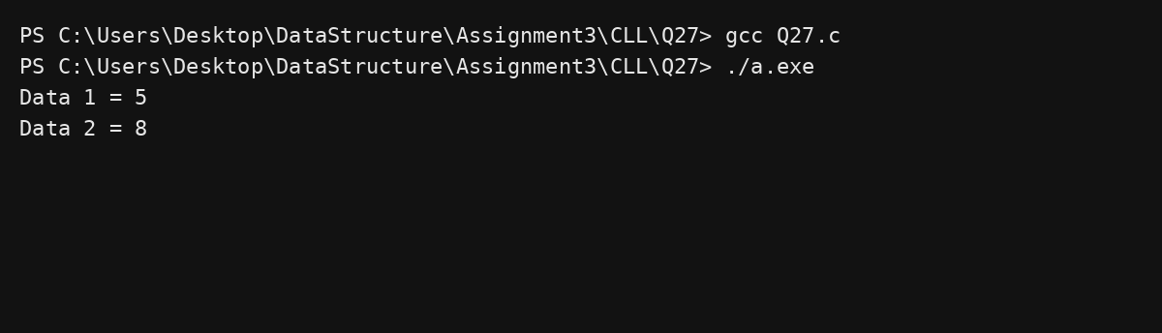

Question 28
Write a program in C to delete a node from the middle of a circular linked list. C Program:
#include <stdio.h> #include <stdlib.h>
struct Node{int data; struct Node* next;}; int main(){
int arr[]={2,5,8};
struct Node *head=NULL,*tail=NULL; for(int i=0;i<3;i++){
struct Node* n=malloc(sizeof(struct Node)); n‐>data=arr[i]; n‐>next=NULL;
if(!head) head=tail=n; else tail‐>next=n, tail=n;
}
tail‐>next=head; int pos=3;
struct Node* temp=head;
for(int i=1;i<pos‐1;i++) temp=temp‐>next; struct Node* del=temp‐>next; temp‐>next=del‐>next;
free(del);

struct Node* t=head; int i=1;
do{
printf("Data %d = %d\n",i++,t‐>data); t=t‐>next;

}while(t!=head); return 0;
}
Output:
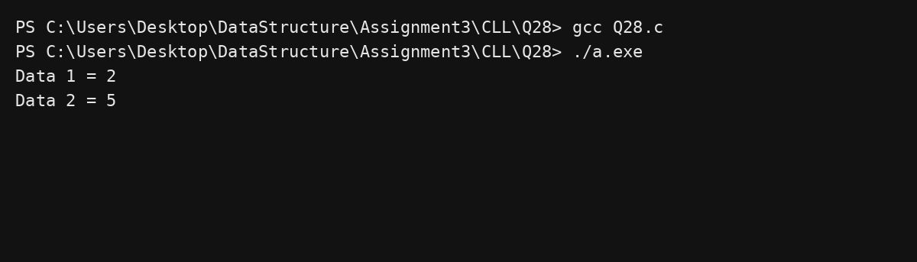

Question 29
Write a program in C to delete the node at the end of a circular linked list. C Program:
#include <stdio.h> #include <stdlib.h>
struct Node{int data; struct Node* next;}; int main(){
int arr[]={2,5,8};
struct Node *head=NULL,*tail=NULL; for(int i=0;i<3;i++){
struct Node* n=malloc(sizeof(struct Node)); n‐>data=arr[i]; n‐>next=NULL;
if(!head) head=tail=n; else tail‐>next=n, tail=n;
}
tail‐>next=head;
struct Node* temp=head; while(temp‐>next!=tail) temp=temp‐>next; temp‐>next=head;
free(tail); tail=temp;

struct Node* t=head; int i=1;
do{
printf("Data %d = %d\n",i++,t‐>data); t=t‐>next;

}while(t!=head); return 0;
}
Output:
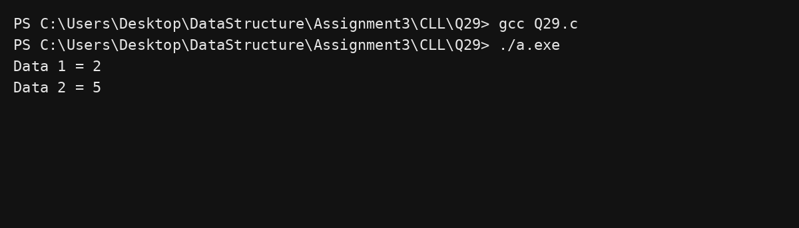

Question 30
Write a program in C to search an element in a circular linked list. C Program:
#include <stdio.h> #include <stdlib.h>
struct Node{int data; struct Node* next;}; int main(){
int arr[]={2,5,9};
struct Node *head=NULL,*tail=NULL; for(int i=0;i<3;i++){
struct Node* n=malloc(sizeof(struct Node)); n‐>data=arr[i]; n‐>next=NULL;
if(!head) head=tail=n; else tail‐>next=n, tail=n;
}
tail‐>next=head;
int key=5,pos=1,found=0; struct Node* t=head;
do{
if(t‐>data==key){ found=1; break; } pos++;
t=t‐>next;
}while(t!=head);

if(found) printf("Element found at node %d",pos); else printf("Element not found");

return 0;
}
Output:
