Linked List Assignment

Name = Smruti Ranjan Behera
Reg-No = 2025CA096
Date = 29.01.26

Question 1
Create & display SLL C Program:
#include <stdio.h> #include <stdlib.h>
struct Node { int data; struct Node* next; }; void print(struct Node* h){
while(h){ printf("%d ‐> ", h‐>data); h=h‐>next; } printf("NULL\n");
}
int main(){int a[]={5,6,7}; struct Node *h=NULL,*t=NULL;
for(int i=0;i<3;i++){struct Node*n=malloc(sizeof(*n)); n‐>data=a[i]; n‐>next=NULL; if(!h)h=t=n; else t‐>next=n,t=n;}
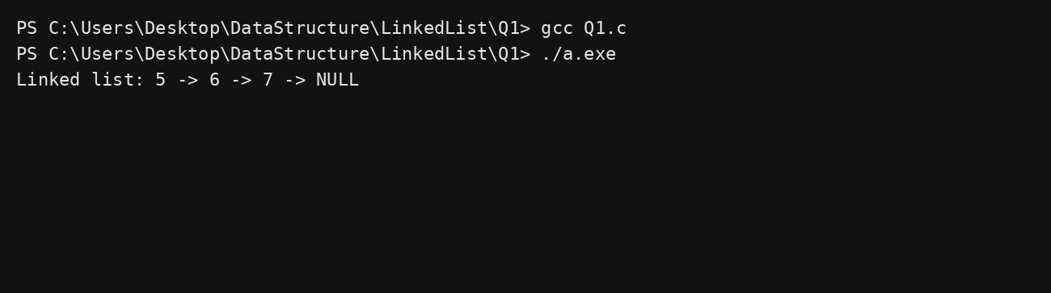
printf("Linked list: "); print(h); return 0;} Output:

Question 2
Display SLL in reverse C Program:
#include <stdio.h> #include <stdlib.h>
struct Node { int data; struct Node* next; }; void print(struct Node* h){
while(h){ printf("%d ‐> ", h‐>data); h=h‐>next; } printf("NULL\n");
}
void rev(struct Node*h){ if(!h)return; rev(h‐>next); printf("%d ‐> ",h‐>data);} int main(){int a[]={5,6,7}; struct Node*h=NULL,*t=NULL;
for(int i=0;i<3;i++){struct Node*n=malloc(sizeof(*n)); n‐>data=a[i]; n‐>next=NULL;

if(!h)h=t=n; else t‐>next=n,t=n;} printf("Linked list: "); print(h);
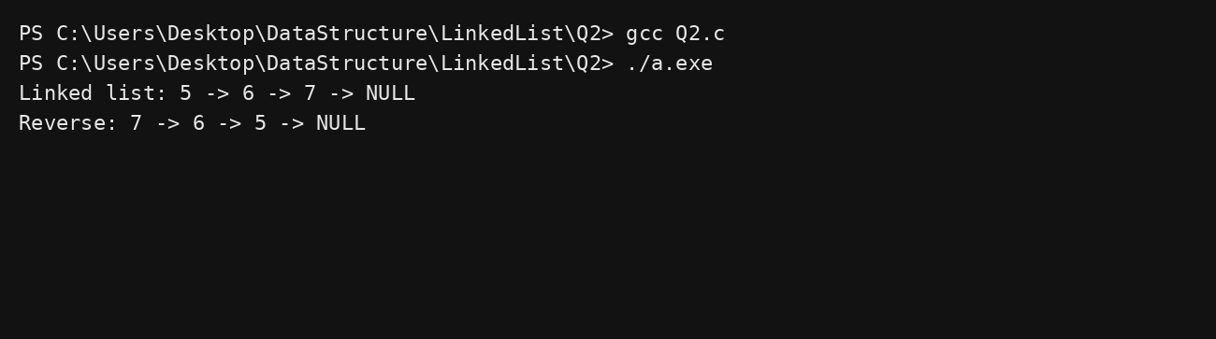
printf("Reverse: "); rev(h); printf("NULL\n"); return 0;} Output:

Question 3
Count nodes in SLL C Program:
#include <stdio.h> #include <stdlib.h>
struct Node { int data; struct Node* next; }; void print(struct Node* h){
while(h){ printf("%d ‐> ", h‐>data); h=h‐>next; } printf("NULL\n");
}
int main(){int a[]={5,6,7}; struct Node*h=NULL,*t=NULL; int c=0;
for(int i=0;i<3;i++){struct Node*n=malloc(sizeof(*n)); n‐>data=a[i]; n‐>next=NULL; if(!h)h=t=n; else t‐>next=n,t=n;}
for(struct Node*x=h;x;x=x‐>next)c++; printf("Linked list: "); print(h); printf("Total nodes = %d\n",c); return 0;}
Output:

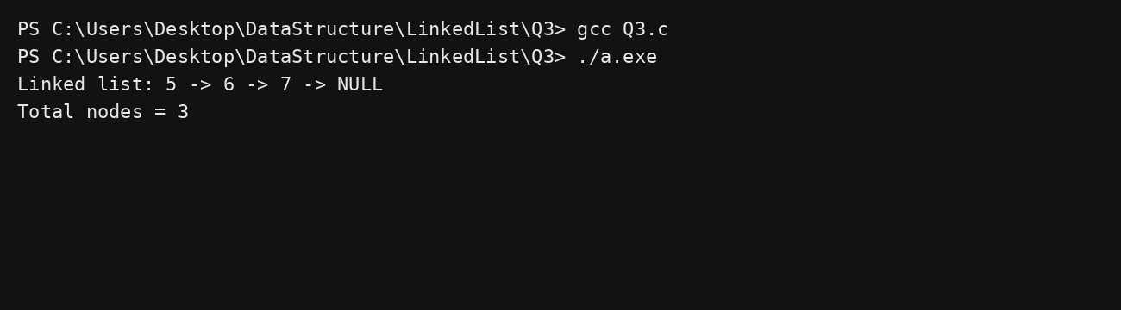

Question 4
Insert at beginning (SLL) C Program:
#include <stdio.h> #include <stdlib.h>
struct Node { int data; struct Node* next; }; void print(struct Node* h){
while(h){ printf("%d ‐> ", h‐>data); h=h‐>next; } printf("NULL\n");
}
int main(){int a[]={5,6,7}; struct Node*h=NULL,*t=NULL;
for(int i=0;i<3;i++){struct Node*n=malloc(sizeof(*n)); n‐>data=a[i]; n‐>next=NULL; if(!h)h=t=n; else t‐>next=n,t=n;}
printf("Before: "); print(h);
struct Node*n=malloc(sizeof(*n)); n‐>data=4; n‐>next=h; h=n; printf("After: "); print(h); return 0;}
Output:
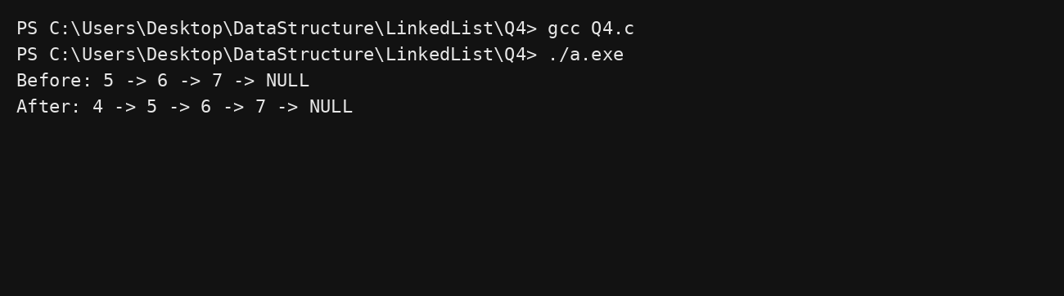

Question 5
Insert at end (SLL)

C Program:
#include <stdio.h> #include <stdlib.h>
struct Node { int data; struct Node* next; }; void print(struct Node* h){
while(h){ printf("%d ‐> ", h‐>data); h=h‐>next; } printf("NULL\n");
}
int main(){int a[]={5,6,7}; struct Node*h=NULL,*t=NULL;
for(int i=0;i<3;i++){struct Node*n=malloc(sizeof(*n)); n‐>data=a[i]; n‐>next=NULL; if(!h)h=t=n; else t‐>next=n,t=n;}
printf("Before: "); print(h);
struct Node*n=malloc(sizeof(*n)); n‐>data=8; n‐>next=NULL; t‐>next=n; t=n; printf("After: "); print(h); return 0;}
Output:
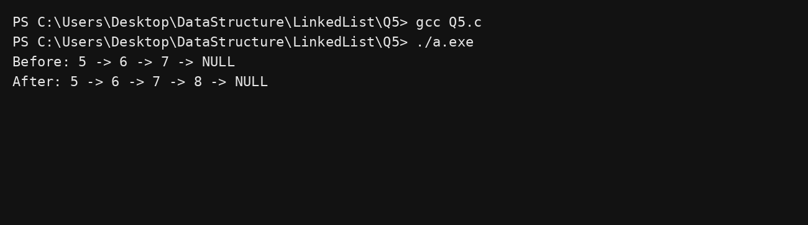

Question 6
Insert in middle (SLL) C Program:
#include <stdio.h> #include <stdlib.h>
struct Node { int data; struct Node* next; }; void print(struct Node* h){
while(h){ printf("%d ‐> ", h‐>data); h=h‐>next; } printf("NULL\n");
}
int main(){int a[]={1,2,3,4}; struct Node*h=NULL,*t=NULL;
for(int i=0;i<4;i++){struct Node*n=malloc(sizeof(*n)); n‐>data=a[i]; n‐>next=NULL; if(!h)h=t=n; else t‐>next=n,t=n;}
printf("Before: "); print(h);

struct Node*x=h; for(int i=1;i<2;i++)x=x‐>next;
struct Node*n=malloc(sizeof(*n)); n‐>data=5; n‐>next=x‐>next; x‐>next=n; printf("After: "); print(h); return 0;}
Output:
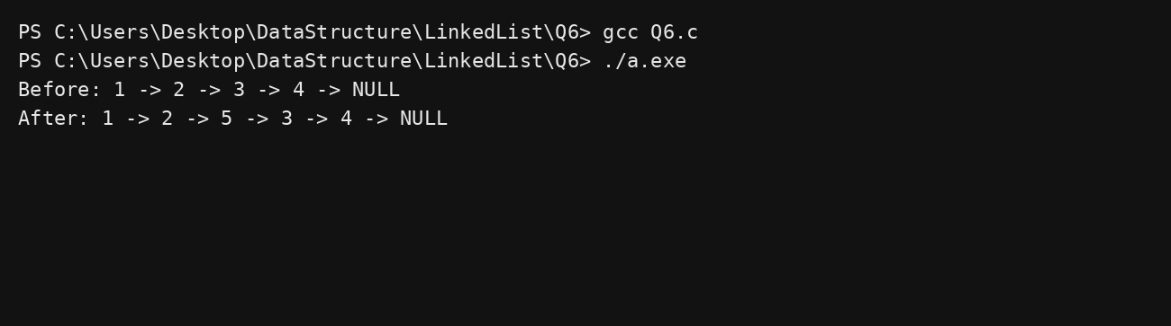

Question 7
Delete first (SLL) C Program:
#include <stdio.h> #include <stdlib.h>
struct Node { int data; struct Node* next; }; void print(struct Node* h){
while(h){ printf("%d ‐> ", h‐>data); h=h‐>next; } printf("NULL\n");
}
int main(){int a[]={2,3,4}; struct Node*h=NULL,*t=NULL;
for(int i=0;i<3;i++){struct Node*n=malloc(sizeof(*n)); n‐>data=a[i]; n‐>next=NULL; if(!h)h=t=n; else t‐>next=n,t=n;}
printf("Before: "); print(h);
struct Node*del=h; h=h‐>next; free(del); printf("After: "); print(h); return 0;}
Output:

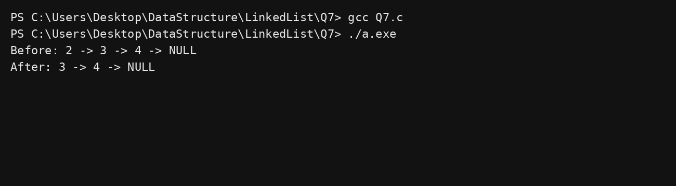

Question 8
Delete middle (SLL) C Program:
#include <stdio.h> #include <stdlib.h>
struct Node { int data; struct Node* next; }; void print(struct Node* h){
while(h){ printf("%d ‐> ", h‐>data); h=h‐>next; } printf("NULL\n");
}
int main(){int a[]={2,5,8}; struct Node*h=NULL,*t=NULL;
for(int i=0;i<3;i++){struct Node*n=malloc(sizeof(*n)); n‐>data=a[i]; n‐>next=NULL; if(!h)h=t=n; else t‐>next=n,t=n;}
printf("Before: "); print(h);
struct Node*x=h; struct Node*del=x‐>next; x‐>next=del‐>next; free(del); printf("After: "); print(h); return 0;}
Output:
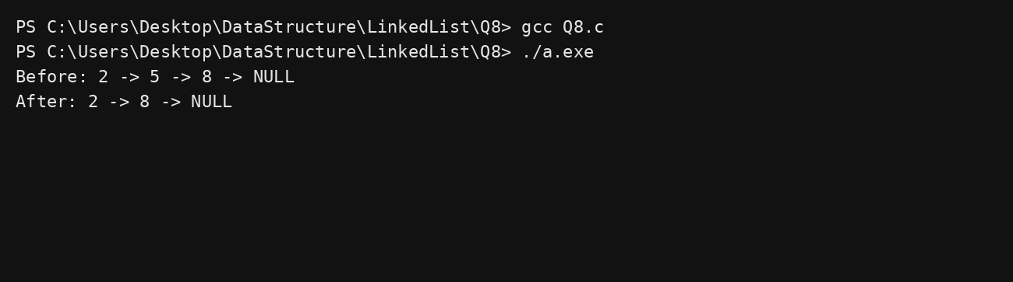

Question 9
Delete last (SLL)

C Program:
#include <stdio.h> #include <stdlib.h>
struct Node { int data; struct Node* next; }; void print(struct Node* h){
while(h){ printf("%d ‐> ", h‐>data); h=h‐>next; } printf("NULL\n");
}
int main(){int a[]={1,2,3}; struct Node*h=NULL,*t=NULL;
for(int i=0;i<3;i++){struct Node*n=malloc(sizeof(*n)); n‐>data=a[i]; n‐>next=NULL; if(!h)h=t=n; else t‐>next=n,t=n;}
printf("Before: "); print(h);
struct Node*x=h; while(x‐>next‐>next)x=x‐>next; free(x‐>next); x‐>next=NULL; printf("After: "); print(h); return 0;}
Output:
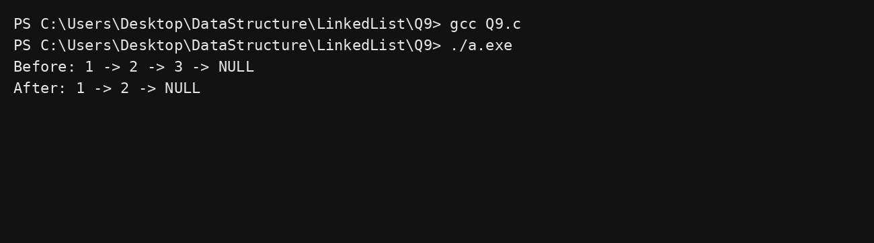

Question 10
Search in SLL C Program:
#include <stdio.h> #include <stdlib.h>
struct Node { int data; struct Node* next; }; void print(struct Node* h){
while(h){ printf("%d ‐> ", h‐>data); h=h‐>next; } printf("NULL\n");
}
int main(){int a[]={2,5,8}; struct Node*h=NULL,*t=NULL; int pos=1;
for(int i=0;i<3;i++){struct Node*n=malloc(sizeof(*n)); n‐>data=a[i]; n‐>next=NULL; if(!h)h=t=n; else t‐>next=n,t=n;}
printf("Linked list: "); print(h);

for(struct Node*x=h;x;x=x‐>next,++pos) if(x‐>data==5){printf("Found at %d\n",pos); break;}
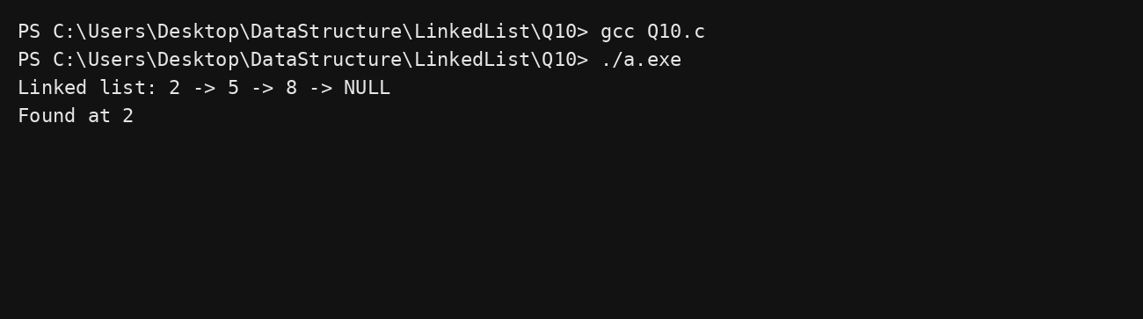
return 0;} Output:

Question 11
Create & display DLL C Program:
#include <stdio.h> #include <stdlib.h>
struct Node { int data; struct Node* prev; struct Node* next; }; void print(struct Node* h){
while(h){ printf("%d ‐> ", h‐>data); h=h‐>next; } printf("NULL\n");
}
int main(){int a[]={2,5,8}; struct Node*h=NULL,*t=NULL;
for(int i=0;i<3;i++){struct Node*n=malloc(sizeof(*n)); n‐>data=a[i]; n‐>prev=t; n‐>next=NULL;
if(!h)h=n; else t‐>next=n; t=n;} printf("DLL: "); print(h); return 0;}
Output:

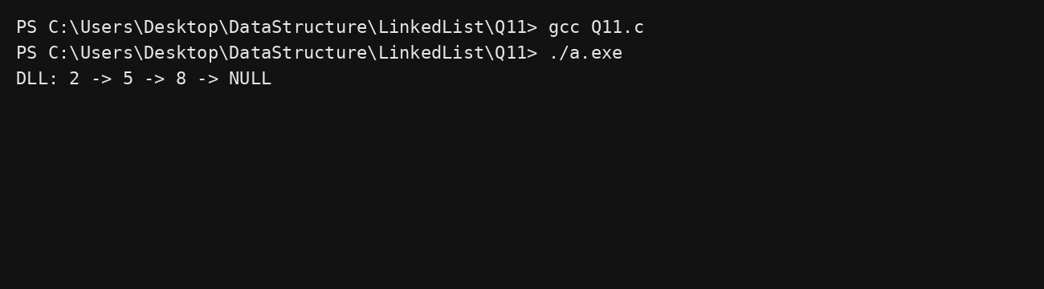

Question 12
Display DLL in reverse C Program:
#include <stdio.h> #include <stdlib.h>
struct Node { int data; struct Node* prev; struct Node* next; }; void print(struct Node* h){
while(h){ printf("%d ‐> ", h‐>data); h=h‐>next; } printf("NULL\n");
}
int main(){int a[]={2,5,8}; struct Node*h=NULL,*t=NULL;
for(int i=0;i<3;i++){struct Node*n=malloc(sizeof(*n)); n‐>data=a[i]; n‐>prev=t; n‐>next=NULL;
if(!h)h=n; else t‐>next=n; t=n;}
printf("Reverse: "); while(t){printf("%d ‐> ",t‐>data); t=t‐>prev;} printf("NULL\n"); return 0;}
Output:
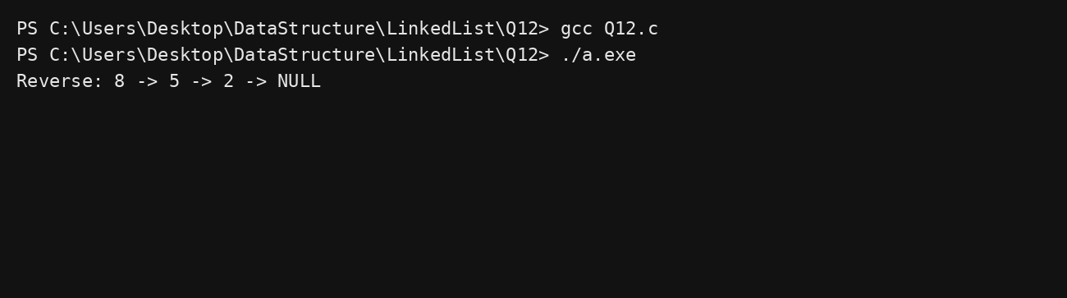

Question 13
Insert at beginning (DLL)

C Program:
#include <stdio.h> #include <stdlib.h>
struct Node { int data; struct Node* prev; struct Node* next; }; void print(struct Node* h){
while(h){ printf("%d ‐> ", h‐>data); h=h‐>next; } printf("NULL\n");
}
int main(){int a[]={2,5,8}; struct Node*h=NULL,*t=NULL;
for(int i=0;i<3;i++){struct Node*n=malloc(sizeof(*n)); n‐>data=a[i]; n‐>prev=t; n‐>next=NULL;
if(!h)h=n; else t‐>next=n; t=n;} printf("Before: "); print(h);
struct Node*n=malloc(sizeof(*n)); n‐>data=1; n‐>prev=NULL; n‐>next=h; h‐>prev=n; h=n; printf("After: "); print(h); return 0;}
Output:
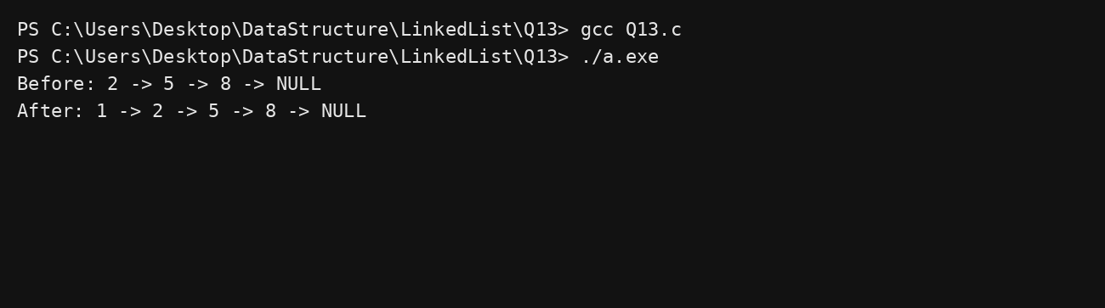

Question 14
Insert at end (DLL) C Program:
#include <stdio.h> #include <stdlib.h>
struct Node { int data; struct Node* prev; struct Node* next; }; void print(struct Node* h){
while(h){ printf("%d ‐> ", h‐>data); h=h‐>next; } printf("NULL\n");
}
int main(){int a[]={2,5,8}; struct Node*h=NULL,*t=NULL;
for(int i=0;i<3;i++){struct Node*n=malloc(sizeof(*n)); n‐>data=a[i]; n‐>prev=t; n‐>next=NULL;

if(!h)h=n; else t‐>next=n; t=n;} printf("Before: "); print(h);
struct Node*n=malloc(sizeof(*n)); n‐>data=9; n‐>prev=t; n‐>next=NULL; t‐>next=n; t=n; printf("After: "); print(h); return 0;}
Output:
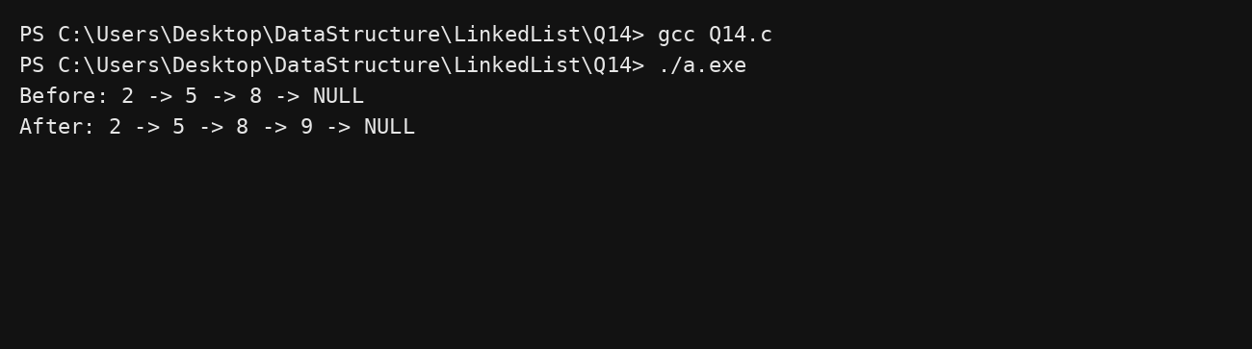

Question 15
Insert at any position (DLL) C Program:
#include <stdio.h> #include <stdlib.h>
struct Node { int data; struct Node* prev; struct Node* next; }; void print(struct Node* h){
while(h){ printf("%d ‐> ", h‐>data); h=h‐>next; } printf("NULL\n");
}
int main(){int a[]={2,4,5}; struct Node*h=NULL,*t=NULL;
for(int i=0;i<3;i++){struct Node*n=malloc(sizeof(*n)); n‐>data=a[i]; n‐>prev=t; n‐>next=NULL;
if(!h)h=n; else t‐>next=n; t=n;} printf("Before: "); print(h); struct Node*x=h‐>next;
struct Node*n=malloc(sizeof(*n)); n‐>data=3; n‐>prev=x‐>prev; n‐>next=x; x‐>prev‐>next=n; x‐>prev=n;
printf("After: "); print(h); return 0;} Output:

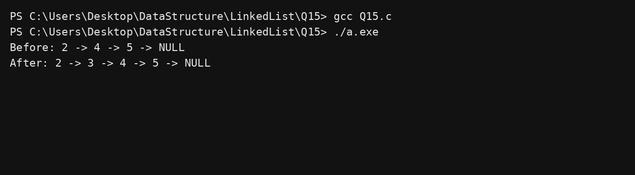

Question 16
Insert at middle (DLL) C Program:
#include <stdio.h> #include <stdlib.h>
struct Node { int data; struct Node* prev; struct Node* next; }; void print(struct Node* h){
while(h){ printf("%d ‐> ", h‐>data); h=h‐>next; } printf("NULL\n");
}
int main(){int a[]={2,4,5}; struct Node*h=NULL,*t=NULL;
for(int i=0;i<3;i++){struct Node*n=malloc(sizeof(*n)); n‐>data=a[i]; n‐>prev=t; n‐>next=NULL;
if(!h)h=n; else t‐>next=n; t=n;} printf("Before: "); print(h); struct Node*x=h‐>next;
struct Node*n=malloc(sizeof(*n)); n‐>data=3; n‐>prev=x‐>prev; n‐>next=x; x‐>prev‐>next=n; x‐>prev=n;
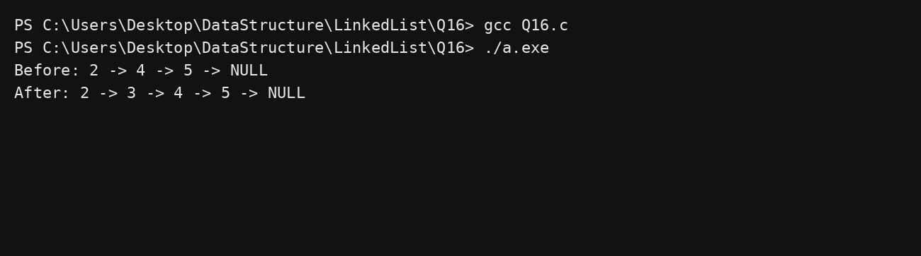
printf("After: "); print(h); return 0;} Output:

Question 17
Delete beginning (DLL) C Program:
#include <stdio.h> #include <stdlib.h>
struct Node { int data; struct Node* prev; struct Node* next; }; void print(struct Node* h){
while(h){ printf("%d ‐> ", h‐>data); h=h‐>next; } printf("NULL\n");
}
int main(){int a[]={1,2,3}; struct Node*h=NULL,*t=NULL;
for(int i=0;i<3;i++){struct Node*n=malloc(sizeof(*n)); n‐>data=a[i]; n‐>prev=t; n‐>next=NULL;
if(!h)h=n; else t‐>next=n; t=n;} printf("Before: "); print(h);
struct Node*del=h; h=h‐>next; h‐>prev=NULL; free(del); printf("After: "); print(h); return 0;}
Output:
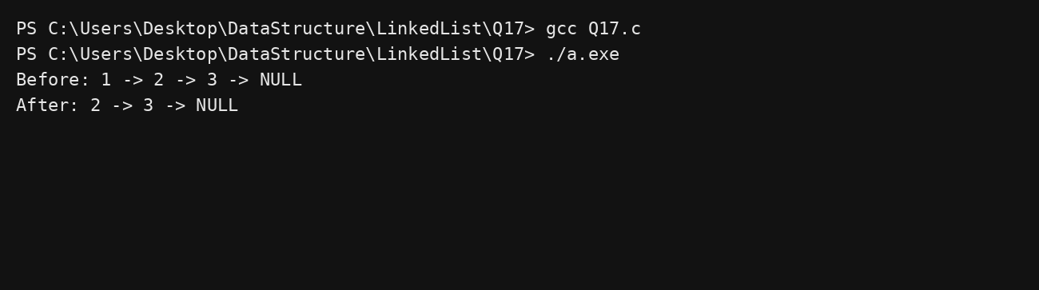

Question 18
Delete last (DLL) C Program:
#include <stdio.h> #include <stdlib.h>
struct Node { int data; struct Node* prev; struct Node* next; }; void print(struct Node* h){
while(h){ printf("%d ‐> ", h‐>data); h=h‐>next; } printf("NULL\n");
}
int main(){int a[]={1,2,3}; struct Node*h=NULL,*t=NULL;

for(int i=0;i<3;i++){struct Node*n=malloc(sizeof(*n)); n‐>data=a[i]; n‐>prev=t; n‐>next=NULL;
if(!h)h=n; else t‐>next=n; t=n;} printf("Before: "); print(h);
struct Node*del=t; t=t‐>prev; t‐>next=NULL; free(del); printf("After: "); print(h); return 0;}
Output:
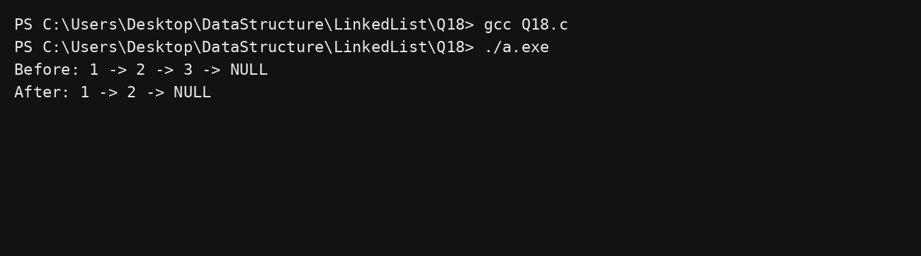

Question 19
Delete any position (DLL) C Program:
#include <stdio.h> #include <stdlib.h>
struct Node { int data; struct Node* prev; struct Node* next; }; void print(struct Node* h){
while(h){ printf("%d ‐> ", h‐>data); h=h‐>next; } printf("NULL\n");
}
int main(){int a[]={1,2,3}; struct Node*h=NULL,*t=NULL;
for(int i=0;i<3;i++){struct Node*n=malloc(sizeof(*n)); n‐>data=a[i]; n‐>prev=t; n‐>next=NULL;
if(!h)h=n; else t‐>next=n; t=n;} printf("Before: "); print(h);
struct Node*x=h‐>next‐>next; x‐>prev‐>next=x‐>next; free(x); printf("After: "); print(h); return 0;}
Output:

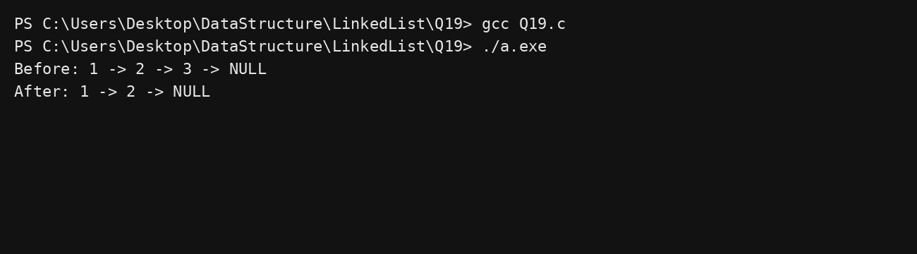

Question 20
Delete middle (DLL) C Program:
#include <stdio.h> #include <stdlib.h>
struct Node { int data; struct Node* prev; struct Node* next; }; void print(struct Node* h){
while(h){ printf("%d ‐> ", h‐>data); h=h‐>next; } printf("NULL\n");
}
int main(){int a[]={1,2,3}; struct Node*h=NULL,*t=NULL;
for(int i=0;i<3;i++){struct Node*n=malloc(sizeof(*n)); n‐>data=a[i]; n‐>prev=t; n‐>next=NULL;
if(!h)h=n; else t‐>next=n; t=n;} printf("Before: "); print(h);
struct Node*x=h‐>next; x‐>prev‐>next=x‐>next; x‐>next‐>prev=x‐>prev; free(x); printf("After: "); print(h); return 0;}
Output:
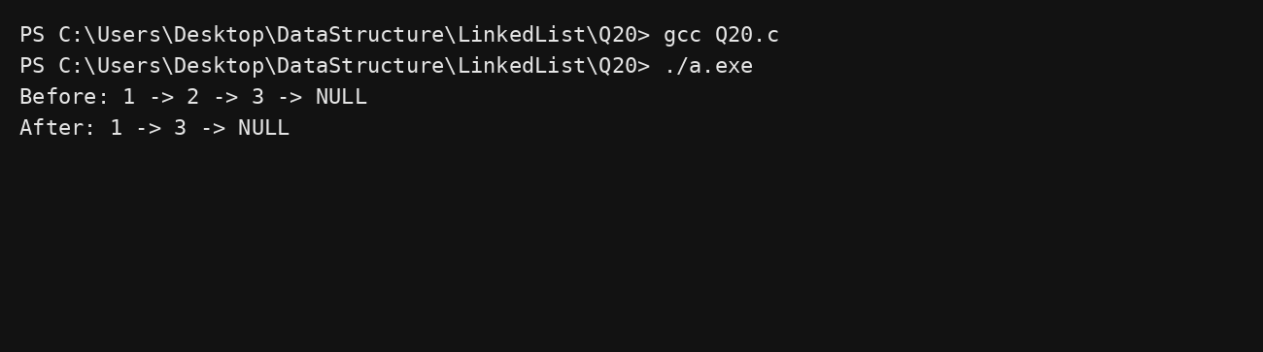

Question 21
Max in DLL

C Program:
#include <stdio.h> #include <stdlib.h>
struct Node { int data; struct Node* prev; struct Node* next; }; void print(struct Node* h){
while(h){ printf("%d ‐> ", h‐>data); h=h‐>next; } printf("NULL\n");
}
int main(){int a[]={5,9,1}; struct Node*h=NULL,*t=NULL; int mx=‐1;
for(int i=0;i<3;i++){struct Node*n=malloc(sizeof(*n)); n‐>data=a[i]; n‐>prev=t; n‐>next=NULL;
if(!h)h=n; else t‐>next=n; t=n;}
for(struct Node*x=h;x;x=x‐>next) if(x‐>data>mx) mx=x‐>data; printf("Max = %d\n",mx); return 0;}
Output:
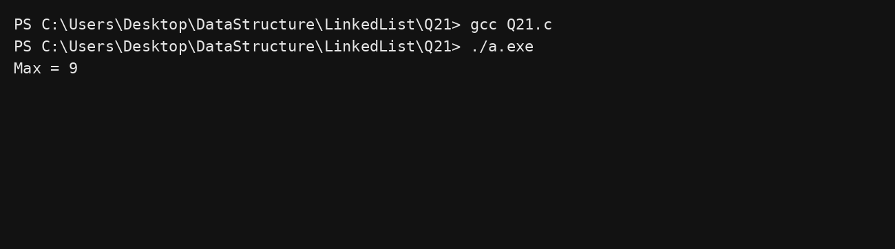

Question 22
Create & display CLL C Program:
#include <stdio.h> #include <stdlib.h>
struct Node { int data; struct Node* next; }; void print(struct Node* h){
if(!h) return; struct Node* t=h;
do{ printf("%d ‐> ", t‐>data); t=t‐>next; }while(t!=h); printf("(back to head)\n");
}
int main(){int a[]={2,5,8}; struct Node*h=NULL,*t=NULL;
for(int i=0;i<3;i++){struct Node*n=malloc(sizeof(*n)); n‐>data=a[i]; n‐>next=NULL;

if(!h)h=t=n; else t‐>next=n,t=n;} t‐>next=h; printf("CLL: "); print(h); return 0;}
Output:
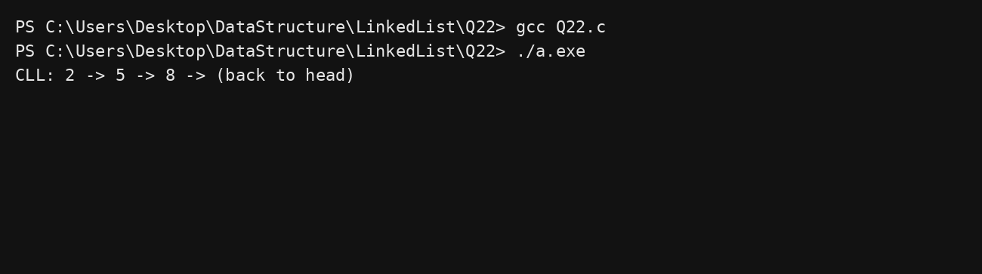

Question 23
Insert beginning (CLL) C Program:
#include <stdio.h> #include <stdlib.h>
struct Node { int data; struct Node* next; }; void print(struct Node* h){
if(!h) return; struct Node* t=h;
do{ printf("%d ‐> ", t‐>data); t=t‐>next; }while(t!=h); printf("(back to head)\n");
}
int main(){int a[]={2,5,8}; struct Node*h=NULL,*t=NULL;
for(int i=0;i<3;i++){struct Node*n=malloc(sizeof(*n)); n‐>data=a[i]; n‐>next=NULL; if(!h)h=t=n; else t‐>next=n,t=n;} t‐>next=h;
printf("Before: "); print(h);
struct Node*n=malloc(sizeof(*n)); n‐>data=1; n‐>next=h; t‐>next=n; h=n; printf("After: "); print(h); return 0;}
Output:

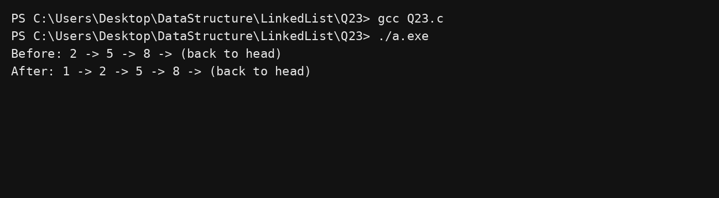

Question 24
Insert end (CLL) C Program:
#include <stdio.h> #include <stdlib.h>
struct Node { int data; struct Node* next; }; void print(struct Node* h){
if(!h) return; struct Node* t=h;
do{ printf("%d ‐> ", t‐>data); t=t‐>next; }while(t!=h); printf("(back to head)\n");
}
int main(){int a[]={2,5,8}; struct Node*h=NULL,*t=NULL;
for(int i=0;i<3;i++){struct Node*n=malloc(sizeof(*n)); n‐>data=a[i]; n‐>next=NULL; if(!h)h=t=n; else t‐>next=n,t=n;} t‐>next=h;
printf("Before: "); print(h);
struct Node*n=malloc(sizeof(*n)); n‐>data=9; n‐>next=h; t‐>next=n; t=n; printf("After: "); print(h); return 0;}
Output:
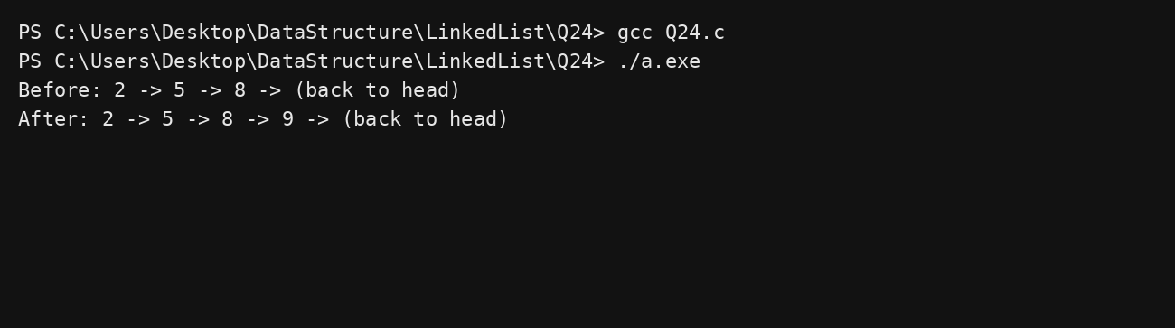

Question 25
Insert any position (CLL) C Program:
#include <stdio.h> #include <stdlib.h>
struct Node { int data; struct Node* next; }; void print(struct Node* h){
if(!h) return; struct Node* t=h;
do{ printf("%d ‐> ", t‐>data); t=t‐>next; }while(t!=h); printf("(back to head)\n");
}
int main(){int a[]={2,5,8}; struct Node*h=NULL,*t=NULL;
for(int i=0;i<3;i++){struct Node*n=malloc(sizeof(*n)); n‐>data=a[i]; n‐>next=NULL; if(!h)h=t=n; else t‐>next=n,t=n;} t‐>next=h;
printf("Before: "); print(h);
struct Node*x=h; struct Node*n=malloc(sizeof(*n)); n‐>data=7; n‐>next=x‐>next; x‐>next=n printf("After: "); print(h); return 0;}
Output:
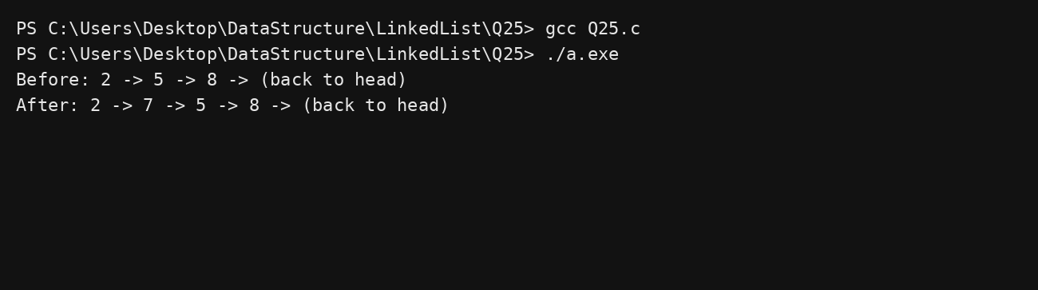

Question 26
Delete beginning (CLL) C Program:
#include <stdio.h> #include <stdlib.h>
struct Node { int data; struct Node* next; }; void print(struct Node* h){
if(!h) return; struct Node* t=h;
do{ printf("%d ‐> ", t‐>data); t=t‐>next; }while(t!=h);

printf("(back to head)\n");
}
int main(){int a[]={2,5,8}; struct Node*h=NULL,*t=NULL;
for(int i=0;i<3;i++){struct Node*n=malloc(sizeof(*n)); n‐>data=a[i]; n‐>next=NULL; if(!h)h=t=n; else t‐>next=n,t=n;} t‐>next=h;
printf("Before: "); print(h);
struct Node*del=h; h=h‐>next; t‐>next=h; free(del); printf("After: "); print(h); return 0;}
Output:
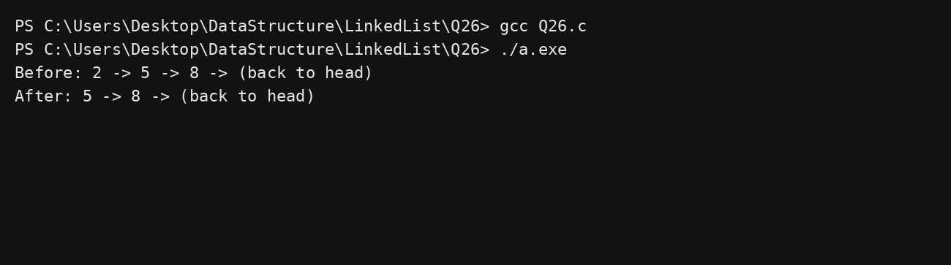

Question 27
Delete middle (CLL) C Program:
#include <stdio.h> #include <stdlib.h>
struct Node { int data; struct Node* next; }; void print(struct Node* h){
if(!h) return; struct Node* t=h;
do{ printf("%d ‐> ", t‐>data); t=t‐>next; }while(t!=h); printf("(back to head)\n");
}
int main(){int a[]={2,5,8}; struct Node*h=NULL,*t=NULL;
for(int i=0;i<3;i++){struct Node*n=malloc(sizeof(*n)); n‐>data=a[i]; n‐>next=NULL; if(!h)h=t=n; else t‐>next=n,t=n;} t‐>next=h;
printf("Before: "); print(h);
struct Node*x=h; struct Node*del=x‐>next‐>next; x‐>next‐>next=del‐>next; free(del); printf("After: "); print(h); return 0;}
Output:

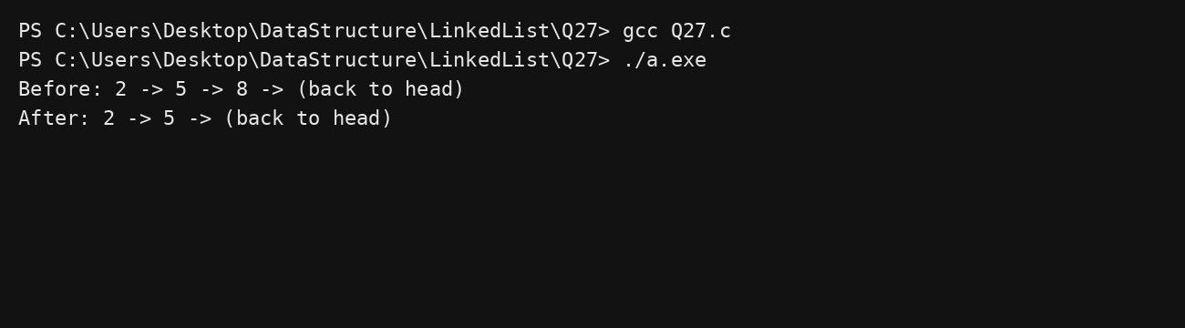

Question 28
Delete end (CLL) C Program:
#include <stdio.h> #include <stdlib.h>
struct Node { int data; struct Node* next; }; void print(struct Node* h){
if(!h) return; struct Node* t=h;
do{ printf("%d ‐> ", t‐>data); t=t‐>next; }while(t!=h); printf("(back to head)\n");
}
int main(){int a[]={2,5,8}; struct Node*h=NULL,*t=NULL;
for(int i=0;i<3;i++){struct Node*n=malloc(sizeof(*n)); n‐>data=a[i]; n‐>next=NULL; if(!h)h=t=n; else t‐>next=n,t=n;} t‐>next=h;
printf("Before: "); print(h);
struct Node*x=h; while(x‐>next!=t) x=x‐>next; x‐>next=h; free(t); t=x; printf("After: "); print(h); return 0;}
Output:
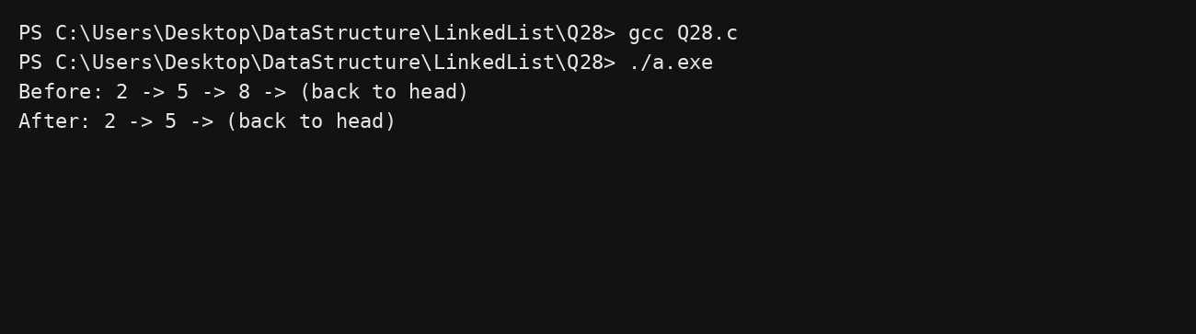

Question 29
Search in CLL C Program:
#include <stdio.h> #include <stdlib.h>
struct Node { int data; struct Node* next; }; void print(struct Node* h){
if(!h) return; struct Node* t=h;
do{ printf("%d ‐> ", t‐>data); t=t‐>next; }while(t!=h); printf("(back to head)\n");
}
int main(){int a[]={2,5,9}; struct Node*h=NULL,*t=NULL;
for(int i=0;i<3;i++){struct Node*n=malloc(sizeof(*n)); n‐>data=a[i]; n‐>next=NULL; if(!h)h=t=n; else t‐>next=n,t=n;} t‐>next=h;
printf("CLL: "); print(h);
int pos=1; struct Node*x=h;
do{ if(x‐>data==5){printf("Found at %d\n",pos); break;} pos++; x=x‐>next; }while(x!=h); return 0;}
Output:
