DS Lab Assignment
NAME – SMRUTI RANJAN BEHERA
DATE – 02-02-2026
Reg-No – 2025CA096

Question 1: Library Book Request Management System
A university library maintains a dynamic list of book requests submitted by students. Each
request contains the following details:
● Request ID
● Student Roll Number
● Book ISBN
● Request Date
The system must support the following operations:
1. Add a new request to the end of the list.
2. Remove a request once the book has been issued.
3. Display all pending requests in the order they were received.
4. Count the total number of pending requests.
The library processes requests strictly in the order of arrival, and once a request is fulfilled, it will
never be revisited.
Task
Design and implement an efficient data structure in C to support the above operations.
Write functions for each operation and demonstrate their working using a menu-driven program.
/*
Smruti ranjan Behera
2025ca096
02.02.26
*/
#include <stdio.h>
#include <stdlib.h>
#include <string.h>
struct Request {
int requestId;
int roll;
char isbn[20];
char date[20];
struct Request* next;
};
struct Request* front = NULL;
struct Request* rear = NULL;
void addRequest() {
struct Request* temp = (struct Request*)malloc(sizeof(struct Request));
printf("Enter Request ID, Roll No, ISBN, Date: ");
scanf("%d %d %s %s", &temp->requestId, &temp->roll, temp->isbn, temp->date);
temp->next = NULL;
if (!rear)
front = rear = temp;
else {
rear->next = temp;
rear = temp;
}
}
void removeRequest() {
if (!front) {
printf("No pending requests\n");
return;
}
struct Request* temp = front;
front = front->next;
if (!front) rear = NULL;
free(temp);
}
void displayRequests() {
struct Request* temp = front;
while (temp) {
printf("ID:%d Roll:%d ISBN:%s Date:%s\n",
temp->requestId, temp->roll, temp->isbn, temp->date);
temp = temp->next;
}
}
void countRequests() {
int c = 0;
struct Request* temp = front;
while (temp) { c++; temp = temp->next; }
printf("Total Requests: %d\n", c);
}
int main() {
int ch;
do {
printf("\n1.Add 2.Remove 3.Display 4.Count 0.Exit\n");
scanf("%d", &ch);
if (ch==1) addRequest();
else if (ch==2) removeRequest();
else if (ch==3) displayRequests();
else if (ch==4) countRequests();
} while (ch!=0);
return 0;
}
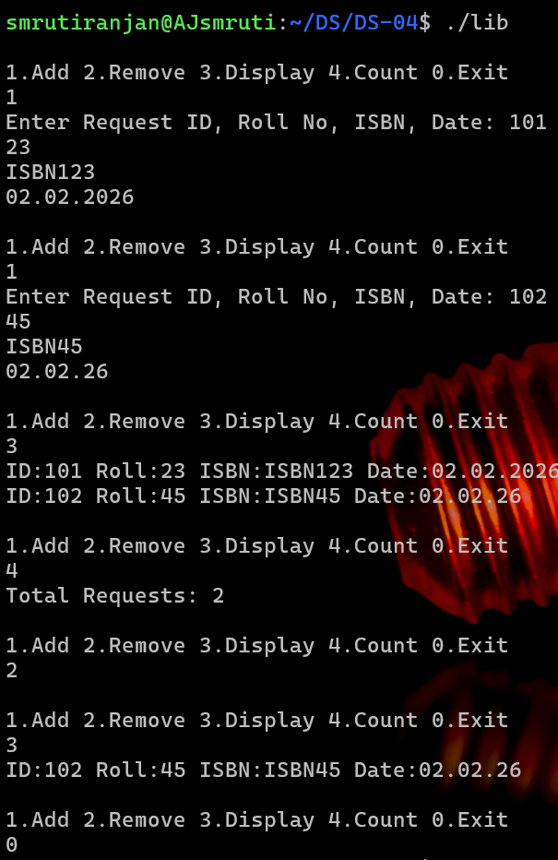
Revised Question 2: Text Editor Undo–Redo System
A text editor maintains a history of user actions to support undo and redo functionality. Each
action contains:
● Action ID
● Action Type (Insert / Delete / Replace)
● Timestamp
● Description of the change
The editor allows the following operations:
1. Perform a new action and add it to the history.
2. Undo the most recent action.
3. Redo an undone action.
4. Delete a specific action from the history.
5. Display the complete action history from the first action to the most recent one.
Once a new action is performed after an undo operation, all actions that were undone must be
permanently discarded.
Navigation through the action history must support moving both backward and forward efficiently
without restarting from the beginning.
Task
Select an appropriate dynamic data structure and implement the above functionality in C.
Your implementation should correctly handle edge cases such as undoing the first action,
redoing the last action, and deleting the current action.
/*
Smruti ranjan Behera
2025ca096
02.02.26
*/
#include <stdio.h>
#include <stdlib.h>
#include <string.h>
struct Action {
int id;
char type[10];
char desc[50];
struct Action* prev;
struct Action* next;
};
struct Action* head = NULL;
struct Action* current = NULL;
void performAction() {
struct Action* temp = (struct Action*)malloc(sizeof(struct Action));
printf("Enter ID, Type, Description: ");
scanf("%d %s %[^\n]", &temp->id, temp->type, temp->desc);
temp->next = NULL;
temp->prev = current;
if (current)
current->next = temp;
else
head = temp;
current = temp;
}
void undo() {
if (current)
current = current->prev;
else
printf("Nothing to undo\n");
}
void redo() {
if (current && current->next)
current = current->next;
else
printf("Nothing to redo\n");
void display() {
struct Action* temp = head;
while (temp) {
printf("ID:%d Type:%s Desc:%s\n", temp->id, temp->type, temp->desc);
temp = temp->next;
}
}
int main() {
int ch;
do {
printf("\n1.Perform 2.Undo 3.Redo 4.Display 0.Exit\n");
scanf("%d", &ch);
if (ch==1) performAction();
else if (ch==2) undo();
else if (ch==3) redo();
else if (ch==4) display();
} while (ch!=0);
return 0;
}
