ROLL NO: 73

Assignment 3:- Application in Appex Programming

STEP1:- Open and login to Salesforce.com

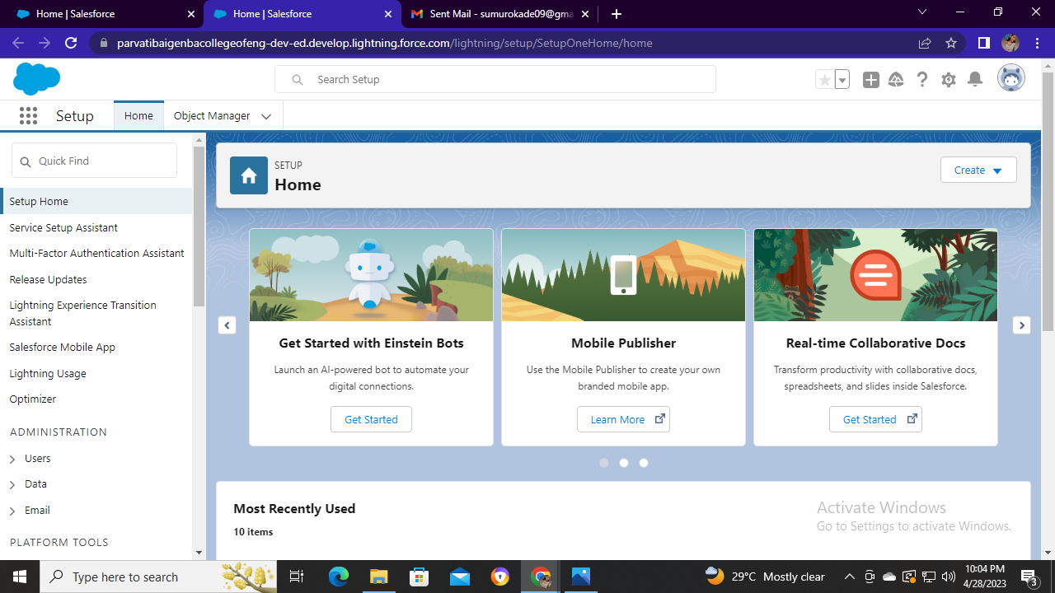

STEP2:- Click on settings icon ‘setup’ and then click on open developer console

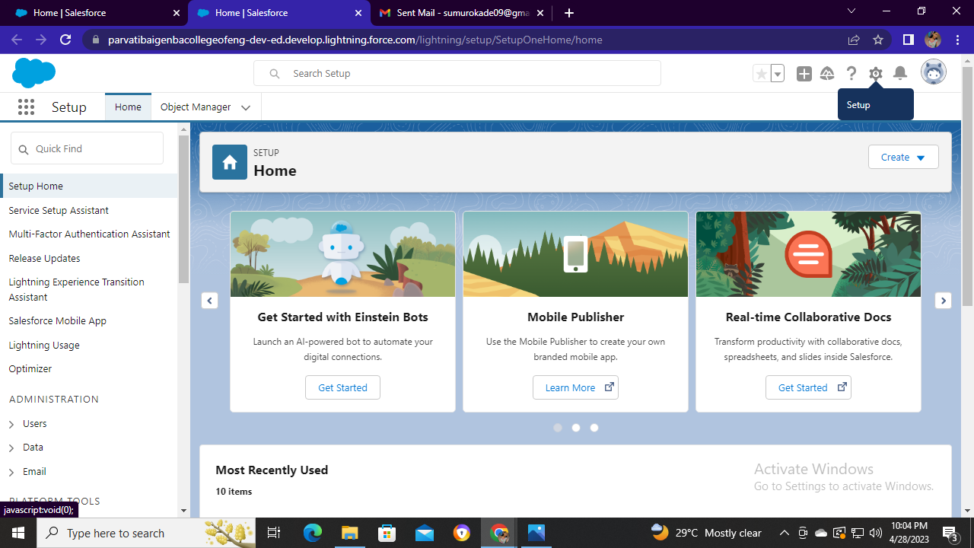

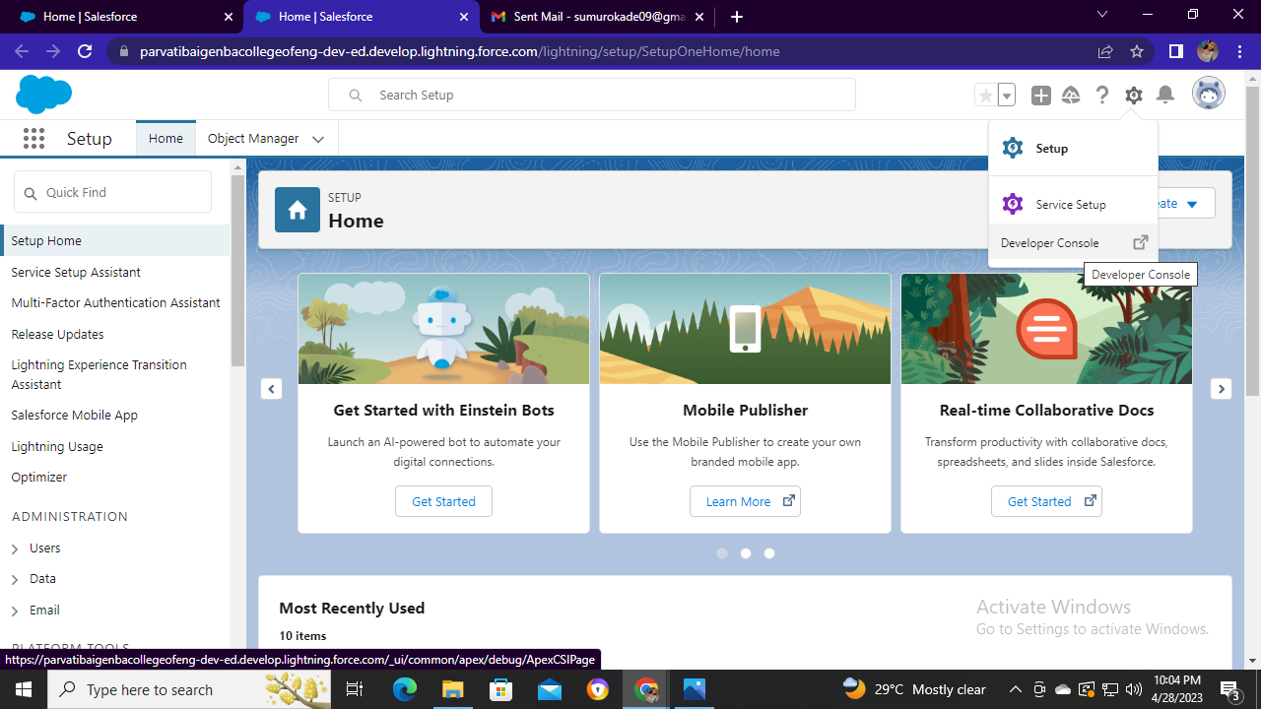

STEP3:- After opening developer console you will see the interface as below image

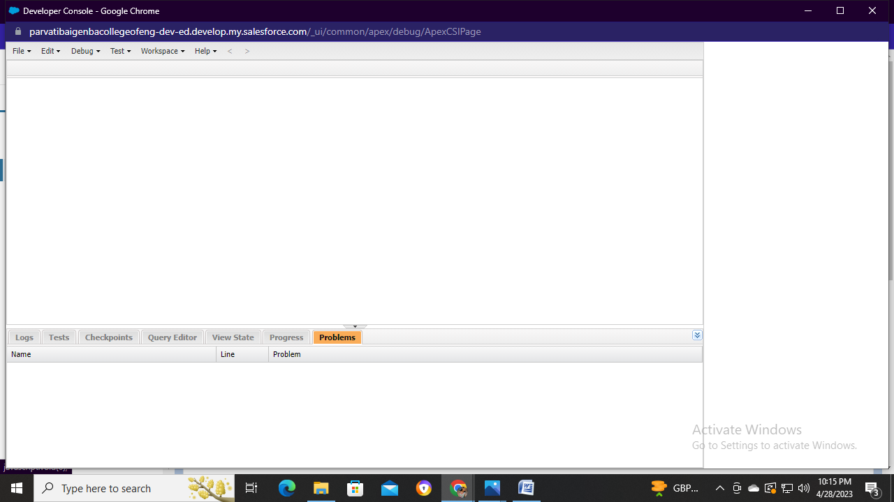

STEP4:- Then click on file then click on new and then click apex class

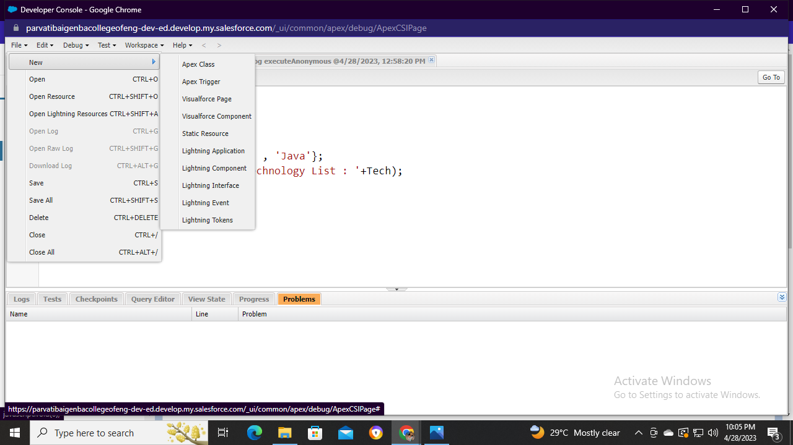

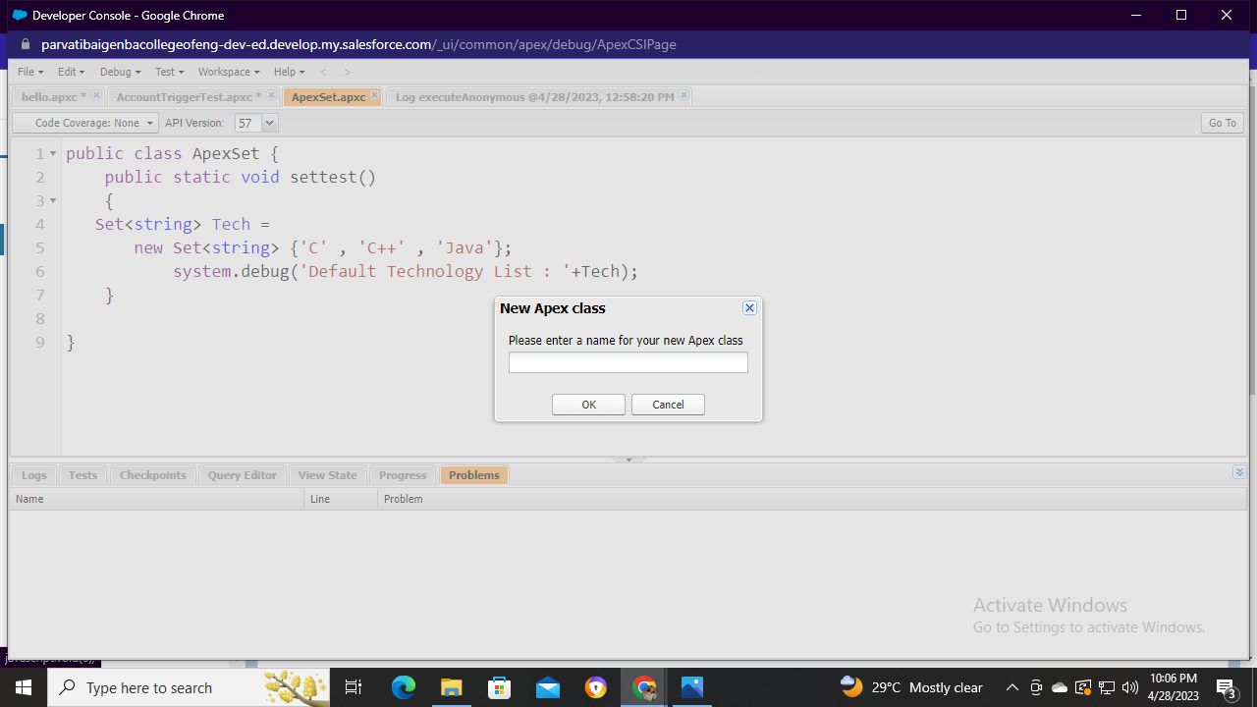

Enter new apex class and create a program

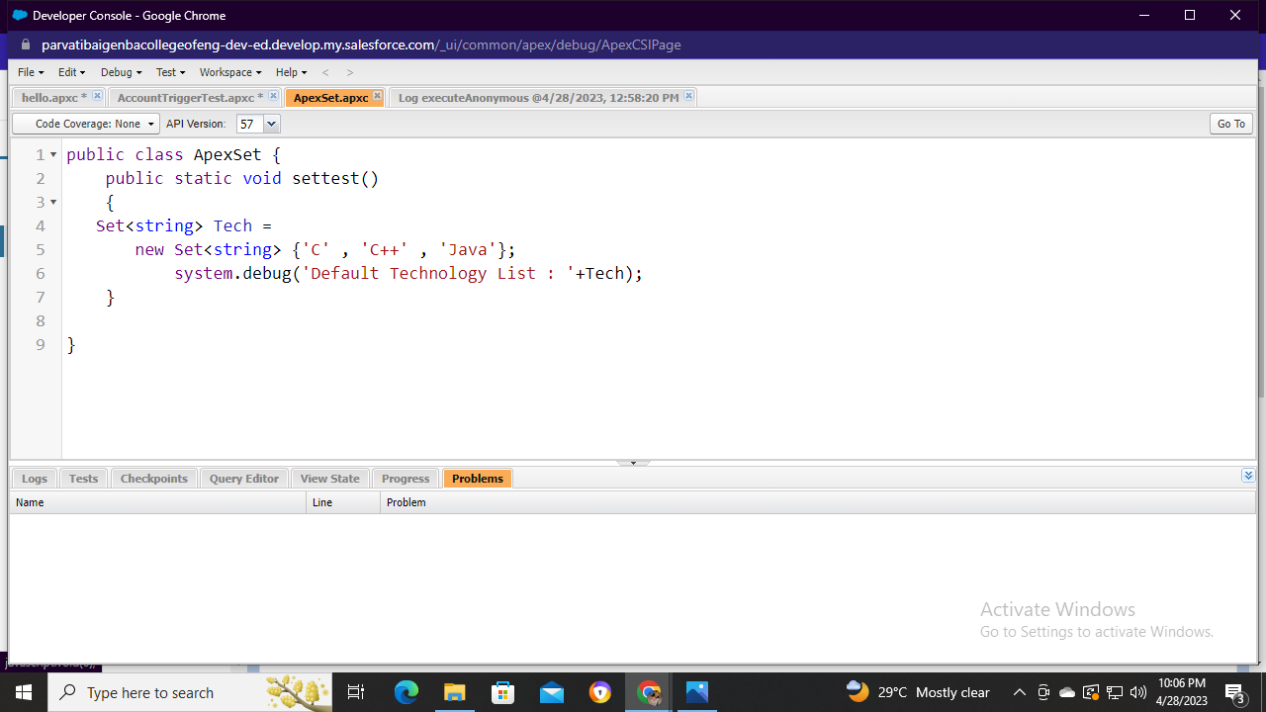

STEP5:-Then debug the existing code and click on open execute anonymous window

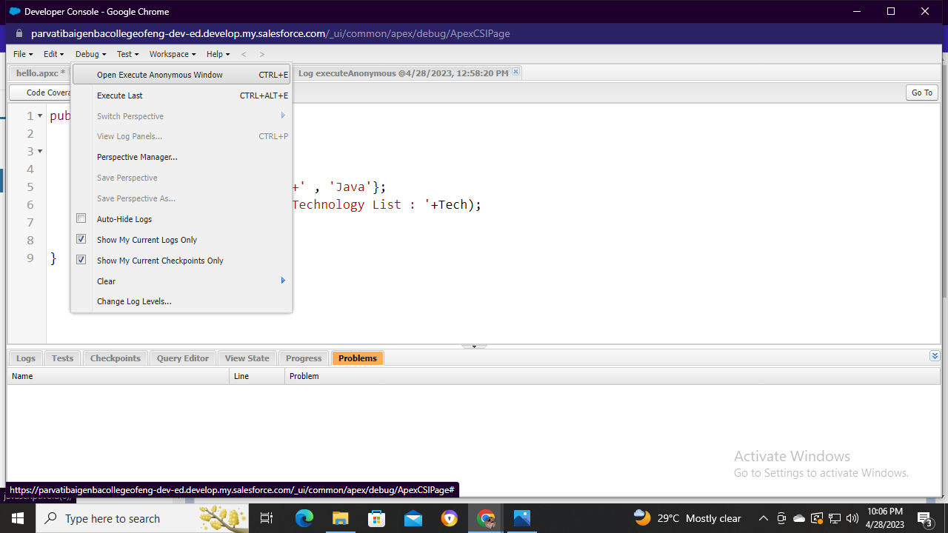

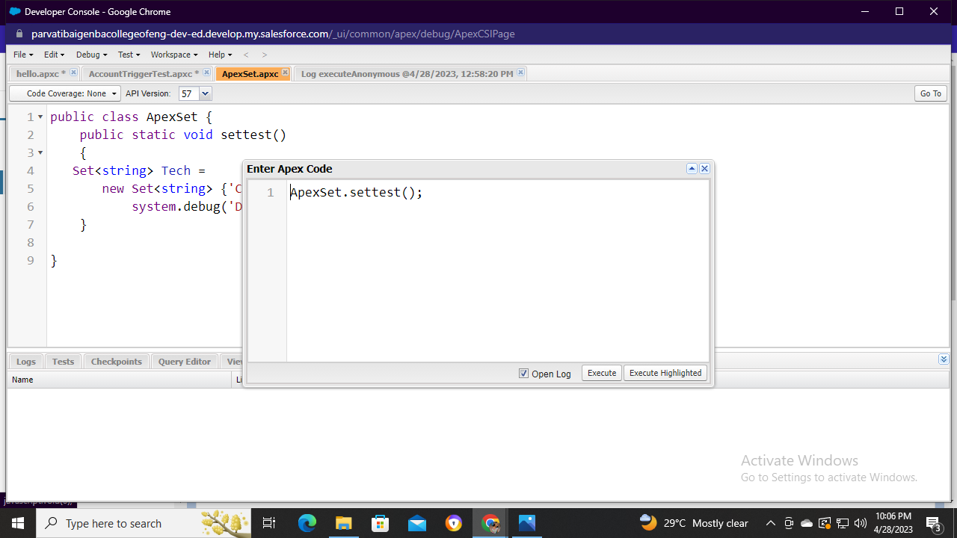

Write your class name and click on open log to execute

STEP6:-After debugging your interface will appear as image below

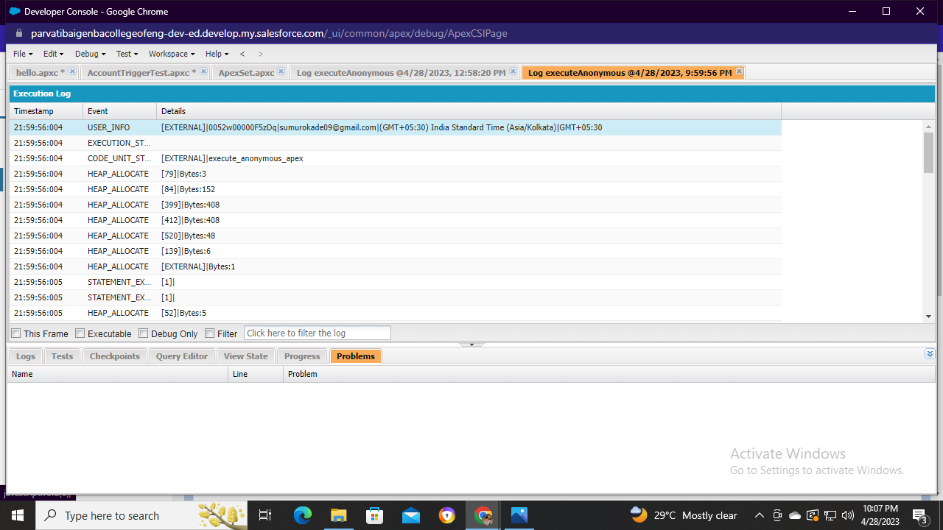

Then click on debug only

