**Roll_No: 58**

**AssignmentNo:**2

## TitleofAssignment:

InstallationandconfigureGoogleAppEngine.

## Objective:

1. InstallandConfigureGoogleAppEngine
2. CreateasimplecodeinpythononGithubandexecuteonGoogleAppEngine
3. **Outcome:**UsetoolsandtechniquesintheareaofCloudComputing

Step 1:

Sing in to google:

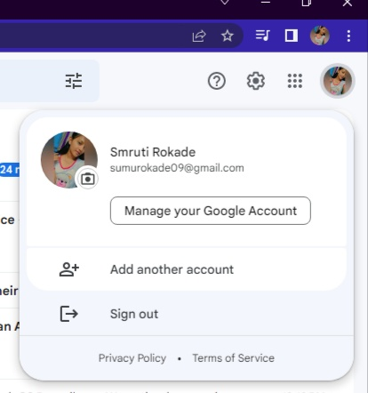

Step 2:

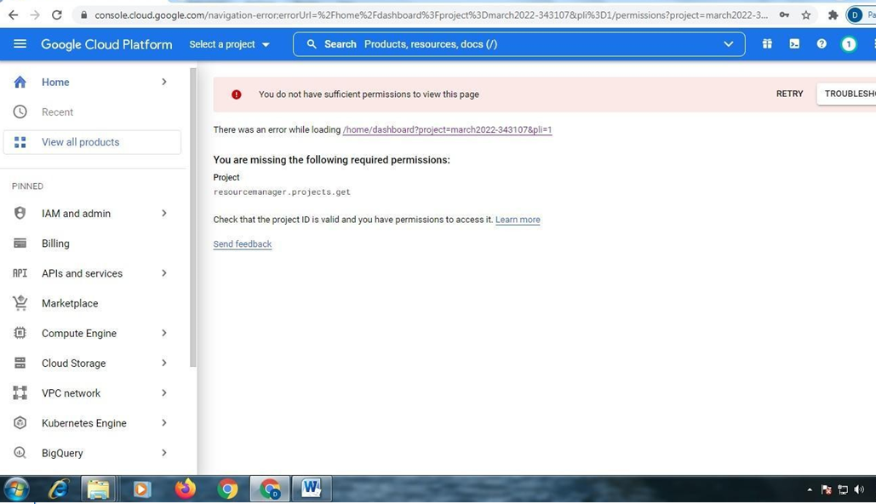

Step 3:

Click on new

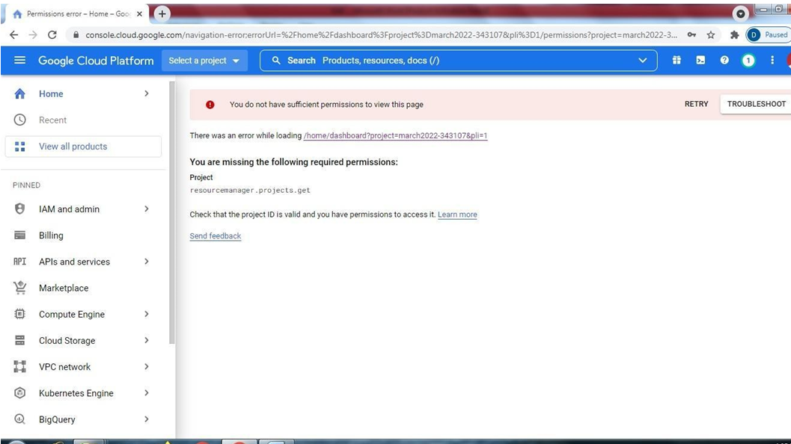

Step 4:

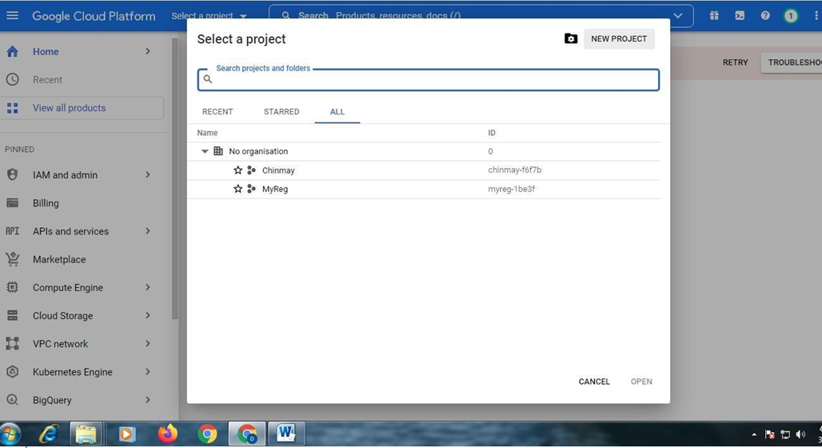

Step 5:

Click on create:

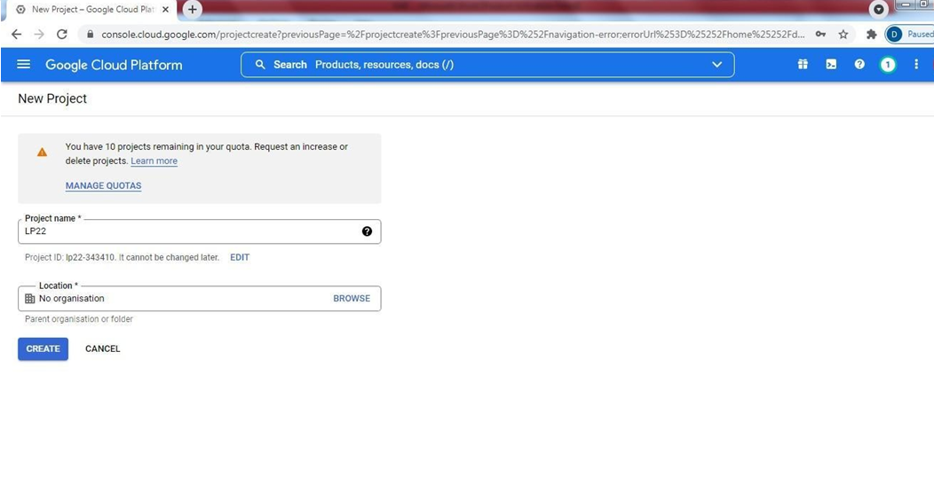

Step 6:

Select Project:

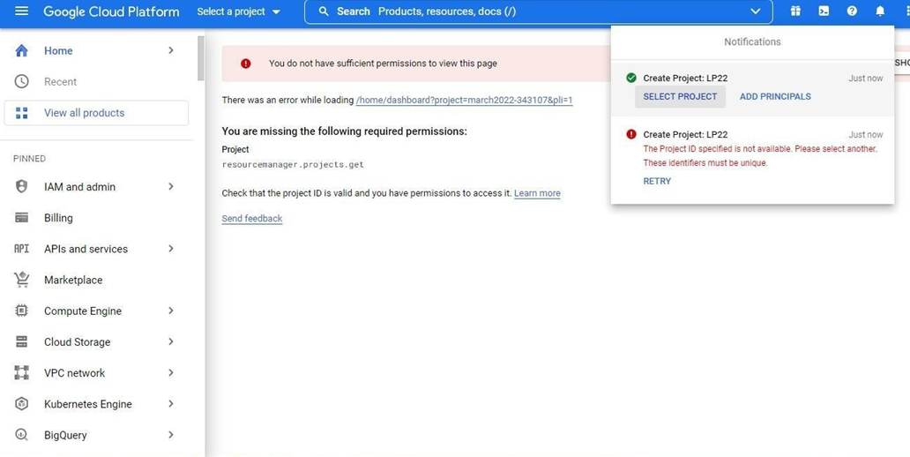

Step 7:

In search tab type App Engine:

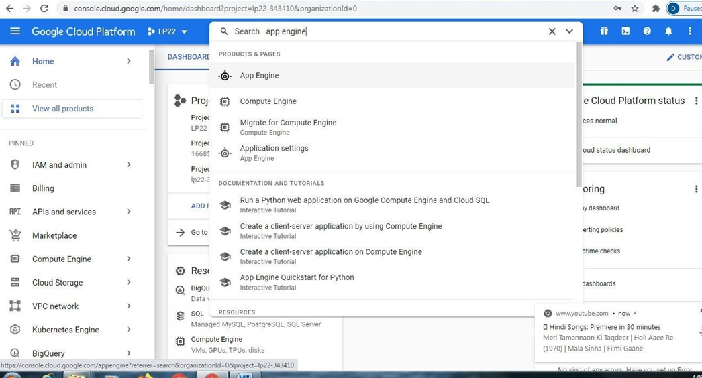

Step 8:

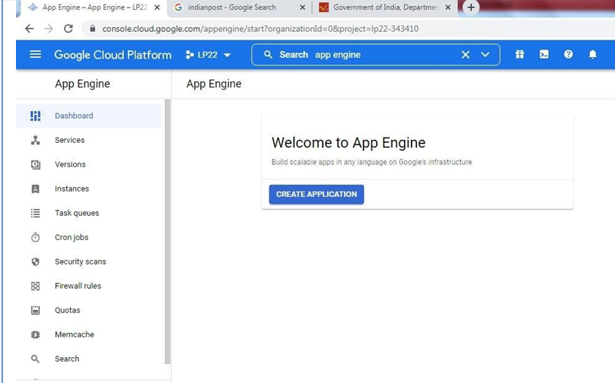

Step 9:

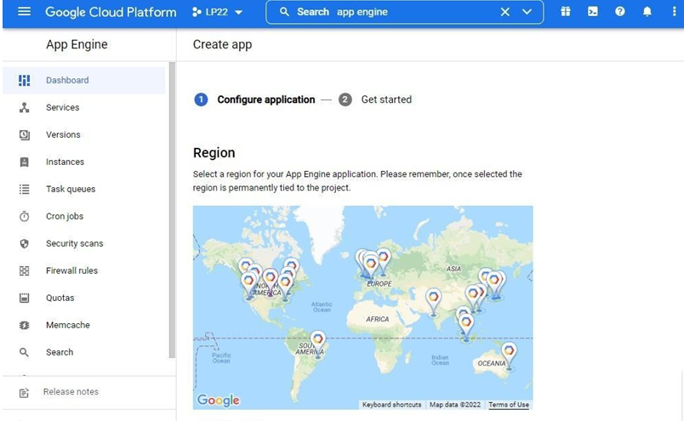

Scroll down

Step 10:

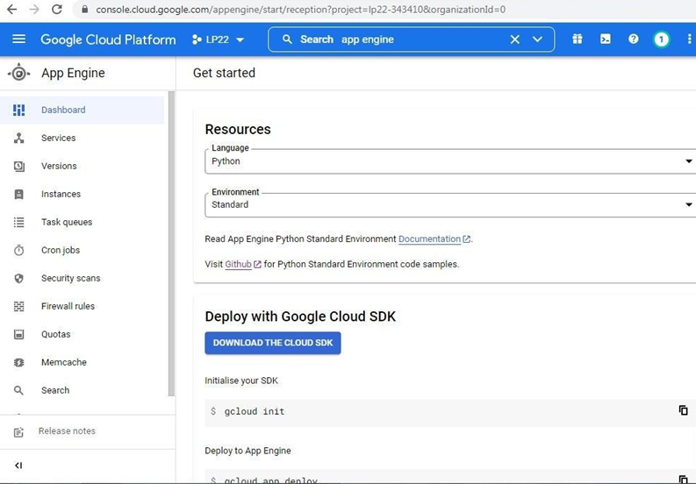

Step 11:

Click on I’ll be later

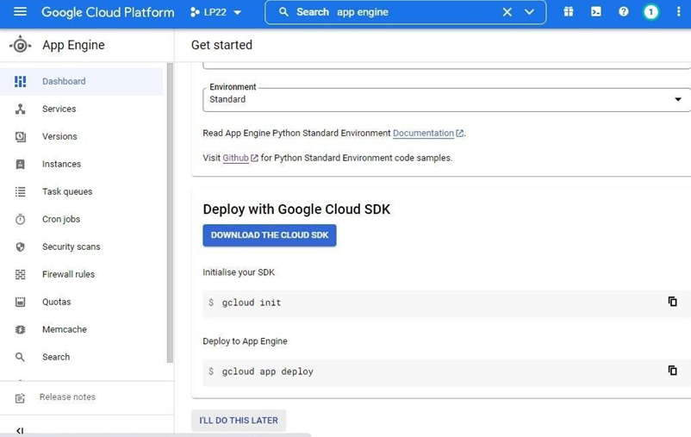

Step 12:

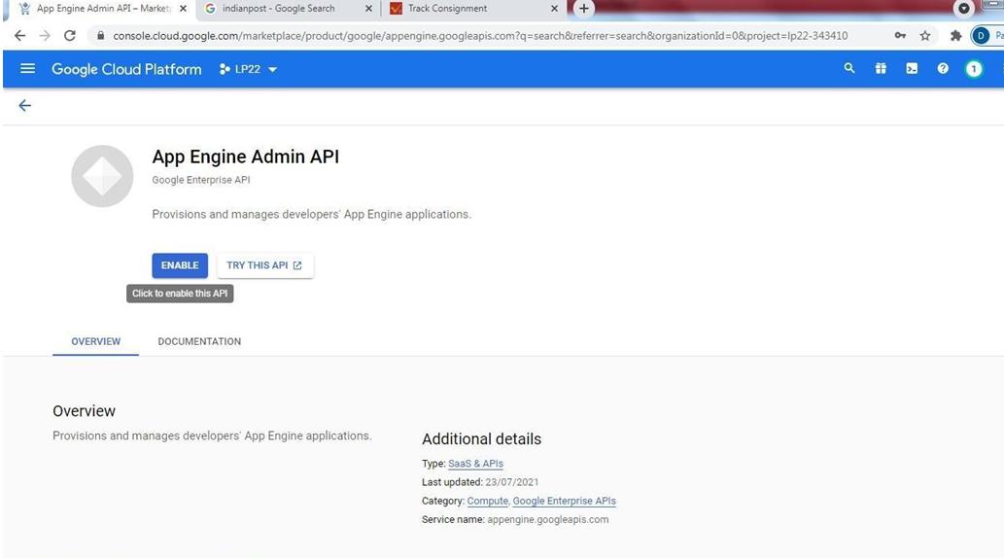

Step13:

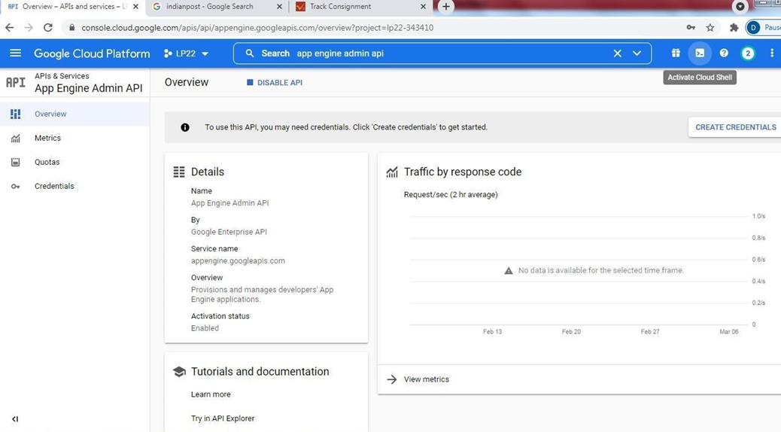

Step 14:

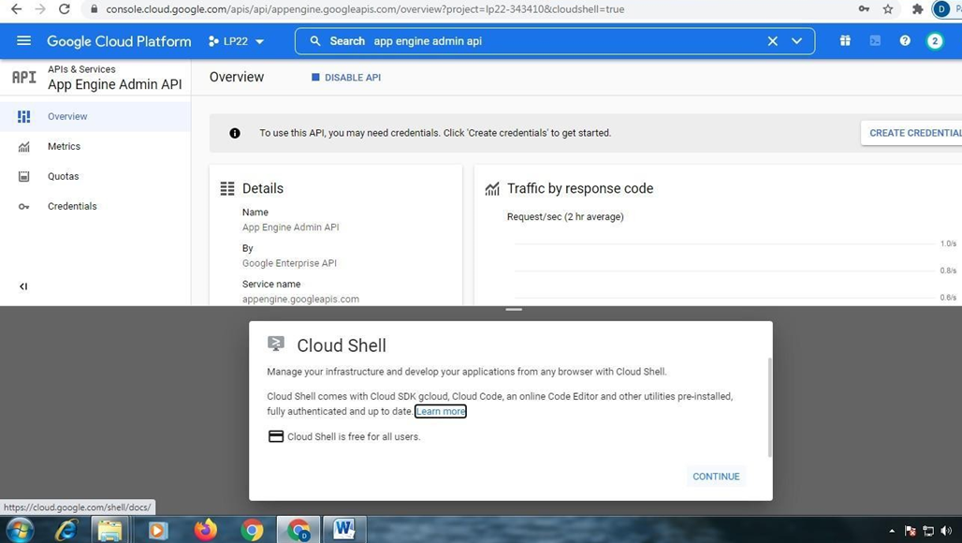

Step 15:

Gotocloudplatform□type―gitcloneǁ{PasteURLHere}

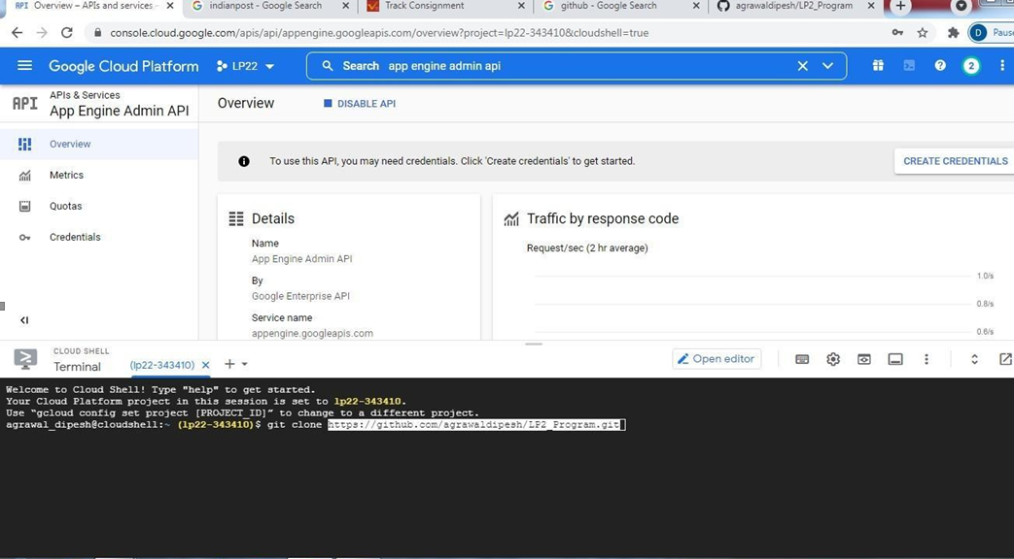

Step 15:

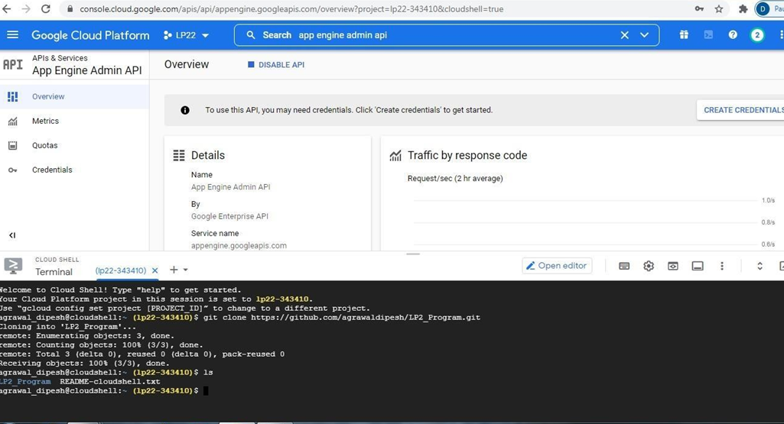

Step 16:

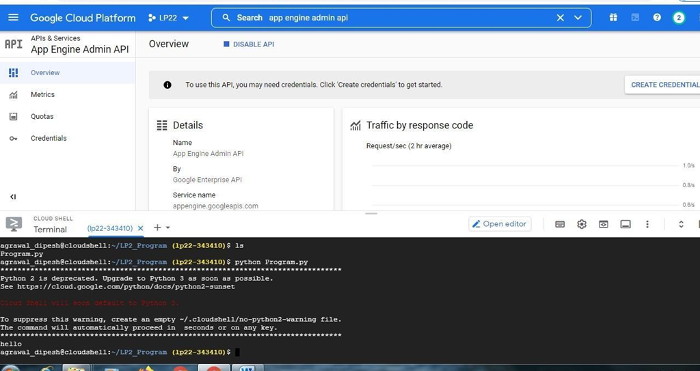

Step 18: