ROLL NO:- 73

Assignment 4:- Custom Application in Salesforce.com

STEP1: Open and login to salesforce.com

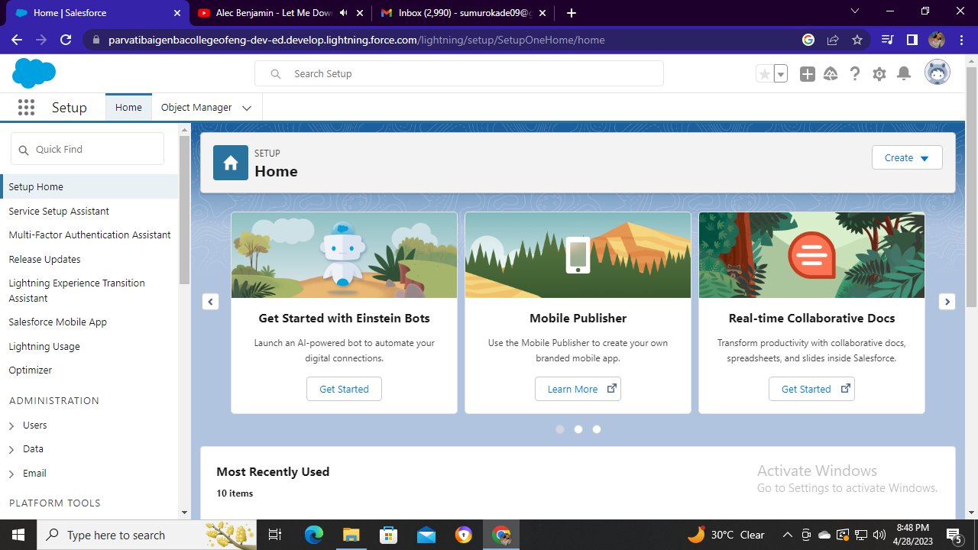

STEP2:- Go to search menu and search for ‘app manager’

Then the interface looks like below image

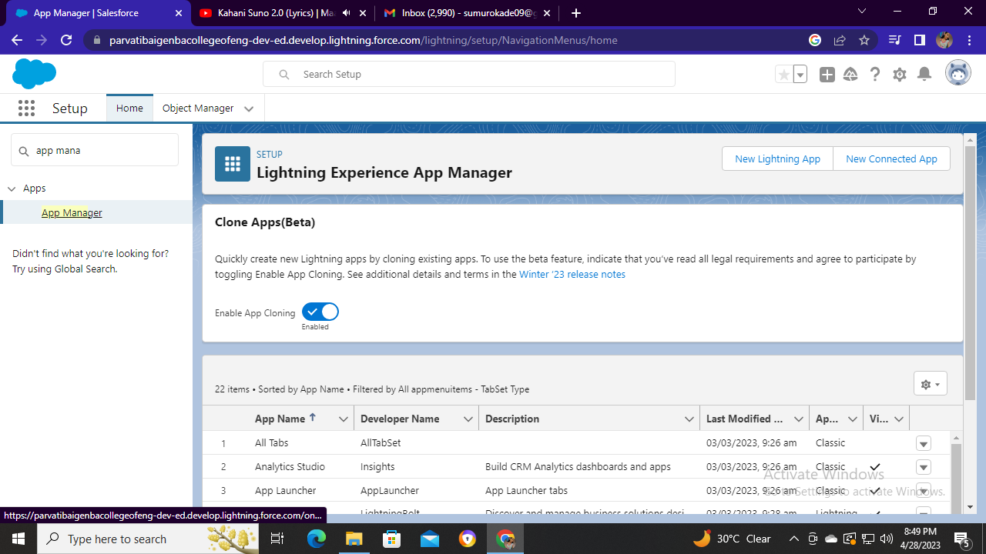

STEP3:- Then click on ‘New Lightning App’ in the right side corner

After clicking the interface looks like below image

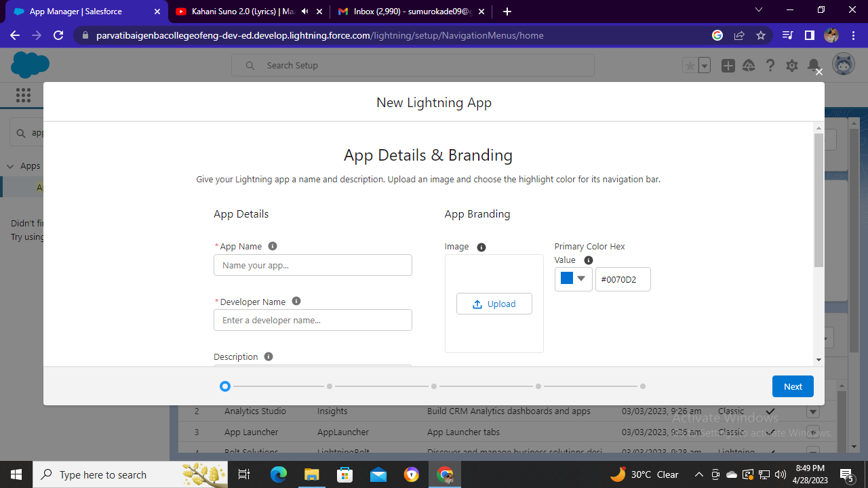

STEP4:- Then create an application you want to create

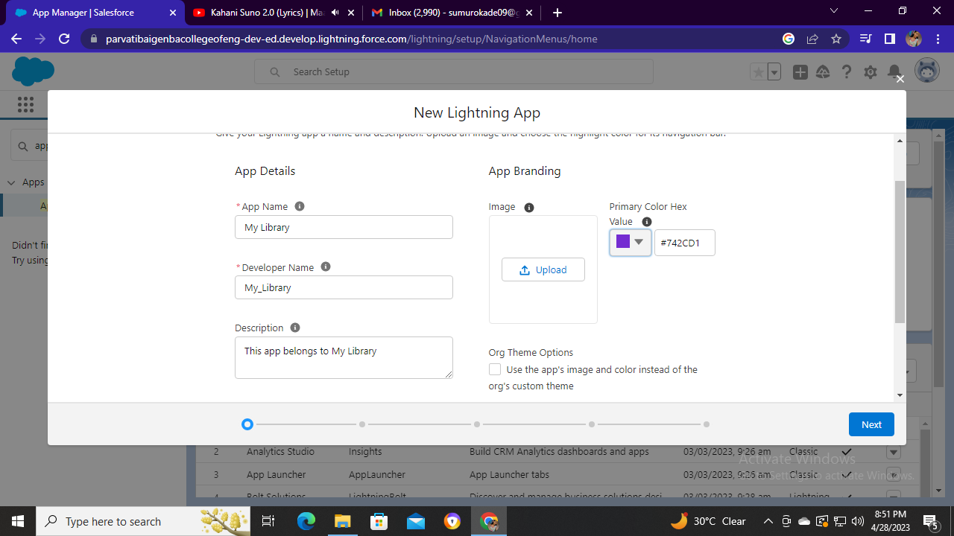

STEP5:- Then click on next and insert the utility items you want

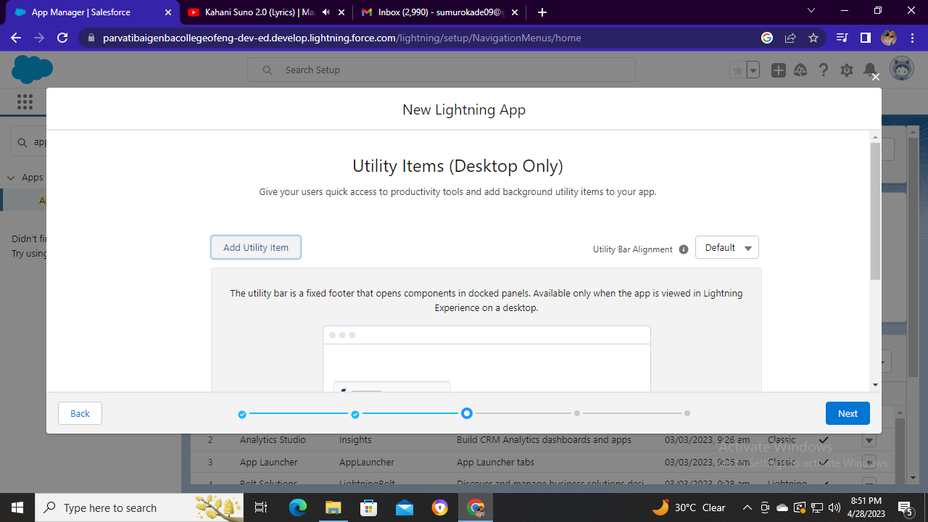

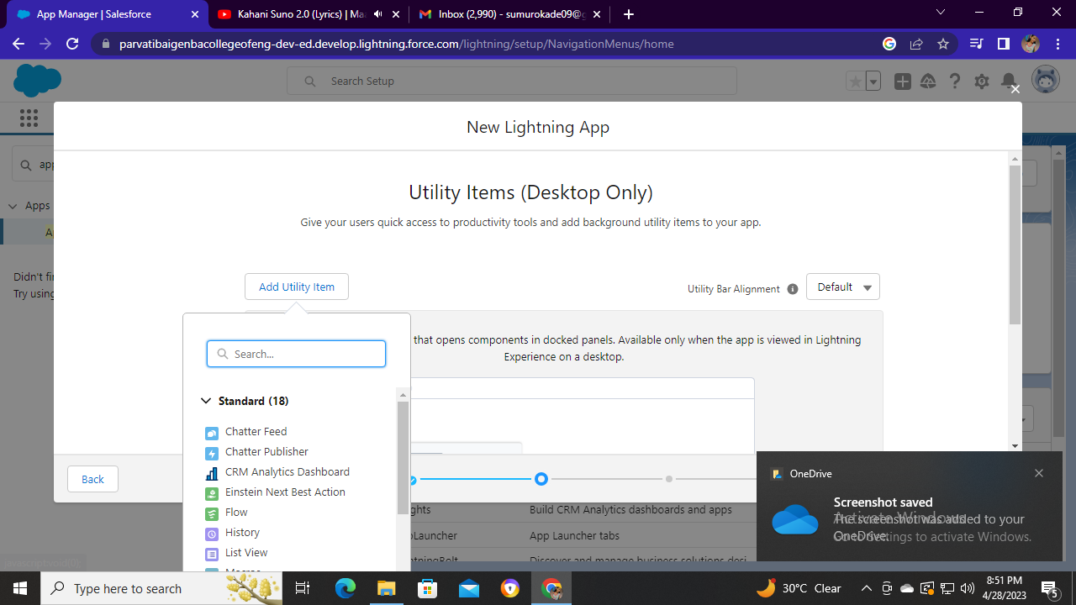

STEP6:- Then click on next to insert navigation items

You can select as per your requirement

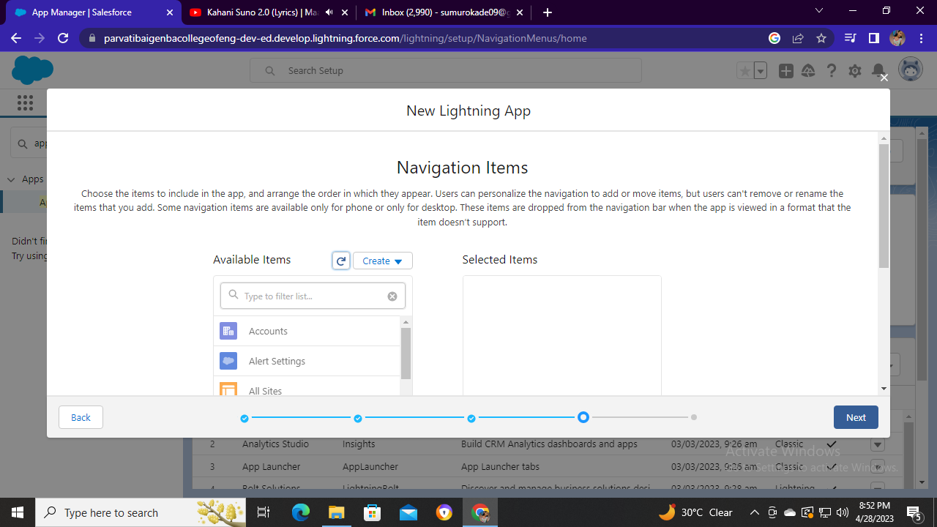

Step7:- Then select user profile as I have selected ‘System Administrator’ for my application

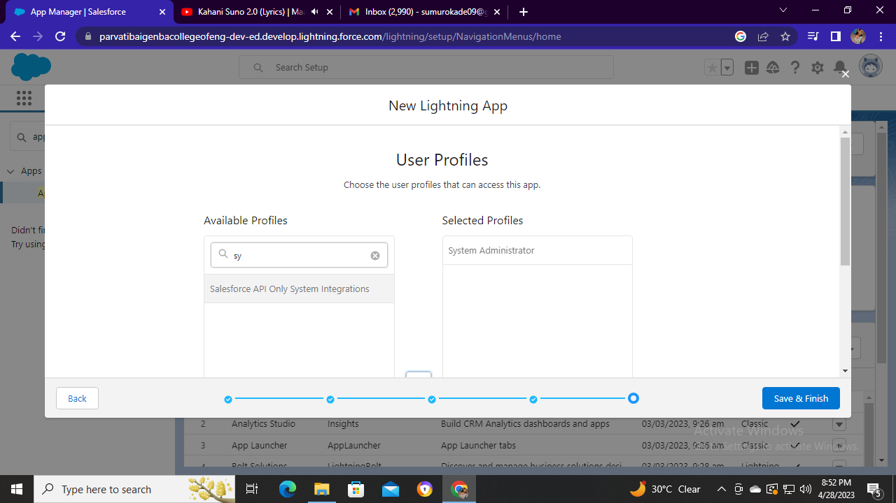

Then click on save and finish and your custom app is created

STEP8:- You can see your custom app is created in app manager after creation as ‘My Library’

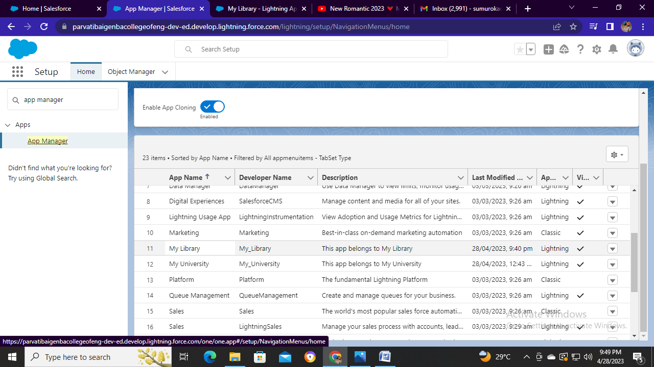

STEP9:- Now you can click on app launcher in left side corner to view your app is existing

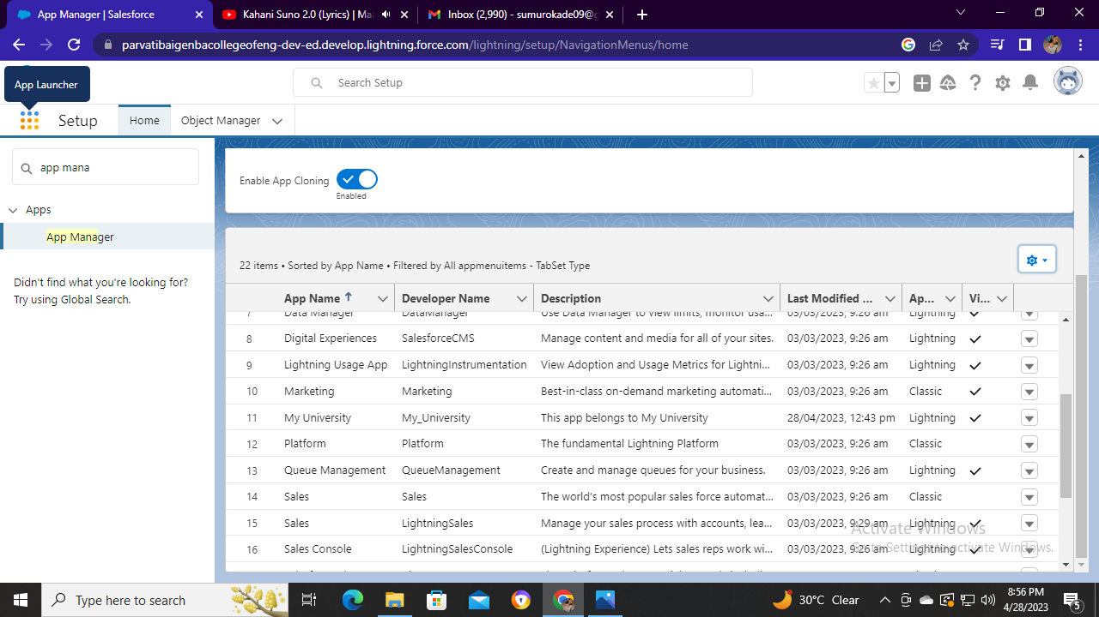

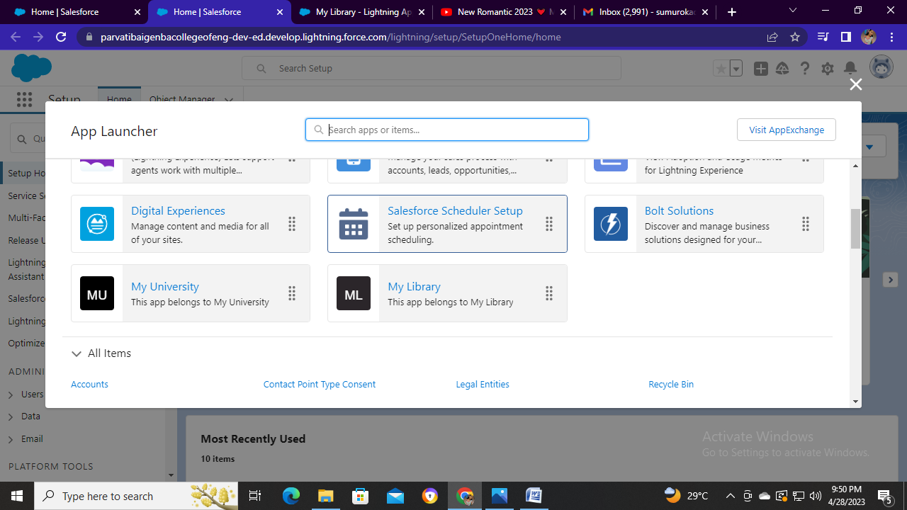

STEP10:- Your app is created and you can see your interface as below image

