Casting from Meta Quest
Casting allows you to display what the user sees inside the headset on another device such as a phone, computer, or TV. Before starting, make sure that all devices are connected to the same Wi-Fi network and, if applicable, that they are logged into the same Meta account.

Contents
- headset-preparation
- Set up the Chromecast
- Cast to a TV using Google Chromecast
- Tips

Set up the Chromecast
- Plug the Chromecast into an HDMI port on the TV.
- Connect the Chromecast’s USB power cable (either to the TV’s USB port or a wall outlet).
- Turn on the TV and select the HDMI input where the Chromecast is connected.
- Open the Google Home app on your phone.
- Tap “+ → Set up device → New device” and follow the instructions:
  - Allow Bluetooth and location access.
  - Confirm the code shown on the TV.
  - Connect Chromecast to your Wi-Fi network.
- Wait for the device to update and complete setup.
- Once done, your TV will show the Chromecast home screen. .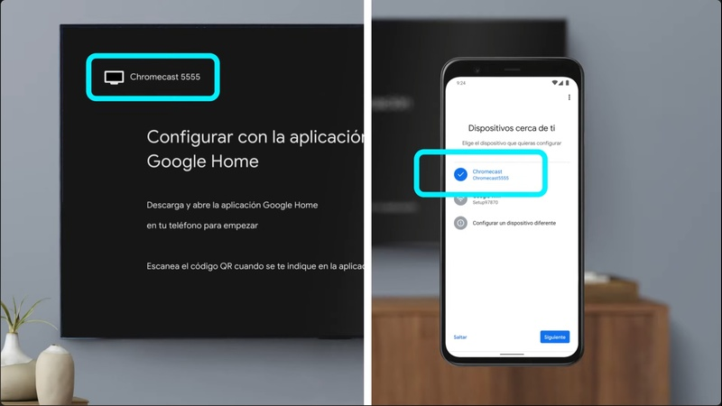

Cast to a TV using Google Chromecast
Requirements
- A Google Chromecast device (or a smart TV with Chromecast built-in).
- The Google Home app installed on your phone.
- All devices on the same Wi-Fi network.

Cast from the Meta Quest headset
- Put on your Meta Quest 2 or 3 headset.
- Press the Meta (Oculus) button on the right controller to open the Universal Menu.
- Select the clock on the left-hand side to open Quick Settings.
- Tap Cast.
- In the list of devices, select your Chromecast or TV.
- Select Next, and the TV will begin showing the headset display.
To stop casting
- Open Quick Settings → Cast → Stop Casting.
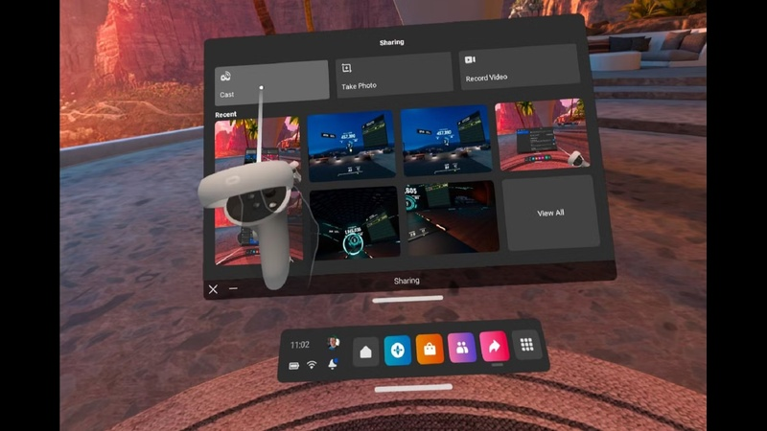
Cast to tv

Tips
- If casting doesn’t appear, verify all devices are on the same Wi-Fi network and frequency band (2.4GHz or 5GHz).
- Restart your headset, Chromecast, or router if the device list doesn’t update.
- For best performance, keep all devices close to the Wi-Fi router.
- You can also cast to the Meta Quest Link app on PC if it’s connected to the headset.

