**Protecting Your Estate: insurance amount options**

**Protecting Your Estate** presentation in Toolkit Direct projects your tax liability and total liability in the future. Your liability for which your estate will be responsible usually grows each year as your assets grow.  Buying life insurance now will protect your estate when the time comes.

**How much insurance do you need for this growing requirement?**

One approach is to purchase a permanent life insurance policy with the Face + Fund feature and a short premium payment period where death benefit grows over time. You need to start with an initial face amount that would grow to match your needs at Life Expectancy.

Here is a way to explore this approach with trial and error:

* Make a note of the insurance amount required Today and at Life Expectancy
* Save your work
* Open **Life Insurance Funding Options** presentation with the default values
* You can simply start with Insurance Needs of Today as the new Face Amount, select a short-pay premium, and adjust the Face Amount and Premium amount/duration to get to the desired death benefit at Life Expectancy.
* You can also select Fix Premium; where detailed steps are shown below: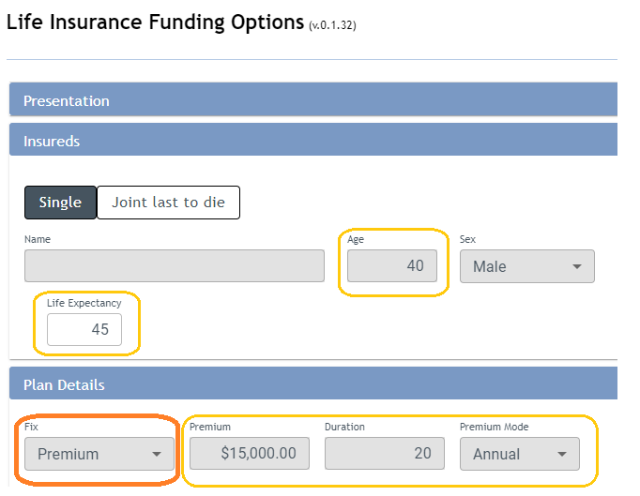

* Select a Permanent plan and note the calculated Initial Face Amount based on your Premiums. Let us target a face Amount of 700,000 at Life Expectancy.

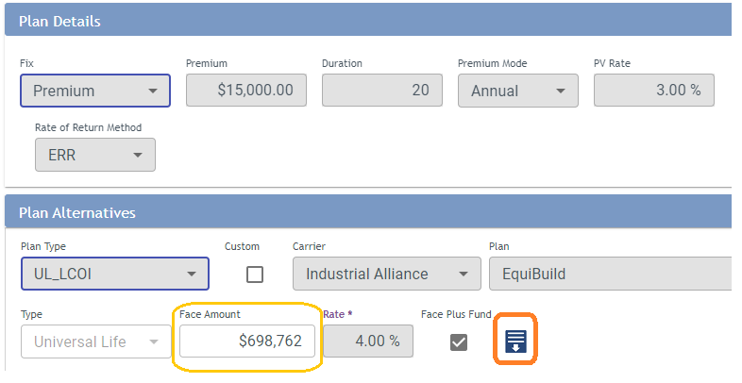

* Open the projection grid; focus on the death benefit at life expectancy (age 84)

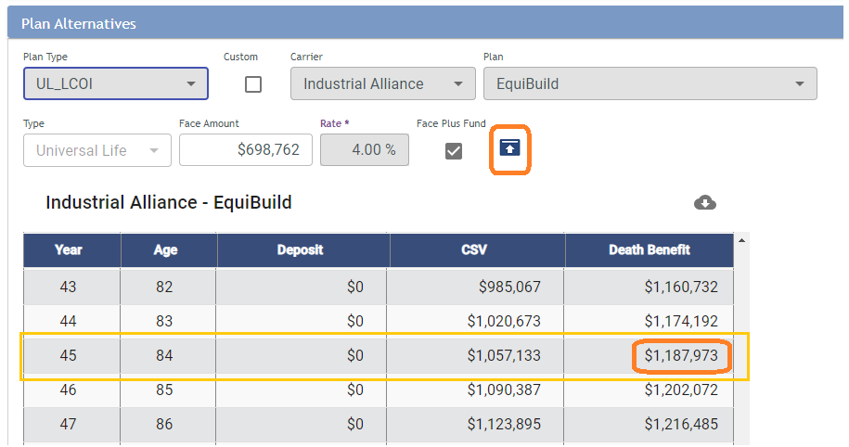

* Now start the trial and error by changing the premium amount (and/or duration) until you hit the desired value of $700,000 at age 84:
  + with default premium death benefit is 1,187,973
  + reducing the premium to 10,000 results in 770,608
  + reducing the premium to 9,000 results in 693,548
  + increase the premium to 9,100 to get 701,254, which is good enough.
* You may continue with other durations and other permanent plans
* The resulting initial Face Amount for your insurance purchase (in this case 413,036 to be rounded) will usually be above your needs if death occurs today but will satisfy insurance needs for other years up to Life Expectancy and beyond.

