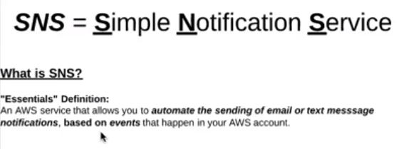

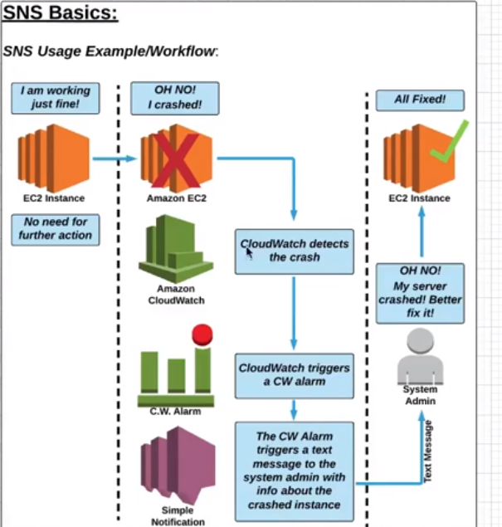

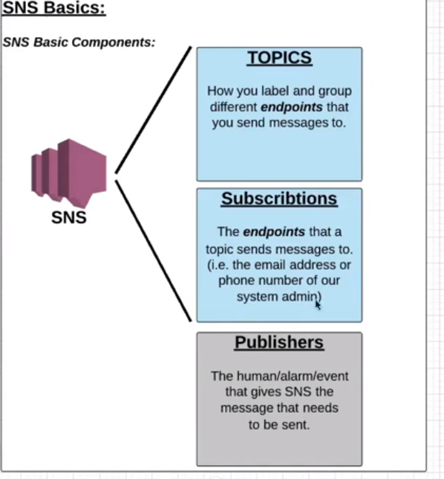

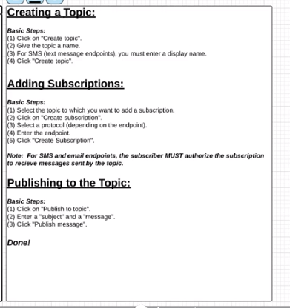

**HOW TO CREATE SNS**

**Step-1: Click on create topic**

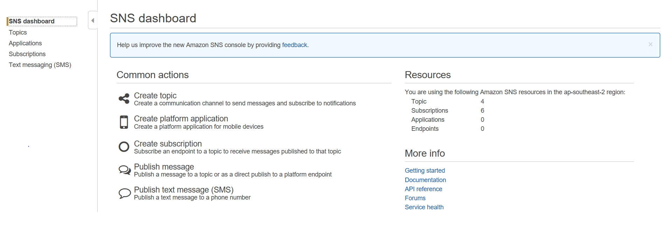

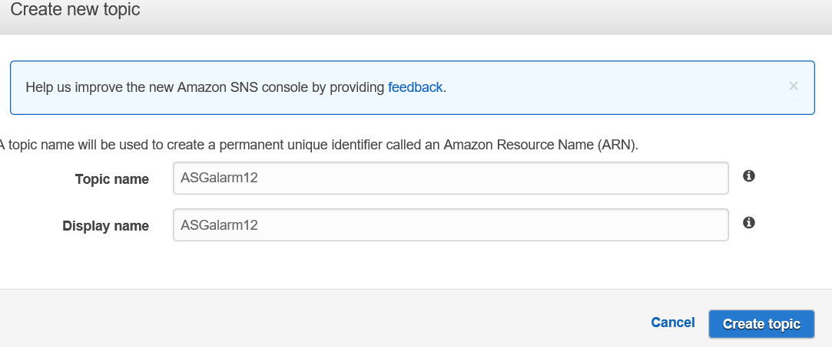

Give topic name and display name and click on create topic.

**STEP 2**: Next you will be taken to this window. **Click on create subscription**

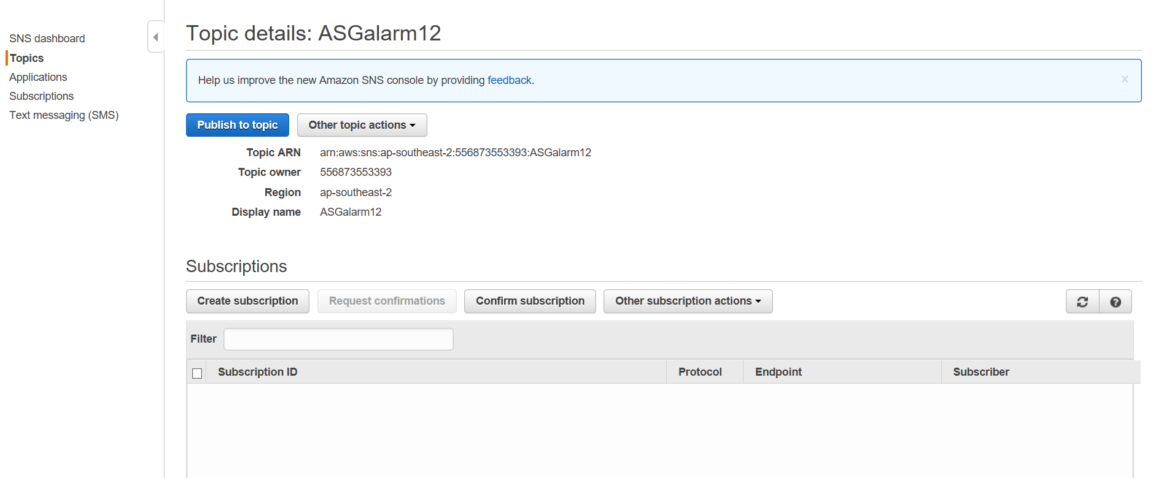

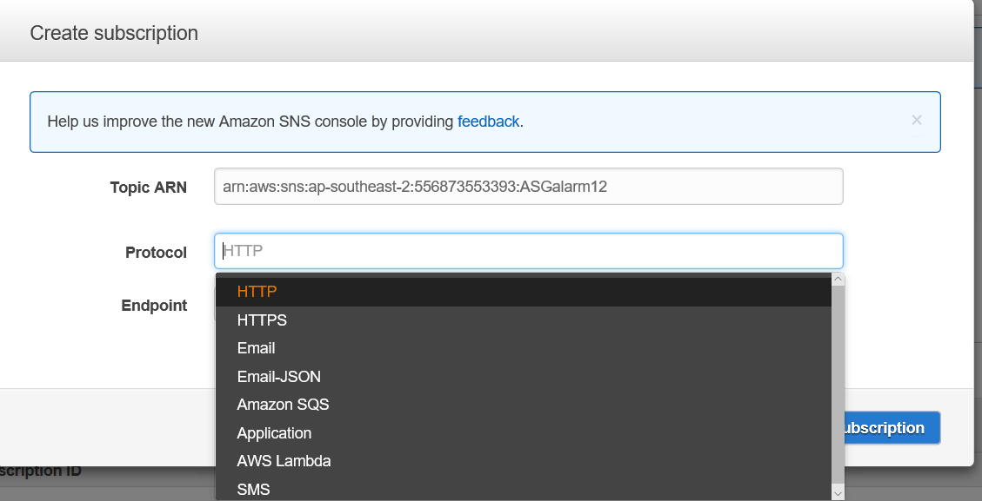

You will have to choose any of the protocol how you wants the message to be sent to example: email and then click on create subscription.

It would appear like below if you have selected email.

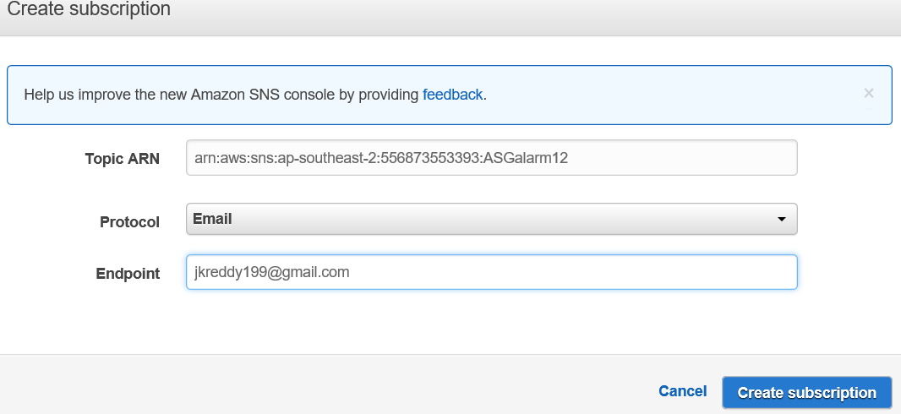

Next it would show as pending. Open email and click on subscription and then pending status will go.

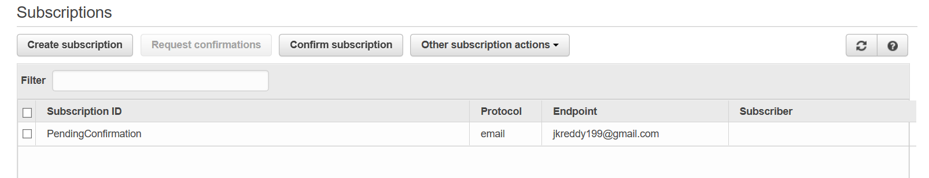

**Step 3: Next select subscription ID and click on publish to topic**

