Q.1)

1. Bisection Method:

* f(x) = $600x^{4 }-550x^{3}+200x^{2}-20x-1$
* xl=0.1, xu=1.0
* 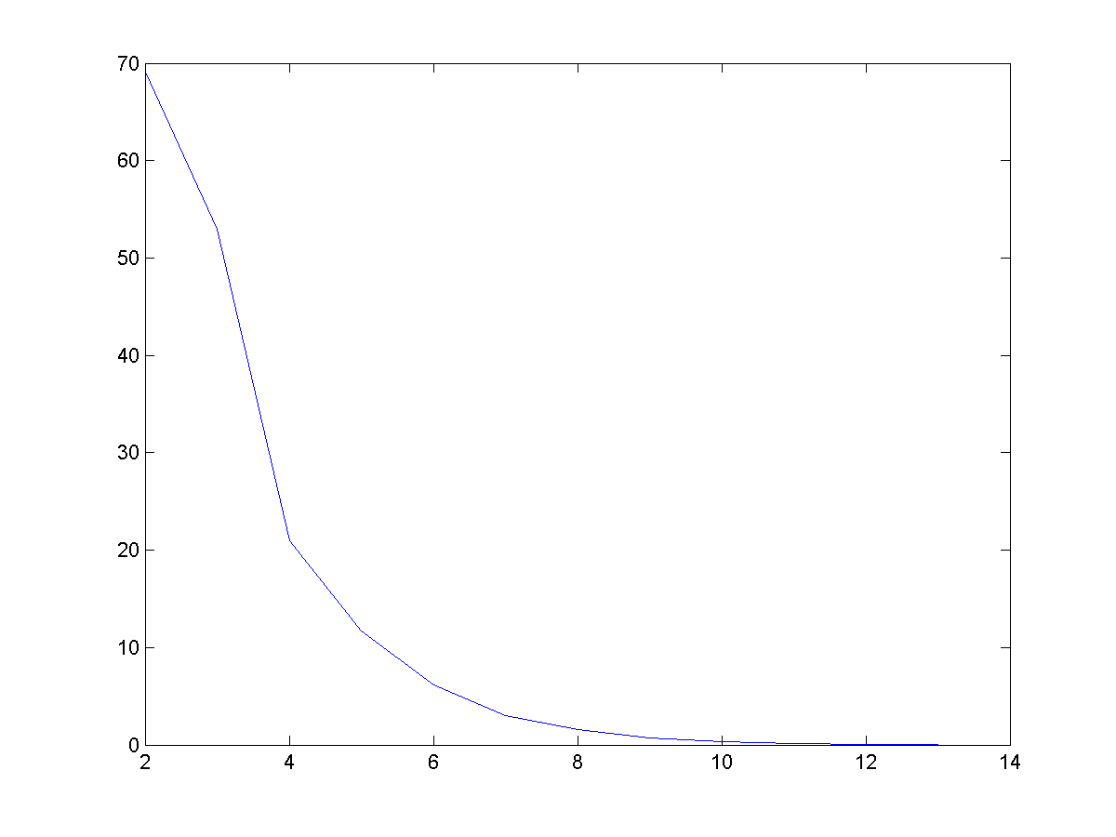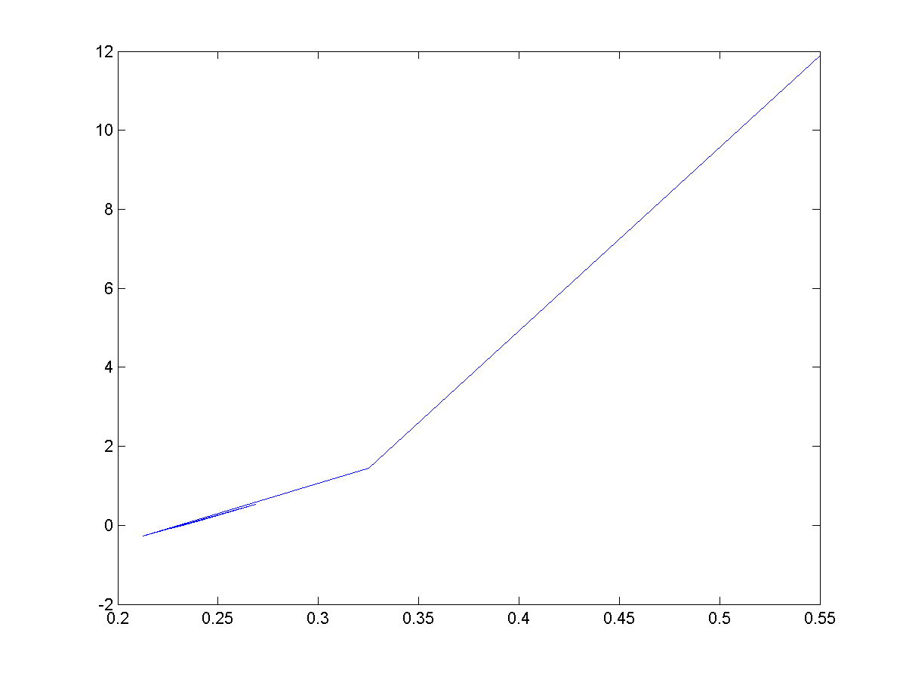Solution: x=0.2324

* f(x) = $e^{-x}-x$ xl=0, xu=1.0

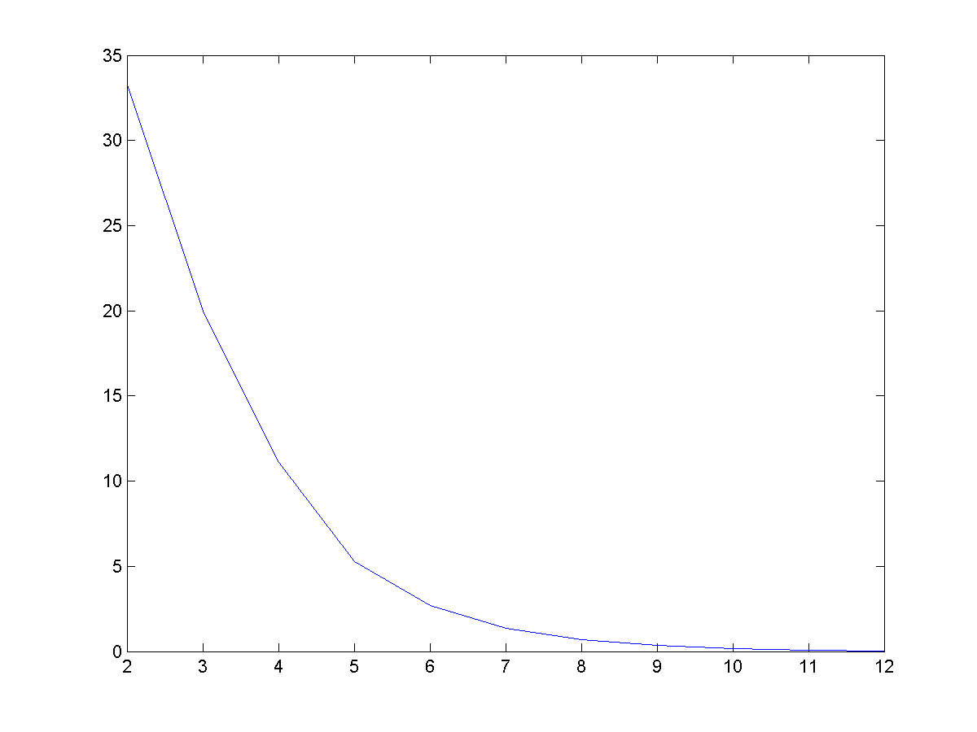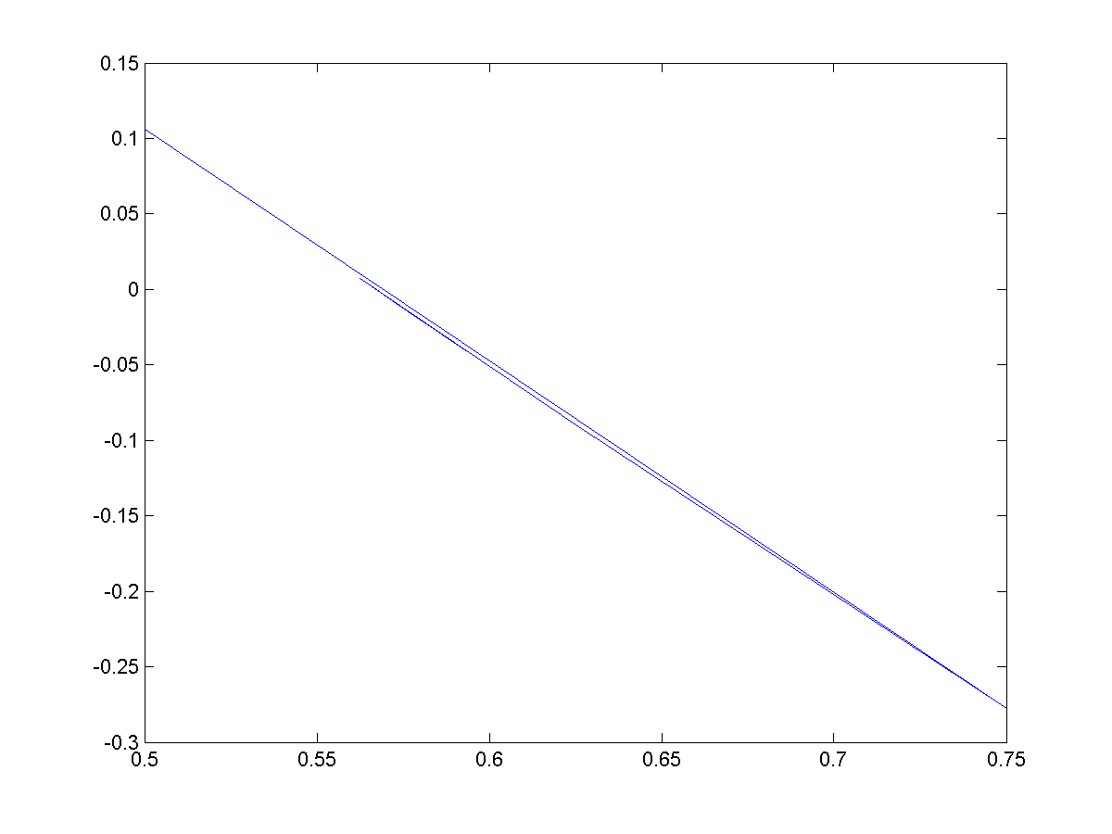Solution x=0.5671

Plot f(X) vs X Plot rel error vs iteration

1. False position method:

* 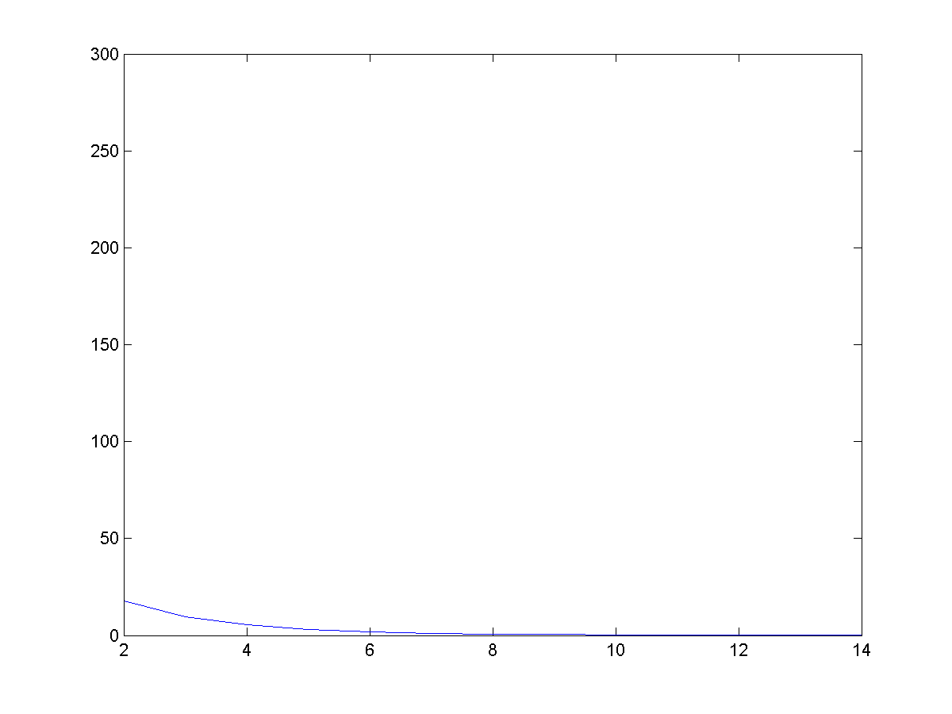f(x) = $600x^{4 }-550x^{3}+200x^{2}-20x-1$, xl=0.1, xu=1.0

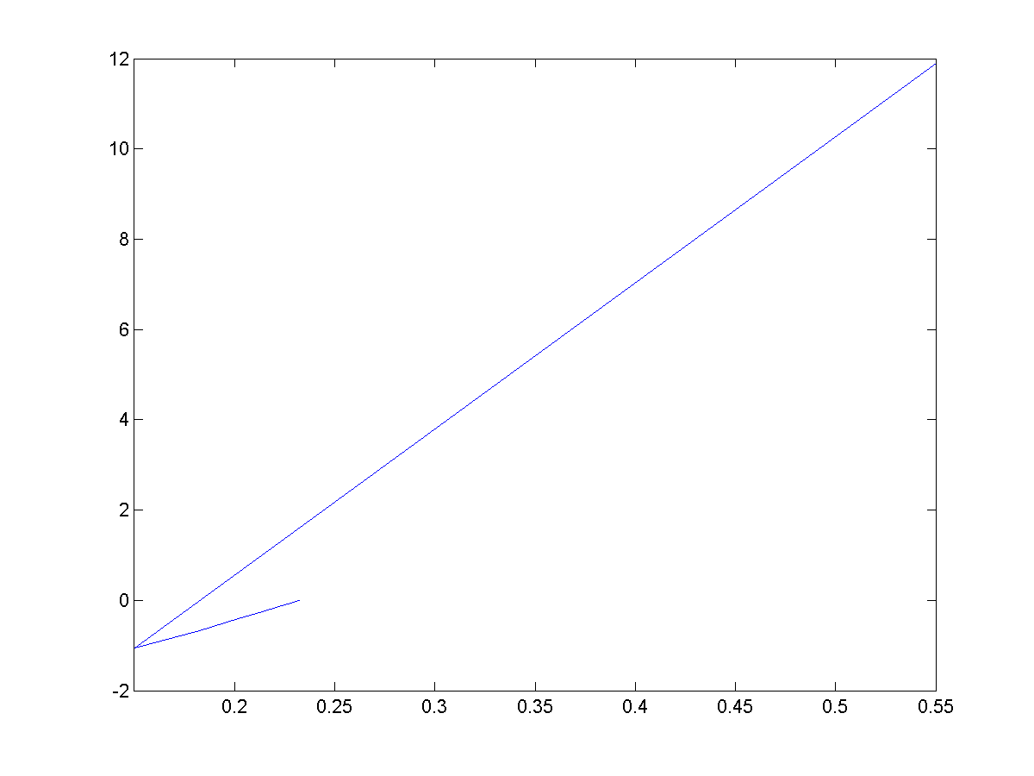Solution x=0.2322

* F(x) = $e^{-x}-x$, xl=0, xu=1.0

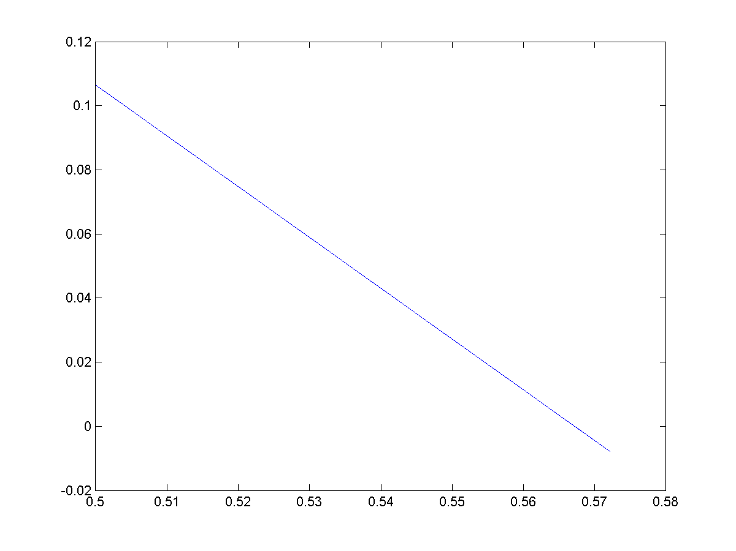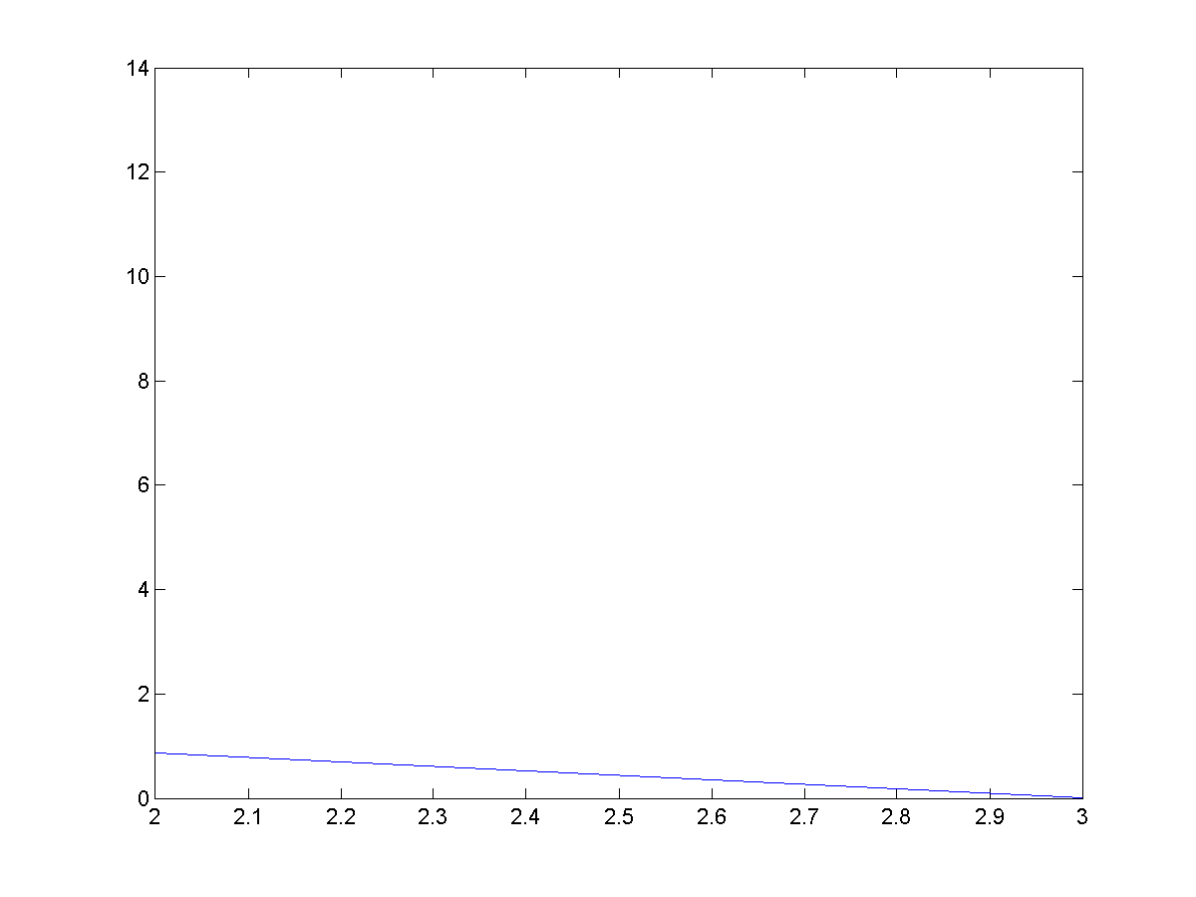Solution x=0.5671

1. Modified false position method:

* f(x) = $600x^{4 }-550x^{3}+200x^{2}-20x-1$, xl=0.1 ,xu=1.0

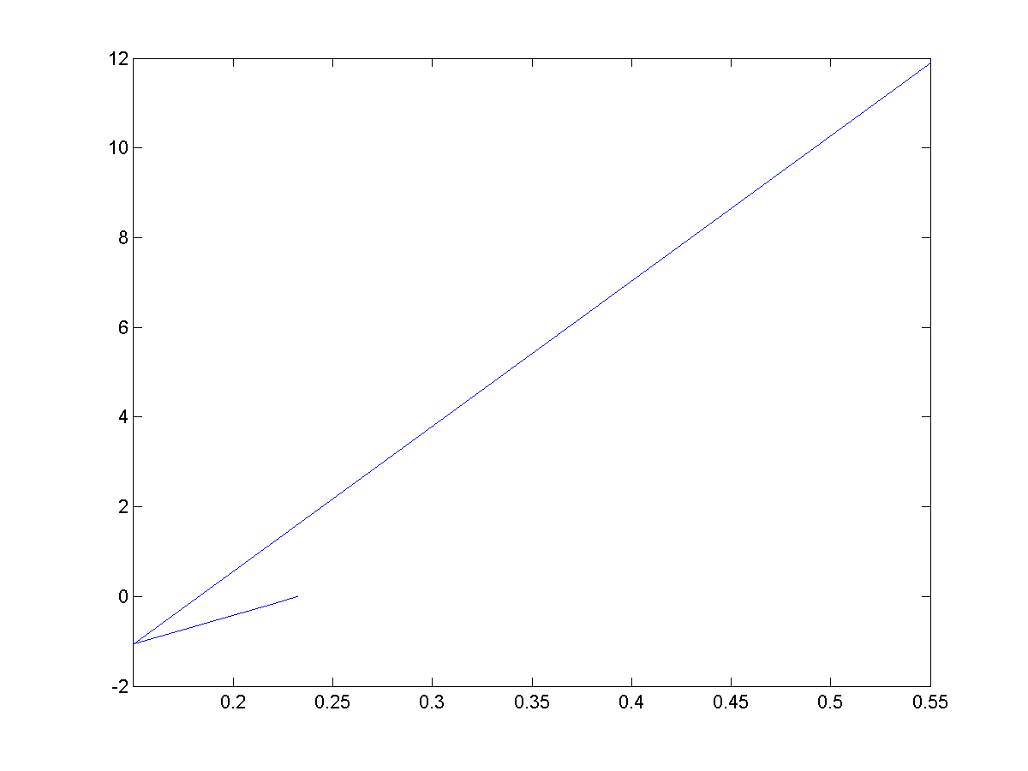Solution x=0.2324

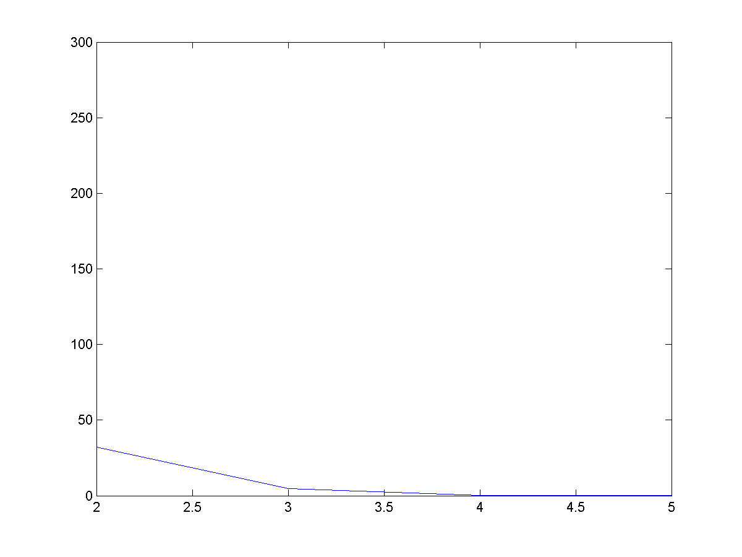

* f(x) = $e^{-x}-x$, , xl=0 ,xu=1.0

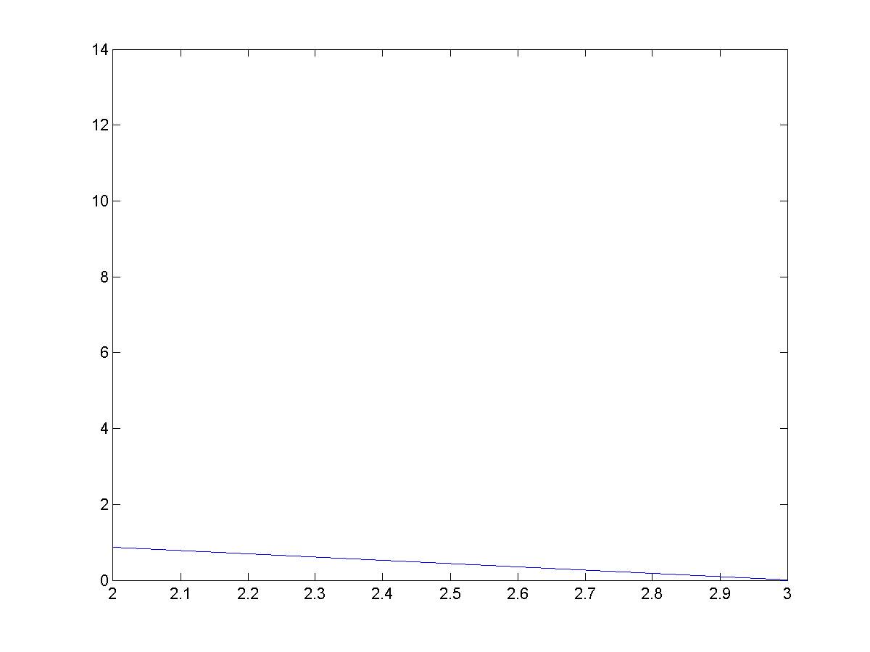Solution x=0.5671

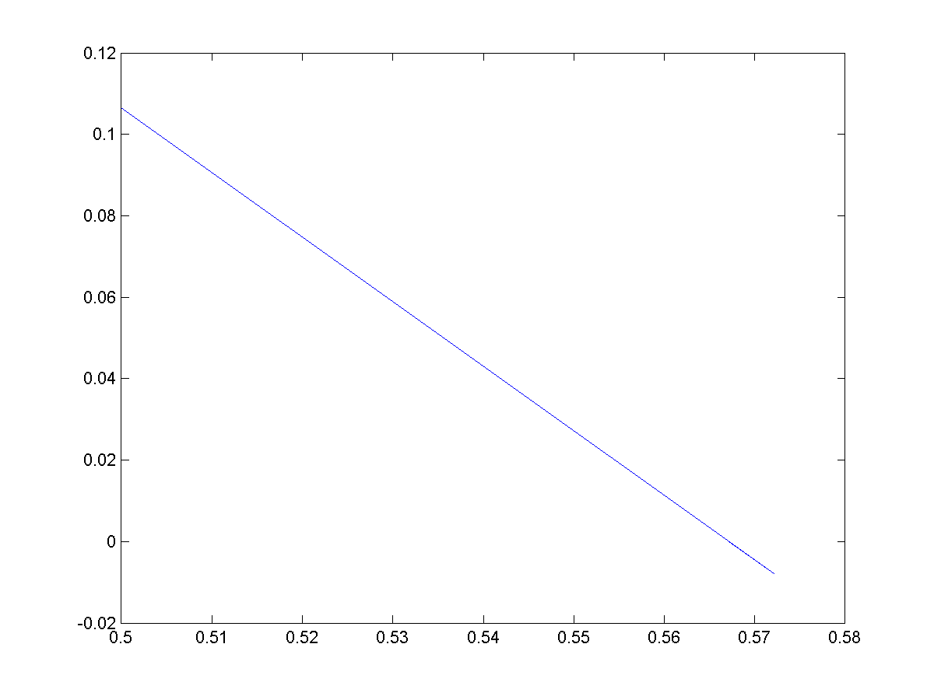

1. Newton-Raphson Method:

* f(x) = , x0=0.5

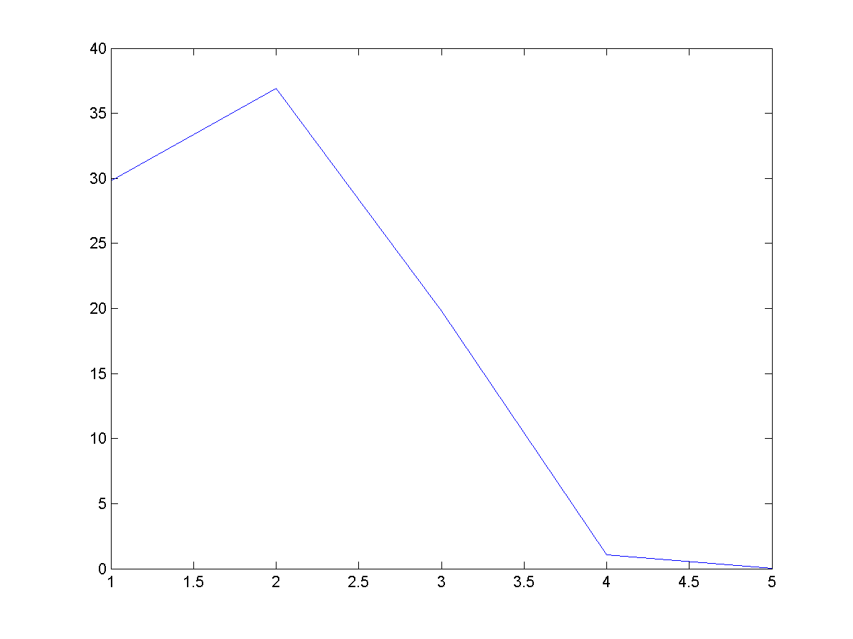Solution x=0.2325

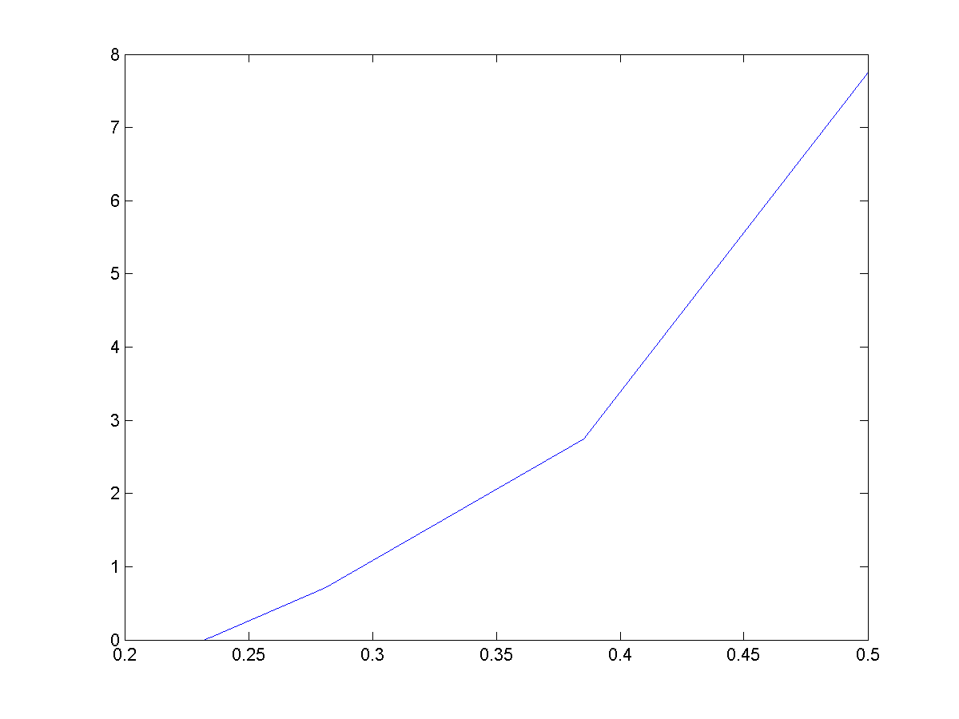

* f(x) = , x0=0.5

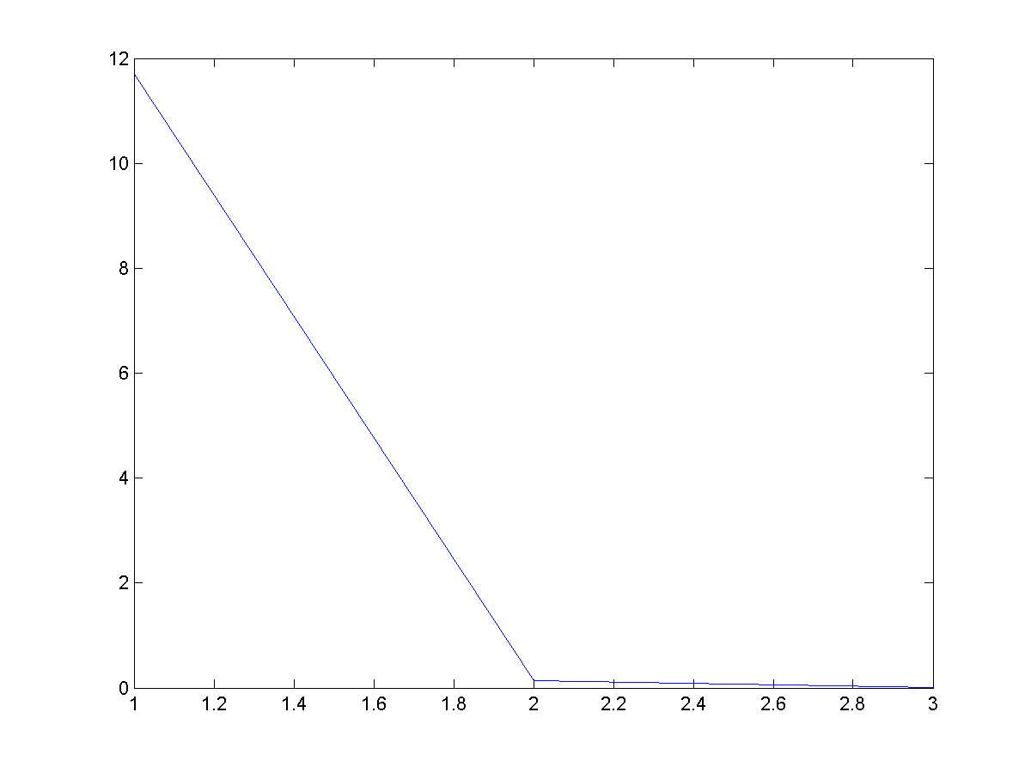Solution x=0.5673

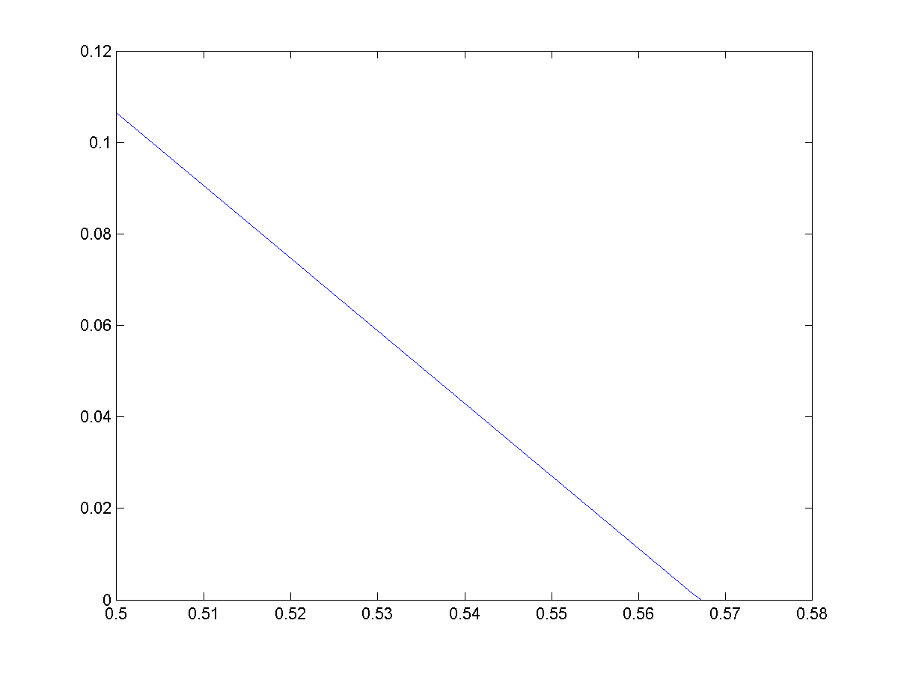

1. Secant Method:

* f(x) = x-1=0.1, x0=1

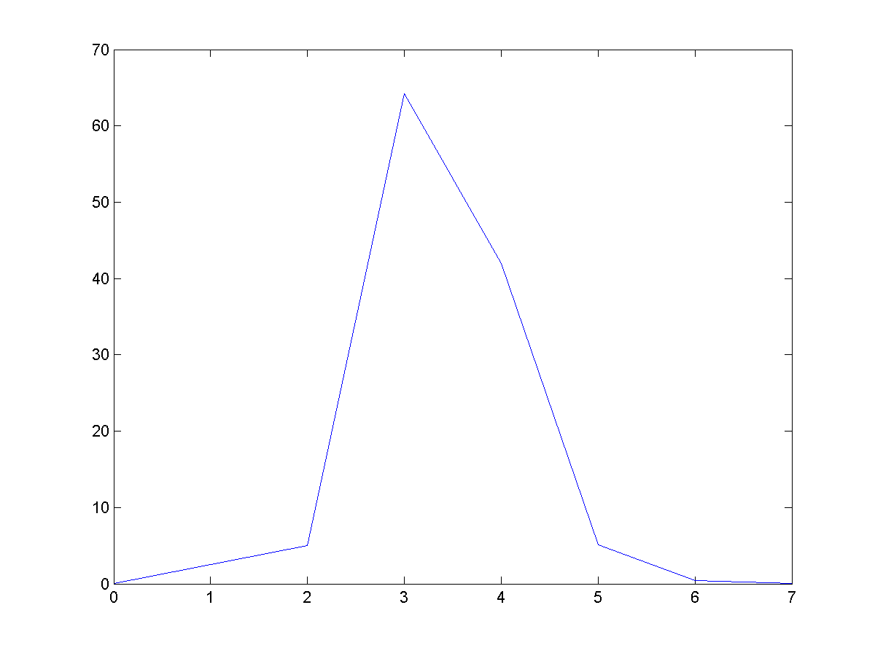Solution x=0.2324

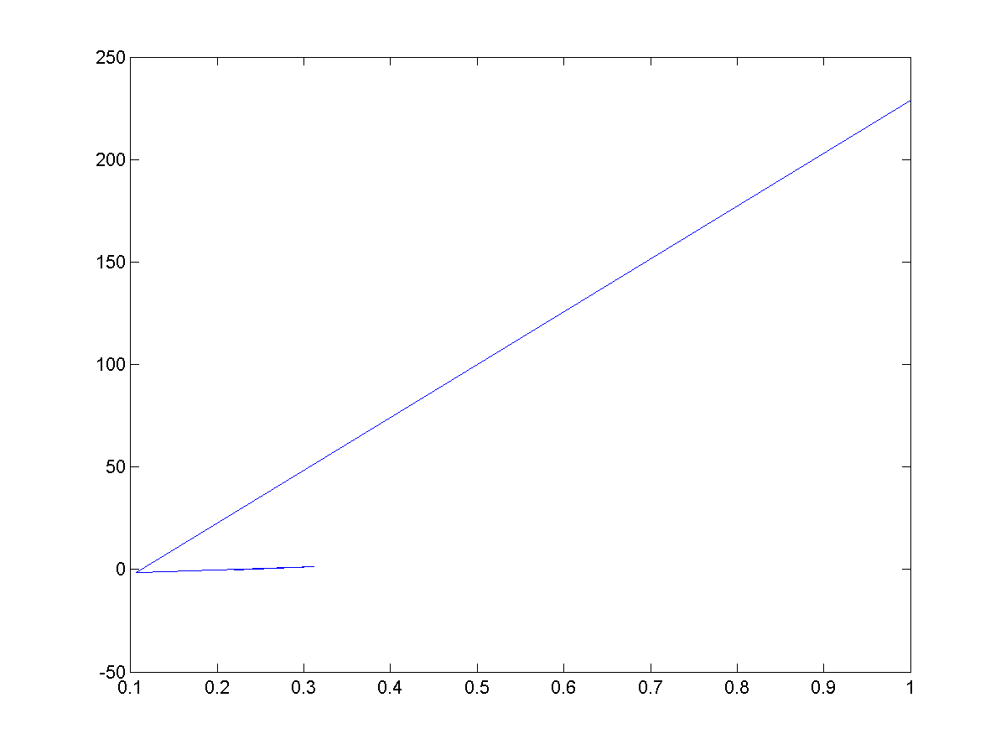

f(x) = , x0=0.1 x1=1

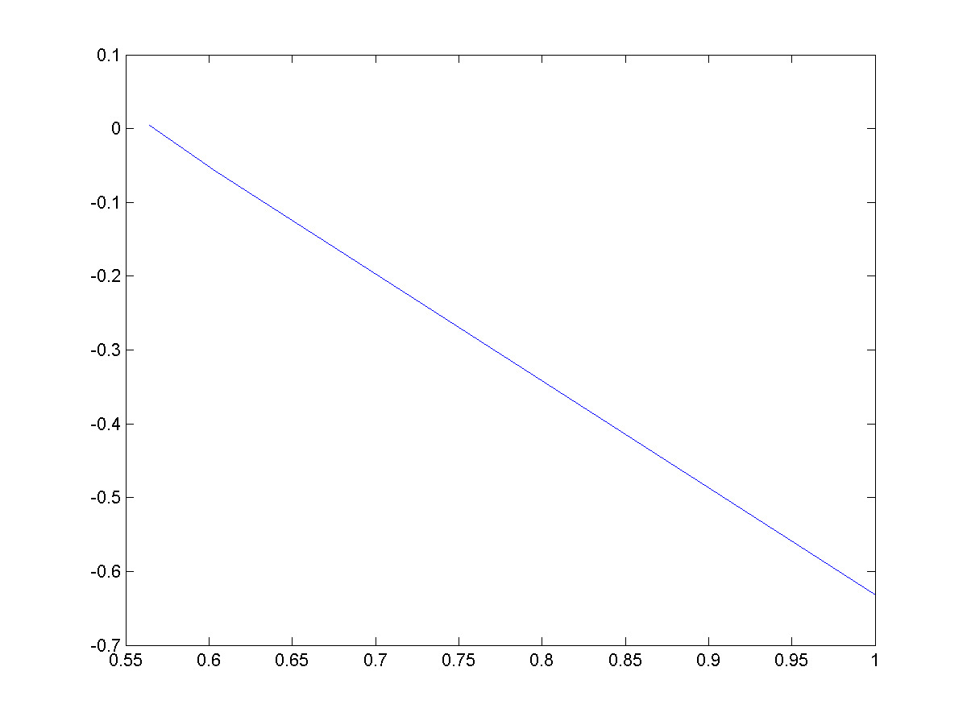Solution x=0.5671

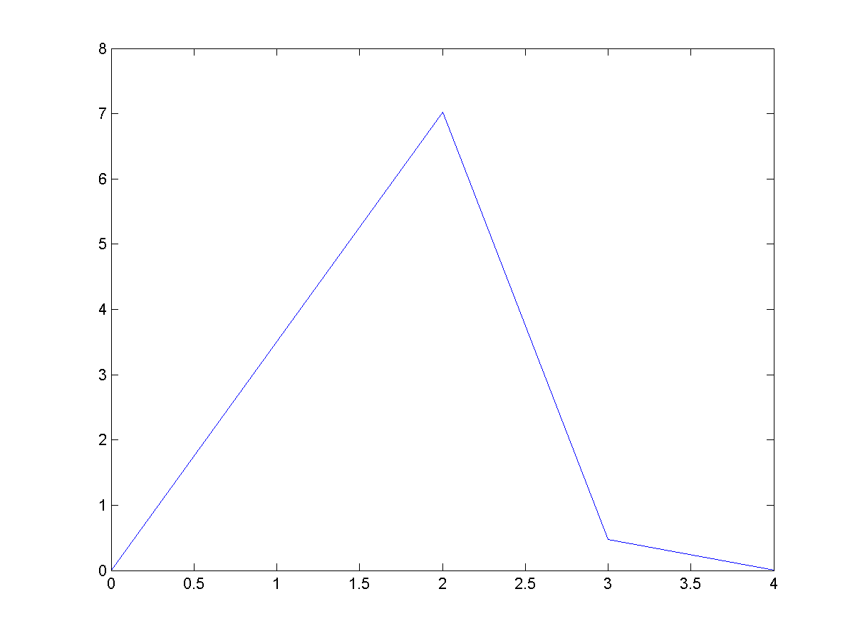

Q.2)

1. Muller Method:

* f(x) = , x0=0.0 ,x1=0.1, x2=0.3

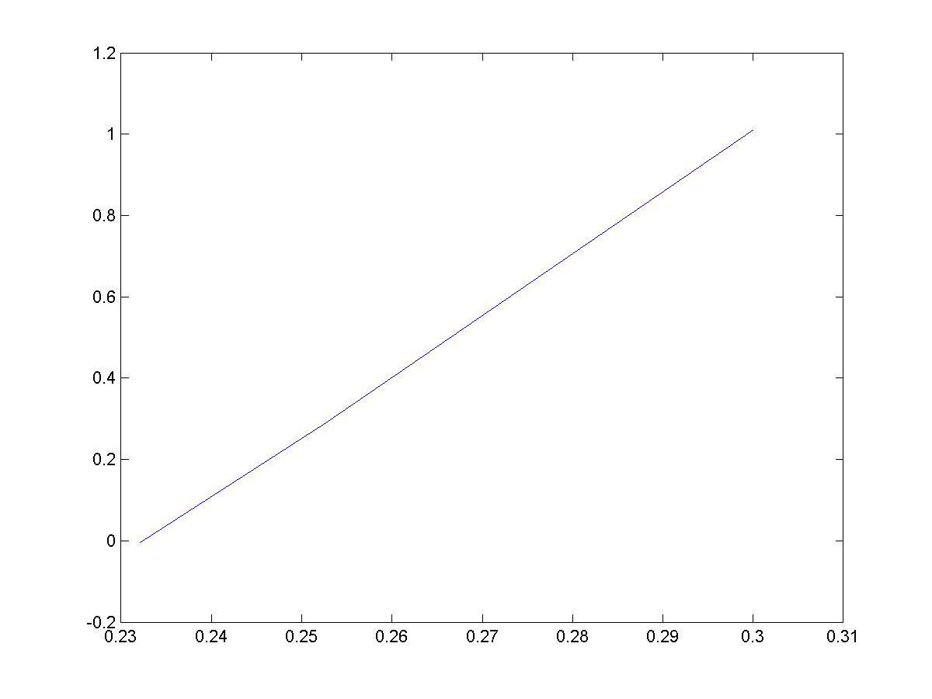Solution x=0.2324

f(x) = , x0=0, x1=0.5, x2=1

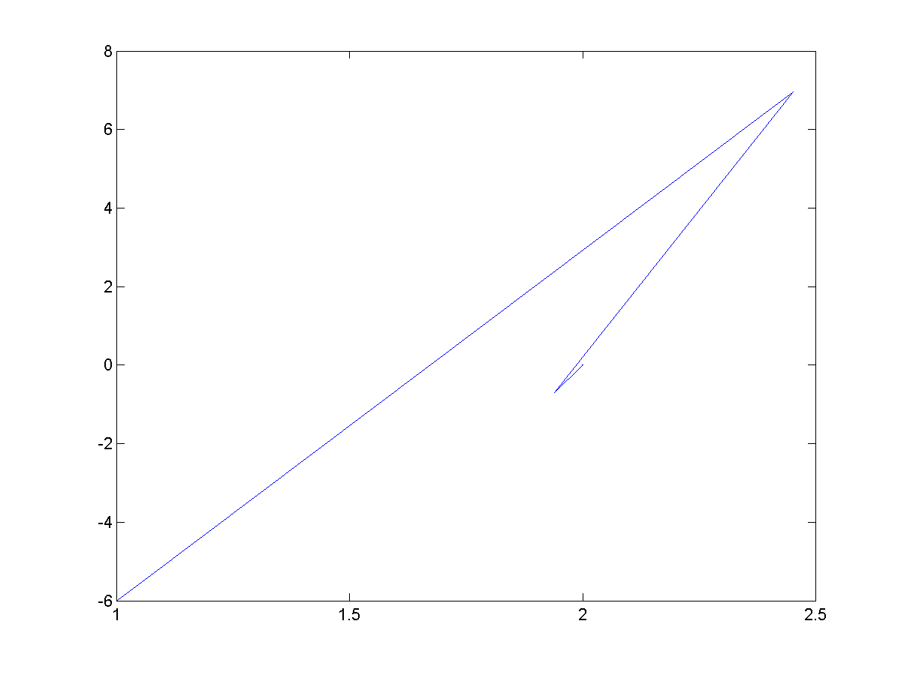Solution x=2

(G)Bairstow Method:

* f(x) = $600x^{4 }-550x^{3}+200x^{2}-20x-1$, r=-1 s=-1
* 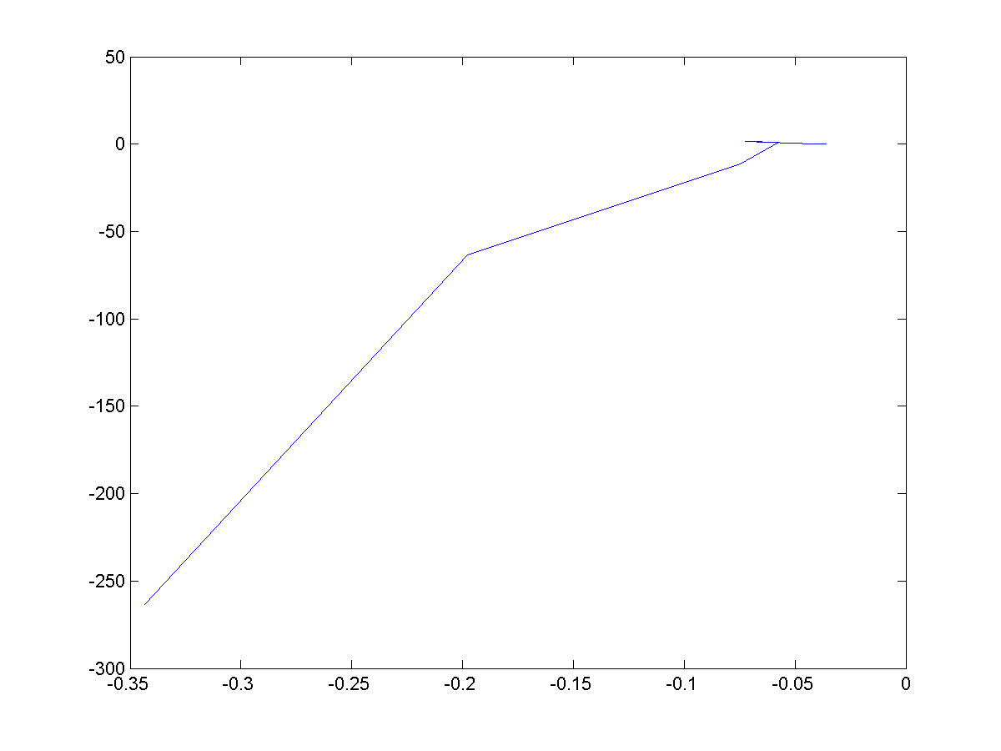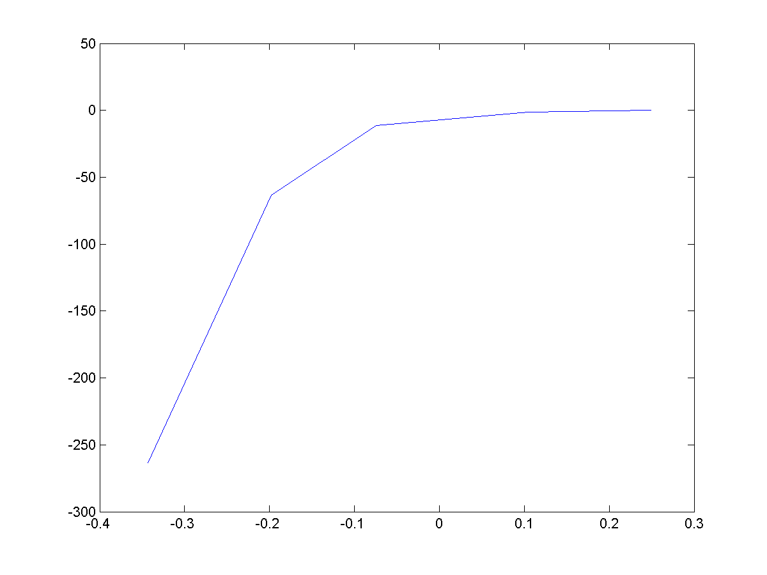Solution x=0.2324, -0.0358

f(x) = $x^{3}+x^{2}-4x-4$,

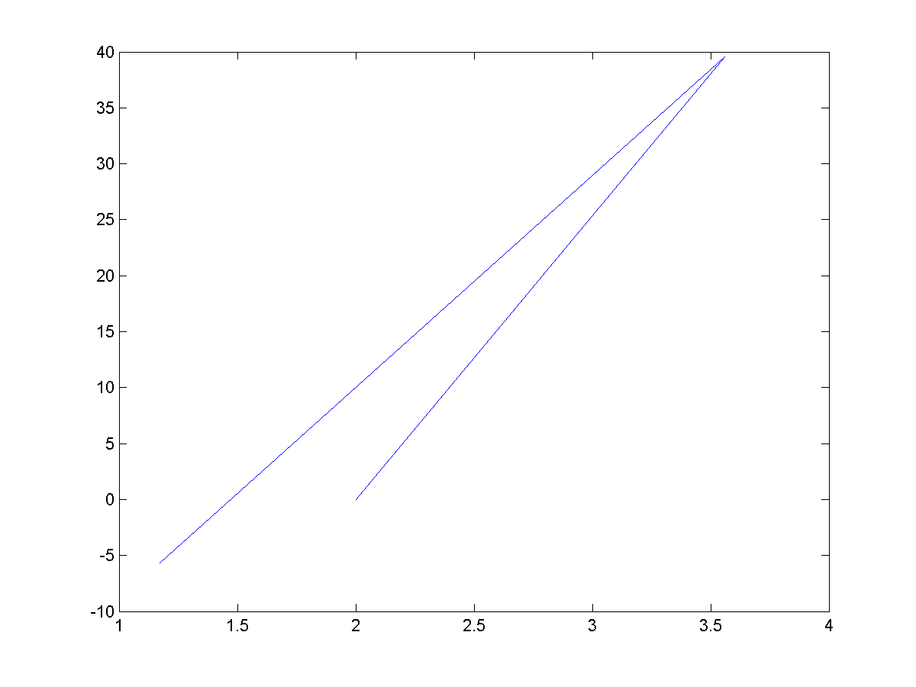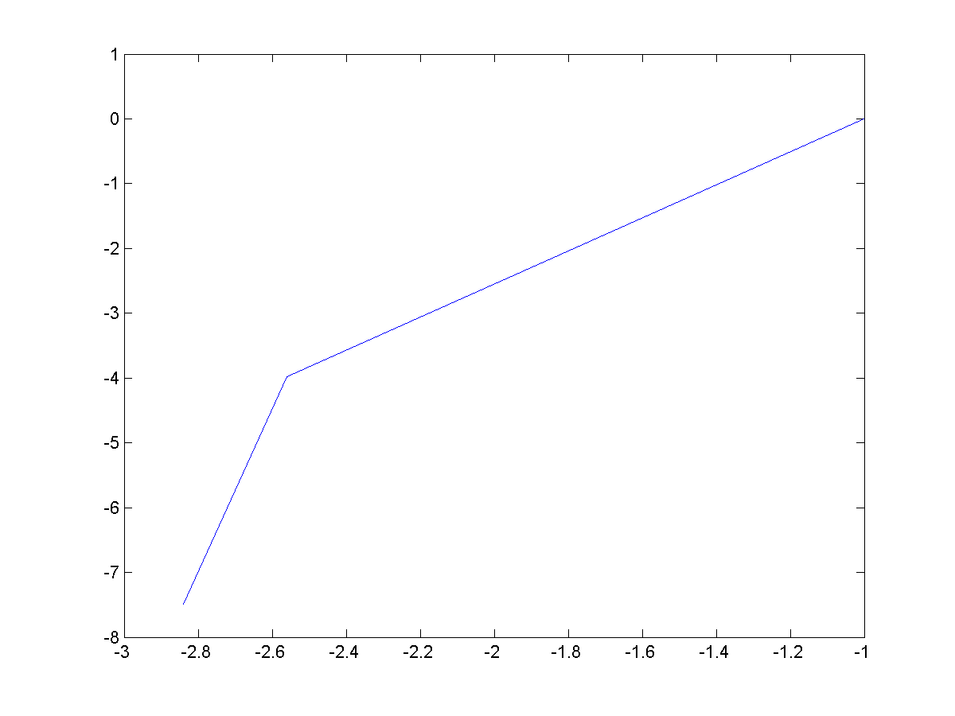Solution x=2, -1