Project 5a

MYGRADLEAPP

To understand the process of creating a Maven project and managing it using Maven commands.To study the structure and role of the POM (Project Object Model) file in handling project configuration and dependencies.

Step 1: Create a Maven project by running following command into terminal:

mvn archetype:generate -DgroupId=com.example -DartifactId=MyMavenApp - DarchetypeArtifactId=maven-archetype-quickstart -DinteractiveMode=false

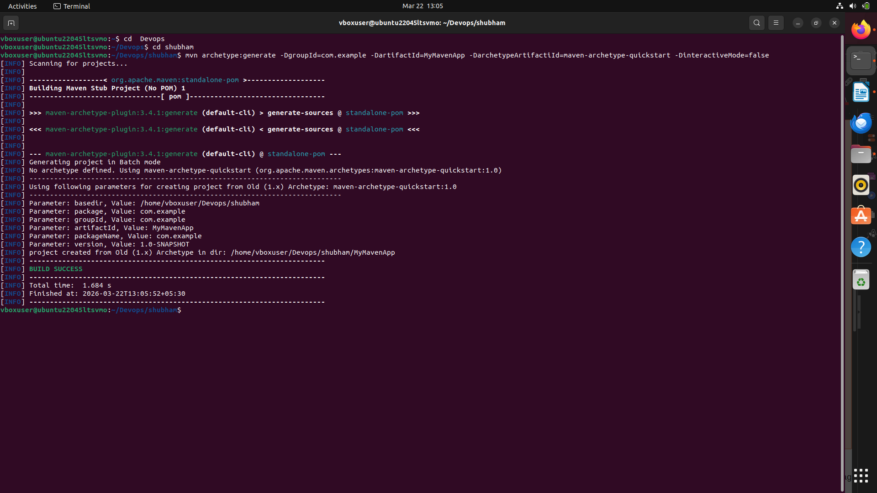

This command generates a basic Maven project structure with a sample App.java and AppTest.java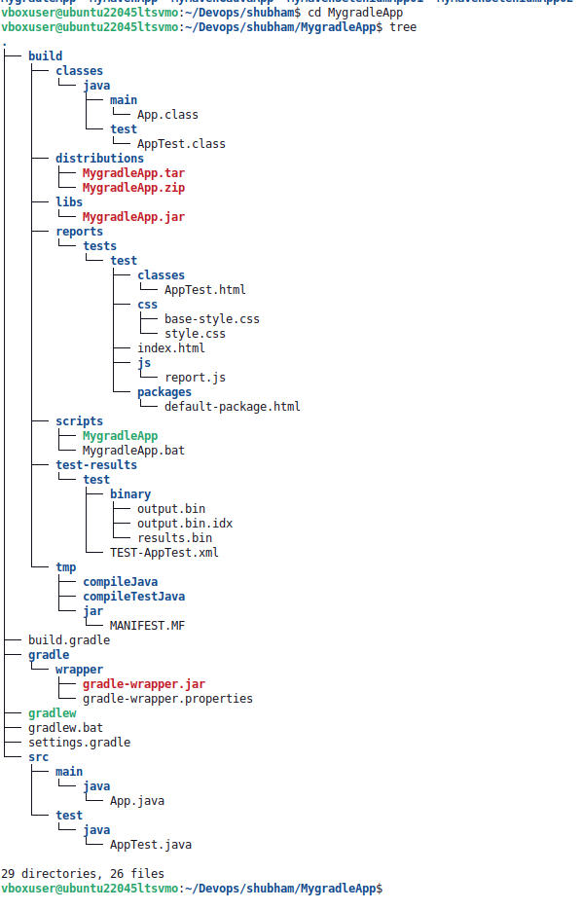

This “Build Success” will confirm that the project is created successfully

Step 2: Go to the project directory using command - cd MyMavenApp
Step 3: Open and edit pom. xml file using command gedit pom.xml
- Go to https://mvnrepository.com
- Search for a dependency “junit”
- Select the latest version and copy the dependency XML snippet.
- Paste it under the <dependencies> section in pom.xml
- Updated pom.xml is below:
<project xmlns="http://maven.apache.org/POM/4.0.0" xmlns:xsi="http://www.w3.org/2001/XMLSchema-instance"
xsi:schemaLocation="http://maven.apache.org/POM/4.0.0 http://maven.apache.org/maven-v4_0_0.xsd">
<modelVersion>4.0.0</modelVersion>
<groupId>com.example</groupId>
<artifactId>MyMavenSeleniumApp01</artifactId>
<packaging>jar</packaging>
<version>1.0-SNAPSHOT</version>
<name>MyMavenSeleniumApp01</name>
<url>http://maven.apache.org</url>
<dependencies>
<dependency>
<groupId>junit</groupId>
<artifactId>junit</artifactId>
<version>3.8.1</version>
<scope>test</scope>
</dependency>
<!-- https://mvnrepository.com/artifact/org.seleniumhq.selenium/selenium-java -->
<dependency>
<groupId>org.seleniumhq.selenium</groupId>
<artifactId>selenium-java</artifactId>
<version>4.29.0</version>
</dependency>
</dependencies>
<!-- Build: Configuring plugins and build settings -->
<build>
<plugins>
<!-- Example: Maven Compiler Plugin to compile Java code -->
<plugin>
<groupId>org.apache.maven.plugins</groupId>
<artifactId>maven-compiler-plugin</artifactId>
<version>3.8.1</version>
<configuration>
<source>1.7</source>
<target>1.7</target>
</configuration>
</plugin>
<!-- Example: Maven Surefire Plugin to run tests -->
<plugin>
<groupId>org.apache.maven.plugins</groupId>
<artifactId>maven-surefire-plugin</artifactId>
<version>2.22.2</version>
</plugin>
<plugin>
<groupId>org.apache.maven.plugins</groupId>
<artifactId>maven-jar-plugin</artifactId>
<version>3.0.1</version>
<configuration>
<archive>
<manifestEntries>
<Main-Class>com.example.App</Main-Class>
</manifestEntries>
</archive>
</configuration>
</plugin>
</plugins>
</build>
</project>

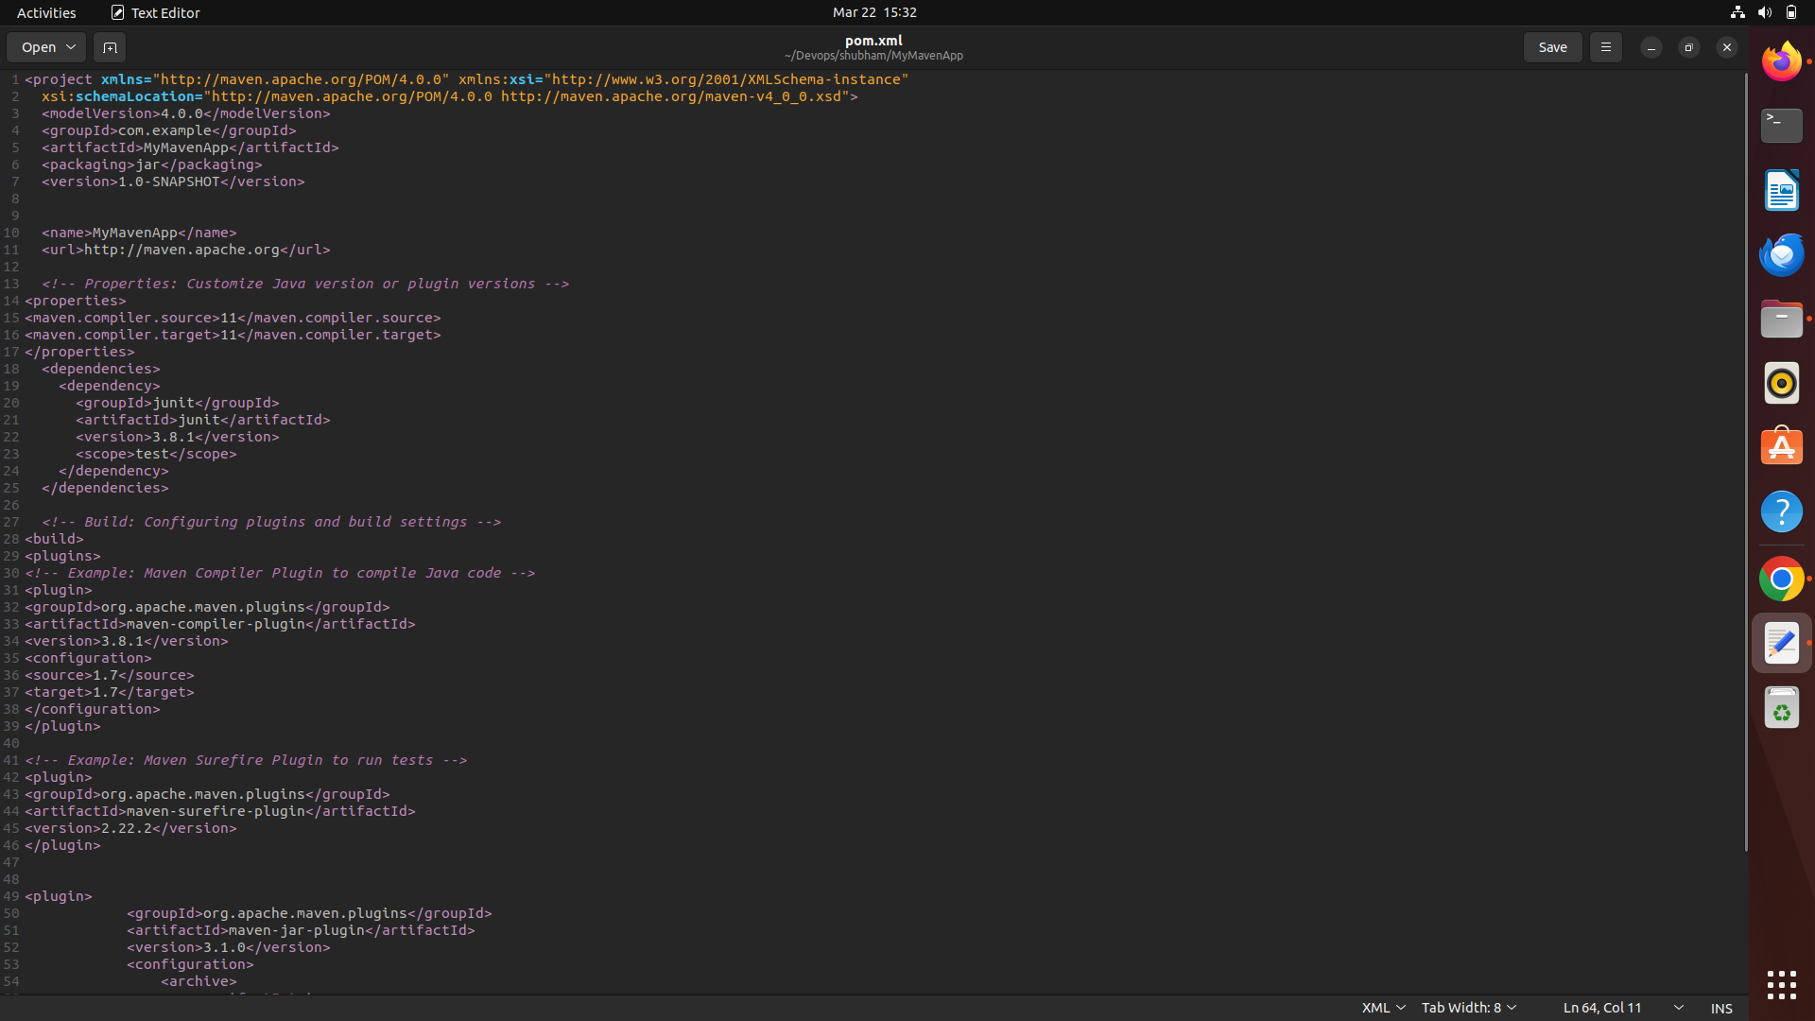

Update App.java: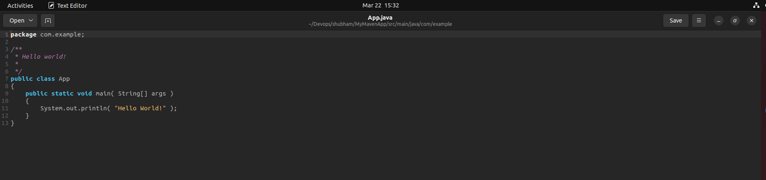
Step 4: Build the Maven Project
Run the following command - mvn clean install
This command cleans the previous build files, compiles the project, runs tests, and builds the JAR file in the target directory.
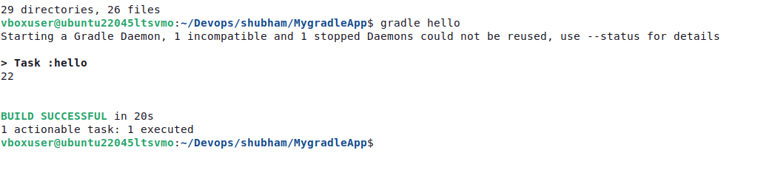

The “Build Success” message ensures that our Maven project is built successfully.

Step 5: To run the Maven application
- Go to target directory present in MyMavenApp using command cd target
- Execute the JAR file with the command:

java -jar MyMavenApp-1.0-SNAPSHOT.jar
- After completing the execution, the output will look like:

This will show output as the code present in App.java file we can edit the text to get any other output.

