Project 2

Maven Project with Guava and Commons-IO Dependencies

Objective

To create a Maven-based Java project and understand dependency management using external libraries like Guava and Commons IO.
To implement a simple file copy operation using these libraries and execute the project using Maven commands.

Step1:
Create a Maven Project Using Terminal by following command:
mvn archetype: generate -DgroupId=com.example -DartifactId=MyMavenGuavaApp - DarchetypeArtifactId=maven-archetype-quickstart -DinteractiveMode=false

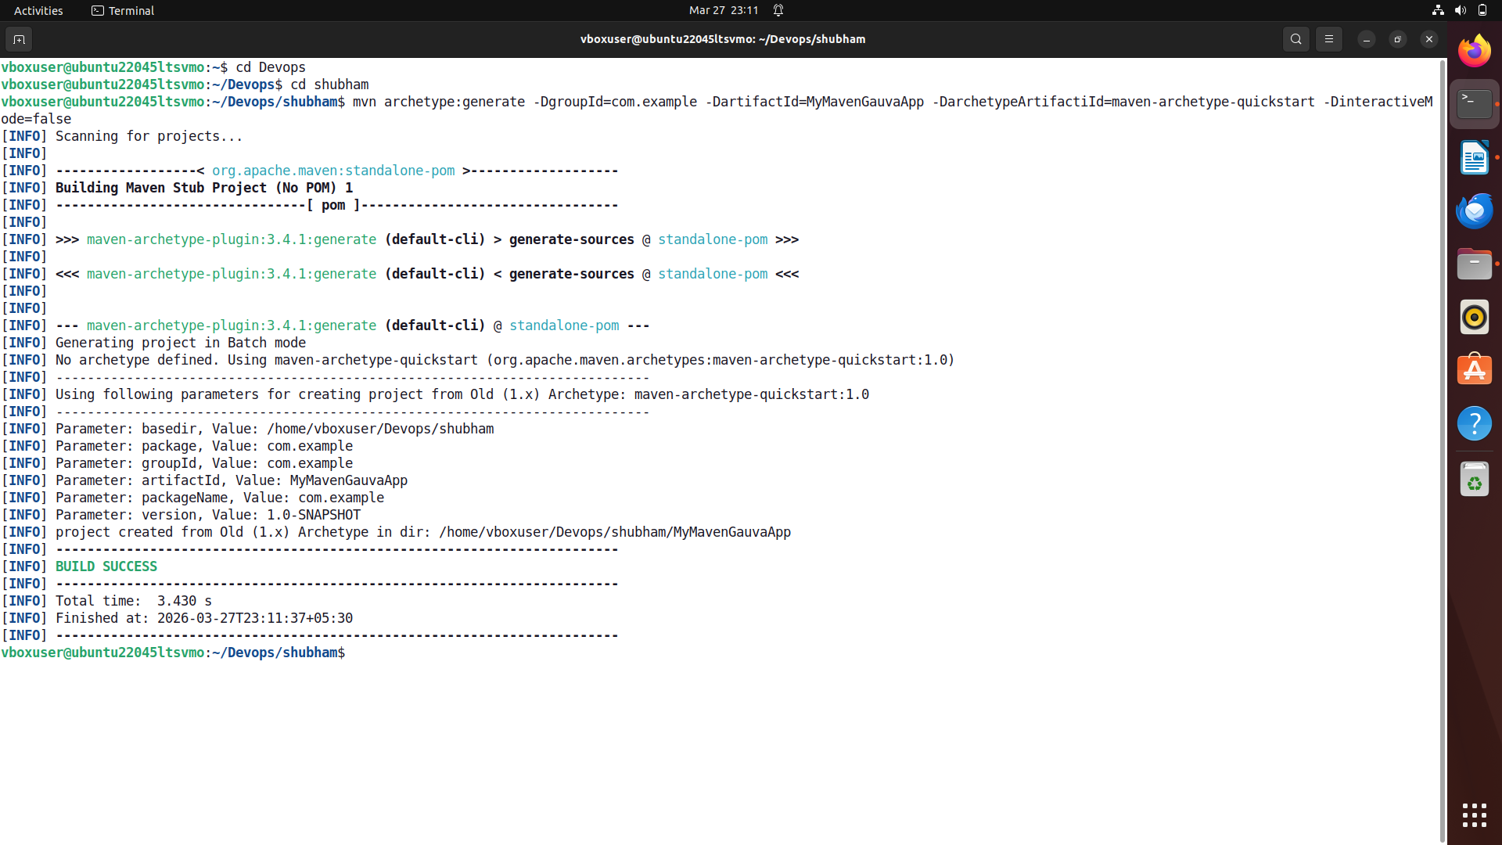

Step 2:
Now Navigate to the Project Directory usingcommand: cd MyMavenGuavaApp
Then, use tree command to check the directory structure created by our comman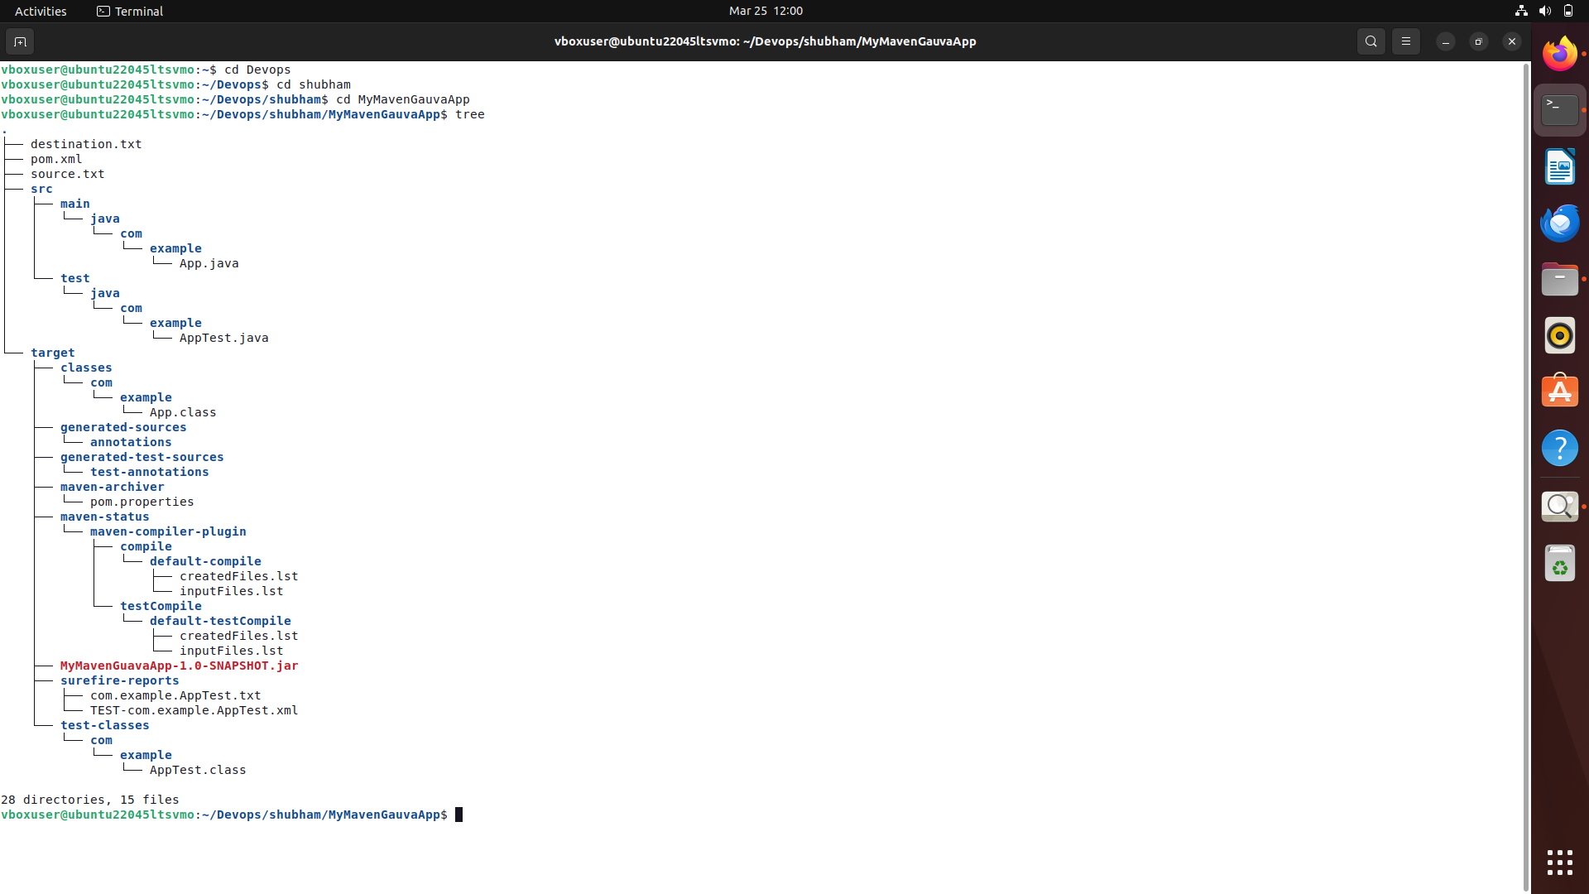

Step 3:
a. Edit the pom.xml File to Add Dependencies using gedit pom.xml and inside the
Dependencies:
<dependencies>
<dependency>
<groupId>com.google.guava</groupId>
<artifactId>guava</artifactId>
<version>31.1-jre</version>
</dependency>

<dependency>
<groupId>commons-io</groupId>
<artifactId>commons-io</artifactId>
<version>2.11.0</version>
</dependency>
</dependencies>

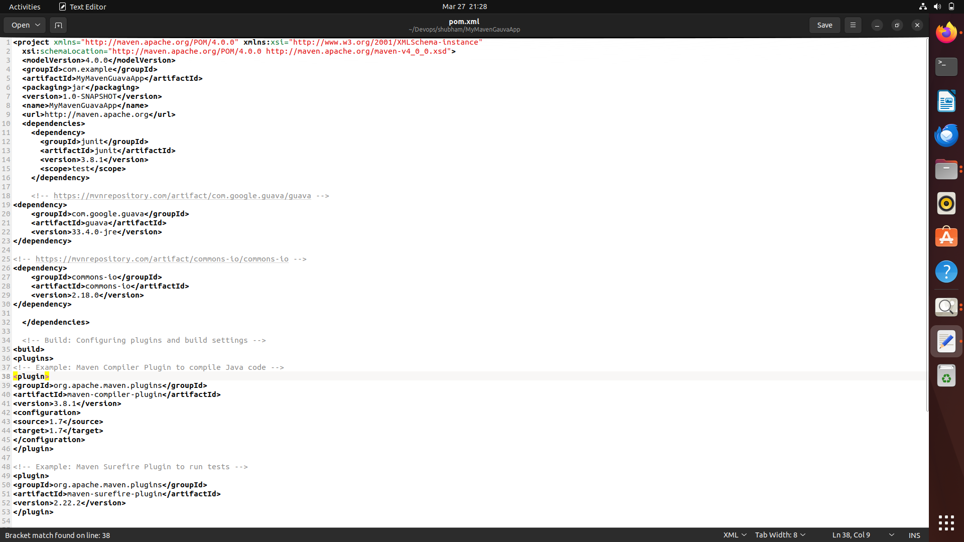

b. Modify App.java

Got to App.java using command -cd src/main/java/com/example/ and
Bash the cmd -gedit App.java to type the file with following code
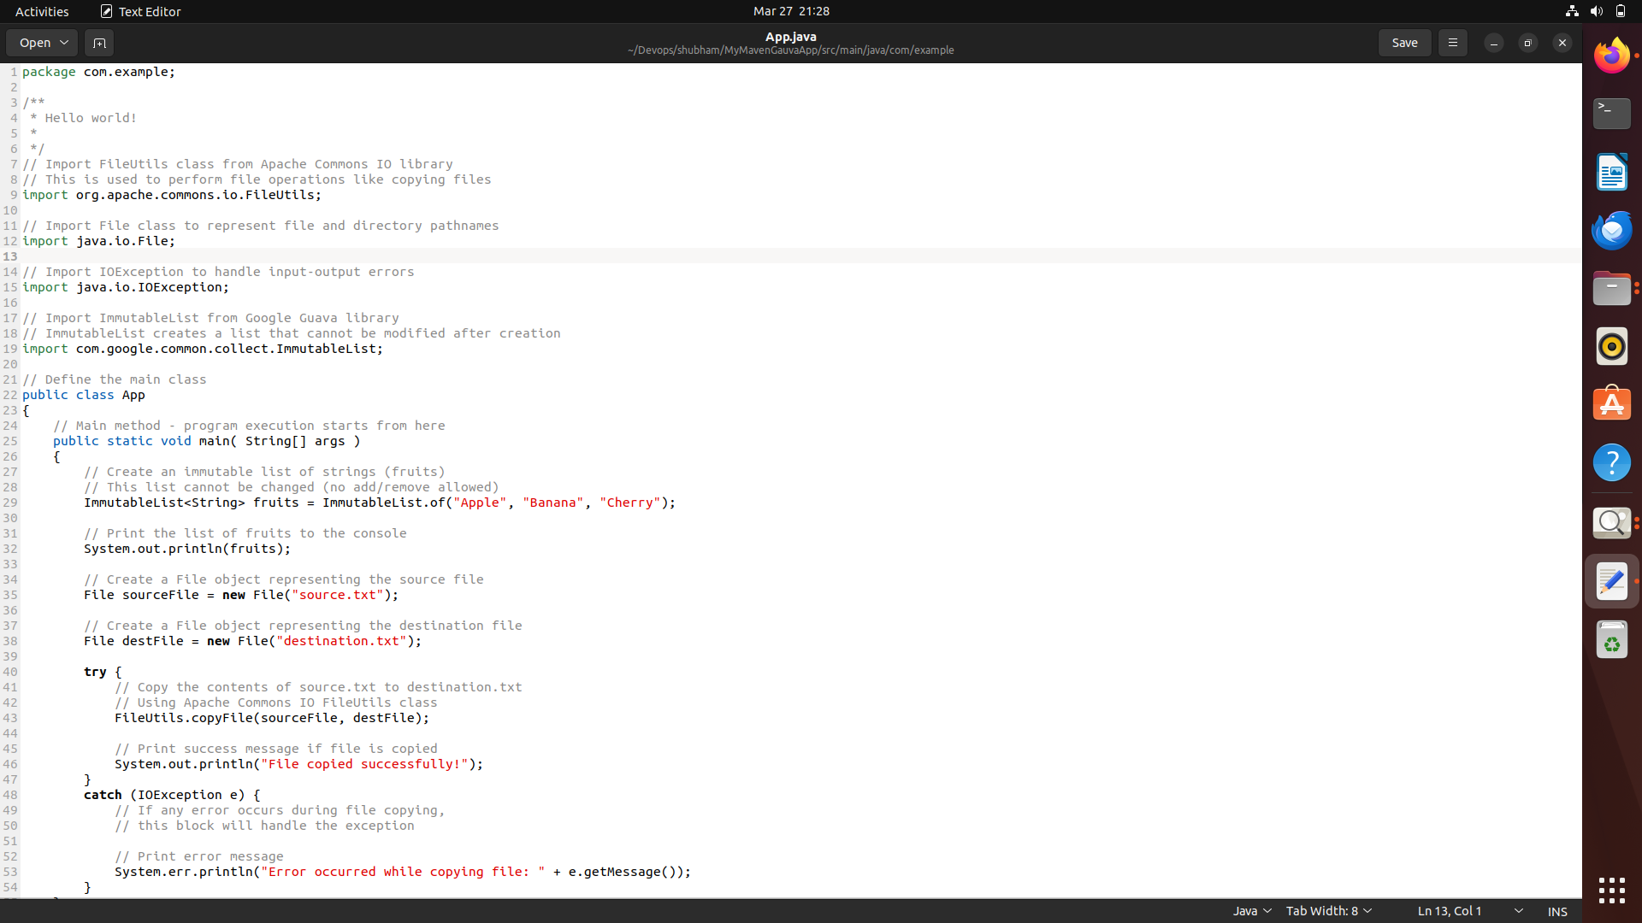

Step 4:
Build the Maven Project
Run the following command - mvn clean install
This command cleans the previous build files, compiles the project, runs tests, and builds the JAR file in the target directory.
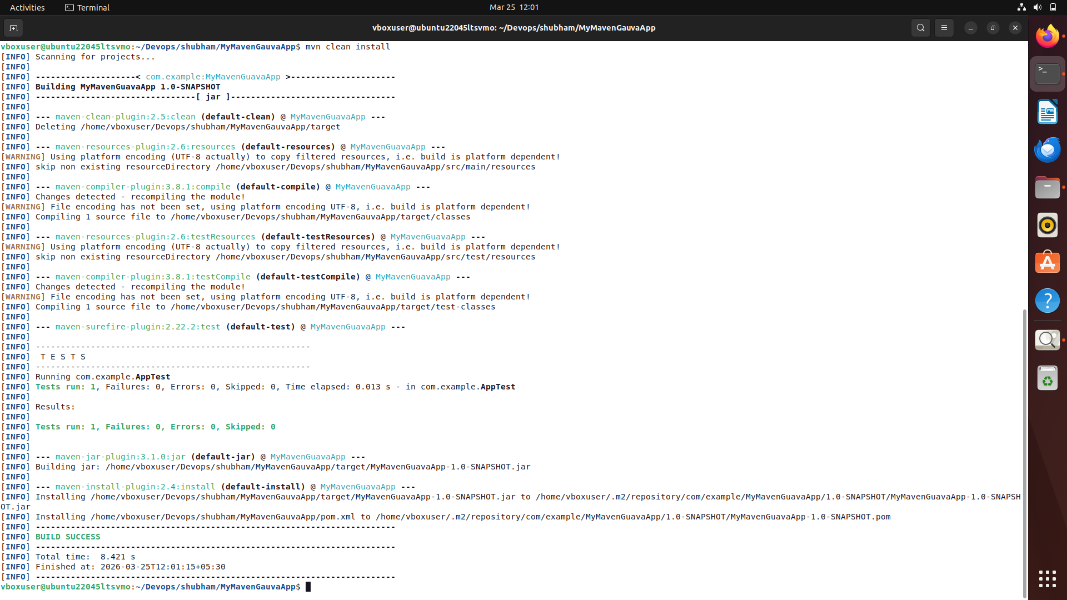

Step 5:
a. This compiles the project and creates a JAR in the target/ folder.

Run the Application:
If java-jar command give an error which is most probable, use the following command

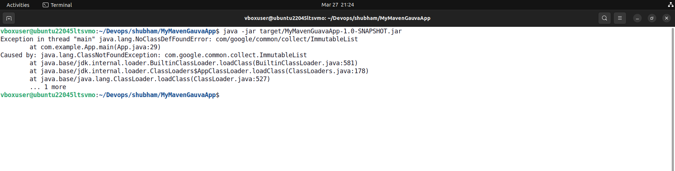

b. Now Run the command mvn exec:java -Dexec.mainClass=”com.example.App”

This command is used to execute the Java application through Maven by specifying the main class (com.example.App) without manually running the compiled JAR file.

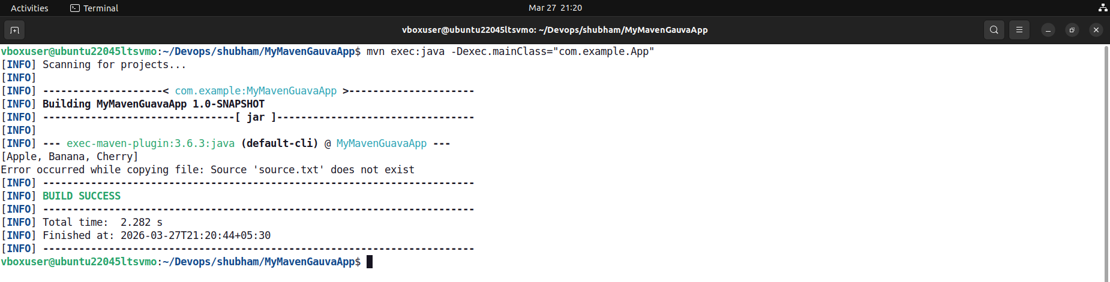

This command gives error as
Error while copying file:Source ‘source.txt’ does not exist

Step 5:To overcome the error
Now, Create a Sample File to Copy using echo "My Data needs to be transferred of shubham" > source.txt
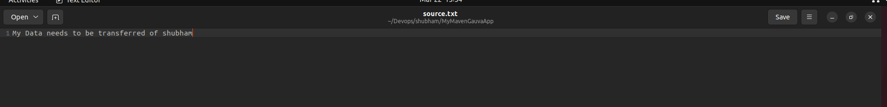

Step 6: Now Run the command mvn exec:java -Dexec.mainClass=”com.example.App”

This command is used to execute the Java application through Maven by specifying the main class (com.example.App) without manually running the compiled JAR file.

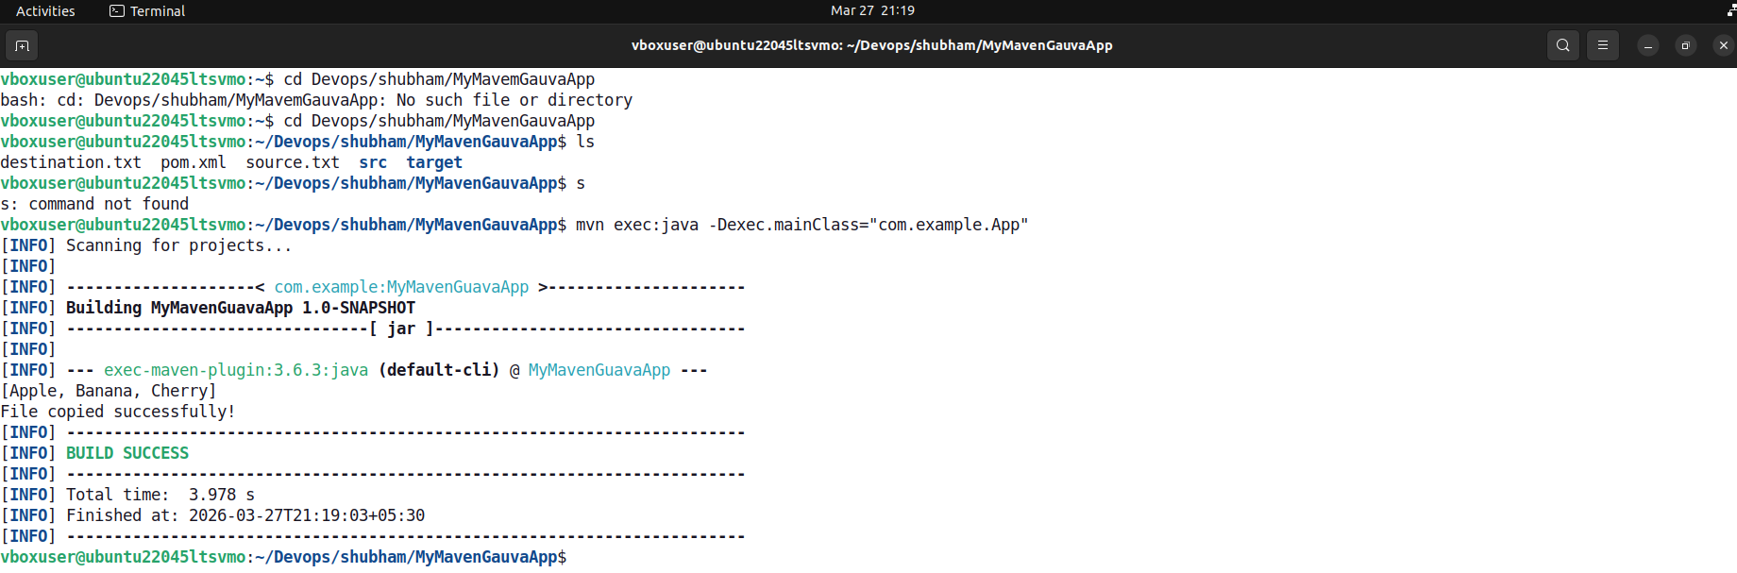

The output shows file copied successfully.
We can see newly created destination.txt using gedit destination.txt if you are still in Project’s directory
