Project 3A
Maven Selenium Project – Automating Login For Sauce Demo Using Selenium

To create a Maven-based Selenium project that automatically opens a web page, adds selected products to the cart, and views the cart using Java Selenium WebDriver.

Sample Website Used for Automation
Website used for testing: https://saucedemo.com
This website contains multiple products that can be added to the cart using automation.

Step 1: Create a Maven Project Using Terminal
Open the terminal and run the following command to create a Maven project.
mvn archetype:generate -DgroupId=com.example -DartifactId=MyMavenSeleniumApp01 -DarchetypeArtifactId=maven-archetype-quickstart -DinteractiveMode=false
This command creates a Maven project named MyMavenSeleniumApp01.

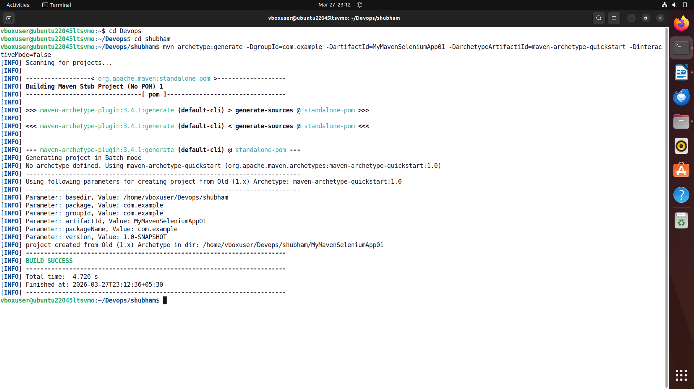

To get tree structure bash cmd - tree

Project Structure:

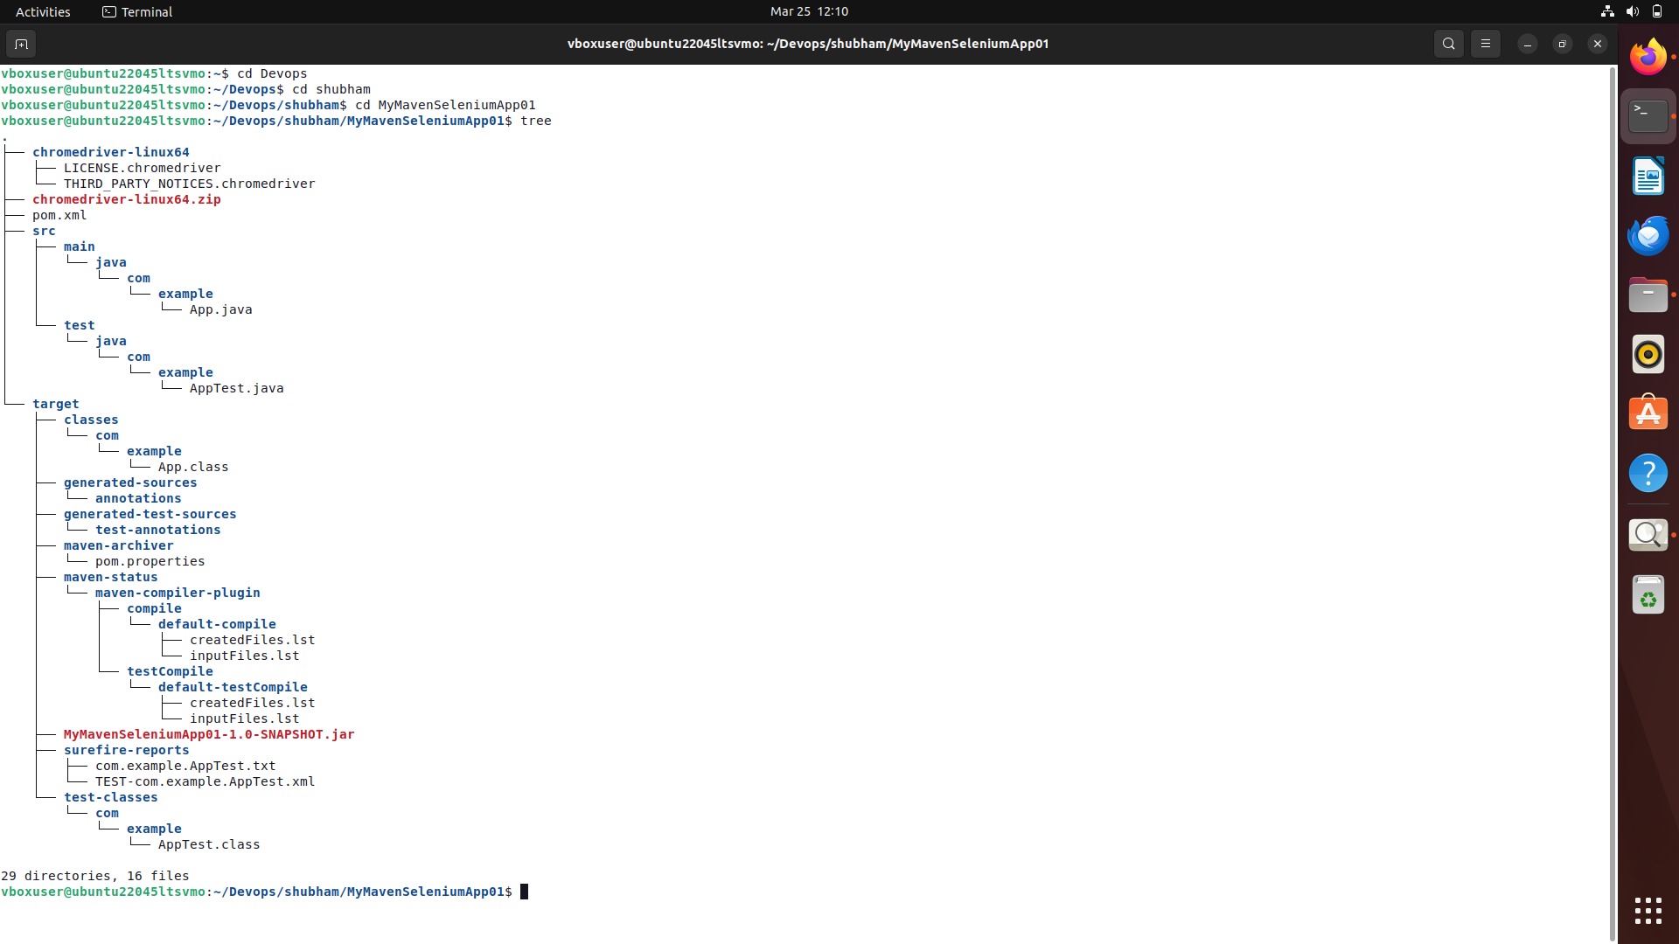
Get into directory of MyMavenSeleniumApp01 by running following cmd- cd MyMavenSeleniumApp01.

Step 2: Install ChromeDriver
Before running Selenium scripts, ChromeDriver must be installed.

Check Installed Chrome Version
Run the following command:
google-chrome --version
Example Output:
Google Chrome 133.0.6943.141

Extract Chrome Version
CHROME_VERSION=$(google-chrome --version | awk '{print $3}' | cut -d'.' -f1-3)
This extracts the Chrome version and stores it in the variable CHROME_VERSION.

Install jq (Used for JSON Parsing)
sudo apt install jq

Install curl (If Not Installed)
sudo apt install curl

Get Latest Compatible ChromeDriver Version
LATEST_DRIVER=$(curl -s "https://googlechromelabs.github.io/chrome-for-testing/latest-patch-versions-per-build.json" | jq -r ".builds[\"$CHROME_VERSION\"].version")

Download ChromeDriver
wget https://storage.googleapis.com/chrome-for-testing-public/$LATEST_DRIVER/linux64/chromedriver-linux64.zip

Extract ChromeDriver
unzip chromedriver-linux64.zip

Move ChromeDriver to System Path
sudo mv chromedriver-linux64/chromedriver /usr/local/bin/chromedriver
sudo chmod +x /usr/local/bin/chromedriver

Verify ChromeDriver Installation
chromedriver --version
Example Output:
ChromeDriver 133.0.6943.141
The version should match your Chrome version.

Step 3: Update pom.xml
Open the pom.xml file and replace the whole code by
<project xmlns="http://maven.apache.org/POM/4.0.0" xmlns:xsi="http://www.w3.org/2001/XMLSchema-instance"
xsi:schemaLocation="http://maven.apache.org/POM/4.0.0 http://maven.apache.org/maven-v4_0_0.xsd">
<modelVersion>4.0.0</modelVersion>
<groupId>com.example</groupId>
<artifactId>MyMavenSeleniumApp01</artifactId>
<packaging>jar</packaging>
<version>1.0-SNAPSHOT</version>
<name>MyMavenSeleniumApp01</name>
<url>http://maven.apache.org</url>
<dependencies>
<dependency>
<groupId>junit</groupId>
<artifactId>junit</artifactId>
<version>3.8.1</version>
<scope>test</scope>
</dependency>
<!-- https://mvnrepository.com/artifact/org.seleniumhq.selenium/selenium-java -->
<dependency>
<groupId>org.seleniumhq.selenium</groupId>
<artifactId>selenium-java</artifactId>
<version>4.29.0</version>
</dependency>
</dependencies>
<!-- Build: Configuring plugins and build settings -->
<build>
<plugins>
<!-- Example: Maven Compiler Plugin to compile Java code -->
<plugin>
<groupId>org.apache.maven.plugins</groupId>
<artifactId>maven-compiler-plugin</artifactId>
<version>3.8.1</version>
<configuration>
<source>1.7</source>
<target>1.7</target>
</configuration>
</plugin>
<!-- Example: Maven Surefire Plugin to run tests -->
<plugin>
<groupId>org.apache.maven.plugins</groupId>
<artifactId>maven-surefire-plugin</artifactId>
<version>2.22.2</version>
</plugin>
<plugin>
<groupId>org.apache.maven.plugins</groupId>
<artifactId>maven-jar-plugin</artifactId>
<version>3.0.1</version>
<configuration>
<archive>
<manifestEntries>
<Main-Class>com.example.App</Main-Class>
</manifestEntries>
</archive>
</configuration>
</plugin>
</plugins>
</build>
</project>
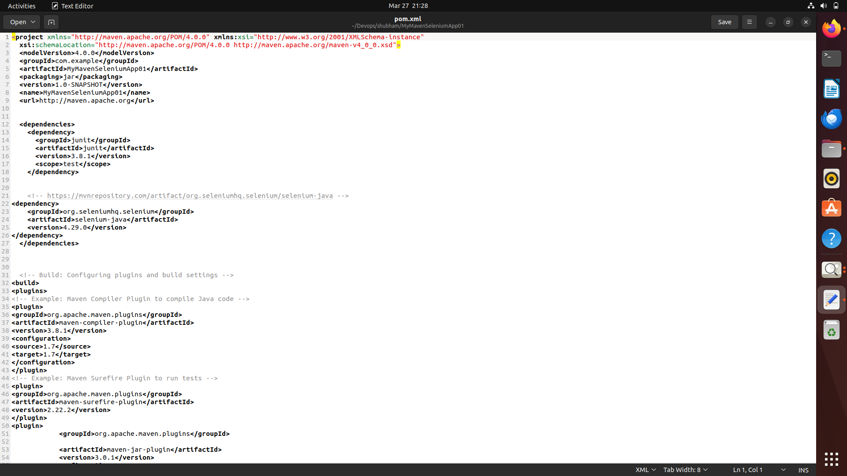

Step 4: Inspect Elements in the Website
Before writing Selenium code, we must inspect the HTML elements.

Steps:
- Open the website - https://saucedemo.com
- Right-click on the webpage.
- Click Inspect.
- Use the cursor tool to select product buttons.
Make use of below username and password for login process

Step 5: Create App.java
package com.example;
import org.openqa.selenium.By;
import org.openqa.selenium.WebDriver;
import org.openqa.selenium.chrome.ChromeDriver;
/**
* Hello world!
*
*/
public class App
{
public static void main( String[] args )
{
WebDriver driver=new ChromeDriver();
driver.get("https://www.saucedemo.com/");
driver.manage().window().maximize();
driver.findElement(By.id("user-name")).sendKeys("standard_user");
driver.findElement(By.id("password")).sendKeys("secret_sauce");
driver.findElement(By.id("login-button")).click();
}
}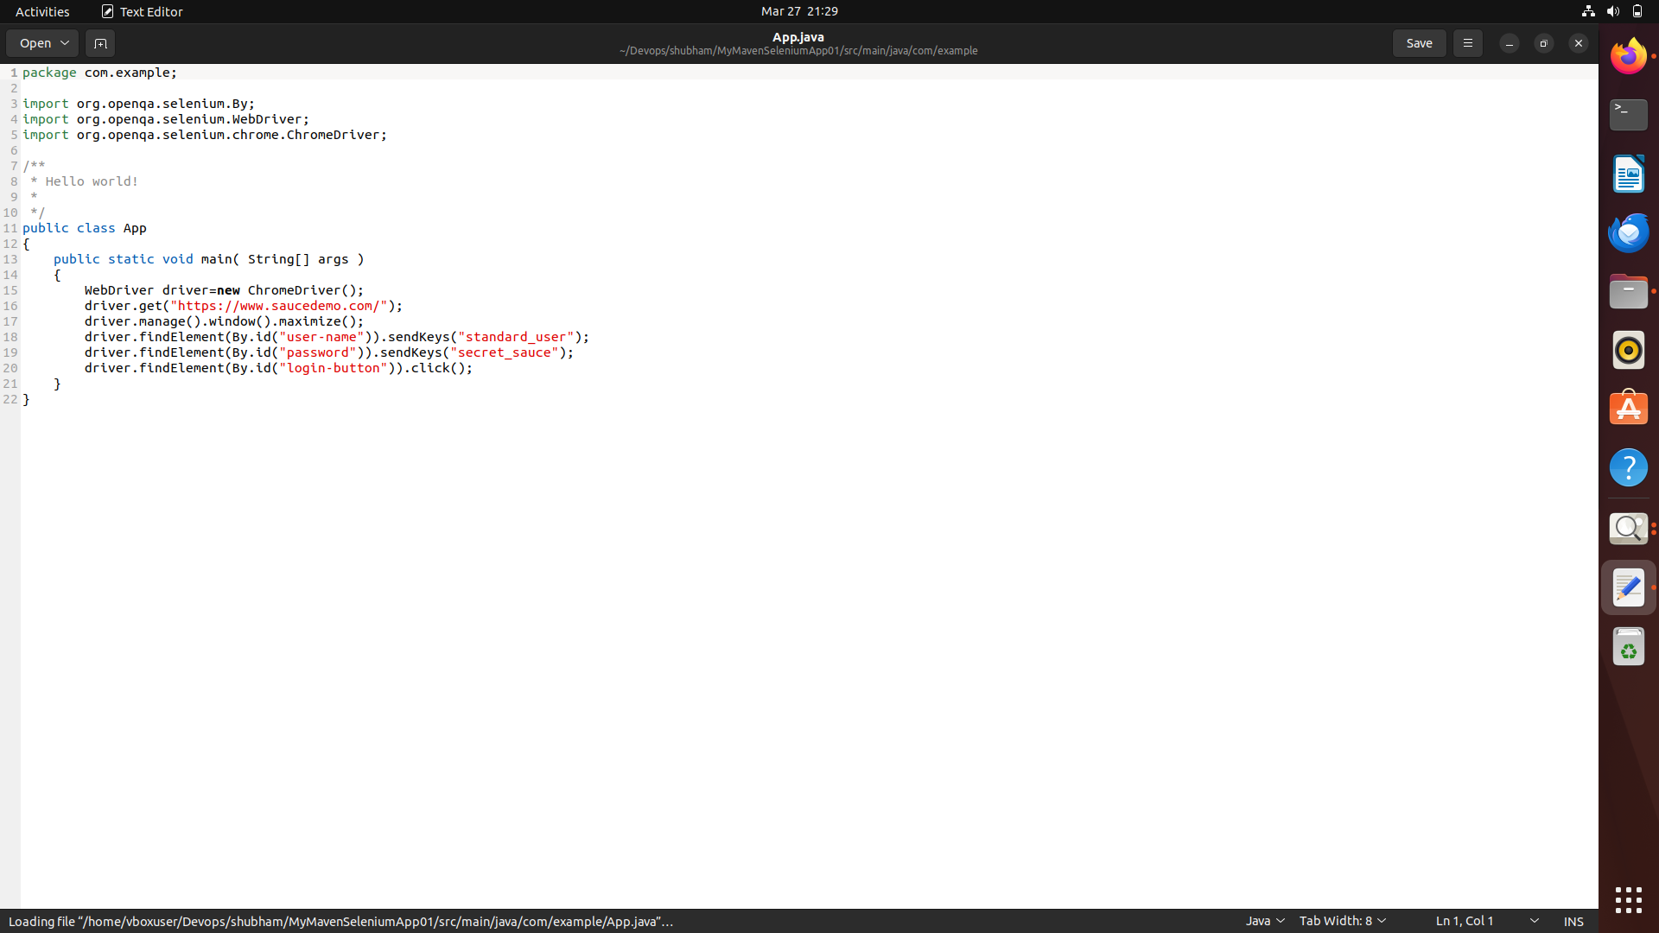

Step 6: Build the Maven Project
Run the following command -mvn clean install
This command compiles the project and builds the JAR file.

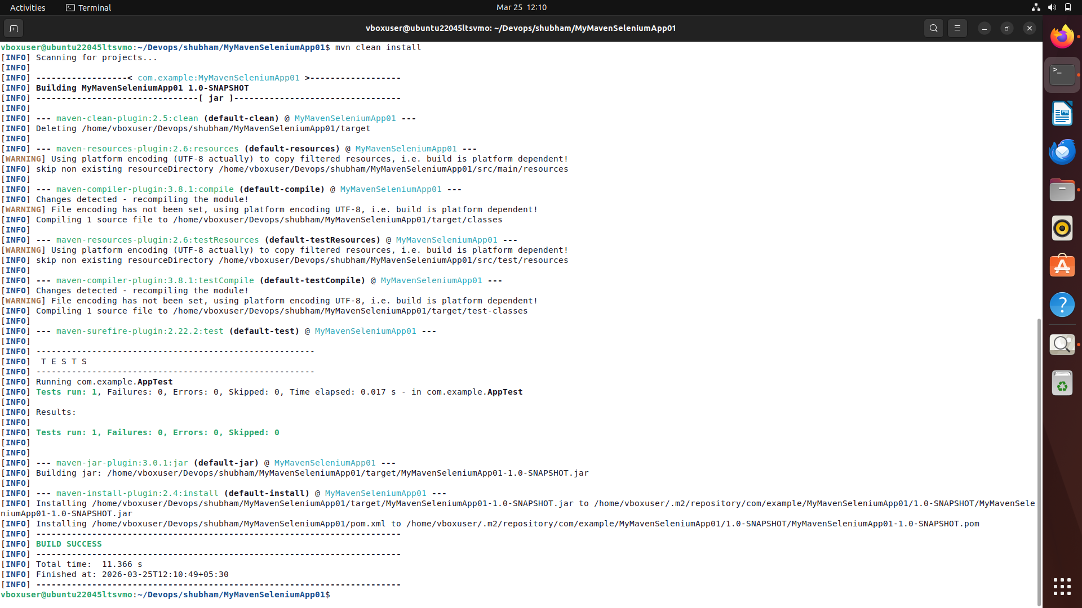

Step 7: Bash - mvn exec:java -Dexec.mainClass=”com.example.App”
This command is used to run the Maven project by executing the specified main class (com.example.App) using the Maven Exec plugin, without manually running the compiled JAR file.

