Project 3B
Maven Selenium Project – Automating Product Selection Using Selenium

To create a Maven-based Selenium project that automatically opens a web page, adds selected products to the cart, and views the cart using Java Selenium WebDriver.

Sample Website Used for Automation
Website used for testing - https://automationexercise.com/products
This website contains multiple products that can be added to the cart using automation.

Step 1: Create a Maven Project Using Terminal
Open the terminal and run the following command to create a Maven project.
mvn archetype:generate -DgroupId=com.example -DartifactId=MyMavenSeleniumApp02 -DarchetypeArtifactId=maven-archetype-quickstart -DinteractiveMode=false

This command creates a Maven project named MyMavenSeleniumApp02.

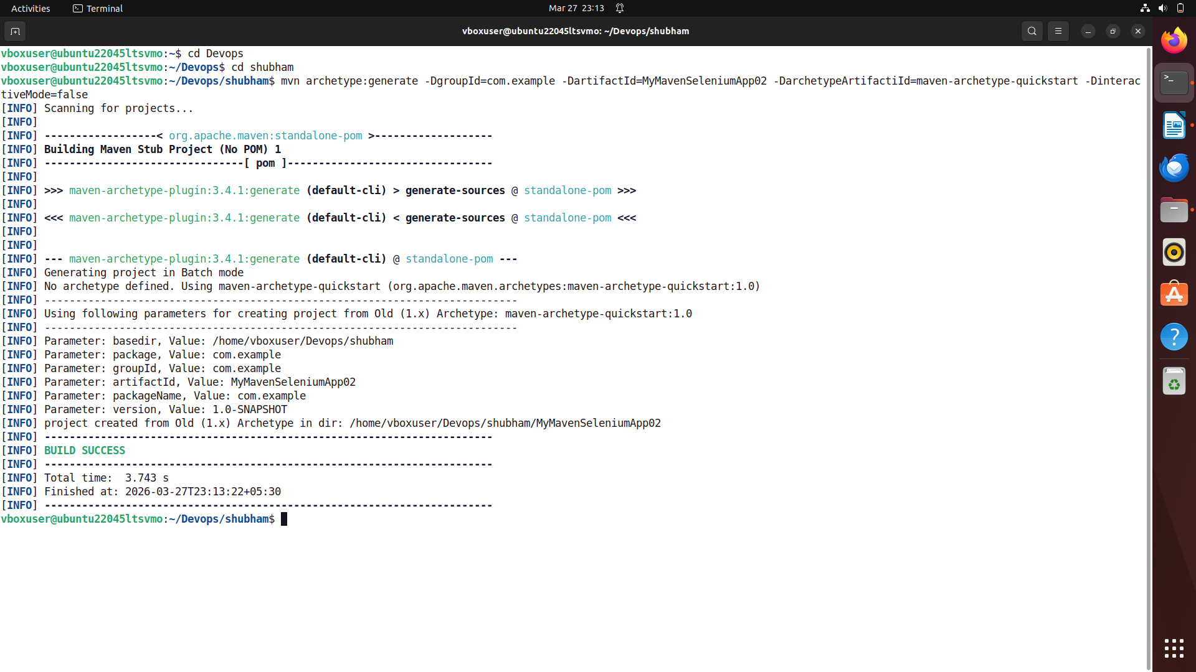

To get tree structure bash cmd – tree

Project Structure:
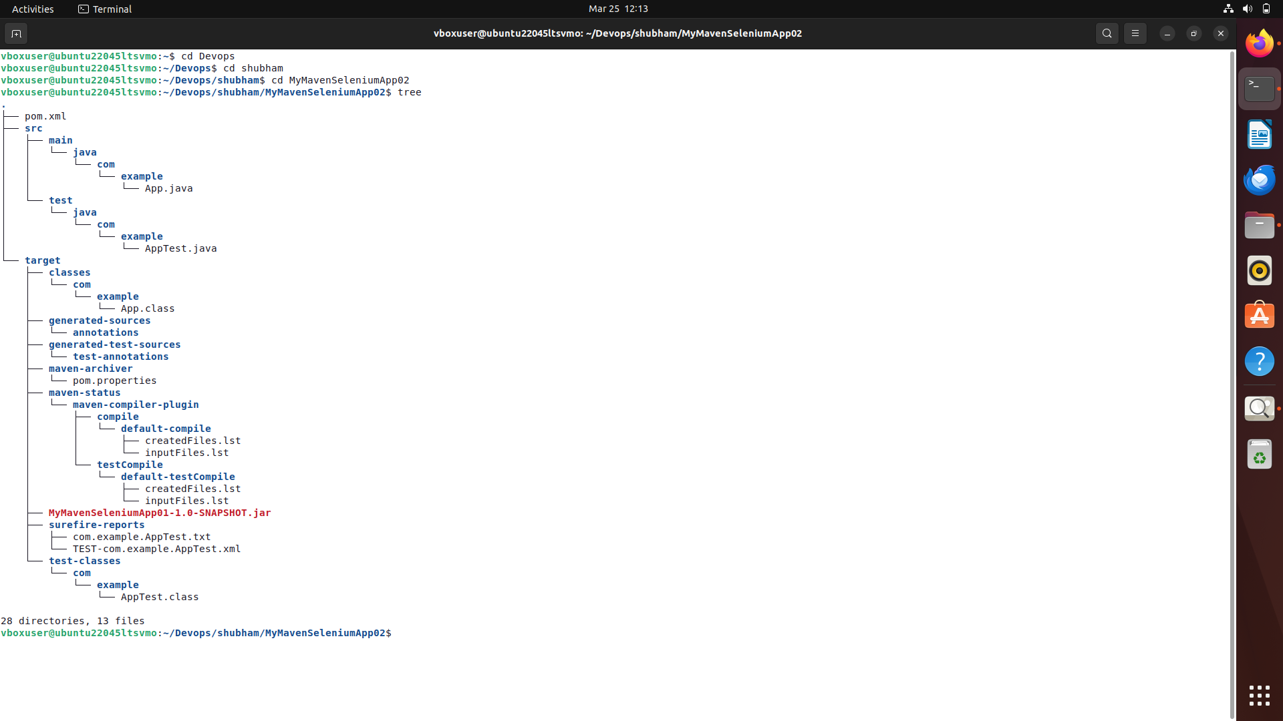

Get into directory of MyMavenSeleniumApp02 by running following cmd- cd MyMavenSeleniumApp02.

Step 2: Install ChromeDriver
Before running Selenium scripts, ChromeDriver must be installed.

Check Installed Chrome Version
Run the following command:
google-chrome --version
Example Output:
Google Chrome 133.0.6943.141

Extract Chrome Version
CHROME_VERSION=$(google-chrome --version | awk '{print $3}' | cut -d'.' -f1-3)
This extracts the Chrome version and stores it in the variable CHROME_VERSION.

Install jq (Used for JSON Parsing)
sudo apt install jq

Install curl (If Not Installed)
sudo apt install curl

Get Latest Compatible ChromeDriver Version
LATEST_DRIVER=$(curl -s "https://googlechromelabs.github.io/chrome-for-testing/latest-patch-versions-per-build.json" | jq -r ".builds[\"$CHROME_VERSION\"].version")

Download ChromeDriver
wget https://storage.googleapis.com/chrome-for-testing-public/$LATEST_DRIVER/linux64/chromedriver-linux64.zip

Extract ChromeDriver
unzip chromedriver-linux64.zip

Move ChromeDriver to System Path
sudo mv chromedriver-linux64/chromedriver /usr/local/bin/chromedriver
sudo chmod +x /usr/local/bin/chromedriver

Verify ChromeDriver Installation
chromedriver --version
Example Output:
ChromeDriver 133.0.6943.141
The version should match your Chrome version.

Step 3: Update pom.xml

Open the pom.xml file and replace whole code.
<project xmlns="http://maven.apache.org/POM/4.0.0" xmlns:xsi="http://www.w3.org/2001/XMLSchema-instance"
xsi:schemaLocation="http://maven.apache.org/POM/4.0.0 http://maven.apache.org/maven-v4_0_0.xsd">
<modelVersion>4.0.0</modelVersion>
<groupId>com.example</groupId>
<artifactId>MyMavenSeleniumApp01</artifactId>
<packaging>jar</packaging>
<version>1.0-SNAPSHOT</version>
<name>MyMavenSeleniumApp01</name>
<url>http://maven.apache.org</url>
<dependencies>
<dependency>
<groupId>junit</groupId>
<artifactId>junit</artifactId>
<version>3.8.1</version>
<scope>test</scope>
</dependency>
<!-- https://mvnrepository.com/artifact/org.seleniumhq.selenium/selenium-java -->
<dependency>
<groupId>org.seleniumhq.selenium</groupId>
<artifactId>selenium-java</artifactId>
<version>4.29.0</version>
</dependency>
</dependencies>
<!-- Build: Configuring plugins and build settings -->
<build>
<plugins>
<!-- Example: Maven Compiler Plugin to compile Java code -->
<plugin>
<groupId>org.apache.maven.plugins</groupId>
<artifactId>maven-compiler-plugin</artifactId>
<version>3.8.1</version>
<configuration>
<source>1.7</source>
<target>1.7</target>
</configuration>
</plugin>
<!-- Example: Maven Surefire Plugin to run tests -->
<plugin>
<groupId>org.apache.maven.plugins</groupId>
<artifactId>maven-surefire-plugin</artifactId>
<version>2.22.2</version>
</plugin>
<plugin>
<groupId>org.apache.maven.plugins</groupId>
<artifactId>maven-jar-plugin</artifactId>
<version>3.0.1</version>
<configuration>
<archive>
<manifestEntries>
<Main-Class>com.example.App</Main-Class>
</manifestEntries>
</archive>
</configuration>
</plugin>
</plugins>
</build>
</project>

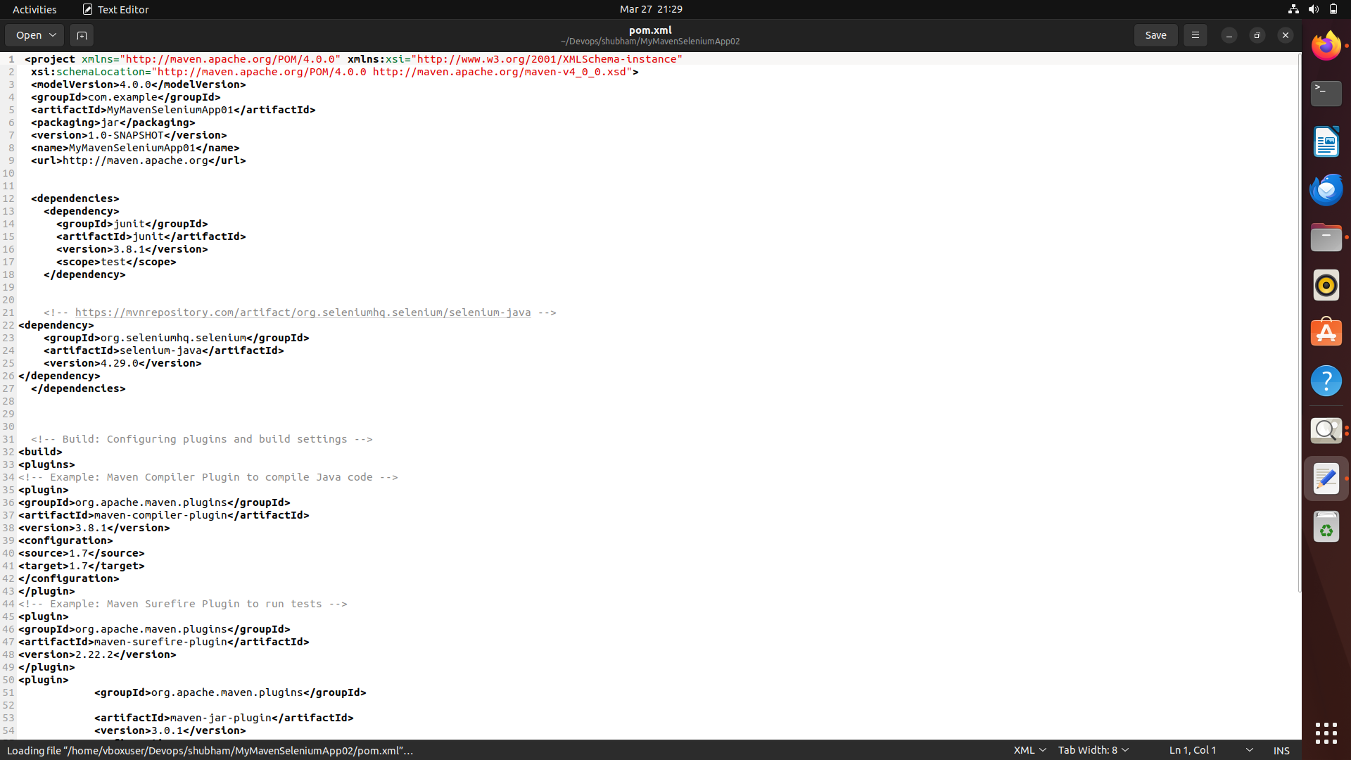

Step 4 : Inspect Elements in the Website
Before writing Selenium code, we must inspect the HTML elements.

Steps:
- Open the website -https://automationexercise.com/products
- Right-click on the webpage.
- Click Inspect.
- Use the cursor tool to select product buttons.
Search for t-shirt in products and add the 1st item of it into cart and go to cart page.

Step 5: Create App.java
package com.example;
import org.openqa.selenium.By;
import org.openqa.selenium.WebDriver;
import org.openqa.selenium.WebElement;
import org.openqa.selenium.chrome.ChromeDriver;
import org.openqa.selenium.support.ui.ExpectedConditions;
import org.openqa.selenium.support.ui.WebDriverWait;
import java.time.Duration;

public class App {
public static void main(String[] args) throws InterruptedException {
// Step 1: Open Chrome and maximize window
WebDriver driver = new ChromeDriver();
driver.get("https://automationexercise.com/");
driver.manage().window().maximize();
WebDriverWait wait = new WebDriverWait(driver, Duration.ofSeconds(10));
// Step 2: Click on "Products" from navbar
WebElement productsMenu = wait.until(
ExpectedConditions.elementToBeClickable(By.xpath("//a[@href='/products']"))
);
productsMenu.click();
// Step 3: Find the search box and search for "t-shirt"
WebElement searchBox = wait.until(
ExpectedConditions.visibilityOfElementLocated(By.id("search_product"))
);
searchBox.sendKeys("t-shirt");
// Step 4: Click the Search button
WebElement searchBtn = driver.findElement(By.id("submit_search"));
searchBtn.click();
// Step 5: Wait for results and hover/click "Add to Cart" on the 1st product
WebElement firstAddToCart = wait.until(
ExpectedConditions.elementToBeClickable(
By.xpath("(//div[@class='product-image-wrapper']//a[@data-product-id])[1]")
)
);
firstAddToCart.click();
// Step 6: Handle the popup - click "Continue Shopping" to stay or "View Cart"
WebElement viewCartBtn = wait.until(
ExpectedConditions.elementToBeClickable(
By.xpath("//u[text()='View Cart']")
)
);
viewCartBtn.click();
// Step 7: Cart page is now displayed
System.out.println("Product added to cart successfully!");
System.out.println("Current URL: " + driver.getCurrentUrl());
// Optional: pause to see the result before browser closes
Thread.sleep(5000);
driver.quit();
}
}

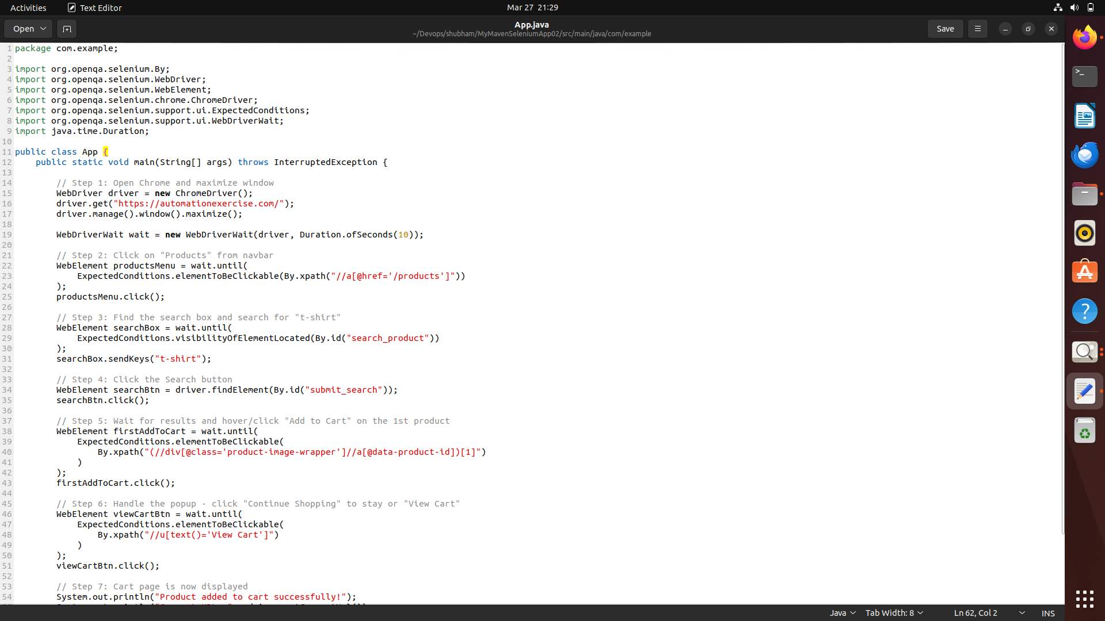

Step 6: Build the Maven Project
Run the following command - mvn clean install
This command cleans the previous build files, compiles the project, runs tests, and builds the JAR file in the target directory.
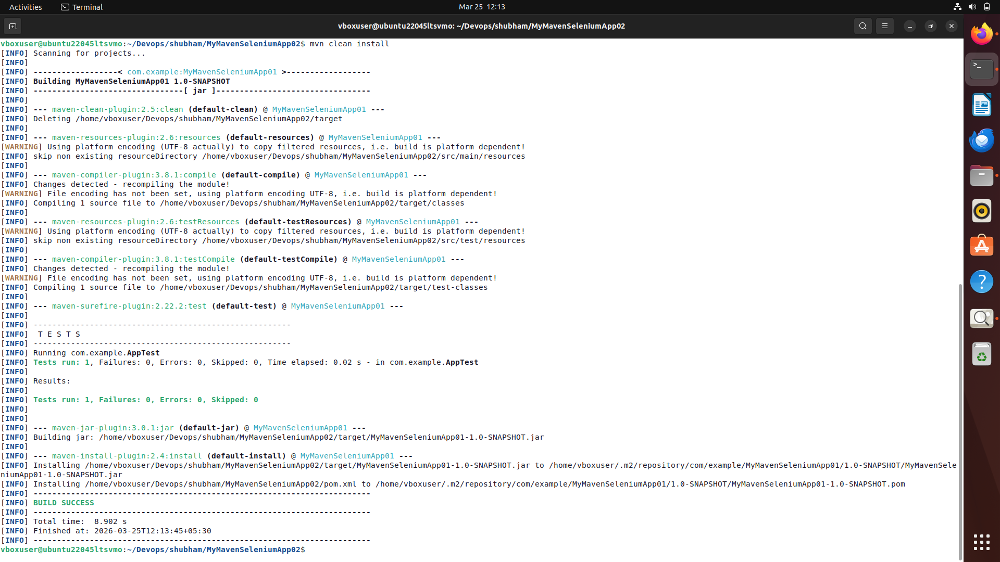
Step 7: Bash - mvn exec:java -Dexec.mainClass=”com.example.App”
This command is used to run the Maven project by executing the specified main class (com.example.App) using the Maven Exec plugin, without manually running the compiled JAR file