Project 3C
Maven Selenium Project –Practice Test Automation Using Selenium

To create a Maven-based Selenium project that automates a login process by opening a web page, entering valid credentials, and verifying successful login using Java Selenium WebDriver..

Sample Website Used for Automation
Website used for testing: https://practicetestautomation.com/
This website provides a login page that can be automated using Selenium to validate user authentication functionality.

Step 1: Create a Maven Project Using Terminal
Open the terminal and run the following command to create a Maven project.
mvn archetype:generate -DgroupId=com.example -DartifactId=MyMavenSeleniumApp03 -DarchetypeArtifactId=maven-archetype-quickstart -DinteractiveMode=false

This command creates a Maven project named MyMavenSeleniumApp03.
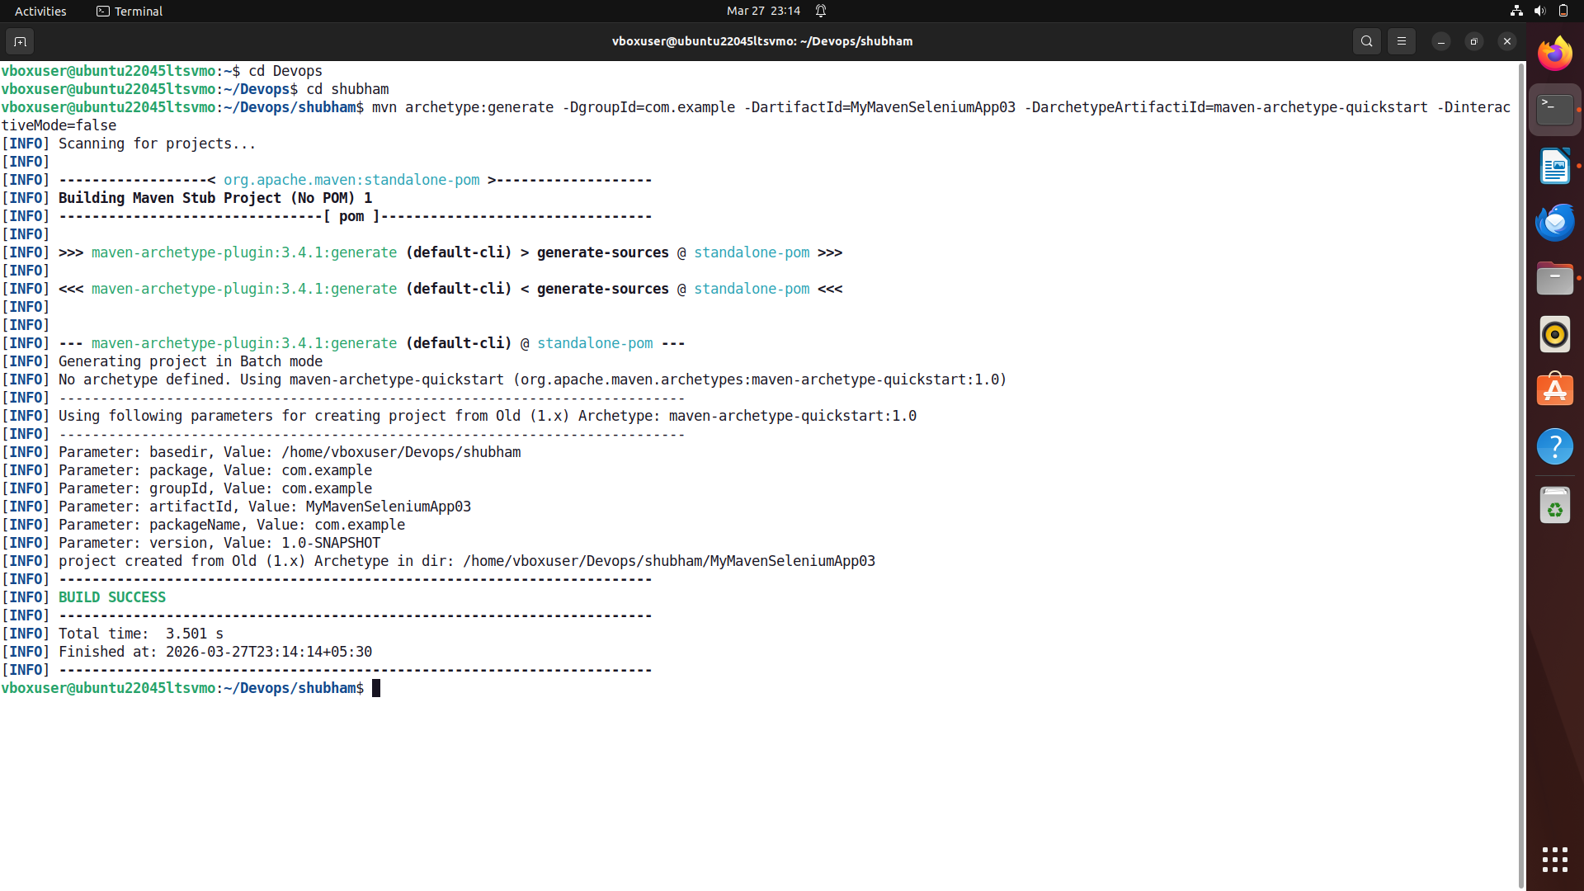

To get tree structure bash cmd – tree.

Project Structure:

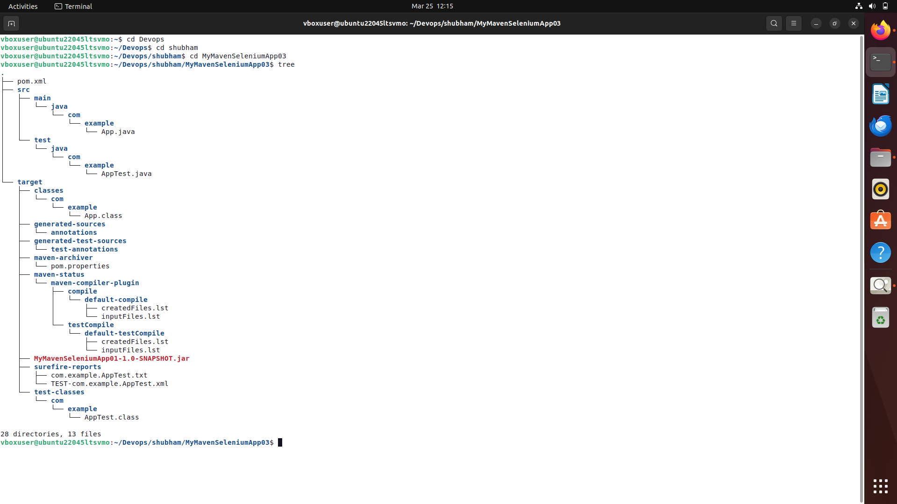
Get into directory of MyMavenSeleniumApp03 by running following cmd- cd MyMavenSeleniumApp03.

Step 2: Install ChromeDriver
Before running Selenium scripts, ChromeDriver must be installed.

Check Installed Chrome Version
Run the following command:
google-chrome --version
Example Output:
Google Chrome 133.0.6943.141

Extract Chrome Version
CHROME_VERSION=$(google-chrome --version | awk '{print $3}' | cut -d'.' -f1-3)
This extracts the Chrome version and stores it in the variable CHROME_VERSION.

Install jq (Used for JSON Parsing)
sudo apt install jq

Install curl (If Not Installed)
sudo apt install curl

Get Latest Compatible ChromeDriver Version
LATEST_DRIVER=$(curl -s "https://googlechromelabs.github.io/chrome-for-testing/latest-patch-versions-per-build.json" | jq -r ".builds[\"$CHROME_VERSION\"].version")

Download ChromeDriver
wget https://storage.googleapis.com/chrome-for-testing-public/$LATEST_DRIVER/linux64/chromedriver-linux64.zip

Extract ChromeDriver
unzip chromedriver-linux64.zip

Move ChromeDriver to System Path
sudo mv chromedriver-linux64/chromedriver /usr/local/bin/chromedriver
sudo chmod +x /usr/local/bin/chromedriver

Verify ChromeDriver Installation
chromedriver --version
Example Output:
ChromeDriver 133.0.6943.141
The version should match your Chrome version.

Step 3: Add Selenium Dependency in pom.xml
Open the pom.xml file and add the Selenium dependency.
<project xmlns="http://maven.apache.org/POM/4.0.0" xmlns:xsi="http://www.w3.org/2001/XMLSchema-instance"
xsi:schemaLocation="http://maven.apache.org/POM/4.0.0 http://maven.apache.org/maven-v4_0_0.xsd">
<modelVersion>4.0.0</modelVersion>
<groupId>com.example</groupId>
<artifactId>MyMavenSeleniumApp01</artifactId>
<packaging>jar</packaging>
<version>1.0-SNAPSHOT</version>
<name>MyMavenSeleniumApp03</name>
<url>http://maven.apache.org</url>
<dependencies>
<!-- JUnit -->
<dependency>
<groupId>junit</groupId>
<artifactId>junit</artifactId>
<version>3.8.1</version>
<scope>test</scope>
</dependency>
<!-- Selenium Java -->
<dependency>
<groupId>org.seleniumhq.selenium</groupId>
<artifactId>selenium-java</artifactId>
<version>4.29.0</version>
</dependency>
<!-- NOTE: selenium-devtools-v146 is NOT on Maven Central yet (Chrome 146 is too new).
The CDP warning is harmless and can be ignored. Remove this block entirely. -->
</dependencies>
<build>
<plugins>
<!-- Compiler Plugin: upgraded to Java 11 (matches your JVM) -->
<plugin>
<groupId>org.apache.maven.plugins</groupId>
<artifactId>maven-compiler-plugin</artifactId>
<version>3.8.1</version>
<configuration>
<source>11</source>
<target>11</target>
</configuration>
</plugin>
<!-- Surefire Plugin -->
<plugin>
<groupId>org.apache.maven.plugins</groupId>
<artifactId>maven-surefire-plugin</artifactId>
<version>2.22.2</version>
</plugin>
<!-- JAR Plugin with Main-Class -->
<plugin>
<groupId>org.apache.maven.plugins</groupId>
<artifactId>maven-jar-plugin</artifactId>
<version>3.0.1</version>
<configuration>
<archive>
<manifestEntries>
<Main-Class>com.example.App</Main-Class>
</manifestEntries>
</archive>
</configuration>
</plugin>
<!-- Exec Plugin to run via: mvn exec:java -->
<plugin>
<groupId>org.codehaus.mojo</groupId>
<artifactId>exec-maven-plugin</artifactId>
<version>3.6.3</version>
<configuration>
<mainClass>com.example.App</mainClass>
</configuration>
</plugin>
</plugins>
</build>
</project>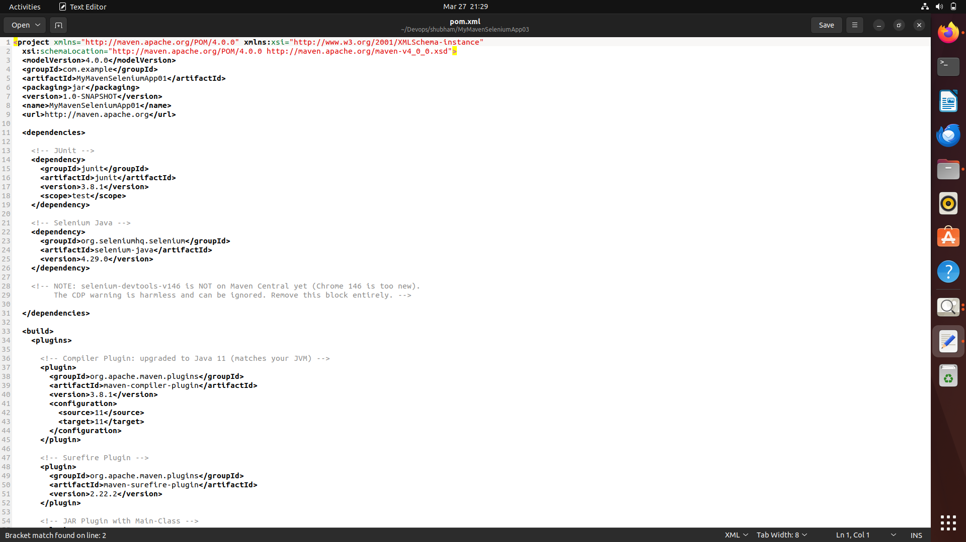

Step 4: Inspect Elements in the Website
Before writing Selenium code, we must inspect the HTML elements.

Steps:
- Open the website - https://automationexercise.com/products
- Right-click on the webpage.
- Click Inspect.
- Use the cursor tool to select product buttons.
Example attribute used for product buttons:
data-product-id
Example:
data-product-id="4"
data-product-id="5"
data-product-id="6"
These attributes are used to add specific products to the cart.

Step 5: Create App.java
package com.example;
import org.openqa.selenium.By;
import org.openqa.selenium.WebDriver;
import org.openqa.selenium.WebElement;
import org.openqa.selenium.chrome.ChromeDriver;
import org.openqa.selenium.chrome.ChromeOptions;
import org.openqa.selenium.support.ui.ExpectedConditions;
import org.openqa.selenium.support.ui.WebDriverWait;
import java.time.Duration;
public class App {
public static void main(String[] args) {
// Set ChromeOptions to ignore SSL errors
ChromeOptions options = new ChromeOptions();
options.addArguments("--ignore-certificate-errors");
options.addArguments("--allow-insecure-localhost");
options.addArguments("--disable-web-security");
options.addArguments("--no-sandbox");
options.addArguments("--disable-dev-shm-usage");
// Spoof user-agent to avoid bot detection / rate limiting
options.addArguments("--user-agent=Mozilla/5.0 (X11; Linux x86_64) AppleWebKit/537.36 (KHTML, like Gecko) Chrome/146.0.0.0 Safari/537.36");
WebDriver driver = new ChromeDriver(options);
try {
driver.get("https://practicetestautomation.com/practice-test-login/");
driver.manage().window().maximize();
System.out.println("Current URL: " + driver.getCurrentUrl());
System.out.println("Page Title : " + driver.getTitle());
// Wait 3 seconds to avoid rate limiting (429)
Thread.sleep(3000);
// Wait up to 30s for elements to be visible
WebDriverWait wait = new WebDriverWait(driver, Duration.ofSeconds(30));
WebElement usernameField = wait.until(
ExpectedConditions.visibilityOfElementLocated(By.id("username"))
);
usernameField.sendKeys("student");
WebElement passwordField = wait.until(
ExpectedConditions.visibilityOfElementLocated(By.id("password"))
);
passwordField.sendKeys("Password123");
WebElement submitBtn = wait.until(
ExpectedConditions.elementToBeClickable(By.id("submit"))
);
submitBtn.click();
// Wait for successful login - verify post-login page
wait.until(ExpectedConditions.urlContains("logged-in-successfully"));
System.out.println("Login Successful! Current URL: " + driver.getCurrentUrl());
} catch (Exception e) {
System.err.println("Test Failed: " + e.getMessage());
String pageSource = driver.getPageSource();
System.out.println("Page Source: "
+ pageSource.substring(0, Math.min(1000, pageSource.length())));
} finally {
// Always quit the driver
driver.quit();
}
}
}

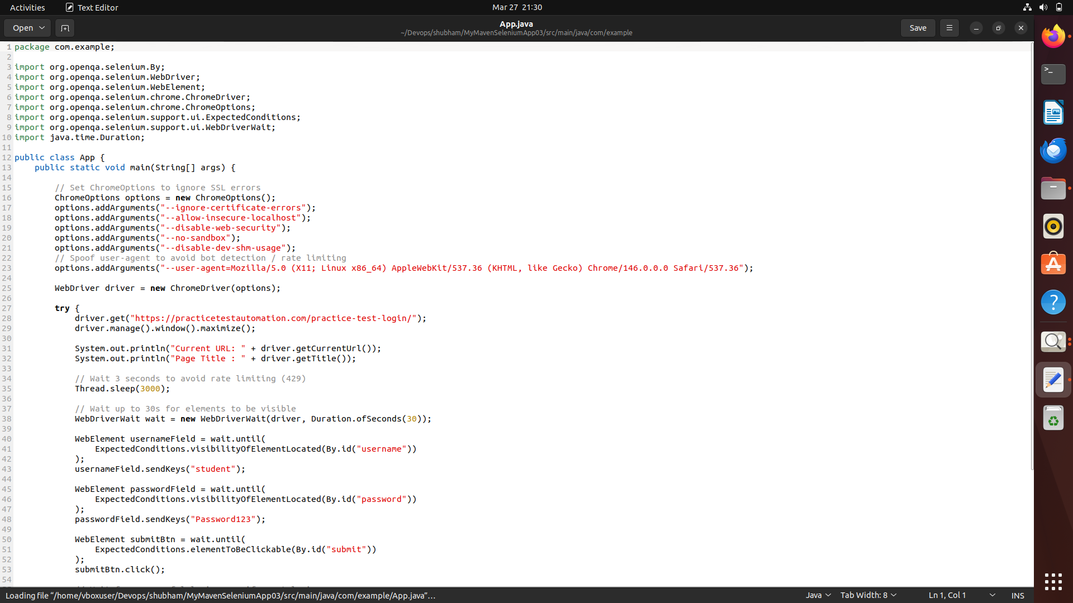

Step 6: Build the Maven Project
Run the following command - mvn clean install
This command cleans the previous build files, compiles the project, runs tests, and builds the JAR file in the target directory.
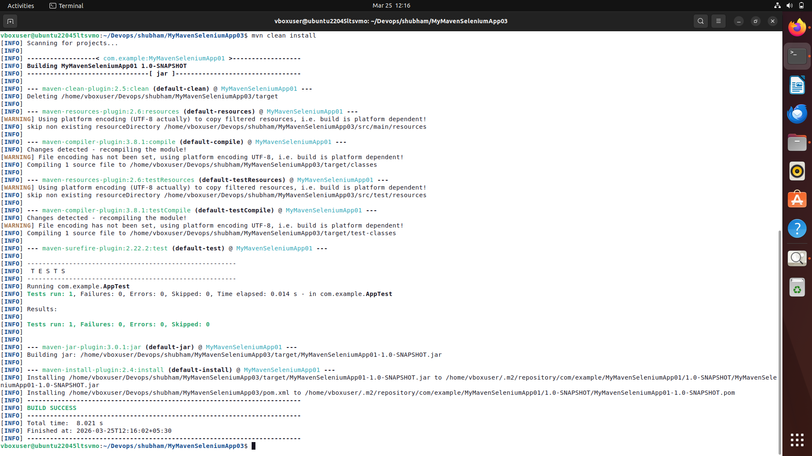
Step 7: Bash - mvn exec:java -Dexec.mainClass=”com.example.App”
This command is used to run the Maven project by executing the specified main class (com.example.App) using the Maven Exec plugin, without manually running the compiled JAR file
