Project 4
Maven Selenium Project – Automating Web Applications Using Firefox Browser

To create a Maven-based Selenium project using the Firefox browser that performs the following tasks:
- Login to the SauceDemo website
- Search and add a product to the cart on AutomationExercise website
- Login to the Practice Test Automation website
- Demonstrate multi-tab browser automation using Selenium WebDriver

Websites Used for Automation
The following websites are used in this project:
- SauceDemo
https://www.saucedemo.com/
- Automation Exercise
https://automationexercise.com/products
- Practice Test Automation
https://practicetestautomation.com/practice-test-login/
Step 1: Create a Maven Project
Open the terminal and create a Maven project using the following command:
mvn archetype:generate -DgroupId=com.example -DartifactId=MyMavenSeleniumApp04 -DarchetypeArtifactId=maven-archetype-quickstart -DinteractiveMode=false
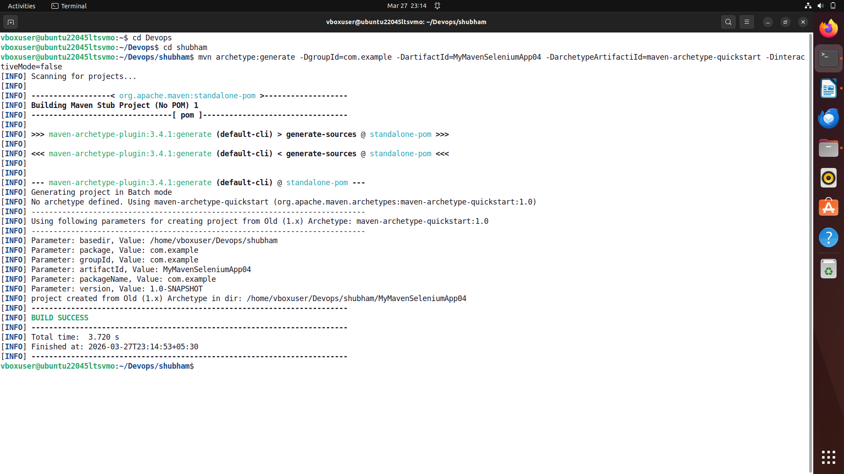

To get tree structure run cmd -tree
Project Structure:
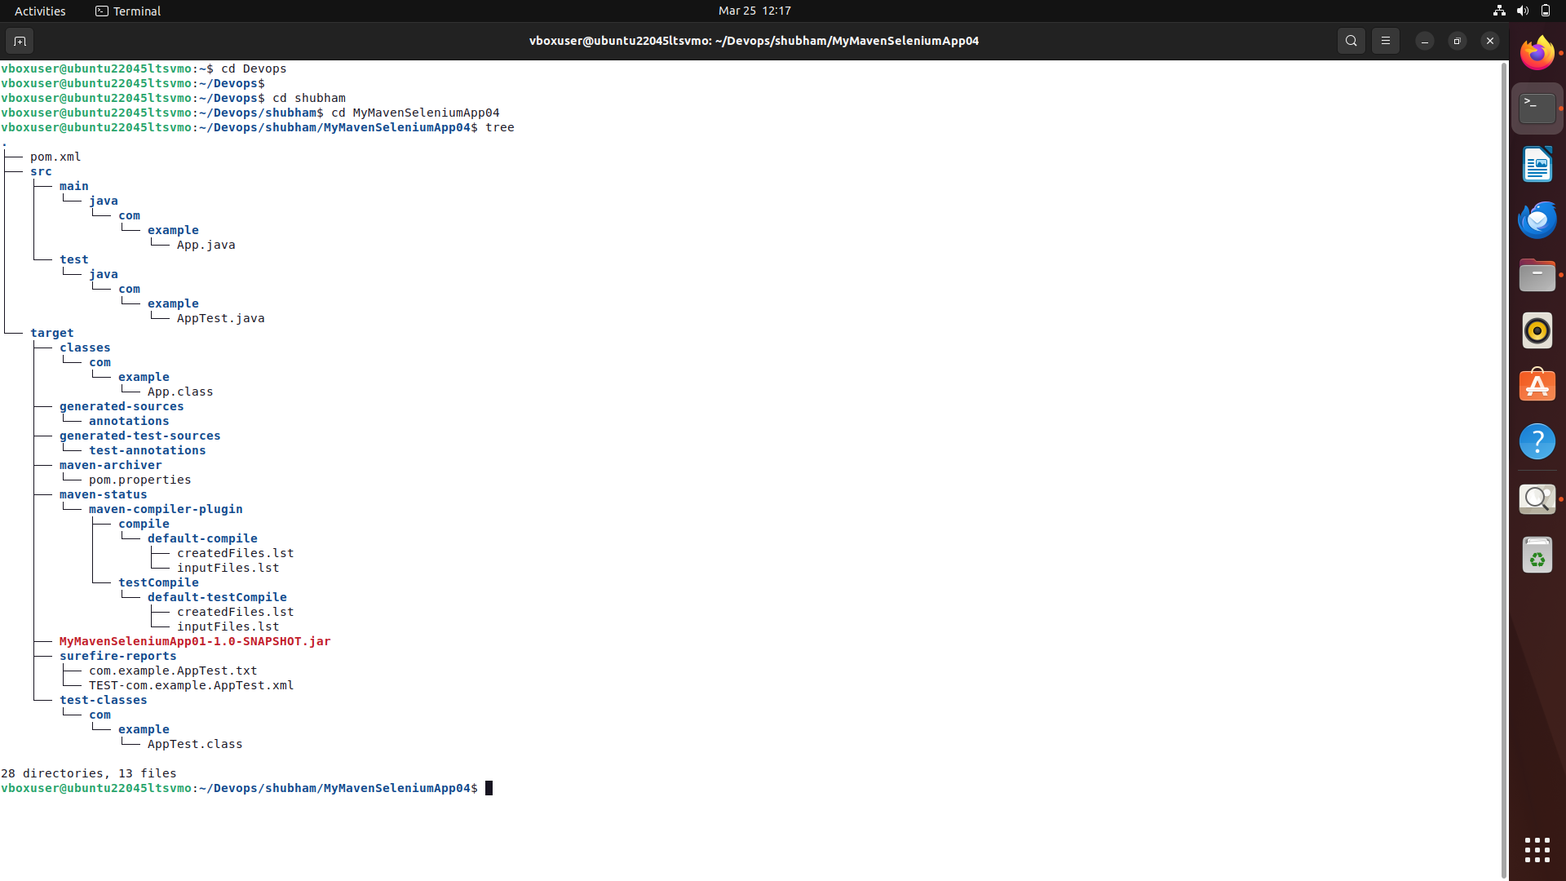

Get into directory MyMavenSeleniumApp04 by running following the cmd – cd MavenSeleniumApp04.

Step 2: Install Firefox Browser And Install GeckoDriver
Check whether Firefox is installed.
firefox --version
Example output:
Mozilla Firefox 124.0
If Firefox is not installed:
sudo apt install firefox

Install GeckoDriver
Selenium requires GeckoDriver to control Firefox.
Download GeckoDriver:
wget https://github.com/mozilla/geckodriver/releases/latest/download/geckodriver-v0.34.0-linux64.tar.gz
Extract the file:
tar -xvzf geckodriver-v0.34.0-linux64.tar.gz
Move it to system path:
sudo mv geckodriver /usr/local/bin/
sudo chmod +x /usr/local/bin/geckodriver
Verify installation:
geckodriver --version

Step 3: Add Selenium Dependency in pom.xml
Open the pom.xml file and add the Selenium dependency.
pom.xml
<project xmlns="http://maven.apache.org/POM/4.0.0" xmlns:xsi="http://www.w3.org/2001/XMLSchema-instance"
xsi:schemaLocation="http://maven.apache.org/POM/4.0.0 http://maven.apache.org/maven-v4_0_0.xsd">
<modelVersion>4.0.0</modelVersion>
<groupId>com.example</groupId>
<artifactId>MyMavenSeleniumApp04</artifactId>
<packaging>jar</packaging>
<version>1.0-SNAPSHOT</version>
<name>MyMavenSeleniumApp01</name>
<url>http://maven.apache.org</url>
<dependencies>
<!-- JUnit -->
<dependency>
<groupId>junit</groupId>
<artifactId>junit</artifactId>
<version>3.8.1</version>
<scope>test</scope>
</dependency>
<!-- Selenium Java -->
<dependency>
<groupId>org.seleniumhq.selenium</groupId>
<artifactId>selenium-java</artifactId>
<version>4.29.0</version>
</dependency>
</dependencies>
<build>
<plugins>
<!-- Compiler Plugin - CHANGED 1.7 to 11 -->
<plugin>
<groupId>org.apache.maven.plugins</groupId>
<artifactId>maven-compiler-plugin</artifactId>
<version>3.8.1</version>
<configuration>
<source>11</source>
<target>11</target>
</configuration>
</plugin>
<!-- Surefire Plugin -->
<plugin>
<groupId>org.apache.maven.plugins</groupId>
<artifactId>maven-surefire-plugin</artifactId>
<version>2.22.2</version>
</plugin>
<!-- JAR Plugin -->
<plugin>
<groupId>org.apache.maven.plugins</groupId>
<artifactId>maven-jar-plugin</artifactId>
<version>3.0.1</version>
<configuration>
<archive>
<manifestEntries>
<Main-Class>com.example.App</Main-Class>
</manifestEntries>
</archive>
</configuration>
</plugin>
<!-- Exec Plugin to run App directly -->
<plugin>
<groupId>org.codehaus.mojo</groupId>
<artifactId>exec-maven-plugin</artifactId>
<version>3.1.0</version>
<configuration>
<mainClass>com.example.App</mainClass>
</configuration>
</plugin>
</plugins>
</build>

</project>
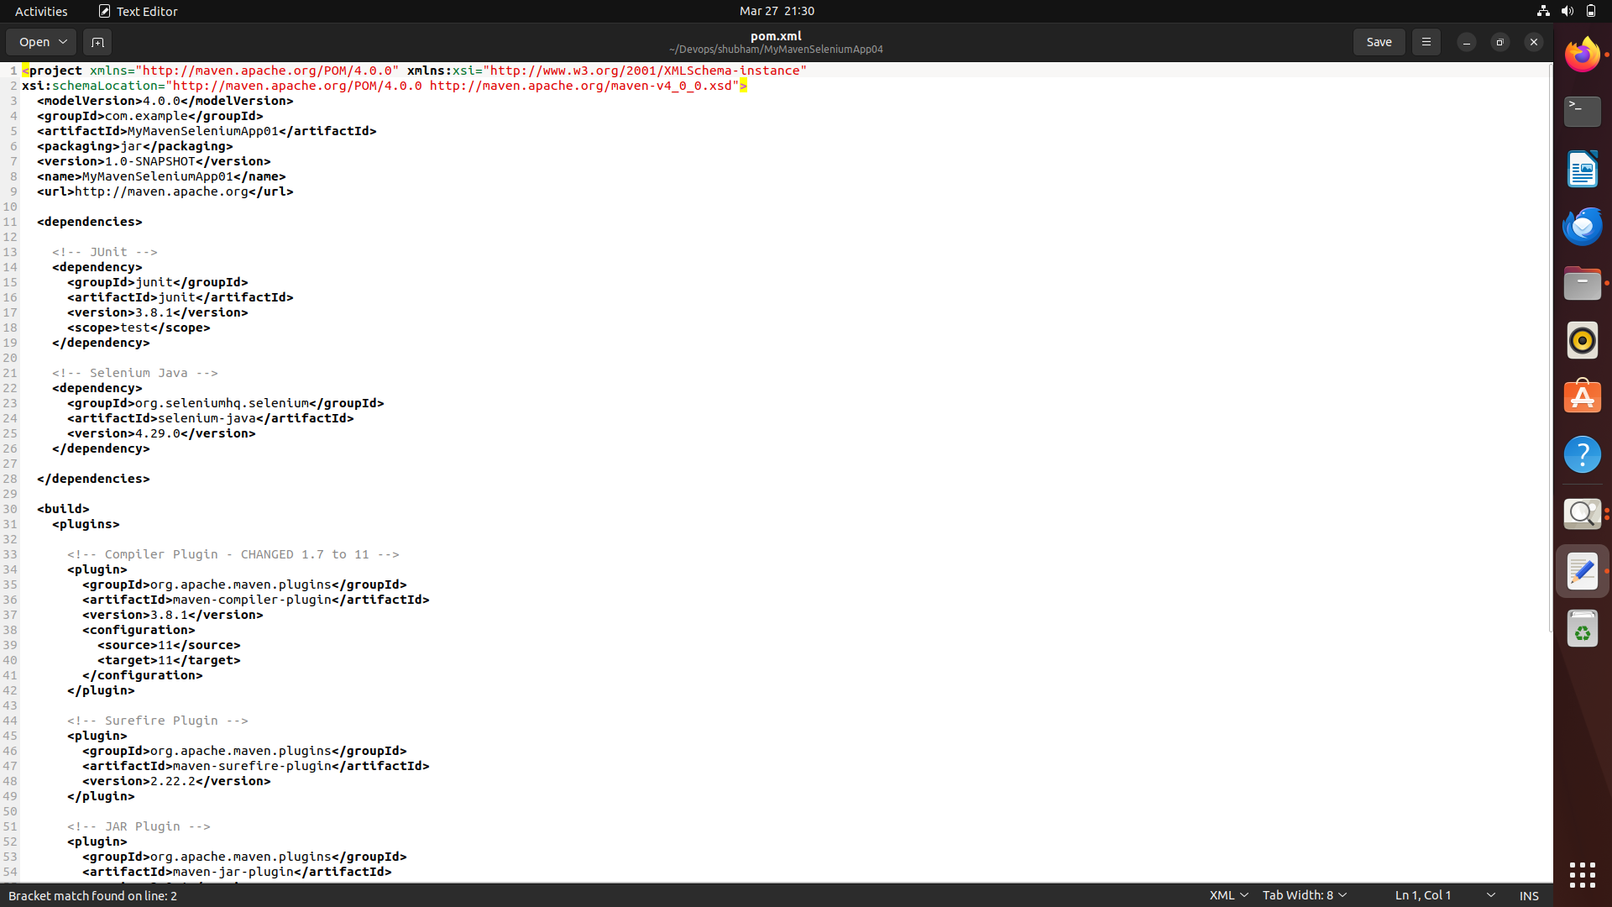
Step 4: Inspect Elements in the Websites
Before writing Selenium code, inspect the webpage elements.
Steps:
- Open the website.
- Right-click on the webpage.
- Click Inspect.
- Use the cursor tool to identify HTML elements.
Important IDs used in this project:
SauceDemo
Field | ID
Username | user-name
Password | password
Login Button | login-button

Automation Exercise
Field | ID
Search Box | search_product
Search Button | submit_search
Product Button | data-product-id

Practice Test Automation
Field | ID
Username | username
Password | password
Login Button | submit

Step 5: Create App.java
Location -src/main/java/com/example/App.java
Java Code:
package com.example;
import org.openqa.selenium.By;
import org.openqa.selenium.JavascriptExecutor;
import org.openqa.selenium.WebDriver;
import org.openqa.selenium.WebElement;
import org.openqa.selenium.firefox.FirefoxDriver;
import org.openqa.selenium.firefox.FirefoxOptions;
import org.openqa.selenium.support.ui.ExpectedConditions;
import org.openqa.selenium.support.ui.WebDriverWait;
import java.time.Duration;
import java.util.ArrayList;

public class App {
public static void main(String[] args) throws InterruptedException {

System.setProperty("webdriver.gecko.driver", "/snap/bin/geckodriver");

FirefoxOptions options = new FirefoxOptions();
WebDriver driver = new FirefoxDriver(options);
driver.manage().window().maximize();
driver.manage().timeouts().pageLoadTimeout(Duration.ofSeconds(120));
driver.manage().timeouts().implicitlyWait(Duration.ofSeconds(15));

JavascriptExecutor js = (JavascriptExecutor) driver;
WebDriverWait wait = new WebDriverWait(driver, Duration.ofSeconds(60));

// ============================================================
// TAB 1 - https://www.saucedemo.com/ - LOGIN
// ============================================================
System.out.println("========== TAB 1: saucedemo.com ==========");

driver.get("https://www.saucedemo.com/");
driver.manage().window().maximize();
Thread.sleep(2000);

wait.until(ExpectedConditions.visibilityOfElementLocated(By.id("user-name")));
driver.findElement(By.id("user-name")).clear();
driver.findElement(By.id("user-name")).sendKeys("standard_user");
Thread.sleep(500);

driver.findElement(By.id("password")).clear();
driver.findElement(By.id("password")).sendKeys("secret_sauce");
Thread.sleep(500);

driver.findElement(By.id("login-button")).click();
Thread.sleep(2000);

System.out.println("TAB 1 - Saucedemo Login Successful!");
System.out.println("TAB 1 - URL: " + driver.getCurrentUrl());

// ============================================================
// TAB 2 - https://automationexercise.com/ - SEARCH & ADD TO CART
// ============================================================
System.out.println("\n========== TAB 2: automationexercise.com ==========");

js.executeScript("window.open('https://automationexercise.com/', '_blank');");
Thread.sleep(2000);

ArrayList<String> tabs = new ArrayList<>(driver.getWindowHandles());
driver.switchTo().window(tabs.get(1));
driver.manage().window().maximize();
Thread.sleep(3000);

WebElement productsMenu = wait.until(
ExpectedConditions.elementToBeClickable(By.xpath("//a[@href='/products']"))
);
productsMenu.click();
Thread.sleep(2000);

WebElement searchBox = wait.until(
ExpectedConditions.visibilityOfElementLocated(By.id("search_product"))
);
searchBox.clear();
searchBox.sendKeys("t-shirt");
Thread.sleep(500);

driver.findElement(By.id("submit_search")).click();
Thread.sleep(2000);

WebElement firstAddToCart = wait.until(
ExpectedConditions.elementToBeClickable(
By.xpath("(//div[@class='product-image-wrapper']//a[@data-product-id])[1]")
)
);
js.executeScript("arguments[0].click();", firstAddToCart);
Thread.sleep(2000);

WebElement viewCart = wait.until(
ExpectedConditions.elementToBeClickable(By.xpath("//u[text()='View Cart']"))
);
js.executeScript("arguments[0].click();", viewCart);
Thread.sleep(2000);

System.out.println("TAB 2 - T-shirt added to cart successfully!");
System.out.println("TAB 2 - URL: " + driver.getCurrentUrl());

// ============================================================
// TAB 3 - https://practicetestautomation.com/ - LOGIN
// ============================================================
System.out.println("\n========== TAB 3: practicetestautomation.com ==========");

js.executeScript("window.open('https://practicetestautomation.com/practice-test-login/', '_blank');");
Thread.sleep(3000);

tabs = new ArrayList<>(driver.getWindowHandles());
driver.switchTo().window(tabs.get(2));
driver.manage().window().maximize();
Thread.sleep(3000);

WebElement usernameField = wait.until(
ExpectedConditions.visibilityOfElementLocated(By.id("username"))
);
usernameField.clear();
usernameField.sendKeys("student");
Thread.sleep(500);

WebElement passwordField = driver.findElement(By.id("password"));
passwordField.clear();
passwordField.sendKeys("Password123");
Thread.sleep(500);

WebElement loginBtn = wait.until(
ExpectedConditions.elementToBeClickable(By.id("submit"))
);
js.executeScript("arguments[0].click();", loginBtn);
Thread.sleep(3000);

WebElement successMsg = wait.until(
ExpectedConditions.visibilityOfElementLocated(
By.xpath("//h1[contains(text(),'Logged In Successfully')]")
)
);

System.out.println("TAB 3 - Login Successful!");
System.out.println("TAB 3 - URL: " + driver.getCurrentUrl());
System.out.println("TAB 3 - Message: " + successMsg.getText());

// ============================================================
// FINAL SUMMARY
// ============================================================
System.out.println("\n========== ALL 3 TABS COMPLETED ==========");
System.out.println("TAB 1 -> saucedemo.com : Logged In Successfully ✅");
System.out.println("TAB 2 -> automationexercise.com : T-shirt Added to Cart ✅");
System.out.println("TAB 3 -> practicetestautomation.com : Logged In Successfully ✅");

Thread.sleep(3000);

// ============================================================
// SAFE QUIT - Fixes "Failed to decode response from marionette"
// ============================================================
try {
driver.quit();
} catch (Exception e) {
System.out.println("Browser already closed, ignoring cleanup error.");
}
}
}
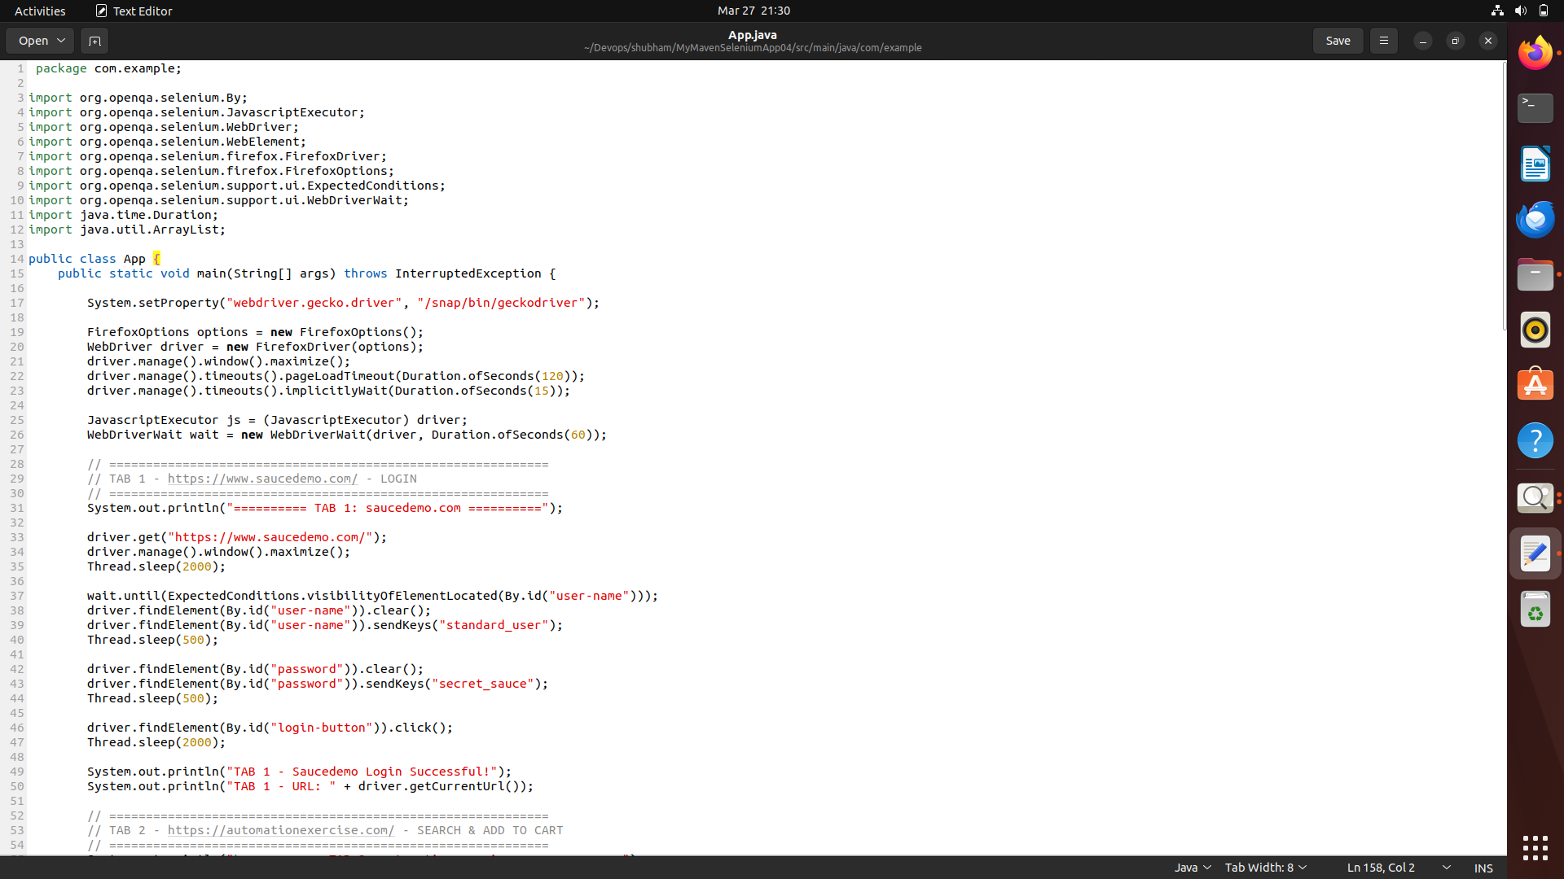
Step 6: Build the Maven Project
Run the following command - mvn clean install
This command cleans the previous build files, compiles the project, runs tests, and builds the JAR file in the target directory 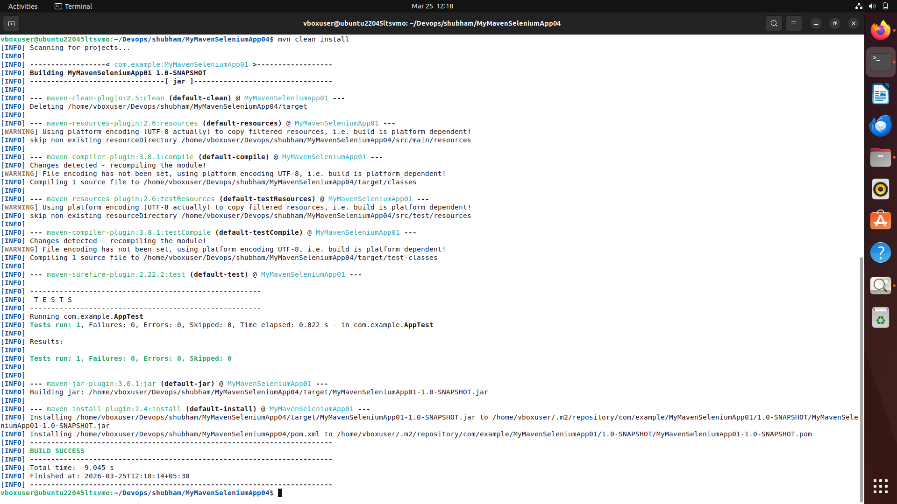

Step 7: Bash - mvn exec:java -Dexec.mainClass=”com.example.App”
This command is used to run the Maven project by executing the specified main class (com.example.App) using the Maven Exec plugin, without manually running the compiled JAR file

