Program: Jenkins Pipeline Setup for Simple Maven

Jenkins is a popular open-source automation server used for continuous integration and continuous delivery (CI/CD). It enables developers to automate the process of building, testing, and deploying applications efficiently. Jenkins pipelines allow users to define the entire workflow of a project as code using a file called a Jenkinsfile, which ensures consistency and repeatability in the build process.

A Jenkins pipeline is divided into multiple stages such as checkout, where the source code is retrieved from a version control system; build, where the application is compiled; test, where automated tests are executed; and deployment or run, where the application is executed or deployed. These stages help in organizing the workflow and identifying issues at different phases of development.

In this experiment, a Jenkins pipeline is created and configured to automate the process of fetching a Maven- based project from a repository, building it, running tests, and executing the application. This demonstrates the basic working of Jenkins pipelines and highlights how automation improves efficiency and reliability in software development.

Step 1: Access Jenkins Dashboard
Open Jenkins in your browser using the URL: http://localhost:8080 Log in using your username and password.
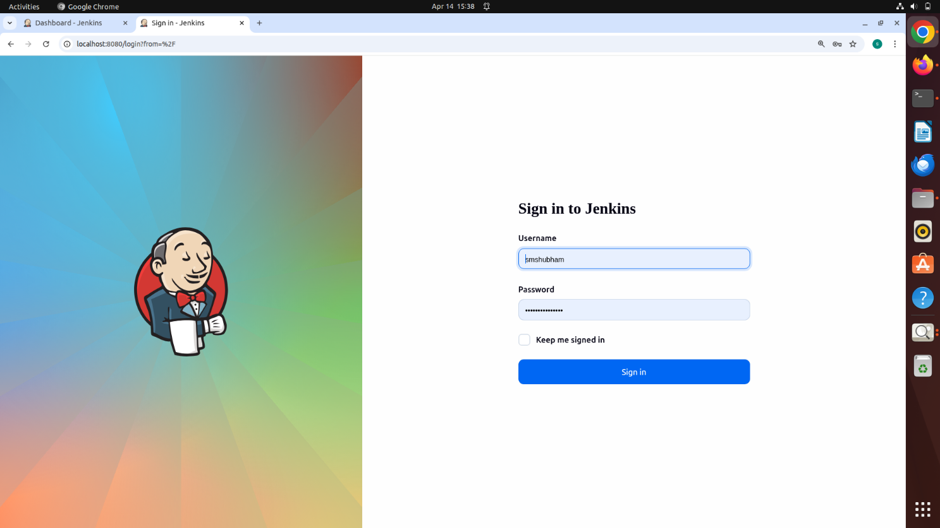

The Dashboard will be visible
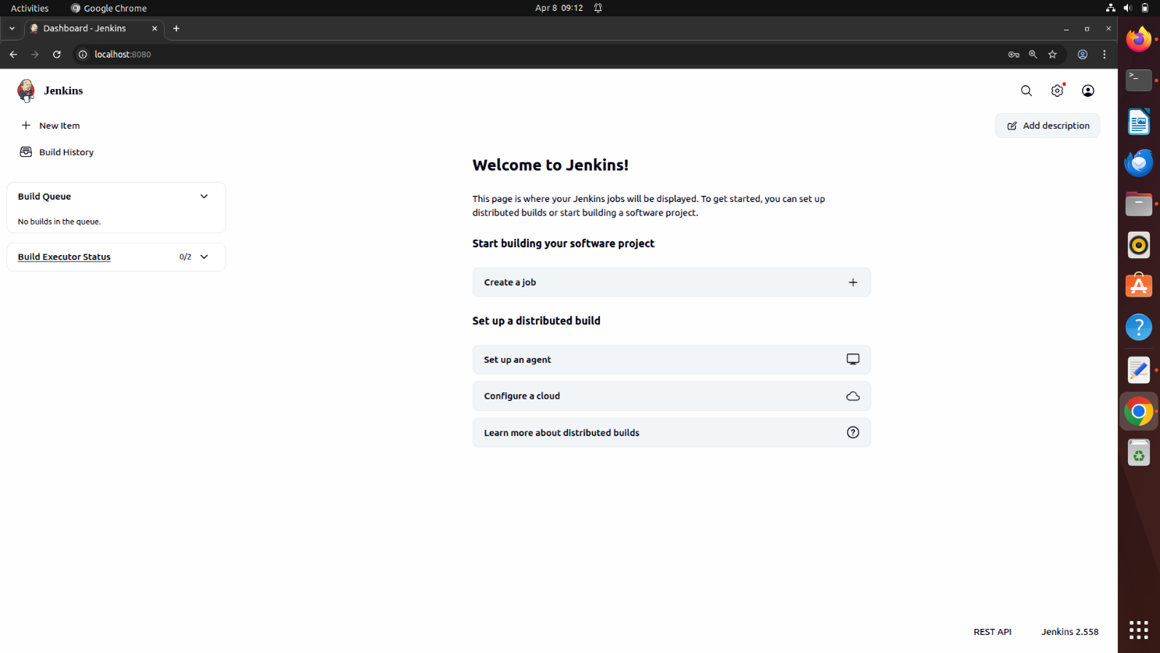

Step 2: Open Manage Jenkins
From the dashboard, click on “Manage Jenkins” by selecting the settings icon located at the top right.

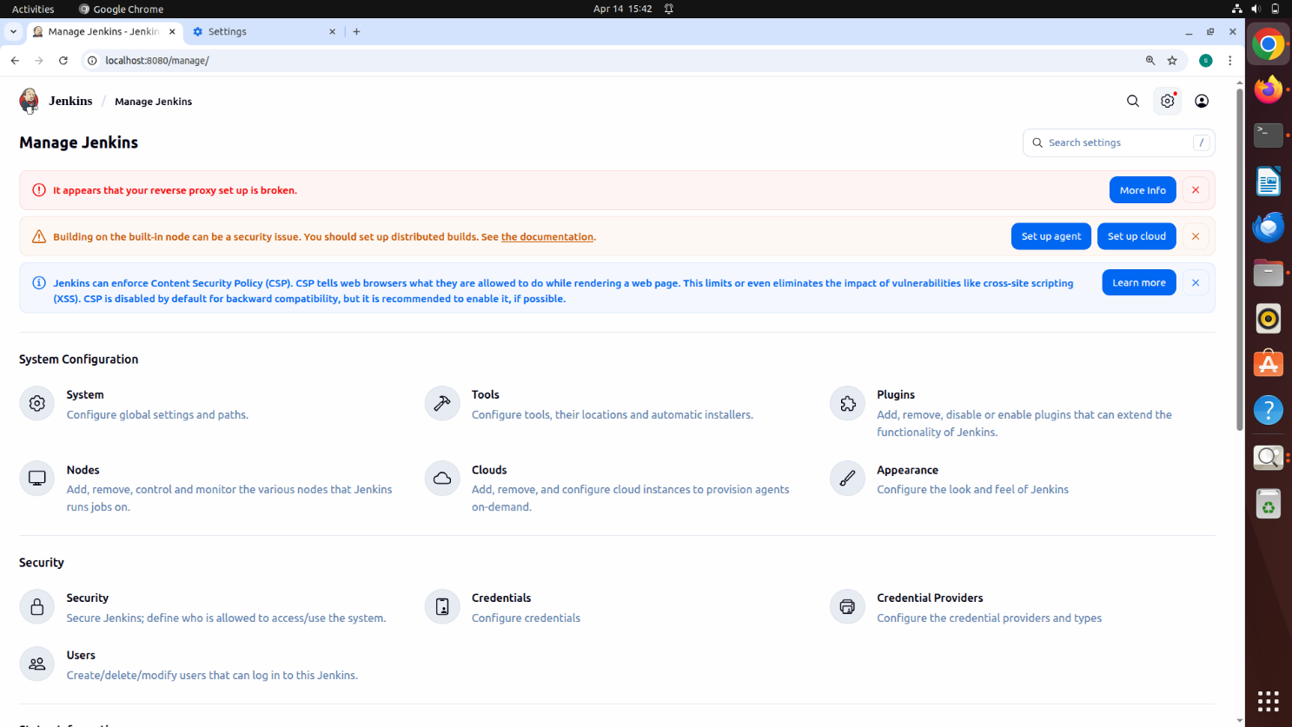

Step 3: Install Required Plugins
Navigate to Manage Jenkins → Plugins → Available Plugins.
Install Maven Integration, Pipeline: Stage View, and GitHub Integration. Wait for each plugin to install completely.
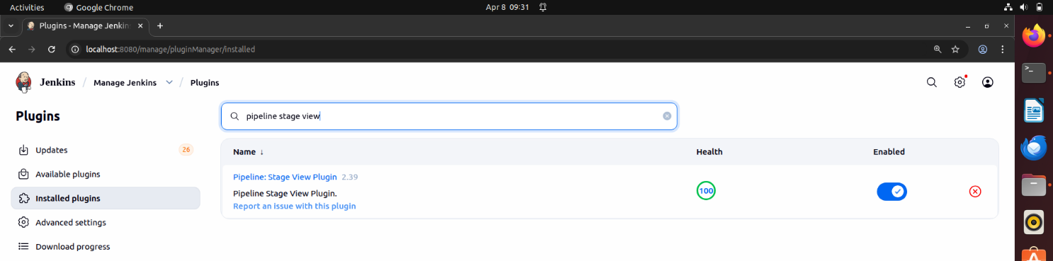

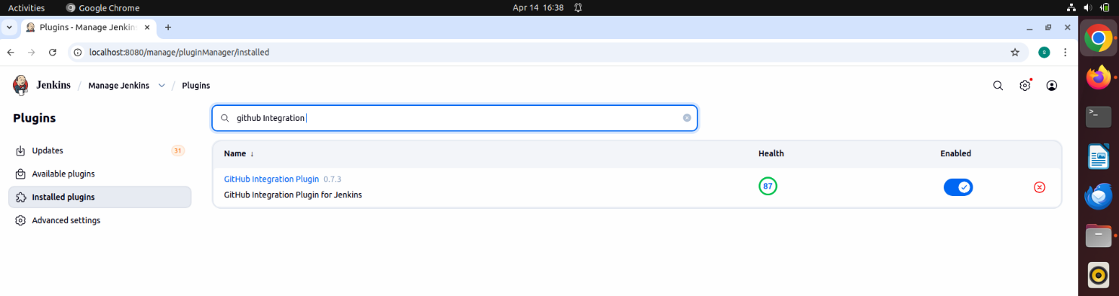

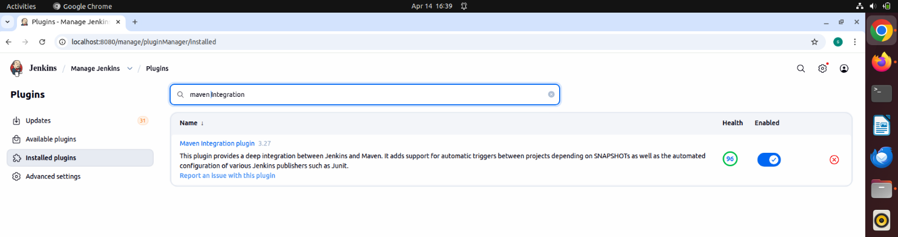

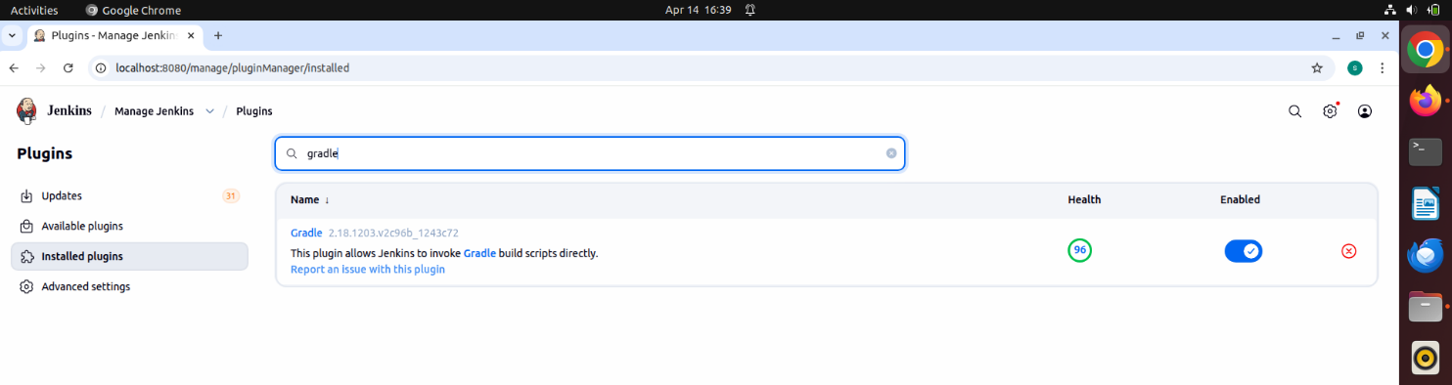

Step 4: Verify Gradle Plugin
Check the Installed Plugins section for Gradle plugin. If not available, install it.

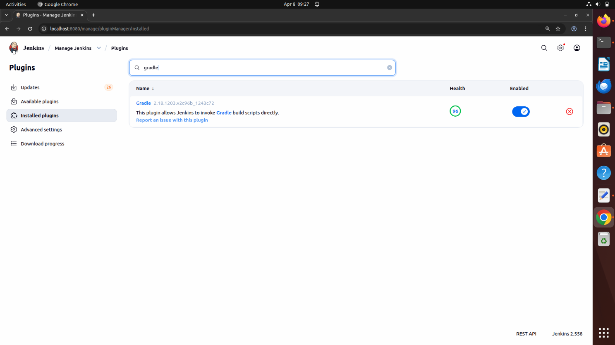

Step 5: Restart Jenkins
Once the installation is complete restart Jenkins by visiting http://localhost:8080/safeRestart

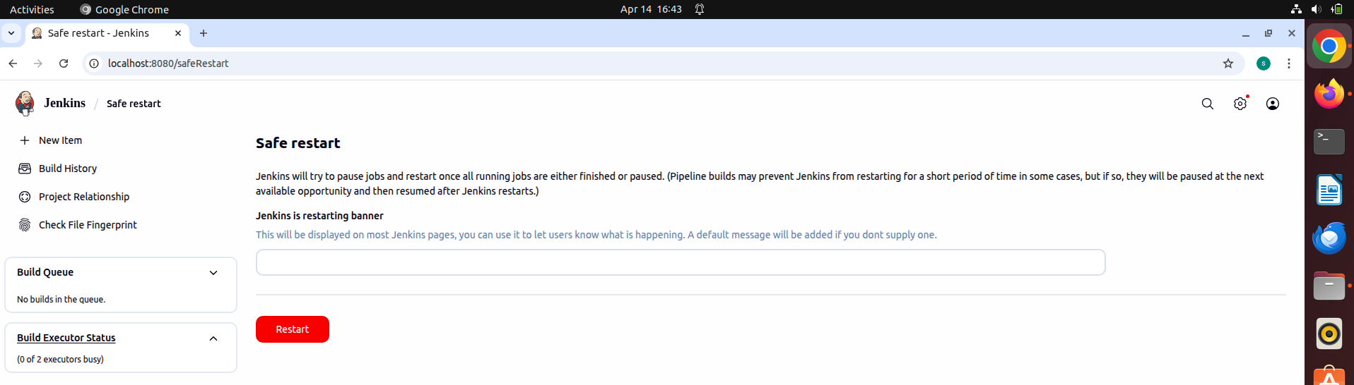

Step 6: Configure Tools
Go to Manage Jenkins → Tools. Scroll down and click Add JDK.
Enter JDK name and path (Computer → lib → jvm → jdk).



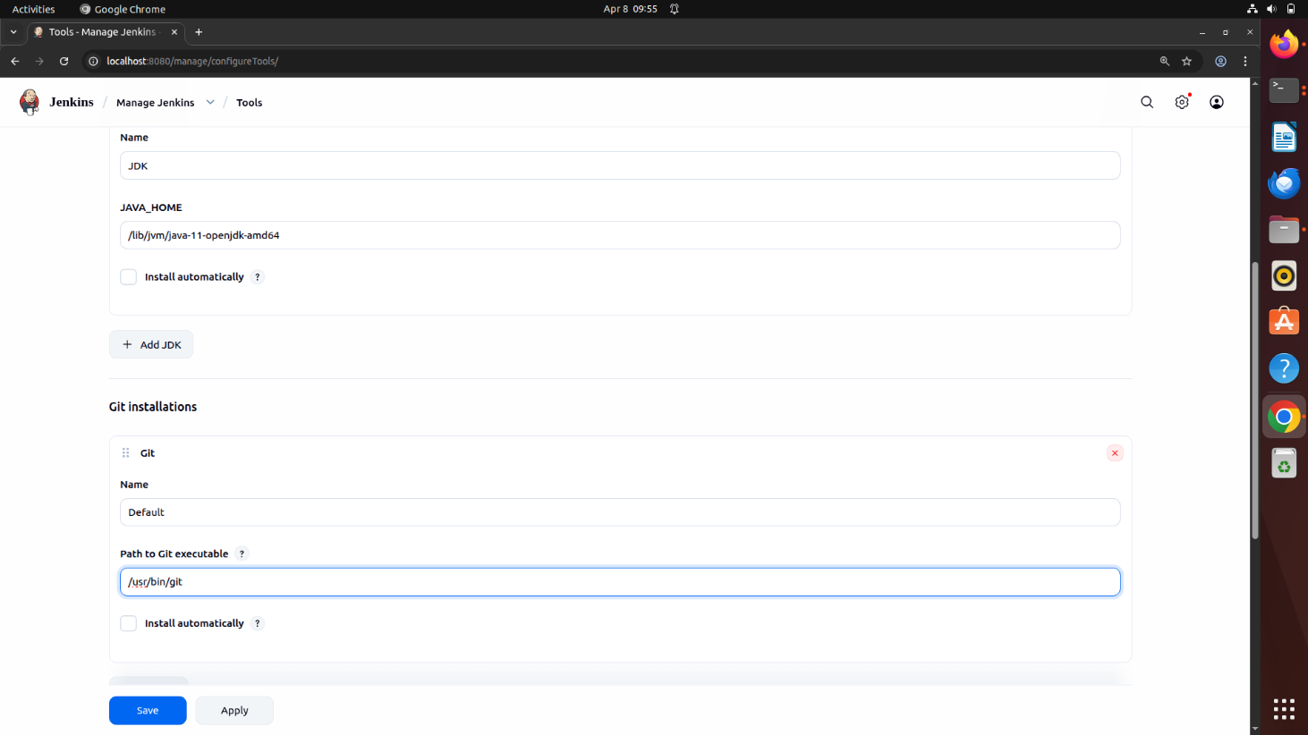

Enter the name and address
The address of the JDK can be found in your files -> other location -> computer -> lib -> jvm -> jdk

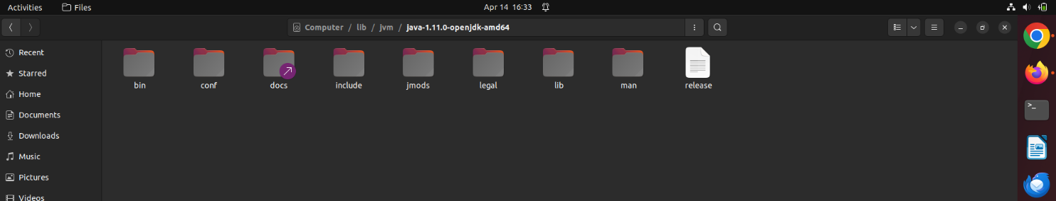

Step 7: Configure Build Tools
Find installation paths for Git, Maven, and Gradle using terminal. Enter these paths in Jenkins and click Apply and Save.
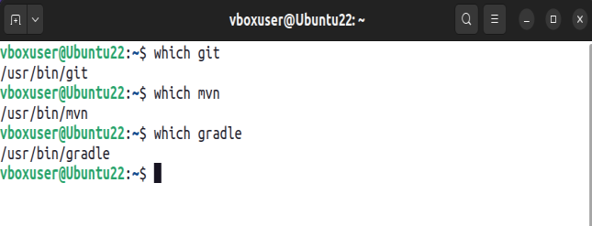

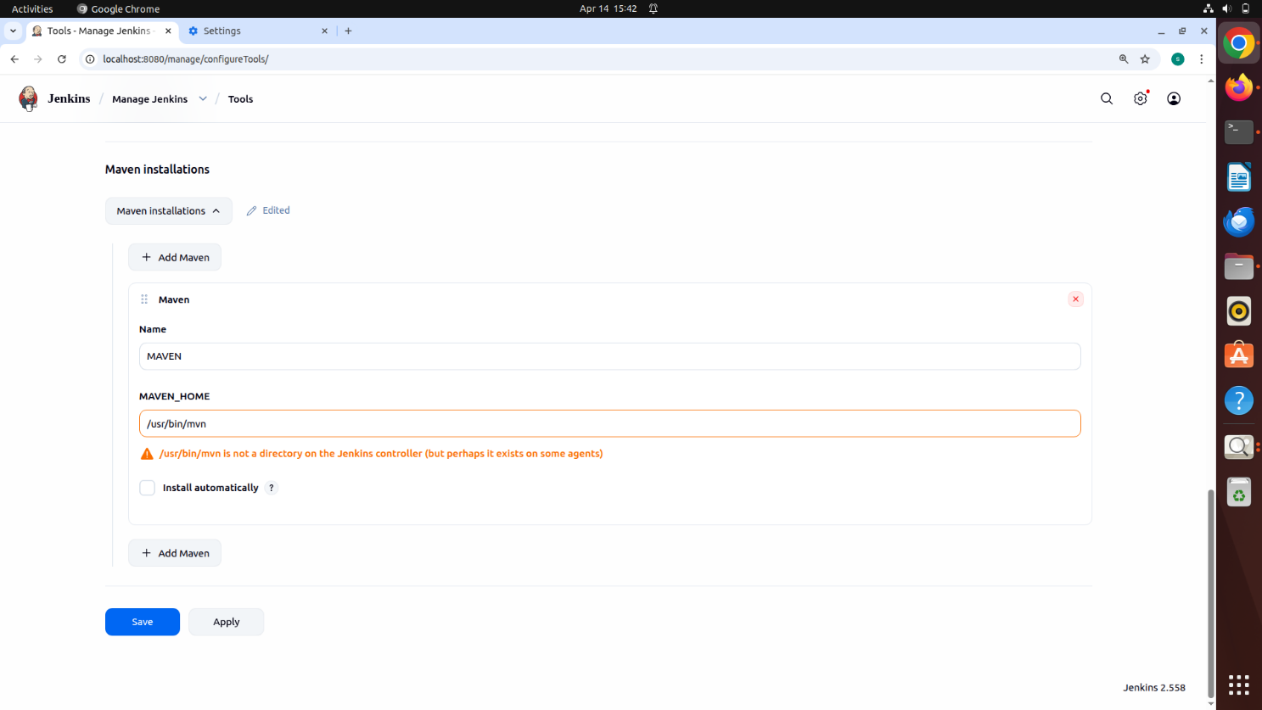
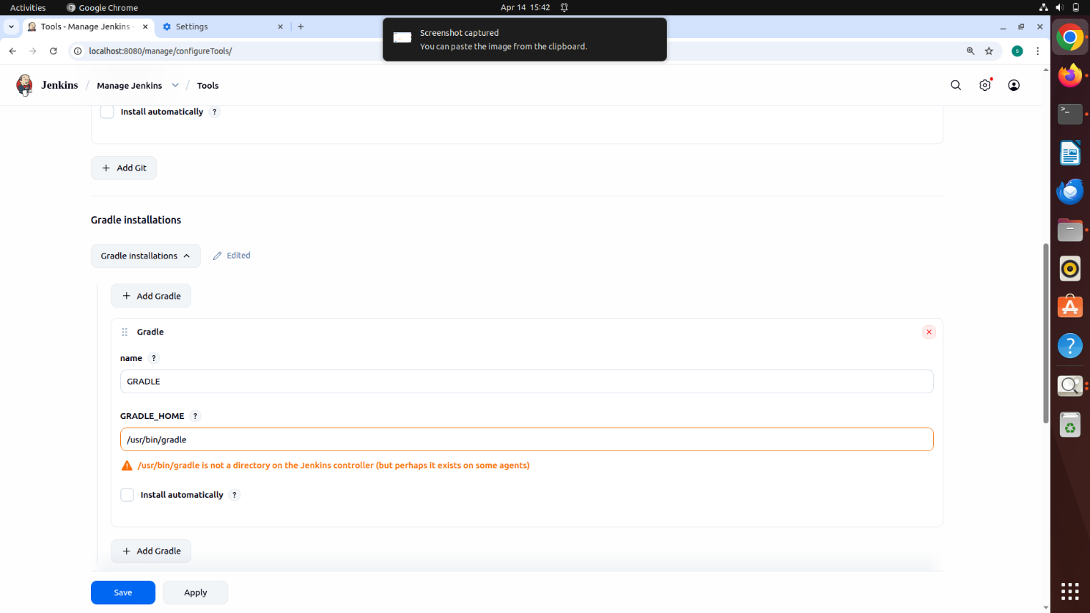

Step 8: Add GitHub Credentials
Go to Manage Jenkins → Credentials. Add Username with Password.
Enter GitHub credentials and description as 'GitHub Credentials'.

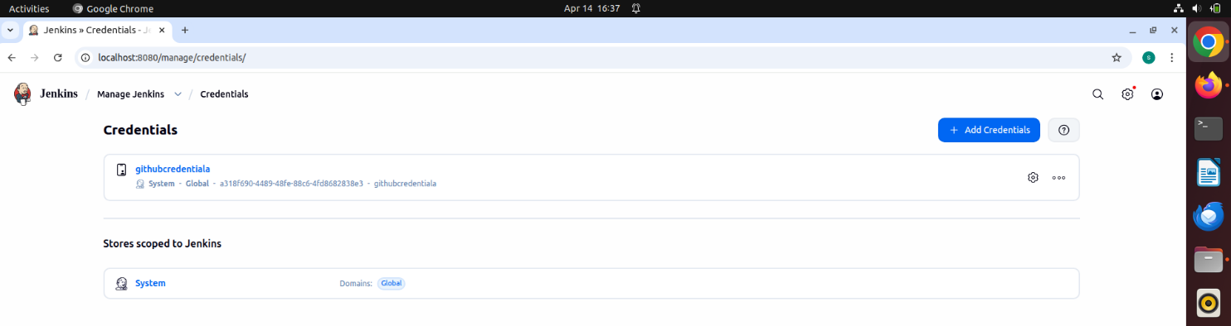

Select add username with password and enter your github username and password

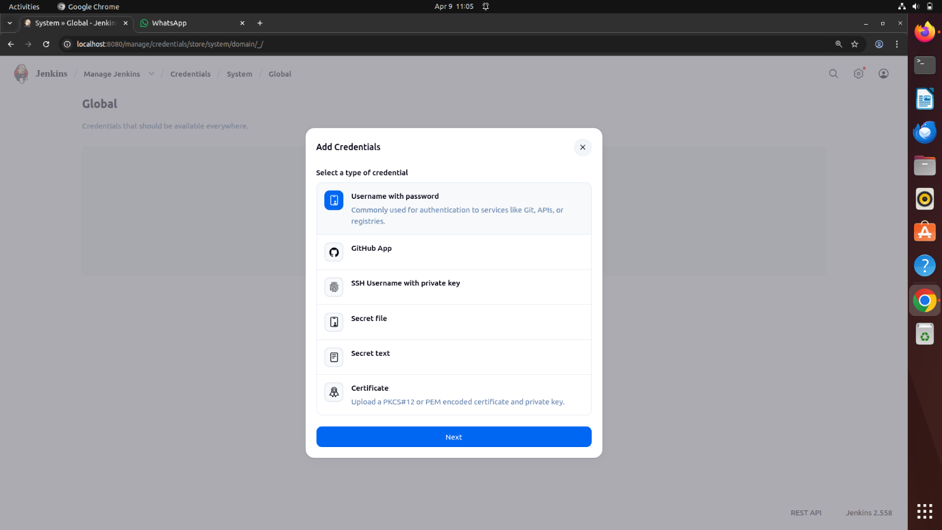

Enter the description as GitHub Credentials
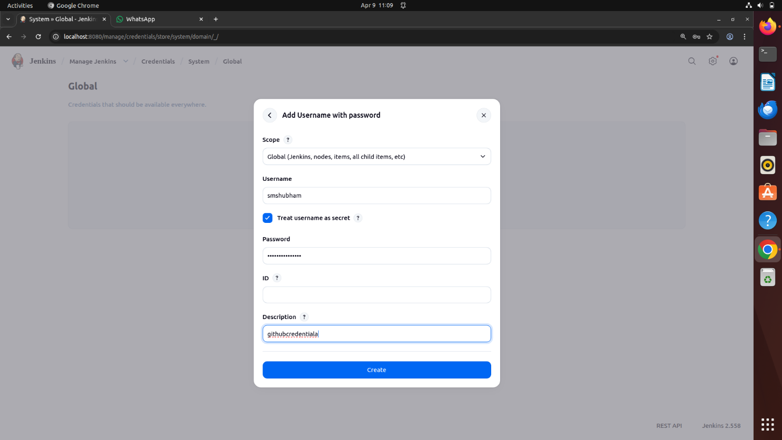

Step 9: Create a New Pipeline Job
Go to Dashboard → + New Item.
Enter name, select Pipeline, and click OK.


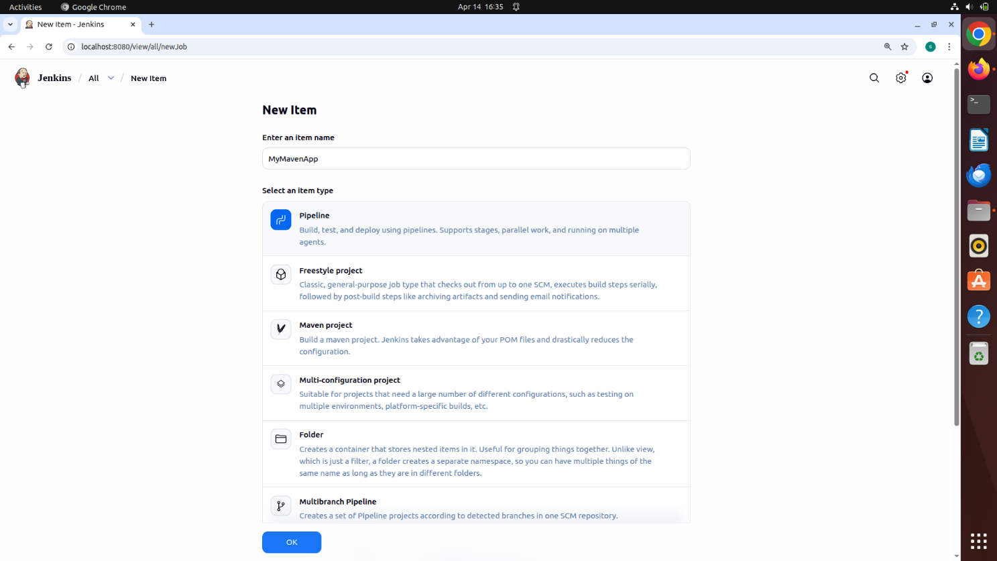

Step 10: Configure Pipeline from SCM
Scroll down and select Pipeline script from SCM. SCM: Git
Enter repository URL and select GitHub credentials. Click Apply and Save.

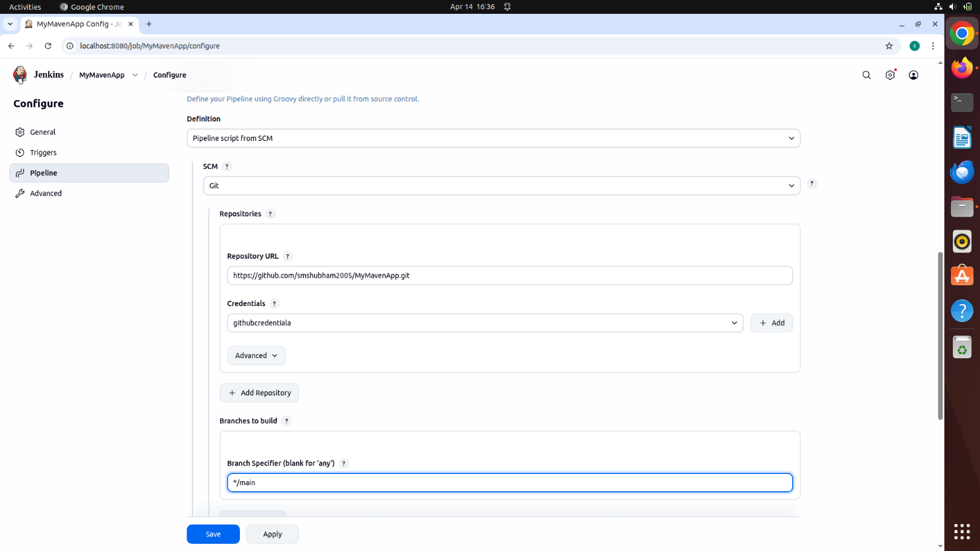
SCM: Git
Repository URL: Enter your MyMavenApp repo url Credentials: GitHub Credentials

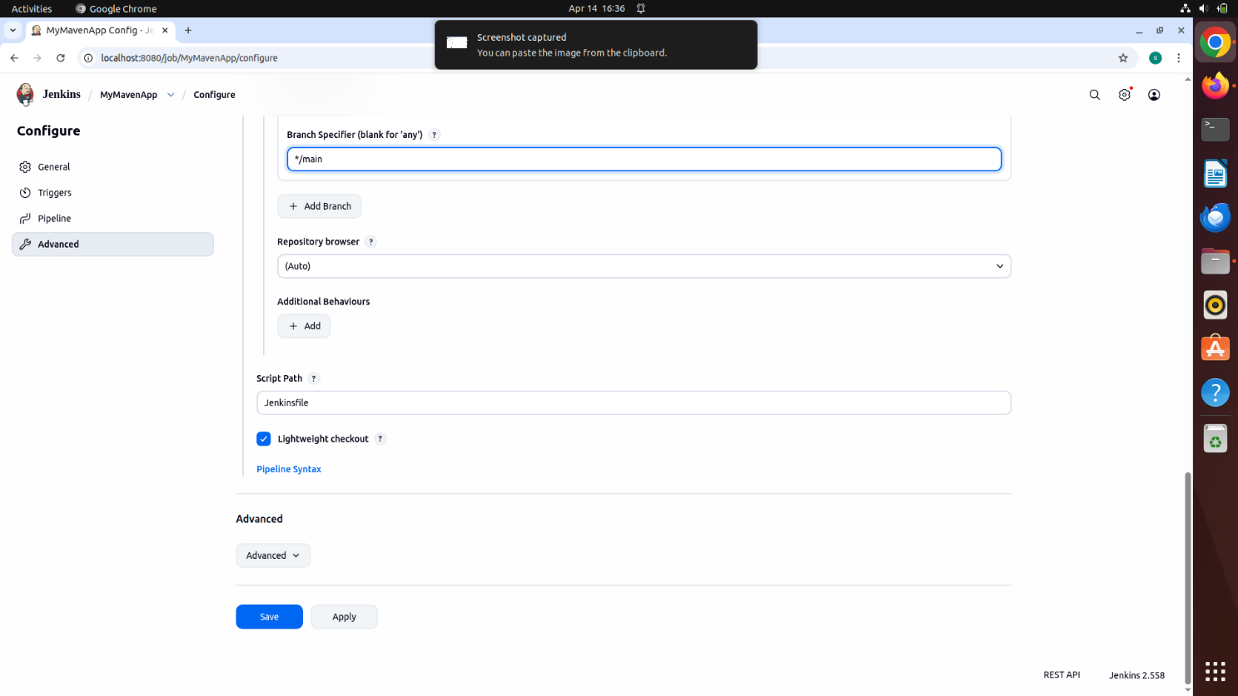

Apply and Save the changes

Step 11: Create Jenkinsfile
Create a Jenkinsfile in your MyMavenApp project and add the pipeline script.
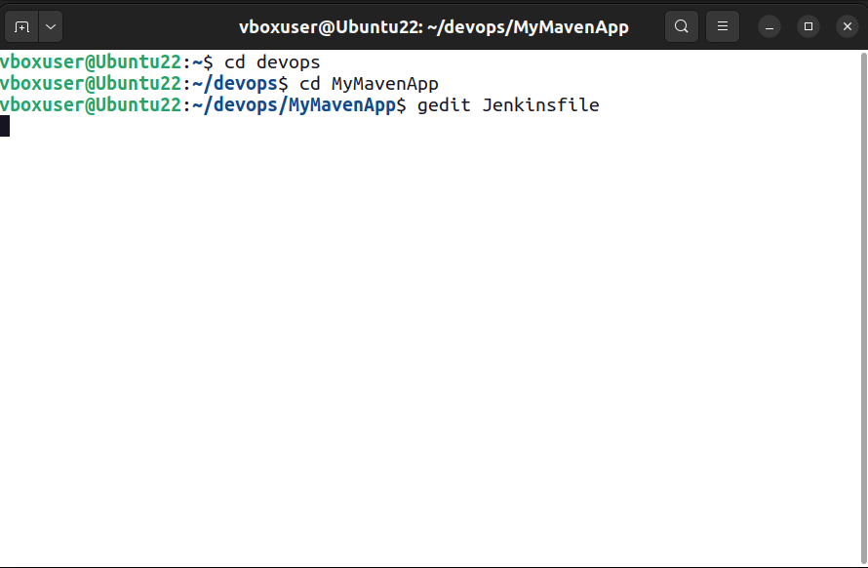

Enter the following code into the Jenkins file – Make sure to Add Your Username and Repo Name
pipeline {
agent any // Use any available agent

tools {
maven 'MAVEN' // Ensure this matches the name configured in Jenkins
}
stages {
stage('Checkout') { steps {
git branch: 'main', url: 'https://github.com/smshubham2005/MyMavenApp.git'
}
}

stage('Build') { steps {
sh 'mvn clean package' // Run Maven build
}
}

stage('Test') { steps {
sh 'mvn test' // Run unit tests
}
}

stage('Run Application') { steps {
// Start the JAR application
sh 'java -jar target/MyMavenApp-1.0-SNAPSHOT.jar'
}
}
}

post {
success {
echo 'Build and deployment successful!'
}
failure {
echo 'Build failed!'
}
}
}

Step 12: Update pom.xml
Change source and target versions from 1.7 to 1.8.
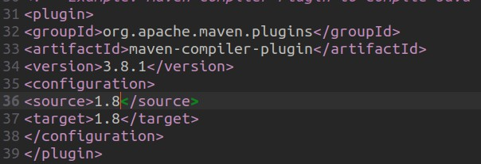

Step 13: Push Changes to GitHub
Commit changes and push to your GitHub repository.
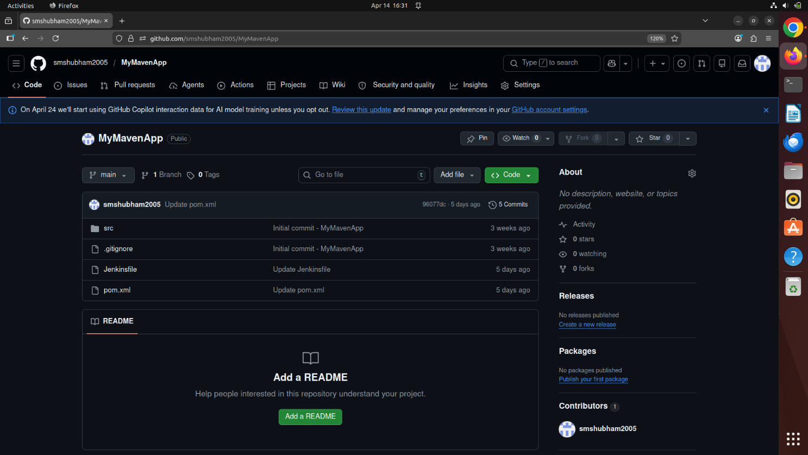

Step 14: Build the Pipeline
Go to Jenkins and click Build Now.

Step 15: Monitor Build Stages
Use Stage View and Full Stage View to monitor execution.
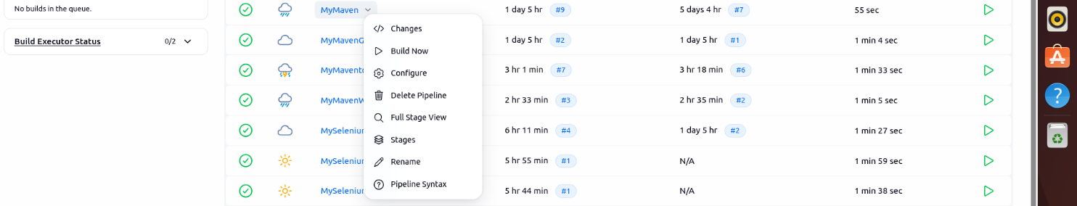
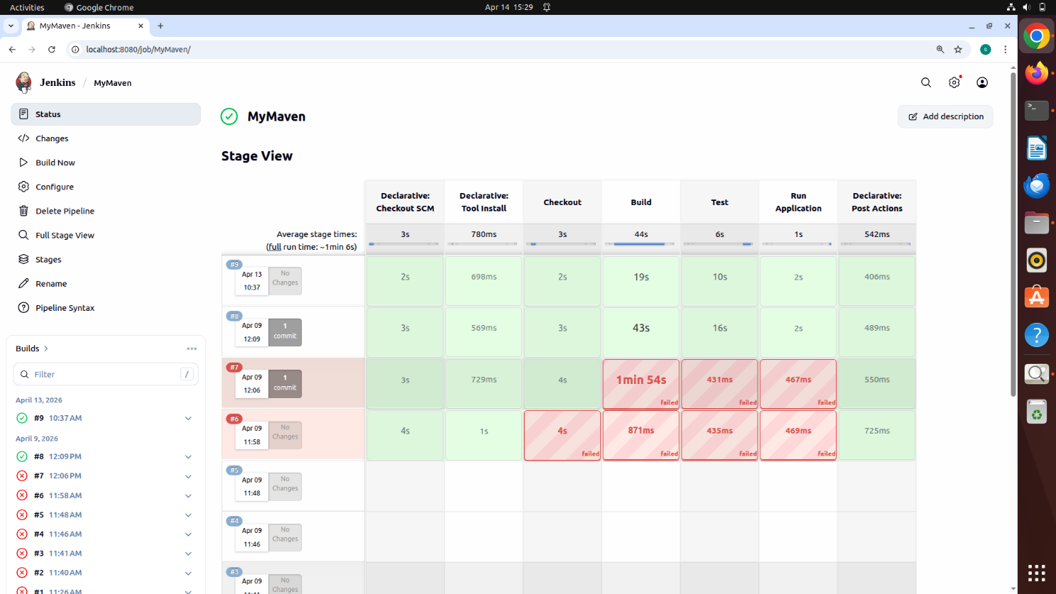

Step 16: Verify Pipeline Execution
If all stages complete successfully, the pipeline is built.

