Installation of Apache Tomcat and Jenkins Pipeline for MyMavenWebApp Installation of Apache Tomcat:
Step 1: Open Terminal
- sudo -i → Switches the user to root (administrator) mode with full system privileges.
- sudo apt update && sudo apt upgrade -y → Updates the package list and upgrades all installed packages automatically without asking for confirmation.
- 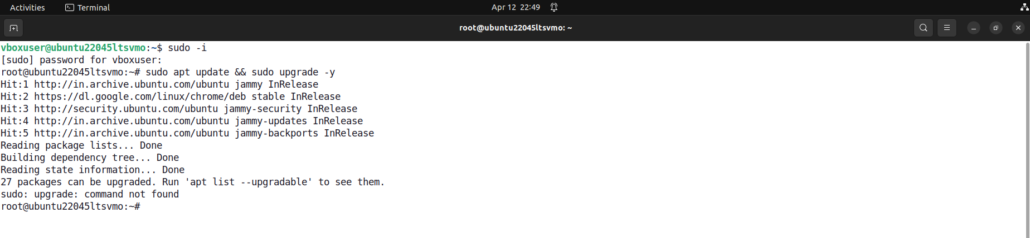

Step 2: Download Apache Tomcat
- cd /tmp → Changes the current directory to the system’s temporary folder.
- wget https://archive.apache.org/dist/tomcat/tomcat-9/v9.0.95/bin/apache-tomcat-9.0.95.tar.gz → Downloads Apache Tomcat 9.0.95 compressed file from the official Apache archive to the system.
- 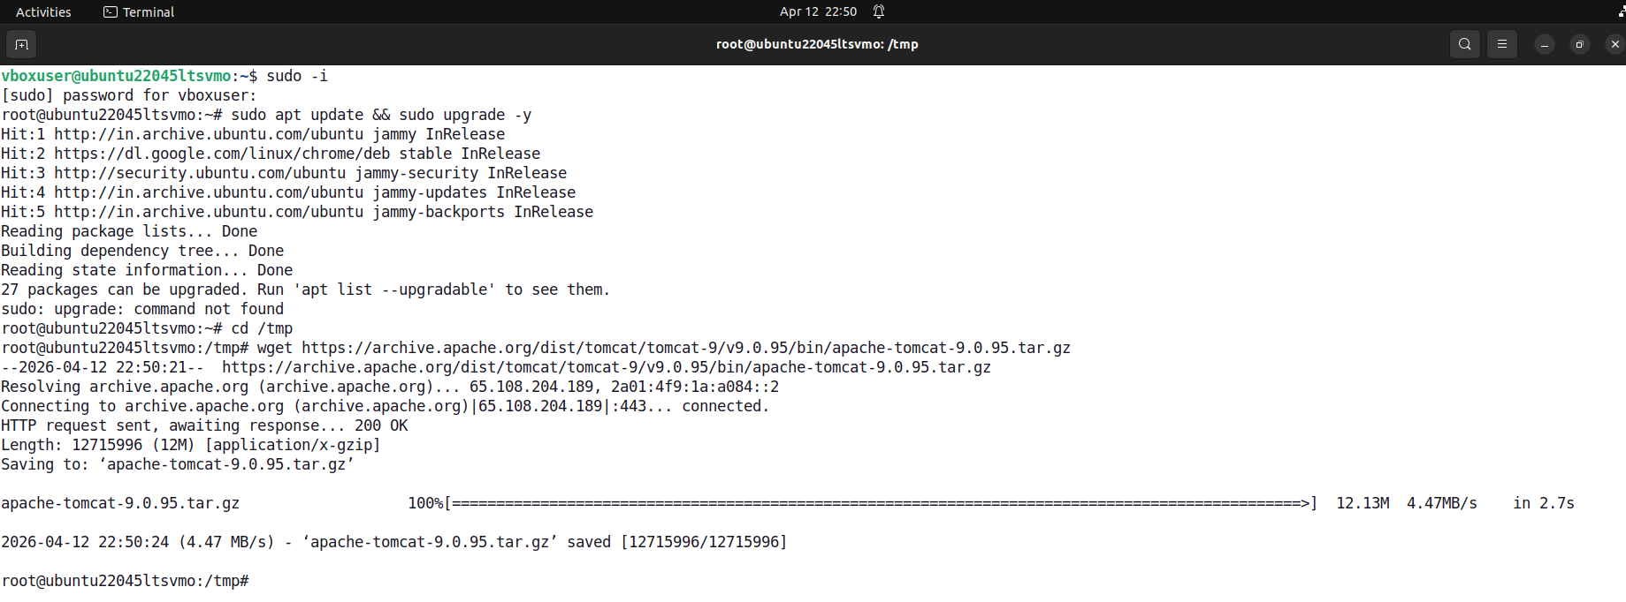

Step 3: Create Directory for Tomcat Installation
- cd .. → Moves one level up from the current directory.
- cd /opt → Navigates to the /opt directory used for installing optional software.
- mkdir tomcat → Creates a new directory named tomcat to store the Tomcat files.
- ls → Lists directory contents to verify that the tomcat folder is created successfully.

Step 4: Extract Apache Tomcat Files
- sudo tar -xvzf apache-tomcat-9.0.95.tar.gz -C /opt/tomcat --strip-components=1 → Extracts the downloaded Tomcat archive into /opt/tomcat directory by removing the top-level folder and placing all files directly inside it.
- 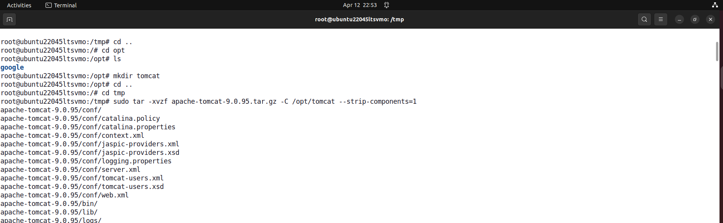

Step 5: Configure Tomcat Server
- cd /opt/tomcat/conf → Navigates to the Tomcat configuration directory.
- ls → Lists configuration files inside the directory.
- gedit server.xml → Opens the main Tomcat configuration file for editing.
- Port Change (8080 → 9090) → Modifies the default Tomcat port to 9090 to avoid conflicts with other services.
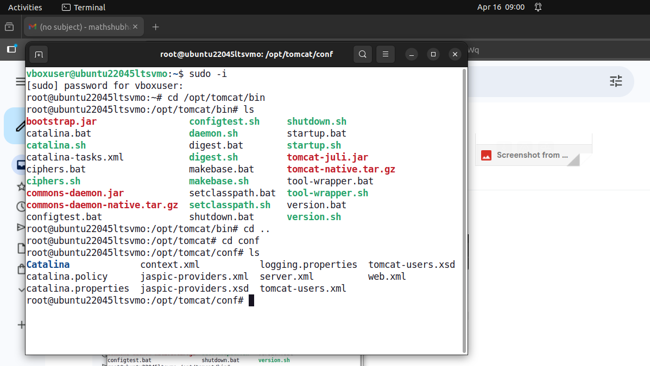

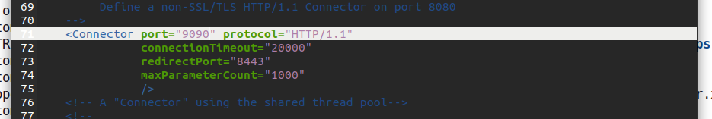

Step 6: Configure Tomcat User Access
- gedit tomcat-users.xml → Opens the Tomcat user configuration file.
- Add user with role → Creates a user (admin) with password and assigns manager-gui role to access the Tomcat Manager dashboard.
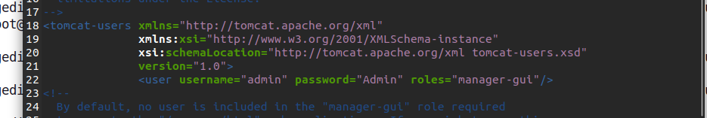

Step 7: Start Tomcat Server
- cd /opt/tomcat/bin → Navigates to the Tomcat binary directory.

- ls → Lists all available startup and shutdown scripts.
- sh startup.sh → Starts the Apache Tomcat server successfully.
- 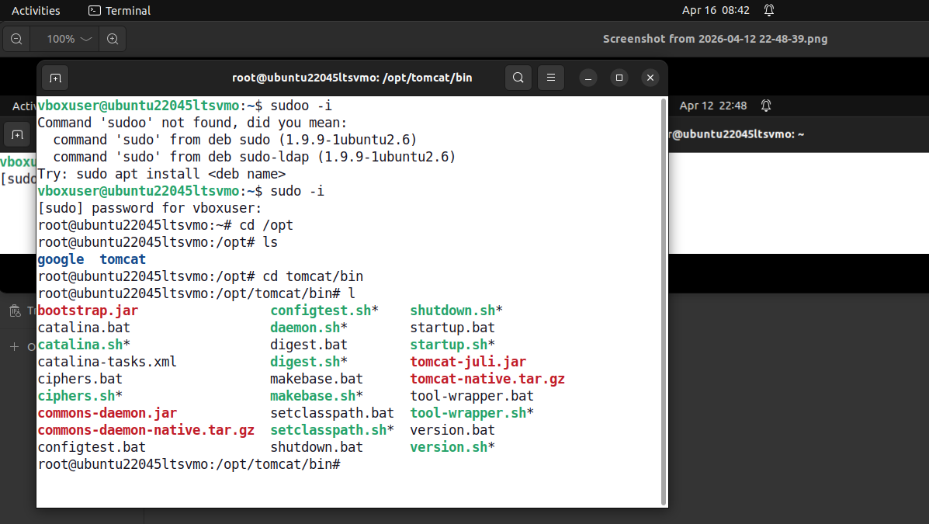

Step 8: Verify Tomcat Installation
- Open Browser (http://localhost:9090) → Confirms Tomcat server is running successfully by displaying the default Tomcat page.
- Access Manager (http://localhost:9090/manager/html) → Logs into the Tomcat Manager dashboard to manage and deploy web applications.
