The text here should be bold. The lines appearing all over the dashboard should be deleted.

Text font and size should be changed to provide better view.



It should be **Departmental Risk Ratings (Residual)**.

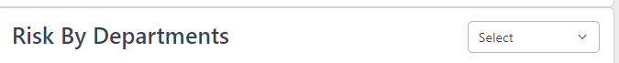

It should be **Risks by Departments (Residual)**.

I had asked to remove certain categories from this following chart (strategic, technology and commercial should be removed). In risk register it says risk category, in dashboard it says risk classification.

Colour for these charts (grey bars) does not look good. Please make it line with scheme.

The numbers in charts axis (x, y) should not be in decimal (in all charts).

This U/I should be changed to look good.

When we try to add risk by writing in above boxes (not selecting any existing one) so the screen disappears.

If there is not action plan so it should appear as N/A in all cells.

The report template should be improved. Formatting is not correct. The template can be landscape instead of portrait. To look good. Lines should be coming to better look.

Why two dots? Please check all and remove all dots.

Once selected, we are not able to change the sub department in risk registers.

Whether these are residual risks or inherent risks.

Need to add the date in Risk registers and adjust the previous ranking accordingly.

**Internal Audit Module**



The above text should be centrally aligned.



The U/I needs to be improved here.

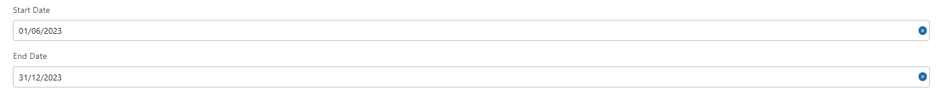

It should be changed to Period Start & Period End. Further, it can be back dated.

This U/I should be changed, instead it should be line by line in whole application.

* Audit plan created is locked without approval not able to change.
* The department so selected in the audit plan, should not confirm until the whole schedule is selected.
* There is refresh problem in the application, it does not update automatically.

Why two dots..?

U/I needs to be improved.



It should be # of Staff.

Why investment audit program has audit procedures of compliance.

When I created engagement of Investment so it should open new line below Audit Plan 2023

Why this 0 appearing?

Navigation issues in audit program screen.



The implications is not saved even after writing the text.



There should be back button next to confirm.

The screen should confirm only if all fields are filled.



Where do we add the agreed date of action plan?



Please make this Effective or Ineffective (only two options)

Audit report template to be corrected.

Policies & Regulatory Compliance

The S should be capital.

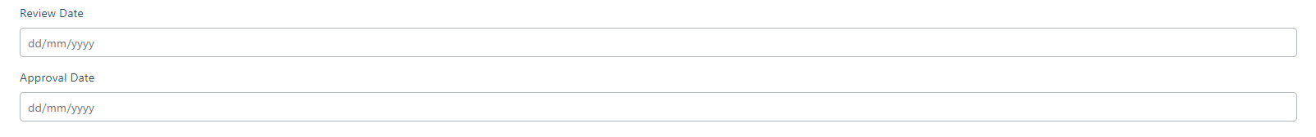

First should be the approval date and next review date. Review date shall be in future. Approval date shall be in past.

Not able to add policy.

Spelling of excellent

UI issue between add and delete (Blue color background)

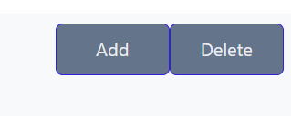

If action plan is not required, then the action plan owner should be NA instead of null

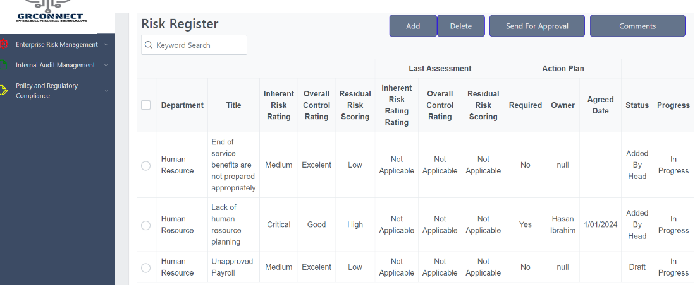

When I sent for approval, the message appeared “Sucessfully Deleted”

It should be Sent for Approval instead of Sended For approval.

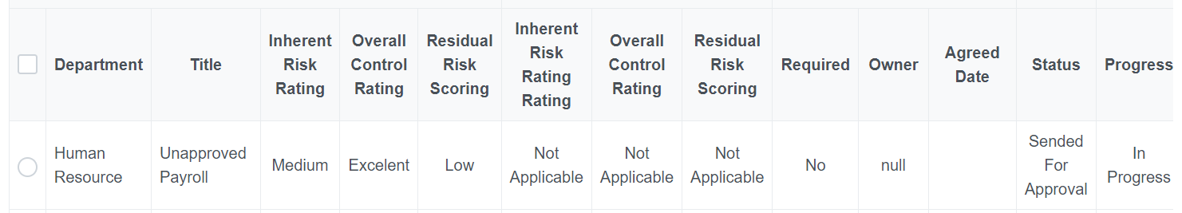

UI issue. Unable to view complete although page is completely scrolled up

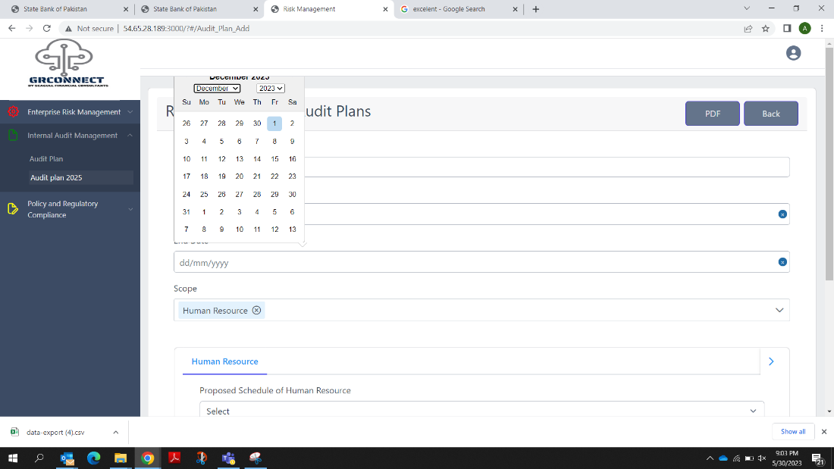

When I added internal audit plan and sent for approval, no notification appeared.

No dots after Approval Date

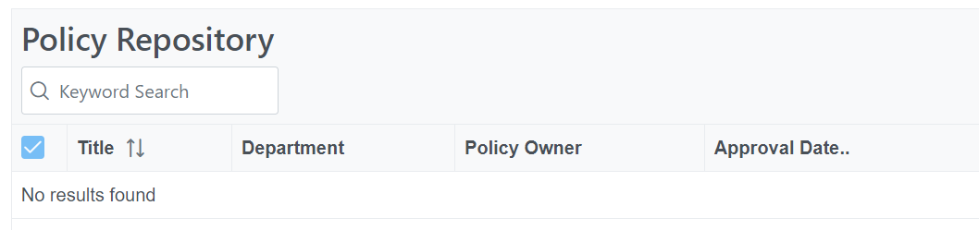

Using admin rights – Unable to attach policy document or add any policy.