Developing Terpene Task

Terpene 1.1

(U) Purpose
(U) This document provides step-by-step tutorial of the development of the java terpene task component gets-publog-monitor. This document is intended to supplement the gets-publog-monitor code and inline code documentation which can be downloaded from https://github.com/geoint/gets-publog-monitor. The deployment, monitoring, and management of the gets-publog-monitor component can be found in the Terpene Administration Guide.

(U) Background
(U) gets-publog-monitor monitors a remote HTTP(S) endpoint for summarized report publication changes using the https://github.com/geoint/gets-publog project. When the publog indicates the reports publication status changed this component publishes either a ReportPublished or ReportRescinded event to the event stream describing the change (see Figure 1).

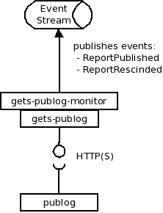Figure 1: (U) gets-publog-monitor component publishes events

(U) A related project, gets-publog-service, is terpene component which implements the HTTP(S) endpoint, deployed as a terpene component. The gets-publog-service component sources its information from ReportPublished and ReportRescinded events published on the event stream and isn't itself a originator (source) of these events. This is because the GETS publog isn't the application which manages the publication state of the report, that is done by an external system. Currently, this external system is GETSv2, which does not itself publish events to the event stream. We use the gets-publog-monitor to source the GETSv2 publog and generate the publication events to the stream. GETSv3 report publication components (planned) are expected to publish these same events to record publication state change, not requiring the gets-publog-monitor to source these events (see Figure 2).
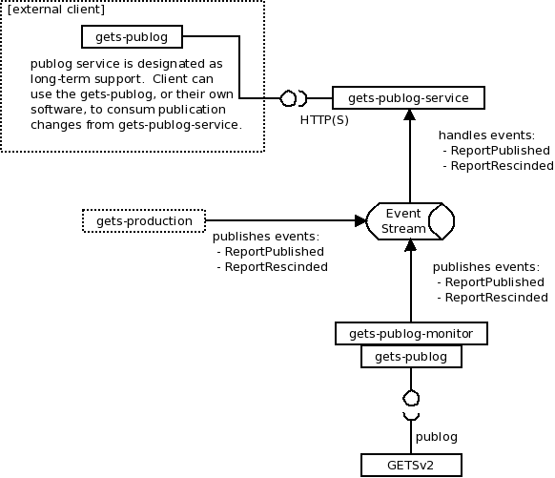Figure 2: (U) gets-publog-monitor component used as part of a complex system
(U) This architecture demonstrates the flexibility of a component-based system, allowing smaller pieces of code be composed at deployment-time to create a complex integrated system supported by the event stream. More information on this approach to application design can be found in the Terpene Overview guide.

(U) Component Structure
(U) The gets-publog-monitor component ensures that the current report publication state described by the publog service it monitors is accurately reflected by the event stream. As a result, applications replaying the event stream can be confident that the resultant publication state of reports mirrors that of the publog source. The requirements of the gets-publog-monitor can be decomposed into logical steps:
- Scheduled execution of the publog monitoring task (time-based trigger).
- Retrieval of the “last successful ingest” time of the publog, used to limit the events return from publog.
- Retrieval of any new publication changes from the publog.
- Processing of publog response, creating ReportPublished and ReportRescinded events.
- Publication of any created events to the EventStream.
- On successful synchronization, update the “last successful ingest” time from the publog.
(U) NOTE: The component leverages the gets-publog library to interface with the remote publog service. This library is out of scope of this document, but is available for review at https://github.com/geoint/gets-publog.
(U) Since this component runs as a terpene task, many of the administrative steps described above are handled by the terpene container itself, leaving the component developer to focus on the business logic rather than administrative overhead. As a result, the component is implemented as a single class, PublogMonitor, that simply implements the well-known java.util.concurrent.Runnable interface (see Figure 3).
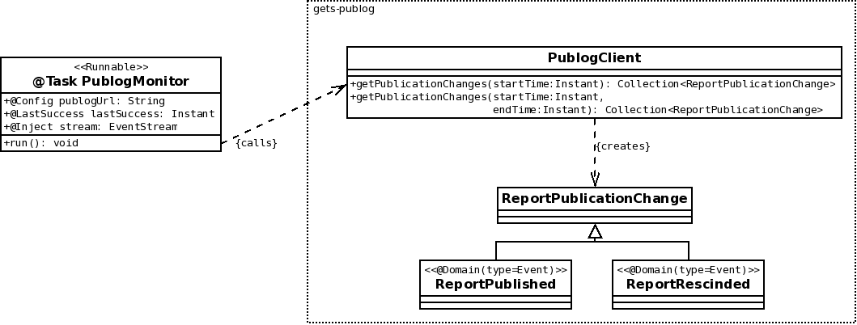Figure 3: (U) gets-publog-monitor component structure

(U) PublogMonitor Task Implementation
(U) A Task is simply code that is configured to execute by a terpene container on a defined schedule. Like a component, a task may be administratively managed globally (for all tasks of this type across all containers) or on each container. A Task may be defined in different ways, most conveniently as a java class annotated with @org.geoint.terpene.task.Task annotation within a component jar, which is how the PublogMonitor Task is implemented. The PublogMonitor task is described with a default name, description, schedule, and auto-start status (see Figure 4).
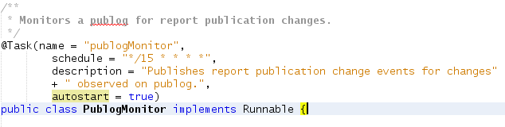Figure 4: (U) PublogMonitor @Task identification and descriptor
(U) The default task configuration for PublogMonitor has the Task auto-starting and executing every 15 minutes (0/15/30/45) on every container the gets-publog-monitor component is deployed. Because the PublogMonitor is defined within a terpene component

