SECTZG629T: Dissertation (For SE)

CLOUD BASED DOCUMENT VERSIONING AND MANAGEMENT SYSTEM

(MID-semester Report)

By

Siva Prakash S M
(BITS ID: 2014HT78173/ Associate ID: 399536)

Dissertation work carried out at
Cognizant Technology Solutions

Dissertation Submitted in partial fulfillment of the requirement of
M.Tech in Software Engineering

Under the Supervision of
Bhanu Prakash G
Sr. Manager – Projects
Cognizant Technology Solutions, Bangalore


BIRLA INSTITUTE OF TECHNOLOGY AND SCIENCE
PILANI, RAJASTHAN-333031

October 2016

BIRLA INSTITUE OF TECHNOLOGY AND SCIENCE, PILANI

CERTIFICATE

This is to certify that the Dissertation entitled “Cloud based document versioning and management system” submitted by Siva Prakash S M, BITS ID-No. 2014HT78173 for the partial fulfillment of the requirements of M.Tech. Software engineering degree of BITS, embodies the work done by him under my supervision.

Bhanu Prakash G

Signature of the Guide / Account Manager

Name : Bhanu Prakash G
Designation : Sr. Manager – Projects
Cognizant Technology Solutions
Location : Bangalore
Date : 17th October 2016

ABSTRACT

Dissertation Title : Cloud based document versioning and management system

Name of Supervisor/Guide : Bhanu Prakash G
Name of the Student : Siva Prakash S M
BITS ID. No. : 2014HT78173
Semester : I Semester 2016-2017
Course Code : SECTZG629T (DS)

The main objective of this tool is to provide document storage and management options in cloud. For a project team that works extensively on documents, they need an easy mechanism to store and manage the documents. This tool comes in handy for them. The tool involves creating a docstore, uploading, downloading, moving, copying and deleting of the documents. Apart from these basic features, the tool also provides automatic archival of the documents based on predefined business rules, creating files on the fly and versioning of documents. The docstore owner can grant default, limited or full access to a particular user or user group. This user group or individual user gets email notifications when particular actions such as creation or deletion of a file or folder are carried out. These notification action preferences can also be set by the docstore owner.

There are tools available in the market for document storage. But they incur more cost to the users. As the application proposed in this dissertation is backed by cloud storage, it acts as a potential cost reducer to the users. Most of the currently available tools in the market offer basic storage and retrieval features. But this tool offers advanced features such as automatic archival of documents, storing and maintaining previous versions of a document and creating files on the fly, at a minimum cost. For a 20 member team whose work heavily depends on document sharing, the cost incurred would be approximately $ 1.68 per month.

This application uses AWS S3 services for storage. So the users need not worry about having backup for their data, as AWS S3 duplicates data in multiple servers, which offers backup and 99.9 % availability. So there is no question of application downtime.

Siva Prakash S M Bhanu Prakash G

Signature of Supervisor

Date: 17th October 2016
Name of Supervisor: Bhanu Prakash G

Designation: Sr. Manager - Projects

Cognizant Technology Solutions

Location: Bangalore

Signature of Student

Date: 17th October 2016
Name: Siva Prakash S M

Designation: Programmer Analyst

Cognizant Technology Solutions

Location: Bangalore

Acknowledgement

I take this opportunity to express my gratitude to my project guide Bhanu Prakash G (Sr. Manager - Projects, Cognizant Technology Solutions) for providing his insight, guidance & advice whenever & wherever I needed. His sound understanding of the IT business, project management techniques, clear communication and guidance has helped me shape the direction of this dissertation project work.

Proposed Activities

Stage | Purpose | Activities | Status | Deliverable
Stage 1 | Define Scope of Dissertation  Define Requirements | Defining business problem statement and the proposed solution framework | 100% | Preliminary Report
Stage 1 | Define Scope of Dissertation  Define Requirements | Defining functional and non-functional requirements | 100% | Preliminary Report
Stage 2 | Refining the requirements  Proposed  Solution  Detailed design for the proposed Solution | Coming up with use case scenarios for the business problem | 100% | Mid Review report
Stage 2 |  | - High level design  - Technical Requirements | 100% | Mid Review report
Stage 2 |  | - Overall architecture  - Backend Data flow and data model  - Front end screen flow | 100% | Mid Review report
Stage 3 | Development QA and Implementation | - Coding & Unit testing  - Frontend screens design  - Java code for cloud interaction  - Backend scripts for data persistence  - System testing and User acceptance testing  - Deployment of code | 30% | Final review Report

Table of Contents

1. Objective 7
2. Scope 7
Software Requirement Specification 8
2.1 Functional Requirements 8
2.1.1 Use case scenarios 8
2.1.1.1 Creating a Docstore 8
2.1.1.2 Listing of docstores 8
2.1.1.3 Listing of files and folders in a docstore 8
2.1.1.4 Creating files and folders in a docstore 9
2.1.1.5 Uploding/Downloading a file in a docstore 9
2.2 Non Functional Requirements (NFR) 10
Solution for the business problem: 10
2.3 Proposed Solution 10
2.4 Technical Requirements 10
2.4.1 Software Requirements for End Users 10
2.4.2 Software Used in Development 10
2.5 Solution Architecture 11
2.5.1 Data sources 11
2.5.2 Segmentation platform 12
Detailed Design (Low Level) 13
2.6 Front end screen flow Diagram 13
2.7 Backend data model tables 14
3. Coding & Unit Testing 16
3.1 Coding Strategy 16
3.2 Best Practices 16
3.3 Coding Convention 17
3.4 Construction 17
3.5 Code Review 17
3.6 Unit Testing 17
4. QA 17
4.1 QA Strategy 17
4.1.1 QA Scope 17
4.2 Functional QA 17
4.3 QA Assessment 17
5. Application Screenshots 17
6. Future Extensibility 20
6.1 Scope for Future Extension 20
6.2 Guidelines 20
References 22

Objective

The basic objective of this tool is to help the analysts to generate various customer or user segmentation models and *not* just ad-hoc segmentations based on the given metric in quick time and to validate the models beforehand instead of implementing the models in the real world & gauging their value later. Generally the segmentation model will be derived by the analysts manually after multiple iterations of research by writing codes to extract the data from the Data Warehouse tables. Multiple manual iterations extends the lead time & in almost all the cases the model will be redefined after a period of time based on the ROI value which involves additional effort & cost.

The tool will present different options to choose and will guide the analyst to come up with a segmentation model even if the analyst has least idea about what he/she wants to generate. The various operational metrics for the users/customers are user/customer’s revenue, number of purchases, Overall Feedback – positive, negative or neutral, Shipping rating, Number of disputes etc., and the various behavioral metrics are page view count, count of Items viewed on the site, count of purchase intentions showed like add to cart, wish list. Tool will also present the options to customize user geography for which the analyst wants the segmentation to happen.

Scope

The Scope of my dissertation is to provide a self-service segmentation application which would provide the framework for generating various segmentation models based on different operational and behavioral metrics. The model could be derived based on a given combination of inputs. The inputs are not only the metrics but time interval for the metrics aggregation (either trailing 30 days or trailing 7 days), Region (or countries), role of the user (buyer, seller or customer group – group of user accounts created by the same individual) and type of thresholds (static or dynamic). Analyst can select from a given set of segmentation models or define their custom models with user defined thresholds. Generated SQL for the given inputs could be exported and also the segmentation models could be exported out of the tool.

Out of Scope:

- Scheduling the generated segmentation model SQLs to run at definite time intervals to refresh the segment data.

- Sharing customizable data model if this application needs to be implemented in a new client environment

Software Requirement Specification

Functional Requirements
The various functional requirements of the application are described in the below use case scenarios.

Use case scenarios

Creating a Docstore

- The user logs in to the application and clicks on the ‘Create Docstore’ button on the home page
- The user enters the docstore name and description
- User clicks on ‘Create’ button
- If the docstore name is available, a new docstore with the specified name is created and the user is navigated to the view docstore page
- Else, an error message is displayed in the create docstore page
- From the view docstore page, the user can grant access permissions for the docstore to other users by click on the ‘Access Permissions’ tab
- The user clicks on ‘Notifications’ tab to set the notification events, on occurrence of which the email notification will be triggered to the docstore users
- The user clicks on ‘Business Rules’ tab so set the business rules, based on which the docstore contents will be automatically archived

Listing of docstores

- The user logs in to the application and is navigated to the home page where all the docstores created by the user is listed
- If no docstore is found, then empty docstore message is displayed
- The user can click on each docstore name so that the user is navigated to view docstore page where the contents of that particular docstore are listed
- The user also clicks on the ‘delete’ icon across each docstore, so that the docstore and all its contents are permanently deleted from the application

Listing of files and folders in a docstore

- The user logs in to the application and clicks on a docstore name, so that the user is navigated to the view docstore page
- In the view docstore page, all the files and folders of that docstore are listed
- Clicking of folder name will list the contents of that particular folder
- Clicking of file name will list the previous versions of that particular file
- The user can select multiple files and folders and click on ‘Delete’ button, so that the file/folder and its previous versions will be deleted
- The user can select multiple files and folders and click on ‘Copy’ button, so that the files/folders will be copied to memory and user can navigate to the desired folder and click on ‘Paste’ button, so that the files will be pasted

Creating files and folders in a docstore

- The user logs in to the application and clicks on a docstore name, so that the user is navigated to the view docstore page
- The user clicks on the ‘Create’ dropdown and selects ‘Folder’ option, so that create folder popup opens
- User enters the folder name and clicks ‘OK’, so that a folder with specified name is created under the docstore
- The user clicks on the ‘Create’ dropdown and selects ‘File’ option, so that a new text editor window opens
- The user can type the desired content and click on ‘Save’ to create a new file under the docstore

Uploading/Downloading a file in a docstore

- The user logs in to the application and clicks on a docstore name, so that the user is navigated to the view docstore page
- The user clicks on ‘Upload’ button so that file upload popup opens
- User browses the file from local machine click ‘Upload’ button, so that the file is uploaded to the current folder of the docstore
- From the list of files and folders displayed, the user clicks on the ‘Download’ icon of a particular file, so that the file is downloaded to the local machine
- From the list of previous versions of a file, the user clicks on the ‘Download’ icon, so that the particular version of that file is downloaded to the local machine

Solution for the business problem:

Proposed Solution
The document versioning and management system proposed in this dissertation, overcomes the following problems faced by a collaborative project team which shares documents as a part of their daily work.

- Limited storage space
- Loss of business data due to overwriting of files
- Higher procurement cost for external servers to store and share documents

The tool provides an elastic storage capacity through cloud. As there is no storage limit and no initial procurement cost, the user can expand or shrink the amount of data stored and the user pays only for what he/she uses. This tool also offers additional features such as automatic archival of files, creating of files on the fly and versioning of documents. The cost incurred by the user is much lesser when compared with other document management tools in the market.

Technical Requirements

Software Requirements for End Users
Operating System: Windows

Software Used in Development
Programming language used: Java
Server/Client side programming: HTML, JSP, Javascript
Tools used: Eclipse
Framework: Spring, Hibernate, JQuery
Database: MySQL
Application Server: JBoss

Solution Architecture
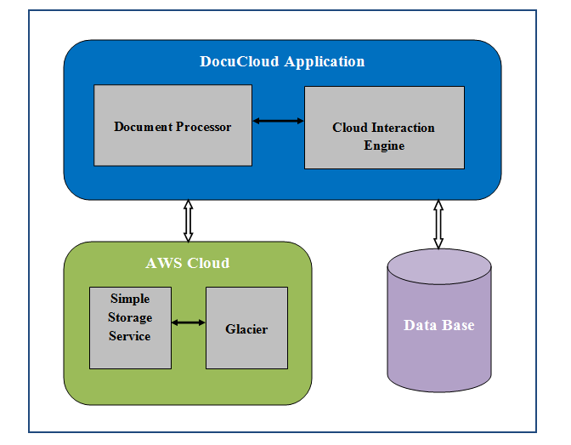

Data sources
The data source for this application contains tables such as user details, docstore details, access type, access permission, notification events, notification details and business rules. The master tables among them are: access type table, which contains types of access permission that a user can have and notification events table, which contains the type of events, on occurrence of which notification emails are triggered. Each user can create multiple docstores. The details of the docstore are persisted in docstore details table. The docstore owner can grant access for the docstore to other users or user group. These details are saved in the access permissions table. For each docstore, the docstore owner can specify a set of business rules, which are saved in business rules table. Based on these rules the files in the docstore are moved to archive.

Segmentation platform
Segmentation platform is the frontend application that will be used to define the segmentation models by the analysts using the even driven approach of guiding the analyst with different options for the segmentation.

Detailed Design (Low Level)

Front end screen flow Diagram

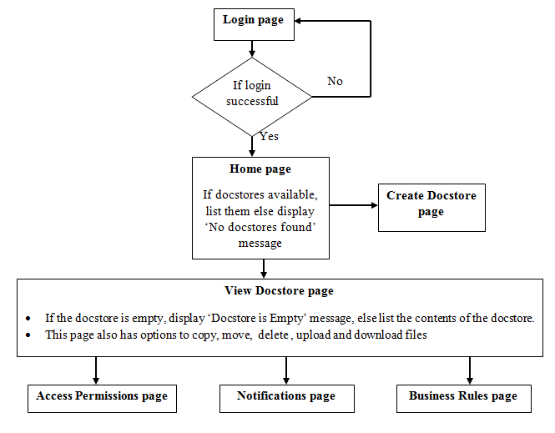

Backend data model tables

User details table | t_usr
Column description | Column name | Data type
User id | usr_id | int(11)
User name | usr_name | varchar(200)
Email id of the user | email | varchar(500)
Password of the user | password | varchar(20)
User first name | first_name | varchar(75)
User last name | last_name | varchar(75)
Docstore details table | t_docstore
Column description | Column name | Data type
Docstore id | docstore_id | int(11)
Docstore name | docstore_name | varchar(63)
Docstore description | description | varchar(500)
Docstore creator id | created_by | int(11)
Docstore created date | create_dt | datetime
Access type table | t_access_type
Column description | Column name | Data type
Access type id | access_type_id | int(11)
Access type name | access_type_name | varchar(63)

Access permission table |  | t_access_permission
Column description |  | Column name | Data type
User id |  | usr_id | int(11)
Docstore id |  | docstore_id | int(11)
Access type id |  | access_type_id | int(11)
Notification events table |  | t_events
Column description |  | Column name | Data type
Notification event id |  | event_id | int(11)
Notification event name |  | event_name | varchar(100)
Notification details table |  | t_notifications
Column description |  | Column name | Data type
Notification id |  | notification_id | int(11)
Notification name |  | notification_name | varchar(500)
Docstore id |  | docstore_id | int(11)
Event id |  | event_id | int(11)
Prefix |  | prefix | varchar(100)
Suffix |  | suffix | varchar(100)
Business Rules table |  | t_buss_rule
Column description |  | Column name | Data type
Business rule id |  | buss_rule_id | int(11)
Business rule name |  | buss_rule_name | varchar(500)
Docstore id |  | docstore_id | int(11)
No. of days after which the file is to be moved to the archive |  | movement_days | int(11)

Coding & Unit Testing

Coding Strategy
As the application follows MVC pattern and involves Generic DAO pattern, the code base will be separated into following layers:
- Controller
- Business services
- DAO services
- DAO Implementation
- Entity objects
- Views – which has the JSP pages including Java script and CSS

Best Practices
The application will be coded in such a way that the code is maintainable and reusable. The modules within the application will be loosely coupled so that the code is highly maintainable. The code will be refactored periodically based on the PMD suggestions.

Coding Convention
The following conventions will be followed in the coding of the application.
- Comments – Each method and variable in the code will have proper comments, so that the code can be understood and edited by anyone.
- Logging – Loggers will be added at necessary places in the code. The logging will be done at different levels such as info, debug and error levels throughout the code so that the code flow and error points can be tracked easily.

- Program to interface – The use of interface and implementation in the code, helps in having multiple implementations for a single type and any future changes can be easily addressed.

- Exception handling – Proper error handling and exception handling will be done. All fatal errors would be caught and business exceptions with valid message would be thrown.

Construction

Code Review
Manual code review will be done.

Unit Testing
Manual unit testing will be done.

QA

QA Strategy

QA Scope

Functional QA

QA Assessment

Application Screenshots

Below are the mock screenshots for the front end application.

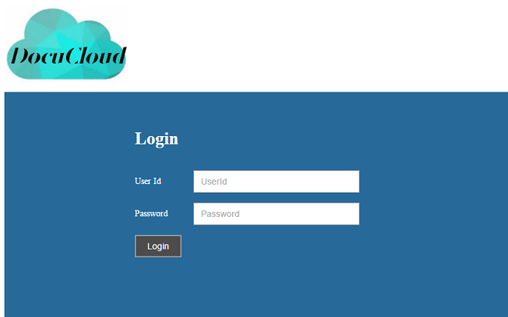

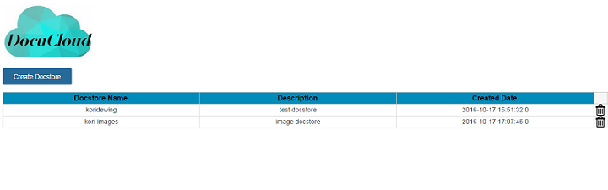

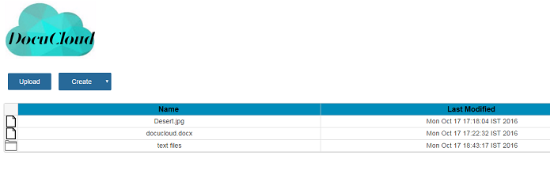

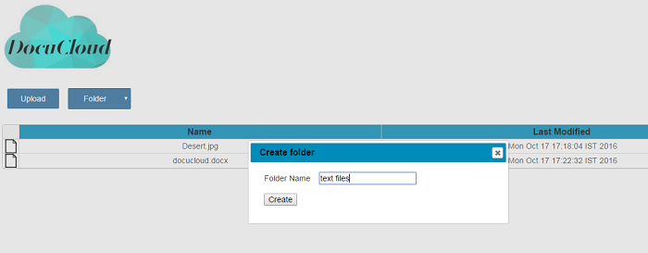

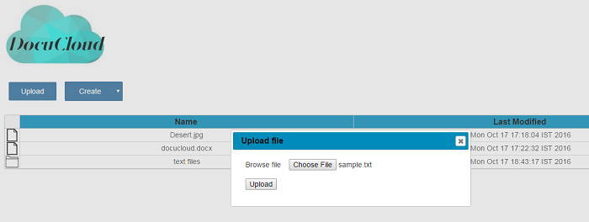

Future Extensibility

Scope for Future Extension
This application uses AWS cloud for document storage. The application can be integrated with any other cloud in future if needed. The cloud interaction services are separated from the business services so that the application can be easily integrated with any cloud storage service.

The application can be integrated with any third party text editing APIs such as Microsoft API, Google API, and Apache Open Office for creating files on the fly.

More advanced features such as, creating and editing spread sheets and presentations can be implemented.

The tool can be made more collaborative by adding discussion forums and commenting features in the application.

Guidelines
The following are tips and guidelines for Java developers:

Always program to interface so that in future, new implementations can be added and existing code can be changed easily.

Separate each layer from the other. For example, instead of using JDBC for persistence layer, any JPA implementation such as Hibernate can be used, so that

Use generic implementations for each layer. For example, instead of using Hibernate Adapter for persistence layer, JPA vendor adapter can be used so that any persistence implementation can be used.

References

