Processor / Controller
2.1 Processor/Controller Basic

How is a Controller different from a Processor..? Use cases for each..? Limitations..?
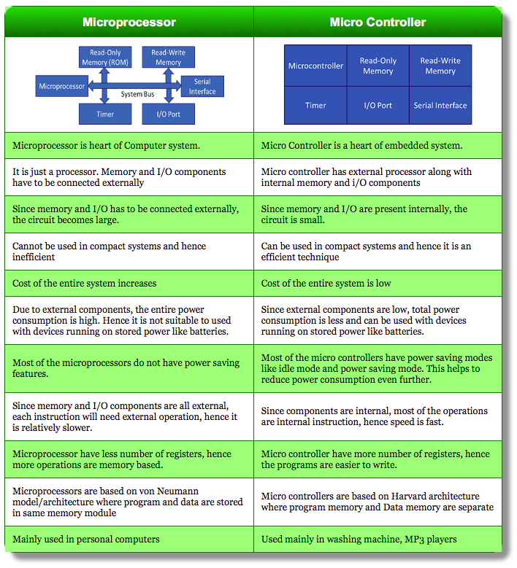

2.2 System on Chip
What is SOC? How is it different from Controller?
System on Chip includes analog digital and radio frequency functions on a single chip substrate. SoC is usually used in embedded systems with the whole chip designed on one substrate to include all the possible applications.
Now you would ask that the same thing as a microcontroller? Well, it’s difficult to actually distinguish between the two. Microcontrollers have less memory like 100kB and less processing capacity but both would need external peripherals to prepare a full system. Designers manage to implement highest number of peripherals to cater to all of the functions to process in both controllers and SoC. But microcontroller is a hyper scaled down version of SoC.
Again the question is where do chips call themmicrocontrollers and where are they called SoC. Usually, SoC is something that has processing capability of a computer and can do all the tasks like running an OS like Linux.
Another feature of SoC is they provide more flexibility with the programming. In microcontroller you can change the bits to program a timer, whereas in SoC we can change the circuit entirely as few of the SoCs contain FPGA modules.

OMAP
OMAP (Open Multimedia Applications Platform) is a series of image/video processors developed by Texas Instruments. They are a category of proprietary system on chips (SoCs) for portable and mobile multimedia applications. OMAP devices generally include a general-purpose ARM architecture processor core plus one or more specialized co-processors. Earlier OMAP variants commonly featured a variant of the Texas Instruments TMS320 series digital signal processor.
http://www.ti.com/general/docs/wtbu/wtbugencontent.tsp?contentId=4638&navigationId=11988&templateId=6123

2.3 Embedded system Architecture
https://www.tutorialspoint.com/embedded_systems/es_architectures.htm

Von Neumann Architecture
one data path or bus exists for both instruction and data. As a result, the CPU does one operation at a time. It either fetches an instruction from memory, or performs read/write operation on data. So an instruction fetch and a data operation cannot occur simultaneously, sharing a common bus.

Harvard Architecture
The Harvard architecture offers separate storage and signal buses for instructions and data. This architecture has data storage entirely contained within the CPU, and there is no access to the instruction storage as data. Computers have separate memory areas for program instructions and data using internal data buses, allowing simultaneous access to both instructions and data.
2.4 Peripheral Interfacing
What is GPIO?
General-purpose input/output (GPIO) is a generic pin on an integrated circuit or computer board whose behavior—including whether it is an input or output pin—is controllable by the user at run time.
Memory mapped I/O
Memory-mapped I/O (not to be confused with memory-mapped file I/O) uses the same address space to address both memory and I/O devices. The memory and registers of the I/O devices are mapped to (associated with) address values. So when an address is accessed by the CPU, it may refer to a portion of physical RAM, but it can also refer to memory of the I/O device. Thus, the CPU instructions used to access the memory can also be used for accessing devices. Each I/O device monitors the CPU's address bus and responds to any CPU access of an address assigned to that device, connecting the data bus to the desired device's hardware register. To accommodate the I/O devices, areas of the addresses used by the CPU must be reserved for I/O and must not be available for normal physical memory. The reservation may be permanent or temporary. An example of the latter is found in the Commodore 64, which uses a form of memory mapping to cause RAM or I/O hardware to appear in the $D000-$DFFF range.
2.6 Catche & MMU
CATCH
In computing, a cache is a hardware or software component that stores data so future requests for that data can be served faster; the data stored in a cache might be the result of an earlier computation, or the duplicate of data stored elsewhere. A cache hit occurs when the requested data can be found in a cache, while a cache miss occurs when it cannot. Cache hits are served by reading data from the cache, which is faster than recomputing a result or reading from a slower data store; thus, the more requests can be served from the cache, the faster the system performs.

Level 1 (L1) Cache
It is also called primary or internal cache. It is built directly into the processor chip. It has small capacity from 8 Km to 128 Kb.

Level 2 (L2) Cache
It is slower than L1 cache. Its storage capacity is more, i-e. From 64 Kb to 16 MB. The current processors contain advanced transfer cache on processor chip that is a type of L2 cache. The common size of this cache is from 512 kb to 8 Mb.

Level 3 (L3) Cache
This cache is separate from processor chip on the motherboard. It exists on the computer that uses L2 advanced transfer cache. It is slower than L1 and L2 cache. The personal computer often has up to 8 MB of L3 cache.
MMU
A memory management unit (MMU), sometimes called paged memory management unit (PMMU), is a computer hardware unit having all memory references passed through itself, primarily performing the translation of virtual memory addresses to physical addresses. It is usually implemented as part of the central processing unit (CPU), but it also can be in the form of a separate integrated circuit.

Page table entries

Most MMUs use an in-memory table of items called a "page table", containing one "page table entry" (PTE) per page, to map virtual page numbers to physical page numbers in main memory. An associative cache of PTEs is called a translation lookaside buffer (TLB) and is used to avoid the necessity of accessing the main memory every time a virtual address is mapped. Other MMUs may have a private array of memory[3] or registers that hold a set of page table entries. The physical page number is combined with the page offset to give the complete physical address.[2]
A PTE may also include information about whether the page has been written to (the "dirty bit"), when it was last used (the "accessed bit," for a least recently used (LRU) page replacement algorithm), what kind of processes (user mode or supervisor mode) may read and write it, and whether it should be cached.

2.8 Memory types
https://en.wikipedia.org/wiki/Flash_memory
Flash memory(NAND/NOR)
Flash memory is an electronic (solid-state) non-volatile computer storage medium that can be electrically erased and reprogrammed. Toshiba developed flash memory from EEPROM (electrically erasable programmable read-only memory) in the early 1980s and introduced it to the market in 1984. The two main types of flash memory are named after the NAND and NOR logic gates. The individual flash memory cells exhibit internal characteristics similar to those of the corresponding gates.
Where EPROMs had to be completely erased before being rewritten, NAND-type flash memory may be written and read in blocks (or pages) which are generally much smaller than the entire device. NOR-type flash allows a single machine word (byte) to be written – to an erased location – or read independently.
The NAND type operates primarily in memory cards, USB flash drives, solid-state drives (those produced in 2009 or later), and similar products, for general storage and transfer of data. NAND or NOR flash memory is also often used to store configuration data in numerous digital products, a task previously made possible by EEPROM or battery-powered static RAM. One key disadvantage of flash memory is that it can only endure a relatively small number of write cycles in a specific block.
NOR FLASH
In NOR flash, each cell has one end connected directly to ground, and the other end connected directly to a bit line. This arrangement is called "NOR flash" because it acts like a NOR gate: when one of the word lines (connected to the cell's CG) is brought high, the corresponding storage transistor acts to pull the output bit line low. NOR flash continues to be the technology of choice for embedded applications requiring a discrete non-volatile memory device. The low read latencies characteristic of NOR devices allow for both direct code execution and data storage in a single memory product.[23]

NAND FLASH
NAND flash also uses floating-gate transistors, but they are connected in a way that resembles a NAND gate: several transistors are connected in series, and the bit line is pulled low only if all the word lines are pulled high (above the transistors' VT). These groups are then connected via some additional transistors to a NOR-style bit line array in the same way that single transistors are linked in NOR flash.

Writing and erasing
NAND flash uses tunnel injection for writing and tunnel release for erasing. NAND flash memory forms the core of the removable USB storage devices known as USB flash drives, as well as most memory card formats and solid-state drives available today.

