Protocol interface

4.3 MDIO/MDC
Management Data Input/Output (MDIO), also known as Serial Management Interface (SMI) or Media Independent Interface Management (MIIM), is a serial bus defined for the Ethernet family of IEEE 802.3 standards for the Media Independent Interface, or MII. The MII connects Media Access Control (MAC) devices with Ethernet physical layer (PHY) circuits. The MAC device controlling the MDIO is called the Station Management Entity (SME).

Relationship with MII
MII has two signal interfaces:
- A Data interface to the Ethernet MAC, for sending and receiving Ethernet frame data.
- A PHY management interface, MDIO, used to read and write the control and status registers of the PHY in order to configure each PHY before operation, and to monitor link status during operation.

Electrical specification
The MDIO interface is implemented by two signals:
- MDC clock: driven by the MAC device to the PHY.
- MDIO data: bidirectional, the PHY drives it to provide register data at the end of a read operation.
The bus only supports a single MAC as the master, and can have up to 32 PHY slaves.
The MDC can be periodic, with a minimum period of 400 ns, which corresponds to a maximum frequency of 2.5 MHz. Newer chips, however, allow faster accesses.
The MDIO requires a specific pull-up resistor of 1.5 kΩ to 10 kΩ, taking into account the total worst-case leakage current of 32 PHYs and one MAC.

Bus timing
Before a register access, PHY devices generally require a preamble of 32 ones to be sent by the MAC on the MDIO line. The access consists of 16 control bits, followed by 16 data bits. The control bits consist of 2 start bits, 2 access type bits (read or write), the PHY address (5 bits), the register address (5 bits), and 2 "turnaround" bits.
During a write command, the MAC provides address and data. For a read command, the PHY takes over the MDIO line during the turnaround bit times, supplies the MAC with the register data requested, then releases the MDIO line.
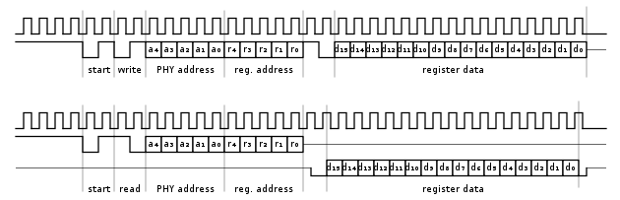
When the MAC drives the MDIO line, it has to guarantee a stable value 10 ns (setup time) before the rising edge of the clock MDC. Further, MDIO has to remain stable 10 ns (hold time) after the rising edge of MDC.
When the PHY drives the MDIO line, the PHY has to provide the MDIO signal between 0 and 300 ns after the rising edge of the clock.[1] Hence, with a minimum clock period of 400 ns (2.5 MHz maximum clock rate) the MAC can safely sample MDIO during the second half of the low cycle of the clock..

MDIO Packet Format
PRE_32 | 32-bits of '1'
ST | 2-bits of '01'
OP | 2-bits of Opcode
PA5 | 5-bits of PHY address
RA5 | 5-bits of register address
TA | 2-bits of turn-around
D16 | 16-bits of data (sent by either SME or PHY, depending on OP)
Z | tristate MDIO

4.4 USB/PCI
1. what is USB?
USB is a system for connecting a wide range of peripherals to a computer, including pointing devices, displays, and data storage and communications products. Although not a relatively new development in personal computing, it has only recently gained popularity due to increasing software support. This document discusses what the USB system does and how it is done. The technical detail covers the system's logical structure, rather than the electrical or software characteristics.

2. How the USB System is Arranged
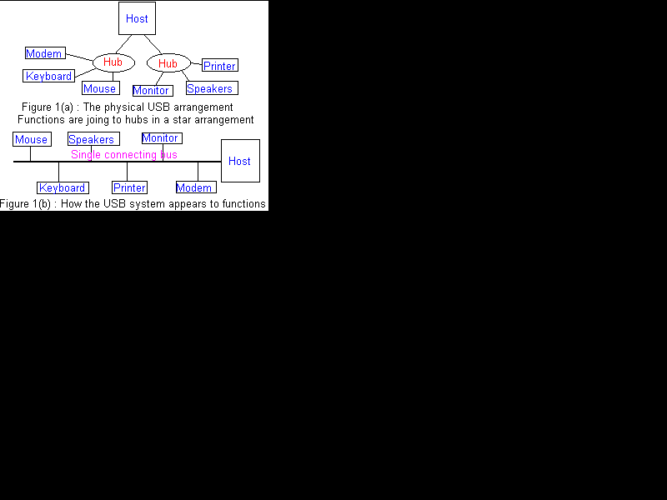
The Universal Serial Bus is a network of attachments connected to the host computer. These attachments come in two types known as Functions and Hubs. Functions are the peripherals such as mice, printers, etc. Hubs basically act like a double adapter does on a power-point, converting one socket, called a port, into multiple ports. Hubs and functions are collectively called devices.
As far as the functions are concerned, hubs are furthermore like double adapters because although the entire system is physically in the star topology seen in Figure 1(a), logically the system acts like a bus topology. This means that signals appear to travel along a single set of wiring, called the bus, to the host and is accessible by all functions, as illustrated in Figure 1(b). However, the host does keep track of the physical arrangements so that if a hub becomes disconnected, it is aware that all hubs and functions attached to it will consequently be disconnected too.
The host has a hub embedded in it called the root hub, and in practical implementations hubs are usually combined with one or more functions, such as keyboards or monitors. These are called compound devices and act like a hub with the functions permanently connected, along with any additional ports. Hubs may be connected to other hubs in a tiered arrangement, but the bus topology still applies.

3. How Does Data Get to the Right Places?
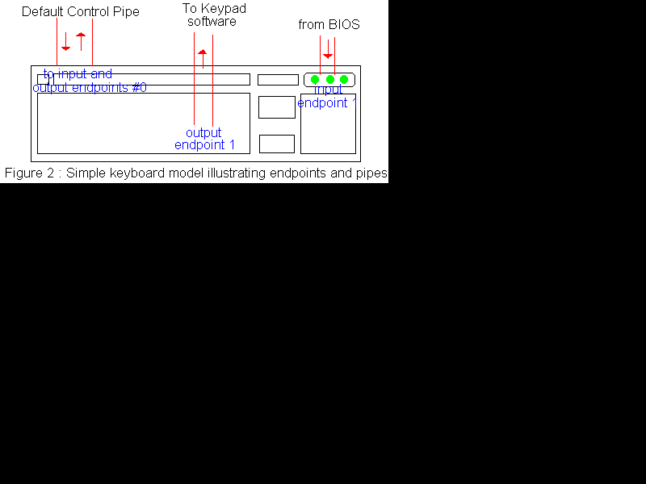
Even with this type of arrangement, we still have the same problem as with the traditional PC layout. Each function has to know when a piece of data is meant for it, and the host needs to know where signals are coming from, so numbers are assigned to each component on the USB. However, rather than each using a fixed IRQ and I/O address, the USB system takes a different approach.
When a device is attached to the USB system, it gets assigned a number called its address. The address is uniquely used by that device while it is connected and, unlike the traditional system, this number is likely to be different to the address given to that device the last time it was used. Each device also contains a number of endpoints, which are a collection of sources and destinations for communications between the host and the device.
Endpoints operate in simplex mode, meaning that they are either an input or output, but not both. For example, a simplistic model of a keyboard (figure 2) could have a keypad as output endpoint number 1, and the LED key lock display as receiving endpoint 1. All USB devices have one of each of their 16 possible input and output endpoints reserved as "zero endpoints". These are used for the auto-detection and configuration of the device when it is connected, and are the only accessible endpoints until this occurs. In addition each endpoint sets, upon connection, its own set of characteristic requirements concerning its requirements when accessing the bus.
The combination of the address, endpoint number and direction are what is used by the host and software to determine along which pipe data is travelling. A pipe is simply a data path between an endpoint and the associated portion of the controlling software, such as between the Keyboard LEDs and the BIOS routine which determines what LEDs should be lit. A special pipe is defined to connect to the zero endpoints, and is called the Default Control Pipe.

4. Types of data transfers
Before we can understand any further detail about the communications process within a USB network, we need to be aware of the types of data that it must cope with. To accommodate the different types of data that needs to travel across the USB, each pipe can be configured as one of four transfer types.
- Control Transfers : These differ from the other types in that they are intended for use in configuring, controlling, and checking the status of a USB device. A request is sent to the device from the host, and appropriate data transfers follow in the appropriate pipes. At some later stage, a status indicator is returned to the host. The pipe used for this type of data may be bidirectional, but uses the same numbered endpoint for each direction. In addition, a device only handles one control request at a time, with the host withholding outstanding requests until a status is returned on the one in progress. For example, the Default Control Pipe uses Control Transfers and accomplishes such tasks as initialising the device, and telling the host of the requirements of each of its endpoints. This type of pipe might also be used to control the operation of other pipes.
- Isochronous Transfers : These involve data whose accuracy is not critical and which is sent at a rate corresponding to some timing mechanism. For example, 44100KHz audio fits into this category since it doesn't have to be perfectly accurate and every 44100 samples indicates one second of audio. USB provides a special type of transfer for this data, giving it preference to guarantee a constant transmission rate with the required bandwidth. To ensure that the USB has enough time to handle the maximum data flow (1023 bytes) in each frame, a check is made during the initial configuration and the pipes will only be configured if this check is successful. This transfer method uses unidirectional pipes with no error handling procedures. Even though an error may be indicated in the status reply to a request, the pipe will not be halted and it is up to the software to decide what to do.
- Interrupt Transfers : These are used for small, infrequent transfers which require priority over other requests. As with Isochronous transfers, pipe configuration is granted on whether or not the system can handle the maximum packet size within the required time, with a further restriction that stops Interrupt and Isochronous Transfers from using more than 90% of any frame (discussed later) and stopping other transfers from occurring. The endpoint tells the host during configuration how often it should be polled for interrupt requests, and upon each polling returns a NAK signal if there is nothing to send. The use of this type of pipe is in some ways similar in purpose to the IRQ lines of the traditional peripheral system used in computers.
- Bulk Transfers : As the name suggests, the intended purpose is for transmitting large amounts of data. This type of transfer gets the lowest priority, so pipes using this method are only allowed to transmit when there is available bandwidth. This means that a heavily loaded USB may have relatively slow bulk transfers compared to one with is servicing few devices. This transfer type would be useful for sending data from devices like digital scanners.

5. Low Speed Devices
The description of USB devices so far has describe full speed USB peripherals, however there exists a special class of device known as low speed devices. These are simpler devices such as joysticks, and are the same as the full speed versions, except for the following restrictions:
- The maximum packet size for data transfers is 8 bytes
- They cannot use Isochronous nor Bulk Transfer pipes
- May only have 2 endpoints other than the zero endpoints
This simplification makes such devices easier, and thus cheaper, to design and implement.

6. How is data sent across the USB?
When the software requires data transfer to occur between itself and the USB, it sends a block of data called an I/O Request Packet (IRP) to the appropriate pipe, and the software is later notified when this request is completed successfully or terminated by error. Other than the presence of an IRP request, the pipe has no interaction with the USB. In the event of an error after three retry attempts, the IRP is cancelled and all further and outstanding IRPs to that pipe are ignored until the software responds to the error signal that is generated by sending an appropriate call to the USB. How exactly this is handled depends upon the type of device and the software.
As suggested by the name Universal Serial Bus, data transmission in the bus occurs in a serial form. Bytes of data are broken up and sent along the bus one bit at a time, with the least significant bit first as illustrated by figure 3.
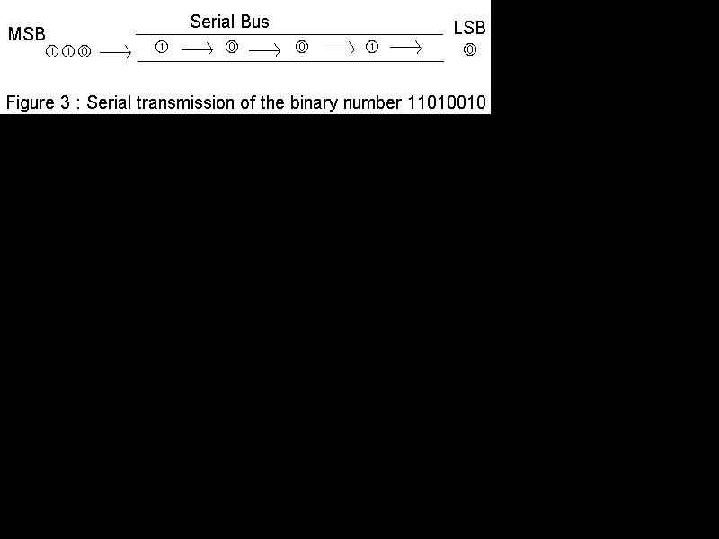
The actual data is sent across the bus in packets. Each packet is a bundle of data along with information concerning the source, destination and length of the data, and also error detection information. Since each endpoint sets, during configuration, a limit to the size of the packet it can handle, an IRP may require several packets to be sent. Each of these packets should be the maximum possible size except for the final packet. The USB host has a built in mechanism so that the software can tell it when to expect full sized packets.
In the event that a less than maximum size packet is received earlier than expected, an error is assumed and the pipe is stalled with all IRPs being cancelled until the problem is dealt with by the controlling software. If an endpoint is busy, but no error has occurred, it responds with a special signal labelled NAK (Negative AcKnlowedge), which tells the other end of the pipe to wait a while. How these conditions are handled depends on the type of device and the software.
Each packet is made up of a set of components called fields including the following, summarised in figure 4 :
- An eight bit "SYNC" synchronisation field used by inputs to correct their timing for accepting data. Part of this field is a special symbol used to mark the start of a packet.
- The 8 bit Packet Identifier (PID) which uses 4 bits to determine the type, and hence format, of the packet data. The remaining 4 bits are a 1's complement of this, acting as check bits. Part of this field determines which of the four groups (token, data, handshake, and special) that the packet belongs to, and also specifies an input, output or setup instruction.
- An address field which gives the address of the function on the end of the pipe to be used
- The 4 bit endpoint field, giving the appropriate endpoint which sends or receives the packet.
- A data field consisting of 0-1023 bytes
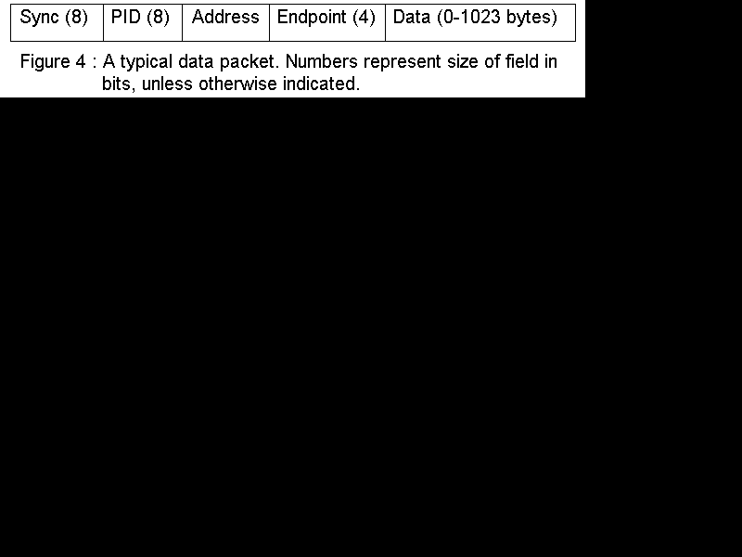
These fields are put together and used by the various types of packets (summarised in Appendix B) for meaningful communication across the USB. Errors are detected by use of a Cyclic Redundancy Check (CRC) on all fields except the PID, which has its own checking mechanism. CRC is considered almost 100% accurate in error detection, and its process is described further in appendix A.

7. Examples of data transactions
A data transaction is simply a movement of data between the host and a connected device. The different types of possible transactions depend upon what transfer type the corresponding pipe is configured for.
7.1 Bulk Transfers
When the host wants to initiate a bulk transfer from a device, it sends a Token Packet specifying whether input or output is desired. If the host wants input, the function in turn sends either a packet of data or a non-ACK handshake. If the host is sending a request to transmit, it will immediately send the data packet and wait for an appropriate handshake to be returned by the recipient.
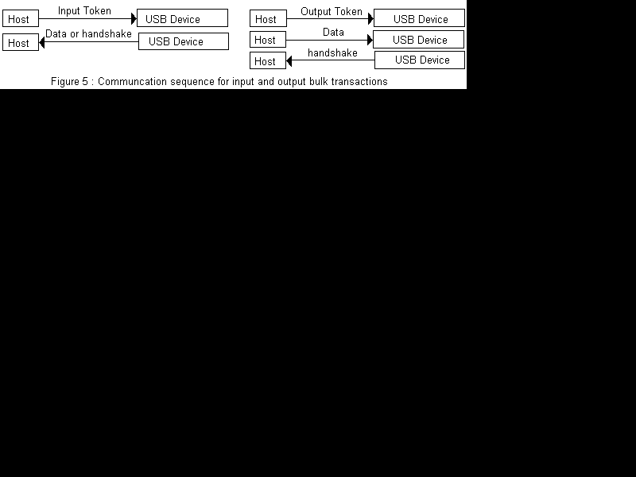
7.2 Control Transactions
This is initiated by the host via an appropriately coded token packet with information regarding the control command being issued. The recipient either replies with an ACK handshake, or ignores the token totally. This type of transfer also contains an optional unidirectional data transfer between the host and the device. Lastly, a status is returned to whatever end of the pipe was last to transmit.
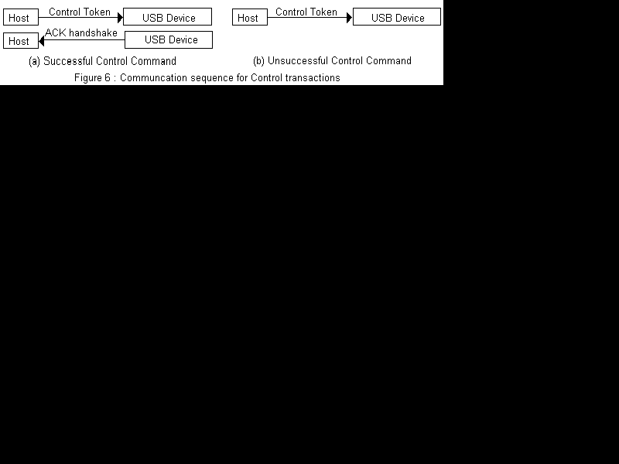
7.3 Interrupt Transactions
The function is queried by the host via a token packet, and returns data if it has any interrupt related information to transmit, or a NAK handshake if it doesn't.
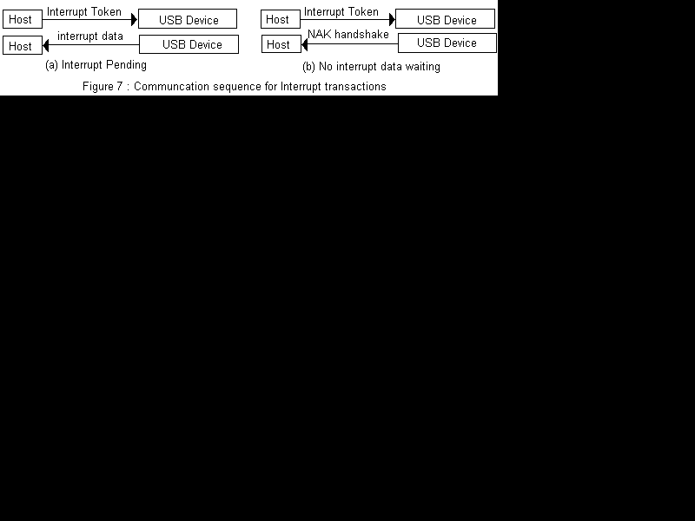
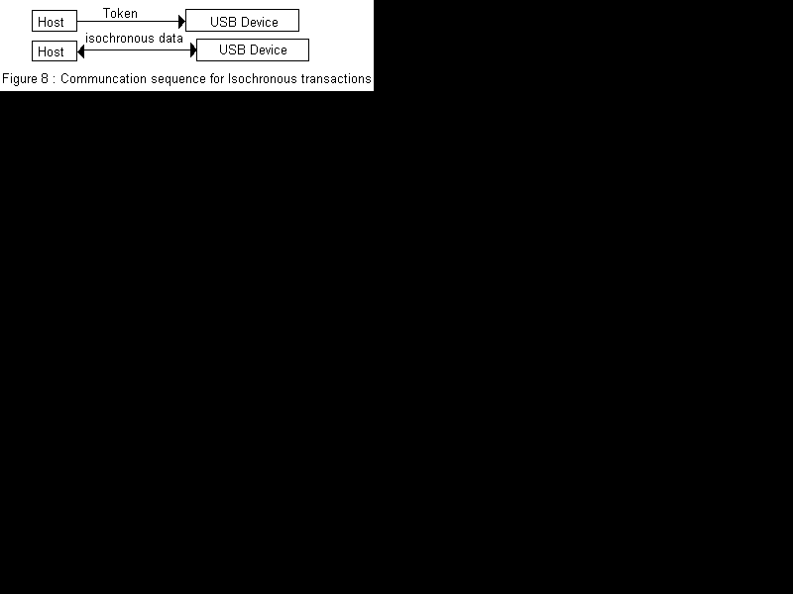
7.4 Isochronous Transactions
These are also begun with an appropriate token packet being sent to the function, and then data is transmitted as required. However, due to the assumed error-tolerance of isochronous data, no handshake packets are used.

8. The Role of Hubs
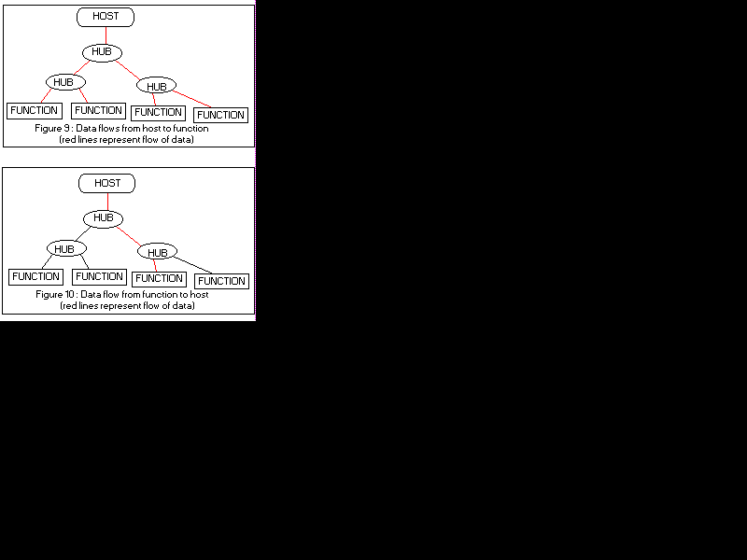
To the consumer, a hub simply expands one USB port into multiple ports. However, to manage this the hub must by able to be able to manage communications between itself and other devices, ensuring that only one transmission occurs on the bus at one time. Communications flows through the hub can be either from the host to a device, or vice versa.
A hub goes into an idle state whenever there are no communications requests coming into it. When it detects data coming to it from wherever it connects to the USB, it immediately establishes a communications connection between itself and all devices connected to its ports, relaying that data as in figure 9. If a connected device has data to send to the host, the hub temporarily switches off all communications with other devices and relays the data to the point where it connects to the USB. This is then repeated by all further hubs (figure 10) until the data finally reaches the host.
The hub is also responsible for monitoring what devices are connected to its ports. When a connection or disconnection occurs, the host is notified by use of the status reply to a token packet. The host then sends another packet to the hub to inquire exactly what changes occurred. If it was a connection, a reset signal is sent to the appropriate port, an address is assigned to the device by the host, and a configuration sequence occurs via the default control pipe of that device. If a device is detached, the host updates its information to remove all devices on the disconnected chain from its records.

9. The Role of Functions
The whole point of the USB system is to define a communications protocol so that peripherals may communicate with their host computer. This is done via the various transaction types previously described, but the important concept in the USB system is that no functions may transmit as soon as they are ready to do so. They must wait to be queried, and then send the appropriate request via a reply or interrupt transfer.
As previously described, functions view the entire USB as a bus network of peripherals, oblivious to the role of hosts. They act no differently if they are connected 3 hubs down a chain than if they were directly connected to the root hub.

10. In Conclusion
The Universal Serial Bus offers a realistic alternative to the existing problem of configuring new peripherals for use with personal computers. The main advantage is the ease of use for the consumer, who simply has to plug the device into any available port for the device to immediately become available to appropriate software. In addition, USB devices are equally suited to any computer platform supporting the protocol, unlike current differences between some devices for the PC and Apple Macintosh. The option for devices to use a low speed mode allows cheaper peripherals such as joysticks to be designed for the system without the additional complexity. The only major disadvantage for the consumer is likely to be the cost of upgrading their computer in order to use the system. USB capable computers still support the traditional system too, so there is no problem with the compatibility of older hardware with such a computer. The barriers which have slowed USB's growth in popularity have been mainly due to the unavailability of supporting software and hardware. The software problem is currently being overcome with USB support being included in the latest version of both Apple's and Microsoft's operating systems. Thus, there is now incentive for people to consider buying USB hardware, and hence for manufacturers to build it.

USB 2.0
http://www.usbmadesimple.co.uk/ums_1.htm
USB 2.0 is a Universal Serial Bus (USB) standard, released in April 2000. Almost all devices with USB capabilities, and nearly all USB cables, support at least USB 2.0.
USB 2.0 is often referred to as Hi-Speed USB.
Devices that adhere to the USB 2.0 standard have the ability to transmit data at a maximum speed of 480 Mbps. This is faster than the older USB 1.1 standard and much slower than the newer USB 3.0 standard.

USB 2.0 Connectors
Note: Plug is the name given to the male connector on a USB 2.0 cable or flash drive, while the receptacle is the name given to the female connector on a USB 2.0 device or extension cable.
- USB Type A: These connectors are technically called USB 2.0 Standard-A and are the perfectly rectangular USB connectors you'll find on most non-mobile devices. USB 2.0 Type A connectors are physically compatible with those from USB 3.0 and USB 1.1.
- USB Type B: These connectors are technically called USB 2.0 Standard-B and are square except for a small notch on top. USB 2.0 Type B plugs are physically compatible with USB 3.0 and USB 1.1 Type B receptacles but USB 3.0 Type B plugs are not backward compatible with USB 2.0 Type B receptacles.
- USB Micro-A: These connectors, especially the plugs, look like miniature versions of USB 2.0 Type A connectors. USB 2.0 Micro-A plugs are compatible with both USB 2.0 Micro-AB receptacles and USB 3.0 Micro-AB receptacles. However, newer USB 3.0 Micro-A plugs will not fit in USB 2.0 Micro-AB receptacles.
- USB Micro-B: These connectors are small and rectangular but two corners on one side are slanted instead of square. USB 2.0 Micro-B plugs are compatible with four receptacles: both USB 2.0 and USB 3.0 Micro-B and Micro-AB receptacles. Newer USB 3.0 Micro-B plugs are not backward compatible with either USB 2.0 Micro receptacle.
- USB Mini-A: These connectors are small and mostly rectangular with one very rounded side. USB 2.0 Mini-A plugs are only compatible with USB 2.0 Mini-AB receptacles.
- USB Mini-B: These connectors are small and mostly rectangular with noticeable indentions on the short sides. USB 2.0 Mini-B plugs are compatible with USB 2.0 Mini-B and USB 2.0 Mini-AB receptacles.
USB 3.0
USB 3.0 is the third major version of the Universal Serial Bus (USB) standard for interfacing computers and electronic devices. Among other improvements, USB 3.0 adds the new transfer rate referred to as SuperSpeed USB (SS) that can transfer data at up to 5 Gbit/s (625 MB/s), which is about ten times as fast as the USB 2.0 standard. Manufacturers are recommended to distinguish USB 3.0 connectors from their USB 2.0 counterparts by blue color-coding of the Standard-A receptacles and plugs,[2] and by the initials SS.[3]

The specification of USB 3.0 is similar to that of USB 2.0, but with many improvements and an alternative implementation. Earlier USB concepts such as endpoints and the four transfer types (bulk, control, isochronous and interrupt) are preserved but the protocol and electrical interface are different. The specification defines a physically separate channel to carry USB 3.0 traffic. The changes in this specification make improvements in the following areas:
- Transfer speed – USB 3.0 adds a new transfer type called SuperSpeed or SS, 5 Gbit/s (electrically, it is more similar to PCI Express 2.0 and SATA than USB 2.0)[7]
- Increased bandwidth – instead of one-way communication, USB 3.0 uses two unidirectional data paths: one to receive data and the other to transmit
- Power management – U0 to U3 link power management states are defined
- Improved bus use – a new feature is added (using packets NRDY and ERDY) to let a device asynchronously notify the host of its readiness, with no need for polling
- Support to rotating media – the bulk protocol is updated with a new feature called Stream Protocol that allows a large number of logical streams within an Endpoint
USB 3.0 has transmission speeds of up to 5 Gbit/s, which is about ten times faster than USB 2.0 (480 Mbit/s) even before taking into account the fact that USB 3.0 is full duplex whereas USB 2.0 is half duplex. This gives USB 3.0 a potential total bandwidth, if used both ways, of twenty times that of USB 2.0.[8]

PCI
PCI is an abbreviation for Peripheral Component Interconnect, which is a term used to describe a common connection interface for attaching computer peripherals to a PC's motherboard, or main circuit board. It is also called a PCI bus. A bus is a term for a path between the components of a computer.
Most often, a PCI slot was used to connect sound and network cards. PCI at one time was used to connect video cards, but graphics demand from gaming made it inadequate for that use.
PCI was popular from 1995-2005 but was generally replaced by other technology such as USB or PCI Express. Desktop computers after that era may have PCI slots on the motherboard in order to be backward compatible. But the devices that used to be attached as PCI expansion cards are now integrated onto motherboards or attached by other connectors such as PCI Express (PCIe).
- Also Known As: Peripheral Component Interconnect, PCI Bus, Conventional PCI
- Not to Be Confused With: PCI compliance, which stands for payment card industry compliance, and PCI DSS which stands for payment card industry data security standard.

PCI Connects Peripherals to the Motherboard
A PCI bus lets you change different peripherals that are attached to the computer system. It allowed using different sound cards and hard drives. Usually here were three or four PCI slots on the motherboard. You could simply unplug the component you want to swap and plug in the new one in the PCI slot on the motherboard.
Or, if you have an open slot, you can add another peripheral. Computers may have more than one type of bus handling different types traffic. The PCI bus came in both 32-bit and 64-bit versions. PCI runs at 33 MHz or 66 MHz.

PCI Cards
PCI cards exist in several shapes and sizes called form factors. Full-size PCI cards are 312 millimeters long.
Short cards range from 119 to 167 millimeters to fit into smaller slots. There are further variations such as compact PCI, Mini PCI, Low-Profile PCI, etc. PCI cards use 47 pins to connect. It supports devices that use 5 volts or 3.3 volts.

