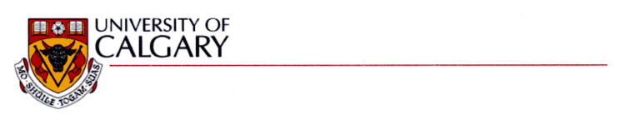

November 24, 2010

University of Calgary

2500 University Drive NW

Calgary, Alberta T2N 1N4

I, Frank Maurer, give S. M. Sohan permission to use co-authored work from our paper:

S. M. Sohan, Michael M. Richter, and Frank Maurer. Auto-tagging emails with user stories using project context. In Agile Processes in Software Engineering and Extreme Programming, volume 48 of Lecture Notes in Business Information Processing, pages 103 - 116. Springer Berlin Heidelberg, 2010.

for chapters of this MSc thesis and to have this work microfilmed.

Sincerely,

Frank Maurer



November 24, 2010

University of Calgary

2500 University Drive NW

Calgary, Alberta T2N 1N4

I, Michael Richter, give S. M. Sohan permission to use co-authored work from our paper:

S. M. Sohan, Michael M. Richter, and Frank Maurer. Auto-tagging emails with user stories using project context. In Agile Processes in Software Engineering and Extreme Programming, volume 48 of Lecture Notes in Business Information Processing, pages 103 - 116. Springer Berlin Heidelberg, 2010.

for chapters of this MSc thesis and to have this work microfilmed.

Sincerely,

Michael Richter