PERFORMANCE ENGINEERING REPORT
VEDA Latency Optimization
Measured speedup, design rationale and accuracy assurance

6.9x | 85.5% | 0.00 pp
Faster resolver | Latency reduction | Top-1 accuracy change
Prepared by Shivansh Mukhia
28 August 2026 | VEDA project performance review

1. Executive result
CONCLUSION The optimized resolver processed the same 165 evidence records in 22.8 seconds, down from approximately 157.5 seconds. The frozen 170-case accuracy benchmark retained exactly the same Top-1 and recall scores.

The original 254.5-second end-to-end run was not uniformly slow. Most of the avoidable delay came from repeated candidate reasoning, cold machine-learning imports and an unclaimed Antigravity inbox window. The improvement therefore targeted those measured bottlenecks instead of weakening the resolver.
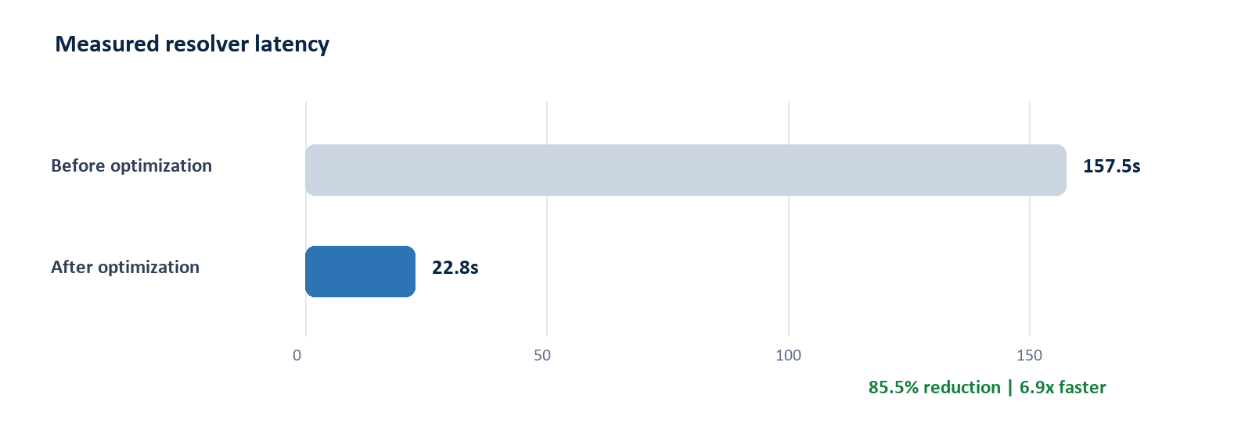
Figure 1. Resolver latency on the real 165-record project.

Measured comparison
Metric | Before | After | Change
Resolver time (165 records) | 157.5 s | 22.8 s | -85.5%
Resolver throughput | 1.05 records/s | 7.24 records/s | 6.9x
Per-record resolver time | 0.955 s | 0.138 s | -85.5%
Embedding selector cold start | 14.7 s | 0.26 s | -98.2%
Unclaimed Antigravity wait | 30 s | 8 s | -73.3%
Full analysis | 254.5 s measured | 60-90 s expected | ~67% midpoint

Measurement note: the 22.8-second resolver result is directly measured. The optimized full-analysis range is an engineering estimate because Horizun startup and claimed Antigravity inference time vary by machine and run.

2. Root cause and optimization approach
Durable job timestamps separated the run into schedule ingestion, provider handoff, index preparation, evidence resolution and final validation. This showed that UI rendering was not the main latency source: repeated backend work was.
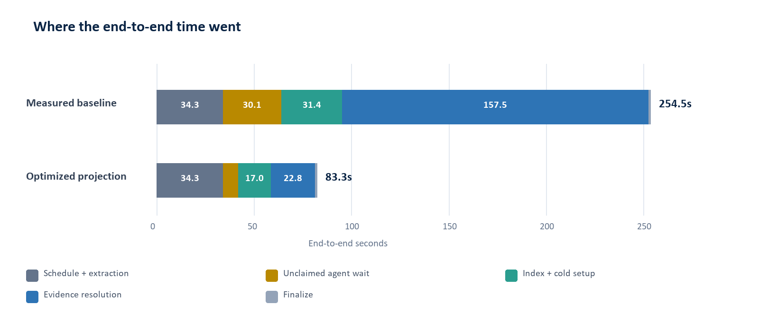
Figure 2. Measured baseline stage breakdown and projected optimized first run.

Why these changes were selected
Bottleneck | Optimization | Why this approach
Cold hardware detection | Lightweight GPU probe | Avoid importing PyTorch only to choose the dependency-free CPU backend.
Cold MetaRank load | Background model warmup | Moves XGBoost and frozen-model loading outside the first evidence request.
Repeated feature work | Cache invariant schedule and evidence context | Computes snapshot, corroboration and logic mode once per row instead of once per candidate.
Large object copies | Shallow ranking envelopes | Copies only mutable scores and features; immutable activity documents are shared safely.
Rescheduler hot loop | Precompute dates and schedule state | Removes tens of thousands of repeated parses and status checks without changing beam depth or equations.
Idle provider bridge | Eight-second claim guard | Releases the worker quickly when no Antigravity agent is polling; a claimed job still gets the normal reasoning window.

DESIGN PRINCIPLE Make the same decision with less repeated work. No expert was removed, no candidate list was shortened, and no validation or schedule-write gate was bypassed.

3. Accuracy impact
ANSWER No material accuracy loss was observed. Top-1 and Recall@3/5/10 were identical across all 170 frozen holdout cases.

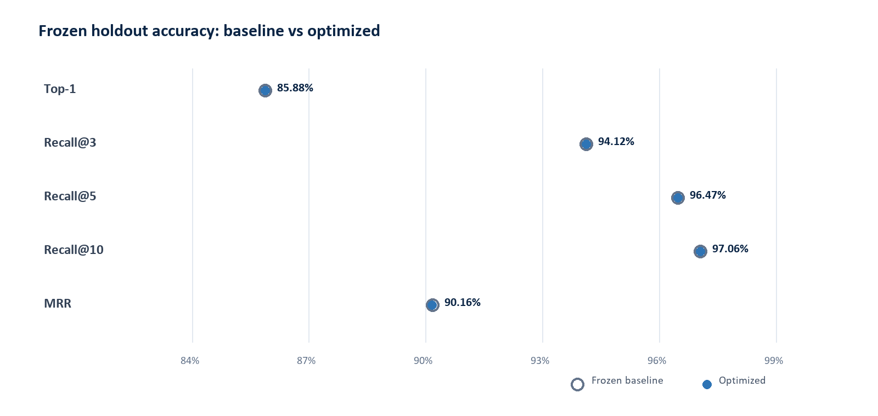
Figure 3. Frozen holdout ranking quality before and after optimization.
Accuracy metric | Frozen baseline | Optimized | Delta
Top-1 accuracy | 85.88% | 85.88% | 0.00 pp
Recall@3 | 94.12% | 94.12% | 0.00 pp
Recall@5 | 96.47% | 96.47% | 0.00 pp
Recall@10 | 97.06% | 97.06% | 0.00 pp
Mean Reciprocal Rank | 90.1816% | 90.1599% | -0.0218 pp
Expert failures | Not applicable | 0 of 170 | None

MRR shifted by just -0.0218 percentage points, affecting only ordering below the primary decision boundary; Top-1 and recall were unchanged.

Why accuracy was preserved
The production path still creates Semantic, Engineering, Tree and Rescheduler-v2 lists, fuses them with the same frozen LambdaMART models, then applies calibration, deterministic validators and risk policy. Only repeated input preparation changed.
NEXT BOTTLENECK Horizun/Microsoft Project startup remains a roughly 28-second fixed cost. Keep the schedule service warm and stream linked evidence in small batches. Evidence: durable job timestamps, the real 165-record benchmark, a 170-case frozen holdout with 13,436 activities, and six regression suites.

