Morning Market & Macro
Verification Brief
Verification and synthesis of the headlines, screenshots, memo and labor-market PDF supplied this morning
20 August 2026
BOTTOM LINE
The bundle points to a difficult macro mix rather than a clean recession signal: fiscal stress and an energy shock are pushing long-duration yields higher while hiring, GDP growth and consumer-sensitive data soften. Initial claims remain unusually low, so the labor market still looks “low-fire,” but weak payrolls and rising continuing claims make it increasingly “low-hire.” The strongest immediate market pressure is the combination of higher oil/gas prices and a long-end Treasury selloff.

What changed after verification
• The NRSC “Ohio Data Center Risk” memo is authentic in substance; Axios obtained and reported it. The memo’s private polling and ad-point claims remain campaign-source claims, not independently established facts.
• The jobless-claims headline numbers are correct: 206K initial claims and 1.799M continuing claims. However, the supplied ZeroHedge PDF contains a state-level factual reversal: Labor Department data show Michigan had the largest increase in the cited week, while Kentucky was among the decreases.
• Walmart did not broadly miss the quarter: revenue and adjusted EPS beat. The damage came from U.S. comparable sales (2.6% versus roughly 3.8% expected) and a soft Q3 EPS guide; the stock fell about 8.8%, its biggest percentage drop since 2022.
• The 10-year Treasury’s move back toward/through 4.70% effectively erased the immediate yield relief from Treasury’s stepped-up buybacks; the 30-year was around 5.24%-5.25%.
• The energy-risk headlines are real and mutually reinforcing: Trump escalated economic pressure on Iran, Brent moved above $94 in some live reports, European TTF gas moved above €65/MWh, and a separate Gulf of Aden tanker hijacking added maritime risk.
Verification labels used below: CONFIRMED = supported by primary or strong independent reporting; REPORTED = credible press report but not issuer-confirmed; PARTIAL = core fact supported but a superlative/metric/attribution remains source-dependent; PRIVATE / POLITICAL = campaign framing, internal polling or persuasion claim.

Verification matrix
The quickest way to distinguish hard facts from market shorthand, private polling and source-dependent claims.
Item | Status | What holds up | Caveat / correction
NRSC Ohio data-center memo | CONFIRMED + NUANCE | Axios reported the memo and quoted its warning that data centers have become a major liability in the Ohio Senate race. | Authenticity is solid. The memo’s internal polling, “6,000 TV points,” and message-effect claims are not public-source facts.
Ohio race is a “dead heat” | CONFIRMED + NUANCE | RealClearPolitics currently averages Brown 47.8%, Husted 47.2% (Brown +0.6; Toss Up). | Latest Fox poll had Brown 53%-45%. “Dead heat” fits one aggregate, not every poll.
Trump Ratepayer Protection Pledge | CONFIRMED | White House materials say large data-center operators should bring/buy new generation, fund grid upgrades and use structures intended to shield existing ratepayers. | “No higher costs” is a policy objective/commitment, not a guarantee that every local bill outcome will be zero-impact.
Initial claims 206K | CONFIRMED | Labor Department: 206,000 for week ended Aug. 15, down 6,000 from a revised 212,000. | The 210K consensus expectation is consistent with Reuters-type survey reporting.
Continuing claims 1.799M | CONFIRMED | Labor Department: 1,799,000 for week ended Aug. 8, up 18,000. | Expectation feeds differ slightly; ~1.788M-1.790M was cited across market sources.
ZeroHedge state claims detail | PARTIAL | The article’s national claims figures and low-hire/low-fire framing are directionally supported. | Its state sentence is wrong for the cited week: DOL shows Michigan had the largest increase; Kentucky was a decrease, not the biggest increase.
July payrolls -23K / unemployment 4.1% | CONFIRMED | BLS reported payrolls down 23,000 in July and unemployment at 4.1%. | Claims resilience therefore coexists with weak hiring rather than disproving it.
Q2 real GDP +1.5% annualized | CONFIRMED | BEA advance estimate: 1.5% in Q2 versus 2.1% in Q1. | Supports “slowing, not collapsing” growth.
10Y > 4.70%; 30Y ~5.25% | CONFIRMED + NUANCE | Live market reporting had the 10-year back near 4.70% and the 30-year around 5.24%-5.25%, reversing much of the post-buyback yield drop. | Intraday levels move continuously; treat exact ticks as time-stamped, not fixed closes.
U.S. debt exceeds $40T | CONFIRMED | AP reports gross federal debt crossed $40 trillion on Aug. 19. | The milestone is nominal gross debt; market implications depend on deficits, issuance, inflation and demand for Treasuries.
Bessent buybacks as “circuit breaker” | CONFIRMED + NUANCE | Treasury buybacks briefly lowered long yields; by the next session the 10-year had largely retraced the move. Analysts warn buybacks do not fix fiscal imbalance. | “Circuit breaker” is analyst characterization, not an official Treasury description.
Walmart “huge comp miss” / crash | CONFIRMED + NUANCE | U.S. comps rose 2.6% versus about 3.8% expected; shares fell about 8.8%, the largest percentage decline since 2022. | Revenue ($187.94B) and adjusted EPS ($0.81) beat. The weak point was comps plus Q3 EPS guidance ($0.62-$0.64 vs ~$0.68 expected).
Virtu explores >$3.5B brokerage sale | REPORTED | Market reports citing Bloomberg say Virtu is considering a sale of its brokerage unit for more than $3.5B. | This is a deal-process report, not a publicly announced transaction by Virtu.
Trump “crushing” economic operation vs Iran | CONFIRMED | Trump announced a major new economic pressure campaign and threatened consequences for countries helping Iran. | Scope and enforcement details remain the key variable; secondary-sanctions risk is the market transmission channel.
Brent above $93 | CONFIRMED | Live reporting showed Brent above $94 at points Thursday, so the supplied “above $93” line was conservative. | Oil remains headline-sensitive to Hormuz flows, sanctions enforcement and diplomacy.
U.S.-run Hormuz shipping corridor | CONFIRMED | Axios, citing U.S. officials, reported 15-20 tankers moving nightly through a southern channel and roughly 10M bbl/day of oil exports. | This improves flow versus worst-case closure, but remains below pre-war traffic and depends on military protection.
European gas above €65/MWh | CONFIRMED | Dutch TTF futures moved above €65/MWh, the highest since March. | The move compounds Europe’s storage/refill vulnerability and adds an inflationary energy impulse.
Gulf of Aden tanker hijacked / diverted to Somalia | CONFIRMED | UKMTO Warning 118-26 states six armed persons boarded a tanker and were redirecting it toward Somalia. | A discrete piracy/security event, separate from the Iran/Hormuz confrontation, but directionally adds shipping-risk premium.
North Korea missile barrage | CONFIRMED | AP: about 10 short-range ballistic missiles launched toward eastern waters after Pyongyang dismissed the latest U.S. overture. | Geopolitical risk headline; limited direct macro transmission unless escalation follows.
U.S.-Canada tariff deal nearing | CONFIRMED + NUANCE | WSJ reported a framework under discussion that could cut steel/aluminum tariffs 50%→25% and auto tariffs 25%→15%. | Terms were still not finalized in the reporting; “closing in” is more accurate than “done.”
Four senators press Warsh on Trump contacts | CONFIRMED | WSJ reported four Democratic senators asked Fed Chair Kevin Warsh for a written account of conversations with Trump. | Main market relevance is perceived Fed independence, not a direct policy change.
Japan exports +23.2% YoY | CONFIRMED + NUANCE | Japan’s exports rose 23.2% to ¥11.51T; autos and electronics were strong. | The 23.2% figure is confirmed. “Fastest since 2022” was not necessary to establish the underlying surge.
China closing AI gap / leads on cost & usage | CONFIRMED + NUANCE | Independent reporting supports rapidly improving Chinese models and materially lower inference prices; platform data show very high Chinese-model usage. | “Usage lead” is dataset-dependent (e.g., OpenRouter) and should not be read as universal global AI market share.
Mutual-fund cash 1.2% at end-June | PARTIAL | Goldman research has documented historically low mutual-fund cash, including 1.1% at end-2025 and 1.4% at end-March 2026. | The supplied 1.2% end-June figure is Goldman-attributed and plausible, but should be treated as note-specific until the current underlying report is in hand.
Habibi: China in crosshairs; Iraq/Türkiye in focus | PARTIAL | The policy design clearly raises secondary-sanctions exposure for major Iran trading/financial partners, especially China; Türkiye is also commonly cited. | The exact analyst quote/wording is attribution-dependent. “No long-term strategy” is analysis/opinion, not a verifiable fact.

Macro synthesis: rates up, labor soft but not broken
READ-THROUGH
The combination is more stagflationary/risk-premium-heavy than recessionary: long yields are rising even as growth and hiring soften because fiscal supply concerns and energy inflation are pushing in the opposite direction from the labor data.

1. The long end is rejecting a purely technical fix
The user-supplied 10-year chart is consistent with live reporting: the 10-year moved back toward/through 4.70% after briefly falling near 4.64% on news of larger Treasury buybacks. The 30-year traded around 5.24%-5.25%. That means the immediate “buyback relief” was largely erased. With gross federal debt now above $40T, investors are treating buybacks as liquidity management rather than a substitute for lower deficits or less duration supply.
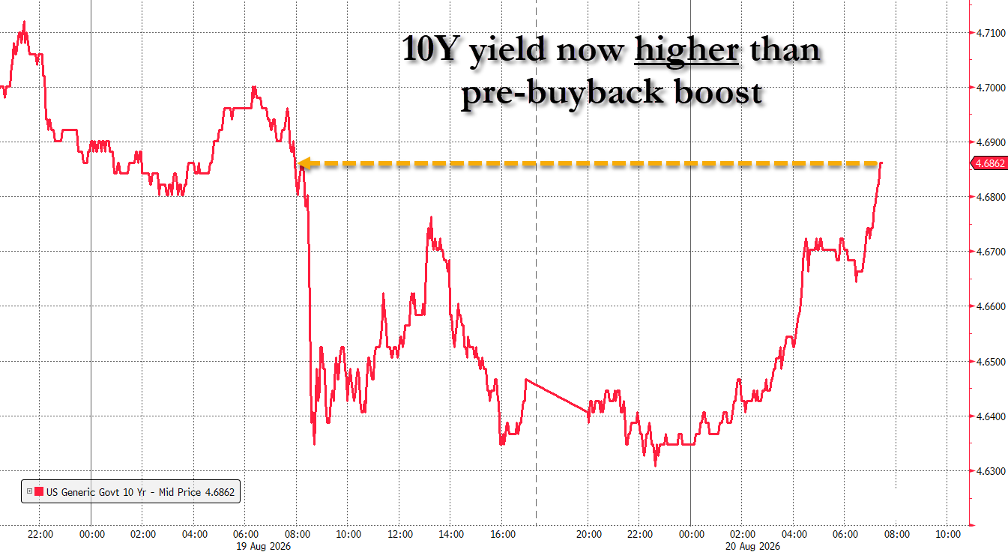
Figure 1. User-supplied 10-year Treasury chart: the yield recovered above its pre-buyback area during the Aug. 19-20 session.

2. Claims remain strong, but the broader labor tape is fragile
• Initial claims: 206K, below the 210K consensus cited in the market feed and down 6K week over week. That is not a layoff-recession signal.
• Continuing claims: 1.799M, up 18K. Workers who do lose jobs are taking longer to cycle off benefits than the exceptionally low initial-claims number alone suggests.
• July payrolls: -23K; unemployment: 4.1%. Q2 GDP: +1.5% annualized after +2.1% in Q1. This is a “low-hire, low-fire” economy with less cushion if demand weakens further.
IMPORTANT CORRECTION TO THE SUPPLIED PDF
The ZeroHedge article says Michigan had the largest decline in initial claims and Kentucky the largest increase. The Labor Department’s state table for the cited week shows the opposite direction: Michigan had the largest increase (+1,931), while Kentucky was among the decreases (-87); Ohio had the largest decrease (-252). The article’s national 206K / 1.799M figures are correct.

Geopolitics & energy: the inflation impulse is getting harder to ignore
Three separate risk channels are now stacking on top of each other: Iran/Hormuz, European gas, and Gulf of Aden piracy. They are not the same event, but they all raise the cost or perceived risk of moving energy and goods.

Iran / Hormuz
• Trump announced what he called a “crushing” economic operation against Iran and threatened consequences for countries that sustain Iran’s trade and finance. The market relevance is secondary-sanctions enforcement: China is the obvious large exposure, with Türkiye and regional financial/logistics hubs also in focus.
• Brent moved above $94 in live reporting, making the earlier “above $93” headline conservative. That feeds directly into inflation expectations and indirectly into long-duration yields.
• Axios reports a U.S.-coordinated southern shipping lane moving 15-20 tankers per night and roughly 10M barrels/day out of Hormuz. This materially reduces the worst-case supply shock, but traffic remains below pre-war levels and requires military protection.

Europe / maritime security
• Dutch TTF gas moved above €65/MWh, highest since March. Low inventories, heat-driven power demand and supply-route uncertainty leave Europe exposed to a costly refill/winter setup.
• Separately, UKMTO Warning 118-26 says six armed persons took control of a tanker 136 nautical miles east of Al Mukalla and redirected it toward Somalia. This is a piracy/security shock in the Gulf of Aden, not evidence that the Hormuz corridor itself was hijacked.
MARKET IMPLICATION
If oil and European gas stay elevated while the 10-year/30-year remain near these levels, the market has to price a higher inflation/risk premium at the same time growth-sensitive data are weakening. That is a tougher backdrop for long-duration assets than a simple “weak labor = lower yields” setup.

Consumer & corporates: Walmart was a quality-of-growth miss, not an earnings collapse
Walmart’s headline selloff is real, but the wording matters. Adjusted EPS of $0.81 beat roughly $0.74 expected, and revenue of $187.94B beat roughly $186.6B expected. The problem was U.S. comparable sales growth of 2.6% versus about 3.8% expected, plus Q3 adjusted EPS guidance of $0.62-$0.64 versus about $0.68 expected. Shares fell about 8.8%, the largest percentage drop since 2022.
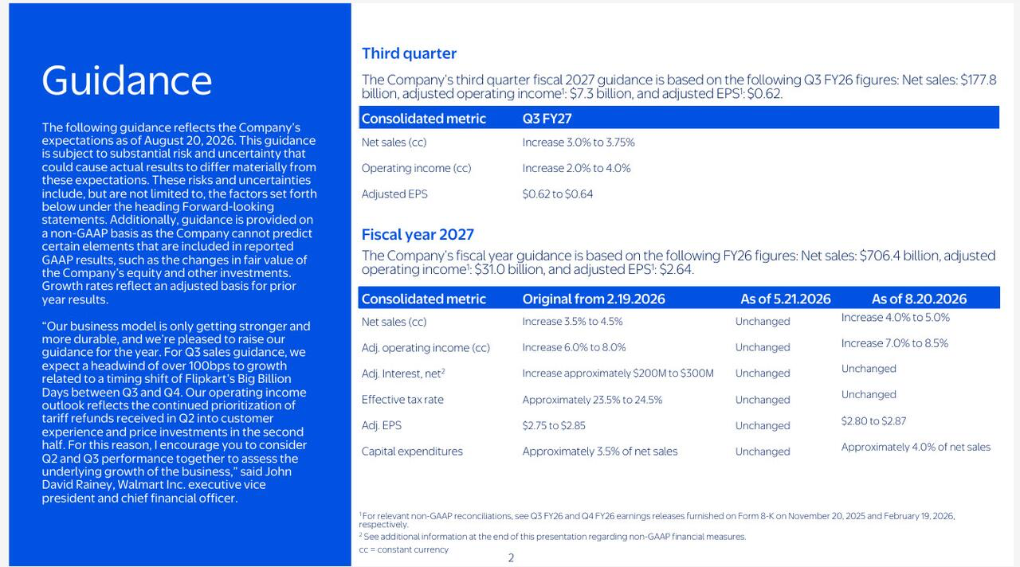
Figure 2. User-supplied Walmart guidance slide. Full-year sales and operating-income ranges were raised, while Q3 guidance and timing/tariff-refund commentary highlighted near-term pressure.
• Consumer signal: the comp miss is consistent with households prioritizing essentials and reacting to higher gasoline/price pressure, but Walmart is still gaining share and e-commerce grew strongly. It is not proof of an imminent consumer collapse.
• Valuation/expectations signal: when a defensive bellwether beats EPS and revenue yet falls nearly 9%, the market is demanding cleaner top-line momentum and better forward guidance.

Virtu Financial
The “$3.5B+ sale” headline is best treated as a credible deal report, not a completed corporate action. Bloomberg-sourced reporting says Virtu is exploring a sale of its brokerage unit for more than $3.5B; the company had not publicly announced a signed transaction in the material reviewed.

Politics, data centers & AI

Ohio data-center backlash is a real political risk
The NRSC memo is not a fabricated document. Axios reported it and quoted the same core language supplied here. The central thesis — data centers are becoming politically toxic because of electricity, water, utility-bill and local-control concerns — is supported by the reporting. The memo’s inference that an Ohio loss would alter national politicians’ willingness to approve future projects is plausible strategic analysis, not a measurable fact today.
• Polling needs qualification: RealClearPolitics currently has Brown +0.6 (47.8%-47.2%) and rates the race a toss-up, while the latest Fox poll had Brown ahead 53%-45%. “Dead heat” is defensible as an aggregate description, but not as a statement that all polling is tied.
• The Ratepayer Protection Pledge is real. It calls for new data-center power demand to be paired with new generation/infrastructure and for operators to bear costs. Whether those commitments fully prevent local rate impacts will depend on implementation and utility regulation.
• The memo’s “three ads / 6,000 points,” private-message testing, and claim that voters overwhelmingly prefer its exact Republican-vs-Democrat framing should be treated as internal campaign data unless independently released.
• The statement that Brown simply wants to stop all data-center construction is campaign framing; it should not be promoted to verified fact without a specific Brown policy proposal establishing a blanket ban.

China AI competition: the threat is credible, the metrics are narrower than the headline
• Recent AP/FT reporting supports the broad claim that Chinese open-weight models are closing the capability gap and forcing U.S. labs to compete much harder on price.
• Some platform data show Chinese models dominating token usage and costing far less per task. But that is not equivalent to China leading worldwide enterprise AI revenue, installed base or every frontier benchmark. “China leads on usage” must be tied to the dataset being cited.
• This distinction matters politically: the “AI race with China” argument has real competitive evidence behind it, but it does not automatically validate every data-center siting, subsidy or ratepayer claim in the NRSC memo.

Other overnight items
North Korea: Confirmed: about 10 short-range ballistic missiles were launched toward eastern waters after Pyongyang dismissed the latest U.S. diplomatic gesture.
U.S.-Canada trade: Confirmed with nuance: a framework under discussion could reduce steel/aluminum tariffs from 50% to 25% and autos from 25% to 15%, but reporting still described terms as unfinished.
Fed / Kevin Warsh: Confirmed: four Democratic senators asked the Fed chair to disclose conversations with Trump, citing concerns over the appearance of White House influence on monetary policy.
Japan exports: Confirmed: exports rose 23.2% year over year to ¥11.51T, with autos and electronics strong; imports rose even faster, leaving a trade deficit.
Mutual-fund cash: Directionally supported: cash allocations are historically low. The supplied 1.2% end-June figure is a Goldman-attributed current datapoint; older Goldman material confirms 1.1% at end-2025 and a still-low 1.4% at end-March 2026.
ONE-SENTENCE SYNTHESIS
The market is being asked to absorb slower domestic growth, a still-tight layoff picture, higher energy prices, a $40T debt milestone and renewed long-end yield pressure at the same time — a mix that keeps both inflation risk and growth risk alive.

What matters next
• Whether the 10-year can hold above ~4.70% and the 30-year near ~5.25% after the buyback bounce failed. Sustained levels would confirm that fiscal/term-premium pressure is overpowering the technical Treasury support.
• Whether Brent remains above the low-$90s and TTF stays above €60-€65/MWh. Persistence matters more for inflation than a single headline spike.
• Evidence that Trump’s Iran campaign actually reaches major third-country counterparties. Announced secondary sanctions are more market-moving when enforcement starts affecting Chinese or regional trade flows.
• Whether continuing claims keep grinding higher while initial claims remain low. That would reinforce the “hard to get fired, hard to get hired” regime.
• Whether Walmart’s comp weakness spreads to other retailers or proves company/category-specific. Cross-retailer confirmation would make the consumer signal much stronger.
• Whether Ohio data-center polling moves after the ad blitz. Public polling, rather than NRSC private message testing, is the cleaner way to judge if the issue is changing the race.

Source notes
Primary sources are favored where available; press sources are used for live-market levels, private memos and deal/geopolitical reporting. User-supplied screenshots/headlines are treated as leads and cross-checked where possible.
1. Axios — “Exclusive: GOP warns AI companies that data centers are politically radioactive” (Aug. 19, 2026)
2. RealClearPolling — 2026 Ohio Senate Special Election: Husted vs. Brown
3. Fox News poll cross-tabs — Ohio, Aug. 6-10, 2026
4. White House — Ratepayer Protection Pledge release (July 2026)
5. White House — Ratepayer Protection Pledge fact sheet (March 2026)
6. U.S. Department of Labor — Unemployment Insurance Weekly Claims, Aug. 20, 2026
7. U.S. Bureau of Labor Statistics — Employment Situation, July 2026
8. U.S. Bureau of Economic Analysis — GDP Advance Estimate, Q2 2026
9. AP — “US national debt hits a record $40 trillion”
10. MarketWatch — “Benchmark bond yields rub out Bessent slide” (Aug. 20, 2026)
11. WSJ — “Will Bessent’s Intervention Work?” (Aug. 20, 2026)
12. AP — Walmart Q2 report and guidance (Aug. 20, 2026)
13. Barron’s — Walmart’s largest percentage drop since 2022 (Aug. 20, 2026)
14. Investing.com — Virtu brokerage-unit sale report (Aug. 20, 2026)
15. Al Jazeera — Trump announces economic operation against Iran (Aug. 19, 2026)
16. Axios — U.S. shipping corridor through Hormuz (Aug. 19, 2026)
17. MarketWatch — Oil jumps after Trump economic-war announcement (Aug. 20, 2026)
18. Euronews — European gas above €65/MWh, highest since March (Aug. 20, 2026)
19. UKMTO — Recent incidents / Warning 118-26
20. AP — North Korea ballistic-missile launches (Aug. 20, 2026)
21. WSJ — U.S. considers lower Canada tariffs on metals and autos (Aug. 20, 2026)
22. WSJ — Democrats press Kevin Warsh to disclose Trump calls (Aug. 20, 2026)
23. AP — Japan imports/exports set July records; exports +23.2% (Aug. 20, 2026)
24. AP — Chinese AI models gain ground on price, openness and capability (July 2026)
25. FT — OpenAI and Anthropic price competition as Chinese models gain ground (Aug. 2026)
26. Goldman Sachs — Mutual Fundamentals, Feb. 18, 2026 (historical cash-balance context)
Also reviewed: the user-supplied NRSC memo text, Treasury-yield screenshot, Walmart guidance screenshot, the supplied ZeroHedge jobless-claims PDF, and the overnight headline/terminal snippets in this chat.

