Basic Report Writing: format
(V202604149)

Abstract
Shape memory materials (SMMs) are featured by the ability to recover their original shape from a significant and seemingly plastic deformation upon a particular stimulus is applied1. This is known as the shape memory effect (SME). Super-elasticity (in alloys) or visco-elasticity (in polymers) is also commonly observed if a SMM is deformed at the present of the stimulus. The SME can be utilized in many fields, from aerospace engineering (e.g., in deployable structures and morphing wings) to medical devices (e.g., in stents and filters).

Justify both right and left sides.

i
Content
Abstract | i
Acknowledgement | ii
List of Figures | Iv
List of Tables | v
Chapter 1 | 1
Chapter 2 | 3
References | 4
Appendix A | 5
Appendix B | 6

- Page number
No page number for cover page
Chapter 1, page No. 1.
Before that (abstract, acknowledgements, content, list of figures, list of tables, ...) using i, ii, iii.

iii
Chapter 1 Start a new page only for a new chapter
Short term must be defined first. Shape memory effect (SME) refers to …
1.1 Figures
Refer to Figure 1(a) for the format of a proper plot. Some important points are highlighted in Figure 1(b). No border for figures.
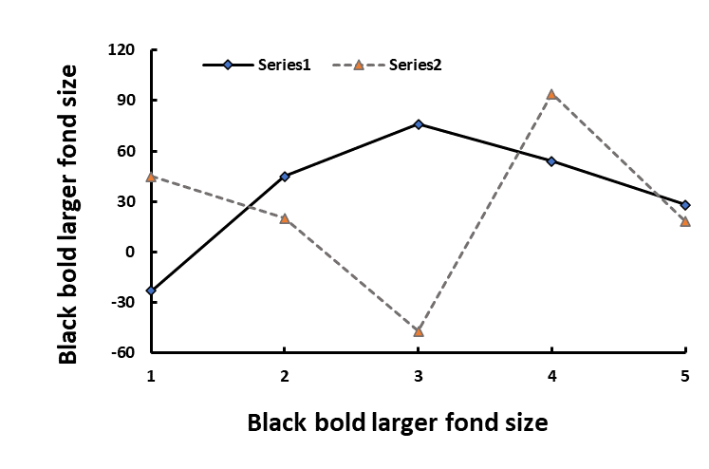
(a)
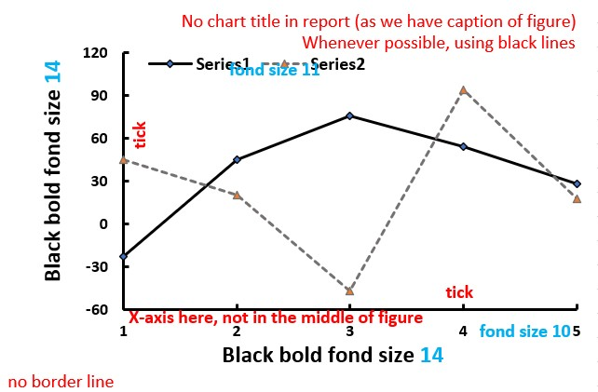
(b)
Figure 1 Format of figure (a) and important points as highlighted in (b). (caption after figure, full stop at the end)
Fill in excessive blank space at the bottom of a page whenever possible. Bring next section/paragraph to fill in the gap at the bottom of a page.
Follow this color sequence in Excel to assign colors for a sequence of lines/symbols, e.g., results of 1 Hz, 2 Hz, ..... Using different line styles, solid, dashed, dash-dotted, dotted (following this sequence), if necessary.
1


1.2 Tables
Title of table is always atop the table. Refer to Table 1.
Table 1 Blank table. (caution atop the table, full stop at the end)

1.3 Equations
Every equation must have a number.

$a=b$ (1) or (1.1)
Every symbol used must be defined.

1.4 Remarks
Every figure/table must be referred in the maintext.
Do not use “figure/table below or above figure/table”.
Number[space]Unit: 20 Kg, 100 ml; not 20Kg, 100ml.

10 ºC (superscrip o C)

2
Chapter 2 Start a new page

2.1
$a=sb$ (2) or (2.1)

2.2
2.3

3
References (do not include [abcd] in the report)
[1] Huang W.M., Ding Z., Wang C.C., Wei J., Zhao Y., Purnawali H., Shape memory materials. Materials Today, 2010. 13(7-8), p. 54-61. [Journal paper]
[2] Huang W.M., Yang B., and Fu Y.Q., Polyurethane shape memory polymers. 2011, New York, USA: CRC Press. [Book]
[3] Chen L., Design of shape memory shoes for comfort fitting, FYP report, 2018, Nanyang Technological University, Singapore. [FYP report]

- Format
Journal paper [1]
Names of authors, title of paper, title, journal, year, issue/no, page number.
Book [2]
Names of authors, book name, year, (location of publisher), publisher.
FYP report [3]
Name, title, FYP report or PhD Dissertation or MEng Thesis or MSci Thesis, Year, Nayang Technological University, Singapore.

Every reference must be cited in the maintext.
You may use footnote in the maintext as additional.

4
Appendix A
Including details of specifics of materials used (supplier, cost etc, e.g., receipt, if needed).
Appendix should be mentioned in the relevant part of the maintext part.
If you have too many experimental results (original), include here. Figure A1 is the original photo used in Section 3.1.
Data used in Figure 1 in the maintext part is listed in Table A1.

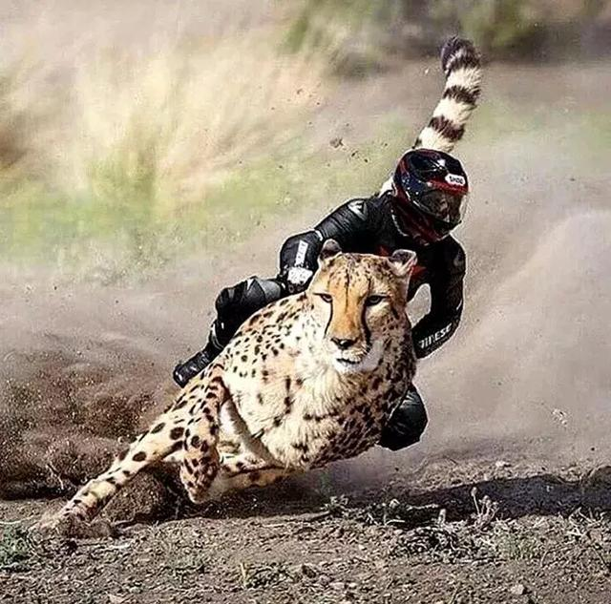
Figure A1 Let’s go.

Table A1 Where are we?

$a=sab$ (3) or (A.1)

5
Appendix B

Figure B1 Additional information.

Table B1 New data.

$a=sfab$ (4) or (B.1)

6

