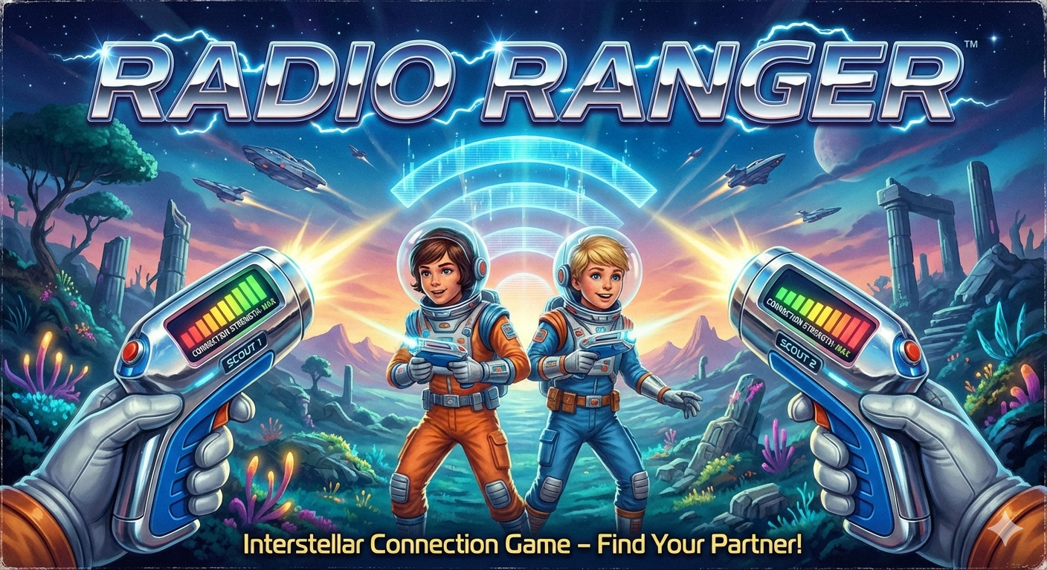
Radio Ranger

Radio Ranger is a proximity sensing device. The LED meter increases in proportion to how close the two devices are to one another.

After the devices are turned on they will begin searching (single red light sweeping).
When one device discovers the other, it will display how close it is to the other device:

Far ← | Red | Yellow | Green | → Close

Games

- Blood Hound
  - Hide one device and search with it with the other
- Radio Tag
  - Tag if green
- Marco Polo
- Use your imagination

Battery Charge

Flashing indicates battery level
- No Flash = Charged
- Slow Flash = Battery Low
- Fast Flash = Charge Immediately

To charge plug in a usb-c cable to a standard 5v receptacle.
The device must be turned ON in order to charge.

