TARA Acupoints Ontology Project
A Comprehensive Overview
NIH/NCCIH-Funded | SciCrunch / UC San Diego | June 2026

The TARA Project
TARA — the Topological Atlas and Repository for Acupoint Research — is a multi-site research collaboration funded by the National Center for Complementary and Integrative Health (NCCIH) at the National Institutes of Health (NIH). Its overarching goal is to build a comprehensive, open, and computationally accessible platform for acupuncture research: one that integrates anatomical atlases, curated research literature, and formal knowledge resources into a unified, queryable system for researchers and clinicians alike.
Acupuncture is one of the most widely used complementary and integrative health practices worldwide, yet the research community has long lacked a common infrastructure for aggregating, comparing, and reasoning over acupuncture data. TARA was established to fill this gap by combining rigorous anatomical mapping, structured data curation, and ontological knowledge engineering in a single coordinated effort.

Project Cores
TARA is organized into five collaborative cores, each contributing a distinct layer of the platform:

Core | Lead | Role
Ontology Core | Maryann Martone, PhD — UC San Diego | Formal knowledge representation; TARA ontology development and maintenance
Team Core | Richard Harris, PhD LAc — UC Irvine / SAR | Clinical expertise; literature extraction; acupoint content validation
Atlas Core | Peter Hunter, PhD — University of Auckland | 3D anatomical atlas; topological mapping of acupoints on the body
Data Core | Karl Helmer, PhD — MGH, Harvard Medical School | Data management; research article metadata curation and integration
Admin Core | Vitaly Napadow, PhD LAc — Spaulding Rehab, Harvard | Project coordination; community engagement; dissemination

The Ontology Core works in close coordination with all other cores. The ontology provides the shared semantic layer that connects the atlas (anatomical terms), the data core (article metadata and condition mappings), and the team core (acupoint content and clinical validation). Special thanks to Drs. Lixing Lao and Richard Harris for content expertise and guidance throughout the project.

The Role of the Ontology in TARA
The TARA Ontology serves as the semantic backbone — the "Rosetta Stone" — across all TARA tools, atlases, and data resources. Without a shared formal vocabulary, data produced by different cores, in different formats and terminologies, cannot be reliably integrated or queried together. The ontology solves this by providing:
- A single authoritative identifier for every acupoint, meridian, and special point role
- Formal links between acupoints and anatomical regions grounded in the community-standard UBERON ontology
- Mappings from acupuncture research conditions to MONDO and HP disease ontology terms
- A machine-readable structure that the TARA portal, search interface, and AI tools can query directly

What is an Ontology?
The word "ontology" comes from the philosophical branch of inquiry concerned with the nature of existence — "what exists, and how." In computer science and biomedicine, it has taken on a precise technical meaning: an ontology is an explicit, formal representation of concepts and relationships within a particular domain, encoding human knowledge in a machine-readable form that computers can reason over and query.
Unlike a simple glossary or database schema, an ontology defines not just the terms in a field but the logical relationships between them: what is a subtype of what, what can be located where, what role something plays, how entities are connected. These logical axioms allow automated reasoning — a computer can infer new facts, detect inconsistencies, and answer queries that were never explicitly programmed.

Ontologies in Biomedicine
Biomedical ontologies have become foundational infrastructure for modern science. They function as shared vocabularies that allow disparate datasets, tools, and systems to "speak the same language" — enabling data integration across studies, institutions, and species that would otherwise be impossible.

Ontology | Domain and Purpose
Gene Ontology (GO) | Gene function, cellular components, and biological processes — used across thousands of databases worldwide
UBERON | Cross-species anatomy — body regions, organs, and structures mapped consistently across organisms
MONDO | Disease terminology — integrates MeSH, OMIM, ORDO, and other disease vocabularies into a single hierarchy
Human Phenotype Ontology (HP) | Clinical phenotypes and abnormalities — used in clinical genomics and rare disease research
Basic Formal Ontology (BFO) | Top-level formal structure — used as the foundation for hundreds of biomedical ontologies including TARA

These ontologies underpin semantic search, automated inference, and AI-assisted discovery across modern biomedicine. They are the reason a search for "lung disease" in one database can retrieve results about pulmonary fibrosis, COPD, or asthma from another — because all three are formally classified as subtypes of lung disease in a shared ontology.

Key Capabilities Enabled by Ontologies
- Semantic search: query by meaning and class membership, not just exact text match
- Automated reasoning: infer new relationships and classifications from existing axioms
- Data integration: unify datasets that use different terminologies for the same concepts
- Knowledge graph construction: link entities across domains (anatomy, disease, research literature)
- AI/LLM grounding: provide structured, verifiable knowledge that AI systems can reference and reason over

The TARA Ontology: Applying This to Acupuncture
The TARA Ontology brings the ontological approach to the acupuncture domain for the first time at this scale. It formalizes acupoints, meridians, anatomical locations, special point roles, and links to clinical evidence in a unified, interoperable knowledge structure — aligned with established biomedical standards including UBERON, MONDO, and the Human Phenotype Ontology.

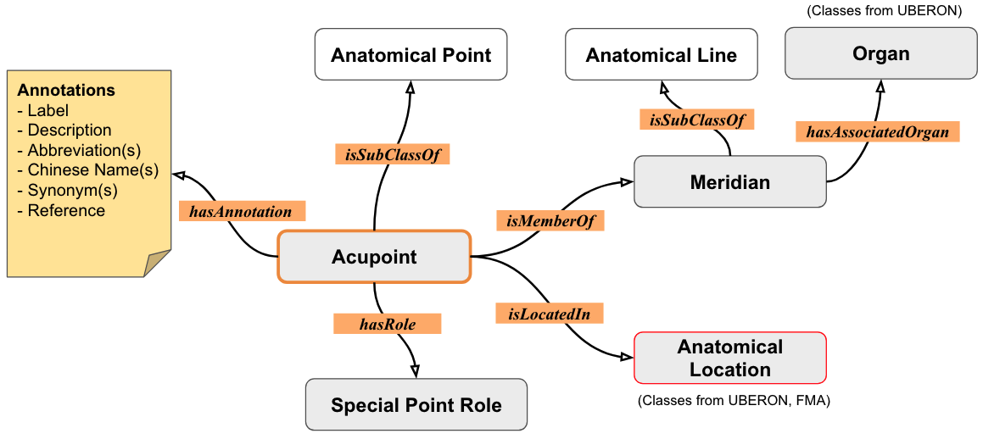
Figure 1. Core entity relationships in the TARA Ontology: an Acupoint is a member of a Meridian, bears a Special Point Role, is located in an Anatomical Region, is studied in research Articles, and is associated with Conditions

Why an Ontology for Acupuncture?
Acupuncture research faces a set of challenges that formal ontological representation is uniquely positioned to solve. Thousands of clinical studies exist, but they use inconsistent terminology, vary in how they name acupoints and conditions, and are scattered across incompatible databases. Integrating and querying this body of evidence at scale requires a semantic backbone.

Data Integration  Unifies terminology across TARA's atlas, data, and research components, enabling seamless cross-tool interoperability and consistent semantics. | Semantic Search  Powers intelligent queries across acupoints, meridians, anatomy, and clinical literature — connecting acupoints to conditions studied and the evidence base. | AI-Ready Knowledge  Structured knowledge that can be fed into AI systems for summarization, pattern discovery, and clinical insight generation across the acupuncture literature.
Research Discovery  Connects acupoints to published studies and conditions, enabling researchers to identify patterns and evidence gaps at scale. | Interoperability  Grounded in community standards (UBERON, MONDO, HPO), ensuring compatibility with the broader biomedical ontology ecosystem including HEAL, SPARC, and HuBMAP. | Standardization  Based on WHO Standard Acupuncture Point Locations and established references, providing a rigorous, citable foundation for acupuncture informatics.

Without the ontology, a researcher asking "what acupoints are used to treat pain conditions in the lower back?" would need to manually search for every known acupoint name variant, every synonym for low back pain, and cross-reference hundreds of papers by hand. With the ontology, this becomes a structured query that the system resolves automatically — inferring relevant acupoints, mapping condition synonyms, and surfacing the evidence in seconds.

Executive Summary
The TARA Acupoints Ontology is a formal OWL-DL knowledge resource providing a rigorously structured, interoperable representation of acupuncture knowledge — bridging traditional Chinese medicine (TCM) and Western biomedical science — for use by researchers, clinicians, and computational systems alike.

What it covers:
- 371 meridian acupoints (361 classical + 10 sex-specific variants) and 43 extra acupoints, each with a unique TARA identifier
- 14 meridian channels (12 primary + 2 extra), formally linked to associated organs via UBERON cross-references
- 1,197 anatomical location axioms covering 266 unique body-surface regions, grounded in UBERON and InterLex (ILX)
- 58 special point designations across hierarchical categories (Five-Shu, Front-Mu, Back-Shu, Xi-Cleft, Confluent, and more)
- Clinical annotations: indications, needling method, vasculature, and innervation for each acupoint
- An Articles Knowledge Base linking acupoints to pain research literature via MONDO/HP disease ontology terms

Key characteristics:
- OWL-DL ontology following OBO Foundry principles and FAIR data standards
- Built on BFO, UBERON, RO, IAO, Dublin Core, MONDO, and HP — ensuring maximum interoperability
- Accessible via Protégé, WebProtégé, NCBO BioPortal, Stardog SPARQL endpoint, and GitHub
- Current release: v1.2.0 (April 2026); Version 2.0 roadmapped for December 2026
- Supports semantic search and AI/LLM-based natural language querying of acupuncture knowledge

Ontology Architecture

Upper-Level and Mid-Level Foundations
The ontology is layered on community-standard upper-level ontologies to maximize interoperability:

Ontology | Role | Scope
Basic Formal Ontology (BFO) | Top-level formal structure | Universal/particular, continuant/occurent
UBERON | Anatomy terms | Body regions, organs, structures
Relation Ontology (RO) | Object properties | has member, bearer of, located in
IAO | Annotation properties | Information artifacts, metadata
Dublin Core (DC) | Article metadata | Title, creator, date, citation
MONDO / HP | Disease & phenotype terms | Condition mapping for literature KB

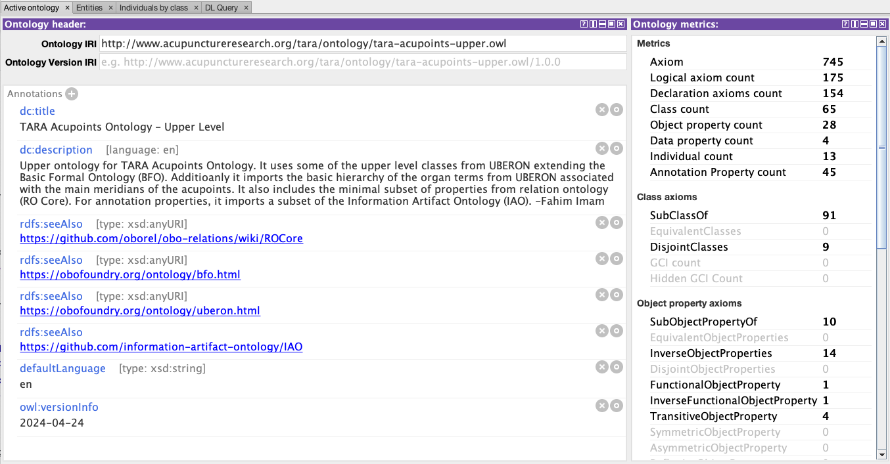
Figure 2. Upper-level ontology structure: BFO-aligned classes and properties reused from UBERON and RO

Core Entities and Relationships
The core ontology (tara-acupoints-core.ttl) defines domain-specific classes and properties extending the upper-level structure. The diagram below shows the core entities as seen in Protégé.

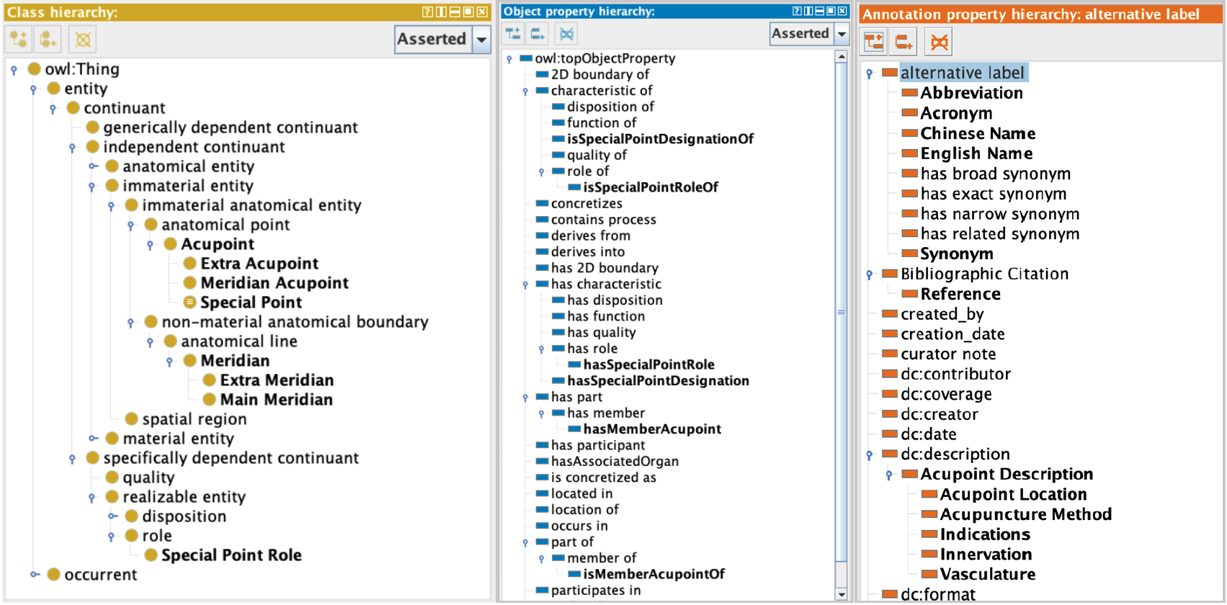
Figure 3. Core ontology classes (bold) and properties extending upper-level terms in Protégé

Acupoints
Each of the 371 meridian acupoints and 43 extra acupoints is an OWL class with a unique TARA numeric identifier (e.g., TARA:0913913 for LU 1). Every acupoint carries 12 annotation sub-properties:

Property | Description | Example (LU 1)
rdfs:label | WHO alphanumeric code | LU 1
tara:hasPinyinLabel | Pinyin name | Zhongfu
tara:hasChineseLabel | Chinese character name | 中府
tara:hasSynonym | Alternate names/aliases | Lung 1, Front-Mu of Lung
tara:hasSurfaceLocation | General body region | Anterior Thoracic Region
tara:hasRelatedLocation | Proximal anatomical structures | 1st intercostal space, infraclavicular fossa
tara:hasLocationalDescription | WHO canonical text | "6 B-cun lateral to the anterior median line"
tara:hasIndicationsDescription | TCM clinical indications | Cough, asthma, chest pain
tara:hasMethodDescription | Needling method & depth | Oblique 0.5–0.8 cun; moxibustion applicable
tara:hasVasculatureDescription | Nearby blood vessels | Thoracoacromial artery and vein
tara:hasInnervationDescription | Nearby nerve supply | Intermediate supraclavicular nerve
tara:hasDesignatedOrgan | TCM organ designation | Lung

Meridians
The 14 meridian channels are formal OWL classes. Each carries a label, Chinese name, Pinyin, abbreviation, and a tara:hasAssociatedOrgan object property linking to its corresponding UBERON organ class (e.g., Lung Meridian → UBERON:0002048 lung).

Special Points
58 meridian acupoints hold one or more special point designations modeled as both annotation properties and OWL object properties, enabling the reasoner to infer subclass membership. Categories include Five-Shu Points (Jing-Well, Ying-Spring, Shu-Stream, Jing-River, He-Sea), Yuan-Primary, Luo-Connecting, Xi-Cleft, Back-Shu, Front-Mu, Confluent, Crossing, Lower He-Sea, and eight categories of Influential Points.

OWL Object Properties
The core ontology defines 9 TARA-specific object properties, each sub-classing an RO relation, with inverses for bidirectional reasoning. SWRL rules infer hasSpecialPointRole from asserted hasSpecialPointDesignation axioms.

Property | RO Parent | Example
hasMemberAcupoint / isMemberAcupointOf | RO:0002351/0002350 | Lung Meridian ↔ LU 1...LU 11
hasSpecialPointDesignation (asserted) | RO:0000053 bearer of | LU 1 → Front-Mu Point of the Lung Role
hasSpecialPointRole (inferred via SWRL) | RO:0000087 has role | Inferred from hasSpecialPointDesignation
locatedOnTheSurfaceOf | RO:0001025 located in | LU 1 → Anterior Thoracic Region
locatedInRelationTo | RO:0001025 located in | LU 1 → First Intercostal Space, Radial Artery
hasAssociatedOrgan | (top-level) | Lung Meridian → UBERON lung

Example Ontology Hierarchies
The following Protégé screenshots illustrate the core classification hierarchies of the TARA Acupoints Ontology.

Hierarchy of the Meridians
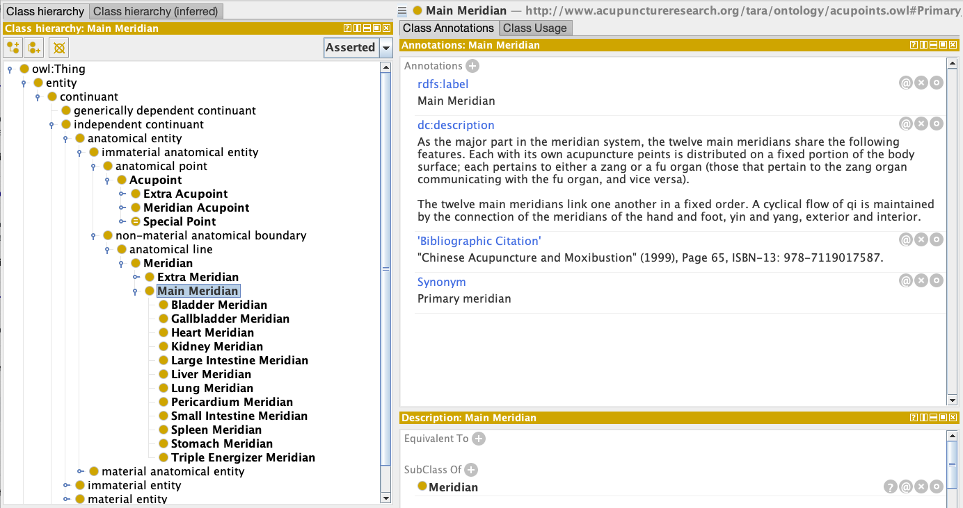
Figure 4. Meridian hierarchy: 12 main meridians and 2 extra meridians as OWL subclasses

Hierarchy of the Meridian Acupoints
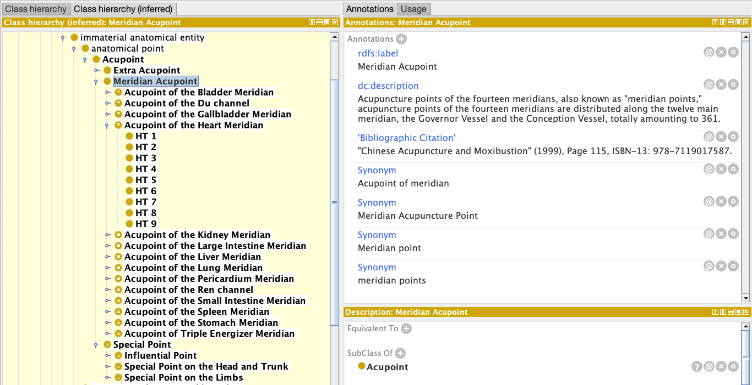
Figure 5. Acupoints organized under their meridians — each acupoint is an OWL subclass

Classification of Special Acupoints
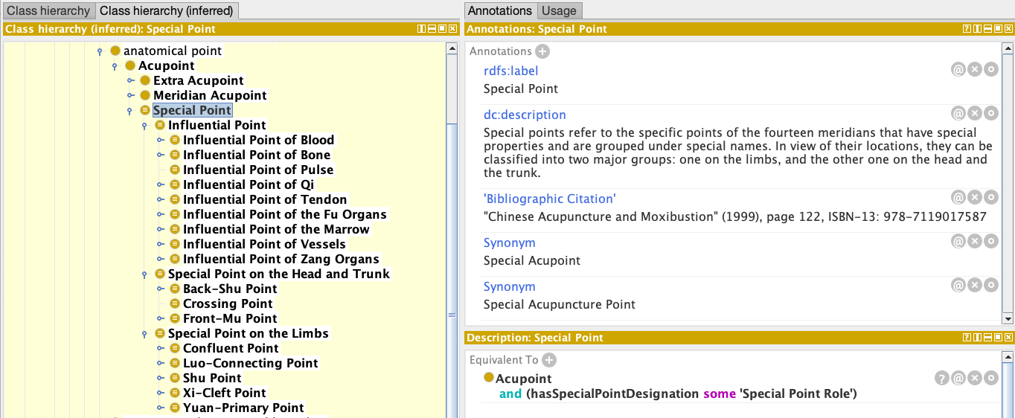
Figure 6. Special point role hierarchy — the structured classification of special point categories

Inferred Special Points Classification
The OWL reasoner automatically infers subclass membership for special point categories. The example shows reasoner-inferred subclasses of Xi-Cleft Point: acupoints from different meridians classified automatically via hasSpecialPointDesignation axioms.

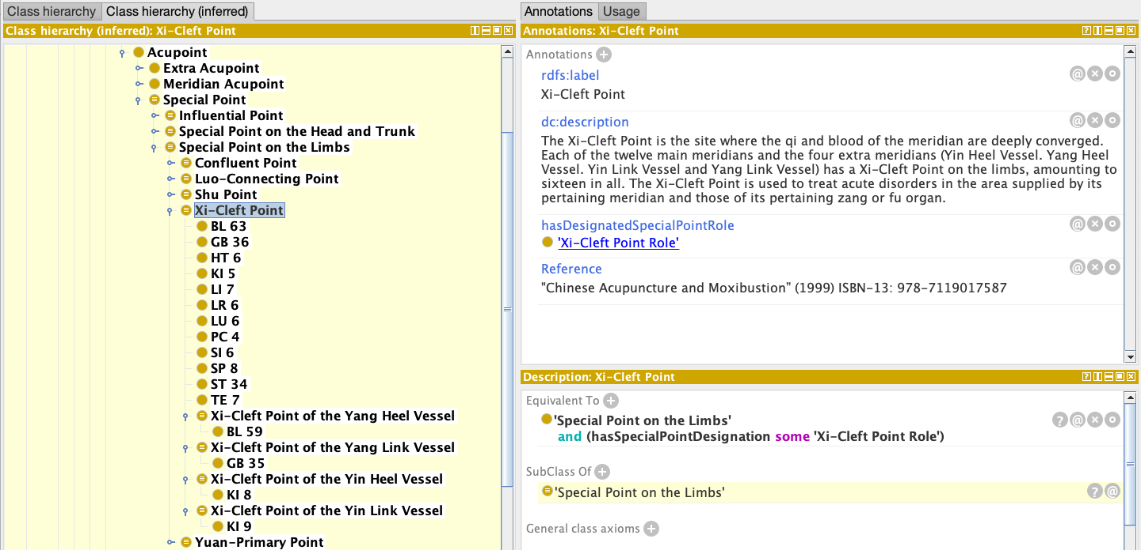
Figure 7. Reasoner-inferred subclasses of Xi-Cleft Point — classification derived automatically from axioms

Semantic Search and Use Cases
The defining advantage of an ontology over a flat database is semantic search: the ability to query by meaning, inferred class membership, and hierarchical relationships rather than exact text strings. When a user searches for "pain conditions" in the TARA system, the ontology automatically retrieves results annotated with any MONDO subclass of pain — including back pain, migraine, osteoarthritis, and dozens of others — without the user needing to enumerate each term.

Competency Queries
Competency queries define what a well-formed ontology must be capable of answering. These questions — drawn from community surveys — guided the TARA ontology's design and serve as its testing framework for completeness and correctness.

Q1 | What acupoints are located on meridian X?
Q2 | What is the anatomy around acupoint X, within a specified scope?
Q3 | What research is connected to acupoint X?
Q4 | Which acupoints are most commonly combined to treat condition X?
Q5 | Are there research studies about condition X related to acupoint Y?
Q6 | What research studies involve acupoints located within meridian X?
Q7 | What acupoints are located on the torso?
Q8 | What are the Front-Mu points and which meridians do they belong to?

Each of these questions requires either hierarchical inference ("located on the torso" must match all acupoints in UBERON regions that are parts of the torso) or semantic linking across knowledge domains ("research connected to acupoint X" must join the acupoint ontology with the articles knowledge base).

How Semantic Search Works in Practice
Three examples illustrate the power of ontology-driven search over keyword search:

Search type | Keyword search (flat database) | Semantic search (ontology)
By meridian | Returns only papers that literally mention "Lung Meridian" | Returns all papers using any LU 1–LU 11 acupoint, inferred as Lung Meridian members
By special role | Returns only papers that use the phrase "Front-Mu Point" | Returns all 12 Front-Mu point acupoints across all meridians, inferred from the special role hierarchy
By body region | Returns only papers using the exact term "head acupoints" | Returns all acupoints whose UBERON surface location is a part-of head — including face, scalp, temple, etc.

DL Query Examples in Protégé
The following Protégé DL query screenshots demonstrate the ontology's semantic capabilities. Each query uses the Manchester OWL syntax and runs after activating the HermiT reasoner.

Acupoints by Meridian
Query: 'Meridian Acupoint' that isMemberAcupointOf some 'Heart Meridian'
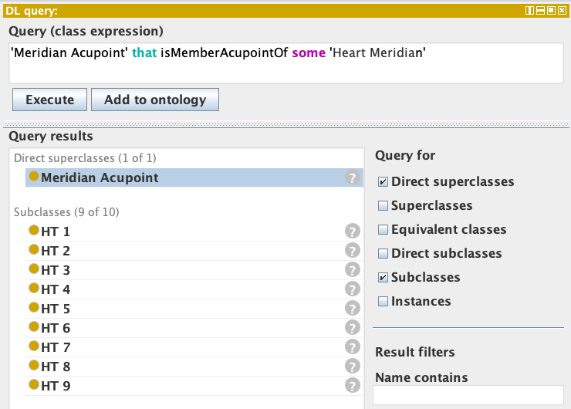
Figure 8. All acupoints of the Heart Meridian — returned via isMemberAcupointOf reasoning

Special Point Role Queries
Query: 'Meridian Acupoint' that hasSpecialPointDesignation some 'Xi-Cleft Point Role'
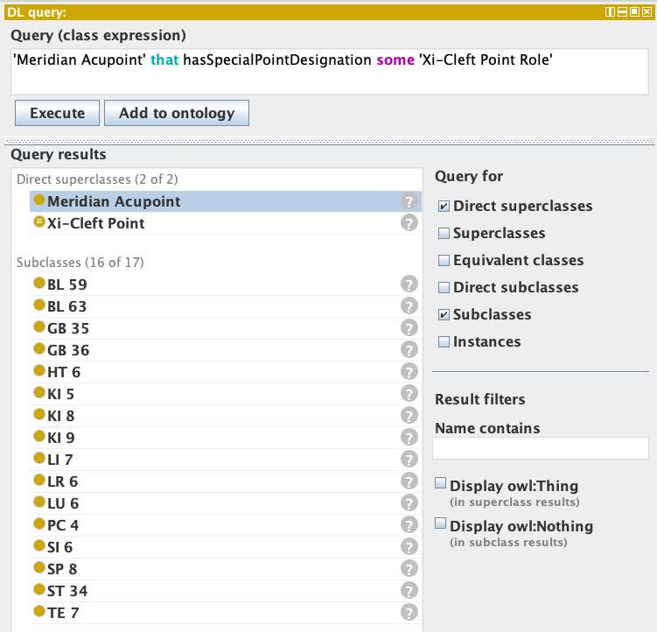
Figure 9. All Xi-Cleft Points across main meridians — inferred from hasSpecialPointDesignation axioms

Query: 'Xi-Cleft Point' and 'Acupoint of the Kidney Meridian'
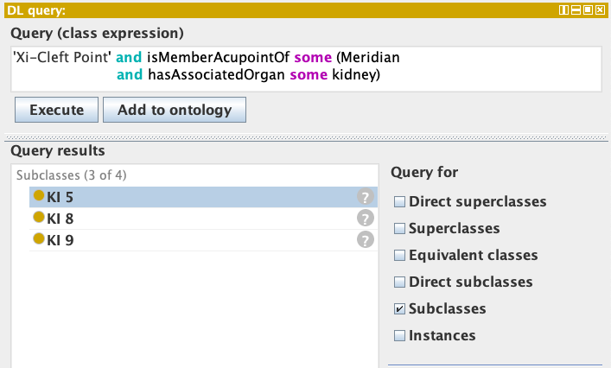
Figure 10. Xi-Cleft Points restricted to the Kidney Meridian — combining two defined class constraints

Query: 'Confluent Point' and isMemberAcupointOf some 'Main Meridian'
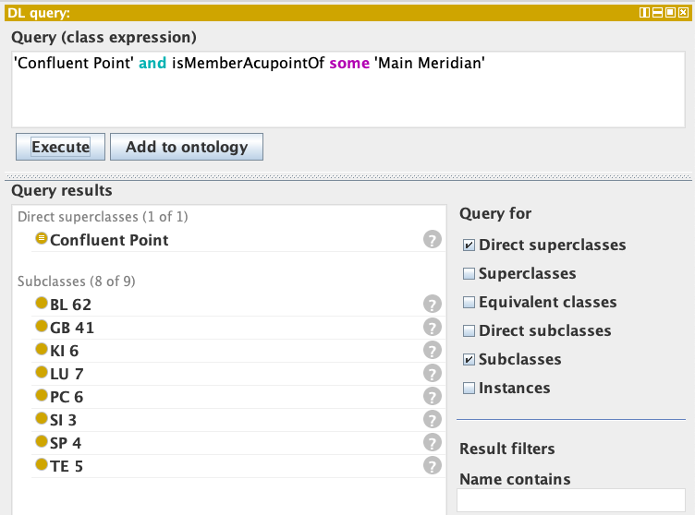
Figure 11. The 8 Confluent Points of the main meridians

Query: 'Meridian Acupoint' and 'Luo-Connecting Point'
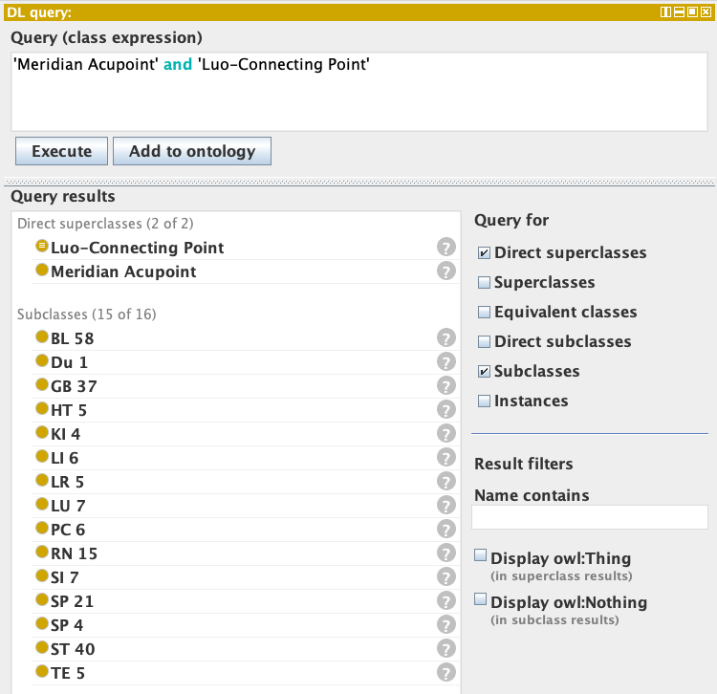
Figure 12. The 15 Luo-Connecting Points across meridians

Anatomical Region Queries
Because surface locations are grounded in UBERON's hierarchical anatomy, region-based queries cascade down the anatomical hierarchy automatically — no need to enumerate every sub-region.

Query: Acupoint and (locatedOnTheSurfaceOf some ('part of' some chest))
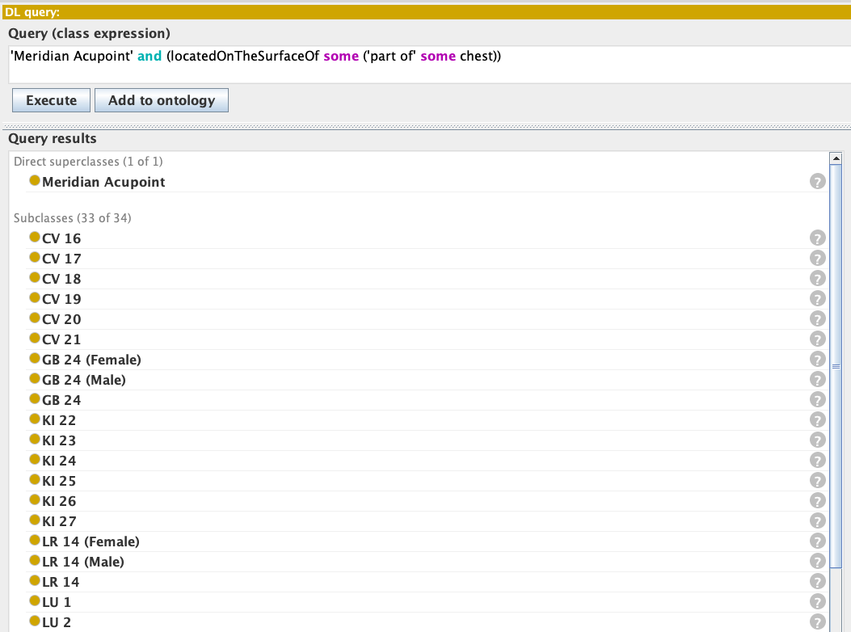
Figure 13. Acupoints located on the surface of the chest — first 16 of 59 total, inferred via UBERON part-of hierarchy

AI and LLM-Based Natural Language Query
While DL queries and SPARQL are powerful, they require technical expertise. A major goal of the TARA project is to make the knowledge base accessible to researchers and clinicians who do not have a background in formal ontologies or query languages. To achieve this, the team has developed a prototype AI/LLM integration that allows users to query the TARA Knowledge Base in plain English.

The Challenge: From Natural Language to Structured Query
The TARA Search Interface is a form-based web application that lets users filter and explore the knowledge base. The traditional form-based approach has limitations: it requires users to know the controlled vocabulary, navigate complex filter menus, and manually interpret results across multiple studies. A single research question like "what acupoints are commonly used to treat low back pain, and what special roles do they have?" might require combining five separate filter selections and reading through dozens of results.
Large language models (LLMs) like Claude and Gemini offer a solution: they can interpret the intent of a natural language query, extract the relevant filter entities, execute a structured search, and then summarize the results in a readable narrative — all in a single step.

Two-Stage LLM Integration Architecture
The TARA LLM integration operates in two stages. In Stage 1, the user's natural language query is sent to the LLM, which extracts structured filter entities. In Stage 2, the search results are returned to the LLM for summarization and insight generation.

Stage | Step and Description
Stage 1  Query Processing | User submits a natural language query → LLM extracts filter entities (acupoints, meridians, conditions, anatomical regions, special point roles) → Structured filters passed to TARA search engine → TARA KB queried with ontology-grounded filters
Stage 2  Result Enhancement | Search results returned to LLM → LLM analyzes results for patterns and key insights → LLM generates a structured summary narrative → User sees both the raw results and the AI-generated summary on the same page

The single-interface advantage is important: because the AI summary and the underlying result list are displayed together, users can verify the AI-generated insights against the raw data without leaving the page. This addresses a key limitation of standalone LLM interfaces, where AI outputs can be hard to audit.

What the LLM Extracts (Entity Recognition)
When a user submits a query, the LLM identifies and extracts filter entities from the following categories:
- Acupoints — specific acupoint names or codes (e.g., "LU 7", "Hegu", "ST 36")
- Meridians — meridian names (e.g., "Lung Meridian", "Stomach channel")
- Studied conditions — disease or symptom terms mapped to MONDO/HP (e.g., "low back pain" → MONDO:0005374, "migraine" → MONDO:0100431)
- Anatomical regions — body locations mapped to UBERON (e.g., "head", "forearm", "torso")
- Special point roles — category names (e.g., "Back-Shu points", "Xi-Cleft", "Front-Mu")

These extracted entities are then used as structured filters against the TARA Knowledge Base — which means the search is grounded in the ontology, not just text matching. A query for "back pain" will retrieve studies about low back pain, chronic back pain, and lumbar pain because MONDO groups them all under the same semantic hierarchy.

Example Natural Language Queries
The following queries have been tested against the TARA prototype interface:

Natural Language Query | What the System Does
"Find acupoints used for low back pain. Summarize the results." | Extracts condition 'low back pain' → MONDO mapping → retrieves relevant studies → LLM summarizes most frequently used acupoints and study patterns
"What acupoints are studied for pain? Summarize the results." | Broad condition query → retrieves all 48 pain-related studies in the KB → LLM generates overview of acupoint usage patterns across pain types
"What pain conditions are studied using the Back-Shu points? Summarize focusing on different conditions." | Extracts special point role 'Back-Shu' → retrieves all Back-Shu point studies → LLM groups by condition studied
"What acupoints are located on the head? What pains are studied using those acupoints?" | Location query resolved via UBERON → finds all head acupoints → joins with pain condition studies → LLM summarizes connections
"What acupoints are used for pain? Are there any trends over time?" | Retrieves pain studies → LLM analyzes by publication date → identifies temporal trends in acupoint usage across the literature

LLM Comparison: Claude vs. Gemini
The prototype has been tested with both Claude (Anthropic) and Gemini (Google). Key observations from testing:

Characteristic | Claude | Gemini
Summary quality | Better linguistic style; more structured and readable summaries | Faster response time; occasionally inconsistent style
Response time | Slower, especially for longer result sets | Faster
Consistency | More consistent across repeated runs | Some variation in style across runs
Best suited for | High-quality summaries for expert review | Rapid prototyping and speed-sensitive use cases

The current summary format is experimental. Consultation with acupuncture domain experts is planned to refine the structure of AI-generated summaries to best serve the needs of researchers and clinicians.

Current Status and Next Steps
The LLM integration is currently at prototype stage as of mid-2025. The roadmap includes:
- Expert consultation to define the most useful summary formats and output structures for the acupuncture research community
- Refinement of the LLM prompting strategy based on expert feedback
- Decision on API key model (user-provided vs. centralized, with implications for cost and context length)
- Integration of the NLP interface into the production TARA Search Interface
- Extension to cover the full v1.5/v2.0 knowledge base as conditions and subsurface anatomy are added

Articles Knowledge Base
Alongside the acupoints ontology, a parallel Articles Knowledge Base (tara-articles-kb.ttl) stores metadata for pain research publications annotated with acupoints and studied conditions. Article metadata follows Dublin Core conventions (dc:title, dc:creator, dc:date, dcterms:bibliographicCitation) and links acupoints and conditions to TARA and MONDO/HP identifiers via DOI/PMID.
The knowledge base currently contains curated metadata for approximately 1,800 articles (QC in progress). The ingestion pipeline uses AI-assisted extraction via Elicit, followed by manual normalization of condition terms and mapping to MONDO/HP ontology IDs in collaboration with the Data Core and Team Core.
This structured article annotation enables the competency queries described earlier — in particular, the condition-based queries (Q3, Q4, Q5, Q6) that join acupoint data with research evidence. It also provides the data substrate for the LLM-based natural language query interface.

Knowledge Curation Sources
The ontology draws from a carefully selected set of authoritative primary sources:

- WHO Standard Acupuncture Point Locations in the Western Pacific Region (WHO, 2008) — standardized alphanumeric codes, Pinyin names, Chinese character names, and surface-anatomy locations for the 361 canonical acupoints
- Chinese Acupuncture and Moxibustion, ed. C. Xinnong (Beijing, 1999) — Extra Acupoints, Special Points classification, and clinical annotations (indications, needling, vasculature, innervation)
- Acupuncture: A Comprehensive Text (Shanghai College of TCM, 1981) — alternative alphanumeric codes for Extra Acupoints
- UBERON Multi-Species Anatomy Ontology — standard mappings of body regions, nerves, veins, and arteries
- MONDO Disease Ontology and Human Phenotype Ontology (HP) — standardized disease/condition mappings for the Articles Knowledge Base

Curation is managed via a Google Sheets workflow. Curated CSV files feed a Python-based generator pipeline that produces the final Turtle (.ttl) ontology files.

Project Evolution and Roadmap
Period | Milestone | Key Deliverables
Dec 2023 | Project initiation | Working group; use cases solicited; initial framework
Apr 2024 | First ontology concept | Initial model: meridians, acupoints, special points, relationships
Jun–Jul 2024 | Version 0.5–0.6 | Anatomical locations; UBERON/ILX terms; surface axioms for LU & LI
Sep 2024 | Beta release | Testing against use cases; initial BioPortal submission
Jan 2025 | Production release | BioPortal release; v0.7.1 with full surface anatomy for all 371 acupoints
Jun 2025 | Version 1.0–1.1 | Complete ontology (Eastern & Western); full location coverage; LLM prototype
Jan 2026 | Version 1.2 planning | Subsurface anatomy initiated; conditions pipeline scoped
Apr 2026 | Version 1.2.0 (current) | Chinese character labels; 193 synonyms; dual-source provenance
Jun 2026 | Version 1.5 (planned) | First tranche of conditions (MONDO/HP); subsurface anatomy complete
Dec 2026 | Version 2.0 (target) | Full conditions; fascial anatomy; TARA portal integration; manuscript submitted

Current Work in Progress (June 2026)
- Subsurface anatomy: Mapping nerve and vasculature terms to UBERON for all 361 acupoints. LU and LI meridians complete; full completion targeted June 2026.
- Conditions modeling: QC of ~1,800 article records; MONDO/HP mapping; TCM conditions as free-text annotations initially.
- Synonym expansion: Aligning literature name variants with TARA canonical IDs for improved article annotation.
- LLM interface: Expert consultation on summary formats; production integration planned.
- Fascial anatomy: Planned collaboration with Atlas Core for V2.0.

Accessing the Ontology
Platform | Access Method
GitHub Repository | https://purl.org/tara/ontology/repo — raw .ttl files, generator scripts, curated CSV data, SPARQL notebook
NCBO BioPortal | https://bioportal.bioontology.org/ontologies/TARA — all major versions with inferred hierarchy and annotations
WebProtégé | View and comment on the inferred ontology at webprotege.stanford.edu (free account required)
Protégé Desktop | File > Open From URL with the raw tara-acupoints.ttl link; use HermiT reasoner for DL queries
Stardog SPARQL | Public SPARQL endpoint; Jupyter notebook with example queries in the sparql/ directory of the repo

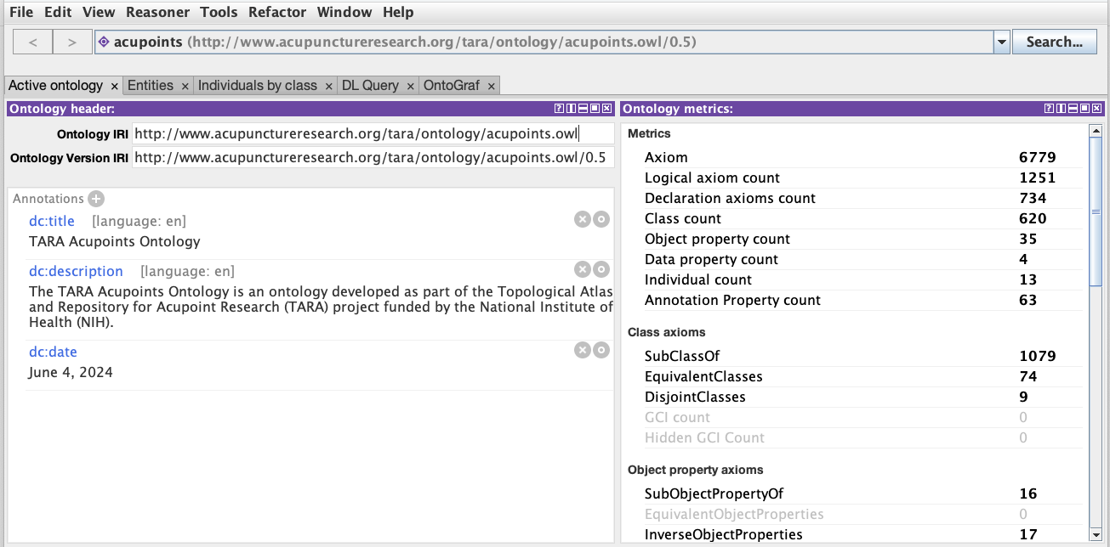
Figure 14. Loading the TARA Acupoints Ontology in Protégé via File > Open From URL

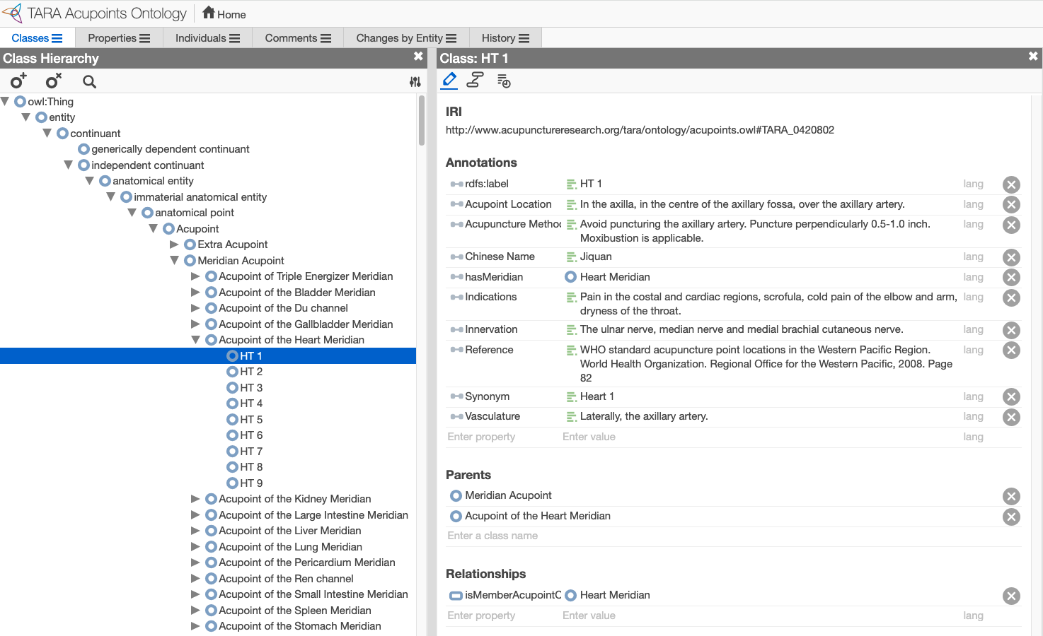
Figure 15. Browsing the TARA Acupoints Ontology in WebProtégé — available for viewing and expert feedback

For Ontologists: Technical Notes
- OWL profile: OWL-DL (Description Logic), reasoning with HermiT
- Serialization: Turtle (.ttl); asserted and inferred versions provided separately
- Defined classes: Named equivalent classes for each meridian's acupoints (e.g., 'Acupoint of the Heart Meridian' ≡ Meridian Acupoint ∩ isMemberAcupointOf some Heart Meridian)
- SWRL rules: hasSpecialPointRole / isSpecialPointRoleOf inferred from asserted hasSpecialPointDesignation axioms
- Versioning and release notes: https://purl.org/tara/ontology/updates

Broader Impact and Integration
The TARA ontology is designed from the outset as a node in a larger biomedical knowledge graph. The longer-term vision connects it to:
- HEAL (Helping to End Addiction Long-term) Knowledge Graph — linking acupoint-based pain treatment data to HEAL study data via shared MONDO/HP terms
- SPARC (Stimulating Peripheral Activity to Relieve Conditions) — connecting acupoint anatomy to SPARC's autonomic nervous system connectivity resources
- HuBMAP (Human BioMolecular Atlas Program) — bridging to human body atlas data through shared UBERON anatomy terms

This positions the TARA ontology as a translational bridge: enabling acupuncture research data to be queried and reasoned over alongside mechanistic and clinical biomedical data from entirely separate NIH programs.

Project Team
TARA is a multi-site NIH NCCIH-funded collaboration. The Ontology Core is led by UC San Diego and works in close coordination with the Atlas, Data, Team, and Admin cores.

ONTOLOGY CORE  Maryann Martone, PhD  UC San Diego (Lead) | ONTOLOGY DEVELOPMENT  Fahim Imam, PhD  UC San Diego | ONTOLOGY CURATION  Ilias Ziogas, PhD  UC San Diego | PROJECT MANAGEMENT  Laura Triplett  Society for Acupuncture Research
TEAM CORE  Richard Harris, PhD LAc  UC Irvine / SAR (Lead) | ATLAS CORE  Peter Hunter, PhD  University of Auckland (Lead) | DATA CORE  Karl Helmer, PhD  MGH, Harvard Medical School | ADMIN CORE  Vitaly Napadow, PhD LAc  Spaulding Rehab, Harvard Medical School

Special thanks to Drs. Lixing Lao and Richard Harris for content expertise and guidance. Funded by the National Center for Complementary and Integrative Health (NCCIH), National Institutes of Health.

Quick Reference
Item | Detail
Project full name | Topological Atlas and Repository for Acupoint Research (TARA)
Funding | National Center for Complementary and Integrative Health (NCCIH), NIH
Ontology Core Lead | Maryann Martone, PhD — UC San Diego
Ontology type | OWL-DL (Description Logic)
Current version | 1.2.0 (released April 20, 2026)
Meridian acupoints | 371 (361 canonical + 10 sex-specific variants)
Extra acupoints | 43
Location axioms | 1,197 covering 266 unique body-surface regions
Special point designations | 58 acupoints with defined special roles
Articles in KB | ~1,800 (QC in progress)
Primary sources | WHO (2008), Chinese Acupuncture & Moxibustion (1999)
Upper ontologies | BFO, UBERON, RO, IAO, Dublin Core, MONDO, HP
GitHub | https://purl.org/tara/ontology/repo
BioPortal | https://bioportal.bioontology.org/ontologies/TARA
Release notes | https://purl.org/tara/ontology/updates

