**American International University-Bangladesh**

Advanced Programming with Java [A]

Project Description

**Project Title: Travel management system (ghura ghuri)**

**Group No/Name: /GCORE**

|  |  |  |
| --- | --- | --- |
| **Student Id** | **Student Name** | **Signature** |
| 19-40903-2 | Refat, Mahfujar Rahman | Refat |
| 19-40861-2 | Mustakim, S M Tusher | *Tusher* |
|  |  |  |

**Short Description of your project:**

|  |
| --- |
| Nowadays people are more and more interested in traveling. So we chose this idea from the thought of making travel easier for travelers through this application. This application will have 3 users. Admin, employees, and customers. Admin will be able to access and update everything in this application. Employees will have limited access. They will be able to see various information about customers and act accordingly. However, if there is a complex problem, they will need admin approval. And customers will be able to open their own profiles and book the place where they love to go. And they can change their profile. Through this application, the user can safely go to their desired place without any hassle. Customers can easily get transportation, hotel accommodation, and catering facilities through this application. Users can also Shop for any accessories for traveling. And also users can book hotels, buy transport tickets, etc. So We will try to make this application more user-friendly. |

**E-R Diagram:** (Please use any online tool to draw E-R diagram then upload as image here)

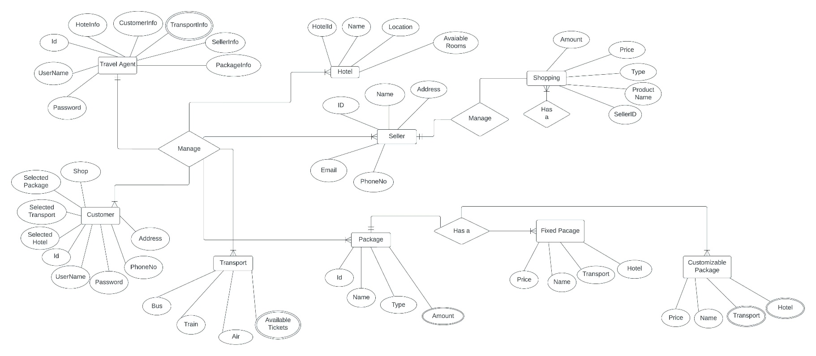

**Roles & Responsibilities:** (Please provide all user types in your system and name/mention the attributes/features of your roles)

User 1: (Admin)

Describe the Features

User 2: (Agent)

Describe the Features

User 3: (Customer)

Describe the Features